|  |  |  |  |
| --- | --- | --- | --- |
|  | **Radiocommunication Study Groups** | |  |
| **INTERNATIONAL TELECOMMUNICATION UNION** | |  | |
|  | |  | |
| Source: Document 5A/TEMP/13 | | **Annex 27 to Document 5A/114-E** | |
| **24 May 2016** | |
| **English only** | |
| Annex 27 to Working Party 5A Chairman’s Report | | | |
| WORKING DOCUMENT TOWARDS A PRELIMINARY DRAFT NEW REPORT ITU-R M.[SHARE] | | | |
| Sharing schemes in the land mobile service on the basis of geographical use, frequencies, services, new technologies and applications  (Question ITU-R 238-2/5) | | | |

Table of Contents

1. Introduction 1

2. Relevant ITU-R Recommendations and Reports 2

3. Use of the frequency spectrum for different services/applications by zones 3

4 Use of technologies that improve spectrum usage 4

5 Application to suitable bands allocated to both mobile and satellite services 4

# 1 Introduction

In order to maximize the usefulness of the frequency spectrum for land mobile service it is timely to study whether certain system sharing schemes could enhance the use of the spectrum.

This Report studies the use of the frequency spectrum for different services/applications by zones by taking advantage of the properties of alternative wireless access technologies on the basis of user density and traffic requirements. Indeed, certain combinations of frequencies and technologies are able to provide high capacity and high density coverage through frequency reuse and densification, while others are more suitable to provide more effective wide area coverage. It is now technologically possible to mix and match wireless access technologies to optimize the coverage in urban, sub-urban, rural, and remote areas.

Recommendation ITU-R F.1401 provides characteristic of various bands for terrestrial wireless access and certain ITU-R studies on compatible operations with systems in other radio services sharing the same bands, characteristics and operational requirements, spectrum requirements, and interference mitigation technologies. It appears that the propagation characteristics of bands above 3 GHz, which include allocations to the mobile service, the fixed service, and the fixed satellite service, offer good opportunities to explore the shared used on a geographical basis by arranging the coverage area into zones and using the most appropriate technology in each zone.

Therefore it is necessary to develop a scheme to use a frequency band allocated to multiple services more efficiently (e.g., appropriate design of cell sizes, use of technologies such as multiuser detection (MUD) and smart antennas) by using possibly geographical separation. This is investigated in Section 3.

# 2 Relevant ITU-R Recommendations and Reports

*[Editor’s Note: Suggestions are invited to add relevant Recommendations]*

|  |  |
| --- | --- |
| Recommendation [ITU-R F.1401](http://www.itu.int/rec/R-REC-F.1401/en) | Considerations for the identification of possible frequency bands for fixed wireless access and related sharing studies |
| Recommendation [ITU-R M.1825](http://www.itu.int/rec/R-REC-M.1825/en) | Guidance on technical parameters and methodologies for sharing studies related to systems in the land mobile service |
| Recommendation [ITU-R SM.1603](http://www.itu.int/rec/R-REC-SM.1603/en) | Spectrum redeployment as a method of national spectrum management |
| *[Editor’s Note:*  Preliminary draft revision of Recommendation ITU-R SM.1132-2 ([Annex 1](https://www.itu.int/md/dologin_md.asp?lang=en&id=R12-WP1A-C-0234!N01!MSW-E) to Doc. [1A/234](http://www.itu.int/md/R12-WP1A-C-0234/en))  *Update the reference as the draft report progresses; only references to Recommendations in force may appear in the final draft].* | *[Editor’s Note:*  General principles and methods for sharing between radiocommunication services  *This draft revised Recommendation contains general principles and technical sharing methods for facilitating efficient and effective sharing of spectrum by multiple radiocommunication services. The presented methods imply sharing dimensions of frequency, space, time and signal separation. Any sharing of the spectrum will have to take into account one or more of these four dimensions. It is expected that other ITU-R Recommendations would be developed to provide guidance on the use of these principles in sharing situation. The draft revision includes: licensed shared access, spectrum database, spectrum access controller, geo-location database, beacon, and sensing.]* |
| Report [ITU-R M.2109](http://www.itu.int/pub/R-REP-M.2109) | Sharing studies between IMT Advanced systems and geostationary satellite networks in the fixed-satellite service in the 3 400 – 4 200 and 4 500 – 4 800 MHz frequency bands |
| Report [ITU-R M.2225](http://www.itu.int/pub/R-REP-M.2225) | Introduction to cognitive radio systems in the land mobile service |
| Report [ITU-R M.2242](http://www.itu.int/pub/R-REP-M.2242) | Cognitive Radio Systems specific for IMT Systems |
| Report [ITU-R M.2330](http://www.itu.int/pub/R-REP-M.2330) | Cognitive radio systems (CRSs) in the land mobile service |
| Report [ITU-R S.2199](http://www.itu.int/pub/R-REP-S.2199) | Studies on compatibility of broadband wireless access (BWA) systems and fixed-satellite service (FSS) networks in the 3 400-4 200 MHz band |
| *[Editor’s Note:*  Working document towards a preliminary draft new Report ITU-R SM.[innovative regulatory tools] ([Annex 5](https://www.itu.int/md/dologin_md.asp?lang=en&id=R12-WP1B-C-0238!N05!MSW-E) to Doc. [1B/238](http://www.itu.int/md/R12-WP1B-C-0238/en))  *Update the reference as the draft report progresses; only references to Reports in force may appear in the final draft].* | *[Editor’s Note:*  Innovative regulatory tools to support enhanced shared use of the spectrum.  *The original proposal for this new report in* [*Doc. 1B/171*](http://gsims.lmc.ericsson.se/ITU-R/1B-2014-06-Geneva/Inputs/R12-WP1B-C-0171-E.htm) *was based on* [*ECC Report 205*](http://www.erodocdb.dk/Docs/doc98/official/pdf/ECCREP205.PDF)*; 14 pages of the working document are devoted to licensed shared access and other tools could be added at future meetings based on contributions (the working document has placeholder annexes).]* |

# 3 Use of the frequency spectrum for different services/applications by zones

Various sharing alternatives are possible and available, including geographical separation and/or frequency separation (cf. Recommendation ITU-R SM.1132). The approach being investigated here is the use of geolocation databases, in cases whenever it is applicable, to determine which frequencies are available in each zone by systems operating under different radiocommunication services.

Figure 1 illustrates the concept whereby certain frequencies are for exclusive use by the mobile and fixed services in urban and suburban areas while other frequencies are for exclusive use by the fixed satellite service in rural and remote areas. Carefully delineated specific coordination zones provide mutual protection between services.

Figure 1

Example of shared use of the frequency range f1 – f3 MHz by terrestrial mobile broadband   
and fixed satellite by differentiating geographical zones

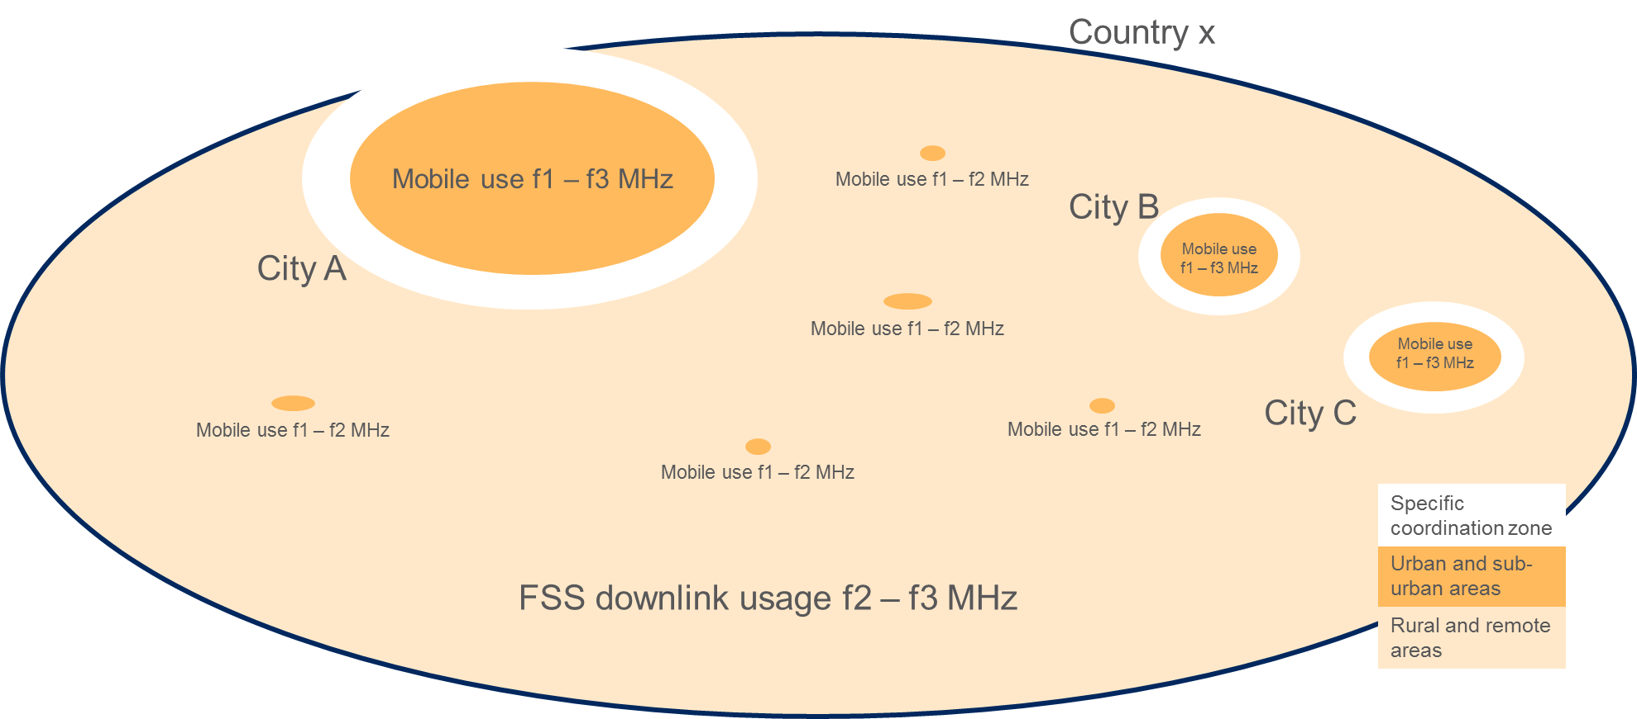

This approach can be effectively implemented using Licensed Shared Access (LSA) and similar schemes such as geo-location databases. The working document towards a preliminary draft new Report ITU-R SM.[innovative regulatory tools] (cf. [Annex 5](https://www.itu.int/md/dologin_md.asp?lang=en&id=R12-WP1B-C-0238!N05!MSW-E) to Doc. [1B/238](http://www.itu.int/md/R12-WP1B-C-0238/en)) describes LSA.

Cognitive Radio Systems, as described in Report [ITU-R M.2225](http://www.itu.int/pub/R-REP-M.2225), Report [ITU-R M.2242](http://www.itu.int/pub/R-REP-M.2242) and Report [ITU-R M.2330](http://www.itu.int/pub/R-REP-M.2330), describe technical capabilities which could be used for the implementation of LSA.

Using the zonal approach for sharing the frequency spectrum, in this example, both satellite and terrestrial networks could work together in the band. Each network “complements” the other’s coverage – and with technical capabilities such as “inter-system handover,” coverage could be optimized. Report ITU-R M.2330 describes many ways to utilize CRS capabilities for inter-system handover, e.g., implementing the capabilities to terminals, base stations, and core networks.

In order to implement the new schemes, spectrum redeployment approaches, may be used to evolve the radio operations based on the new technologies and changing operational requirements. This needs further study.

# 4 Use of technologies that improve spectrum usage

…

# 5 Application to suitable bands allocated to both mobile and satellite services

Spectrum in the bands above 3 GHz are expected to be in high demand to help service providers address future capacity constraints. Although the propagation properties of the spectrum are not ideal for mobile systems covering large rural and remote areas, the spectrum is expected to be highly useful in expanding the wireless capacity of mobile systems in urban areas and may also be deployed for fixed wireless systems in rural areas. In a complementary manner, satellite networks can effectively support rural areas with capacity and extended coverage requirements.

Therefore, it would be advantageous to structure the terrestrial mobile broadband and satellite networks in such a manner that the spectrum usage is maximized. This could be accomplished by many techniques, not limited to Recommendation [ITU-R M.1825](http://www.itu.int/rec/R-REC-M.1825/en), including the sharing scheme presented in Figure 1.

*[Editor’s Note: It is suggested to study specific scenarios taking into account existing sharing studies in suitable bands and the zonal sharing approach described in Section 3.]*