|  |  |
| --- | --- |
| **Radiocommunication Study Groups** |  |
|  |  |
|  |  |
| Received: 3 October 2022  Source: Wireless World Research Forum | **Document 5D/1492-E** |
| **4 October 2022** |
| **English only  TECHNOLOGY ASPECTS** |
| Wireless World Research Forum | |
| Final Evaluation Report For The Candidate IMT-2020 RIT “EUHT-5G” Submitted by Nufront For M.2150 “Revision After Year 2021” | |
|  | |

This contribution contains the final evaluation report from the Independent Evaluation Group (IEG) Wireless World Research Forum (WWRF) for the candidate IMT-2020 radio interface(s) ‘EUHT-5G’ submitted by Proponent ‘Nufront’ in WP5D #41 as part of the M.2150 “Revision after Year 2021”.

The evaluation which is based on the new EUHT-5G specifications, follows the characteristics defined in ITU-R Reports M.2410-0, M.2411-0 and M.2412-0 [1] – [3] using a methodology described in Report ITU-R M.2412-0 [3].

The final evaluation report follows the following structure.

• Part I: Administrative Aspects of the WWRF

• Part II: Technical Aspects of the work of WWRF

• Part III: Conclusions

# Part I: Administrative aspects of the Independent Evaluation Group

# I-1 Name of the Independent Evaluation Group (IEG)

Wireless World Research Forum (WWRF).

# I-2 Introduction and background of the Independent Evaluation Group

WWRF’s goal is to encourage research that will achieve unbounded communications to address key societal challenges for the future. The term “Wireless World” is used in this broad sense to address the support of innovation and business, social inclusion and infrastructural challenges. This will be achieved by creating a range of new technological capabilities from wide-area networks to short-range communications, machine-to-machine communications, sensor networks, wireless broadband access technologies and optical networking, along with increasing intelligence and virtualization in networks. This will then support a dependable future Internet of people, knowledge and things and the development of a service universe. WWRF is the unique forum where the wireless community can tackle the key research challenges. By searching out the issues, flagging them up to opinion leaders, and then working with liaison partners to deal with them, WWRF drives the development of the Wireless World. WWRF organizes two major events each year combining inputs from industry and academic experts, the exchange of ideas and the evolution of the research agenda and technology roadmaps. WWRF has a strong publication programme, working with partners such as IEEE and Wiley, and makes the key messages and results available to the wireless research sector. To ease standardization, WWRF disseminates and harmonizes views, and together with our major liaison partners, we initiate collaborative research, and develop the global vision.

Over the last ten years, WWRF has championed several activities focused on the wireless evolution to and beyond 5G, including workshops and special sessions, presentations, white papers and journal special issues. WWRF has been very supportive of the ITU’s evaluation process for IMT-2020 and participates as an independent evaluation group (IEG).

For the last three years, beginning 2019, the IEG has been fully engaged in the WP5D IMT-2020 process for evaluation of IMT-2020 candidate technologies. The group has participated in the evaluation of 4 candidate radio interface technologies (RITs) as of today. These activities were performed:

• initially in the context of Step 4 which was open for all submitted RITs,

• next in the re-engagement of the evaluation (Option 2) for two specific RITs that did not receive a complete evaluation,

• and more recently in IMT-2020 submission and evaluation process for M.2150 “Revision after Year 2021” planned to complete in 2023.

The evaluated technologies are listed below:

• TSDSI (IMT-2020/19)

• NUFRONT (IMT-2020/18 and IMT-2020/18(Rev1))

• ETSI (TC DECT) and DECT Forum (IMT-2020/17 and IMT-2020/17(Rev1))

• EUHT-5G (IMT-2020/75 for M.2150 “Revision after Year 2021”)

The contributed material to the respective WP 5D meetings is summarized in the following Table:

|  |  |  |
| --- | --- | --- |
| Meeting | Document | Remarks |
| WP5D #34  (02-2020) | 5D/120-E | Final evaluation report for RIT submissions From TSDSI (IMT-2020/19) and NUFRONT (IMT-2020/18) |
| WP5D #37  (02-2021) | 5D/476 | Interim evaluation report on the Candidate Technology Submission for FOR IMT-2020 “ETSI (TC DECT) and DECT Forum Proponent” As Part of the Re-engagement in Step 4 Evaluation (Report with Provisional Results). |
| WP5D #37  (02-2021) | 5D/475 | Interim evaluation report on the Candidate Technology Submission for IMT-2020 “EUHT” as part of the re-engagement in Step 4 Evaluation. |
| WP5D #38  (06-2021) | 5D/658 | Evaluation report on the Candidate Technology Submission for IMT-2020 “ETSI (TC DECT) and DECT Forum Proponent” as part of the re-engagement in Step 4 evaluation. |
| WP5D #38  (06-2021) | 5D/659 | Evaluation report on the Candidate Technology Submission for IMT-2020 “EUHT” as part of the re-engagement in Step 4 Evaluation |
| WG Technology Aspects Interim Meeting  (08-2021) | 5D/736 | Updated final evaluation report on the Candidate Technology Submission for IMT-2020 “ETSI (TC DECT) and DECT Forum Proponent” as part of the re-engagement in step 4 evaluation. |
| WG Technology Aspects Interim Meeting  (08-2021) | 5D/743 | Interim report based on further evaluations on the Candidate Technology Submission for IMT-2020 “EUHT technology” as part of the re-engagement in step 4 evaluation. (Final results were included subject to minor clarification from the Nufront proponent) |
| WP5D #39  (10-2021) | 5D/760 | Final report including re-evaluation of the final results for the Candidate Technology Submission for IMT-2020 “EUHT technology” as part of the re-engagement in step 4 evaluation. |
| WP5D #41  (06-2022) | 5D/1283 | Interim Evaluation Report for the candidate IMT-2020 RIT "EUHT 5G" submitted by Nufront for M.2150 "Revision after year 2021" |

# I-3 Method of work

## I-3-1 Background

ITU-R announced in June 2021, with Circular Letter [6], the initiation of the update cycle for the revision ‘after year 2021’ of Recommendation ITU-R M.2150 for those radio interface technologies that would currently be included in the published Recommendation having the status of “in force” as of approximately March 2022. In addition it invited the submission of new proposals for candidate radio interface technologies (RITs) or a set of RITs (SRITs) for the terrestrial components of IMT 2020. The letter also initiated, for any new candidate technology submissions, the process to evaluate the candidate RITs or SRITs for IMT‑2020 and invited the formation of Independent Evaluation Groups (IEGs) and the subsequent submission of evaluation reports on these new candidate RITs or SRITs according to the established detailed timeline. With the amendment 1 of the Circular Letter in March 2022 [7], ITU-R announced the acknowledgement of a candidate submission from Nufront under Step 3 of the IMT-2020 process in WP 5D #40. The candidate IMT-2020 radio interface(s) submitted by Proponent ‘Nufront’ included an RIT. The submitted proposal is referenced in Document IMT-2020/75 [8]. WWRF IEG informed ITU-R WP 5D in April 2022 of its intention to participate in the evaluation of the new EUHT-5G technology submission.

## I-3-2 Organizational Issues

The work was organized using the following channels:

1. Regular online meetings of the steering board (SB) of WWRF
2. Nufront’s Workshop for their new Technical Specifications for EUHT-5G
3. Step 5 Consultation Workshop (in September 2022)
4. Weekly meetings of the technical teams
5. File sharing through secure shared space
6. Workshops/Seminars organised by the WWRF
7. Monitoring of the ITU Discussion Forum

## I-4 Administrative contact details

**Name & Affiliation:** Dr Nigel Jefferies, WWRF Chairman.

**Email:** [nigel.jefferies@wwrf.ch](mailto:nigel.jefferies@wwrf.ch)

## I-5 Technical contact details

|  |  |  |
| --- | --- | --- |
| [**Name**](mailto:hakan.batikhan@turkcell.com.tr) | **Affiliation** | **e-mail** |
| Prof. Christos Politis | Kingston University, UK | [c.politis@kingston.ac.uk](mailto:c.politis@kingston.ac.uk) |
| Dr. Rafay Ansari | Kingston University, UK | [rafay.ansari@kingston.ac.uk](mailto:rafay.ansari@northumbria.ac.uk) |
| Dr. M Arslan Usman | Kingston University, UK | [m.usman@kingston.ac.uk](mailto:m.usman@kingston.ac.uk) |
| Mr. Nuwan Weerasinghe | Kingston University, UK | [nuwan.weerasinghe@kingston.ac.uk](mailto:nuwan.weerasinghe@kingston.ac.uk) |
| Prof. Angeliki Alexiou | University of Piraeus, Greece | [aalexiou@ieee.org](mailto:aalexiou@ieee.org) |
| Dr. Antonis Gotsis | University of Piraeus, Greece | [antonis.gotsis@feron-tech.com](mailto:antonis.gotsis@feron-tech.com) |
| As. Prof. Konstantinos Maliatsos | University of Aegean, Greece | [kmaliat@aegean.gr](mailto:kmaliat@aegean.gr) |

# Part II: Technical aspects of the work of the Independent Evaluation Group

# II-A What candidate technologies or portions of the candidate technologies this IEG is or might anticipate evaluating?

The WWRF IEG has evaluated a portion of the candidate RIT, based on the following submitted material:

|  |  |  |
| --- | --- | --- |
| Meeting number | Input contributions | Remarks |
| WP 5D #40 | 5D/[979](https://www.itu.int/dms_ties/itu-r/md/19/wp5d/c/R19-WP5D-C-0979!!MSW-E.docx)  (Attachment Part 1: 5D/[979!P1](https://www.itu.int/dms_ties/itu-r/md/19/wp5d/c/R19-WP5D-C-0979!P01!ZIP-E.zip);  Attachment Part 2: 5D/[979!P2](https://www.itu.int/dms_ties/itu-r/md/19/wp5d/c/R19-WP5D-C-0979!P02!ZIP-E.zip);  Attachment Part 3: 5D/[979!P3](https://www.itu.int/dms_ties/itu-r/md/19/wp5d/c/R19-WP5D-C-0979!P03!ZIP-E.zip);  Attachment Part 4: 5D/[979!P4](https://www.itu.int/dms_ties/itu-r/md/19/wp5d/c/R19-WP5D-C-0979!P04!ZIP-E.zip);  Attachment Part 5: 5D/[979!P5](https://www.itu.int/dms_ties/itu-r/md/19/wp5d/c/R19-WP5D-C-0979!P05!ZIP-E.zip)) | * Final submission * Characteristics template * Compliance template * Link budget template * Self-evaluation report * EUHT-5G specification |

The technical performance requirements listed in the table below have been assessed (Ref: Report ITU-R M.2412-0). In this Table we list for each addressed characteristic the assessment method used (based on ITU evaluation methodology), references to the requirements and exact methodology steps from corresponding ITU documents M.2410-0 and M.2412-0.

|  |  |  |  |
| --- | --- | --- | --- |
| Characteristic for evaluation (test-environment) | High-level assessment method | Reference to M.2410-0 Requirements Document | Reference to M.2412-0 Evaluation Document |
| Reliability (URLLC) | Simulation | § 4.10 | § 7.1.5 |
| Connection density (mMTC) | Simulation | § 4.8 | § 7.1.3 |
| Bandwidth | Inspection | § 4.13 | § 7.3.1 |

# II-B Confirmation of utilization of the ITU-R evaluation guidelines in Report ITU-R M.2412

The IEG is cognisant of the ITU-R evaluation guidelines and the evaluation plan is developed under the light of those guidelines.

# II-C Documentation of simulation-based evaluation methodology

## II-C-1 Reliability (Urban-Macro URLLC)

### II-C-1-A Requirement & Evaluation methodology

The minimum requirements for reliability is determined as 1-10-5 success probability of transmitting a layer 2 PDU (protocol data unit) of 32 bytes within 1ms in channel quality of coverage edge for the Urban Macro-URLLC test environment, assuming small application data (e.g., 20 bytes application data + protocol overhead).

The evaluation methodology followed to evaluate the candidate technology EUHT-5G can be found in *section 7.1.5 of ITU-R M.2412.*

### II-C-1-B Link Level Parameters for EUHT-PHY layer

The range of link-level simulation parameters for the EUHT-5G PHY layer are taken from the updated system specifications provided by *NuFront* for EUHT-5G and are summarised as follows. In our link-level simulation design, we are considering both Uplink and Downlink.

Table 1

Range of simulation parameters for link level EUHT-5G PHY layer

|  |  |
| --- | --- |
| Scenario | Dense Urban |
| Carrier Frequency | 4 GHz |
| Bandwidth | Configuration A; 20 MHz |
| Signalling Waveform | CP-OFDM (SU-MIMO) |
| Subcarrier Spacing | 78.125 KHz (Practical) |
| FFT | 256, 512, 768, 1024, 1280, 1536, 2048, 2560 |
| Cyclic Prefix | FFT/8 (Short CP) or FFT/4 (Normal CP) |
| Guard Band | True |
| Propagation Channel | Tap Delay Line - III |
| Mobility | True |
| Errors Considered | Block Error Rate (BLER) |
| Channel Coding | Low Density Parity Check (LDPC) |
| Modulation | BPSK, QPSK, 16-QAM, 64-QAM, 256-QAM & 1024-QAM |
| Channel Estimation | Imperfect, Non-Ideal |

Table 2

Different configurations for antenna support in EUHT-5G

|  |  |  |  |
| --- | --- | --- | --- |
| **Configurations** |  | Downlink | Uplink |
| **Configuration A** | **Transmit Antennas** | 16 | 8 |
| **Receiver Antennas** | 8 | 2, 4, 8, 16 |

### II-C-1-C Description of simulation parameters and design for the simulator

According to NuFront’s system specifications, different bandwidths are associated with different FFT sizes. For example, for a bandwidth of 20 MHz an FFT size of 1 024 should be used. Cyclic prefixes (CP) can be used in two different forms, i.e., short and normal form. For an FFT size of 256, the CP size will be 32 and 64 for short and normal form respectively. Sub-carrier spacings 19.53 KHz or 39.0625 KHzare optional for actual product.

There are two types of channel coding techniques that are specified in EUHT specifications, namely convolutional channel coding and low-density parity check (LDPC) channel coding. There is a vast range of different code rates that are specified, and we have considered them in our simulation design.

The simulation design for evaluation of Reliability for EUHT-5G consists of two major steps including link level simulations, followed by system level simulations. Figure 1 explains the two steps that have been followed for the evaluation of EUHT-5G.

Figure 1

Breakdown of the EUHT-5G Simulation tool

### II-C-1-D Channel Modelling

The applicable channel model is based on the Channel Model Configuration A (UMa_A) and Configuration B (UMa_B) [5D/736], respectively, for the test environment Urban Macro-URLLC. The configuration parameters will be taken from Annex 1 of R-REP-M.2412-2017-MSW-E. As some parameters are defined in terms of ranges, our aim is to model evaluations in such a manner that a number of values in the range are considered.

The simulation model considers 4GHz carrier frequency for evaluation of Configuration A. An important aspect that impacts the evaluation is the service profile, which in our case will be the ‘full buffer best effort’. The simulation bandwidth can be up to 100 MHz for 4GHz of carrier frequency. Based on the parameters provided for EUHT-5G, a subcarrier spacing of 78.125 kHz is considered. This is based on two channel conditions: non-line-of sight (NLoS) and line-of-sight (LoS). Making a distinction between the two cases is important, as the tapped delay line (TDL) model for each case is different. The previously submitted self-evaluation provided by Nufront considers NLoS scenario for URLLC, hence our simulation model will consider the same. The fading distribution for the TDL is Rayleigh, with the tap delays and normalised power provided in TABLE A1-41 [3]. The delay spread and angular spread will be taken from the Table A4-9 (UMa) in Annex 1 [3]. The path loss and shadow fading model are provided in TABLE A1-3 [3] for both LoS and NLoS scenarios. Finally, the baseline for the channel coefficient generation procedure will be the figure A1-2 [3] ‘Channel coefficient generation main procedure’, starting from assigning the general parameters, then moving towards small scale parameters, which results in channel coefficient generation.

Figure 2

Channel coefficient generation procedure

### II-C-1-E System-level simulation parameters and technical assumptions

The EUHT-5G system-level simulator has been developed according to the ITU specifications. The simulator includes a 19-cell two-tier scenario as shown in Figure 3.

Figure 3

System Level Simulation Plan: 19-Cell Scenario with Two Tiers.

The system-level simulator solely focuses on evaluating the reliability of the EUHT-5G technology. The ITU-R guideline on system-level simulation requirements for evaluating reliability is defined in Report ITU-R M.2410-0 [1], section 4.10 [1] and Report ITU-R M.2412-0, section 7.1.5 [3]. The system-level simulation runs downlink and uplink full buffer system-level simulations of EUHT-5G using the evaluation parameters of the Urban Macro-URLLC test environment defined in Report ITU-R M.2412-0, section 8.4.1 [3] and summarised in Table 4 and collects overall statistics for downlink and uplink SINR values and constructs a CDF over these values. Then the CDF values are used for the Urban Macro-URLLC test environment to save the respective 5th percentile downlink and uplink SINR value. The simulation was done for Configuration A only.

Table 3

System configuration

|  |  |
| --- | --- |
| Parameter | Value |
| **Number of sites** | 19 |
| **Number of sectors per site** | 3 |
| **Frequency reuse factor** | 3 |
| **Total number of cells** | 19 × 3 = 57 |
| **Number of STA devices per cell** | 10 |
| **Total STA devices** | 57 × 10 = 570 |
| **STA antenna height** | 1.5 m |
| **CAP antenna height** | 25 m |
| **Inter-site distance** | 500 m |

Table 4

Common system-level technical assumptions & parameters (downlink and uplink)

|  |  |
| --- | --- |
| Parameter | Value |
| Base station noise figure | 5 dB |
| STA noise figure | 7 dB |
| CAP antenna element gain | 8 dBi |
| STA antenna element gain | 0 dBi |
| STA power class | 23 dBm |
| Thermal noise level | ‒174 dBm/Hz |
| Traffic model | Full buffer |
| Simulation bandwidth | 20 MHz |
| Percentage of high loss and low loss building type | 100% low loss |
| Mechanic tilt | 90° in GCS |
| Electronic tilt | 99° in LCS |
| STA mobility model | Fixed and identical speed |v| of all UEs, randomly and uniformly distributed direction |
| STA speeds of interest | 3 km/h |

Table 5

Configuration based System level technical assumptions & parameters

|  |  |
| --- | --- |
| Parameter | Configuration A |
| Number of antenna elements per TRxP | 16 |
| Number of STA antenna elements | 8 |
| Carrier frequency for evaluation | 4 GHz |

The following details the stepwise workflow for the system-level simulator for both downlink and uplink.

**Downlink (DL) Steps:**

**Uplink (UL) Steps:**

## II-C-2 Connection Density (Urban Macro mMTC)

The system simulation methodology for the connection density KPI evaluation is detailed in M.2412 [3]. The methodology offers two approaches:

• non-full buffer system-level simulation.

• full-buffer system-level simulation followed by link-level simulation.

In our evaluation study the non-full buffer approach was followed. The generic steps described in M.2412 are the following:

• The user number per TRxP is set as N.

• User packets are generated according to the traffic model, also described in M.2412

• Non-full buffer system-level simulation is executed in order to obtain the packet outage rate. The outage rate is defined as the ratio of the number of packets that failed to be delivered to the destination receiver within a transmission delay of less than or equal to 10s to the total number of packets.

• The total value of N is changing in order to obtain a user number per TRxP that satisfies the packet outage requirement.

• The connection density is calculated from *C = N’ / A*, where the TRxP area *A* is calculated *as A = ISD2 × sqrt(3)/6*, and ISD is the inter-site distance.

An End-to-End Physical Layer simulator of the EUHT technology was developed by WWRF IEG in MATLAB, able to perform the required simulation experiments. WWRF IEG developed a system model simulator that is able to take into account the particularities of the EUH-5G RIT, while remaining aligned with the evaluation guidelines defined in ITU-R M.2412-0 Report.

In the following paragraphs, a brief description of the evaluated configuration, the simulator and the used methodology that was adopted by WWRF IEG for the Connection Density evaluations are presented.

### II-C-2-A Evaluation Parameters

For the connection density evaluation, Configuration A was assessed. The parameters are detailed in the following table.

Table 6

Connection Density evaluation parameters

| Parameters | Urban Macro–mMTC |
| --- | --- |
| Connection Density Evaluation |
| Configuration A |
| Baseline evaluation configuration parameters | |
| Carrier frequency for evaluation | 700 MHz |
| BS antenna height | 25 m |
| Total transmit power per TRxP | 46 dBm for the Operational Bandwidth (10 MHz). |
| UE power class | 23 dBm |
| Percentage of high loss and low loss building type | 20% high loss, 80% low loss |
| Additional parameters for system-level simulation | |
| Inter-site distance | 500 m |
| Number of antenna elements per TRxP | 8 antennas with the element patterns provided in M.2412 (MRC for reception, beamforming for unicast transmissions) |
| Number of UE antenna elements | 2 isotropic |
| Device deployment | 80% indoor, 20% outdoor  Randomly and uniformly distributed over the area |
| UE mobility model | Fixed and identical speed |v| of all UEs of the same mobility class, randomly and uniformly distributed direction. |
| UE speeds of interest | 3 km/h for indoor and outdoor |
| Inter-site interference modelling | Explicitly modelled |
| BS noise figure | 5 dB |
| UE noise figure | 7 dB |
| BS antenna element gain | 8 dBi |
| UE antenna element gain | 0 dBi |
| Thermal noise level | ‒174 dBm/Hz |
| Traffic model | With layer 2 PDU (Protocol Data Unit) message size of 32 bytes:  1 message/day/device  or  1 message/2 hours/device  Packet arrival follows Poisson arrival process for non-full buffer system-level simulation. The target was set to 1 message /2 hours / device according to the suggestion. |
| Simulation bandwidth | 10 MHz (either as one channel, or two channels of 5MHz) |
| UE density | Not applicable for non-full buffer system-level simulation as evaluation methodology of connection density |
| UE antenna height | 1.5 m |

Table 7

Channel model parameters for Connection Density

| Parameters | Urban Macro–mMTC  (for Connection density) |
| --- | --- |
| Link-level Channel model | NLOS: TDL-iii  LOS: TDL-v |
| Delay spread scaling parameter (s) | Log10() =lgDS in  Table A4-9 (UMa) in Annex 1 |
| AoA, AoD, ZoA angular spreads scaling parameter   (degree) | Log10() =lgASA /lgASD /lgZSA in Table A4‑9 (UMa) in Annex 1 |
| ZoD angular spreads scaling parameter   (degree) | Log10() =lgZSD in Table A4‑10 (UMa) in Annex 1 |

The system level simulator was configured according to the Configuration A for Urban Macro–mMTC described in the Report ITU-R M.2412-0. The selection of parameters was based on the parameter set of the EUHT-5G submission that best fits the configurations without violating any constraint.

The event-based simulator used for the evaluation of the Connection Density configurations is implemented in MATLAB utilizing simulator results for reliability evaluation.

The connection density evaluation methodology is implemented in the following steps:

*Step 1*: Frequency planning options are investigated based on the available number of channels and the simulation bandwidth. Given that the smallest supported bandwidth for EUHT-5G is 5MHz and the simulation bandwidth in Configuration A is 10 MHz, there was no possibility to implement frequency reuse of 1/3 and 1/7. Two scenarios were investigated – 2 × 5MHz carriers shared among the TRxPs with no optimal allocation strategy, or a single 10 MHz carrier for all TRxPs. Given the fact that OFDMA is also supported, subchannels may remain unused depending on the scheduling policy, even in the latter case where reuse 1 is assumed.

*Step 2*: The SINR Cumulative Density Function (CDF) distribution is extracted assuming that there is constant demand by users at all cells. Since, for the Connection Density evaluations, high congestion of users is expected, the CDF can be used in order to statistically generate the SINR for each user, when performing mMTC system-level simulations. In order to reduce interference, the three TRxPs belonging to the same base station use different subchannels in the given set of subcarriers.

*Step 3*: Link Level simulation is performed for the specified PHY configuration using the channel model setups described in Table 7 for a wide range of SINRs. The packet error rate curves are derived.

*Step 4*: The following investigation focuses on the procedures that take place in one site hosting three TRxPs. A large number of users is dropped into the cell. More specifically, for Configuration A, 120,000 users are uniformly generated for each sector

Note: In order to fulfil the connection density requirement for Configuration A, complete transmission by approximately 72,000 users is required. However, due to the stochastic generation of traffic, some users may attempt more than one transmission in the time period of interest, while other users remain silent. Through test and trial, it can be found that for 120,000 generated users, the probability that at least 72,000 will attempt transmission approaches unity. It is noted that the connection density requirement for Configuration A per sector is 73,000.

The process of traffic generation precedes the main simulation loop. Thus, we first establish the timeline for the users and then perform the connection density simulation. The process for timeline establishment is presented in Figure 4.

Figure 4

Traffic generation and timeline establishment process

*Step 5*: Through the Poisson point process, the packets are generated for all users. More specifically, 32-byte packets for each user are considered, and the output of Step 5 provides the time instants of each packet being available at the UT for transmission. In the following analysis, the EUHT-5G frame duration was (approximately) 4 msec following the sampling period/time granularity of the simulator. Thus, new events are taken into account at a frame-by- frame basis. The transmission times are “translated” to frame indexes, that indicate when each UE is ready to transmit. The traffic generation process is described in Figure 4 .

*Step 6:* A simple Proportional Fair scheduler is defined, that takes into account the time of the user arrival/waiting time, as well as the users channel quality at a given time. Practically, a weighted FIFO queue is implemented at the scheduler. When a UE has data available for transmission, it performs the process for connection establishment and request the first available opportunity (the UE enters the queue). All packets and users have the same priority. TDD duplex mode is implemented. The DL/UL ratio in the EUHT-5G frame changes dynamically in order to favour the system operations. Actually, the minimum necessary slots are allocated for downlink, that carry the reference signals (e.g., DL-preamble, DL-DRS, CCH, DL-TCH), as well as the required scheduling information, and acknowledgments. It is noted that according to the described operation, a large portion is assigned to DL for each frame in order to carry the CCH symbols for scheduling and all responses and acknowledgments. A typical ratio for DL/UL was ½.

*Step 7*: Based on the defined setup and the PHY and multiplexing parameterization, we define the minimum block of resources that can be allocated to a user (consisting of 16 consecutive OFDM subcarriers during the time slot) and, then specify a block that can be used to carry the 32 bytes of message per modulation and coding scheme. The scheduler can monitor simultaneously the complete cluster of neighboring TRxPs in order to perform interference mitigation and control. All UTs are assumed to have 2 antennas using codebook precoders or Maximal Ratio Transmission towards the associated TRxP. Assuming block fading, beamforming is performed exploiting channel reciprocity in TDD. The receiver is MMSE-IRC taking into account the First-Tier cells, as presented in Figure 3.

*Step 8*: For all UEs, the SINR for the TRxP link is generated from the SINR CDF that was extracted in Step 2 of this process.

*Step 9*: Evaluation is performed with increasing complexity. If the requirement is not met, then we move to a more complicated setup, that can possibly deal with the imposed challenges. The following assumptions are made:

• TRxPs with 8 antennas.

• Transmission in the uplink is based on QPSK and ½ LDPC (MCS1) or BPSK and ½ LDPC (MCS0) depending on the quality of the channel (as perceived by the reception of DL signals).

• Transmission in the downlink is based on:

○ BPSK and Convolutional Coding or QPSK and LDPC 3/14 for SICHs (Type I, II)

○ QPSK with LDPC 4/7 or QPSK with LDPC 3/14 for CCHs (Type I, II)

○ MCS1 or MCS0 for other signals/channels/responses contained in DL-TCH or UL-TCH.

• Sounding symbols were not used.

*Step 10*: At this point, the main loop of the simulation engine can be executed. The logical flow is presented in Figure 5. The loop simulates the time succession of frames during the time period of interest. More specifically,

• At the beginning of each frame all new UEs that have available data for transmission are inserted into the weighted FIFO queue of the scheduler.

• The scheduler assigns sequentially the available resources to the UEs. Allocation is performed in a proportionally fair manner. Information for the Channel State Information is utilized in case of prior channel knowledge targeting resources with estimated 8dB SINR. If no such available resources exist, the scheduler waits 4 frames (16ms) for better conditions and then performs a best effort selection.

• At each frame, the allocated UEs attempt transmission.

○ If this is the first attempted transmission, the number of transmissions is zeroed.

○ For the given SINR, the probability of Packet Error is calculated by the link-level simulation curves, and with the use of a random variable, it is decided if the transmission is successful or not.

○ In case of an unsuccessful transmission, then an ARQ-like process is activated (according to the EUHT-5G re-transmission strategy). Thus, after a time period (based on the random access resource allocation assignment processes), the packet will re-enter the FIFO queue and eventually re-attempt transmission.

○ If the maximum number of retransmissions is reached, a transmission failure is marked.

○ If the transmission is successful, the latency from the packet generation instance is calculated and if it is under 10 seconds, the transmission has succeeded. Otherwise, it is considered a failure.

○ In case of re-transmission, the scheduler re-evaluates the resource allocation based on the channel quality feedback received from the previous attempt.

○ The loop completes after simulating a timeline of 2h or 24h according to the specifications, or when a TRxP is able to serve more than 73,000 UTs (the requirement is approximately 72,000 UTs). Focus was given on the 2h target.

• The simulation is executed several times for obtaining statistical significance.

A simplified view of the simulator process is provided in Figure 5, whereas in Figure 6, a more detailed view of all the required steps in order to complete the transmission is provided.

Figure 5

Connection Density Simulation Methodology

Figure 6

a) Initial steps for network joining, b) Steps for allocation of service, resources and data transmission

### II-C-2-B PHY configuration at the simulator

In this paragraph, a summary of the physical layer parameters considered is provided.

Table 8

Physical Layer Parameters

|  |  |
| --- | --- |
| Parameter | Value |
| Channel Bandwidth | 5 or 10 MHz |
| Nfft | 256 @ 5/10 MHz or 512 @ 10 MHz were tested. |
| Subcarrier Spacing | 19.53125 kHz or 39.0625 kHz depending on the Nfft/BW setup |
| Cyclic Prefix | N/4 (normal) |
| Frame Structure | As provided by the Proponent in Figure 69 of EUHT specifications    It is noted that no sounding channels were considered. |
| Frame duration | Approximately 4 ms (62 OFDM symbols in 5MHz/256subcarriers configuration). |
| TDD Ratio | Dynamically specified from scheduler. In most cases the DL/UL ratio was around ½. |
| Modulation and Coding | BPSK or QPSK.  Convolutional Coding 1/3, LDPC 3/14, LDPC1/2, LDPC 4/7 depending on the signal type and channel. |
| Receiver | MMSE-IRC for the first-tier neighboring stations. |
| MIMO | Single User MIMO  With space-time coding at UL transmissions. |

### II-C-2-C MAC sublayer and Transmission process

For each 32 byte packet transmission, a quite significant number of steps should be completed according to the MAC specification of the EUHT-5G proposal. The process is presented in the EUHT-5G proposal (Figure 6). The detailed process was implemented as a 21-step procedure for the simulator. More specifically, the steps towards a successful transmission are the following:

1 UE Synchronization with the use of preambles.

2 Acquisition of SICH, CCH (broadcast), and the BCF carried in DL-TCH. Channel estimation is performed using the preambles. The BCF can be dynamically set. For our simulation, BCF is present in every frame (i.e., period 4ms).

3 The UE attempts to transmit a PN sequence at the UL-Random Access Channel (UL-RACH) in order to indicate its presence and eventually request services.

4 The TRxP (CAP), attempts to detect the random-access sequence. If multiple users select the same sequence, this will lead to a collision.

5 The users that experienced a collision will trigger a backoff procedure. For our simulation the maximum backoff duration was set to 60 frames (or 240 ms).

6 Assuming no collision and sufficient SINR, the TRxP will send a response acknowledging the reception (as a CCH) and will allocate resources to the UE for Random Access Request (RA-REQ).

7 The UE attempts to receive and decode the CCH and if it succeeds it will transmit the RA-REQ packet.

8 Upon RA-REQ reception, the TRxP will send a Random-Access Request Response (RA-RES) back to the UE.

9 Through the CCH, the TRxP will allocate resources requesting the UE basic capability set (process known as capability negotiation).

10 The UE will send the capability set.

11 The TRxP will respond on the capability negotiation

12 The UE will send an acknowledgment.

13 At the next phase, the UE will request for a service with the transmission of a dynamic service addition request frame. The requested type of service is irrelevant for the simulation.

14 The TRxP will attempt to receive the request and respond.

15 The UE will acknowledge.

16 The resource allocation request process also includes a random-access procedure. The UE sends a scheduling request sequence (randomly selected) in the UL scheduling request channel.

17 In case of correct reception, the TRxP will allocate resources in order to receive the scheduling request, otherwise, backoff should again be triggered.

18 The UE sends the scheduling request.

19 The resource allocation is performed.

20 The resources for the 32 bytes are now available to the UE, that will attempt transmission. No fragmentation is performed.

21 The TRxP will acknowledge correct reception. Otherwise, retransmission will be performed.

### II-C-2-D Error handling and failures

The process contains many information exchange that is handled by the simulator (and based on the suggestions included in the proponent document) as follows:

• Failure to decode SICH, CCH, or BCH at the initial stage will trigger a re-synchronization process.

• After a maximum number of failed random-access attempts (set to 10), the packet is dropped.

• After a maximum number of consecutive failed transmissions by the UE (of any type), the transmission is dropped.

• After a maximum number of failed capability negotiations (set to 4), the transmission is dropped.

• After a maximum number of failed service stream responses (set to 4), the transmission is dropped.

• After a maximum number of failed attempts to acquire resources (set to 4), the transmission is dropped.

• After a maximum number of retransmissions (set to 5), the MPDU is dropped.

• After 10s of unsuccessful transmission, the packet is dropped.

• After a timeout of 4 frames, the UE or the TRxP should consider:

○ Random access responses and acknowledgments.

○ Capability negotiation resources and acknowledgments.

○ Service stream resources and acknowledgments.

○ Resource allocation responses and acknowledgments.

as failed and should be repeated.

• Timeout of capability negotiation will retrigger random access.

# II-D Verification of the compliance templates and the self-evaluation for each candidate technology as indicated in A)

No clarification on compliance templates or self-evaluation has been requested.

# II-E Assessment

## II-E-1 Compliance Templates

### II-E-1-1 Services

|  |  |
| --- | --- |
|  | Service capability requirements |
| **5.2.4.1.1** | **Support for wide range of services**  Is the proposal able to support a range of services across different usage scenarios (eMBB, URLLC, and mMTC)?: YES / 🗹 NO  Specify which usage scenarios (eMBB, URLLC, and mMTC) the candidate RIT or candidate SRIT can support |
| **Evaluator’s Comments:**  The WWRF IEG has investigated the URLLC and mMTC usage scenarios. For these scenarios the Reliability and Connection Density KPIs were evaluated using a Simulation-Based methodology and Bandwidth & Scalability KPI using an Inspection approach. Not all KPIs were shown to meet the ITU requirements. |

### II-E-1-2 Spectrum

|  |  |
| --- | --- |
|  | Spectrum capability requirements |
| **5.2.4.2.1** | **Frequency bands identified for IMT**  Is the proposal able to utilize at least one frequency band identified for IMT in the ITU Radio Regulations?: 🗹 YES / NO  Specify in which band(s) the candidate RIT or candidate SRIT can be deployed. |
| **Evaluator’s Comments:**  According to EUHT-5G Submission provided in WP 5D #40, 5D/[979](https://www.itu.int/dms_ties/itu-r/md/19/wp5d/c/R19-WP5D-C-0979!!MSW-E.docx), Attachment Part 5: 5D/[979!P5](https://www.itu.int/dms_ties/itu-r/md/19/wp5d/c/R19-WP5D-C-0979!P05!ZIP-E.zip) (EUHT-5G specification), the operating Sub-6GHz frequency bands for the candidate RIT are:   |  |  |  |  | | --- | --- | --- | --- | | Uplink (UL) and Downlink (DL) operating band | Duplex Mode | Uplink (UL) and Downlink (DL) operating band | Duplex Mode | | 450 - 470 MHz | TDD | 2300 - 2400 MHz | TDD | | 470 - 698 MHz | TDD | 2500 - 2690 MHz | TDD | | 694/698 - 960 MHz | TDD | 3300 - 3400 MHz | TDD | | 1427 - 1518 MHz | TDD | 3400 - 3600 MHz | TDD | | 1710 - 2025 MHz | TDD | 3600 - 3700 MHz | TDD | | 2110 - 2200 MHz | TDD | 4800 - 4990 MHz | TDD |   Note: The noted Sub-6GHz bands are fully aligned with the bands identified for IMT in the ITU Radio Regulations, in the context of IMT-2020 Spectrum Requirements (Reference: ITU-R M.2411 Sec. 3.2.). |
| **5.2.4.2.2** | **Higher Frequency range/band(s)**  Is the proposal able to utilize the higher frequency range/band(s) above 24.25 GHz?:  🗹 YES / NO  Specify in which band(s) the candidate RIT or candidate SRIT can be deployed.  NOTE 1 – In the case of the candidate SRIT, at least one of the component RITs need to fulfil this requirement. |
| **Evaluator’s Comments:**  According to EUHT-5G Submission provided in WP 5D #40, 5D/[979](https://www.itu.int/dms_ties/itu-r/md/19/wp5d/c/R19-WP5D-C-0979!!MSW-E.docx), Attachment Part 5: 5D/[979!P5](https://www.itu.int/dms_ties/itu-r/md/19/wp5d/c/R19-WP5D-C-0979!P05!ZIP-E.zip) (EUHT-5G specification), the operating mmWave frequency bands for the candidate RIT are:   |  |  | | --- | --- | | Uplink (UL) and Downlink (DL) operating band | Duplex Mode | | 26500 MHz – 29500 MHz | TDD | | 24250 MHz – 27500 MHz | TDD | | 37000 MHz – 40000 MHz | TDD | | 27500 MHz – 28350 MHz | TDD |   Note: The use of mmWave bands is aligned with ITU-R M.2083 Recommendation, which indicates a need of higher frequency bands to support the different usage scenarios. |

### II-E-1-3 Technical Performance

| Minimum technical performance requirements item (5.2.4.3.x), units, and Report ITU-R M.2410-0 section reference(1) | Category | | | Required value | Value(2) | Requirement met? | Comments (3) |
| --- | --- | --- | --- | --- | --- | --- | --- |
| Usage scenario | Test environment | Downlink or uplink |  |  |  |  |
| **5.2.4.3.9** Connection density (devices/km2) *(4.8)* | mMTC | Urban Macro – mMTC |  | 1 000 000 users with less than 1% outage for a) one message per day, b) one message per 2 hours | >1 000 000 users per 2 hours per device, with 0.085% outage with perfect channel estimation and 1.15% outage for imperfect channel estimation | Yes 🗹 No | Refer to Section  II-E-2-2  for further analysis |
| **5.2.4.3.11** Reliability *(4.10)* | URLLC | Urban Macro –URLLC | Uplink | 99.999% | 47.045% | Yes 🗹 No | Refer to Section  II-E-2-1  for further analysis |
|  | URLLC | Urban Macro –URLLC | Downlink | 99.999% | 99.988% | Yes 🗹 No | Refer to Section  II-E-2-1  for further analysis |
| **5.2.4.3.15** Bandwidth and Scalability *(4.13)* | Not applicable | Not applicable | Not applicable | At least 100 MHz | Example: 1 × 100 MHz channels in 39.0625kHz, 78.125 kHz subcarrier spacing modes | 🗹 Yes  No | Refer to Section  II-E-2-3  for further analysis |
| Up to 1 GHz | Example: 1 × 1 GHz channels in 976.5625 kHz subcarrier spacing mode | 🗹 Yes  No |
| Support of multiple different bandwidth values(4) | Flexible and scalable bandwidth as determined by bandwidth options for a single carrier (5/10/15/20/25/30/40/50/60/80/100 MHz, 50/100/200/400 MHz, 1 GHz) and the use of up to 16 components carriers. | 🗹 Yes  No |

|  |
| --- |
| (1) As defined in Report ITU-R M.2410-0.  (2) According to the evaluation methodology specified in Report ITU-R M.2412-0.  (3) Proponents should report their selected evaluation methodology of the Connection density, the channel model variant used, and evaluation configuration(s) with their exact values (e.g. antenna element number, bandwidth, etc.) per test environment, and could provide other relevant information as well. For details, refer to Report ITU-R M.2412-0, in particular, § 7.1.3 for the evaluation methodologies, § 8.4 for the evaluation configurations per each test environment, and Annex 1 on the channel model variants.  (4) Refer to § 7.3.1 of Report ITU-R M.2412-0. |

## II-E-2 Minimum Technical Performance Requirements Analysis

### II-E-2-1 Reliability in Urban-Macro URLLC Downlink and Uplink

**Uplink:**

The 5%-tile SINR applied for link level simulations in uplink URLLC is -7.3603 dB as it can be seen from the following figure. The final evaluation result can be seen in Table 9 and it can be observed that EUHT-5G does not meet the passing criteria.

Figure 7

Uplink SINR distribution obtained from System-Level simulations

Table 9

Results for Uplink, Configuration A (Antenna Config 8×16)

| **Minimum technical performance requirements (ITU-R M.2410)** | **Category** | | | **Required value** | **Value** | **Meets the Requirement?** | **Remarks** |
| --- | --- | --- | --- | --- | --- | --- | --- |
| **Usage scenario** | **Test environment** | **Downlink or Uplink** |
| **Reliability** | URLLC | Urban macro-URLLC | Uplink | 99.999% | **47.045%** | **No** | *The candidate under evaluation does not meet the reliability criteria.* |

**Downlink:**

The 5%-tile SINR applied for link level simulations in downlink URLLC, without considering the RS pollution problem in CRS is -2.40558 dB. However, for practical implementation, the RS pollution problem must be considered as channel estimation is the most crucial step in wireless communication. This scenario is discussed as follows.

• In low error mode, the CRS consists of one unique sequence without any identification. However, Nufront in their latest technical specification has suggested to use phase shifting in order to distinguish between the PN sequences.

• During the transmission of one frame, all the cells operate in the same mode i.e., either normal mode or low error mode. Therefore, it can be assumed that all the cells in Urban-Macro URLLC simulations should be in the low error mode.

• During the transmission, the cross-correlation of original 8 PN sequences is not 0. The cross-correlation will be further increased by the propagation delay, multiple-path etc. This will lead to interference being accumulated and the **RS pollution problem will still exist**.

• After considering the RS pollution problem, the 5%-tile SINR applied for link level simulations in downlink URLLC is -2.6601 dB compared to the case without RS pollution discussed above and leads to much higher BLER. Based on this, the candidate technology **does not meet the minimum criteria** for Reliability in Urban-Macro URLLC.

**Based on the scenarios discussed above, the WWRF IEG concludes that the RS pollution problem still exists in EUHT-5G, hence the technology does not meet the minimum criteria for reliability in urban-macro URLLC. The results are provided in the following table.**

Table 10

Results for Downlink, Configuration A (Antenna Config 16×8)

| **Minimum technical performance requirements (ITU-R M.2410)** | **Category** | | | **Required value** | **Value** | **Meets the Requirement?** | **Remarks** |
| --- | --- | --- | --- | --- | --- | --- | --- |
| **Usage scenario** | **Test environment** | **Downlink or Uplink** |
| **Reliability** | URLLC | Urban macro-URLLC | Uplink | 99.999% | **99.988%** | **No** | *The candidate under evaluation does not meet the reliability criteria.* |

### II-E-2-2 Connection Density Evaluation for Urban Macro mMTC

Two empirical CDFs were used as a reference. These were resulted from the application of the assumed scheduler without any frequency reuse. In the first case, perfect channel estimation was assumed, while in the latter imperfect channel estimation for the MMSE-IRC receiver was considered – as modelled for the EUHT -5G pilot configurations. Figure 8 depicts the reference CDF for the imperfect channel estimation case.

Figure 8

Uplink SINR distribution obtained from System-Level simulations with imperfect channel estimation on MMSE-IRC receiver.

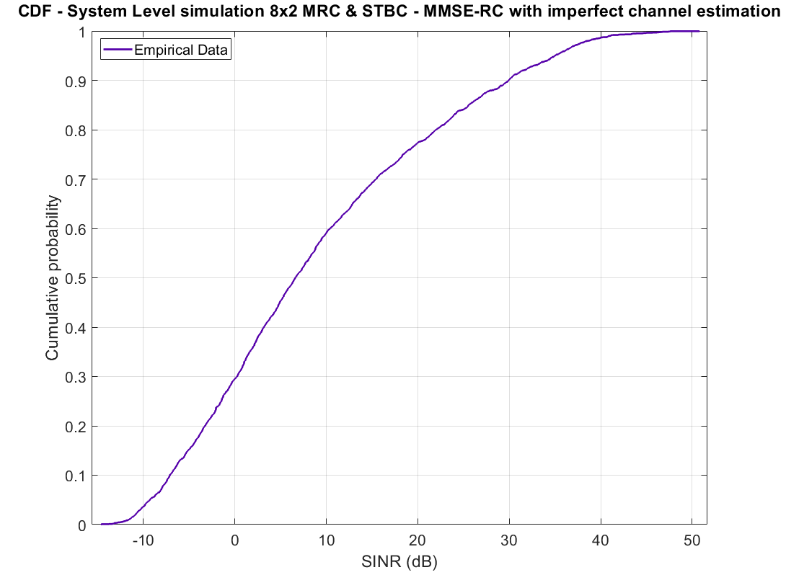

Additionally, we provide the BLER curves for the Modulation and Coding schemes used during the simulation study. In these figures, axis x corresponds to the narrowband (per subcarrier) Eb/No right prior to the application of the soft demodulator and decoder.

Figure 9

BLERs vs Eb/No for the Modulation and Coding schemes used in the simulator.

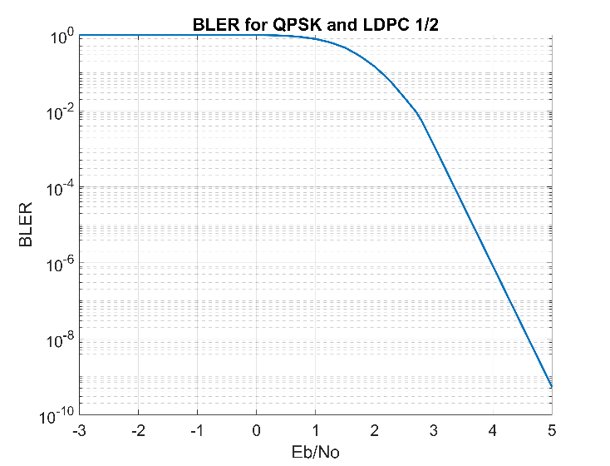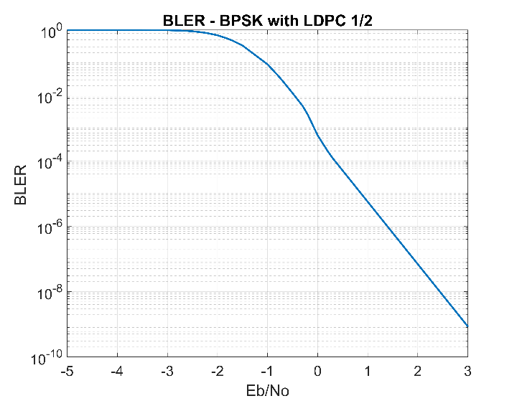

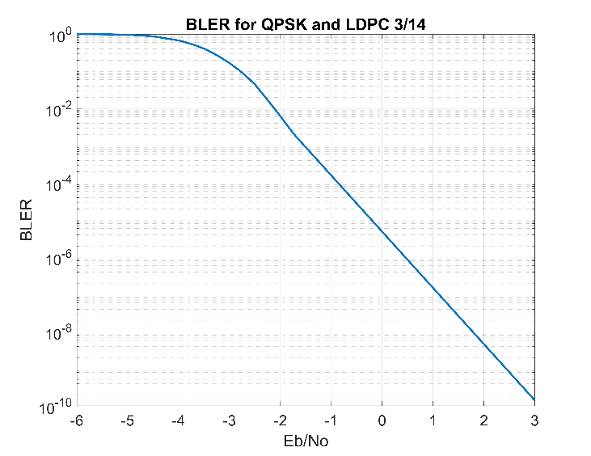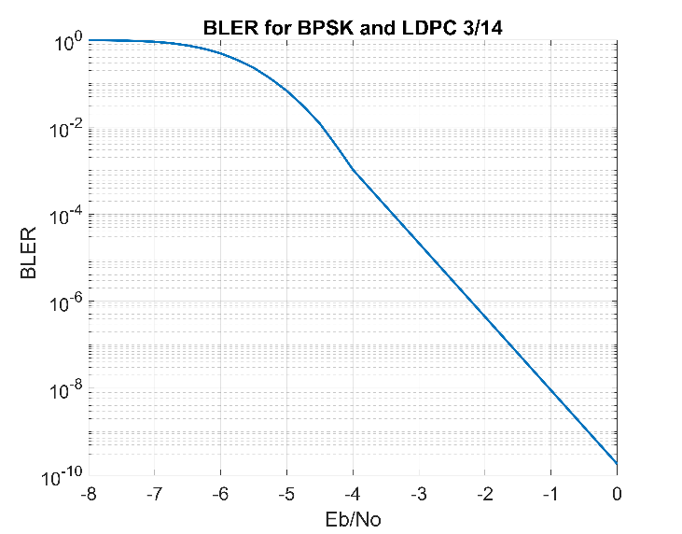

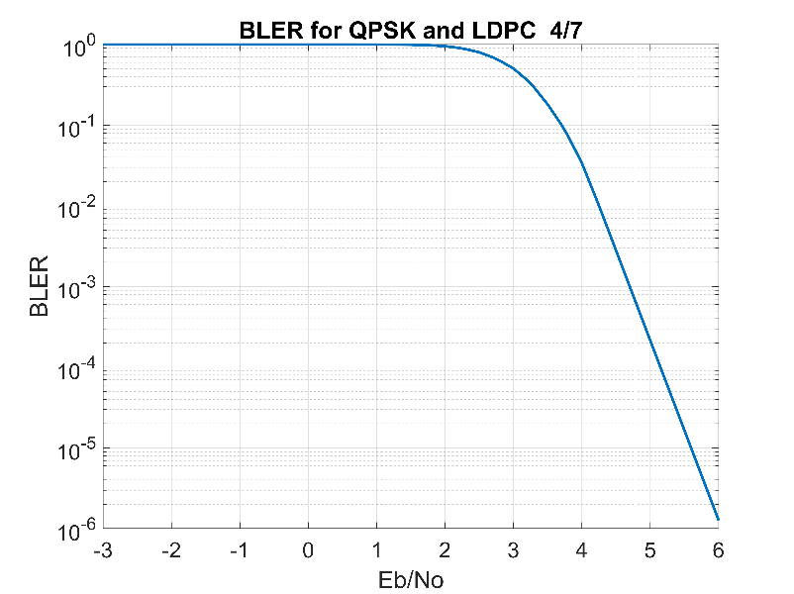

Using the system and link level results, we were able to simulate the time duration needed to serve 1,000,000 users by the system. It was made clear that the system has the capacity and flexibility to serve a high-density of users. More specifically, the duration was well below 2 hours for one 32-byte message per device (with 99.9999% confidence).

This is not the case as far as the constraint for 1% outage is concerned.

The requirement is met when perfect channel estimation is assumed, however, it marginally fails when imperfect channel estimation using the EUHT-5G waveform pilots is considered. More specifically:

• Outage 0.085% for perfect channel estimation.

• Outage 1.16% for imperfect channel estimation.

This result is justified because of:

• Reliability issues in the uplink which are also relevant to the pollution of pilots and preambles.

• The complexity of the process for link establishment and the continuous and risky exchange of messages with TRxP.

• Broadcast CCHs and Type I CCHs do not have the required BLER performance to serve cell-edge users that suffer from strong interference (see QPSK-LDPC 4/7 in Figure 9).

• The two random access procedures lead to plenty of collisions, due to primarily the TRxP failing to identify the correct sequence and secondarily the user density.

### II-E-2-3 Bandwidth

Conclusion

WWRF IEG concluded that the Enhanced Ultra High-Throughput Fifth-generation (EUHT-5G) RIT submitted by NUFRONT (referenced in Document IMT-2020/75) is compliant with the bandwidth requirement as specified by Report [ITU‑R M.2410](https://www.itu.int/dms_pub/itu-r/opb/rep/R-REP-M.2410-2017-MSW-E.docx), in Section 4.13.

Verification

ITU denotes, in the M.2410 document, the following minimum technical requirements for Bandwidth, applicable irrespective of the usage scenario:

1) Support of at least 100 MHz wide bands.

2) Up to 1 GHz for operation in higher frequency bands (e.g. above 6 GHz).

3) Consider extensions to support operation in wider bandwidths considering the research targets expressed in Recommendation ITU-R M.2083.

4) Support of scalable bandwidth, i.e. the ability to operate with different bandwidths.

Bandwidth is the maximum aggregated system bandwidth and may be supported by single or multiple radio frequency (RF) carriers. The reference document used for inspection is the EUHT-5G Submission provided in WP 5D #40, 5D/979, Attachment Part 5: 5D/979!P5 (EUHT-5G specification). With respect to bands configuration, EUHT-5G specification – Sec. 1.7.1.2 Tables 44-51 include the possible system bandwidth for a single component carrier, for both sub-6GHz and mmWave bands as follows:

Table 11

EUHT-5G System Bandwidth Options for Single Carrier Component

|  |  |
| --- | --- |
| Subcarrier spacing | System bandwidth |
| Sub-6 GHz bands | |
| 19.53125 kHz | 5/10/15/20/25/30/40/50 MHz |
| 39.0625 kHz | 5/10/15/20/25/30/40/50/60/80/100 MHz |
| 78.125 kHz | 5/10/15/20/25/30/40/50/60/80/100 MHz |
| mmWave bands | |
| 390.625 kHz | 50/100/200/400 MHz |
| 976.5625 kHz | 1 GHz |

In addition, The EUHT-5G system uses component carriers to support higher bandwidths by carrier aggregation, with the number of component carriers being up to 16 (ref: EUHT-5G specification – Sec. 1.7.11).

The STA is able to retrieve information about the used component carriers (how many are used and under which bandwidth size) through dedicated signaling structures, in particular the Fixed and Extensible Parts of BCF, as detailed in EUHT-5G specification - Sec. 1.5.3.4.1, Tables 3-10.

Based on the above analysis the following conclusions are drawn:

1) EUHT-5G supports -in sub-6 GHz- 100 MHz bands either through a single component carrier (in 39.0625kHz, 78.125 kHz subcarrier spacing modes) or through carrier aggregation (e.g. using 2 × 50 MHz channels in 19.53125kHz subcarrier spacing modes).

2) EUHT-5G supports -in higher frequencies- 1 GHz bands either through a single component carrier (in 976.5625kHz subcarrier spacing case) or through carrier aggregation (e.g. using 5 × 200 MHz channels in 390.625 kHz subcarrier spacing).

3) EUHT-5G supports operation in wider than 1 GHz bandwidths considering the research targets expressed in Recommendation ITU-R M.2083. for example using 16 × 100 MHz channels in 390.625 kHz subcarrier spacing.

4) EUHT-5G supports flexible and scalable bandwidth as determined by Table 11 bandwidth options for a single carrier and the use of up to 16 components carriers.

# II-F Questions and feedback to WP 5D and/or the proponents or other IEGs

This IEG has referred to the self-evaluation report provided by Nufront and has also fully considered the new technical specifications document for EUHT-5G. Also, the IEG engaged with Nufront during the first week of September 2022 for clarification on some parameters related to the overall design.

# II-G Proposed next steps

The WWRF IEG will publish a final report in the WWRF Outlook series in its upcoming 48th meeting in which it will include all the results in detail for all the three KPIs presented in this report.

# Part III: Conclusions

In this report, the WWRF IEG evaluated the EUHT-5G based on new technical specifications submitted by the proponent. We have considered the several new changes submitted by the proponent and re-designed our link and system level simulators. Based on the aforementioned results and discussions, the WWRF IEG concludes that EUHT-5G does not meet the minimum criteria for Reliability in Urban-macro URLLC for Uplink & Downlink and Connection density in Urban Macro mMTC for Configuration A.

References & Additional Material

ITU-R: Minimum requirements related to technical performance for IMT-2020 radio interface(s). Report ITU-R M.2410-0, (11/2017).

ITU-R: Requirements, evaluation criteria and submission templates for the development of IMT-2020. Report ITU-R M.2411-0, (11/2017).

ITU-R: Guidelines for evaluation of radio interface technologies for IMT-2020. Report ITU-R M.2412-0, (10/2017).

3GPP. 2018. TR 38.901. Study on channel for frequencies from 0.5 to 100 GHz. V.15.0.0. (2018-06).

Menglei Zhang, Michele Polese, Marco Mezzavilla, Sundeep Rangan, Michele Zorzi. “ns-3 Implementation of the 3GPP MIMO Channel Model for Frequency Spectrum above 6 GHz”. In Proceedings of the Workshop on ns-3 (WNS3 ‘17). 2017.

ITU Radiocommunication Bureau (BR), Circular Letter, 5/LCCE/94, 28 June 2021

ITU Radiocommunication Bureau (BR), Addendum 1 to Circular Letter, 5/LCCE/94, 8 March 2022

IMT-2020/75, ITU-R IMT.2020 Contribution 75, Submission received for proposals of candidate radio interface technologies from proponent 'Nufront' under step 3 of the IMT-2020 process, 2022-03-03, https://www.itu.int/md/R15-IMT.2020-C-0075/en

______________