|  |  |
| --- | --- |
| **Radiocommunication Study Groups** |  |
|  |  |
|  |  |
| Source: Document 5D/1251  Subject: The Fifth Generation Mobile Communications Promotion Forum | **Revision 1 to**  **Document IMT-2020/77-E** |
| **26 October 2022** |
| **English only**  **TECHNOLOGY ASPECTS** |
| Director, Radiocommunication Bureau[1]* | |
| Interim evaluation Report from The Fifth Generation Mobile Communications Promotion Forum on the IMT-2020 proposal  in Document IMT-2020/76 by “Nufront” IN THE  IMT-2020 EVALUATION PROCESS | |
|  | |

This document describes the interim evaluation results and activities by 5GMF Evaluation Group regarding the IMT-2020 candidate technology submission in Document [IMT-2020/76](https://www.itu.int/md/R15-IMT.2020-C-0076/en) by “Nufront”. The candidate technology was evaluated as the Step 4 in the IMT-2020 development process.

Part I

Administrative aspects of the Independent Evaluation Group

1. **Name of the Independent Evaluation Group**

IMT-2020 Evaluation Group, the Fifth Generation Mobile Communications Promotion Forum (5GMF IEG)

**2 Introduction and background of the Independent Evaluation Group**

The Fifth Generation Mobile Communications Promotion Forum (5GMF) was founded in September 2014. 5GMF has been conducting research & development concerning 5G Communications Systems including the standardization thereof, along with liaison & coordination with related organizations, the collection of information, and the dissemination & enlightenment activities. In September 2017, 5GMF IMT-2020 Evaluation Group (5GMF IEG) was established under the Technical Committee of the 5GMF and registered as an Independent Evaluation Group (IEG) committing in the process of IMT-2020 evaluation.

In December 2019, 5GMF IEG submitted the interim evaluation report for IMT-2020 candidate technology SRIT and RIT proposed by 3GPP.

In February 2020, 5GMF IEG submitted final evaluation report for IMT-2020 candidate technology SRIT and RIT proposed by 3GPP, and concluded the 3GPP SRIT and RIT meet the minimum technical performance requirements of IMT-2020 technology. Besides, 5GMF IEG submitted final evaluation report for IMT-2020 candidate technology RIT proposed by Nufront, and concluded the EUHT RIT cannot meet the minimum technical performance requirements of IMT-2020 technology.

In October 2020, 5GMF IEG received a liaison statement from WP5D which invited IEGs to re‑engage in Step 4 evaluation that was granted by WP5D as an exceptional extension of the IMT‑2020 evaluation process (refer to Att. 7.4 of Doc. [5D/360](https://www.itu.int/md/R19-WP5D-C-0360/en)). 5GMF decided to re-engage the process and started its re-evaluation exercises taking into account the useful materials informed in Annex 3 of the liaison statement mentioned above.

In June, August and September 2021, 5GMF IEG submitted evaluation reports for IMT-2020 candidate technology SRIT proposed by ETSI (TC DECT) and DECT forum and RIT proposed by Nufront. 5GMF IEG concluded the EUHT RIT cannot meet the minimum technical performance requirements of IMT-2020 technology.

In February 2022, 5GMF IEG received a liaison statement from WP5D which invited IEGs to engage in Step 4 evaluation on the EUHT technology proposal as new proposals for candidate radio interface technologies for the terrestrial components of the radio interface(s) for IMT-2020 evaluation process (refer to Att. 7.4 to Doc. [5D/1078](https://www.itu.int/md/R19-WP5D-C-1078/en)). 5GMF decided to engage the process and started its evaluation exercises taking into account the useful materials informed in the liaison statement mentioned above.

In this contribution, 5GMF IEG submits the interim evaluation results on the EUHT technology proposal, especially on Dense-Urban and Indoor Hotspot test environments of eMBB usage scenario. The evaluations on other usage scenarios and on different configurations are still going on and 5GMF IEG plans to submit those results in the final evaluation report in WP 5D October meeting.

**3 Method of Work**

The evaluation method in this report is in line with what are suggested in Report ITU-R M.2412 that are inspection, analysis and simulation.

**4 Administrative Contact Details**

Mr. OHMURA, Yoshinori (Secretary General of 5GMF)

[y-ohmura@arib.or.jp](mailto:y-ohmura@arib.or.jp)

**5 Technical Contact Details**

Mr. NAKAMURA, Takaharu (Principal Engineer, FUJITSU LIMITED)

[n.takaharu@fujitsu.com](mailto:n.takaharu@fujitsu.com)

Mr. TAKETSUGU, Masanori (Senior Manager, NEC Corporation)

[m-taketsugu@nec.com](mailto:m-taketsugu@nec.com)

**6 Other pertinent administrative information**

None.

Part II

Technical aspects of the work of the Independent Evaluation Group

1. **Evaluated candidate technologies for IMT-2020**

This report is an interim evaluation report on EUHT, as the candidate RIT technology submitted in Document IMT-2020/76.

1. **Utilization of ITU-R evaluation guidelines**

This interim evaluation report contains evaluation performed in accordance with Report ITU‑R M.2412‑0.

1. **Documentation of any additional evaluation methodologies**

There are no additional evaluation methodologies developed to complement the evaluation guidelines in Report ITU-R M.2412-0.

1. **Verification as per Report ITU-R M.2411 of the compliance templates**

# 1 Gaps/deficiencies in submitted material and/or self-evaluation

Firstly, 5GMF Evaluation Group has observed that, compared with 8T8R antennas in the previous round of IMT-2020 evaluation process, the average cell spectral efficiency was slightly improved by increasing the antenna number of the CAP. Considering that the average cell spectral efficiency is strongly affected by the number of transmission layers and the number of transmission layers is mainly determined by the wireless channel characteristics, simply increasing the number of antennas does not help improve the wireless channel characteristics. Therefore, when the number of antennas continues to increase, the number of transmission layers will not increase too much, and the improvement of spectral efficiency is limited. So, the results using 16 antennas cannot also meet the IMT-2020 requirements of ITU-R Report M.2411. This is demonstrated in the results of one of the sources, even without modeling the signaling/feedback channel, dynamic switching feature and dynamic overhead as mentioned in section 1.1, 1.2 and 1.3.

Furthermore, several issues have been initially identified in submitted material of EUHT technology and its corresponding self‑evaluation and these are discussed in the following sections.

**1.1 EUHT signaling/feedback transmission channel for eMBB evaluation**

After 5GMF Evaluation Group constructs control channel models into system-level simulation, 5GMF Evaluation Group observes that EUHT technology does not meet the IMT-2020 requirements of average spectral efficiency and 5th percentile user spectral efficiency in Indoor Hotspot-eMBB and Dense Urban-eMBB for Configuration A, according to the results.

The non-ideal control channel performance has been discussed in the evaluation report in Doc. 5D/756 of 5GMF IEG as below:

“For the feedback / signaling channel, the impact on the user plane, and thereby spectral efficiency, is more complex, …, When including the impact also on the feedback / signalling channel, the results are further reduced.”

The “EUHT specification with changes track” posted in the discussion area about signalling/feedback transmission channel is cited as below.

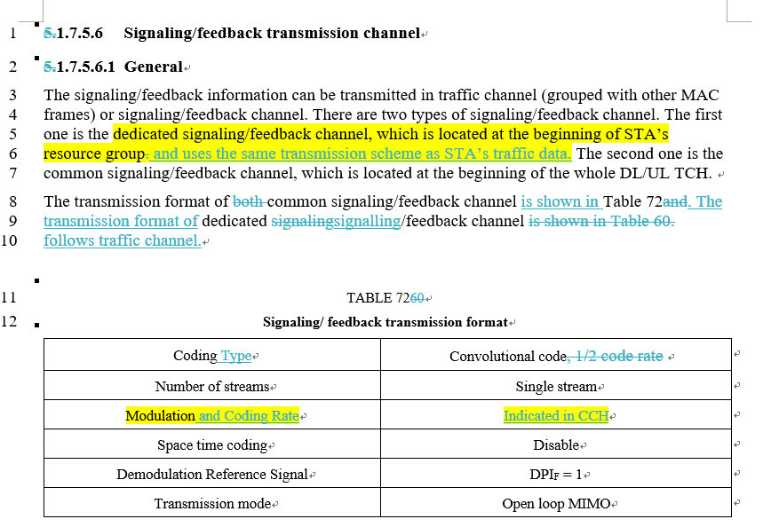

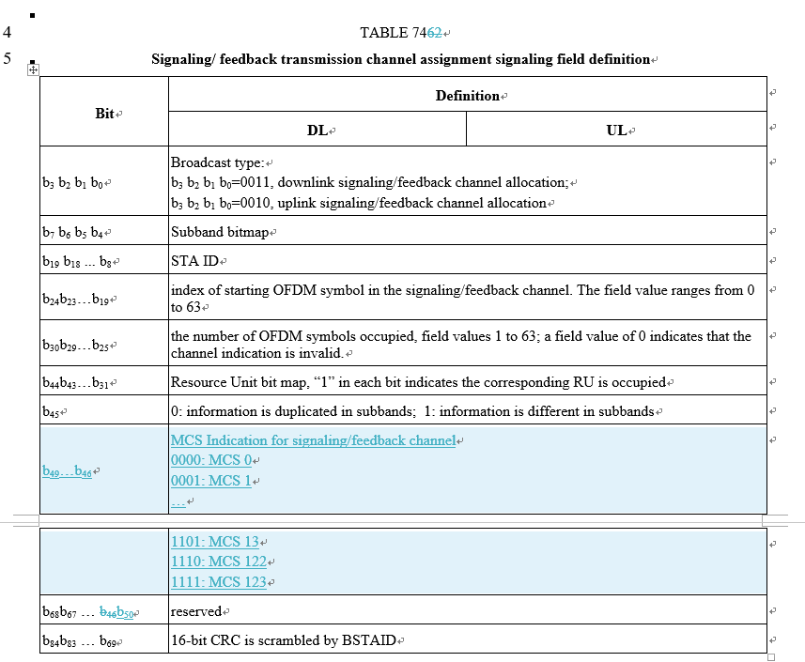

The current EUHT specification about signaling/feedback channel had small changes as summarized in the table below. After including the models of signaling/feedback transmission channel in new simulations in 2022, the conclusion remained the same, namely, “When including the impact also on the feedback / signalling channel, the results are further reduced”.

|  |  |  |  |
| --- | --- | --- | --- |
|  |  | 2021 EUHT specification | 2022 EUHT specification |
| Dedicated signaling/ feedback channel |  | No mention what transmission scheme | Use the same scheme as TCH |
| Common signaling/ feedback channel | Modulation | QPSK | Indicated in CCH,  as one of BPSK, QPSK, 16QAM, 64QAM, 256QAM and 1024QAM |
| Code rate | 1/2 | Indicated in CCH,  as one of 1/2, 3/4, 5/6, 4/7, 5/8 and 7/8 |
| Coding Type | Convolutional code | Same with the 2021 version |
| Number of streams | Single stream | Same with the 2021 version |
| Demodulation Reference Signal | DPIF = 1 | Same with the 2021 version |
| Transmission mode | Open loop MIMO | Same with the 2021 version |

5GMF Evaluation Group has observed that the success rate of receiving TCH is degraded and system overhead is increased after constructing the model of signaling/feedback channel into the simulator.

Considering the above analysis and results, 5GMF Evaluation Group has concluded that signaling/feedback channel performance of EUHT technology would degrade the spectral efficiency. It is one of the reasons that EUHT technology cannot meet the requirements of average spectral efficiency and 5th percentile user spectral efficiency.

## 1.2 EUHT dynamic switching of normal/low-error modes for eMBB evaluation

5GMF Evaluation Group has also constructed the model of dynamic switching of normal/low-error modes into system-level simulation. Then 5GMF Evaluation Group has observed that EUHT technology cannot meet the IMT-2020 requirements of average spectral efficiency and 5th percentile user spectral efficiency in Indoor Hotspot-eMBB and Dense Urban-eMBB for Configuration A, according to the results.

Observations of 5GMF Evaluation Group are as follows:

A. Spectral efficiency of low-error mode is too low for eMBB scenario.

TCH transmission in low-error mode has no-MIMO, only QPSK, small codeword size, at least 4 repetition transmission and so on, according to the section 1.7.4.2 of EUHT specification (see below).

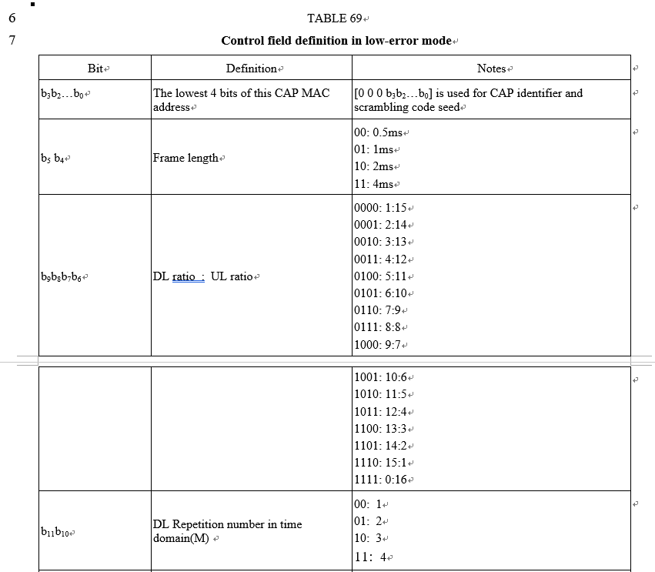

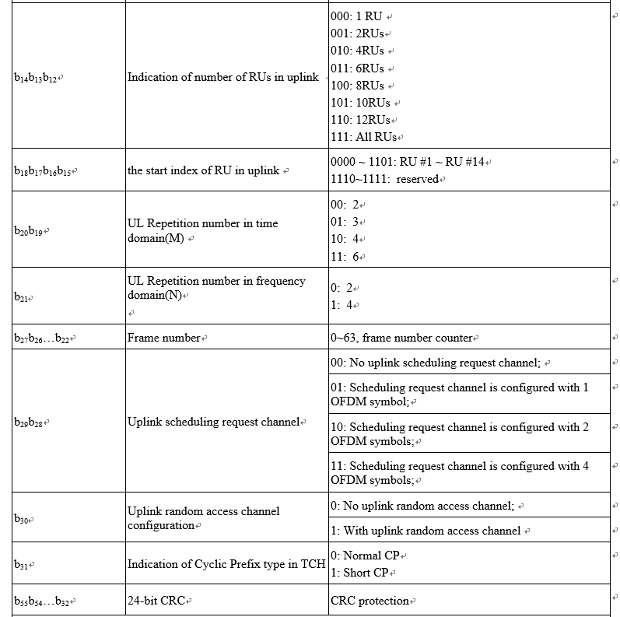

B. Dynamic switching feature will affect the performance of eMBB scenario

According to the EUHT specification below, dynamic switching feature is not changed in the 2022 specification. S-preamble is used for the mode selection, and is a cell-specific signal. Then, the mode switching is per cell, not per user. If the s-preamble is changed between “normal mode” and “low error mode”, all users in this cell have to switch into the corresponding mode for receiving CRS, SICH and CCH. Hence, a cell is in one mode in one frame.

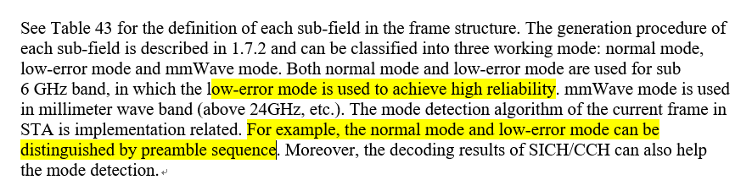

For the dynamic switching feature of EUHT technology, 5GMF Evaluation Group has the following observations:

a. When a cell is in low-error mode, the spectral efficiency in the frame(s) will be too low, considering the analysis in part A above and the characteristics of low-error mode summarised in the table below.

|  |  |  |  |
| --- | --- | --- | --- |
|  | | Low-error mode @2021 | Low-error mode @2022 |
| SICH | | integrated into CCH | Same with the 2021 version |
| CCH | | Support frequency and time domain rep | Same with the 2021 version |
| TCH | Modulation | QPSK | Same with the 2021 version |
| Code rate | 1/2，4/7 | 4/7 |
| Code length | 448 | Same with the 2021 version |
| Repetition | Support 1-32 times rep | DL: 4-16 times rep  UL: 4-24 times rep |
| MIMO | MU-MIMO | Not support | Same with the 2021 version |
| Stream number | 1 | Same with the 2021 version |
| Code word number | 1 | Same with the 2021 version |

b. When a cell is in normal mode, the reliability of transmission for cell-edge STA is not good.

Given that only new Type-II/III CCH has repetition and low coding rate as shown in the summary table of Section 1.3, the broadcast CCHs for common signalling/feedback channels and other functions have no repetition and no low coding rate. Therefore, the low SINR of cell-edge STA will cause the miss-detection of broadcast CCH. As shown in the process below the transmission of the signalling/feedback channels depends on the broadcast CCHs transmission. And then the indication of resource pool and also the indication of the signalling/feedback channel may be missed.

|  |
| --- |
| Step3: common signaling/feedback channel transmission process  Step1：broadcast CCH indicates common signaling/feedback channel resource pool for all STA  Step2：broadcast CCH indicates per STA common signaling/feedback channel resources  S  S |

It shall be noted that the simulations have not considered the impact of false preamble detection

possibility, which will further degrade the performance.

Considering the above analysis and results, 5GMF Evaluation Group has concluded that dynamic switching feature of EUHT technology would degrade the spectral efficiency. It is one of the reasons that EUHT technology cannot meet the IMT-2020 requirements of average spectral efficiency and 5th percentile user spectral efficiency.

## 1.3 Dynamic system overhead

In the simulations of 5GMF Evaluation Group in 2021, the fixed overhead in the simulations was assumed, namely, the same system overhead is assumed in each simulation frame.

This time 5GMF Evaluation Group has constructed the model of dynamic system overhead into system-level simulation. Here, dynamic overhead means that the system overhead in each simulation frame will change, by applying with realistic modeling of CCH types, CCH number, signaling/feedback information amount and etc.

By doing so, 5GMF Evaluation Group has observed that EUHT technology could not meet the IMT-2020 requirements of average spectral efficiency and 5th percentile user spectral efficiency in Indoor Hotspot-eMBB and Dense Urban-eMBB for Configuration A, according to the results.

Compared with EUHT specification in 2021, In the EUHT specification of 5D/979 more reliable channel design is introduced as shown in the table below. However, the new changes would also bring some disadvantages, as new types of SICH/CCH/CRS transmission need more time-frequency resources of the system, which bring extra system overhead. This impact is considered in the current evaluation.

|  |  |  |
| --- | --- | --- |
|  | normal mode@2021 | normal mode@2022 |
| SICH | Type-I SICH BPSK 1/2, and No rep | Same with the 2021 version |
| N/A | New Type-II SICH QPSK 4/7, and 2 time-domain rep |
| CCH | Type-I CCH for TCH and dedicated signaling feedback channel QPSK 4/7 and No rep | Same with the 2021 version |
| N/A | New Type-II CCH for TCH QPSK 3/14 and No rep  New Type-III CCH for TCH QPSK 3/14 and 2 time-domain rep |
| The broadcast CCHs for common signaling feedback channels | Same with the 2021 version |
| CRS | Type-I long preamble in one symbol | Same with the 2021 version |
| N/A | New Type-II long preamble, which is Type-I long preamble with 2 time-domain rep |

In addition, it shall be noted that the successful transmission of SICH/CCH/CRS depends on STA detection results. If any one of them was detected incorrectly, it will lead to the TCH transmission failure. Current evaluation has not taken into account the false detection possibility yet.

Considering the above analysis and results, 5GMF Evaluation Group has concluded that new types of SICH/CCH/CRS transmission required more time-frequency resources and would degrade the spectral efficiency. It is one of the reasons that EUHT technology cannot meet the IMT-2020 requirements of average spectral efficiency and 5th percentile user spectral efficiency.

# 2 Areas requiring clarifications

# 3 General questions

No specific questions that should be clarified were identified.

1. **Assessment as per Reports ITU-R M.2410, ITU-R M.2411 and ITU‑R M.2412**

# 1 Provision of compliance template for services (Section 5.2.4.1 of Report ITU-R M.2411-0)

|  |  |  |
| --- | --- | --- |
|  | **Service capability requirements** | **Evaluator’s comments** |
| **5.2.4.1.1** | **Support for wide range of services**  Is the proposal able to support a range of services across different usage scenarios (eMBB, URLLC, and mMTC)?: YES / NO  Specify which usage scenarios (eMBB, URLLC, and mMTC) the candidate RIT or candidate SRIT can support.(1) | As provided in this evaluation report, EUHT-5G RIT cannot support the usage scenarios of eMBB for configuration A. |
| (1) As defined in Report ITU-R M.2410-0. | | |

# 2 Provision of compliance template for spectrum (Section 5.2.4.2 of Report ITU-R M.2411-0)

|  |  |
| --- | --- |
|  | **Spectrum capability requirements** |
| **5.2.4.2.1** | **Frequency bands identified for IMT**  Is the proposal able to utilize at least one frequency band identified for IMT in the ITU Radio Regulations?: 🗹 YES / NO  Specify in which band(s) the candidate RIT or candidate SRIT can be deployed. |
| **As shown in Annex A-1, the following frequency bands are supported by EUHT-5G RIT, which contains certain frequency bands identified for IMT in the ITU Radio Regulations (Edition 2016).**  **EUHT-5G operating bands in Sub-6GHz bands**   |  |  | | --- | --- | | Uplink (UL) and Downlink (DL) operating band | Duplex Mode | | 450 - 470 MHz | TDD | | 470 - 698 MHz | TDD | | 694/698 - 960 MHz | TDD | | 1427 - 1518 MHz | TDD | | 1710 - 2025 MHz | TDD | | 2110 - 2200 MHz | TDD | | 2300 - 2400 MHz | TDD | | 2500 - 2690 MHz | TDD | | 3300 - 3400 MHz | TDD | | 3400 - 3600 MHz | TDD | | 3600 - 3700 MHz | TDD | | 4800 - 4990 MHz | TDD | |
| **5.2.4.2.2** | **Higher Frequency range/band(s)**  Is the proposal able to utilize the higher frequency range/band(s) above 24.25 GHz?:  YES / NO  Specify in which band(s) the candidate RIT or candidate SRIT can be deployed.  NOTE 1 – In the case of the candidate SRIT, at least one of the component RITs need to fulfil this requirement. |
| **EUHT-5G operating bands in mmWave bands**   |  |  | | --- | --- | | Uplink (UL) and Downlink (DL) operating band | Duplex Mode | | 26500 MHz – 29500 MHz | TDD | | 24250 MHz – 27500 MHz | TDD | | 37000 MHz – 40000 MHz | TDD | | 27500 MHz – 28350 MHz | TDD | |

# 3 Provision of compliance template for technical performance (Section 5.2.4.3 of Report ITU-R M.2411-0)

| **Minimum technical performance requirements item (5.2.4.3.x), units, and Report ITU-R M.2410-0 section reference(1)** | **Category** | | | **Required value** | **Value(2)** | **Requirement met?** | **Comments (3)** |
| --- | --- | --- | --- | --- | --- | --- | --- |
| **Usage scenario** | **Test environment** | **Downlink or uplink** |
| **5.2.4.3.1** Peak data rate (Gbit/s) *(4.1)* | eMBB | Not applicable | Downlink | 20 |  |  |  |
| Uplink | 10 |  |  |
| **5.2.4.3.2** Peak spectral efficiency (bit/s/Hz) *(4.2)* | eMBB | Not applicable | Downlink | 30 |  |  |  |
| Uplink | 15 |  |  |
| **5.2.4.3.3** User experienced data rate (Mbit/s) *(4.3)* | eMBB | Dense Urban – eMBB | Downlink | 100 |  | Yes  No |  |
| Uplink | 50 |  | Yes  No |
| **5.2.4.3.4** 5th percentile user spectral efficiency (bit/s/Hz) *(4.4)* | eMBB | Indoor Hotspot – eMBB | Downlink | 0.3 | 0.097 | Yes 🗹 No | For evaluation configuration of 4 GHz. Channel model B, 12 TRxP |
| Uplink | 0.21 | 0.117 | Yes 🗹 No |
|  |  |  |  |  |
|  |  |  |  |
| eMBB | Dense Urban – eMBB | Downlink | 0.225 | 0.090 | Yes 🗹 No | For evaluation configuration of 4 GHz, Channel modelB. |
| Uplink | 0.15 | 0.104 | Yes 🗹 No |
|  |  |  |  |  |
|  |  |  |  |
| eMBB | Rural – eMBB | Downlink | 0.12 |  | Yes  No |  |
| Uplink | 0.045 |  | Yes  No |
|  |  |  |  |  |
|  |  |  |  |
| **5.2.4.3.5** Average spectral efficiency (bit/s/Hz/ TRxP) *(4.5)* | eMBB | Indoor Hotspot – eMBB | Downlink | 9 | 6.09 | Yes 🗹 No | For evaluation configuration of 4 GHz. Channel model B, 12 TRxP |
| Uplink | 6.75 | 3.70 | Yes 🗹 No |
|  |  |  |  |  |
|  |  |  |  |
| eMBB | Dense Urban – eMBB | Downlink | 7.8 | 5.47 – 7.694 | Yes 🗹 No | For evaluation configuration of 4 GHz, Channel model B. |
| Uplink | 5.4 | 3.51 | Yes 🗹 No |
|  |  |  |  |  |
|  |  |  |  |
| eMBB | Rural – eMBB | Downlink | 3.3 |  | Yes  No |  |
| Uplink | 1.6 |  | Yes  No |
|  |  |  |  |  |
|  |  |  |  |
| **5.2.4.3.6** Area traffic capacity (Mbit/s/m2) *(4.6)* | eMBB | Indoor-Hotspot – eMBB | Downlink | 10 |  | Yes  No |  |
| **5.2.4.3.7** User plane latency (ms) *(4.7.1)* | eMBB | Not applicable | Uplink and Downlink | 4 |  |  |  |
| URLLC | Not applicable | Uplink and Downlink | 1 |  |  |  |
| **5.2.4.3.8** Control plane latency (ms) *(4.7.2)* | eMBB | Not applicable | Not applicable | 20 |  |  |  |
| URLLC | Not applicable | Not applicable | 20 |  |  |  |
| **5.2.4.3.9** Connection density (devices/km2) *(4.8)* | mMTC | Urban Macro – mMTC | Uplink | 1 000 000 |  |  |  |
| **5.2.4.3.10** Energy efficiency *(4.9)* | eMBB | Not applicable | Not applicable | Capability to support a high sleep ratio and long sleep duration |  |  |  |
| **5.2.4.3.11** Reliability *(4.10)* | URLLC | Urban Macro –URLLC | Uplink | 1-10−5 success probability of transmitting a layer 2 PDU (protocol data unit) of size 32 bytes within 1 ms in channel quality of coverage edge |  | Yes  No |  |
| Downlink |  | Yes  No |  |
| **5.2.4.3.12** Mobility classes *(4.11)* | eMBB | Indoor Hotspot – eMBB | Uplink | Stationary, Pedestrian |  |  |  |
| eMBB | Dense Urban – eMBB | Uplink | Stationary, Pedestrian,  Vehicular (up to 30 km/h) |  |  |  |
| eMBB | Rural – eMBB | Uplink | Pedestrian, Vehicular, High speed vehicular |  |  |  |
| **5.2.4.3.13**  Mobility Traffic channel link data rates (bit/s/Hz) *(4.11)* | eMBB | Indoor Hotspot – eMBB | Uplink | 1.5 (10 km/h) |  |  |  |
|  |  |  |
| eMBB | Dense Urban – eMBB | Uplink | 1.12 (30 km/h) |  |  |  |
|  |  |  |
| eMBB | Rural – eMBB | Uplink | 0.8 (120 km/h) |  |  |  |
| 0.45 (500 km/h) |  |  |
| 0.8 (120 km/h) |  |  |  |
| 0.45 (500 km/h) |  |  |  |
| **5.2.4.3.14** Mobility interruption time (ms)  *(4.12)* | eMBB and URLLC | Not applicable | Not applicable | 0 |  |  |  |
| **5.2.4.3.15** Bandwidth and Scalability *(4.13)* | Not applicable | Not applicable | Not applicable | At least 100 MHz |  |  |  |
| Up to 1 GHz |  |  |
| Support of multiple different bandwidth values(4) |  |  |
| (1) As defined in Report ITU-R M.2410-0.  (2) According to the evaluation methodology specified in Report ITU-R M.2412-0.  (3) Proponents should report their selected evaluation methodology of the Connection density, the channel model variant used, and evaluation configuration(s) with their exact values (e.g. antenna element number, bandwidth, etc.) per test environment, and could provide other relevant information as well. For details, refer to Report ITU-R M.2412-0, in particular, § 7.1.3 for the evaluation methodologies, § 8.4 for the evaluation configurations per each test environment, and Annex 1 on the channel model variants.  (4) Refer to § 7.3.1 of Report ITU-R M.2412-0. | | | | | | | |
| Under-lined part: Evaluation results in the extended IMT-2020 evaluation process.  Strikethrough part: Evaluation results in the original Step 4 that was replaced by the updated results in the extended IMT-2020 evaluation process. | | | | | | | |

Part III

Conclusion

The followings are the evaluation summary for a RIT for IMT-2020 candidate technology in Document IMT-2020/76.

# 1 Summary the Final Evaluation Report

**1.1 Use of information in Report ITU-R M.2412**

Does Independent Evaluation Group confirm use of Report ITU-R M.2412 in their work?

🗹 Yes 🞎 No

**1.2 Provision of compliance templates**

Provision of compliance template for services (section 5.2.4.1 of Report ITU-R M.2411)

🗹 Yes 🞎 No

Provision of compliance template for technical performance (section 5.2.4.3 of Report ITU-R M.2411)

🗹 Yes 🞎 No

**1.3 Summary of conclusions of the evaluation report**

Does the Evaluation Report indicate that the candidate technology meet minimum service and spectrum requirements?

Service requirements: 🞎 Yes 🞎 No

Spectrum requirements: 🞎 Yes 🞎 No

Which test environments have been considered in the evaluation report? What is outcome of the evaluation?

|  |  |
| --- | --- |
| **Test environment** | **Does the evaluation report indicate that the minimum technical performance requirements are met in the test environment?** |
| 🗹 Indoor Hotspot – eMBB | 🞎 Yes 🗹 No for configuration A |
| 🗹 Dense Urban – eMBB | 🞎 Yes 🗹 No for configuration A |
| 🞎 Rural – eMBB | 🞎 Yes 🞎 No |
| 🞎 Urban Macro – mMTC | 🞎 Yes 🞎 No |
| 🞎 Urban Macro – URLLC | 🞎 Yes 🞎 No |

**1.4 Additional evaluation methodologies and assumptions**

Have any additional evaluation methodologies or assumptions that had not been included in the Report ITU-R M.2412 been used in evaluation?

🞎 Yes 🗹 No

**Annex A  
  
Evaluation Results**

## A-1 Frequency bands identified for IMT

### A-1.1 450-6 000 MHz

As can be seen in Table A.1-1, the following frequency bands are supported by EUHT-5G RIT, which either contains, or part of, or overlaps certain frequency bands identified for IMT in the ITU Radio Regulations (Edition 2016).

Table A.1-1

Frequency bands of EUHT-5G RIT (in Sub-6GHz) and IMT bands related articles in Radio Regulations

| Uplink (UL) and Downlink (DL) operating band | Duplex Mode |  | IMT related articles (notes) in Radio Regulations* |
| --- | --- | --- | --- |
| 450 - 470 MHz | TDD |  | **460-890 MHz: 5.295** (470-608 MHz, or portions thereof) **5.296A** (470-698 MHz, or portions thereof, and 610-698 MHz, or portions thereof) **5.308A** (614-698 MHz) **5.313A** (698-790 MHz) **5.317A** (698-960 MHz in Region 2, 694-790 MHz in Region 1 and 790-960 MHz in Regions 1 and 3) |
| 470 - 698 MHz | TDD |  |
| 694/698 - 960 MHz | TDD |  |
| 1427 - 1518 MHz | TDD |  | **1 300-1 525 MHz: 5.341A** (1 427-1 452 MHz and 1 492-1 518 MHz in Region 1) **5.341B** (1 427-1 518 MHz in Region 2) **5.341C** (1 427-1 452 MHz and 1 492-1 518 MHz in Region 3 **5.346** (1 452-1 492 MHz) **5.346A** (1 452-1 492 MHz) |
| 1710 - 2025 MHz | TDD |  | **1 710-2 170 MHz: 5.384A** (1 710-1 885 MHz, 2 300-2 400 MHz and 2 500-2 690 MHz) **5.388** (1 885-2 025 MHz and 2 110-2 200 MHz) **5.388A** (1 885-1 980 MHz, 2 010-2 025 MHz and 2 110-2 170 MHz in Regions 1 and 3 and, 1 885-1 980 MHz and 2 110-2 160 MHz in Region 2) |
| 2110 - 2200 MHz | TDD |  |
| 2300 - 2400 MHz | TDD |  |  |
| 2500 - 2690 MHz | TDD |  |  |
| 3300 - 3400 MHz | TDD |  | **2 700-3 600 MHz: 5.429B** (3 300-3 400 MHz), **5.429D** (3 300-3 400 MHz), **5.429F** (3 300-3 400 MHz), **5.430A** (3 400-3 600 MHz), **5.431B** (3 400-3 600 MHz), **5.432A** (3 400-3 500 MHz), **5.432B** (3 400-3 500 MHz), **5.433A** (3 500-3 600 MHz) **3 600-4 800 MHz**: **5.434** (3 600-3 700 MHz) **4 800-5 250 MHz**: **5.441A** (4 800-4 900 MHz) **5.441B** (4 800-4 990 MHz) |
| 3400 - 3600 MHz | TDD |  |
| 3600 - 3700 MHz | TDD |  |  |
| 4800 - 4990 MHz | TDD |  |  |
|  |  |  | *Excerpted from Radio Regulations Article 1 (Edition of 2016) |

## A-2 User experienced data rate

## A-3 5th percentile user spectral efficiency

Simulation results of 5th percentile user spectral efficiency can be found in an Excel file in Table A-1.

## A-4 Average spectral efficiency

Simulation results of Average spectral efficiency can be found in an Excel file in Table A-1.

## A-5 Area traffic capacity

## A-6 Reliability

Table A-1

Simulation items and Excel files capturing the results

| **Minimum technical performance requirements item (5.2.4.3.x), units, and Report ITU-R M.2410-0 section reference(1)** | **Category** | | | **Required value** | **Value** | | | | **Note** | **Simulation results (in Excel files)** |
| --- | --- | --- | --- | --- | --- | --- | --- | --- | --- | --- |
| **Usage scenario** | **Test environment** | **Downlink or uplink** | **Source 1** | **Source 2** |  |  |
| **5.2.4.3.3** User experienced data rate (Mbit/s) *(4.3)* | eMBB | Dense Urban – eMBB | Downlink | 100 |  |  |  |  |  |  |
| Uplink | 50 |  |  |  |  |  |
| **5.2.4.3.4** 5th percentile user spectral efficiency (bit/s/Hz) *(4.4)* | eMBB | Indoor Hotspot – eMBB | Downlink | 0.3 | 0.097 |  |  |  | 4 GHz. Channel model B, 12 TRxP | SpectralEfficiency - 01 InH-eMBB-v01.xlsx |
| Uplink | 0.21 | 0.117 |  |  |  |
|  |  |  |  |  |  |  |
|  |  |  |  |  |  |
| eMBB | Dense Urban – eMBB | Downlink | 0.225 | 0.090 |  |  |  | 4 GHz, Channel model B | SpectralEfficiency - 02 DenseUrban-eMBB-v01.xlsx |
| Uplink | 0.15 | 0.104 |  |  |  |
|  |  |  |  |  |  |  |
|  |  |  |  |  |  |
| eMBB | Rural – eMBB | Downlink | 0.12 |  |  |  |  |  |  |
| Uplink | 0.045 |  |  |  |  |
|  |  |  |  |  |  |  |
|  |  |  |  |  |  |
| **5.2.4.3.5** Average spectral efficiency (bit/s/Hz/ TRxP) *(4.5)* | eMBB | Indoor Hotspot – eMBB | Downlink | 9 | 6.09 |  |  |  | 4 GHz. Channel model B, 12 TRxP | SpectralEfficiency - 01 InH-eMBB-v01.xlsx |
| Uplink | 6.75 | 3.70 |  |  |  |
|  |  |  |  |  |  |  |
|  |  |  |  |  |  |
| eMBB | Dense Urban – eMBB | Downlink | 7.8 | 5.47 | 7.694 |  |  | 4 GHz. Channel model B | SpectralEfficiency - 02 DenseUrban-eMBB-v01.xlsx |
| Uplink | 5.4 | 3.51 |  |  |  |
|  |  |  |  |  |  |  |
|  |  |  |  |  |  |
| eMBB | Rural – eMBB | Downlink | 3.3 |  |  |  |  |  |  |
| Uplink | 1.6 |  |  |  |  |
|  |  |  |  |  |  |  |
|  |  |  |  |  |  |
| **5.2.4.3.6** Area traffic capacity (Mbit/s/m2) *(4.6)* | eMBB | Indoor-Hotspot – eMBB | Downlink | 10 |  |  |  |  |  |  |
| **5.2.4.3.9** Connection density (devices/km2) *(4.8)* | mMTC | Urban Macro – mMTC | Uplink | 1 000 000 |  |  |  |  |  |  |
|  |  |  |  |  |
| **5.2.4.3.11** Reliability *(4.10)* | URLLC | Urban Macro –URLLC | Uplink | 1-10−5 success probability of transmitting a layer 2 PDU (protocol data unit) of size 32 bytes within 1 ms in channel quality of coverage edge |  |  |  |  |  |  |
| Downlink |  |  |  |  |  |
| **5.2.4.3.13**  Mobility Traffic channel link data rates (bit/s/Hz) *(4.11)* | eMBB | Indoor Hotspot – eMBB | Uplink | 1.5 (10 km/h) |  |  |  |  |  |  |
|  |  |  |  |  |
| eMBB | Dense Urban – eMBB | Uplink | 1.12 (30 km/h) |  |  |  |  |  |  |
|  |  |  |  |  |
| eMBB | Rural – eMBB | Uplink | 0.8 (120 km/h) |  |  |  |  |  |  |
| 0.45 (500 km/h) |  |  |  |  |  |
| 0.8 (120 km/h) |  |  |  |  |  |
| 0.45 (500 km/h) |  |  |  |  |  |
| Underlined part: Evaluation results in the extended imt-2020 evaluation process. | | | | | | | | | | |

**Attachments:** 2

## B.1 eMBB_SE

SpectralEfficiency - 01 InH-eMBB-v01.xlsx



SpectralEfficiency - 02 DenseUrban-eMBB-v01.xlsx



_________________

1. * Submitted on behalf of The Fifth Generation Mobile Communications Promotion Forum (5GMF).