|  |  |
| --- | --- |
| **Radiocommunication Study Groups** |  |
|  |  |
|  |  |
| Received: 10 May 2021 | **Document 5D/576-E** |
| **11 May 2021** |
| **English only**  **TECHNOLOGY ASPECTS** |
| ETSI Evaluation Group (TC MSG, WG MSG EVAL) | |
| Final EVALUATION REPORT FOR SRIT SUBMISSION FROM  ETSI (TC DECT), DECT FORUM (DOC. [IMT-2020/17](https://www.itu.int/md/meetingdoc.asp?lang=en&parent=R15-IMT.2020-C-0017)(rev.1)),  FOR DECT-2020 NR COMPONENT RIT | |
|  | |

PART I

Administrative aspects of the Independent Evaluation Group

# 1 Name of the Independent Evaluation Group

The evaluation group is registered to ITU-R and is known as ETSI Evaluation Group or ETSI EG. <https://www.itu.int/oth/R0A0600007B/en>

# 2 Introduction/background of the Independent Evaluation Group

The ETSI Evaluation Group (ETSI EG) within ETSI is the Working Group (WG) WG EVAL of Technical Committee (TC) Mobile Standards Group (MSG).

Participation in the work of the ETSI EG is open to all ETSI members.

Work in ETSI in general is contribution-driven.

# 3 Method of work

The work of the ETSI EG happens under ETSI directives defining rules of procedures, technical working procedures, and drafting rules.

An overview is available at <https://www.etsi.org/index.php?option=com_content&view=article&id=1434:our-operations&catid=14:about>

This evaluation report is handled by ETSI as a technical report and adopts the general structure and contents as proposed by ITU-R WP 5D (in Document 5D/TEMP/769(Rev. 1)).

Due to the COVID-19 pandemic the ETSI EG scheduled and conducted virtual meetings only.

The ETSI EG encouraged the cooperation of members regarding contributions to its meetings to foster the development of the evaluation report, drafting, and decision-making.

# 4 Administrative contact details

Name: Adrian SCRASE

Telephone:+33 492944254

Email: [adrian.scrase@etsi.org](mailto:adrian.scrase@etsi.org)

# 5 Technical contact details

Chairperson of WG MSG Eval

Name: Dr. Andreas WILZECK

Telephone: +49 5130 600 1607

Email: [andreas.wilzeck@sennheiser.com](mailto:andreas.wilzeck@sennheiser.com)

Chairperson of TC MSG

Name: Dominique EVERAERE

Telephone: +46 722449953

Email: [dominique.everaere@ericsson.com](mailto:dominique.everaere@ericsson.com)

# 6 Other pertinent administrative information

## 6.1 Evaluation Group web site

<http://www.etsi.org>

## 6.2 Candidate proposals submitted to ITU-R and actions taken

The following Table 6.2.1 summarizes the candidate submissions and the actions taken by WP 5D.

Table 6.2.1

Candidate technologies to be evaluated (as determined by the ITU-R)

|  |  |  |  |  |  |  |  |
| --- | --- | --- | --- | --- | --- | --- | --- |
| Proponent | 3GPP | 3GPP | China | Korea | ETSI  (TC DECT) | Nufront | TSDSI |
| Original submission in | Documents [5D/1215](https://www.itu.int/md/R15-WP5D-C-1215/en) and [5D/1216](https://www.itu.int/md/R15-WP5D-C-1216/en) | Documents [5D/1215](https://www.itu.int/md/R15-WP5D-C-1215/en) and [5D/1217](https://www.itu.int/md/R15-WP5D-C-1217/en) | Document [5D/1268](https://www.itu.int/md/R15-WP5D-C-1268/en) | Document [5D/1233](https://www.itu.int/md/R15-WP5D-C-1233/en) | Documents [5D/1230](https://www.itu.int/md/R15-WP5D-C-1230/en) and [5D/1253](https://www.itu.int/md/R15-WP5D-C-1253/en) | Document [5D/1238](https://www.itu.int/md/R15-WP5D-C-1238/en) | Document [5D/1231](https://www.itu.int/md/R15-WP5D-C-1231/en) |
| WP 5D acknowledgement | Document [IMT-2020/13](https://www.itu.int/md/R15-IMT.2020-C-0013/en) | Document [IMT-2020/14](https://www.itu.int/md/R15-IMT.2020-C-0014/en) | Document [IMT-2020/15](https://www.itu.int/md/R15-IMT.2020-C-0015/en) | Document  [IMT-2020/16](https://www.itu.int/md/R15-IMT.2020-C-0016/en) | Document [IMT-2020/17](https://www.itu.int/md/R15-IMT.2020-C-0017/en) | Document [IMT-2020/18](https://www.itu.int/md/R15-IMT.2020-C-0018/en) | Document [IMT-2020/19](https://www.itu.int/md/R15-IMT.2020-C-0019/en) |
| Complete submission? | Yes | Yes | Yes | Yes | Yes | Yes | Yes |
| Classification / Technology label | SRITT:  NR component RIT and  E-UTRA/LTE component RIT | RIT | RIT | RIT | SRIT:  “DECT-2020 NR” component RIT and  “3GPP 5G NR” component RIT | RIT | RIT |
| WP 5D Observations | Document  [IMT-2020/23](https://www.itu.int/md/R15-IMT.2020-C-0023/en) | Document  [IMT-2020/23](https://www.itu.int/md/R15-IMT.2020-C-0023/en) | Document  [IMT-2020/24](https://www.itu.int/md/R15-IMT.2020-C-0024/en) | Document [IMT-2020/25](https://www.itu.int/md/R15-IMT.2020-C-0025/en) | Document  [IMT-2020/26](https://www.itu.int/md/R15-IMT.2020-C-0026/en) | Document [IMT-2020/27](https://www.itu.int/md/R15-IMT.2020-C-0027/en) | Document [IMT-2020/28](https://www.itu.int/md/R15-IMT.2020-C-0028/en) |
| 10 Sep 2019 updates |  |  |  |  | Document [5D/1299](https://www.itu.int/md/R15-WP5D-C-1299/en) | Document [5D/1300](https://www.itu.int/md/R15-WP5D-C-1300/en) | Document [5D/1301](https://www.itu.int/md/R15-WP5D-C-1301/en) |
| Specifications, June 2020 |  |  |  |  | Document [5D/173](https://www.itu.int/md/R19-WP5D-C-0173/en) |  |  |

## 6.3 Materials useful to the Option 2 Evaluation of the ETSI (TC DECT) and DECT Forum Candidate Technology Submission

The ETSI EG considers the “materials useful to the Option 2 Evaluation of the ETSI (TC DECT) and DECT Forum Candidate Technology Submission” as listed by the received LIAISON STATEMENT TO INDEPENDENT EVALUATION GROUPS (Attachment 7.4 to Document 5D/360) in Annex 3.

Related to this additional material we provide the following observations by ETSI EG:

– The material in [Document 5D/222 Chapter 5](https://www.itu.int/dms_ties/itu-r/md/19/wp5d/c/R19-WP5D-C-0222!H05!MSW-E.docx), Att. 5.3, ETSI (TC DECT) portions extracted under the way forward (Document IMT-2020/52) for preliminary draft new Recommendation ITU-R M.[IMT-2020.SPECS] (5D/TEMP/173). This material is identified by ETSI EG to contain except editorials the relevant elements of the published ETSI technical specifications TS 103 636 series (part 1 to 4) for DECT-2020 NR.

## 6.4 Evaluation Group Members

The work item for generation of this DECT-2020 NR evaluation report is supported by

BMWi, PANASONIC R&D Center Germany, OVE, BSI, VTT, Dialog Semiconductor, RTX A/S, Fraunhofer IIS, SHURE Europe GmbH, Sennheiser Electronic GmbH, DSPG Edinburgh Ltd, Wireless Partners S.L.L., AVM Berlin, Gigaset Communications GmbH, Nordic Semiconductor ASA, Wirepas Oy

The work item had been approved by ETSI TC MSG without any comment.

The ETSI EG and its members made use of system-level and link-level simulation environments available from

– Tampere University, Finland (ETSI member) [URLLC, mMTC]

– Gottfried Wilhelm Leibniz University Hannover, IKT, Germany (non-ETSI member) [URLLC, mMTC]

– VTTTechnical Research Centre of Finland Ltd, Finland (ETSI member) [mMTC]

The results of non-ETSI members have been discussed in detail in the meetings and were contributed by ETSI members after their internal evaluation.

We acknowledge especially the scientific excellence, the information exchange, and hard work of the academic partners of ETSI EG.

Part II

Technical aspects of the work of the Independent Evaluation Group

# A) What candidate technologies or portions of the candidate technologies this IEG is or might anticipate evaluating?

# 7 Technologies evaluated by the ETSI Evaluation Group

The ETSI EG focus on evaluating the DECT-2020 NR component RIT of the SRIT proposed by ETSI TC DECT and DECT Forum in the submission in Document [IMT-2020/17(Rev.1)](https://www.itu.int/md/meetingdoc.asp?lang=en&parent=R15-IMT.2020-C-0017).

Table 7.1

ETSI Evaluation Groups’ intention to evaluate submissions or parts thereof

|  |  |
| --- | --- |
|  | ETSI-DECT  [IMT-2020/17(Rev.1)](https://www.itu.int/md/meetingdoc.asp?lang=en&parent=R15-IMT.2020-C-0017) |
|
|  | Partial evaluation (only the DECT component RIT) |
| **Parameters via Inspection** |  |
| * Bandwidth | ● |
| * Energy Efficiency | N/A |
| * Spectrum | ● |
| * Services | ● |
| **Parameters via Analysis** |  |
| * Peak data rate | N/A |
| * Peak spectral efficiency | N/A |
| * User experienced data rate | N/A |
| * Area traffic capacity | N/A |
| * Latency (UP and CP) | ● |
| * Mobility interruption time | ● |
| **Parameters via Simulation** |  |
| * Average spectral efficiency | N/A |
| * 5% spectral efficiency | N/A |
| * Mobility | N/A |
| * Reliability | ● |
| * Connection density | ● |

# B) Confirmation of utilization of the ITU-R evaluation guidelines in Report ITU-R M.2412

# 8 Evaluation Guidelines

The ETSI EG and its members confirm they have utilized the ITU-R evaluation guidelines in Report ITU-R [M.2412](https://www.itu.int/pub/R-REP-M.2412)-0.

# C) Documentation of any additional evaluation methodologies that are or might be developed by the Independent Evaluation Group to complement the evaluation guidelines

# 9 Additional evaluation methodologies to complement the evaluation guidelines

Connection density evaluation of Mesh networking technology requires:

– to select a D2D channel model

– to define a cost function for the next-hop selection

– to handle simulation complexity as we note that it is hard to drive the technology to an outage rate of 1% just by increasing device numbers.

We considered the following recommendations by the proponent:

– D2D channel models of 3GPP are adopted: 3GPP TR 36.843 V12.0.1 (p. 39), 3GPP TR 38.901 V16.1.0, Report ITU-R M.2135-1, Table 8-7 (p. 17)

– Cost function is solely the number of hops required to reach RD, FT (BS)

– The evaluation procedure in Section 7.1.3 in Report ITU-R M.2412-0 aims at finding N’ (devices per TRxP) satisfying a packet outage rate of 1 %. We evaluate the essence of the criteria which is the connection density of 1 000 000 devices/km2 with a maximum 1% outage rate. This ensures that simulation complexity can be handled.

Further, we investigate increasing traffic rates as encouraged by Report ITU-R M.2412-0.

# D) Verification as per Report ITU-R M.2411 of the compliance templates and the self-evaluation for each candidate technology as indicated in A)

– Identify gaps/deficiencies in submitted material and/or self-evaluation

– Identify areas requiring clarifications

– General questions.

# 10 Identify areas requiring clarifications

So far, we were not in need of clarifications.

# 11 Compliance templates

## 11.1 Compliance templates for ETSI/DECT (DECT-2020 “NR” component RIT only)

### 11.1.1 Services

Compliance template for services

|  |  |  |
| --- | --- | --- |
|  | Service capability requirements | Evaluator’s comments |
| **5.2.4.1.1** | **Support for wide range of services**  Is the proposal able to support a range of services across different usage scenarios (eMBB, URLLC, and mMTC)? 🗹 YES / 🞎 NO  Specify which usage scenarios (eMBB, URLLC, and mMTC) the candidate RIT or candidate SRIT can support.(1) | The support of a wide range of services is verified by inspection of the candidate RITs/SRITs ability to meet the minimum technical performance requirements for various usage scenarios and their associated test environments.  The proposed SRIT consists of  – “DECT-2020 NR” component RIT, and  – “3GPP 5G NR” component RIT.  Each component RIT of an SRIT needs to support at least two different usage scenarios.  The candidate RIT 3GPP 5G NR is identical to the submission by 3GPP, which was concluded by ITU-R WP 5D to support eMBB, URLLC, and mMTC.  The proposed RIT DECT-2020 NR supports according to the submission in document [IMT-2020/17(Rev.1)](https://www.itu.int/md/meetingdoc.asp?lang=en&parent=R15-IMT.2020-C-0017) the usage scenarios URLLC and mMTC.  The ETSI EG concluded that DECT-2020 NR is able to support URLLC and mMTC.  In conclusion, the proposal is able to support a range of services across different usage scenarios.  Each component RIT of the proposed SRIT is able to support at least two different usage scenarios. |
| (1) Refer to the process requirements in IMT-2020/2. | | |

### 11.1.2 Spectrum

Compliance template for spectrum

|  |  |
| --- | --- |
|  | Spectrum capability requirements |
| **5.2.4.2.1** | **Frequency bands identified for IMT**  Is the proposal able to utilize at least one frequency band identified for IMT in the ITU Radio Regulations? 🗹 YES / 🞎 NO  Specify in which band(s) the candidate RIT or candidate SRIT can be deployed.  According to information provided in [5D/1299](https://www.itu.int/md/R15-WP5D-C-1299/en)(characteristic template under 5.2.3.2.8.3 and 5.2.4.1.1 of self-evaluation) the DECT-2020 NR component aims to operate in  • 1880 MHz - 1900 MHz  • 1900 MHz - 1980 MHz and 2010-2025 MHz (IMT-2000 FT bands)  • Any other frequency band including above 24.25 GHz  Further frequencies at the 5 GHz band have been considered as possible.  According to published ETSI technical specifications, the following bands are supported by release 1 of DECT-2020 NR:   | **Band number** | **Receiving band (MHz)** | **Transmitting band (MHz)** | | --- | --- | --- | | 1 | 1 880 to 1 900 | 1 880 to 1 900 | | 2 | 1 900 to 1 920 | 1 900 to 1 920 | | 3 | 2 400 to 2 483,5 | 2 400 to 2 483,5 | | 4 | 902 to 928 | 902 to 928 | | 5 | 450 to 470 | 450 to 470 | | 6 | 698 to 806 | 698 to 806 | | 7 | 716 to 728 | 716 to 728 | | 8 | 1 432 to 1 517 | 1 432 to 1 517 | | 9 | 1 910 to 1 930 | 1 910 to 1 930 | | 10 | 2 010 to 2 025 | 2 010 to 2 025 | | 11 | 2 300 to 2 400 | 2 300 to 2 400 | | 12 | 2 500 to 2 620 | 2 500 to 2 620 | | 13 | 3 300 to 3 400 | 3 300 to 3 400 | | 14 | 3 400 to 3 600 | 3 400 to 3 600 | | 15 | 3 600 to 3 700 | 3 600 to 3 700 | | 16 | 4 800 to 4 990 | 4 800 to 4 990 | | 17 | 5 725 to 5 875 | 5 725 to 5 875 |   Some of these bands have been identified for IMT (see Recommendation ITU-R [M.1036](https://www.itu.int/rec/R-REC-M/recommendation.asp?lang=en&parent=R-REC-M.1036)).  The proposed SRIT can support additional IMT frequency ranges due to the component RIT 3GPP 5G NR.  In conclusion, each RIT of the proposal is able to utilize at least one frequency band identified for IMT in the ITU Radio Regulations. |
| **5.2.4.2.2** | **Higher Frequency range/band(s)**  Is the proposal able to utilize the higher frequency range/band(s) above 24.25 GHz?  🗹 YES / 🞎 NO  Specify in which band(s) the candidate RIT or candidate SRIT can be deployed.  NOTE 1 – In the case of the candidate SRIT, at least one of the component RITs need to fulfil this requirement.  According to information provided in [5D/1299](https://www.itu.int/md/R15-WP5D-C-1299/en)(characteristic template under 5.2.3.2.8.3 and 5.2.4.1.1 of self-evaluation) it is envisioned by the proponent that frequency ranges above 24.25 GHz are supported. According to published ETSI technical specifications [TS 103 636-2 V1.1.1](https://www.etsi.org/deliver/etsi_ts/103600_103699/10363602/01.01.01_60/ts_10363602v010101p.pdf)), the support of frequency ranges above 24.25 GHz is not yet implemented.  Therefore, the component RIT DECT-2020 NR is currently not utilizing the higher frequency range/band(s) above 24.25 GHz.  The component RIT 3GPP 5G NR is concluded by ITU-R WP 5D to be able to utilize the higher frequency range/band(s) above 24.25 GHz.  In conclusion, the candidate SRIT fulfills the condition that at least one of the component RITs needs to fulfill this requirement. |

### 11.1.3 Technical Performance

Compliance template for technical performance

Note that the ETSI EG focuses on the evaluation of the DECT-2020 NR component RIT by inspection, analysis, and simulation.

The proponent had confirmed in Document [IMT-2020/17(Rev.1)](https://www.itu.int/md/meetingdoc.asp?lang=en&parent=R15-IMT.2020-C-0017) that this component could only be applied to the UMa-mMTC and UMa-URLLC test environments.

| Minimum technical performance requirements item (5.2.4.3.x), units, and Report ITU-R M.2410-0 section reference(1) | Category | | | Required value | Value(2) | Requirement met? | Comments (3) |
| --- | --- | --- | --- | --- | --- | --- | --- |
| Usage scenario | Test environment | Downlink or uplink |  |  |  |  |
| **5.2.4.3.1** Peak data rate (Gbit/s) *(4.1)* | eMBB | Not applicable | Downlink | 20 | N/A | 🞎 Yes  🞎 No |  |
| Uplink | 10 | N/A | 🞎 Yes 🞎 No |
| **5.2.4.3.2** Peak spectral efficiency (bit/s/Hz) *(4.2)* | eMBB | Not applicable | Downlink | 30 | N/A | 🞎 Yes 🞎 No |  |
| Uplink | 15 | N/A | 🞎 Yes 🞎 No |
| **5.2.4.3.3** User experienced data rate (Mbit/s) *(4.3)* | eMBB | Dense Urban – eMBB | Downlink | 100 | N/A | 🞎 Yes 🞎 No |  |
| Uplink | 50 | N/A | 🞎 Yes 🞎 No |
| **5.2.4.3.4** 5th percentile user spectral efficiency (bit/s/Hz) *(4.4)* | eMBB | Indoor Hotspot – eMBB | Downlink | 0.3 | N/A | 🞎 Yes 🞎 No |  |
| Uplink | 0.21 | N/A | 🞎 Yes 🞎 No |
| eMBB | Dense Urban – eMBB | Downlink | 0.225 | N/A | 🞎 Yes 🞎 No |  |
| Uplink | 0.15 | N/A | 🞎 Yes 🞎 No |
| eMBB | Rural – eMBB | Downlink | 0.12 | N/A | 🞎 Yes 🞎 No |  |
| Uplink | 0.045 | N/A | 🞎 Yes 🞎 No |
| **5.2.4.3.5** Average spectral efficiency (bit/s/Hz/ TRxP) *(4.5)* | eMBB | Indoor Hotspot – eMBB | Downlink | 9 | N/A | 🞎 Yes 🞎 No |  |
| Uplink | 6.75 | N/A | 🞎 Yes 🞎 No |
| eMBB | Dense Urban – eMBB | Downlink | 7.8 | N/A | 🞎 Yes 🞎 No |  |
| Uplink | 5.4 | N/A | 🞎 Yes 🞎 No |
| eMBB | Rural – eMBB | Downlink | 3.3 | N/A | 🞎 Yes 🞎 No |  |
| N/A | 🞎 Yes 🞎 No |  |
| Uplink | 1.6 | N/A | 🞎 Yes 🞎 No |  |
| N/A | 🞎 Yes 🞎 No |  |
| **5.2.4.3.6** Area traffic capacity (Mbit/s/m2) *(4.6)* | eMBB | Indoor-Hotspot – eMBB | Downlink | 10 | N/A | 🞎 Yes 🞎 No |  |
| **5.2.4.3.7** User plane latency (ms) *(4.7.1)* | eMBB | Not applicable | Uplink and Downlink | 4 | N/A | 🞎 Yes 🞎 No |  |
| URLLC | Not applicable | Uplink and Downlink | 1 | 0.11 ms to 0.96 ms | 🗹 Yes 🞎 No | For identified configurations fulfilling the requirement. |
| **5.2.4.3.8** Control plane latency (ms) *(4.7.2)* | eMBB | Not applicable | Not applicable | 20 | N/A | 🞎 Yes 🞎 No |  |
| URLLC | Not applicable | Not applicable | 20 | 2.10 ms to 16.83 ms | 🗹 Yes 🞎 No | For all analyzed configurations. |
| **5.2.4.3.9** Connection density (devices/km2) *(4.8)* | mMTC | Urban Macro – mMTC | Uplink | 1 000 000 | Above  1 000 000 | 🗹 Yes 🞎 No | Based on 3 independent system simulations. Higher traffic densities demonstrated. |
| **5.2.4.3.10** Energy efficiency *(4.9)* | eMBB | Not applicable | Not applicable | Capability to support a high sleep ratio and long sleep duration | N/A | 🞎 Yes 🞎 No |  |
| **5.2.4.3.11** Reliability *(4.10)* | URLLC | Urban Macro –URLLC | Uplink or Downlink | 1-10−5 success probability of transmitting a layer 2 PDU (protocol data unit) of size 32 bytes within 1 ms in channel quality of coverage edge | Better than 1-10−5 | 🗹 Yes 🞎 No | For identified configurations fulfilling the requirement. |
| **5.2.4.3.12** Mobility classes *(4.11)* | eMBB | Indoor Hotspot – eMBB | Uplink | Stationary, Pedestrian | N/A | 🞎 Yes 🞎 No |  |
| eMBB | Dense Urban – eMBB | Uplink | Stationary, Pedestrian,  Vehicular (up to 30 km/h) | N/A | 🞎 Yes 🞎 No |  |
| eMBB | Rural – eMBB | Uplink | Pedestrian, Vehicular, High speed vehicular | N/A | 🞎 Yes 🞎 No |  |
| **5.2.4.3.13**  Mobility Traffic channel link data rates (bit/s/Hz) *(4.11)* | eMBB | Indoor Hotspot – eMBB | Uplink | 1.5 (10 km/h) | N/A | 🞎 Yes 🞎 No |  |
| eMBB | Dense Urban – eMBB | Uplink | 1.12 (30 km/h) | N/A | 🞎 Yes 🞎 No |  |
| eMBB | Rural – eMBB | Uplink | 0.8 (120 km/h) | N/A | 🞎 Yes 🞎 No |  |
| 0.45 (500 km/h) | N/A | 🞎 Yes 🞎 No |  |
| **5.2.4.3.14** Mobility interruption time (ms)  *(4.12)* | eMBB and URLLC | Not applicable | Not applicable | 0 ms | 0 ms | 🗹 Yes 🞎 No | “Make before Break” principle |
| **5.2.4.3.15** Bandwidth and Scalability *(4.13)* | Not applicable | Not applicable | Not applicable | At least 100 MHz | 221.184 MHz | 🗹 Yes 🞎 No |  |
| Up to 1 GHz | Via multiple RF carrier | 🗹 Yes 🞎 No |
| Support of multiple different bandwidth values(4) | 1.728 MHz to 221.184 MHz. | 🗹 Yes 🞎 No |
| (1) As defined in Report ITU-R M.2410-0.  (2) According to the evaluation methodology specified in Report ITU-R M.2412-0.  (3) Proponents should report their selected evaluation methodology of the Connection density, the channel model variant used, and evaluation configuration(s) with their exact values (e.g. antenna element number, bandwidth, etc.) per test environment, and could provide other relevant information as well. For details, refer to Report ITU‑R M.2412-0, in particular, § 7.1.3 for the evaluation methodologies, § 8.4 for the evaluation configurations per each test environment, and Annex 1 on the channel model variants.  (4) Refer to § 7.3.1 of Report ITU-R M.2412-0. | | | | | | | |

# E) Assessment as per Reports ITU-R M.2410, ITU-R M.2411 and ITU‑R M.2412 for each candidate technology as indicated in A)

– Detailed analysis/assessment and evaluation by the IEGs of the compliance templates submitted by the proponents per the Report ITU-R M.2411, § 5.2.4;

– Provide any additional comments in the templates along with supporting documentation for such comments;

– Analysis of the proponent’s self-evaluation by the IEG.

# 12 Evaluation ETSI/DECT Forum SRIT

## 12.1 Introduction

The ETSI EG evaluated the DECT-2020 NR component RIT in the submission in Document [IMT‑2020/17(Rev.1)](https://www.itu.int/md/meetingdoc.asp?lang=en&parent=R15-IMT.2020-C-0017).

3GPP 5G NR component RIT of the proposal was reviewed by other IEGs and already concluded by ITU-R WP 5D to fulfill the requirements.

## 12.2 Parameters evaluated via Inspection

### 12.2.1 Bandwidth

12.2.1.1 Conclusion

Support of at least 100 MHz bandwidth is confirmed with a value of 221.184 MHz.

Support of up to 1 GHz bandwidth is possible by utilizing multiple carriers in parallel. Nevertheless, the support of this requirement is relevant only for higher frequency bands.

Support of multiple different bandwidth values is confirmed with a range from 1.728 MHz to 221.184 MHz.

12.2.1.2 Verification

According to information provided in [5D/1299](https://www.itu.int/md/R15-WP5D-C-1299/en) (characteristic template under 5.2.3.2.8.2 and 5.2.4.1.1 of self-evaluation) the DECT-2020 NR supports scalable bandwidth via

– Scaling FFT Size (64, 128, 256, 512, 1024), and

– Scaling sub-carrier spacing (27 kHz, 54 kHz, 108 kHz, 216 kHz, 432 kHz).

Further transmission via multiple carriers is supported.

From this, the minimum bandwidth for a single RF carrier is found to be 64 x 27 kHz = 1.728 MHz.

From this, the maximum bandwidth for a single RF carrier is found to be 1024 x 432 kHz= 442.368 MHz.

Considering DECT-2020 NR release 1 specification

ETSI [TS 103 636-3 V1.1.1](https://www.etsi.org/deliver/etsi_ts/103600_103699/10363603/01.01.01_60/ts_10363603v010101p.pdf) table 4.3-1 the support of sub-carrier spacings up to 216 kHz is specified. Therefore, the maximum bandwidth for a single RF carrier is currently found to be specified up to 1024 x 216 kHz = 221.184 MHz.

### 12.2.2 Spectrum

12.2.2.1 Conclusion

The ETSI EG concludes that the spectrum requirements are met by the SRIT in submission [IMT‑2020/17(Rev.1)](https://www.itu.int/md/meetingdoc.asp?lang=en&parent=R15-IMT.2020-C-0017).

12.2.2.2 Verification

Each component RIT is found to be able to utilize at least one frequency band identified for IMT in the ITU Radio Regulations (for the list of frequency bands of DECT-2020 NR see clause 11.1.2 of the present document).

The SRIT can utilize the higher frequency range/band(s) above 24.25 GHz at least with the 3GPP NR component.

### 12.2.3 Services

**12.2.3.1** Conclusion

The ETSI EG concluded that DECT-2020 NR is able to support URLLC and mMTC services.

The candidate RIT 3GPP 5G NR is identical to the submission by 3GPP, which was concluded by ITU-R WP 5D to support eMBB, URLLC, and mMTC services.

In conclusion, the proposal is able to support a range of services across different usage scenarios.

Each component RIT of the proposed SRIT is able to support at least two different usage scenarios.

**12.2.3.2** Verification

The support of a wide range of services is verified by inspection of the candidate RITs/SRITs ability to meet the minimum technical performance requirements for various usage scenarios and their associated test environments.

The proposed SRIT consists of

– “DECT-2020 NR” component RIT, and

– “3GPP 5G NR” component RIT.

Each component RIT of an SRIT needs to support at least two different usage scenarios.

The component RIT 3GPP 5G NR is identical to the submission by 3GPP, which was concluded by ITU-R WP 5D to support eMBB, URLLC, and mMTC.

The proposed RIT DECT-2020 NR supports according to the submission in Document [IMT‑2020/17(Rev.1)](https://www.itu.int/md/meetingdoc.asp?lang=en&parent=R15-IMT.2020-C-0017) the usage scenarios URLLC and mMTC.

Considering the evaluation results in clause 12.4.1 of the present document, ETSI EG concluded that DECT-2020 NR is able to support mMTC services.

Considering the evaluation results given in clause 12.4.2 of the present document, ETSI EG concluded that DECT-2020 NR is able to support URLLC services.

## 12.3 Parameters evaluated via Analysis

### 12.3.1 User Plane Latency

**12.3.1.1** Conclusion

The ETSI EG concluded that DECT-2020 NR is able to support user plane latencies below 1 ms as defined in ITU-R M.2410-0, section 4.7.1 in several configurations.

The user plane latency is in the range of 0.11 ms to 0.96 ms for configurations satisfying the requirement.

**12.3.1.2** Verification

In reference to Document [5D/1299](https://www.itu.int/md/R15-WP5D-C-1299/en), characteristics template:

– 5.2.3.2.2.1: multiple access scheme FDMA/TDMA

– 5.2.3.2.7.1: Overall numerology for 27 kHz sub-carrier-spacing

– 5.2.3.2.8.2: Channel bandwidth scalability (see also 12.2.1.1 of this document)

– 5.2.3.2.12.2: Half-slot and frame-less mode

– 5.2.3.2.20.5: Optional use of HARQ with soft-combining

Further, we are considering the Technical Specifications of DECT-2020 NR in ETSI [TS 103 636-3 V1.1.1](https://www.etsi.org/deliver/etsi_ts/103600_103699/10363603/01.01.01_60/ts_10363603v010101p.pdf) (PHY) and ETSI [TS 103 636-4 V1.1.1](https://www.etsi.org/deliver/etsi_ts/103600_103699/10363604/01.01.01_60/ts_10363604v010101p.pdf) (MAC).

We derived transmission configurations as given in Table 1 for evaluation, which enables transmission of more than 32 Bytes (256 bits) employing the possible most robust Modulation Coding Scheme (MCS), variation of Subcarrier Spacing (SCS), and channel bandwidth.

Table 1

Transmission configurations

|  |  |  |  |
| --- | --- | --- | --- |
| Case (,) | Data TX duration | MCS  (transport block size) | Description |
| (1,1) | 416.667 µs  (10 symbols) | MCS1  (296 bits) | 27 kHz SCS, with 1.728 MHz channel bandwidth |
| (2,1) | 208.333 µs  (10 symbols) | MCS2  (368 bits) | 54 kHz SCS, with 3.456 MHz channel bandwidth |
| (2,2) | 208.333 µs  (10 symbols) | MCS0  (288 bits) | 54 kHz SCS, with 6.912 MHz channel bandwidth |
| (2,1) b) | 312.5 µs  (15 symbols) | MCS1  (504 bits) | 54 kHz SCS, with 3.456 MHz channel bandwidth |
| (4,1) | 104.166 µs  (10 symbols) | MCS2  (368 bits) | 108 kHz SCS, with 6.912 MHz channel bandwidth |
| (4,2) | 104.166 µs  (10 symbols) | MCS0  (288 bits) | 108 kHz SCS, with 13.824 MHz channel bandwidth |
| (8,1) | 52.083 µs  (10 symbols) | MCS2  (288 bits) | 216 kHz SCS, with 13.824 MHz channel bandwidth |

Table 2 provides the results of the user plane latency analysis for frame-based transmission and frameless transmission (characteristic template 5.2.3.2.12.2) with and without H-ARQ use. It is considering different implementations (A, B, C) as provided in detail in the corresponding Annex 1, section I together with the calculations.

Notably, 47 configurations, out of 63 different configurations considered at evaluation do meet the requirement of below 1 ms user plane latency.

Table 2

User plane Latency in ms

|  |  |  |  |  |
| --- | --- | --- | --- | --- |
|  |  | Frame based transmission | | Frameless transmission |
| Case (,) |  | Implementation A (Figure UPL.1) | Implementation B  (Figure UPL.2) | Implementation C (Figure UPL.3) |
| (1,1) | **No HARQ** | 1.17 | 0.96 | 0.90 |
| **With HARQ (10%)** | 1.35 | 1.15 | 1.05 |
| **max delay with one HARQ re-transmission** | 3.04 | 2.83 | 2.44 |
| (2,1) | **No HARQ** | 0.58 | 0.48 | 0.45 |
| **With HARQ (10%)** | 0.68 | 0.57 | 0.53 |
| **max delay with one HARQ re-transmission** | 1.52 | 1.42 | 1.22 |
| **(2,2)** | **No HARQ** | 0.58 | 0.48 | 0.45 |
| **With HARQ (10%)** | 0.68 | 0.57 | 0.53 |
| **max delay with one HARQ re-transmission** | 1.52 | 1.42 | 1.22 |
| **(2,1), b)** | **No HARQ** | 0.74 | 0.58 | 0.55 |
| **With HARQ (10%)** | 0.86 | 0.71 | 0.64 |
| **max delay with one HARQ re-transmission** | 1.99 | 1.83 | 1.43 |
| **(4,1)** | **No HARQ** | 0.29 | 0.24 | 0.22 |
| **With HARQ (10%)** | 0.34 | 0.29 | 0.26 |
| **max delay with one HARQ re-transmission** | 0.76 | 0.71 | 0.61 |
| **(4,2)** | **No HARQ** | 0.29 | 0.24 | 0.22 |
| **With HARQ (10%)** | 0.34 | 0.29 | 0.26 |
| **max delay with one HARQ re-transmission** | 0.76 | 0.71 | 0.61 |
| **(8,1)** | **No HARQ** | 0.15 | 0.12 | 0.11 |
| **With HARQ (10%)** | 0.17 | 0.14 | 0.13 |
| **max delay with one HARQ re-transmission** | 0.38 | 0.35 | 0.30 |

### 12.3.2 Control Plane Latency

#### 12.3.2.1 Conclusion

The ETSI EG concluded that DECT-2020 NR is able to support control plane latencies below 20 ms as defined in ITU-R M.2410-0 section 4.7.2 in several configurations.

The control plane latency is in the range of 2.10 ms to 16.83 ms for all analyzed configurations satisfying the requirement.

#### 12.3.2.2 Verification

Table 3 provides the calculated control plane latencies in milliseconds for the different configurations as given in Table 1.

Further details are provided in the corresponding Annex 1, Section II together with the calculations.

Table 3

Control plane Latency in ms

|  |  |  |  |
| --- | --- | --- | --- |
| Case () | RACH resource allocation | RD processing time of 1 ms for Association request | RD processing time of 5 ms for Association request |
| (1,1) | **Constant RACH resource allocation** | 2.83 | 6.83 |
| **RACH resources repeated every 48 subslots** | 12.83 | 16.83 |
| (2,1) | **Constant RACH resource allocation** | 2.41 | 6.41 |
| **RACH resources repeated every 48 subslots** | 7.41 | 11.41 |
| (2,2) | **Constant RACH resource allocation** | 2.41 | 6.41 |
| **RACH resources repeated every 48 subslots** | 7.41 | 11.41 |
| (2,1), b) | **Constant RACH resource allocation** | 2.63 | 6.63 |
| **RACH resources repeated every 48 subslots** | 7.63 | 11.63 |
| (4,1) | **Constant RACH resource allocation** | 2.21 | 6.208 |
| **RACH resources repeated every 48 subslots** | 4.71 | 8.708 |
| (4,2) | **Constant RACH resource allocation** | 2.21 | 6.208 |
| **RACH resources repeated every 48 subslots** | 4.71 | 8.708 |
| (8,1) | **Constant RACH resource allocation** | 2.10 | 6.10 |
| **RACH resources repeated every 48 subslots** | 3.35 | 7.35 |

### 12.3.3 Mobility Interruption Time

#### 12.3.3.1 Conclusion

The ETSI EG concluded that DECT-2020 NR is able to support a mobility interruption time of 0 ms as defined in Report ITU-R M.2410-0 Section 4.12.

#### 12.3.2.2 Verification

In reference to 5D/1299, characteristics template, we note that DECT-2020 NR follows a “make‑before-break” principle for handovers.

DECT 2020 NR details mobility procedures in ETSI Technical Specifications of DECT-2020 NR ETSI [TS 103 636-4 V1.1.1](https://www.etsi.org/deliver/etsi_ts/103600_103699/10363604/01.01.01_60/ts_10363604v010101p.pdf) (MAC) section 5.7. Additional features of the communications process are defined throughout ETSI [TS 103 636-4 V1.1.1](https://www.etsi.org/deliver/etsi_ts/103600_103699/10363604/01.01.01_60/ts_10363604v010101p.pdf).

Key elements include:

– An ability of an RD in PT-mode [Radio Device] to maintain association with multiple RD

– The use of sequence numbers

– The handling of repeated and out-of-order messages.

The procedure outlines a sequence to transition from one RD in FT-mode to another RD in FT‑mode.

The sequence is described as Regularly scan for compatible FTs.

If a beacon from such an FT is received that has higher RSSI-2 than the current FT connection by a margin that is set by the network in the beacon then validate for consistency of the margin.

The margin is transmitted in a Cluster Beacon message with allowed values defined in Section 6.4.2.3 of ETSI [TS 103 636-4 V1.1.1](https://www.etsi.org/deliver/etsi_ts/103600_103699/10363604/01.01.01_60/ts_10363604v010101p.pdf) with a mapping to the RelQuality field “Provides RELATIVE_QUALITY threshold for RD initiate mobility. Coded values: 0 dB, 3 dB, 6 dB, 9 dB.”.

The mobility transition is started after a programmable number (that is controlled by a parameter in the cluster beacon) of consecutive beacons that exceed the original RD RSSI-2 by the amount indicated in the RelQuality field.

An association that allows unicast communication to the new FT is then attempted using procedures specified in ETSI [TS 103 636-4 V1.1.1](https://www.etsi.org/deliver/etsi_ts/103600_103699/10363604/01.01.01_60/ts_10363604v010101p.pdf), section 5.8. In the association procedure the RD can set up the necessary signalling and user plane MAC flows with target RD in FT mode with appropriate radio resource configuration.

It is specifically allowed to maintain the original association and user plane data connection for a time after the new association is successful.

Since messages have sequence numbers and are allowed to be repeated and re-ordered on reception there need be no interruption at the mobility transition if messages are sent via both FTs.

Since there need be no interruption, the minimum interruption time supported is therefore 0 ms.

## 12.4 Parameters evaluated via Simulation

### 12.4.1 Connection density

#### 12.4.1.1 Conclusion

The ETSI EG considered three independent system-level simulations for DECT-2020 NR which are able to fulfill the connection density requirement set out by Report ITU-R M.2410-0 Section 4.8.

Therefore, ETSI EG concluded that DECT-2020 NR is fulfilling the mMTC service requirement.

#### 12.4.1.2 Verification

ETSI EG conducted work on mMTC with three partners from academia and two companies employing three independent system-level simulations and one link-level simulation platform.

We considered the following recommendations by the proponent:

– D2D channel models of 3GPP are adopted: 3GPP TR 36.843 V12.0.1 (p. 39), 3GPP TR 38.901 V16.1.0, Report ITU-R M.2135-1, Table 8-7 (p. 17)

– Cost function is solely the number of hops required to reach RD, FT (BS)

– The evaluation procedure in Section 7.1.3 in Report ITU-R M.2412-0 aims at finding N’ (devices per TRxP) satisfying a packet outage rate of 1%. We evaluate the essence of the criteria which is the connection density of 1 000 000 devices/km2 with a maximum 1% outage rate. This ensures that simulation complexity can be handled.

Further, we investigated increasing traffic rates as encouraged by Report ITU-R M.2412-0.

Details on the link-level simulation and results for the relevant links are provided in Annex 1, section IV.A.

**Annex 1, section IV.B** details the first contribution. The reported results are shown in Table 4 for an mMTC scenario with 1 000 000 devices/km2 and **ISD of 1732 m** accounting for two different network realizations and variation of traffic intensity.

Table 4

Connection Density non-full buffer system level simulation results for ISD 1732 m

|  |  |  |  |
| --- | --- | --- | --- |
| Scenario | Packet arrival time | Packet outage rate (Note) | Packet outage rate below 1% |
| a) 6 channels: 10.37 MHz | **1 message/2 hours/device** | **0%** | **YES** |
| 2 messages/2 hours/device | 0.009% | YES |
| 3 messages/2 hours/device | 0.28% | YES |
| b) 9 channels: 15.5 MHz | **1 message/2 hours/device** | **0%** | **YES** |
| 2 messages/2 hours/device | 0.0005% | YES |
| 3 messages/2 hours/device | 0.012% | YES |
| 4 messages/2 hours/device | 0.11% | YES |
| 5 messages/2 hours/device | 0.63% | YES |
| Note: Packet outage rate considers both packets lost during transmission and packets delayed more than 10 seconds. | | | |

**Annex 1, section IV.C** details the second contribution. The reported results are shown in Table 5 for an mMTC scenario with the device density of 1 000 000 devices/km2 and **ISD of 500 m** accounting for different network realizations while limiting the number of forwarding radio devices (RD-F).

The summary of simulation results is provided in Table 5 for different network configurations regarding the number of FTs (*N*FT), the number of sectors (*N*S), the total number of RDs (*N*RD), and for different RD-F proportions out of all RDs (***ε***). The results of Table 5 have been obtained via considering several independent realisations of random RD locations and channel realisations. Note that although the absolute number of network nodes changes per studied configuration, all configurations satisfy the density requirement of 1 000 000 RDs per km2. It is seen that the target maximum packet outage rate of 1% is fulfilled for all simulated network configurations.

Table 5

Packet outage rates for different network configurations (NFT, NS, NRD) and RD-F proportions (ε)

|  |  |  |  |  |  |  |
| --- | --- | --- | --- | --- | --- | --- |
| Network configuration | | | | Packet Outage Rate | | Packet Outage Rate below 1% |
| *N*FT | *N*S | *N*RD | *N*RD/km2 | *ε* = 0.1 % | *ε* = 0.5 % |
| 1 | 3 | 216 507 | 1 000 000 | 0.25% | 0.28% | YES |
| 7 | 21 | 1 500 000 | 1 000 000 | 0.25% | 0.22% | YES |
| 19 | 57 | 4 000 000 | 1 000 000 | 0.29% | - | YES |

The missing value (marked with ‘-‘) in the Table 5 is due to the computing resource limitations; the scenario is too large compared to the available memory in our computing nodes.

We tested also the 1 FT case using a higher packet rate and a higher node density, as shown in Table 6. In this case, the share of RD-F devices was *ε* = 0.5%. These results also stay well below the target maximum packet outage rate of 1%. Effect of relative simulation time is discussed more in detail in Annex 1, section IV.C.

Table 6

Packet outage rates for higher packet rate and node density

|  |  |  |  |  |  |
| --- | --- | --- | --- | --- | --- |
| Network configuration | | | | Packet Outage Rate | Notes |
| *N*FT | *N*S | *N*RD | *N*RD/km2 | *ε* = 0.5 % |
| 1 | 3 | 216 507 | 1 000 000 | 0.42% | double packet rate, 10x simulation time |
| 1 | 3 | 649 521 | 3 000 000 | 0.34% | 3 times node density |

**Annex 1, section IV.D** provides details of the third contribution and reported the results as shown in Table 7 for an mMTC scenario with the device density of 1 000 000 devices/km2 and **ISD of 500 m** with traffic generated with different packet arrival rates.

The simulation results are provided using a simulation environment that consists of 19 sites each with 3 sectors, resulting in a simulation area of 57 sectors as defined in report ITU-R M.2412-0. Results in Table 7 are provided by using a single 1.728 MHz system operating bandwidth resulting so that all sectors and Device to Device (D2D) transmission employ a single channel.

Table 7

Connection Density non-full buffer system level simulation results for ISD 500 m

|  |  |  |  |
| --- | --- | --- | --- |
| Scenario | Packet arrival time | Packet outage rate (Note) | Packet outage rate below 1 % |
| 1 channel: 1.728 MHz | 1 message/9 hours/device | 0.001 % | YES |
| **1 message/2 hours/device** | **0.024 %** | **YES** |
| 1 message/1 hours/device | 0.123 % | YES |
| 5 message/1 hours/device | 10.54 % | NO |
| Note: Packet outage rate takes into account both packets lost during transmission and packets delayed more than 10 seconds. | | | |

From these results, it is confirmed that a system using a single 1.728 MHz channel, which is 17% of the total allowed system bandwidth, can support roughly 3 message/1 hours/device traffic rate with a packet outage rate of 1%.

This result, 1 message/20 minutes/device, is in line with the self-evaluation results, 1 message/17.4 minutes/device, reported in IMT-2020/17(Rev. 1).

### 12.4.2 Reliability

12.4.2.1 Conclusion

The ETSI EG identified several configurations for DECT-2020 NR which are clearly able to fulfill the reliability requirement set out by Report ITU-R M.2410-0 section 4.10.

Therefore, ETSI EG concluded that DECT-2020 NR is fulfilling the URLLC service requirement.

#### 12.4.2.2 Verification

The physical layer configurations listed in Table 8 have been selected from the configurations identified during the analysis of the user plane latency requirement. For the purpose of reliability evaluation, we decided for a set of PHY configurations and perform the URLLC evaluations that employ receiver diversity (4 Rx antennas), but do not (PHY config 1-3) or do (PHY config 4+5) employ H-ARQ. Further details on the link level simulations are given in the corresponding Annex 1, Section III.

Table 8

PHY Configurations employing 4 Rx Antenna with MRC

|  |  |  |  |  |  |  |
| --- | --- | --- | --- | --- | --- | --- |
| PHY Config | (μ,β) | SCS | MCS | B | Number of RX antenna | H-ARQ use? |
| 1 | (1,1) | 27 kHz | MCS-1 | 1.728 MHz | 4 | no |
| 2 | (2,1) | 54 kHz | MCS-2 | 3.456 MHz | 4 | no |
| 3 | (2,2) | 54 kHz | MCS-0 | 6.912 MHz | 4 | no |
| 4 | (4,1) | 108 kHz | MCS-2 | 6.912 MHz | 4 | yes |
| 5 | (4,2) | 108 kHz | MCS-0 | 13.824 MHz | 4 | yes |

Full buffer simulations are run for Configuration A at a carrier frequency of 4 GHz and Configuration B at a carrier frequency of 700 MHz, both using channel model A (UMa_A). All simulations were run using a total bandwidth of less than 40 MHz for Configuration B and less than 100 MHz for Configuration A depending on the physical layer configurations and channel reuse scheme (3, 7) shown in Figure 1. Distributions of the post-processing SINR’s were collected from the simulation results and are shown in the corresponding Annex with all further configuration details.

Figure 1

Channel re-use schemes

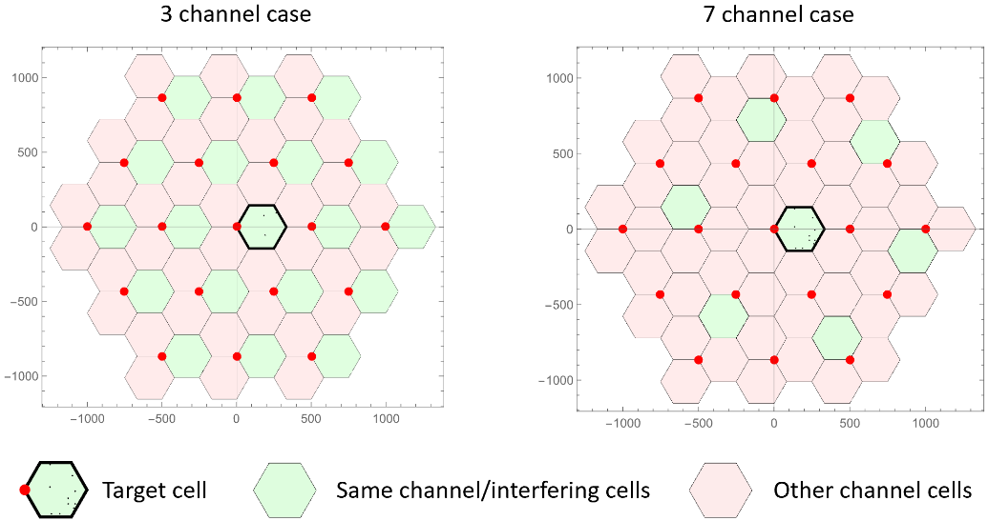

The 5th percentile SINR’s were extracted from the distributions and are shown in Table 9 (4 GHz) and Table 10 (700 MHz) for various TX antenna array configurations.

Further, Table 9 (4 GHz) and Table 10 (700 MHz) provide the minimum link-level SNR requirement for a packet error rate (PER) of 10−5 employing the PHY configurations as of Table 8 in LOS and NLOS channel condition.

Table 9

4 GHz, Tx power scaled (46 dBm/10 MHz bandwidth=36 dBm/MHz)

|  |  |  |  |  |  |  |  |  |
| --- | --- | --- | --- | --- | --- | --- | --- | --- |
| Channel Re-use | PHY Config | B | System-Level | | | | Link-Level | |
| 5th %-ile SINR [dB] for  TX Antenna Array Configurations | | | | SNR [dB] required for PER of 10-5 | |
| 10 x 4 | 15 x 4 | 10 x 10 | 15 x 15 | LOS | NLOS |
| 3 | 2 | 3.456 MHz | 0.312016 | 2.937221 | 7.384183 | 11.5465 | 7.5 | 11.5 |
| 3 | 6.912 MHz | -0.04803 | 3.700301 | 6.22779 | 11.6092 | 1.8 | 3.1 |
| 5 | 13.824 MHz | 0.926608 | 2.256571 | 6.892311 | 12.38978 | -2.5* | -2.0* |
| 7 | 2 | 3.456 MHz | 12.88626 | 14.05113 | 16.9191 | 23.0655 | 7.5 | 11.5 |
| 3 | 6.912 MHz | 11.56701 | 14.01433 | 16.9603 | 22.33368 | 1.8 | 3.1 |
| 4 | 6.912 MHz | 11.56701 | 14.01433 | 16.9603 | 22.33368 | 1.8* | 2.5* |
| 5 | 13.824 MHz | 10.70249 | 14.317 | 17.51877 | 21.81347 | -2.5* | -2.0* |

*: use of 1 iteration of H-ARQ

From Table 9 the following can be observed:

– At 4 GHz and with 3 channel re-use in the URLLC system-level simulations with the PHY configuration 3 at 4 GHz in LOS and NLOS channel condition lead to the **successful fulfillment** of the reliability requirement. PHY configuration 5 enables operation on negative SINR, if one iteration of H-ARQ is used.

– At 4 GHz and with 7 channel re-use in the URLLC system-level simulations the PHY configurations 2 and 3 in LOS and NLOS channel condition lead to the **successful fulfillment** of the reliability requirement. PHY configuration 5 enables operation on negative SINR, if one iteration of H-ARQ is used.

Table 10

700 MHz, Tx power scaled (46 dBm/10 MHz bandwidth=36 dBm/MHz)

|  |  |  |  |  |  |  |  |  |
| --- | --- | --- | --- | --- | --- | --- | --- | --- |
| Channel Re-use | PHY Config | B | System-Level | | | | Link-Level | |
| 5th %-ile SINR [dB] for  TX Antenna Array Configurations | | | | Value required for PER of 10-5 | |
| 5 x 4 | 10 x 4 | 15 x 4 | 8 x 8 | LOS | NLOS |
| 3 | 1 | 1.728 MHz | 2.225499 | 6.73525 | 9.799346 | 9.095797 | 4.7 | 8.3 |
| 2 | 3.456 MHz | 2.64411 | 7.045688 | 9.641699 | 8.6899 | 7.5 | 11.5 |
| 4 | 6.912 MHz | 2.627412 | 6.72673 | 9.754896 | 8.8016 | 1.8* | 2.5* |
| 7 | 1 | 1.728 MHz | 11.4099 | 16.43563 | 19.27987 | 18.8207 | 4.7 | 8.3 |
| 2 | 3.456 MHz | 11.82153 | 16.47648 | 18.55255 | 19.09425 | 7.5 | 11.5 |

*: use of 1 iteration of H-ARQ

From Table 10 the following can be observed:

– At 700 MHz and with 3 channel re-use in the URLLC system-level simulations the PHY configurations 1 and 2 in LOS and NLOS channel condition lead to the **successful fulfillment** of the reliability requirement, for a certain set of TX antenna configurations. PHY configuration 4 enables general operation on low SINR (LOS: 1.8 dB, NLOS: 2.5), if one iteration of H-ARQ is used.

– At 700 MHz and with 7 channel re-use in the URLLC system-level simulations the PHY configuration 1 and 2 in LOS and NLOS channel condition lead to the **successful fulfillment** of the reliability requirement.

Due to the selected PHY configurations (Table 8) in our evaluations, a PER of better than 10−5 results in a success probability better than 1-10−5 for transmitting a layer 2 PDU (protocol data unit) of size 32 bytes within 1 ms in channel quality of coverage edge.

# F) Questions and feedback to WP 5D and/or the proponents or other IEGs

# 13 Questions and feedback

# G) In the interim report, kindly provide the proposed next steps towards the final report to be sent to WP 5D for the June 2021 meeting

# 14 Steps taken after interim report for the final report

The ETSI EG conducted the following work for this final report to ITU-R WP 5D:

– Consideration and discussion of the outcomes of the meeting ITU-R WP 5D #37 (March 2021) and correspondence with other IEGs

– Investigation of additional simulation scenarios and configurations for mMTC and URLLC.

Part III

Conclusion

# 15 Overall conclusions

## 15.1 ETSI/DECT Forum SRIT

The ETSI EG evaluated the DECT-2020 NR component RIT of the submission in Document [IMT‑2020/17(Rev.1)](https://www.itu.int/md/meetingdoc.asp?lang=en&parent=R15-IMT.2020-C-0017).

ETSI EG considered the “materials useful to the Option 2 Evaluation of the ETSI (TC DECT) and DECT Forum Candidate Technology Submission” as listed by the received LIAISON STATEMENT TO INDEPENDENT EVALUATION GROUPS (Attachment 7.4 to Document 5D/360) in Annex 3.

The ETSI EG offers the following observations:

1) This component RIT applies only to URLLC and mMTC. Therefore, no evaluations applying to the eMBB usage scenario are to be implemented.

2) The material in [Document 5D/222 Chapter 5](https://www.itu.int/dms_ties/itu-r/md/19/wp5d/c/R19-WP5D-C-0222!H05!MSW-E.docx), Att. 5.3, ETSI (TC DECT) portions extracted under the way forward (Document IMT-2020/52) for preliminary draft new Recommendation ITU-R M.[IMT-2020.SPECS] (5D/TEMP/173) is identified by ETSI EG to contain except editorials the relevant elements of the published ETSI technical specifications ETSI TS 103 636 series (part 1 to 4) for DECT-2020 NR.

3) Assessment as per Reports ITU-R M.2410, ITU-R M.2411 and ITU R M.2412 for DECT-2020 NR by ETSI EG results in

– Requirements and parameters to be evaluated by inspection (Bandwidth, Spectrum, Services) are fulfilled by DECT-2020 NR.

– Parameters to be evaluated by analysis (User and Control Plane Latency, Mobility Interruption Time) are fulfilled by DECT-2020 NR.

– Parameters to be evaluated via simulation (Reliability, Connection Density) are fulfilled by DECT-2020 NR.

– DECT-2020 NR is able to serve URLLC services and mMTC services.

4) According to the assessment by ETSI EG DECT-2020 NR is fulling the necessary requirements for being a component RIT in an IMT-2020 SRIT, where another qualified component RIT delivers eMBB services support.

5) We conclude that the ETSI/DECT Forum SRIT proposal (DECT-2020 NR + 3GPP NR) is fulling all requirements for IMT-2020 including eMBB, URLLC, and mMTC services.

Annex 1

Additional IMT-2020 evaluation details

# **I User** Plane Latency

In all evaluated transmissions the URLLC application data packet is assumed to be 32 bytes and transmitted with the lowest possible MCS using at least two subslots, i.e. 10 symbols, for all numerologies. For (SDU) data transmission a single subslot, 5 symbols, transmission is not considered at this point even though it is also possible based on ETSI [TS 103 636-3 V1.1.1](https://www.etsi.org/deliver/etsi_ts/103600_103699/10363603/01.01.01_60/ts_10363603v010101p.pdf) (DECT‑2020 NR PHY).

HARQ feedback for the transmission is included in the PHY control channel that is transmitted at the beginning of the slot, allowing the processing of PHY control before receiving a complete subslot. However, the minimum packet size defined in ETSI [TS 103 636-3 V1.1.1](https://www.etsi.org/deliver/etsi_ts/103600_103699/10363603/01.01.01_60/ts_10363603v010101p.pdf) (DECT-2020 NR PHY) is 1 subslot, i.e. 5 symbols, and therefore this duration is always used for the return path for HARQ feedback. Table UPL.1 presents different physical layer configurations used in the evaluation, such as the selection of (,) parameters, and corresponding data transmission durations, MCS, transport block sizes, Subcarrier spacings (SCS), and channel bandwidths. It should be noted that these configurations are a subset of possible options defined in ETSI [TS 103 636-3 V1.1.1](https://www.etsi.org/deliver/etsi_ts/103600_103699/10363603/01.01.01_60/ts_10363603v010101p.pdf) (DECT-2020 NR PHY), and another configuration may be used in practical implementations.

Table UPL.1

Transmission configurations

|  |  |  |  |  |
| --- | --- | --- | --- | --- |
| Case (μ,β) | Data TX duration | Subslot duration (5 symbols) | MCS (transport block size) | Description |
| (1,1) | 416.667 μs  (10 symbols) | 208.333 µs | MCS1  (296 bits) | 27 kHz SCS, with 1.728 MHz channel bandwidth |
| (2,1) | 208.333 µs  (10 symbols) | 104.166 µs | MCS2  (368 bits) | 54 kHz SCS, with 3.456 MHz channel bandwidth |
| (2,1) b) | 312.5 µs  (15 symbols) | 104.166 µs | MCS1  (504 bits) | 54 kHz SCS, with 3.456 MHz channel bandwidth |
| (2,2) | 208.333 µs  (10 symbols) | 104.166 µs | MCS0  (288 bits) | 54 kHz SCS, with 6.912 MHz channel bandwidth |
| (4,1) | 104.166 µs  (10 symbols) | 52.083 µs | MCS2  (368 bits) | 108 kHz SCS, with 6.912 MHz channel bandwidth |
| (4,2) | 104.166 µs  (10 symbols) | 52.083 µs | MCS0  (288 bits) | 108 kHz SCS, with 13.824 MHz channel bandwidth |
| (8,1) | 52.083 µs  (10 symbols) | 26.042 µs | MCS2  (288 bits) | 216 kHz SCS, with 13.824 MHz channel bandwidth |

Results are given with single RD processing capabilities. The MAC specification [TS 103 636-4 V1.1.1](https://www.etsi.org/deliver/etsi_ts/103600_103699/10363604/01.01.01_60/ts_10363604v010101p.pdf) defines the following: "*The processing time for creating the feedback is two subslots, resulting that feedback shall be included in transmission at subslot n+3 or next transmitted packet after that, where n indicates the subslot where the reception of the packet ended"*. This rule is used to determine the TX and RX processing time by dividing the given time equally between the TX and RX processing time even though implementations might have a different delay budget partition. This equal split is further used for minimum initial TX packet processing time as well as minimum RX processing time.

## Frame based system operation

In frame-based system operation, all transmissions are aligned to start at the subslot boundary. The resource allocation is done by using MAC signalling where for both data and ACK/NACK transmission resources are allocated.

Figure UPL.1 presents a system configuration where the resource allocation is done containing two data subslots followed by one ACK subslot (referred to as DDADDA pattern).

The data source is not synchronized with the radio frame timing and therefore data can arrive at any time moment, which represents a case where the application generating data is behind an external interface. The data is then transmitted in the next available data subslot allowing to transmit two subslots, i.e. 10 symbols, and TX side has had the minimum of a single subslot of TX processing time. In case (2,1) b) the configuration is DDDADDDA, as the data transmission uses 15 symbols.

The HARQ feedback is transmitted in the next subslot reserved in another direction that is available after a minimum of 1 subslot RX processing and 1 TX processing time. Furthermore, the retransmission occurs again in the next data subslot with a minimum of 1 subslot RX processing time (HARQ feedback) and 1 subslot TX processing time. The used subslot for data transmissions are highlighted with a blue colour.

It is noted that the delay would be similar in either direction (uplink or downlink), depending on the data subslot allocation.

Figure UPL.1

Subslot pattern of DDADDA (D: data, A: ACK/NACK) when application is not synchronized with the pattern



Figure UPL.2

Subslot pattern of DDADDA (D: data, A: ACK/NACK) when application is synchronized with subslot accuracy



Figure UPL.2 illustrates the same configuration as in Figure UPL.1, but the data source is synchronized with the radio frame timing with subslot accuracy and therefore data arrives 1-2 subslots before the data subslot. This case represents an implementation where the application generating data is within a radio processor or operates in a separate application processor at the same device or an external interface provides synchronized data delivery between application and radio processor. This allows the minimization of random packet waiting time (single subslot timing accuracy is seen as a quite relaxed requirement) in the TX buffer, however, the minimum TX and RX processing times cannot be avoided.

Frameless based system operation

This section introduces a frameless transmission evaluation (disclosed in 5.2.3.2.12.2, of the candidate submission IMT-2020/17(Rev 1.)). In the specifications, no specific **frameless transmission** is specified but the RACH transmissions are operating with a symbol granularity, according to [TS 103 636-4 V1.1.1](https://www.etsi.org/deliver/etsi_ts/103600_103699/10363604/01.01.01_60/ts_10363604v010101p.pdf) (MAC). Based on the MAC specification: *"Slots indicated as random access resources are divided into multiple start positions where the transmission can be initiated. Start positions are counted from the beginning of a random access slot, and are 0, 1, 2, 3… times the duration of STF and GI field, with given -factor as defined in ETSI TS 103 636-3*".

Thus, for frameless transmission, the RACH TX operation timings should be considered. We note that based on ETSI [TS 103 636-4 V1.1.1](https://www.etsi.org/deliver/etsi_ts/103600_103699/10363604/01.01.01_60/ts_10363604v010101p.pdf) the random access resources can be signalled individually, so that channel can be free from other devices’ transmissions. The RACH transmissions are controlled by the exponential *rachBackOff* parameterwhich is a randomly selected value between 0 and *CWCurrent*. The possible value of *CWCurrent* is controlled by *CWmin* and *CWmax* parameters which are signalled as part RACH configuration. By setting both *CWmin* and *CWmax* to zero (which is a valid value in signalling) the transmission can be initiated always after a minimum LBT time, which is defined to be two symbols. The LBT process can be done parallel with TX packet processing time and thus the additional delay is the alignment to a RACH Start position that is available after every STF + GI field duration. Figure UPL.3 presents the transmission and retransmission procedure of the RACH channel.

Figure UPL.3

RACH transmission and re-transmission procedure.



The detailed assumptions of each step are provided in Table UPL.2 for both frame based and frameless system operation.

Table UPL.2

User plane procedure for DECT-2020 NR

|  |  |  |  |
| --- | --- | --- | --- |
| ID | Component | Notations | Value |
| 0 | Symbol alignment time | *t*sym | Average 0.5 times symbol length. |
| 1 | Data transfer | *T*1 = *t*,rd_tx + *t*FA_switch + *t*duration + *t*rd_rx | Steps 1.1 to 1.4 |
| 1.1 | RD TX side processing delay | *t*rd,tx | TX processing time: 1 subslot. Both PCC and PDC are encoded. |
| 1.2 | TX Alignment and TDD switching time | *t*FA_switch | The waiting time to obtain frame alignment and TDD switching in frame based transmission.  See figure UPL.1 and UPL.2. When frameless transmission is used time contains random-access start position. |
| 1.3 | Data packet transmission | *t*duration | Transmission length can be adjusted with subslot granularity. The transmission lengths are given in Table UPL.1. |
| 1.4 | RD RX processing delay | *t*rd_rx | 1 subslot. The time interval between the physical layer packet is received and both PCC and PDC are decoded |
| 2 | HARQ feedback transmission | *T*2 = *t*tx + *t*FA_switch + *t*HARQ-duration + *t*rd-rx | Steps 2.1 to 2.4 |
| 2.1 | RD TX side processing delay | *t*tx | 1 subslot. The time interval between the data is decoded, and transmission containing ACK/NACK (PCC) is generated. |
| 2.2 | TX Alignment and TDD switching time | *t*FA_switch | The waiting time to obtain frame alignment and TDD switching in frame-based transmission. See figure UPL.1 and UPL.2. When frameless transmission is used time contains symbol alignment time. |
| 2.3 | HARQ ACK/NACK transmission | *t*HARQ_duration | 1 subslot, on given numerology. |
| 2.4 | RD processing delay | *t*rd-rx . | 1 subslot. The time interval between the physical layer packet is received and both PCC (containing ACK/NACK) and PDC are decoded |
| 3 | Data re-transmission | *T*3 *=* = *t*,rd_tx + *t*FA_switch+ *t*duration + *t*rd_rx | Steps 3.1 to 3.4 |
| 3.1 | RD TX side processing delay | *t*rd,tx  The time interval between the data is arrived, and packet is generated. | 1 subslot. Time both PCC and PDC are encoding for retransmission |
| 3.2 | TX Alignment and TDD switching time | *t*FA_switch | The waiting time to obtain frame alignment and TDD switching in frame based transmission. See figure UPL.1 and UPL.2.  When frameless transmission is used time contains random-access start position. |
| 3.3 | Data packet transmission | *t*duration | Transmission length can be adjusted with subslot granularity. The transmission lengths are given in Table 1. |
| 3.5 | RD RX processing delay | *t*rd_rx  The time interval between the physical layer packet is received and the data is decoded. | 1 subslot. The time interval between the physical layer packet is received and both PCC and PDC are decoded |
| **Total one way user plane latency without HARQ** | | *T*UP= *t*sym *+ T*1 | |
| **Total one way user plane latency with HARQ** | | *T*UP= *t*sym + *T*1 + *n*×(*T*2 *+T*3)  where *n* is the number of re-transmissions (*n*≥0) percentage (10%). | |
| **Maximum one way user plane latency with one HARQ re-transmission** | | *T*UP= *t*sym + *T*1 + *T*2 *+T*3 | |

II Control Plane Latency

The ETSI TS 103 636-4, defines an association procedure as *"The purpose of association signalling is to initiate unicast data exchange between two RDs."*. Thus, the non-associated state can be considered as "*battery efficient state*" and the associated state as "*Active state*".

Figure CPL.1

Association signalling (ETSI TS 103 636-4)



Before the initiating association procedure, the RD has scanned radio environment to detect a Beacon transmission from other RDs that have enabled the association procedure (Section 5.8.2 of ETSI TS 103 636-4). Scanning of the radio environment and the beacon detection is performed in a power efficient operational mode and is not taken into account in control plane latency analysis.

The state transition to associated, i.e. to an active state, is initiated by sending an Association Request message, and completed with an Association Response message. The Association Request message is sent in a MAC PDU at a random access transmission and the Association Response can be included in MAC PDU of Random Access Response message.

The MAC PDU size carrying an Association Request depends on whether the MAC security is used, number of flows to be setup, and whether a RD performing association provides optional parameters in the Association Request (Beacon period, beacon channel etc.). An example size MAC PDU for an Association Request is presented in Table CPL.1, when two flows are established and both the security and the integrity protection is used for Association Request.

The MAC PDU size carrying the Association Response depends on whether the MAC security is used, and the resource allocation signalling. An example size of MAC PDU for the Association Response is presented in Table CPL.2, when an Association Request is accepted and both the uplink and downlink scheduled resources are allocated, and the security is active for Association Response message.

Table CPL.1

MAC PDU size for Association request

| MAC PDU content | octets | Comment |
| --- | --- | --- |
| MAC header type | 1 |  |
| Unicast header | 10 |  |
| MAC MUX header | 2 |  |
| Security IE | 5 | IE included.  Association request is ciphered |
| MAC MUX header | 2 |  |
| Association request | 5 | Setup of two flows |
| MAC MUX header | 2 |  |
| Capability IE | 3 |  |
| MIC | 5 | Integrity protection of association request |
| Size | 35 | 280 bits. Rest is padding to match transport block size. |

Table CPL.2

MAC PDU size for Association Response

|  |  |  |
| --- | --- | --- |
| MAC PDU content | octets | Comment |
| MAC header type | 1 |  |
| Unicast header | 10 |  |
| MAC MUX header | 2 |  |
| Security IE | 5 | IE included Association Response is ciphered |
| MAC MUX header | 2 |  |
| Association request | 1 | Accept the setup |
| MAC MUX header | 2 |  |
| Capability IE | 3 |  |
| MAC MUX header | 2 |  |
| Resource allocation | 5 | 7 octets for m value 8 |
| MIC | 5 |  |
| Size | 40 | 1) 320 bits, Rest is padding to match transport block size.  2) 42 octets, 336 bits when m is 8. |

In all evaluated configurations, it is assumed that RDs select the lowest possible MCS using at least two subslots, i.e. 10 symbols, in all numerologies for sending Association Request and Associated Response messages. Additionally, for scenario (2,1) an option (2,1) b) of using three subslots, 15 symbols, is presented. Similarly, as in scenario (2,1) b), also in other numerologies longer transmissions are possible that would further reduce the needed MCS level.

Table CPL.3 presents different physical layer configurations used in the evaluation, such as the selection of (,) parameters, the corresponding data transmission durations, the MCS, the transport block sizes, the Subcarrier spacings (SCS), and channel bandwidths.

Table CPL.3

Transmission configurations

|  |  |  |  |  |
| --- | --- | --- | --- | --- |
| Case (μ,β) | Data TX duration for association request and response | MCS  (transport block size) for association request | MCS  (transport block size) for association response | Description |
| (1,1) | 416.667 µs  (10 symbols) | MCS1  (296 bits) | MCS2  (456 bits) | 27 kHz SCS, with 1.728 MHz channel bandwidth |
| (2,1) | 208.333 µs  (10 symbols) | MCS2  (368 bits) | MCS2  (368 bits) | 54 kHz SCS, with 3.456 MHz channel bandwidth |
| (2,2) | 208.333 µs  (10 symbols) | MCS1  (288 bits) | MCS1  (600 bits) | 54 kHz SCS, with 6.912 MHz channel bandwidth |
| (2,1) b) | 312.5 µs  (15 symbols) | MCS1  (504 bits) | MCS1  (504 bits) | 54 kHz SCS, with 3.456 MHz channel bandwidth |
| (4,1) | 104.166 µs  (10 symbols) | MCS2  (368 bits) | MCS2  (368 bits) | 108 kHz SCS, with 6.912 MHz channel bandwidth |
| (4,2) | 104.166 µs  (10 symbols) | MCS0  (288 bits) | MCS1  (600 bits) | 108 kHz SCS, with 13.824 MHz channel bandwidth |
| (8,1) | 52.083 µs  (10 symbols) | MCS2  (288 bits) | MCS3  (392 bits) | 216 kHz SCS, with 13.824 MHz channel bandwidth |

Results are given with two RD processing capabilities. The ETSI [TS 103 636-4 V1.1.1](https://www.etsi.org/deliver/etsi_ts/103600_103699/10363604/01.01.01_60/ts_10363604v010101p.pdf) defines the following: "*The processing time for creating the feedback is two subslots, resulting that feedback shall be included in transmission at subslot n+3 or next transmitted packet after that, where n indicates the subslot where the reception of the packet ended"*. Even though the Association Response could be included in a MAC PDU of the physical layer packet including HARQ feedback, we provide results with RD processing times like presented in the self-evaluation.

The detailed assumptions of each step are provided in Table CPL.4 for the control plane latency.

ETSI TS 103.636-4 defines RACH resource configuration options in subclause 6.4.3.4. The RACH resource could be occurring constantly or repeated either in frame or subslot level.

For the evaluation we present results with two scenarios:

1) RACH resource allocation is constant (valid all the time), this also reflects the situation where state transition from "battery efficient state" starts at the time moment when RACH transmission occurs and waiting time of RACH resource is not counted, as done in section 5.7.2 of 3GPP TR 37.910.

2) RACH resources are repeated at every 10 ms for 27 kHz, i.e. every 48 subslots. For other numerologies RACH resources are occurring also every 48 subslots.

Table CPL.4

Control plane latency for DECT-2020 NR

|  |  |  |
| --- | --- | --- |
| ID | Component | Value |
| 0 | Delay due to RACH resource allocation period | 0 or 10 ms for m =1  0 or 5 ms for m =2  0 or 2.25 ms for m =4  0 or 1.25 ms for m =8 |
| 1 | Transmission of RACH that includes Association Request message | 10 symbol transmission, delay depends on used numerology. |
| 2 | RD processing delay of Association Request and sending Association Response | 1 ms or 5 ms as given in self-evaluation. |
| 3 | Transmission of Association Response message | 10 symbol transmission, delay depends on used numerology. |
| 4 | RD processing delay of Association Response | 1 ms as given in self-evaluation. |

# **III Reliability (URLLC)**

The physical layer (PHY) configurations employing Turbo Coding are provided in Table 8 and employed PCC type 2 (80 bit). Table URLLC.4 provides further details.

Table URLLC.4

Additional PHY receiver configuration details

|  |  |
| --- | --- |
| Number of RX Antennas | 4 (MRC) |
| Time Synchronization | Ideal (on first channel tap) |
| Frequency Synchronization | Ideal (no CFO, only Doppler) |
| Channel Estimate | Wiener filtering |
| Equalization | ZF |

The channel model and the configuration according to the Report ITU-R M.2412-0 is applied in the simulation runs. References can be found in Table *URLLC.5*.

Table URLLC.5

Channel configuration details

|  |  |
| --- | --- |
| Tool | Matlab comm.MIMOChannel |
| Impairment Model | Tapped Delay Line (TDL) + Gaussian Noise |
| Test Environment | URLLC  Report ITU-R M.2412-0, Table 8 (p. 30) |
| TDL  Power Delay Profile | LOS: TDL-v; NLOS: TDL-iii  Report ITU-R M.2412-0, Table 8 (p. 30)  Report ITU-R M.2412-0, Table A1-42 (p. 107 and 108)  Report ITU-R M.2412-0, Table A1-18 (p. 67) |
| TDL  Doppler | Report ITU-R M.2412-0, Table 5 (p. 27 and 28) |

In general, the results for channel model A (700 MHz) and channel model B (4 GHz) are very similar, so that only the channel model A results are reported.

The results for PHY configurations 1, 2 and 3 according to Table 8 for 4 receive antennas and a line of sight (LOS) channel are shown in Figure URLLC.2. The results of a non-line of sight (NLOS) channel are shown in Figure URLLC.3.

Figure URLLC.4 provides the results PHY configuration 4 (Table 8) without and with 1 iteration of H-ARQ for the line of sight (LOS) channel and the non line of sight channel (NLOS). Figure URLLC.5 provides the results for PHY configuration 5 (Table 8).

Figure URLLC.2

Packet Error Rate (PER) over SNR for PHY configurations 1, 2, 3 in a LOS channel and 4 RX antennas. The marked SNR values (1.8dB, 4.7dB and 7.5dB) are obtained at a PER of 10−5

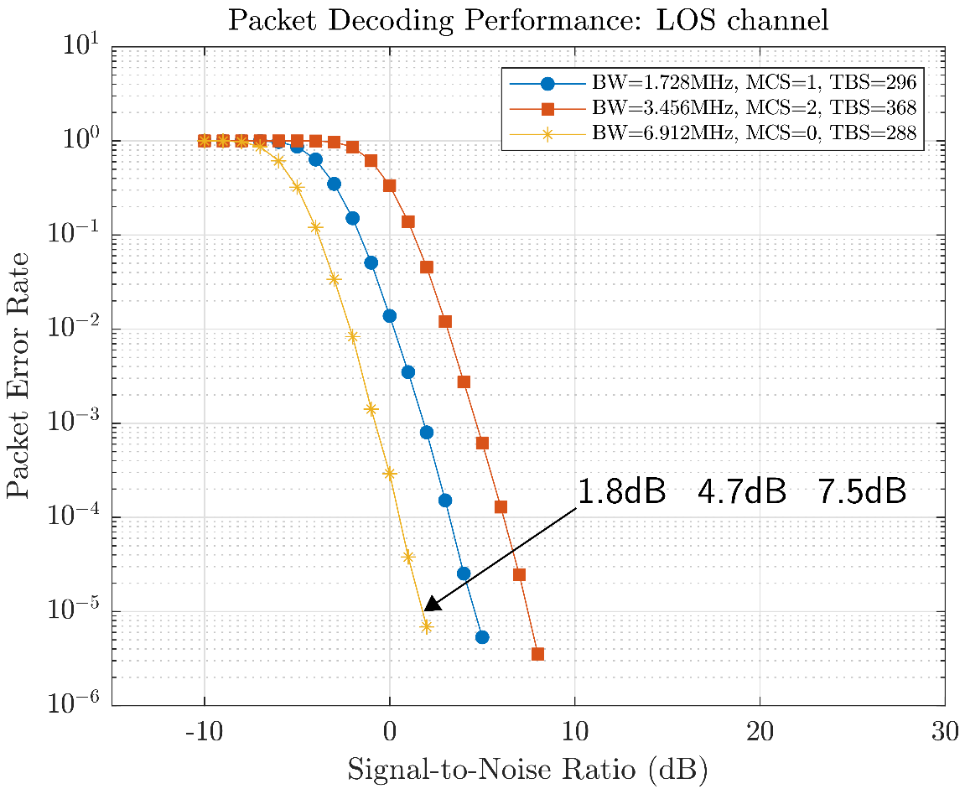

Figure URLLC.3

Packet Error Rate (PER) over SNR for PHY configurations 1, 2, 3 in a NLOS channel and 4 RX antennas. The marked SNR values (3.1dB, 8.3dB and 11.5dB) are obtained at a PER of 10−5.

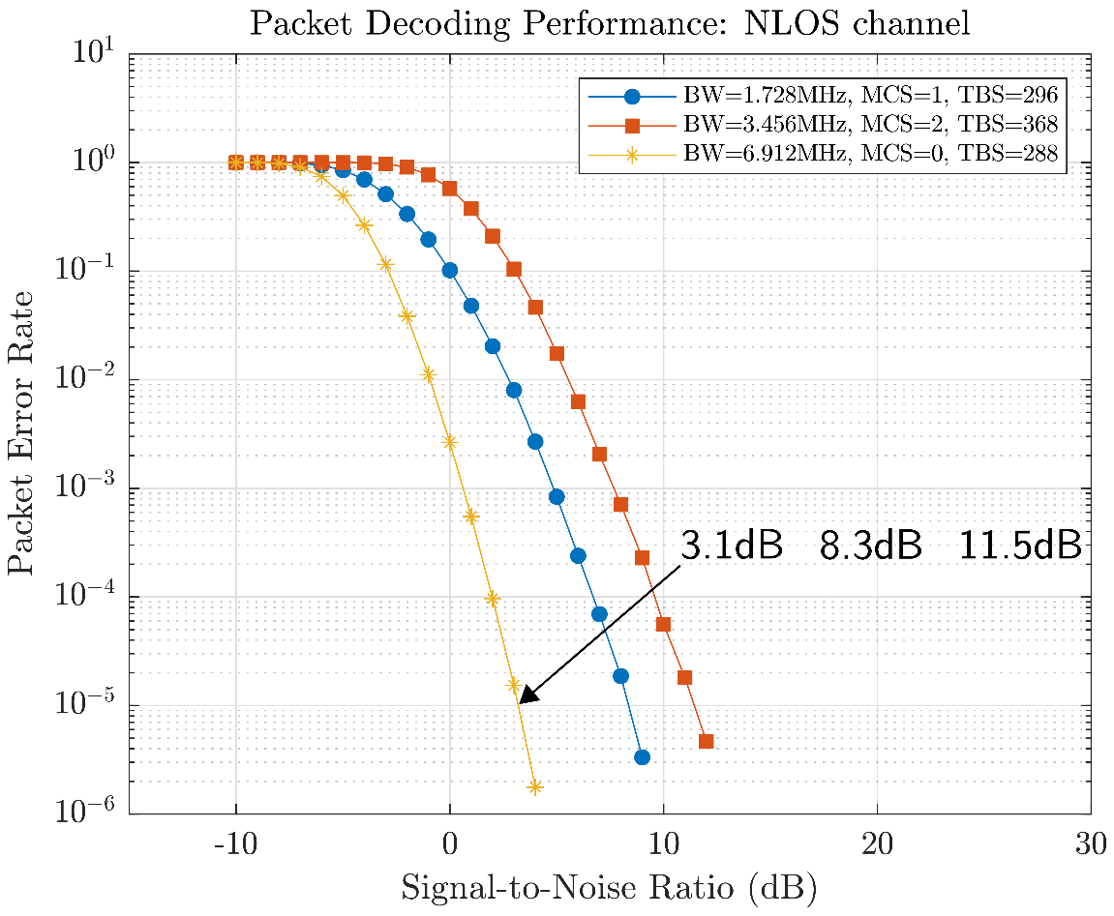

Figure URLLC.4

Packet Error Rate (PER) over SNR for PHY configuration 4 in a NLOS channel and 4 RX antennas.

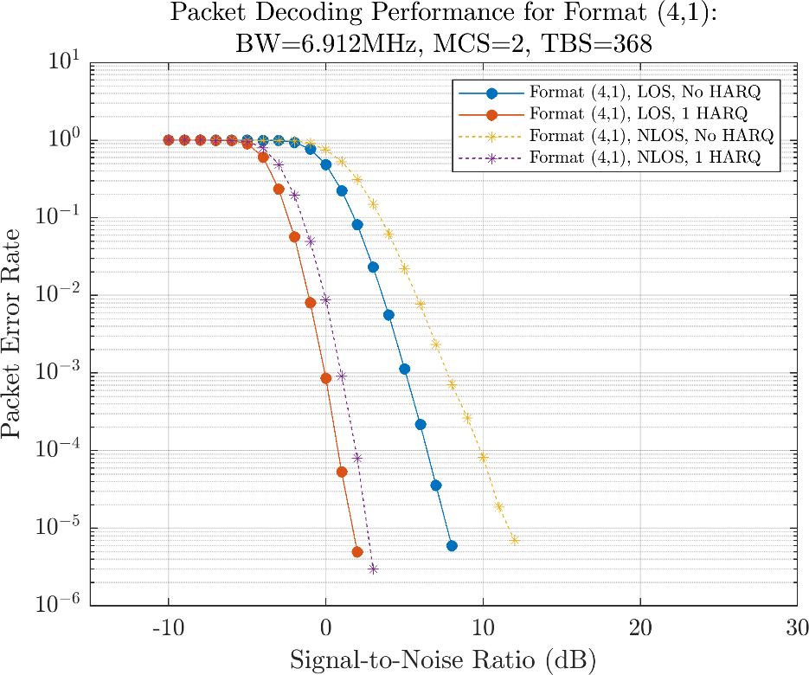

Figure URLLC.5

Packet Error Rate (PER) over SNR for PHY configurations 5 in a NLOS channel and 4 RX antennas.

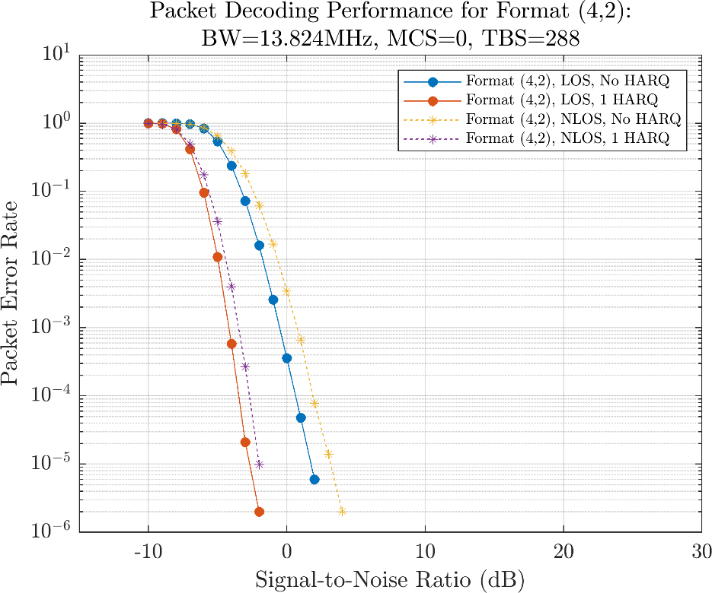

Table URLLC.6 details the system level simulation parameters in accordance with the evaluation guideline given in Report ITU-R M.2412-0. The ETSI EG also performed system simulations with a Total Tx Power per TRxP in BS/sink of 23 dBm. These results are available on request, but do not change the positive evaluation. Distributions of the post-processing SINR’s were collected from the simulation results and are shown in Figure URLLC.6 to Figure URLLC.12 for reference.

Table URLLC.6

System level simulation parameters

| Parameters | Configuration A | Configuration B |
| --- | --- | --- |
| **Baseline evaluation configuration parameters** | | |
| System Architecture | Star with 19 sites, each site has 3 TRxPs (cells). Device connects directly to BS. | Star with 19 sites, each site has 3 TRxPs (cells). Device connects directly to BS. |
| Carrier frequency for evaluation | 4 GHz | 700 MHz |
| Channel model | Urban Macro | Urban Macro |
| BS antenna height | 25m | 25m |
| Total Tx Power per TRxP in BS/sink | 36dBm/MHz | 36dBm/MHz |
| UE/node power class | Not applicable as DL only | Not applicable as DL only |
| Percentage of high loss and low loss building type | 100% low loss | 100% low loss |
| **Additional parameters for system-level simulation** | | |
| Inter-site distance | 500m | 500m |
| Number of antenna elements per TxRP | 40 (10x4), 60 (15x4), 100 (10x10), 225  (15x15) ≤ 256 | 20 (5x4), 40 (10x4), 60 (15x4), 64 (8x8) ≤ 64 |
| UE antennas | 1 < 8 | 1 < 4 |
| Device deployment | 80% outdoor, 20% indoor | 80% outdoor, 20% indoor |
| UE mobility model | Included in link-level simulation | Included in link-level simulation- |
| UE speeds of interest | 3 km/h, 30 km/h considered in link-level Simulation | 3 km/h, 30 km/h considered in link-level simulation |
| Inter-site interference modelling | Explicitly modelled | Explicitly modelled |
| BS noise figure | Not applicable – DL only | Not applicable – DL only |
| UE noise figure | 7 dB | 7 dB |
| BS/sink antenna element gain | 8 dBi | 8 dBi |
| UE antenna element gain | 0 dBi | 0 dBi |
| Thermal noise level | −174 dBm/Hz | −174 dBm/Hz |
| Traffic model | Full buffer | Full buffer |
| Physical layer packet size | greater than 32 bytes (see PHY config considered) | greater than 32 bytes (see PHY config considered) |
| Simulation bandwidth | <100 MHz | <40 MHz |
| UE density | 10 UEs per TRxP | 10 UEs per TRxP |
| UE antenna height | 1.5m | 1.5m |

A mobility of 3 km/h and 30 km/h results in frequency shifts (Doppler) in an order of some tens of Hz - well below the sub-carrier spacing - depending on carrier frequency and speed. Such values can be easily compensated by the carrier frequency offset correction performed at the physical layer. Coherency time of the channel can be concluded by Clarkes’ model to be in the order of several ms to some hundred ms, while transmission interval is in the order of 416.667 µs, half of that or even lower. So that the channel can be assumed to be quasi-static during time intervals of DECT-2020 NR transmission. A DECT-2020 subslot transmission carries all training required to perform proper synchronization in time and frequency, as well channel estimation, tracking and equalization, so that even higher speeds could be supported.

Figure URLLC.6

Tx Antenna Array 5x4

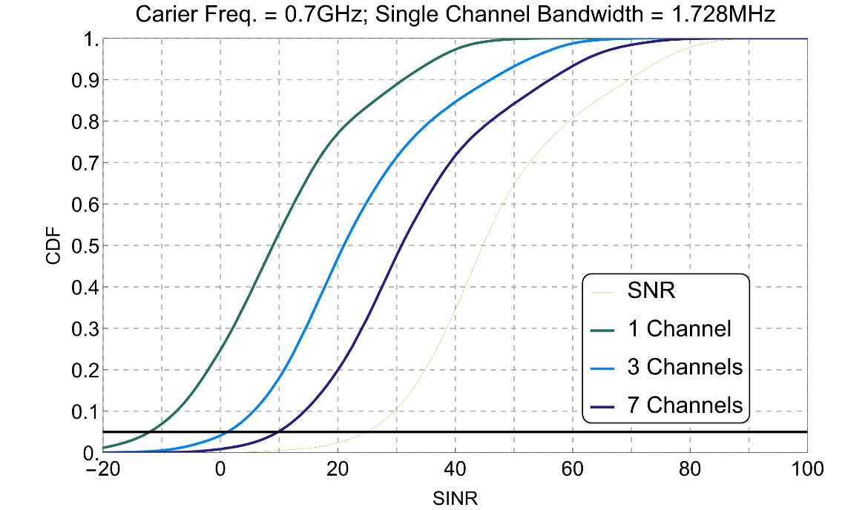

Figure URLLC.7

Tx Antenna Array 10x4

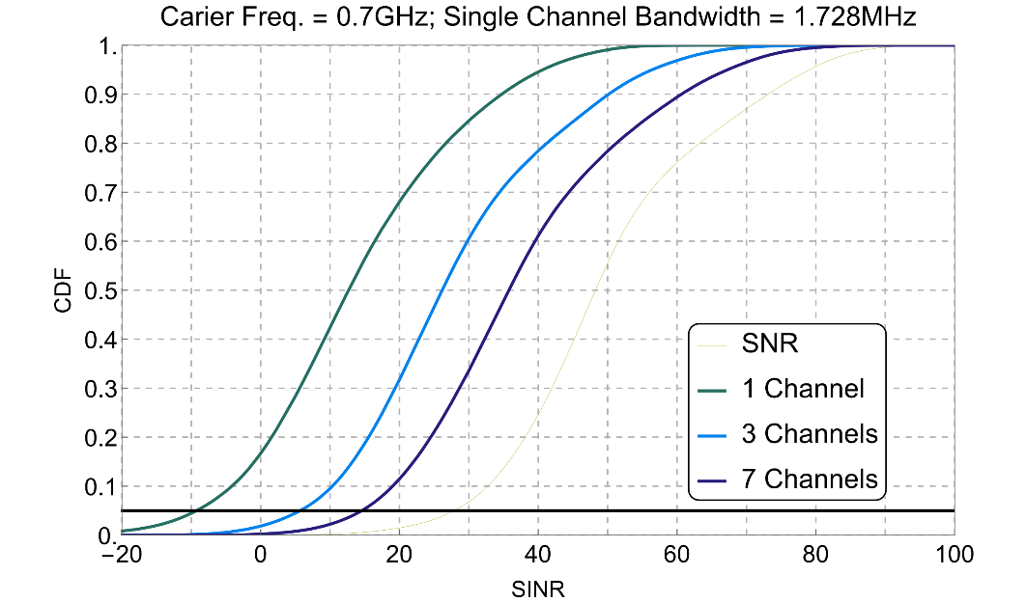

Figure URLLC.8

Tx Antenna Array 10x4

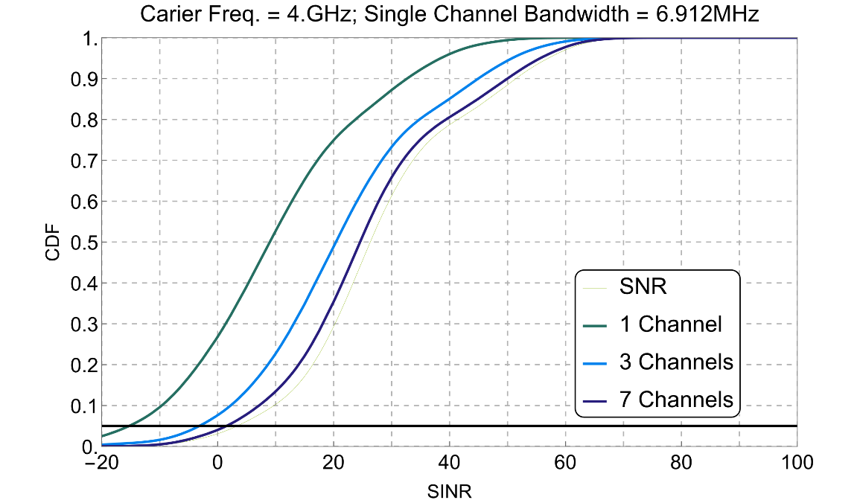

Figure URLLC.9

Tx Antenna Array 15x4

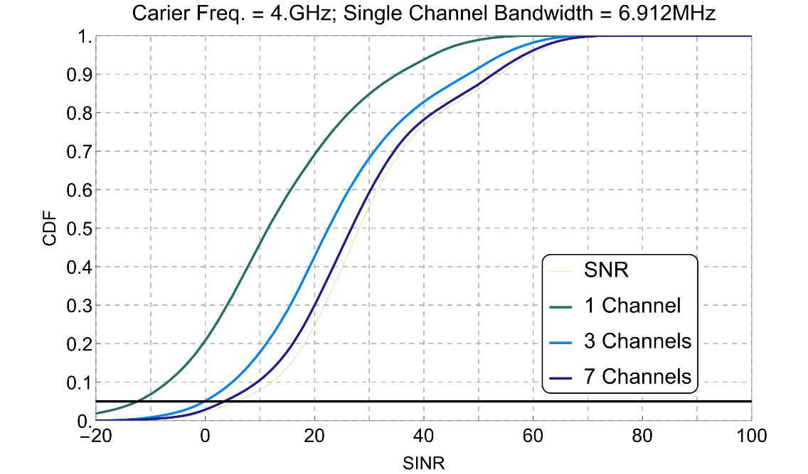

Figure URLLC.10

Tx Antenna Array 10x4

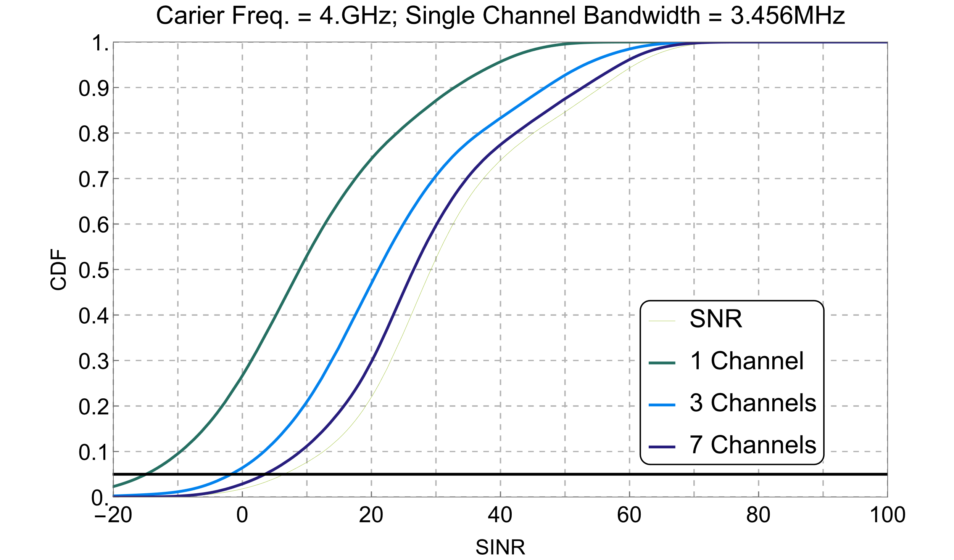

Figure URLLC.11

Tx Antenna Array 15x4

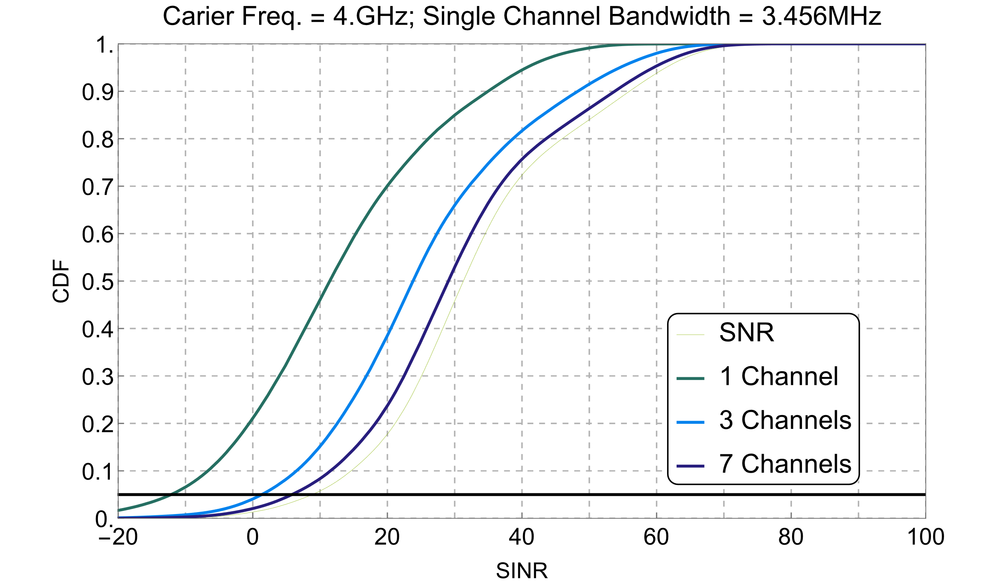

Figure URLLC.12

Tx Antenna Array 5x4

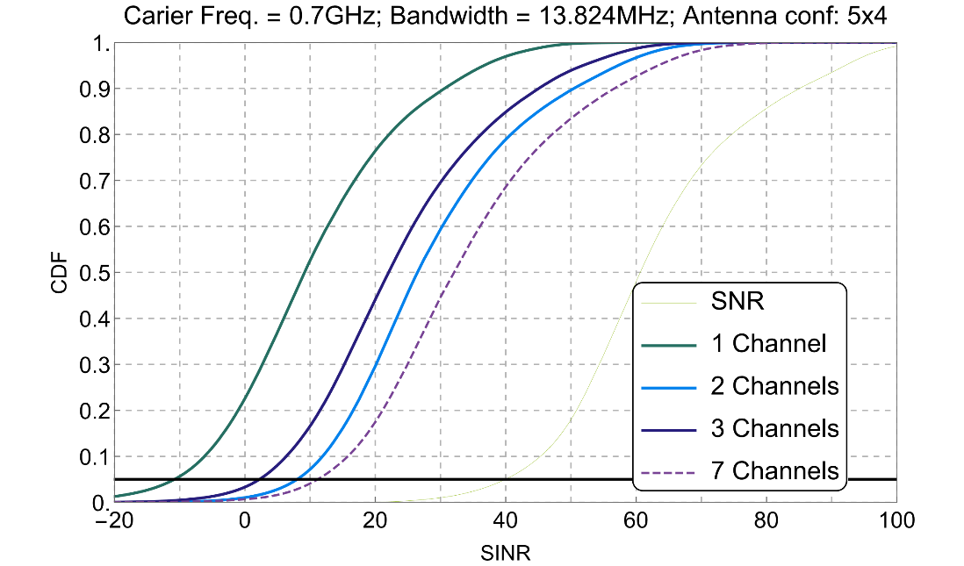

# **IV Connection Density (mMTC)**

# IV.A Link-level Simulations for mMTC, Contribution A

The antenna configuration can be chosen based on the role of the communication device. Since DECT‑2020 NR does not have a strong definition of base stations and user equipment the chosen antenna configuration is set to a maximum of 2 transmit and 2 receive antennas for the link level simulation. All link-level simulations employ turbo coding.

All configuration parameters for the transmitter (TX) are given in Table CD-A.1. The receiver (RX) configuration are provided in Table CD-A.2. The channel configuration for urban macro can be found in Table CD-A.3.

Table CD-A.1

TX configuration parameters

|  |  |
| --- | --- |
| Bandwidth | 1.728 MHz (*μ=1, β=1*) |
| Packet size | 1 slot  10 symbols  PCC type 2, 80 bits  MCS Index 1  PDC TBS 296 bits |
| Number of Spatial Streams | 1 |
| Number of Effective Transmit Antennas | 1 and 2 (2 x 1 Tx Div) |
| Maximum Number of HARQ Retransmission | 0,1,2 |

Table CD-A.2

RX configuration parameters

|  |  |
| --- | --- |
| Number of RX Antennas | 1 and 2 |
| Time Synchronization | Ideal (on first channel tap) |
| Frequency Synchronization | Ideal (no CFO, only Doppler) |
| Channel Estimate | Wiener filtering |
| Equalization | ZF |

Table CD-A.3

Channel configuration parameters for urban macro scenario

|  |  |
| --- | --- |
| Tool | Matlab comm.MIMOChannel |
| Impairment Model | Tapped Delay Line (TDL) + Gaussian Noise |
| Test Environment | mMTC  Report ITU-R M.2412-0, Table 8 (p. 30) |
| TDL  Power Delay Profile | LOS: TDL-v; NLOS: TDL-iii  Report ITU-R M.2412-0, Table 8 (p. 30)  Report ITU-R M.2412-0, Table A1-42 (p. 107 and 108)  Report ITU-R M.2412-0, Table A1-18 (p. 67) |
| TDL  Doppler | Carrier frequency 700MHz  Report ITU-R M.2412-0, Table 5 (p. 27 and 28) |

Figure CD-A.1 to CD-A.4 report the link level simulation results for RD (UE) to RD-FT (BS).

Figure CD-A.1

Packet Error Rate (PER) over SNR for 1 TX, 2 RX antennas and different HARQ settings   
in LOS urban macro channel model (mMTC)

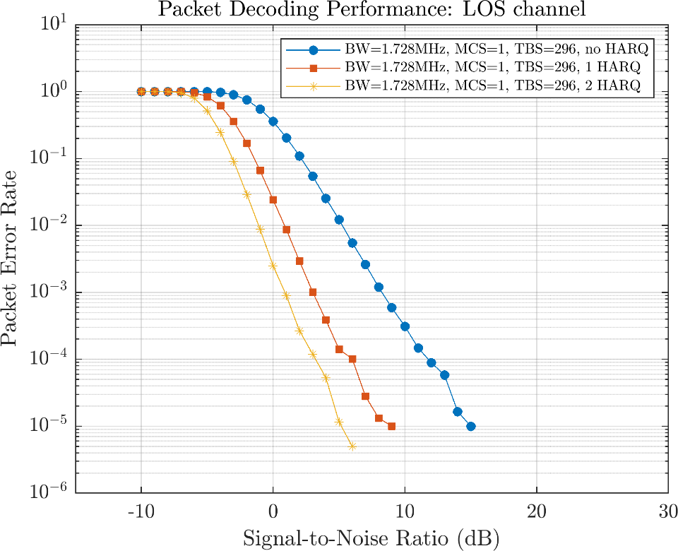

Figure CD-A.2

Packet Error Rate (PER) over SNR for 1 TX, 2 RX antennas and different HARQ settings   
in NLOS urban macro channel model (mMTC)

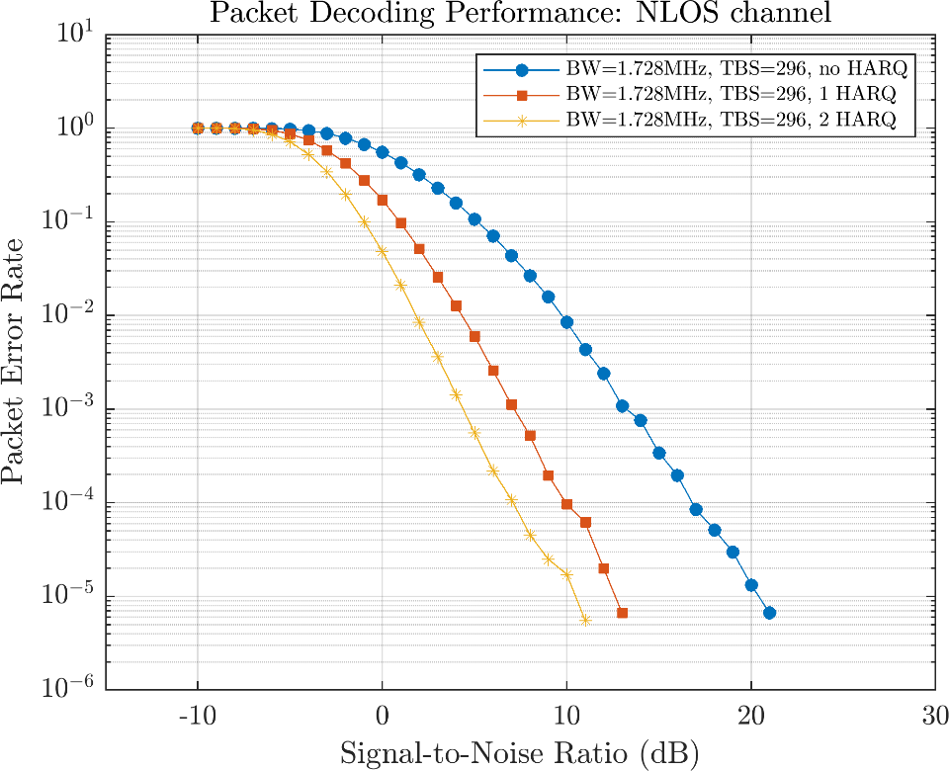

Figure CD-A.3

Packet Error Rate (PER) over SNR for 2 TX, 2 RX antennas and different HARQ settings   
in LOS urban macro channel model (mMTC)

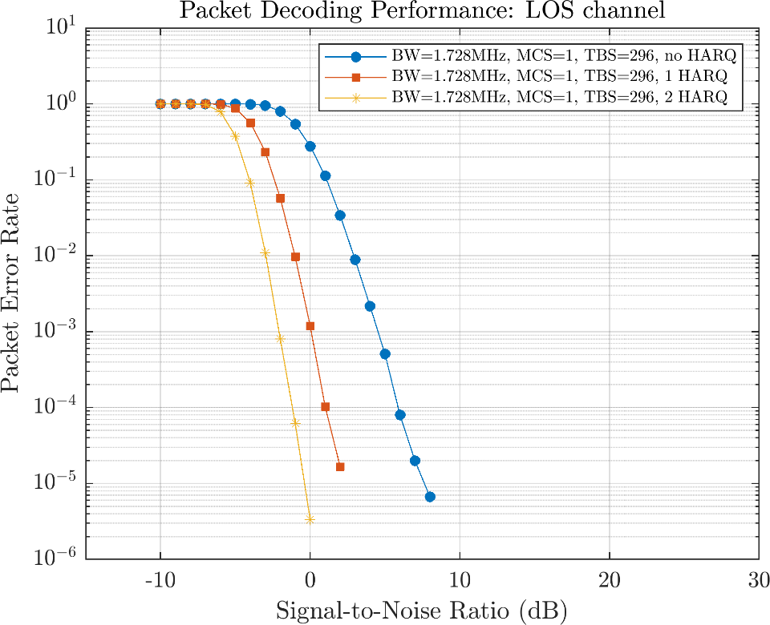

Figure CD-A.4

Packet Error Rate (PER) over SNR for 2 TX, 2 RX antennas and different HARQ settings  
in NLOS urban macro channel model (mMTC)

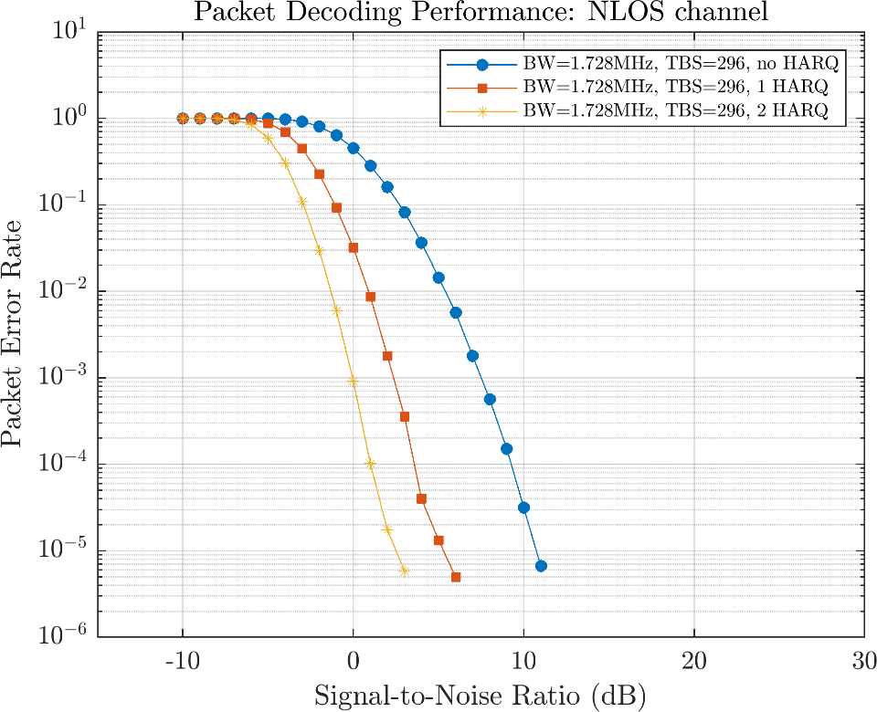

The link level simulation for D2D considered various configurations which represent the communication scenarios:

– Outdoor to outdoor (O-O) in Urban micro LOS and Urban micro NLOS

– Outdoor to indoor (O-I) in Urban micro NLOS

– Indoor to indoor (I-I) in Urban micro Inhouse LOS and Urban micro inhouse NLOS

The channel model is based on the ITU Report M.2135-1. The parameters are according to Report ITU‑R M.2412-0. In D2D we have a SISO (1 RX and 1 TX) channel in an urban micro scenario. The channel configuration can be found in Table CD-A.4.

Table CDL.4

Channel configuration for D2D urban micro scenario

|  |  |
| --- | --- |
| Tool | Matlab’s comm.MIMOChannel |
| Impairment Model | Tapped Delay Line (TDL) + Gaussian Noise |
| Test Environment | Urban micro-cell  3GPP TR 36.843 V12.0.1 (p. 39)  Report ITU-R M.2135-1, Table 8-7 (p. 17) |
| TDL  Power Delay Profile | UMi LOS & UMi NLOS  Report ITU-R M.2135-1, Table A1-1 (p. 27)  Report ITU-R M.2135-1, Table A1-7 (p. 40)  Report ITU-R M.2135-1, Table A1-8 (p. 42)  Report ITU-R M.2135-1, Table A1-11 (p. 43) |
| TDL  Doppler | Carrier frequency 700MHz  Maximum velocity 3 km/h x 2 = 6 km/h (dual mobility)  Report ITU-R M.2135-1, Table 8-2 (p. 14)  Report ITU-R M.2135-1, Table 8-4 (p. 15)  3GPP TR 36.843 V12.0.1 (2014-03) (p. 41) |

The link level simulation results are provided in Figure CD-A.5 to CD-A.6 for the urban micro NLOS scenario, which represents the worst channel realisation. Based on the carrier frequency of 700 MHz the results are very similar between all NLOS scenarios as well as LOS scenarios.

Figure CD-A.5

Packet Error Rate (PER) over SNR for 1 TX, 1 RX antennas and different HARQ settings  
in NLOS urban micro channel model (D2D)

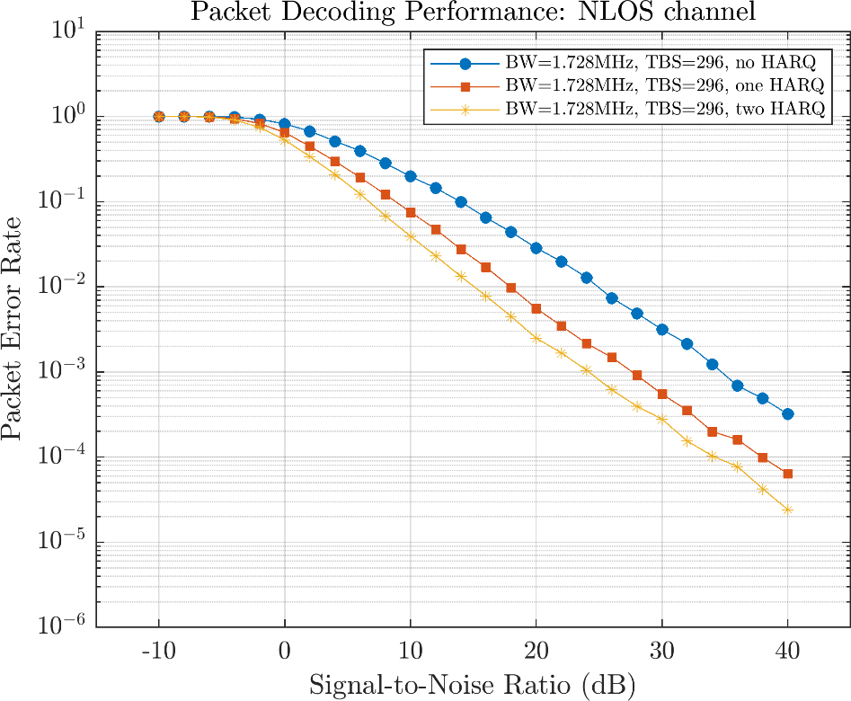

Figure CD-A.6

Packet Error Rate (PER) over SNR for 1 TX, 1 RX antennas and different HARQ settings  
in LOS urban micro channel model (D2D)

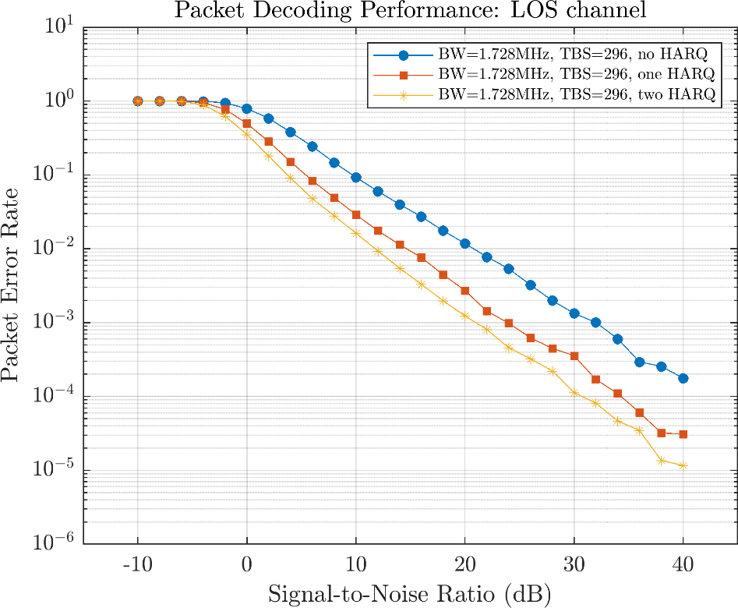

# IV.B mMTC System Level for ISD=1732 m, Contribution B

IV.B.1 Introduction

For supporting mMTC services, the connection density requirement must be met. The minimum connection is defined in Report ITU-R M.2410-0 as follows: *"* *Connection density is the total number of devices fulfilling a specific quality of service (QoS) per unit area (per km2). Connection density should be achieved for a limited bandwidth and number of TRxPs. The target QoS is to support delivery of a message of a certain size within a certain time and with a certain success probability, as specified in Report ITU-R M.2412-0.*

*This requirement is defined for the purpose of evaluation in the mMTC usage scenario. The minimum requirement for connection density is 1 000 000 devices per km2.* *"*

Evaluation methodology for connection density is system simulation approach defined in section 7.1.3 of ITU-R M.2412-0

The section 7.1.3 defines that evaluation can be done either by

– non-full buffer system simulation;

– full buffer system simulations followed by link level simulation.

For non-full buffer system simulations following method is defined:

*"The following steps are used to evaluate the connection density based on non-full buffer system-level simulation. Traffic model used in this method is defined in Table 8-2 in § 8.4 of this Report.*

*– Step 1: Set system user number per TRxP as N.*

*– Step 2: Generate the user packet according to the traffic model.*

*– Step 3: Run non-full buffer system-level simulation to obtain the packet outage rate. The outage rate is defined as the ratio of the number of packets that failed to be delivered to the destination receiver within a transmission delay of less than or equal to 10 s to the total number of packets generated in Step 2.*

*– Step 4: Change the value of N and repeat Step 2-3 to obtain the system user number per TRxP N’ satisfying the packet outage rate of 1%.*

*– Step* 5: Calculate connection density by equation C = N’ / A, where the TRxP area A is calculated as A = ISD2 × sqrt(3)/6, and ISD is the inter-site distance.

*The requirement is fulfilled if the connection density C is greater than or equal to the connection density requirement defined in Report ITU-R M.2410-0.*

*The simulation bandwidth used to fulfill the requirement should be reported. Additionally, it is encouraged to report the connection efficiency (measured as N’ divided by simulation bandwidth) for the achieved connection density."*

The traffic model is for step is given in Table 5 d) of Report ITU-R M.2412-0 as "*With layer 2 PDU (Protocol Data Unit) message size of 32 bytes:*

*1 message/day/device* ***or*** *1 message/2 hours/device Packet arrival follows Poisson arrival process for non-full buffer system-level simulation*". Additional higher traffic loads are encouraged.

Thus, the minimum requirement for connection density is capability to support is 1 000 000 devices per km2 where each device transmits 1 message/day with message size of 32 bytes and 1% outage ratio.

In this contribution, we provide a mMTC connection density system evaluation based on the above definitions and guidelines. System level results are provided based on system definitions given in ETSI TS 103 636-1 to -4.

# IV.B.2. System level simulations for ISD 1732m

## IV.B.2.1 Simulation Configurations

The evaluation was performed by using non-full buffer system simulations with basic parameters as given in Table CD-B.1.

Table CD-B.1

System level configurations for Urban Macro-mMTC simulations

|  |  |  |
| --- | --- | --- |
| Parameter | Value used in simulation | Comment |
| Carrier frequency for evaluation | 700 MHz | According configuration B  of the Table 5 d) in Report ITU-R M.2412 |
| BS antenna height | 25 m | According configuration B  of the Table 5 d) in Report ITU-R M.2412 |
| Total transmit power per TRxP | 23 dBm per 1.728MHz channels.  6 channels: 30.8 dBm for 10.5 MHz  9 channels: 32.5 dBm for 15.5 MHz | Maximum:  49 dBm for 20 MHz bandwidth or  46 dBm for 10 MHz bandwidth  Table 5 d) in Report ITU-R M.2412 |
| UE power class | 23 dBm | According configuration B  of the Table 5 d) in Report ITU-R M.2412 |
| Percentage of high loss and low loss building type | Not differentiated  20 dB building penetration loss for all indoor-outdoor links. | According TABLE A1-7 Table 5 d) in Report ITU-R M.2412. |
| Inter-site distance | 1732 m | According configuration B  of the Table 5 d) in Report ITU-R M.2412 |
| Number of antenna elements per TRxP | 1 Tx/Rx (Omni) | Up to 64 Tx/Rx, Allowed in Table 5 d) in Report ITU-R M.2412 |
| Number of UE antenna elements | 1 Tx/Rx (Omni) | Up to 2 Tx/Rx, allowed in Table 5 d) in Report ITU-R M.2412 |
| Device deployment | 80% indoor, 20% outdoor  based on random and uniform distribution in buildings and outdoors | According configuration B  of the Table 5 d) in Report ITU-R M.2412. See Figure CD-B.1 and table CD-B.2. |
| UE mobility model | Fixed. Mobility taken into account in link simulations performance values. | According configuration B  of the Table 5 d) in Report ITU-R M.2412 |
| UE speeds of interest | 3 km/h for indoor and outdoor, taken into account in link simulations performance values. | According configuration B  of the Table 5 d) in Report ITU-R M.2412 |
| Inter-site interference modelling | Explicitly modelled in the simulation area. | Simulation area limited compared network layout defined in section 8.3.4 of Report ITU-R M.2412. See discussion below. |
| BS noise figure | 5 dB | According configuration B  of the Table 5 d) in Report ITU-R M.2412 |
| UE noise figure | 7 dB | According configuration B  of the Table 5 d) in Report ITU-R M.2412 |
| BS antenna element gain | 0 dBi | 8 dBi allowed in Table 5 d) in Report ITU-R M.2412 |
| UE antenna element gain | 0 dBi | According configuration B  of the Table 5 d) in Report ITU-R M.2412 |
| Thermal noise level | ‒174 dBm/Hz | According configuration B  of the Table 5 d) in Report ITU-R M.2412 |

Based on Table CD-B.1, the simulations followed configuration B of the Table 5 d) in Report ITU-R M.2412 employing an inter-site distance of 1732 meters.

Instead of sectorised antenna configurations in TRxP only single omni antennas were used as shown in Figure CD-B.1. The simulation area was divided to single floor buildings and streets so that 80 percent of the simulation area was covered by buildings and 20 of the area was streets as depicted in Figure CD-B.1 (light green illustrates street).

Figure CD-B.1

Simulation environment



Due to the simulation complexity introduced by a high number of devices, the simulation was limited to single site. This limits the modelling of inter cell interference caused from other sites. In this case the interference is estimated to be related to the overlapping cells, as the interference from transmissions occurring far away has negligible impact, as well as the number of interfered transmissions. If cells would be 100% overlapping the interference would be the same as intra cell interference and would mean doubling the message rate, which is also present in Table CD-B.3.

However, as simulation uses only 21% (10.37 MHz) or 31% (15.5 MHz) of the overall allowed system spectrum (50 MHz), the system could be arranged as shown in Figure CD-B.2, where green cells indicate the simulated area and neighbouring sites would use different 6 or 9 channels. This would result that total system bandwidth is 31 MHz or 46.6 MHz, which is less than the total allowed system simulation bandwidth of 50 MHz.

This setup would not necessarily be the most optimum system deployment from the system capacity point of view but from the evaluation point of view, it explains why modelling of inter cell interference is not necessary and the presented simulation results can be considered valid for this setup and connection density evaluation conclusion can be driven from those.

Figure CD-B.2

Possible frequency re-use scheme to limit inter cell interference



Table CD-B.2

Additional System level simulation parameters

| Parameter | Value used in simulation | Comment |
| --- | --- | --- |
| Simulation area | 2.60 km2 | 3 sectors with ISD of 1732 m.  Area: *A = ISD2 × sqrt(3)/6* |
| Device density | 1 000 000 per km2 | 2.6 million devices in simulation |
| Traffic pattern | Poisson arrival process with increased packet arrival time from 1 message/2 hours/device onwards. | Traffic load of 1 message per day was not simulated |
| Simulation bandwidth | Two scenarios simulated:  a) 6 channels: 10.37 MHz  b) 9 channels: 15.5 MHz | Up to 50 MHz allowed, in configuration B of the Table 5 d) in Report ITU-R M.2412 |
| Number of channels in TRxP | Two scenarios simulated,  a) 6 channels: 10.37 MHz  b) 9 channels: 15.5 MHz | All 3 sectors use either 6 or 9 channels. |
| Channels used for device to device communication | In both a) and b) all device to device transmission happens on one of the channels used by TRxP | Device to device and Device to TxRP communication suffers interference from each other. |
| Data transmission scheme | MCS1 (296 bits, 37bytes) | Packet format from ETSI TS 103 636-3: 416.667 µs (10 symbols), SCS of 27kHz |
| Retransmissions scheme | 1 transmission with 2 HARQ re‑transmissions. | Link performance based on link evaluation performance, presented in section IV.A |
| Building dimensions | 127 m x 127 m | Giving 80% of simulation area |
| Building height | 20 m | Sufficiently high buildings but TRxP antennas above buildings. |
| Street width | 15 m | Giving 20% of simulation area |
| Channel model between device and TRxP | UMa A, LOS/NLOS probability from M.2412 [2]. | Path loss from Table A1-3  LOS probability form Table A1-9 |
| Indoor loss between device and TRxP | Based on UMa A,  0.5 x d2d-in dB,  where d2d-in is based on actual location of the device in building. | According section 3.2 Outdoor to indoor (O-to-I) building penetration loss Report ITU-R M.2412 |
| Channel model for device to device communication | Outdoor to outdoor:  UMi A NLOS, from ITU-R M.2412.  Outdoor to indoor:  UMi A NLOS + building penetration loss + indoor loss from UMa A.  Indoor device in different buildings:  UMi A NLOS + 2 x Building penetration loss + separate indoor losses from UMa A  Indoor device in same building:  UMi A NLOS | Device to device communication height of each device is set to 1.5 m.  Some simplification to channel models for indoor modelling to by using UMi A, instead of Indoor channel model. However, UMi A NLOS is more pessimistic than Indoor channel model A in NLOS provided by Report ITU-R M.2412 |

## IV.B.3 Results

Obtained system level simulation results are summarized in Table CD-B.3.

Table CD-B.3

Connection Density non-full buffer system level simulation results for ISD 1732m.

|  |  |  |  |
| --- | --- | --- | --- |
| Scenario | Packet arrival time | Packet outage rate (Note) | Packet outage rate below 1% |
| a) 6 channels: 10.37 MHz | **1 message/2 hours/device** | **0%** | **YES** |
| 2 messages/2 hours/device | 0.009% | YES |
| 3 messages/2 hours/device | 0.28% | YES |
| b) 9 channels: 15.5 MHz | **1 message/2 hours/device** | **0%** | **YES** |
| 2 messages/2 hours/device | 0.0005% | YES |
| 3 messages/2 hours/device | 0.012% | YES |
| 4 messages/2 hours/device | 0.11% | YES |
| 5 messages/1 hours/device | 0.63% | YES |
| Note: Packet outage rate takes into account both packets lost during transmission and packets delayed more than 10 seconds. | | | |

Figure CD-B.1 provides the graphical illustration of the packet outage rate obtained from system simulations. In Figure CD-B.2 the cumulative distribution of the hop count is presented.

Figure CD-B.1

Packet outage rate  
(red horizontal line represents a 1% packet outage limit)

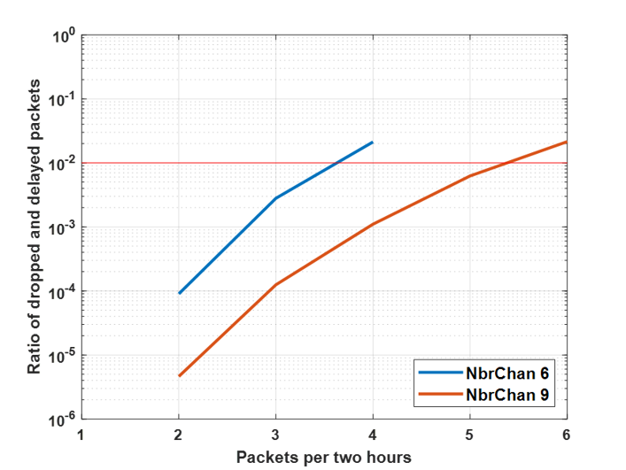

Figure CD-B.2

Cumulative Distribution of number of hops

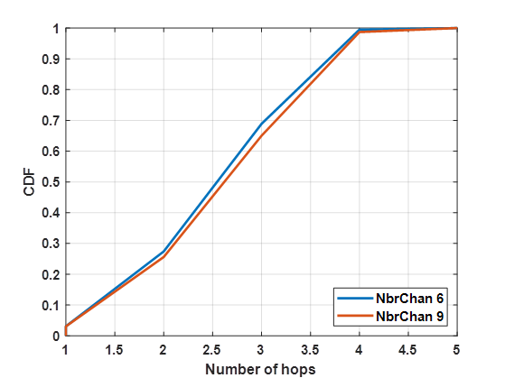

## IV.B.4 Conclusion

Based on the system simulation results obtained, it is concluded that DECT-2020 NR as candidate submission for IMT-2020/17 (Rev 1.), and the corresponding specifications in ETSI TS 103 636-1 to −4, can meet the minimum connection density requirement for mMTC as defined in Report ITU‑R M.2410-0, Section 4.8.

# IV.C mMTC System Level for ISD=500 m, Contribution C

## IV.C.1 Introduction and objectives

The main objective of this contribution is to evaluate the DECT‑2020-NR system in terms of packet outage rate where outages are caused by i) erroneously received packets or ii) late packet arrivals. The maximum allowed **packet** **outage rate is 1 %** and the maximum allowed **packet delay is 10 s** between a source and a sink. The system specifications follow the DECT-2020-NR technical specifications (TS ETSI TS 103 636 -1 to -4) and ITU guidelines and requirements for system simulation modelling in Reports ITU-R M.2410-0 and ITU‑R M.2412-0. The target is to evaluate the network density of up to **one million portable radio devices (RD) per km2** along with a specified number of fixed termination points (FTs). We first introduce our simulation model and related assumptions and parameters. Then we present simulation results and conclusions.

## IV.C.2 Basic assumption

We consider the DECT-2020-NR wireless network conducting uplink transmissions where a portable source RD (aka UE), denoted here as RD-P, is willing to transmit a fixed-length packet of 32 bytes (at Layer 2) to a target fixed termination (FT) point (aka BS) which acts as a message sink. The packet and slot structure follow ETSI TS 103 636-3. The FT may be reached directly or via multiple hops through a selected number of routers which are denoted as RD-F (forwarder). Also, RD-F nodes generate their own packets in addition to the routing packets. The communicating RDs are randomly placed into a network area of interest with a fixed hexagonal grid of FTs having a selected inter-site distance (ISD). Each FT coordinates three sectors. RDs are further divided into clusters which are coordinated by RD-F nodes. Clusters and sectors may have different channels or antenna directions to mitigate interference. RD-F routers are randomly selected from all RDs so that the proportion of RD-Fs out of all RDs is ***ε*** % which is one of the key system parameters of DECT‑2020-NR. It is emphasised that RD-F deployment depends on target application random realization and is neither specified by the standard nor a system design parameter. In practice, any device can act as a RD-F. The link types of one sector are further illustrated in Figure CD-C.1 and different network layouts of interests are presented in Figure CD-C.2.

The communication is divided into association phase and application payload phase. In the association phase, standard-specific beacons are used to find appropriate routes and slot timing for multiple access in each cluster. A simple routing algorithm, which selects the best route that fulfils minimum quality requirements with the smallest number of hops, is applied. The multiple access is performed via the standard listen-before-talk (LBT) method, as specified in ETSI TS 103 636-4. In the application payload phase, application packets are transmitted using a selected modulation and coding scheme (MCS) and hybrid automatic repeat request (HARQ) from ETSI TS 103 636-3 and ETSI TS 103 636-4 and, finally, the resulted packet outage rate is measured over a given spatial area.

Figure CD-C.1

A simplified illustration of different DECT-2020-NR network node roles and link types within a single FT sector. The actual simulated number of RDs within a single FT sector is 72 169 which results in the density  
of 1 million nodes per km2 for ISD = 500 m



Figure CD-C.2

Hexagonal grid network layouts for different FT configurations. Each FT coordinates three sectors.

|  |  |  |
| --- | --- | --- |
|  |  |  |
| a) 1 FT; 3 sectors | b) 7 FTs; 21 sectors | b) 19 FTs; 57 sectors |

**IV.C.3 Detailed Assumptions**

The most essential DECT-2020-NR system parameters used in the simulations are presented in Table CD-C.1 The network simulations to evaluate the packet outage rates are performed using NS‑3 simulation software and the link level simulation results (see section IV.A) used with the network simulations are performed utilizing Matlab communication toolboxes.

Table CD-C.1

DECT-2020-NR system assumptions for packet outage rate evaluation

| Parameter | Value | Comments |
| --- | --- | --- |
| Communication direction | Uplink | Some control messages are sent via downlink |
| Channel bandwidth | 1.728 MHz |  |
| Number of channels | 5 | Each channel has bandwidth of 1.728 MHz, so that system bandwidth is 8.64 MHz (maximum allowed bandwidth for ISD = 500m is 10 MHz in Report ITU-R M.2412-0). Three channels are used by FTs; one FT uses separate channels for its three sectors; an RD-F may select from two remaining channels. |
| Traffic model | Poisson | 1 packet/2h/device; non-full buffer model |
| RD deployment | 80% indoor, 20% outdoor | RDs are randomly dropped to the area of interest; two indoor RDs of the same link are considered to locate in the same building if their distance is less than 50 m, otherwise, they locate in different buildings. |
| Number of FTs | 1, 7 and 19 | Depends on the network configuration, outage rate is observed for the FT in the center |
| Number of RDs | 216k, 1.5M and 4M | Depends on the network configuration. |
| Proportion of RD-Fs | 0.1 and 0.5 % | Depends on the network configuration |
| Maximum number of hops | 3 | This value is selected to simplify simulations. A higher value could improve performance in e.g. larger cells. |
| Inter-site distance (ISD) | 500 m |  |
| RX sensitivity | −99.7 dBm |  |
| Transmission power | 23 dBm |  |
| Thermal noise power | −174 dBm/Hz |  |
| Noise figure | 7 dB |  |
| Carrier frequency | 700 MHz |  |
| Layer 2 packet size | 32 bytes | Transport block size is 296 bits |
| Slot length | 417 us |  |
| Routing | Minimum hops | RDs can connect to the target FTs directly or via RD-Fs using multihop links |
| Channel access | Random access, listen before talk | See ETSI TS 103 636-4 |
| Number of random access slots | FT: 9598; RD-F: 46 | Cluster beacon period 4 s. Low power operation for RD‑F |
| Number of antenna elements | RD: 1; FT: 1 |  |
| Maximum antenna gains | RD: 0 dBi; FT: 8 dBi | Report ITU-R M.2412-0 |
| Antenna heights | RD: 1.5 m; FT: 25 m |  |
| Spatial diversity | None |  |
| Path loss model (incl. shadowing) | UMa-B, 3GPP-D2D | UMa-B from Report ITU-R M.2412-0 is used for RD-FT links; 3GPP- D2D from 3GPP TR 36.843 (rel 12) is used for RD-RD links |
| Link fading model | UMa-B, 3GPP-D2D | UMa-B from ITU-R M.2412-0 for RD-FT links; 3GPP‑ D2D from 3GPP TR 36.843 (rel 12) for RD-RD links |
| Subcarrier spacing | 27 kHz |  |
| FFT length | 64 |  |
| Modulation and coding scheme | MCS Index 1 | See ETSI TS 103 636-3 |
| Maximum HARQ retransmissions | 8 | See ETSI TS 103 636-4 |
| Channel estimation | Wiener |  |
| Equalization | Zero forcing |  |
| Time and frequency synchronization | Indirectly via SINR degradation of 0.5 dB | RDs may apply multiple synchronization strategies at link level |
| RD velocity | 3 km/h | Dual mobility model is used for RD-RD links at physical layer. |

## IV.C.4 Results

The summary of simulation results is provided in Table CD-C.2 for different network configurations regarding number of FTs (*N*FT), number of sectors (*N*S), total number of RDs (*N*RD), and for different RD-F proportions out of all RDs (***ε***). Note that although the absolute number of network nodes changes per studied configuration, all configurations satisfy the density requirement of 1M RDs per km2. It is seen that the target maximum packet outage rate of 1% is fulfilled for all simulated network configurations. The missing value (marked with ‘-‘) in the Table CD-C.2 is due to the computing resource limitations; the scenario is too large compared to the available memory in our computing nodes. We tested also the 1 FT case using higher packet rate and higher node density, as shown in Table CD-C.3. In this case, the share of RD-F devices was ε = 0.5%.

Table CD-C.2

Packet outage rates for different   
network configurations (NFT, NS, NRD) and RD-F proportions (ε).

|  |  |  |  |  |  |
| --- | --- | --- | --- | --- | --- |
| Network configuration | | | | Packet Outage Rate | |
| *N*FT | *N*S | *N*RD | *N*RD/km2 | *ε* = 0.1 % | *ε* = 0.5 % |
| 1 | 3 | 216 507 | 1 000 000 | 0.25 % | 0.28 % |
| 7 | 21 | 1 500 000 | 1 000 000 | 0.25 % | 0.22 % |
| 19 | 57 | 4 000 000 | 1 000 000 | 0.29 % | - |

Table CD-C.3

Packet outage rates for higher packet rate and node density.

|  |  |  |  |  |  |
| --- | --- | --- | --- | --- | --- |
| Network configuration | | | | Packet Outage Rate | Notes |
| *N*FT | *N*S | *N*RD | *N*RD/km2 | *ε* = 0.5 % |
| 1 | 3 | 216 507 | 1 000 000 | 0.42 % | Double packet rate, 10x simulation time |
| 1 | 3 | 649 521 | 3 000 000 | 0.34 % | 3 times node density |

System simulations of large scenarios such as mMTC require extensive computing power and memory. Hence, the time that it takes to run the simulations can be a liming factor. Therefore, the results presented in Table CD-C.2 and Table CD-C.3 are based on the simulation time of two hours when considering the time over which RDs are sending their packets to FTs (except the double packet rate result in Table CD-C.3 that considers 10 times longer simulation time). Because of this, we have also studied the effect of simulation time on the packet outage rate (POR) performance. The results were obtained in the 1 FT case and are presented in Figure CD-C.3. The result of the relative simulation time of 1 in the figure is also presented for parameters *N*FT =1 and *ε* =0.5 in Table CD-C.2. Results of Figure CD-C.3 show that the POR starts to increase when the simulation time is increased. This may be explained by having less interference at the beginning of the simulation. Furthermore, the POR is settling down as the simulation time is increased more and more. With 7 FTs, there has been similar behaviour when comparing relative simulation times of 1 and 10. Additional simulations were also run, and these results showed similar trends. We can also see that the POR of the longest simulation time (600 x 2 hours) is almost double compared to that of the shortest simulation time. However, because of the clear saturation effect well below the POR limit in increasing simulation time, we can conclude that the DECT-2020 system fulfills the ITU requirement of 1% POR limit for mMTC scenario even for higher node densities.

Note that although the absolute number of network nodes changes per studied configuration, all configurations satisfy the density requirement of 1M RDs per km2. It is seen that the target maximum packet outage rate of 1% is fulfilled for all presented network configurations.

Figure CD-C.3

Packet Outage Rate (POR) as a function of relative simulation time

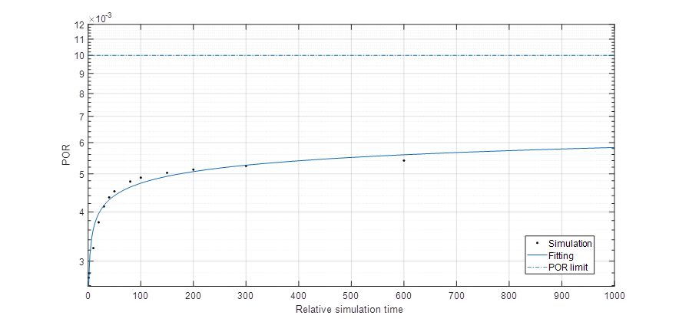

## IV.C.5 Conclusions

The presented simulation results show that DECT-2020 NR fulfils the mMTC user density requirements. Results did not vary significantly when changing the number of FTs, RD-Fs, or RDs.

Results demonstrate also that the system fulfils the requirements with a higher packet rate and node density. In addition, the longer simulation time study shows saturation of POR to a value well below 1%. It is also emphasised that we did not use advanced techniques such as antenna diversity or optimise system parameters extensively that could further improve the system performance.

# IV.D mMTC System Level for ISD=500 m, Contribution D

## IV.D.1 Introduction

For supporting the mMTC service, the connection density should satisfy the following requirement as defined in ITU-R Report M2410-0: *"Connection density is the total number of devices fulfilling a specific quality of service (QoS) per unit area (per km2). Connection density should be achieved for a limited bandwidth and number of TRxPs. The target QoS is to support delivery of a message of a certain size within a certain time and with a certain success probability, as specified in Report ITU‑R M.2412-0. This requirement is defined for the purpose of evaluation in the mMTC usage scenario. The minimum requirement for connection density is 1 000 000 devices per km2.* *"*

For non-full buffer system simulations following method is defined in Report ITU-R M.2412-0:

*"The following steps are used to evaluate the connection density based on non-full buffer system-level simulation. Traffic model used in this method is defined in Table 8-2 in § 8.4 of this Report.*

*Step 1: Set system user number per TRxP as N.*

*Step 2: Generate the user packet according to the traffic model.*

*Step 3: Run non-full buffer system-level simulation to obtain the packet outage rate. The outage rate is defined as the ratio of the number of packets that failed to be delivered to the destination receiver within a transmission delay of less than or equal to 10s to the total number of packets generated in Step 2.*

*Step 4: Change the value of N and repeat Step 2-3 to obtain the system user number per TRxP N’ satisfying the packet outage rate of 1%.*

*Step 5: Calculate connection density by equation C = N’ / A, where the TRxP area A is calculated as A = ISD2 × sqrt(3)/6, and ISD is the inter-site distance.*

*The requirement is fulfilled if the connection density C is greater than or equal to the connection density requirement defined in Report ITU-R M.2410-0.*

*The simulation bandwidth used to fulfill the requirement should be reported. Additionally, it is encouraged to report the connection efficiency (measured as N’ divided by simulation bandwidth) for the achieved connection density."*

The traffic model is for step is given in Table 5 d) in Report ITU-R M.2412-0, as "*With layer 2 PDU (Protocol Data Unit) message size of 32 bytes:*

*1 message/day/device* ***or*** *1 message/2 hours/device Packet arrival follows Poisson arrival process for non-full buffer system-level simulation*".

Additional higher traffic loads are encouraged.

In this contribution, we provide mMTC connection density system evaluation based on the above definitions and guidelines. To evaluate possible limits for DECT-2020 NR technology, we chose density of 1 million devices per square kilometre (i.e., fulfilling the requirement) and increasing the traffic load starting from 1 message/10 hours/device, towards 1 message/2 hours/device, up to 1 message/12 minutes/device.

System level results are provided based on the system definitions given in specifications ETSI TS 103 636-1 to -4.

# IV.D.2 System level simulations for ISD 500m

## IV.D.2.1 Simulation Configurations

Figure CD-D.1

Layout of the environment

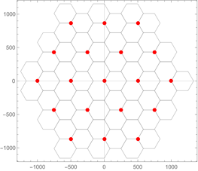

The mMTC simulations are done in the Urban Macro mMTC environment as show in Figure CD‑D.1. The simulation environment consists of 19 sites each with 3 sectors, resulting in a simulation area of 57 sectors as defined in report ITU-R M.2412-0. Results are provided by using a single 1.728 MHz system operating bandwidth resulting that all sites, sectors and Device to Device (D2D) transmission employ the same single channel.

The evaluation was performed by using non-full buffers system simulation with the basic parameters as given in Table CD-D.1.

Table CD-D.1

System level configurations for Urban Macro-mMTC simulations

| Parameters | Rep. ITU-R M.2412-0, Table 5) Urban Macro-mMTC test, Configuration A.  Used for evaluation results | Comments |
| --- | --- | --- |
| **Baseline evaluation configuration parameters** | | |
| System Architecture | 19 gateway sites, each gateway site has 3 sinks – RD_FTs, which is a single TRxP.  Device (RD) can connect to others RD to find router to RD_FT i.e. Sink | Selecting RD_FT or other RD for association is according ETSI TS 103 636-4 |
| UE density | 1 000 000 device/per/km2. |  |
| Simulation bandwidth | 1.728 MHz | Up to 10 MHz allowed in Report M.2412-0 |
| Carrier frequency for evaluation | 700MHz |  |
| Channel model | UMa: TRxP to RD. UMi street canyon: RD to RD (O2O and O2I) based on 3GPP TR38.901  InH mixed office: RD to RD (I2I) based on 3GPP TR 38.901 | Model A as defined report M.2412-0. except for the D2D connections as those are not specified in Report M.2412-0. |
| BS antenna height | 25m |  |
| Total Tx Power per TRxP in BS/sink | 23 dBm |  |
| UE/node power class | 23 dBm |  |
| **Additional parameters for system-level simulation** | | |
| Inter-site distance (sink distance) | 500m |  |
| UE antenna height | 1.5m |  |
| Number of antenna elements (BS/sink) | 2 | Up to 64 Tx/Rx, Allowed in Table 5d) of M.2412-0 |
| UE antennas | 2 | Up to 2 Tx/Rx, allowed in Table 5d) of M.2412-0 |
| Percentage of high loss and low loss building type | 20% high loss, 80% low loss | Not differentiated as for <6GHz  20 dB building penetration loss for all indoor-outdoor links. |
| Device deployment | 80% indoor, 20% outdoor | Buildings are not modeled explicitly; a random coinflip for each RD is done for indoor and outdoor placement.  For two indoor D2D links:  d<25m → I2I, (same building)  d>25m → I2O2I (different buildings) |
| UE mobility model | Fixed. Mobility is taken into account in link simulations performance values in Annex 1, IV.A. |  |
| UE speeds of interest | 3 km/h for indoor and outdoor, taken into account in link simulations performance values in Annex 1, IV.A. |  |
| Inter-site interference modeling | Explicitly modeled. |  |
| BS noise figure | 5 dB |  |
| UE noise figure | 7 dB |  |
| BS/sink antenna element gain | 0 dBi | 0 dBi as omni antennas are used |
| UE antenna element gain | 0 dBi |  |
| Thermal noise level | ‒174 dBm/Hz |  |
| Traffic model | With layer 2 PDU (Protocol Data Unit) message size of 32 bytes:  1 message/day/device  or  1 message/2 hours/device  Packet arrival follows Poisson arrival process defined in Report ITU-R M.2412-0 | Simulation results provide from 1 message/10 hours/device, passing 1 message/2 hours/device, up to 1 message/12 minutes/device. |
| Physical layer packet size | Single 32 byte packet mapped to physical layer packet modulated according MCS1 (QPSK ½ ), that can carry 296 bits of payload in a slot (0.416ms). | Simulated as single slot transmission of using MCS1 |
| Retransmissions scheme | 1 transmission with 2 HARQ re‑transmissions. | Link performance based on link evaluation performance presented in section IV.A |
| Transmission of ack | Explicitly simulated as single subslot (half slot) length of 0.208ms transmission of using MCS1 |  |

## IV.D.3 Results

Obtained system level simulation results are summarized in Table CD-D.2 with different packet arrival rates and conclusions.

Table CD-D.2

Connection Density non-full buffer system level simulation results for ISD 500m

|  |  |  |  |
| --- | --- | --- | --- |
| Scenario | Packet arrival time | Packet outage rate (Note) | Packet outage rate  below 1% |
| 1 channel: 1.728 MHz | 1 message/9 hours/device | 0.001 % | YES |
| **1 message/2 hours/device** | **0.024 %** | **YES** |
| 1 message/1 hours/device | 0.123 % | YES |
| 5 message/1 hours/device | 10.54 % | NO |
| Note: Packet outage rate takes into account both packets lost during transmission and packets delayed more than 10 seconds. | | | |

Figure CD-D.2 provides a graphical illustration of simulated packet outage rate in function of traffic rate. From the results, it is confirmed that a system using a single 1.728 MHz channel, which is 17% of the total allowed system bandwidth, can support roughly 3 message/1 hours/device traffic rate with a packet outage rate of 1%. This result, 1 message/20 minutes /device is in line with self‑evaluation results, 1 message/17.4 minutes/device, reported in IMT-2020/17 (Rev. 1).

Figure CD-D.2

Packet Outage Rate as function of traffic rate.

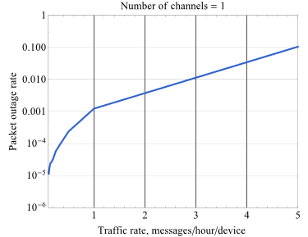

## IV.D.4 Conclusion

Based on system simulation results obtained, it is concluded that DECT-2020 NR as candidate submission for IMT-2020/17 (Rev. 1), and corresponding specifications in ETSI TS 103 636-1 to −4, can meet the minimum connection density requirement for mMTC as defined in ITU-R M.2410-0, Section 4.8.

______________