|  |  |
| --- | --- |
| **Radiocommunication Study Groups** |  |
|  |  |
|  |  |
| Received: 29 May 2021 | **Document 5D/652-E** |
| **1 June 2021** |
| **English only** |
|  | **TECHNOLOGY ASPECTS** |
| Director, Radiocommunication Bureau[1] | |
| FINAL EVALUATION REPORT ON THE SUBMISSION IMT-2020/18(Rev.1) based on EUHT RIT | |
|  | |

# 1 Introduction

This document describes the evaluation results identified for IMT-2020 candidate technology submissions IMT-2020/18(Rev.1) based on Enhanced Ultra High Throughput (EUHT) RIT from [Beijing National Research Center for Information Science and Technology Evaluation Group (Bnrist EG)](https://www.itu.int/oth/R0A0600009B/en).

In the 35th WP 5D E-meeting, the two IMT-2020 candidate technology submissions from ETSI (TC DECT) and DECT forum (IMT-2020/17(Rev.1)) and Nufront (IMT-2020/18(Rev.1)) were agreed to rewind to Step 4 and the subsequent Steps 5-8 of the current IMT-2020 process extension. Bnrist EG re-engaged the renewed Step 4 evaluation and prepared this evaluation report for submission IMT‑2020/18(Rev.1).

# 2 Administrative aspects of the Independent Evaluation Group

## 2.1 Introduction

The members in Bnrist EG who participate in the evaluation activities are as follows:

– Tsinghua University

– Beijing University of Posts and Telecommunications (BUPT).

## 2.2 Contact details

Zhang Xiujun  
[zhangxiujun@tsinghua.edu.cn](mailto:zhangxiujun@tsinghua.edu.cn)

Zhang Xin  
[zhangxin@bupt.edu.cn](mailto:zhangxin@bupt.edu.cn)

# 3 Evaluation summaries

## 3.1 Use of Information in Report ITU-R M.2412

A) What candidate technologies or portions of the candidate technologies this IEG is or might anticipate evaluating?

This contribution is the evaluation report on the submission in Document IMT-2020/18 (REV.1) which is based on EUHT RIT.

B) Confirmation of utilization of the ITU-R evaluation guidelines in Report ITU‑R M.2412;

Bnrist EG confirms that the evaluation reported in this contribution is performed in accord with Report ITU‑R M.2412. The evaluation methodologies and configurations used for each minimum requirement are chosen according to Report ITU-R M.2412.

C) Verification as per Report ITU-R M.2411 of the compliance templates and the self-evaluation for each candidate technology as indicated in A).

Bnrist EG identifies that the technology submissions in Document IMT-2020/18 (REV.1) include complete compliance templates for service, spectrum and technical performance as specified in Report ITU-R M.2411. In addition, Bnrist EG identifies that the technology submission also includes material for independent evaluation.

## 3.2 Provision of Compliance Templates

Provision of compliance template for services (Section 5.2.4.1 of Report ITU-R M.2411)

|  |  |  |
| --- | --- | --- |
|  | Service capability requirements | Evaluator’s comments |
| **5.2.4.1.1** | **Support for wide range of services**  Is the proposal able to support a range of services across different usage scenarios (eMBB, URLLC, and mMTC)?:🗹 YES / NO  Specify which usage scenarios (eMBB, URLLC, and mMTC) the candidate RIT or candidate SRIT can support.(1) | The candidate EUHT RIT can support the usage scenario of eMBB, URLLC and mMTC with the results in this evaluation report. |
| (1) Refer to the process requirements in IMT-2020/2. | | |

Provision of compliance template for spectrum (Section 5.2.4.2 of Report ITU-R M.2411)

|  |  |
| --- | --- |
|  | Spectrum capability requirements |
| **5.2.4.2.1** | **Frequency bands identified for IMT**  Is the proposal able to utilize at least one frequency band identified for IMT in the ITU Radio Regulations?: 🗹 YES / NO  Specify in which band(s) the candidate RIT or candidate SRIT can be deployed.  The following frequency bands can be supported, in accordance with spectrum requirements defined by Report ITU-R M.2411-0.   |  |  | | --- | --- | | **Uplink (UL) and Downlink (DL)operating band** | **Duplex Mode** | | 450 - 470 MHz | TDD | | 470 - 698 MHz | TDD | | 694/698 - 960 MHz | TDD | | 1427 - 1518 MHz | TDD | | 1710 - 2025 MHz | TDD | | 2110 - 2200 MHz | TDD | | 2300 - 2400 MHz | TDD | | 2500 - 2690 MHz | TDD | | 3300 - 3400 MHz | TDD | | 3400 - 3600 MHz | TDD | | 3600 - 3700 MHz | TDD | | 4800 - 4990 MHz | TDD | |
| **5.2.4.2.2** | **Higher Frequency range/band(s)**  Is the proposal able to utilize the higher frequency range/band(s) above 24.25 GHz?: 🗹YES / NO  Specify in which band(s) the candidate RIT or candidate SRIT can be deployed.  NOTE 1 – In the case of the candidate SRIT, at least one of the component RITs need to fulfil this requirement.   |  |  | | --- | --- | | **Uplink (UL) and Downlink (DL) operating band** | **Duplex Mode** | | 26500 MHz – 29500 MHz | TDD | | 24250 MHz – 27500 MHz | TDD | | 37000 MHz – 40000 MHz | TDD | | 27500 MHz – 28350 MHz | TDD | |

Provision of compliance template for technical performance (Section 5.2.4.3 of Report ITU-R M.2411)

| Minimum technical performance requirements item (5.2.4.3.x), units, and Report ITU-R M.2410-0 section reference(1) | Category | | | Required value | Value(2) | Requirement met? | Comments (3) |
| --- | --- | --- | --- | --- | --- | --- | --- |
| Usage scenario | Test environment | Downlink or uplink |  |  |  |  |
| **5.2.4.3.1** Peak data rate (Gbit/s) *(4.1)* | eMBB | Not applicable | Downlink | 20 | 26.39~206.26 | 🗹 Yes  No | Refer to A-3 |
| Uplink | 10 | 10.38~85.54 | 🗹 Yes  No |
| **5.2.4.3.2** Peak spectral efficiency (bit/s/Hz) *(4.2)* | eMBB | Not applicable | Downlink | 30 | 30.59~52.64 | 🗹 Yes  No | Refer to A-2 |
| Uplink | 15 | 18.89~52.95 | 🗹 Yes  No |
| **5.2.4.3.3** User experienced data rate (Mbit/s) *(4.3)* | eMBB | Dense Urban – eMBB | Downlink | 100 | 107~117 | 🗹 Yes  No | Refer to A-5 |
| Uplink | 50 | 52~54 | 🗹 Yes  No |
| **5.2.4.3.4** 5th percentile user spectral efficiency (bit/s/Hz) *(4.4)* | eMBB | Indoor Hotspot – eMBB | Downlink | 0.3 | 0.47 | 🗹 Yes  No | Refer to A-4 |
| Uplink | 0.21 | 0.35~0.41 | 🗹 Yes  No |
| eMBB | Dense Urban – eMBB | Downlink | 0.225 | 0.40~0.44 | 🗹 Yes  No |
| Uplink | 0.15 | 0.26~0.27 | 🗹 Yes  No |
| eMBB | Rural – eMBB | Downlink | 0.12 | 0.37~0.38  (cfg. B) | 🗹 Yes  No |
| 0.14~0.15  (cfg. C) |
| Uplink | 0.045 | 0.10 ~0.12  (cfg. B) | 🗹 Yes  No |
| 0.06~0.08  (cfg. C) |
| **5.2.4.3.5** Average spectral efficiency (bit/s/Hz/ TRxP) *(4.5)* | eMBB | Indoor Hotspot – eMBB | Downlink | 9 | 10.96~11.22 | 🗹 Yes  No | Refer to A-4 |
| Uplink | 6.75 | 8.11~8.45 | 🗹 Yes  No |
| eMBB | Dense Urban – eMBB | Downlink | 7.8 | 9.11~ 9.27 | 🗹 Yes  No |
| Uplink | 5.4 | 8.00~8.12 | 🗹 Yes  No |
| eMBB | Rural – eMBB | Downlink | 3.3 | 8.34~8.78  (cfg. B) | 🗹 Yes  No |
| 4.67~4.92  (cfg. C) |
| Uplink | 1.6 | 5.39~5.65  (cfg. B) | 🗹 Yes  No |
| 4.72~4.90  (cfg. C) |
| **5.2.4.3.6** Area traffic capacity (Mbit/s/m2) *(4.6)* | eMBB | Indoor-Hotspot – eMBB | Downlink | 10 | 10.23~10.47 | 🗹 Yes  No | Refer to A-6 |
| **5.2.4.3.7** User plane latency (ms) *(4.7.1)* | eMBB | Not applicable | Downlink | 4 | 0.65~2.70 | 🗹 Yes  No | Refer to A-8 |
| Uplink | 4 | 0.57~2.62 | 🗹 Yes  No |
| URLLC | Not applicable | Downlink | 1 | 0.53~0.62 | 🗹 Yes  No |
| Uplink | 1 | 0.33~0.43 | 🗹 Yes  No |
| **5.2.4.3.8** Control plane latency (ms) *(4.7.2)* | eMBB | Not applicable | Not applicable | 20 | 4~8 | 🗹 Yes  No |
| URLLC | Not applicable | Not applicable | 20 | 4~8 | 🗹 Yes  No |
| **5.2.4.3.9** Connection density (devices/km2) *(4.8)* | mMTC | Urban Macro – mMTC | Uplink | 1 000 000 | 151 478 330 ~ 155 328 528  / 625kHz | 🗹 Yes  No | Refer to  A-12 |
| **5.2.4.3.10** Energy efficiency *(4.9)* | eMBB | Not applicable | Not applicable | Capability to support a high sleep ratio and long sleep duration | Network Side:  Sleep ratio: 80%~99.9%  Sleep duration: 8ms~999ms | 🗹 Yes  No | Refer to A-9 |
| Device Side:  Sleep ratio: 80%~99.9%  Sleep duration: 8ms~999ms | 🗹 Yes  No |
| **5.2.4.3.11** Reliability *(4.10)* | URLLC | Urban Macro –URLLC | Uplink or Downlink | 1-10−5 success probability of transmitting a layer 2 PDU (protocol data unit) of size 32 bytes within 1 ms in channel quality of coverage edge | >99.9999% | 🗹 Yes  No | Refer to  A-11 |
| **5.2.4.3.12** Mobility classes *(4.11)* | eMBB | Indoor Hotspot – eMBB | Uplink | Stationary, Pedestrian | Stationary, Pedestrian  up to 10 km/h | 🗹 Yes  No | Refer to A-7 |
| eMBB | Dense Urban – eMBB | Uplink | Stationary, Pedestrian,  Vehicular (up to 30 km/h) | Stationary, Pedestrian,  Vehicular  up to 30 km/h | 🗹 Yes  No |
| eMBB | Rural – eMBB | Uplink | Pedestrian, Vehicular, High speed vehicular | Pedestrian, Vehicular, High speed vehicular  up to 500 km/h | 🗹 Yes  No |
| **5.2.4.3.13**  Mobility Traffic channel link data rates (bit/s/Hz) *(4.11)* | eMBB | Indoor Hotspot – eMBB | Uplink | 1.5 (10 km/h) | 5.35~5.47 | 🗹 Yes  No | Refer to A-7 |
| eMBB | Dense Urban – eMBB | Uplink | 1.12 (30 km/h) | 2.16~2.20 | 🗹 Yes  No |
| eMBB | Rural – eMBB | Uplink | 0.8 (120 km/h) | 3.01~3.08 (cfg. A)  1.51~1.55(cfg. B) | 🗹 Yes  No |
| 0.45 (500 km/h) | 2.52~2.57(cfg. A)  0.99~1.01 (cfg. B) | 🗹 Yes  No |
| **5.2.4.3.14** Mobility interruption time (ms)  *(4.12)* | eMBB and URLLC | Not applicable | Not applicable | 0 | 0 | 🗹 Yes  No | Refer to  A-10 |
| **5.2.4.3.15** Bandwidth and Scalability *(4.13)* | Not applicable | Not applicable | Not applicable | At least 100 MHz | At least 800MHz | 🗹 Yes  No | Refer to  A-13 |
| Up to 1 GHz | Up to 6.4GHz | 🗹 Yes  No |
| Support of multiple different bandwidth values(4) | 4~11 supported bandwidth, 5, 10, 15, 20, 25, 30, 40, 50, 60, 80, 100MHz for Sub-6GHz bands and 50, 100, 200, 400MHz for mmWave bands | 🗹 Yes  No |
| (1) As defined in Report ITU-R M.2410-0.  (2) According to the evaluation methodology specified in Report ITU-R M.2412-0.  (3) Proponents should report their selected evaluation methodology of the Connection density, the channel model variant used, and evaluation configuration(s) with their exact values (e.g. antenna element number, bandwidth, etc.) per test environment, and could provide other relevant information as well. For details, refer to Report ITU-R M.2412-0, in particular, § 7.1.3 for the evaluation methodologies, § 8.4 for the evaluation configurations per each test environment, and Annex 1 on the channel model variants.  (4) Refer to § 7.3.1 of Report ITU-R M.2412-0. | | | | | | | |

## 3.3 Summary of the Evaluation Report

Which test environments have been considered in the Evaluation Report? What is outcome of the evaluation?

|  |  |
| --- | --- |
| Test environment | Does the Evaluation Report indicate that the minimum technical performance requirements are met in the test environment? |
| 🗹 Indoor Hotspot-eMBB | 🗹 Yes 🞎No 🞎 Partial evaluation |
| 🗹 Dense Urban-eMBB | 🗹 Yes 🞎No 🞎 Partial evaluation |
| 🗹 Rural-eMBB | 🗹 Yes 🞎No 🞎 Partial evaluation |
| 🗹 Urban Macro–mMTC | 🗹 Yes 🞎No 🞎 Partial evaluation |
| 🗹 Urban Macro–URLLC | 🗹 Yes 🞎No 🞎 Partial evaluation |

## 3.4 Additional Evaluation Methodologies and Assumptions

Have any additional evaluation methodologies or assumptions that had not been included in the Report ITU-R M.2412-0 been used in evaluation?

🞎 Yes 🗹No

# 4 Conclusion

According to methods specified in ITU-R documents, Bnrist EG completed evaluations on the submissions in Docs. IMT-2020/18 (REV.1) (i.e. “EUHT RIT”) and provides assessment and evaluation results.

Bnrist EG identify that for the evaluated submission in Docs. IMT-2020/18 (REV.1) EUHT RIT meets the minimum requirements in all five required test environments.

Annex A

Evaluation Results

## A-1 Introduction

This section contains the evaluation results for EUHT, which are reviewed and harmonized by Bnrist EG and used to summarize the evaluation results for quantitative assessment. All the evaluation results are derived by following the IMT‑2020 evaluation methodology. Table A-1-1 shows the different sources of the evaluation results correspond to contributors from the different affiliations.

Table A-1-1

Sources of the evaluation results

|  |  |
| --- | --- |
| Source 1 | BUPT |
| Source 2 | Tsinghua University |

## A-2 Results of Peak Spectral Efficiency for eMBB Test Environments

Based on the evaluation methodology in Annex B-1, the evaluation results of peak spectral efficiency for EUHT are presented in Table A-2-1 and Table A-2-2.

A range of configurations are considered in the evaluation of downlink/uplink peak spectral efficiency. 8-layer downlink/uplink transmission for Sub-6GHz bands and 6-layer/4-layer downlink/uplink transmission for mmWave bands, with up to 1024QAM modulation is considered. Different ratio of DL and UL to whole frame length (, ) configurations are evaluated. The evaluation results for EUHT fulfill the ITU Requirement.

Table A-2-1

Peak spectral efficiency for sub-6GHz bands

|  |  |  |  |  |  |  |  |  |
| --- | --- | --- | --- | --- | --- | --- | --- | --- |
| DL or UL Ratio | | =0.5,=0.5 | | | =0.8,=0.2 | | | ITU Requirement |
| Frame length ρ [ms] | | 1 | 2 | 4 | 1 | 2 | 4 |
| DL | 256QAM | 34.72 | 39.08 | 41.24 | 38.03 | 40.76 | 42.11 | 30 |
| 1024QAM | 43.4 | 48.84 | 51.55 | 47.54 | 50.94 | 52.64 |
| UL | 256QAM | 39.57 | 41.41 | 42.36 | 33.6 | 38.07 | 40.55 | 15 |
| 1024QAM | 49.47 | 51.76 | 52.95 | 42.0 | 47.59 | 50.68 |

Table A-2-2. Peak spectral efficiency for mmWave bands

|  |  |  |  |  |  |  |  |  |
| --- | --- | --- | --- | --- | --- | --- | --- | --- |
| DL or UL Ratio | | =0.5,=0.5 | | | =0.8,=0.2 | | | ITU Requirement |
| Frame length ρ [ms] | | 10 | 20 | 30 | 10 | 20 | 30 |
| DL | 256QAM | 30.59 | 31.62 | 31.96 | 31.37 | 32.01 | 32.23 | 30 |
| 1024QAM | 38.25 | 39.53 | 39.96 | 39.22 | 40.02 | 40.28 |
| UL | 256QAM | 20.62 | 21.19 | 21.38 | 18.89 | 20.32 | 20.8 | 15 |
| 1024QAM | 25.78 | 26.49 | 26.73 | 23.61 | 25.4 | 26.0 |

## A-3 Results of Peak Data Rate for eMBB Test Environments

Based on the evaluation methodology in Annex B-1 and the evaluation results of peak spectral efficiency in Annex A-2, the evaluation results of peak data rate for EUHT are presented in Table A-3-1 and Table A-3-2.

A range of configurations are considered in the evaluation of downlink/uplink peak data rate. Different ratio of DL and UL to whole frame length (,) configurations are evaluated. Different component carrier (CC) bandwidth are considered. 256/1024 QAM and 4ms frame length are considered for sub-6GHz bands. 256/1024 QAM and 30ms frame length are considered for mmWave bands. It is observed that the evaluation results fulfill the ITU Requirement.

Table A-3-1

EUHT peak data rate for Sub-6GHz bands

|  |  |  |  |  |  |  |  |
| --- | --- | --- | --- | --- | --- | --- | --- |
| DL/UL | DL or UL Ratio | Modulation order | Per CC BW [MHz] | Peak data rate per CC [Gbit/s] | Aggregated peak data rate over 16 CCs [Gbit/s] | Required DL bandwidth to meet the requirement [MHz]1 | ITU Requirement  [Gbit/s] |
| DL | =0.5 | 256QAM | 80 | 1.65 | 26.39 | 971 | 20 |
| 100 | 2.06 | 32.99 | 971 |
| 1024QAM | 80 | 2.06 | 32.99 | 777 |
| 100 | 2.58 | 41.24 | 777 |
| =0.8 | 256QAM | 80 | 2.7 | 43.12 | 594 |
| 100 | 3.37 | 53.9 | 594 |
| 1024QAM | 80 | 3.37 | 53.9 | 475 |
| 100 | 4.21 | 67.38 | 475 |
| UL | =0.5 | 256QAM | 80 | 1.69 | 27.11 | 473 | 10 |
| 100 | 2.12 | 33.89 | 473 |
| 1024QAM | 80 | 2.12 | 33.89 | 378 |
| 100 | 2.65 | 42.36 | 378 |
| =0.2 | 256QAM | 80 | 0.65 | 10.38 | 1234 |
| 100 | 0.81 | 12.98 | 1234 |
| 1024QAM | 80 | 0.81 | 12.98 | 987 |
| 100 | 1.01 | 16.22 | 987 |
| NOTE 1: The value only indicates the required bandwidth to meet the DL peak data rate. It is not necessarily supported as EUHT Transmission bandwidth. | | | | | | | |

Table A-3-2

EUHT peak data rate for mmWave bands

|  |  |  |  |  |  |  |  |
| --- | --- | --- | --- | --- | --- | --- | --- |
| DL/UL | or | Modulation order | Per CC BW [MHz] | Peak data rate per CC [Gbit/s] | Aggregated peak data rate over 16 CCs [Gbit/s] | Required DL bandwidth to meet the requirement [MHz]1 | ITU Requirement  [Gbit/s] |
| DL | =0.5 | 256QAM | 400 | 6.39 | 102.29 | 1252 | 20 |
| 1024QAM | 400 | 7.99 | 127.86 | 1002 |
| =0.8 | 256QAM | 400 | 10.31 | 165.01 | 776 |
| 1024QAM | 400 | 12.89 | 206.26 | 621 |
| UL | =0.5 | 256QAM | 400 | 4.28 | 68.43 | 936 | 10 |
| 1024QAM | 400 | 5.35 | 85.54 | 749 |
| =0.2 | 256QAM | 400 | 1.66 | 26.62 | 2405 |
| 1024QAM | 400 | 2.08 | 33.27 | 1924 |
| NOTE 1: The value only indicates the required bandwidth to meet the DL peak data rate. It is not necessarily supported as EUHT Transmission bandwidth. | | | | | | | |

## A-4 Results of average spectral efficiency and 5th percentile user spectral efficiency for eMBB test environments

Based on the configurations and assumptions in Annex B-7, the evaluation results of average spectral efficiency and 5th percentile user spectral efficiency for eMBB test environments are presented in Table A-4-1. It is observed that ITU Requirement is fulfilled by EUHT.

Table A-4-1

Evaluation result of average spectral efficiency and 5th percentile user spectral efficiency for EUHT

| Test environments and evaluation configuration |  | Category | BUPT | Tsinghua | Result | ITU Requirement |
| --- | --- | --- | --- | --- | --- | --- |
| Indoor Hotspot  (Configuration A) | Average [bit/s/Hz/TRxP] | DL | 10.96 | 11.22 | 11.09 | 9 |
| UL | 8.11 | 8.45 | 8.28 | 6.75 |
| 5th percentile  [bit/s/Hz] | DL | 0.47 | 0.47 | 0.47 | 0.3 |
| UL | 0.35 | 0.41 | 0.38 | 0.21 |
| Dense Urban  (Configuration A) | Average [bit/s/Hz/TRxP] | DL | 9.27 | 9.11 | 9.19 | 7.8 |
| UL | 8.12 | 8.00 | 8.06 | 5.4 |
| 5th percentile  [bit/s/Hz] | DL | 0.44 | 0.40 | 0.42 | 0.225 |
| UL | 0.27 | 0.26 | 0.27 | 0.15 |
| Rural  (Configuration B) | Average [bit/s/Hz/TRxP] | DL | 8.78 | 8.34 | 8.56 | 3.3 |
| UL | 5.39 | 5.65 | 5.52 | 1.6 |
| 5th percentile  [bit/s/Hz] | DL | 0.38 | 0.37 | 0.38 | 0.12 |
| UL | 0.12 | 0.10 | 0.11 | 0.045 |
| Rural  (Configuration C) | Average [bit/s/Hz/TRxP] | DL | 4.92 | 4.67 | 4.80 | 3.3 |
| UL | 4.90 | 4.72 | 4.81 | 1.6 |
| 5th percentile  [bit/s/Hz] | DL | 0.14 | 0.15 | 0.15 | 0.12 |
| UL | 0.08 | 0.06 | 0.07 | 0.045 |

## A-5 Results of user experienced data rate for dense urban - eMBB test environment

Based on the methodology in Annex B-3, the evaluation results of user experienced data rate for Dense Urban-eMBB test environment are shown in Table A-5-1. The user experienced data rate for EUHT fulfills the ITU Requirement.

Table A-5-1

User experienced data rate for EUHT in Dense Urban –eMBB  
(Evaluation configuration A)

|  |  |  |  |  |  |
| --- | --- | --- | --- | --- | --- |
| Category | Assumed system bandwidth [MHz] | User exp. data rate [Mbps] | | | ITU Requirement [Mbps] |
| BUPT | Tsinghua | Result |
| DL | 400 | 117 | 107 | 112 | 100 |
| UL | 600 | 54 | 52 | 53 | 50 |

## A-6 Results of Area Traffic Capacity for Indoor Hotspot - eMBB Test Environment

Based on the configurations and assumptions in Annex B-7 and methodology in Annex B-2, the evaluation results of area traffic capacity for Indoor Hotspot-eMBB test environment are shown in Table A-6-1. Downlink transmission is evaluated for EUHT. It is observed that the evaluation result of area traffic capacity fulfills the ITU Requirement.

Table A-6-1

Area traffic capacity for EUHT in Indoor Hotspot –eMBB with 12TRxP  
(Evaluation configuration A)

|  |  |  |  |  |
| --- | --- | --- | --- | --- |
| Assumed system bandwidth [MHz] | Area traffic capacity [Mbps/m2] | | | ITU Requirement [Mbps/m2] |
| BUPT | Tsinghua | Result |
| 700 | 10.23 | 10.47 | 10.35 | 10 |

## A-7 Results of Mobility for eMBB Test Environments

Based on the configurations and assumptions in Annex B-9, the evaluation results of mobility for eMBB test environments are presented in Table A-7-1. The mobility for EUHT is evaluated with system-level simulation followed by link-level simulation, and the SINR distribution can be found in the attached document in Annex B-9. The evaluation results of normalized traffic channel link data rate fulfill the ITU Requirement.

Table A-7-1

EUHT mobility for eMBB test environments

|  |  |  |  |  |  |  |
| --- | --- | --- | --- | --- | --- | --- |
| Test environment and configuration | Scheme and antenna configuration | Mobility classes | Normalized traffic channel link data rate [bit/s/Hz] | | | ITU  Requirement [bit/s/Hz] |
| BUPT | Tsinghua | Result |
| Indoor Hotspot (configuration A) | 8x8 SU-MIMO | 10km/h | 5.47 | 5.35 | 5.41 | 1.5 |
| Dense Urban  (configuration A) | 2x8 SU-MIMO | 30km/h | 2.20 | 2.16 | 2.18 | 1.12 |
| Rural  (configuration A) | 2x8 SU-MIMO | 120km/h | 3.08 | 3.01 | 3.05 | 0.8 |
| 500km/h | 2.57 | 2.52 | 2.55 | 0.45 |
| Rural  (configuration B) | 2x8 SU-MIMO | 120km/h | 1.55 | 1.51 | 1.53 | 0.8 |
| 500km/h | 1.01 | 0.99 | 1.00 | 0.45 |

## A-8 Results of Latency

(A) User plane latency

Based on the methodology in Annex B-4, the evaluation results of user plane latency are shown in Table A-8-1 and Table A-8-2. A range of configurations are evaluated. Downlink and Uplink user plane latency are evaluated for DL/UL ratio (1:1), different re-transmission probability (0 or 0.1), resource scheduling unit (4, 7, 14 OFDM Symbols) and frame length (1, 2, 4 ms) for eMBB, frame length(0.5ms) for URLLC. It is observed that user plane latency for frame length (1, 2, 4 ms) fulfills the requirement for eMBB, and that for 0.5ms frame length fulfills the requirement for URLLC.

Table A-8-1

DL user plane latency for EUHT (ms)

|  |  |  |  |  |  |  |
| --- | --- | --- | --- | --- | --- | --- |
| Re-transmission probability | Resource scheduling unit | Frame Length | | | | ITU Requirement |
| 0.5ms | 1ms | 2ms | 4 ms |
| 0 | 4OS | 0.53 | 0.65 | 1.15 | 2.15 | 4ms for eMBB  1ms for URLLC |
| 7OS | 0.57 | 0.70 | 1.20 | 2.20 |
| 14OS | - | 0.80 | 1.30 | 2.30 |
| 0.1 | 4OS | 0.58 | 0.75 | 1.35 | 2.55 |
| 7OS | 0.62 | 0.80 | 1.40 | 2.60 |
| 14OS | - | 0.90 | 1.50 | 2.70 |

Table A-8-2

UL user plane latency for EUHT (ms)

| Re-transmission probability | Resource scheduling unit | Frame Length | | | | ITU Requirement |
| --- | --- | --- | --- | --- | --- | --- |
| 0.5 ms | 1 ms | 2 ms | 4 ms |
| 0 | 4OS | 0.33 | 0.57 | 1.07 | 2.07 | 4 ms for eMBB  1 ms for URLLC |
| 7OS | 0.38 | 0.62 | 1.12 | 2.12 |
| 14OS | - | 0.72 | 1.22 | 2.22 |
| 0.1 | 4OS | 0.38 | 0.67 | 1.27 | 2.47 |
| 7OS | 0.43 | 0.72 | 1.32 | 2.52 |
| 14OS | - | 0.82 | 1.42 | 2.62 |

(B) Control plane latency

Based on the methodology in Annex B-4, the evaluation results of control plane latency are presented in Table A-8-3. For frame length of 1ms and 2ms, the control plane latency is evaluated, both fulfilling ITU Requirement.

Table A-8-3

Control plane latency for EUHT

|  |  |  |  |
| --- | --- | --- | --- |
|  | Frame length | | ITU Requirement |
| 1 ms | 2 ms |
| Control plane latency [ms] | 4 | 8 | 20 |

## A-9 Results of Energy Efficiency

Based on the methodology in Annex B-5, the evaluation results of CAP and STA sleep ratio are presented in Table A-9-1 for CAP with 1ms frame length, Table A-9-2 for CAP with 2ms frame length, Table A-9-3 for STA with 1ms frame length and Table A-9-4 for STA with 2ms frame length. It is observed that EUHT supports high sleep ratio and long sleep duration.

Table A-9-1

EUHT CAP sleep ratio for 1ms frame length

|  |  |  |  |
| --- | --- | --- | --- |
| Sleep duration [ms] | Frame numbers N in sleep | Frame numbers (N+1) | Sleep ratio |
| 9 | 9 | 10 | 90% |
| 19 | 19 | 20 | 95% |
| 39 | 39 | 40 | 97.5% |
| ... | | | |
| 999 | 999 | 1000 | 99.9% |

Table A-9-2

EUHT CAP sleep ratio for 2ms frame length

|  |  |  |  |
| --- | --- | --- | --- |
| Sleep duration [ms] | Frame numbers N in sleep | Frame numbers (N+1) | Sleep ratio |
| 8 | 4 | 5 | 80% |
| 18 | 9 | 10 | 90% |
| 38 | 19 | 20 | 95% |
| ... | | | |
| 998 | 499 | 500 | 99.8% |

Table A-9-3

EUHT STA sleep ratio for 1ms frame length

|  |  |  |  |  |  |  |
| --- | --- | --- | --- | --- | --- | --- |
| Duration of sleep [ms] | Numbers of duration | Sleep time [ms] | Listen time [ms] | Frame numbers in sleep | Frame numbers in listen | Sleep ratio |
| 10 | 10 | 9 | 1 | 9 | 1 | 90% |
| 20 | 20 | 19 | 1 | 19 | 1 | 95% |
| 40 | 40 | 39 | 1 | 39 | 1 | 97.5% |
| ... | | | | | | |
| 1000 | 1000 | 999 | 1 | 999 | 1 | 99.9% |

Table A-9-4

EUHT STA sleep ratio for 2ms frame length

|  |  |  |  |  |  |  |
| --- | --- | --- | --- | --- | --- | --- |
| Duration of sleep [ms] | Numbers of duration | Sleep time [ms] | Listen time [ms] | Frame numbers in sleep | Frame numbers in listen | Sleep ratio |
| 10 | 5 | 8 | 2 | 4 | 1 | 80% |
| 20 | 10 | 18 | 2 | 9 | 1 | 90% |
| 40 | 20 | 38 | 2 | 19 | 1 | 95% |
| ... | | | | | | |
| 1000 | 500 | 998 | 2 | 499 | 1 | 99.8% |

## A-10 Results of Mobility Interruption Time

Based on the methodology in Annex B-6, the evaluation result of mobility interruption time is shown in Table A-10-1. The mobility interruption time fulfills the 0 ms requirement of ITU.

Table A-10-1

Mobility interruption time

|  |  |
| --- | --- |
| Interruption time for EUHT in eMBB and URLLC | ITU Requirement |
| 0 ms | 0 ms |

## A-11 Results of Reliability for URLLC Test Environment

Based on the configurations and assumptions in Annex B-10, the evaluation results of reliability for URLLC test environment are shown in Table A-11-1. The reliability is evaluated with system-level simulation followed by link-level simulation, and the SINR distribution can be found in the attached document in Annex B-10. Both downlink and uplink transmissions are evaluated and both fulfill the ITU Requirement.

Table A-11-1

Results of Reliability for URLLC Test Environment  
(Evaluation Configuration A)

|  |  |  |  |  |
| --- | --- | --- | --- | --- |
| Category | Channel condition | Reliability | | ITU Requirement |
| BUPT | Tsinghua |
| DL | NLOS | > 99.9999% | > 99.9999% | 99.999% |
| UL | NLOS | > 99.9999% | > 99.9999% | 99.999% |

## A-12 Results of Connection Density for mMTC Test Environment

Based on the configurations and assumptions in Annex B-11, the evaluation result of connection density for mMTC test environment is presented in Table A-12-1. The connection density is evaluated with system-level simulation followed by link-level simulation, and the SINR distribution and SINR-SE curves can be found in the attached document in Annex B-11. It is observed that the connection density for EUHT fulfills the ITU Requirement.

Table A-12-1

Results of Connection Density for mMTC Test Environment  
(Evaluation Configuration A)

|  |  |  |  |  |
| --- | --- | --- | --- | --- |
| Resource Unit bandwidth  [kHz] | Connection  Density [device/km2] | | | ITU Requirement  [device/km2] |
| BUPT | Tsinghua | Result |
| 625 | 151,478,330 | 155,328,528 | 153,403,429 | 1,000,000 |

## A-13 Bandwidth and Scalability

The maximum bandwidths considering specific frequency range and sub-carrier spacing are presented in Table A-13-1.

Table A-13-1

Maximum bandwidths for EUHT

|  |  |  |  |  |
| --- | --- | --- | --- | --- |
|  | SCS [kHz] | Maximum bandwidth for one component carrier [MHz] | Maximum number of component carriers for carrier aggregation | Maximum aggregated bandwidth [MHz] |
| Sub-6GHz bands | 19.53125 | 50 | 16 | 800 |
| 39.0625 | 100 | 16 | 1600 |
| 78.125 | 100 | 16 | 1600 |
| mmWave bands | 390.625 | 400 | 16 | 6400 |

The bandwidth scalability capability for EUHT is presented in Table A-13-2.

Table A-13-2

Bandwidth scalability capability for EUHT

|  |  |  |  |  |
| --- | --- | --- | --- | --- |
|  | SCS [kHz] | Minimum bandwidth for one component carrier [MHz] | Maximum bandwidth for one component carrier [MHz] | Maximum Number of supported bandwidth options for one component carrier |
| Sub-6GHz bands | 19.53125 | 5 | 50 | 8 |
| 39.0625 | 5 | 100 | 11 |
| 78.125 | 5 | 100 | 11 |
| mmWave bands | 390.625 | 50 | 400 | 4 |

Annex B

Evaluation Methodology and Configuration

## B-1 Methodology for Peak SE and Data Rate Evaluation

Peak spectral efficiency is the maximum data rate under ideal conditions normalized by channel bandwidth, according to Report ITU-R M.2410, and it’s defined for the purpose of evaluation of the eMBB usage scenario.

For *j-th* CC, the peak spectral efficiency is calculated by:



wherein:

*Rmax* is the maximum code rate of LDPC and *Rmax*=0.875

For the *j-th* CC:

 is the maximum number of layers

 is the maximum modulation order

 is the Frame length

 is the duration of Downlink/Uplink in a frame (type)

 is the number of subcarriers allocation in bandwidth  with Frame length, where  is the STA supported maximum bandwidth in the given band or band combination

 is the overhead calculated as the average ratio of the number of OFDMs or subcarriers occupied by L1/L2 control, synchronization signal, sounding signal, demodulation reference signal and guard period, etc.

  For guard period (GP), 50% of GP symbols are considered as downlink overhead, and 50% of GP symbols are considered as uplink overhead.

Peak data rate is the maximum achievable data rate under ideal conditions, according to Report ITU-R M.2410. The peak data rate is given by the equation as follow:



wherein

For the *j-th* CC,

 is the normalized scalar on the *j-th* component carrier considering the downlink/uplink ratio.

Evaluation parameters for EUHT DL peak spectral efficiency and peak data rate is shown in Table B.1-1.

Table B.1-1

EUHT Parameters for DL peak spectral efficiency and peak data rate evaluation

|  |  |  |
| --- | --- | --- |
| Parameters | Values | Remarks |
| Max. number of layers | For Sub-6GHz bands: 8  For mmWave bands: 6 |  |
| Highest modulation order | 10,8 | 1024QAM, 256QAM |
| Max. coding rate  *Rmax* | 7/8 = 0.875 | LDPC |
|  | For Sub-6GHz bands: 1, 2, 4  For mmWave bands:10, 20, 30 | Frame length (ms) |
|  | See 8.1.2 in EUHT specification for Sub-6GHz bands and mmWave bands for specific component carrier bandwidth and SCS. | The maximum number of sub-carrier data for the specific component carrier bandwidth and SCS is used. |

Evaluation parameters for EUHT UL peak spectral efficiency and peak data rate is shown in Table B.1-2.

Table B.1-2

EUHT Parameters for UL peak spectral efficiency and peak data rate evaluation

|  |  |  |
| --- | --- | --- |
| Parameters | Values | Remarks |
| Max. number of layers | For Sub-6GHz bands: 8  For mmWave bands: 4 |  |
| Highest modulation order | 10, 8 | 1024QAM, 256QAM |
| Max. coding rate  *Rmax* | 7/8 = 0.875 | LDPC |
|  | For Sub-6GHz bands: 1, 2, 4  For mmWave bands:10, 20, 30 | Frame length (ms) |
|  | See 8.1.2 in EUHT specification for Sub-6GHz bands and mmWave bands for specific component carrier bandwidth and SCS. | The maximum number of sub-carrier data for the specific component carrier bandwidth and SCS is used. |

## B-2 Methodology for Area Traffic Capacity

Area traffic capacity is the total traffic throughput served per geographic area, according to Report ITU-R M.2410. Area traffic capacity is calculated based on the achievable average spectral efficiency, TRxP density and bandwidth *W*. The area traffic capacity is calculated as follows:



## B-3 Methodology for User Experienced Data Rate

User experienced data rate is the 5% point of the cumulative distribution function (CDF) of the user throughput, according to Report ITU-R M.2410. In case of one frequency band and one layer of transmission reception points (TRxP), the user experienced data rate *Ruser* could be derived based on the 5th percentile user spectral efficiency *SEuser* and the channel band width *W*. The user experienced data rate is calculated as follows:



## B-4 Methodology for Latency Evaluation

(A) User plane latency

User plane latency is the contribution of the radio network to the time from when the source sends a packet to when the destination receives it, according to Report ITU-R M.2410.

The downlink data transfer delay transmission delay is calculated by:



wherein:

*t*CAP,tx is the time interval between the DL data is arrived and packet is generated;

*t*FA,Downlink is composed of frame alignment time and the waiting time for next available Downlink Frame;

*t*DL_duratio is the time between the Downlink period start and the Downlink data packet transmission complete;

*t*STA,rx is the time interval between the Downlink-TCH is received and the data is decoded.

The downlink I-ACK transmission delay is calculated by:



wherein:

*t*STA,tx is the time interval between the data is decoded and I-ACK packet is generated;

*t*FA,Uplink is composed of frame alignment time and the waiting time for next available Uplink Frame;

*t*UL_duratio is the time between the Uplink period start and the I-ACK transmission complete;

*t*CAP,rx is the time interval between the I-ACK is received and I-ACK is decoded.

Assuming *n* (*n*≥0) is the number of re-transmissions, for downlink, the user plane latency is calculated by:



The sum of the  related to the *n*-th retransmission is one strict physical frame period of , the user plane latency is simplified by:

$T_{\text{DL}}=T_{1}(0)+\left(\sum_{i=1}^{n}{{(T}_{1}(i)+T_{2}(i))}\right)=T_{1}(0)\text{+ n}×T_{frame}$

Assuming average retransmission probability, the average delay in the case is as follows:



The uplink data transmission delay is calculated by:



wherein:

*t*STA,tx is the time interval between the data is arrived and packet is generated;

*t*FA,Uplink is composed of frame alignment time and the waiting time for next available Uplink Frame;

*t*UL_duratio is the time between the Uplink period start and the Uplink data packet transmission complete;

*t*CAP,rx is the time interval between the Uplink data is received and the data is decoded.

The uplink I-ACK transmission delay is calculated by:



wherein:

*t*CAP,tx is the time interval between the ul data is decoded and CCH is generated;

*t*FA,Downlink is composed of frame alignment time and the waiting time for next available Downlink Frame;

*t*DL_duratio is the time between the Downlink period start and the I-ACK transmission complete;

*t*STA,rx is the time interval between I-ACK is received and I-ACK is decoded.

Assuming *n* ($n≥0$) is the number of re-transmissions, for uplink, the user plane latency is calculated by:



Since the sum of the  related to the *n*-th retransmission is one strict physical frame period of , the uplink user plane latency is simplified by:

$T_{\text{UL}}=T_{2}(0)+\left(\sum_{i=1}^{n}{\left(T_{1}\left(i\right)+T_{2}\left(i\right)\right)}\right)=T_{2}(0)\text{+n}×T_{frame}$

Assuming average retransmission probability, the average delay in the case is as follows,



(B) Control Plane Latency

Control Plane Latency is the transition time from Idle state to the start of continuous data transfer, according to Report ITU-R M.2410. And for EUHT, control plane latency is evaluated from MAC_INACTIVE state to MAC_CONNECTED state.

The control plane latency for EUHT consists of the following components:

– Transmission of RAPN: when the STA received BCF in the DL duration of *N*th frame, it will send RAPN at the end of this frame

– Preamble detection, Timing Advance Calculation and UL resource assignment for RA Request: when the CAP detects RAPN at the end of *N-*th frame, it will allocate the resource of RA Request at the *N*+2 frame

– Construction and transmission of RA Request: CAP will receive the RA Request in the UL duration of *N*+2 frame

– Analysis of RA Request and Construction and transmission of RA Response: CAP will send RA Response in the DL area of *N*+4 frame after it receives RA Request.

– RA Response processing

## B-5 Methodology for Energy Efficiency Evaluation

1. Network Side

Network energy efficiency is the capability of a RIT/SRIT to minimize the radio access network energy consumption in relation to the traffic capacity provided, according to Report ITU-R M.2410. For network side, the sleep ratio is the fraction of unoccupied time resources in a period of time corresponding to the cycle of the control signaling when no user data transfer takes place. The sleep duration is the continuous period of time with no transmission.

The BCF frame is an always-on transmission frame, which is used for the STA to detect the CAP and carries basic system information of it. A BCF frame is followed by N PHY Frame with no data transmission.

The sleep duration is calculated by the length of N PHY Frame. The sleep ratio is calculated by:



and the sleep duration is N PHY Frame length.

1. Device Side

Device energy efficiency is the capability of the RIT/SRIT to minimize the power consumed by the device modem in relation to the traffic characteristics, according to Report ITU-R M.2410. For the device side, the sleep ratio is the fraction of sleeping time in a period of time corresponding to the cycle of discontinuous reception when no user data transfer takes place. The sleep duration is the continuous period of time with no transmission and reception.

The duration of the sleep mode is composed of a listen window, which enables the STA to perform DTF_IND monitoring and is assumed one PHY Frame length, and a sleep window, which enables the STA to skip the reception of downlink channels to save energy and is assumed to be an integral multiple of PHY Frame length, for example, N PHY Frame.

The sleep ratio is calculated by:



and the sleep duration is N PHY Frame length.

## B-6 Methodology for Mobility Interruption Time

According to Report ITU-R M.2410, mobility interruption time is the shortest time duration supported by the system during which a STA cannot exchange user plane packets with any CAP during mobility transitions.

In EUHT, mobility interruption time is 0ms due to two main reasons:

– In EUHT, OFDMA and carrier aggregation (CA) are supported. Thus STA can connect with both source CAP and target CAP;

– Interaction between source CAP and target CAP. It can greatly save the time when RACH process occurs.

The procedure is listed as follows:

– Source CAP send the message ‘handover Request & Rach - less Request’ to target CAP;

– When Source CAP received feedback message ‘Handover Response’ from Target CAP, STA will communicate with two CAP;

– After the connection between the Target CAP and STA has been established, the source CAP will release STA.

In this way, the EUHT achieves 0 ms mobility interruption time.

## B-7 Evaluation Assumptions and Configurations for eMBB

The detailed evaluation assumptions of eMBB evaluation in different test environments are shown in the attached files.

  

## B-8 System Level Calibration

The simulator used in evaluation has been calibrated and the results are well aligned with the results from other 3GPP companies quoted from 3GPP RT-180010. The assumptions and calibration results are shown in this section.

Rural eMBB

The simulation assumptions for calibration in rural eMBB test environment are shown in the table below.

|  |  |  |
| --- | --- | --- |
| Rural - eMBB | Config. B | Config. C  (LMLC) |
| Carrier frequency for evaluation | 4 GHz | 700 MHz |
| BS antenna height | 35 m | 35 m |
| Total transmit power per TRxP | 46 dBm for 10 MHz bandwidth | 46 dBm for 10 MHz bandwidth |
| UE power class | 23 dBm | 23 dBm |
| Percentage of high loss and low loss building type | 100% low loss (applies to Channel model B) | 100% low loss (applies to Channel model B) |
| Inter-site distance | 1732 m | 6000 m |
| Number of antenna elements per TRxP | 128Tx/Rx, (M,N,P,Mg,Ng) = (8,8,2,1,1), (dH,dV) = (0.5, 0.8)λ  +45°, -45° polarization | 64 Tx/Rx, (M,N,P,Mg,Ng) = (8,4,2,1,1), (dH,dV) = (0.5, 0.8)λ  +45°, -45° polarization |
| Number of TXRU per TRxP | 16TXRU, (Mp,Np,P,Mg,Ng) = (1,8,2,1,1) | 8TXRU, (Mp,Np,P,Mg,Ng) = (1,4,2,1,1) |
| Number of UE antenna elements | 4Tx/Rx, (M,N,P,Mg,Ng) = (1,2,2,1,1), (dH,dV) = (0.5, N/A)λ  0°,90° polarization | 4Tx/Rx, (M,N,P,Mg,Ng) = (1,2,2,1,1), (dH,dV) = (0.5, N/A)λ  0°,90° polarization |
| Number of TXRU per UE | 4TXRU (1-to-1 mapping) | 4TXRU (1-to-1 mapping) |
| Device deployment | 50% indoor, 50% outdoor (in car)  Randomly and uniformly distributed over the area | 40% indoor,  40% outdoor (pedestrian), 20% outdoor (in-car)  Randomly and uniformly distributed over the area |
| UE mobility model | Fixed and identical speed |v| of all UEs of the same mobility class, randomly and uniformly distributed direction | Fixed and identical speed |v| of all UEs of the same mobility class, randomly and uniformly distributed direction |
| UE speeds of interest | Indoor users: 3 km/h;  Outdoor users (in-car): 120 km/h; | Indoor users: 3 km/h;  Outdoor users (pedestrian): 3 km/h;  Outdoor users (in-car): 30 km/h |
| Inter-site interference modeling | Explicitly modelled | Explicitly modelled |
| BS noise figure | 5 dB | 5 dB |
| UE noise figure | 7 dB | 7 dB |
| BS antenna element gain | 8 dBi | 8 dBi |
| BS antenna element pattern | See Table 9 in Report ITU-R M.2412 | See Table 9 in Report ITU-R M.2412 |
| UE antenna element gain | 0 dBi | 0 dBi |
| UE antenna element pattern | Omni-directional | Omni-directional |
| Thermal noise level | -174 dBm/Hz | -174 dBm/Hz |
| Traffic model | Full buffer | Full buffer |
| Simulation bandwidth | 10 MHz | 10 MHz |
| UE density | 10 UEs per TRxP | 10 UEs per TRxP |
| UE antenna height | 1.5 m | 1.5 m |
| Channel model variant | Channel model A | Channel model A |
| TRxP number per site | 3 | 3 |
| Mechanic tilt | 90° in GCS (pointing to horizontal direction) | 90° in GCS (pointing to horizontal direction) |
| Electronic tilt | [100°] in LCS | [96°] in LCS |
| Handover margin (dB) | 0 (i.e., the strongest cell is selected) | 0 (i.e., the strongest cell is selected) |
| TRxP boresight | 30 / 150 / 270 degrees | 30 / 150 / 270 degrees |
| UT attachment | Based on RSRP (formula (8.1-1) in TR36.873) from port 0 | Based on RSRP (formula (8.1-1) in TR36.873) from port 0 |
| Wrapping around method | Geographical distance based wrapping | Geographical distance based wrapping |
| Minimum distance of TRxP and UE | d2D_min=10m | d2D_min=10m |
| Polarized antenna model | Model-2 in TR36.873 | Model-2 in TR36.873 |

The simulation results for calibration in rural eMBB test environment are shown as the figures below.

Figure B-8-1

CDF of coupling loss and geometry for rural-eMBB Config B

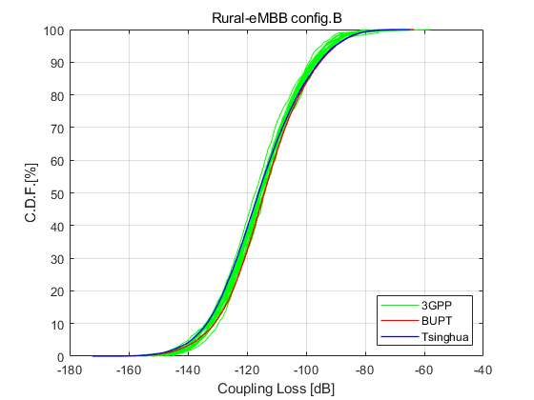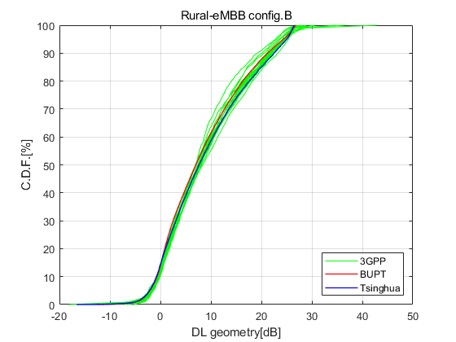

Figure B-8-2

CDF of coupling loss and geometry for rural-eMBB Config C

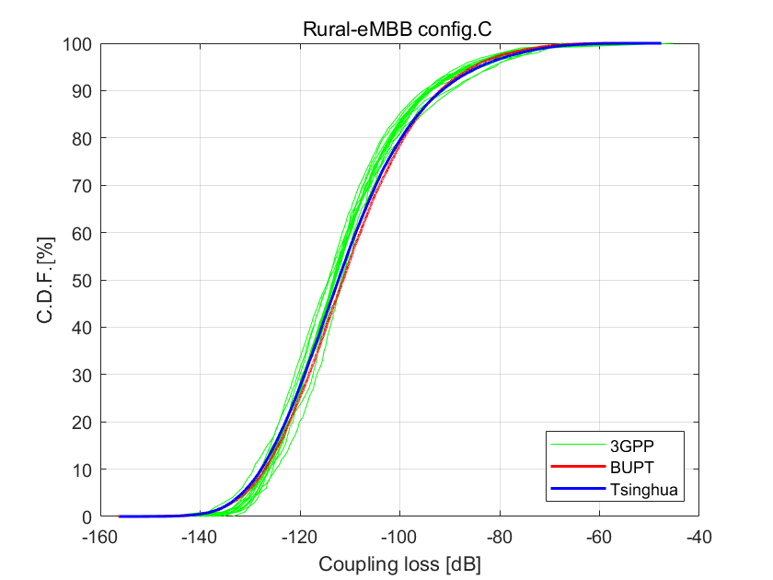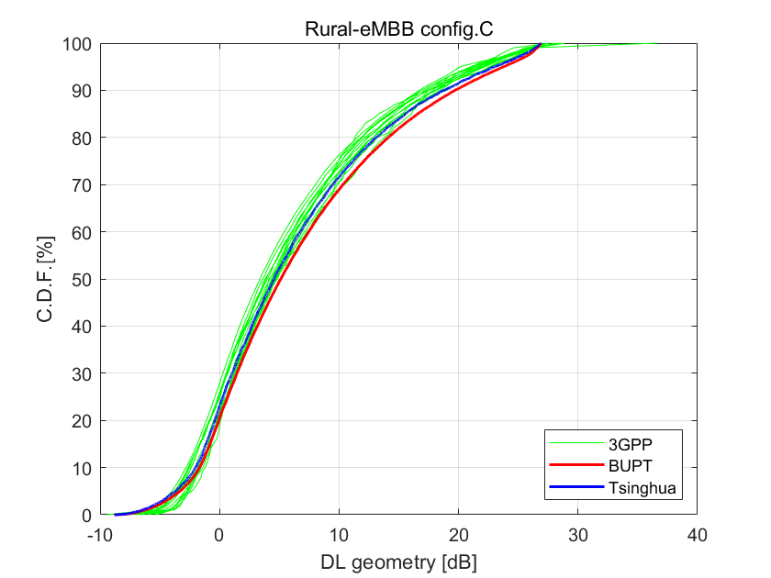

Dense Urban eMBB

The simulation assumptions for calibration in Dense Urban eMBB test environment are shown in the table below.

|  |  |
| --- | --- |
| Dense Urban - eMBB | Config. A |
| Carrier frequency for evaluation | 1 layer (Macro) with 4 GHz |
| BS antenna height | 25 m |
| Total transmit power per TRxP | 41 dBm for 10 MHz bandwidth |
| UE power class | 23 dBm |
| Percentage of high loss and low loss building type | 20% high loss, 80% low loss (applies to Channel model B) |
| Inter-site distance | 200 m |
| Number of antenna elements per TRxP | 128Tx/Rx, (M,N,P,Mg,Ng) = (8,8,2,1,1), (dH,dV) = (0.5, 0.8)λ    +45°, -45° polarization |
| Number of TXRU per TRxP | 4TXRU, (Mp,Np,P,Mg,Ng) = (2,1,2,1,1) |
| Number of UE antenna elements | 4Tx/Rx, (M,N,P,Mg,Ng) = (1,2,2,1,1), (dH,dV) = (0.5, N/A)λ    0°,90° polarization |
| Number of TXRU per UE | 4TXRU, (Mp,Np,P,Mg,Ng) = (1,2,2,1,1)  (1-to-1 mapping) |
| Device deployment | 80% indoor, 20% outdoor (in car)  Randomly and uniformly distributed over the area under Macro layer |
| UE mobility model | Fixed and identical speed |v| of all UEs of the same mobility class, randomly and uniformly distributed direction |
| UE speeds of interest | Indoor users: 3km/h  Outdoor users (in-car): 30 km/h |
| Inter-site interference modeling | Explicitly modelled |
| BS noise figure | 5 dB |
| UE noise figure | 7 dB  (NOTE: this parameter is different from TR38.802) |
| BS antenna element gain | 8 dBi |
| BS antenna element pattern | See Table 9 in Report ITU-R M.2412 |
| UE antenna element gain | 0 dBi |
| UE antenna element pattern | Omni-directional |
| Thermal noise level | -174 dBm/Hz |
| Traffic model | Full buffer |
| Simulation bandwidth | 10 MHz |
| UE density | 10 UEs per TRxP |
| UE antenna height | Outdoor UEs: 1.5 m  Indoor UTs: 3(nfl – 1) + 1.5;  nfl ~ uniform(1,Nfl) where  Nfl ~ uniform(4,8) |
| Channel model variant | Channel model A |
| TRxP number per site | 3 |
| Mechanic tilt | 90° in GCS (pointing to horizontal direction) |
| Electronic tilt | (According to Zenith angle in "Beam set at TRxP") |
| Handover margin (dB) | 0 (i.e., the strongest cell is selected) |
| TRxP boresight | 30 / 150 / 270 degrees |
| UT attachment | Based on RSRP (formula (8.1-1) in TR36.873) from port 0 |
|
| Wrapping around method | Geographical distance based wrapping |
| Minimum distance of TRxP and UE | d2D_min=10m |
| Polarized antenna model | Model-2 in TR36.873 |
| Beam set at TRxP  (Constraints for the range of selective analog beams per TRxP) | For direction of TRxP analog beam steering (in LCS):  Azimuth angle φi = [-5*pi/16, -3*pi/16, -pi/16, pi/16, 3*pi/16, 5*pi/16]  Zenith angle θj = [5*pi/8, 7*pi/8]    NOTE: (azimuth, zenith)=(0, pi/2) is the direction perpendicular to the array.  Precoder for beam at (φi, θj) is given by equation 1 in Appendix (2D DFT beam) |
| Beam set at UE  (Constraints for the range of selective analog beams for UE) |  |
| Criteria for selection for serving TRxP | Maximizing RSRP with best analog beam pair, where the digital beamforming is not considered |
| Criteria for analog beam selection for serving TRxP | Select the best beam pair among the limited set of DFT analog beams, based on the criteria of maximizing receive power after beamforming. |
| Criteria for analog beam selection for interfering TRxP | Random selecting the random beams for non-serving TRxP |

The simulation results for calibration in Dense Urban eMBB test environment are shown as the figures below.

Figure B-8-3

CDF of coupling loss and geometry for Dense Urban eMBB Config A

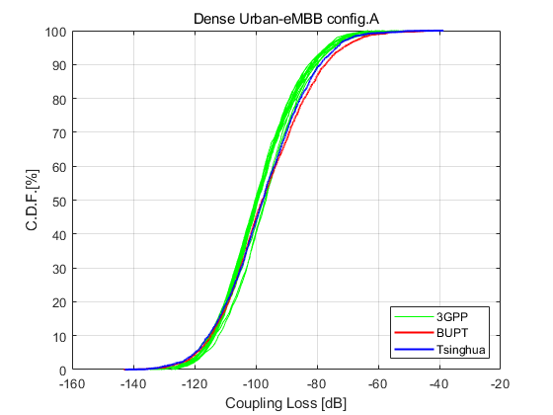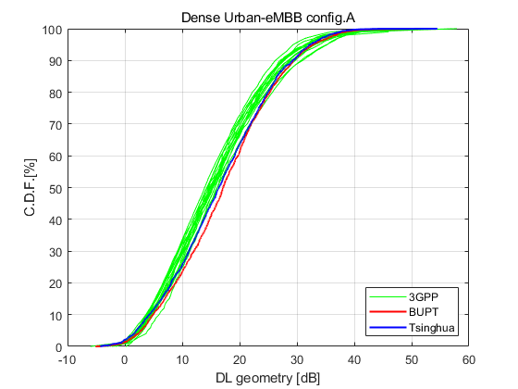

Indoor Hotspot eMBB

The simulation assumptions for calibration in Indoor Hotspot eMBB test environment are shown in the table below.

|  |  |
| --- | --- |
| Indoor Hotspot - eMBB | Config. A |
| Carrier frequency for evaluation | 4 GHz |
| BS antenna height | 3 m |
| Total transmit power per TRxP | Baseline: 21 dBm for 10MHz bandwidth |
| UE power class | 23 dBm |
| Inter-site distance | 20m |
| Number of antenna elements per TRxP | 32Tx/Rx, (M,N,P,Mg,Ng) = (4,4,2,1,1), (dH,dV) = (0.5, 0.5)λ    +45°, -45° polarization |
| Number of TXRU per TRxP | 32TXRU, (Mp,Np,P,Mg,Ng) = (4,4,2,1,1)  (1-to-1 mapping) |
| Number of UE antenna elements | 4Tx/Rx, (M,N,P,Mg,Ng) = (1,2,2,1,1), (dH,dV) = (0.5, N/A)λ    0°,90° polarization |
| Number of TXRU per UE | 4TXRU, (Mp,Np,P,Mg,Ng) = (1,2,2,1,1)  (1-to-1 mapping) |
| Device deployment | 100% indoor  Randomly and uniformly distributed over the area |
| UE mobility model | Fixed and identical speed |v| of all UEs, randomly and uniformly distributed direction |
| UE speeds of interest | 3 km/h |
| Inter-site interference modeling | Explicitly modelled |
| BS noise figure | 5 dB |
| UE noise figure | 7 dB |
| BS antenna element gain | 5dBi |
| BS antenna element pattern | See Table 10 in Report ITU-R M.2412 |
| UE antenna element gain | 0 dBi |
| UE antenna element pattern | Omni-directional |
| Thermal noise level | -174 dBm/Hz |
| Traffic model | Full buffer |
| Simulation bandwidth | 10MHz |
| UE density | 10 UEs per TRxP |
| UE antenna height | 1.5m |
| Channel model variant | Channel model A |
| TRxP number per site | 1 |
| Mechanic tilt | 180° in GCS (pointing to the ground) |
| Electronic tilt | 90° in LCS |
| Handover margin (dB) | 0(i.e., the strongest cell is selected) |
| TRxP boresight | - |
| UT attachment | Based on RSRP (formula (8.1-1) in TR36.873) from port 0 |
| Wrapping around method | No wrapping around |
| Minimum distance of TRxP and UE | d2D_min=0m |
| Polarized antenna model | Model-2 in TR36.873 |
| Beam set at TRxP | - |
| Beam set at UE | - |
| Criteria for analog beam selection for serving TRxP | - |
| Criteria for analog beam selection for interfering TRxP | - |

The simulation results for calibration in Indoor Hotspot eMBB test environment are shown as the figures below.

Figure B-8-4

CDF of coupling loss and geometry for Indoor Hotspot eMBB Config A

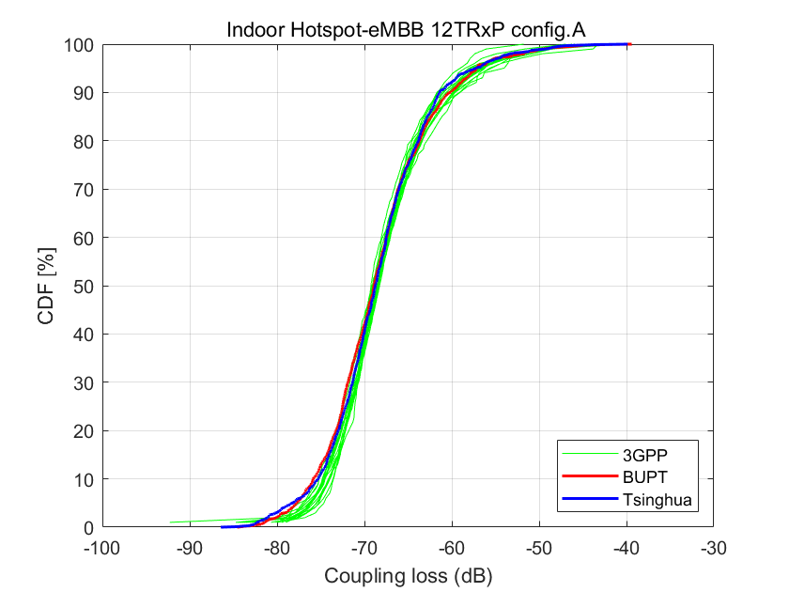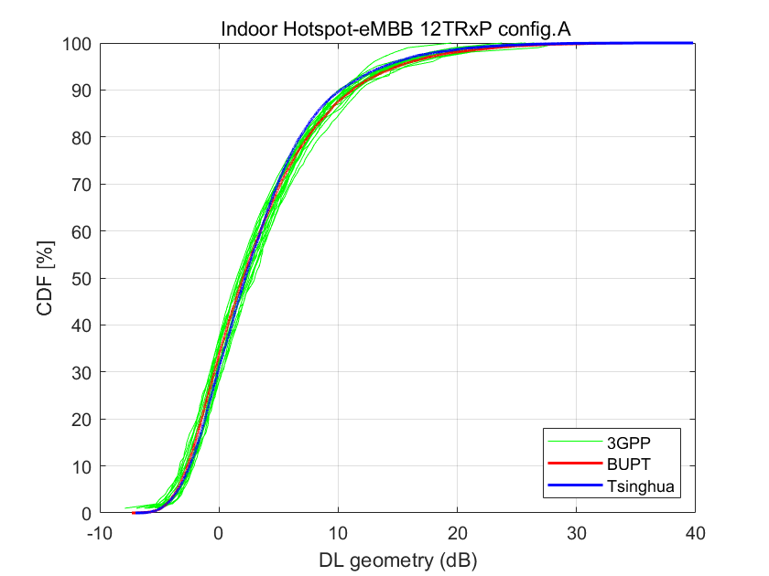

Urban Macro URLLC

The simulation assumptions for calibration in Urban Macro URLLC test environment are shown in the table below.

|  |  |
| --- | --- |
| Urban Macro - URLLC | Config. A |
| Carrier frequency for evaluation | 4 GHz |
| BS antenna height | 25 m |
| Total transmit power per TRxP | 46 dBm for 10 MHz bandwidth |
| UE power class | 23 dBm |
| Percentage of high loss and low loss building type | 100% low loss (applies to Channel model B) |
| Inter-site distance | 500 m |
| Number of antenna elements per TRxP | 64 Tx/Rx, (M,N,P,Mg,Ng) = (8,4,2,1,1), (dH,dV) = (0.5, 0.8)λ    +45°, -45° polarization |
| Number of TXRU per TRxP | 8TXRU, (Mp,Np,P,Mg,Ng) = (1,4,2,1,1) |
| Number of UE antenna elements | 4Tx/Rx, (M,N,P,Mg,Ng) = (1,2,2,1,1), (dH,dV) = (0.5, N/A)λ    0°, 90° polarization |
| Number of TXRU per UE | 4TXRU (1-to-1 mapping) |
| Device deployment | 80% outdoor, 20% indoor  Randomly and uniformly distributed over the area |
| UE mobility model | Fixed and identical speed |v| of all UEs of the same mobility class, randomly and uniformly distributed direction |
| UE speeds of interest | 3 km/h for indoor and 30 km/h for outdoor |
| Inter-site interference modeling | Explicitly modelled |
| BS noise figure | 5 dB |
| UE noise figure | 7 dB |
| BS antenna element gain | 8 dBi |
| BS antenna element pattern | See Table 9 in Report ITU-R M.2412 |
| UE antenna element gain | 0 dBi |
| UE antenna element pattern | Omni-directional |
| Thermal noise level | -174 dBm/Hz |
| Traffic model | Full buffer |
| Simulation bandwidth | 10 MHz |
| UE density | 10 UEs per TRxP |
| UE antenna height | 1.5 m |
| Channel model variant | Channel model A |
| TRxP number per site | 3 |
| Mechanic tilt | 90° in GCS (pointing to horizontal direction) |
| Electronic tilt | [99°] in LCS |
| Handover margin (dB) | 0 (i.e., the strongest cell is selected) |
| TRxP boresight | 30 / 150 / 270 degrees |
| UT attachment | Based on RSRP (formula (8.1-1) in TR36.873) from port 0 |
| Wrapping around method | Geographical distance based wrapping |
| Minimum distance of TRxP and UE | d2D_min=10m |
| Polarized antenna model | Model-2 in TR36.873 |

The simulation results for calibration in Urban Macro URLLC test environment are shown as the figures below.

Figure B-8-5

CDF of coupling loss and geometry for Urban Macro URLLC Config A

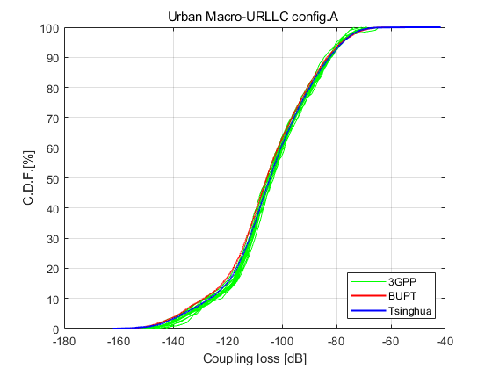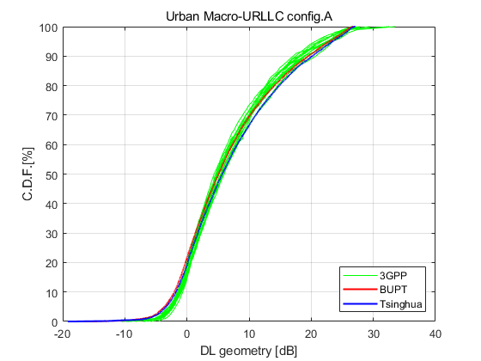

Urban Macro mMTC

The simulation assumptions for calibration in Urban Macro mMTC test environment are shown in the table below.

|  |  |
| --- | --- |
| Urban Macro - mMTC | Config. A |
| Carrier frequency for evaluation | 700 MHz |
| BS antenna height | 25 m |
| Total transmit power per TRxP | 46 dBm for 10 MHz bandwidth |
| UE power class | 23 dBm |
| Percentage of high loss and low loss building type | 20% high loss, 80% low loss (applies to Channel model B) |
| Inter-site distance | 500 m |
| Number of antenna elements per TRxP | 16 Tx/Rx, (M,N,P,Mg,Ng) = (8,1,2,1,1), (dH,dV) = (N/A, 0.8)λ    +45°, -45° polarization |
| Number of TXRU per TRxP | 2TXRU, (Mp,Np,P,Mg,Ng) = (1,1,2,1,1) |
| Number of UE antenna elements | 1Tx/Rx    0° polarization |
| Number of TXRU per UE | 1TXRU |
| Device deployment | 80% indoor, 20% outdoor  Randomly and uniformly distributed over the area |
| UE mobility model | Fixed and identical speed |v| of all UEs of the same mobility class, randomly and uniformly distributed direction. |
| UE speeds of interest | 3 km/h for indoor and outdoor |
| Inter-site interference modeling | Explicitly modelled |
| BS noise figure | 5 dB |
| UE noise figure | 7 dB |
| BS antenna element gain | 8 dBi |
| BS antenna element pattern | See Table 9 in Report ITU-R M.2412 |
| UE antenna element gain | 0 dBi |
| UE antenna element pattern | Omni-directional |
| Thermal noise level | -174 dBm/Hz |
| Traffic model | Full buffer |
| Simulation bandwidth | 10 MHz |
| UE density | 10 UEs per TRxP |
| UE antenna height | 1.5 m |
| Channel model variant | Channel model A |
| TRxP number per site | 3 |
| Mechanic tilt | 90° in GCS (pointing to horizontal direction) |
| Electronic tilt | [99°] in LCS |
| Handover margin (dB) | 0 (i.e., the strongest cell is selected) |
| TRxP boresight | 30 / 150 / 270 degrees |
| UT attachment | Based on RSRP (formula (8.1-1) in TR 36.873) from port 0 |
| Wrapping around method | Geographical distance based wrapping |
| Minimum distance of TRxP and UE | d2D_min=10m |
| Polarized antenna model | Model-2 in TR 36.873 |

The simulation results for calibration in Urban Macro mMTC test environment are shown as the figures below.

Figure B-8-6

CDF of coupling loss and geometry for Urban Macro mMTC Config A

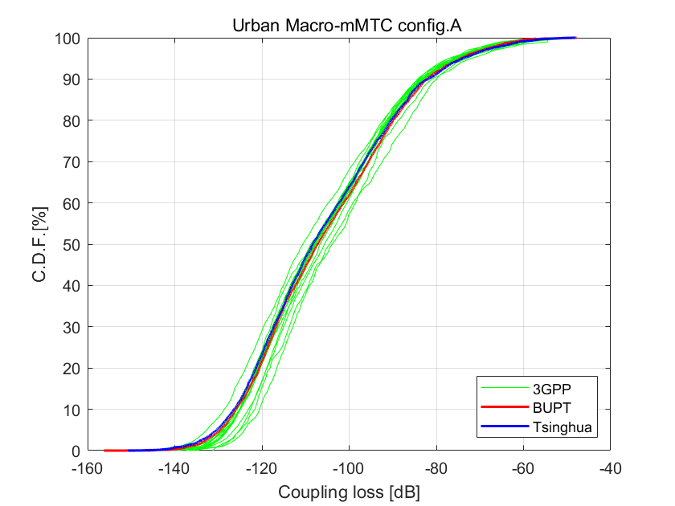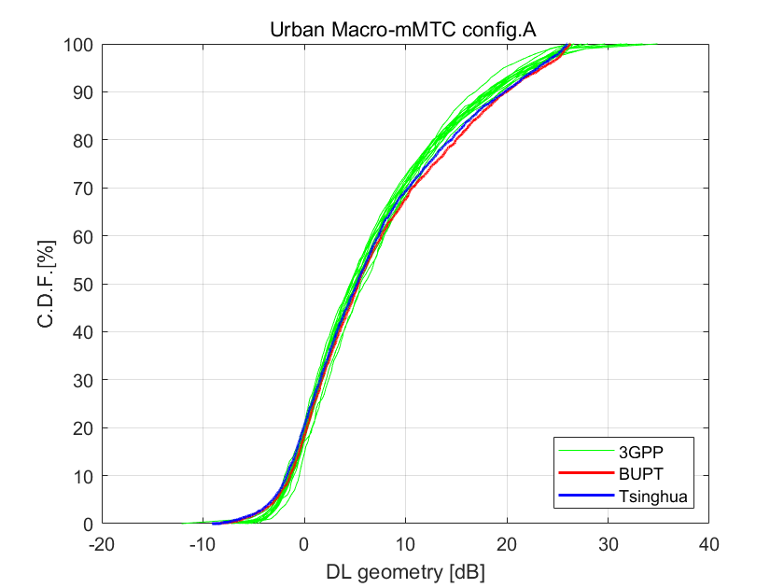

## B-9 Detailed Assumptions and SINR Distribution of Mobility Evaluation

The detailed assumptions and SINR distribution of mobility evaluation can be found in the attached documents.

 

## B-10 Detailed Assumptions and SINR Distribution of Reliability Evaluation

The detailed assumptions and SINR distribution of reliability evaluation can be found in the attached document.



## B-11 Detailed Assumptions, SINR Distribution and SINR-SE Curves of Connection Density Evaluation

The detailed assumptions, SINR distribution and SINR-SE curves of connection density evaluation can be found in the attached document.



______________

1. Submitted on behalf of the [Beijing National Research Center for Information Science and Technology Evaluation Group (Bnrist EG)](https://www.itu.int/oth/R0A0600009B/en).