|  |  |
| --- | --- |
| **Radiocommunication Study Groups** |  |
|  |  |
|  |  |
| Received: 31 May 2021  Source: The Fifth Generation Mobile Communications Promotion Forum | **Document 5D/700-E** |
| **1 June 2021** |
| **English only**  **TECHNOLOGY ASPECTS** |
| Director, Radiocommunication Bureau[1]* | |
| FINAL evaluation Report from The Fifth Generation Mobile Communications Promotion Forum on the IMT-2020 proposal  in Document IMT-2020/18(rev.1) by “Nufront” IN THE  EXTENDED IMT-2020 EVALUATION PROCESS | |
|  | |

This document describes the evaluation results and activities by 5GMF Evaluation Group regarding the IMT-2020 candidate technology submission in Document [IMT-2020/18(Rev.1)](https://www.itu.int/md/R15-IMT.2020-C-0018/en) by “Nufront”. The candidate technology was evaluated as the reset to Step 4 in the extended IMT-2020 evaluation process.

Part I

Administrative aspects of the Independent Evaluation Group

1. **Name of the Independent Evaluation Group**

IMT-2020 Evaluation Group, the Fifth Generation Mobile Communications Promotion Forum (5GMF IEG)

**2 Introduction and background of the Independent Evaluation Group**

The Fifth Generation Mobile Communications Promotion Forum (5GMF) was founded in September 2014. 5GMF has been conducting research & development concerning 5G Communications Systems including the standardization thereof, along with liaison & coordination with related organizations, the collection of information, and the dissemination & enlightenment activities. In September 2017, 5GMF IMT-2020 Evaluation Group (5GMF IEG) was established under the Technical Committee of the 5GMF and registered as an Independent Evaluation Group (IEG) committing in the process of IMT-2020 evaluation.

5GMF IEG reviewed the proposed RIT by Nufront and provided its evaluation report. The report was captured in Document [IMT-2020/48](https://www.itu.int/md/R15-IMT.2020-C-0048/en) in Step 7 of the IMT-2020 development process in February 2020.

In October 2020, 5GMF IEG received a liaison statement from WP5D which invited IEGs to re‑engage in Step 4 evaluation that was granted by WP5D as an exceptional extension of the IMT‑2020 evaluation process (Att. 7.4 of Doc. [5D/360](https://www.itu.int/md/R19-WP5D-C-0360/en)). 5GMF decided to re-engage the process and started its re-evaluation exercises taking into account the useful materials informed in Annex 3 of the liaison statement mentioned above.

**3 Method of Work**

The evaluation method in this report is in line with what are suggested in Report ITU-R M.2412 that are inspection, analysis and simulation.

**4 Administrative Contact Details**

Mr. OHMURA, Yoshinori (Secretary General of 5GMF)

[y-ohmura@arib.or.jp](mailto:y-ohmura@arib.or.jp)

**5 Technical Contact Details**

Mr. NAKAMURA, Takaharu (Principal Engineer, FUJITSU LIMITED)

[n.takaharu@fujitsu.com](mailto:n.takaharu@fujitsu.com)

Mr. TAKETSUGU, Masanori (Senior Manager, NEC Corporation)

[m-taketsugu@nec.com](mailto:m-taketsugu@nec.com)

**6 Other pertinent administrative information**

None.

Part II

Technical aspects of the work of the Independent Evaluation Group

1. **Evaluated candidate technologies for IMT-2020**

This report is a final evaluation report on EUHT, as an RIT, the candidate technology submission in Document IMT-2020/18(Rev.1).

1. **Utilization of ITU-R evaluation guidelines**

This final evaluation report contains evaluation performed in accord within Report ITU‑R M.2412‑0.

1. **Documentation of any additional evaluation methodologies**

There are no additional evaluation methodologies developed to complement the evaluation guidelines in Report ITU-R M.2412-0.

1. **Verification as per Report ITU-R M.2411 of the compliance templates**

# 1 Gaps/deficiencies in submitted material and/or self-evaluation

Several gaps or deficiencies in E) have been identified in submitted material and its corresponding self‑evaluation. In the evaluation captured in E) and Annex A, an MMSE algorithm of the best performance among many types of MMSE Receivers, such as MMSE‑IRC, is applied as per technical information given by the proponent.

**1.1 EUHT control channel in normal mode for eMBB evaluation**

5GMF Evaluation Group raised the questions about control channel performance for eMBB evaluation in Evaluation Group Discussion Area, and Nufront responded as follows.

|  |
| --- |
| **5GMF question on April 8, 2021**  *In the self-evaluation report of IMT-2020/18(Rev.1), is reliability of the control channel considered for the eMBB evaluation (e.g. 5th percentile user spectral efficiency)?*  **Nufront Response on April 14, 2021**  “The reliability of control channel is also considered in the eMBB evaluation, as required in the M 2412 document.”  **5GMF additional question on April 26, 2021**  *Thank you very much for your answer and there is an additional question. Could you elaborate how the reliability of control channel is considered in eMBB system-level simulation? Could you provide the performance curve of control channel in the normal mode from the link-level simulation?*  **Nufront Response on April 28, 2021**  The reliability of CCH in system-level simulations considered as follows,   1. The received SINR of each sub-carrier in CCH is obtained based on the generated channels and receiver detection algorithm. 2. The effective SINR is computed by EESM, MIESM or other mapping algorithms. 3. BLER value of CCH is estimated by looking up the AWGN BLER curve of the corresponding MCS (shown in next slide). 4. Determine if the current CCH is success fully decoded or not based on the BLER value. 5. If the CCH is correctly decoded, start processing TCH. 6. If the CCH decoding is determined to be failed, the relative TCH will be considered as erroneous.   The performance curve of control channel in the normal mode from the link level simulation is shown as below: |

After 5GMF Evaluation Group constructs control channel performance into system-level simulation considering the discussion above, 5GMF Evaluation Group observes that EUHT technology does not meet the average/5th percentile spectral efficiency requirement of IMT-2020 in Indoor Hotspot-eMBB, average/5th percentile spectral efficiency requirement of IMT-2020 in Dense Urban-eMBB at least for UL, and 5th percentile spectral efficiency requirement of IMT-2020 in Rural-eMBB, according to the results from all sources.

5GMF Evaluation Group observation includes:

* CCH in the normal mode has no repetition and only 1/2 coding rate according to the EUHT specification (see below). Consequently, there is no transmission mechanism to achieve high reliability for CCH in the normal mode.

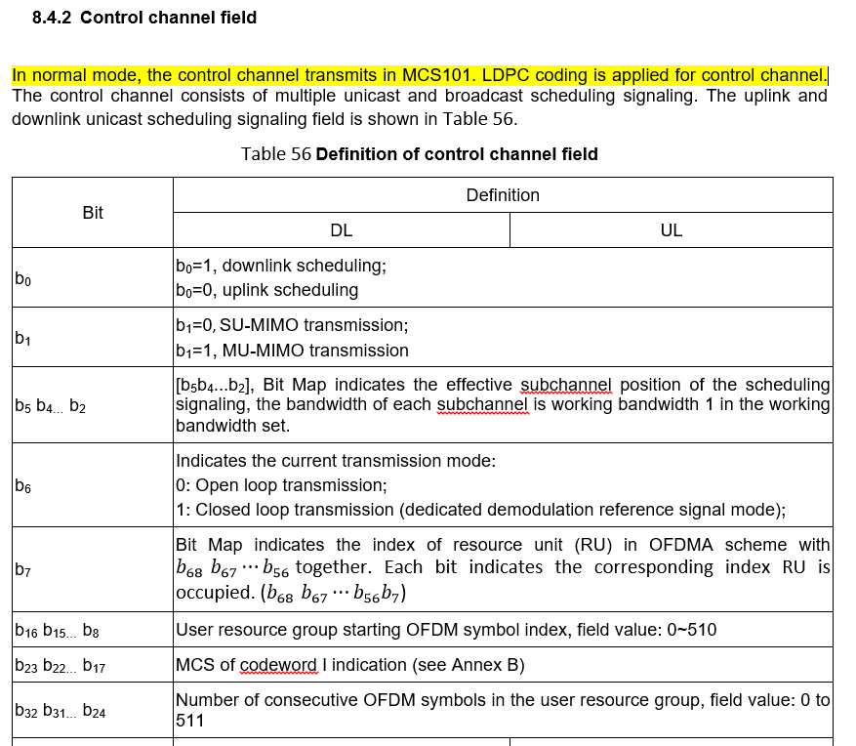

* CCH transmission has little MIMO beam forming gain for the normal and low-error mode. The CRS (long preamble) is used for channel estimation of SICH and CCHs for all STAs. Then CRS transmission has little MIMO beam forming gain, since it should ensure all STAs to decode the cell system information and control information successfully. Hence, CCH transmission is difficult to perform MIMO beam forming.

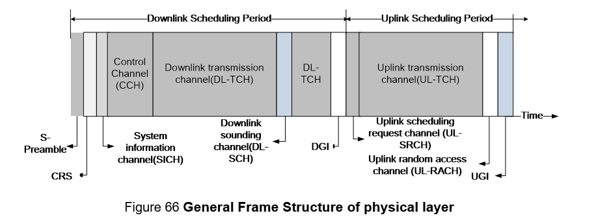

5GMF Evaluation Group observes that the success rate of receiving TCH is obviously degraded after constructing CCH curve that the Nufront provided into one of the simulators.

Considering the above analysis and results, 5GMF Evaluation Group concludes that CCH performance would degrade the spectral efficiency. It is one of reasons that EUHT technology do not meet average/5th percentile spectral efficiency requirement.

**1.2 EUHT dynamic switching of normal/low-error modes for eMBB evaluation**

5GMF Evaluation Group raised the questions about dynamic switching of the normal/low-error modes for eMBB evaluation in Evaluation Group Discussion Area, and Nufront responded as follows.

|  |
| --- |
| **5GMF question on April 8, 2021**  *In the self-evaluation report of IMT-2020/18(Rev.1), is only the normal mode utilized or both of the normal mode and low-error mode are utilized for the eMBB evaluation (e.g. 5th percentile user spectral efficiency)?*  **Nufront Response on April 14, 2021**  “Both the normal mode and low-error mode are utilized for the eMBB evaluation. The mode selection is implemented in the scheduler.”  **5GMF additional question on April 26, 2021**  *Thank you very much for your answer and there is an additional question. Could you elaborate a general strategy to mix those two modes in your self-evaluation and scheduler? How the normal mode or low-error mode is selected for each user and its status? How each user is informed with a selected mode respectively?*  **Nufront Response on April 28, 2021**  The normal mode or low error mode is selected due to CAP scheduling and link adaptation algorithm CAP scheduler selects an appropriate MCS for a specific user according to CQI/SINR/MCS and ACK/NACK feedback information For example, if the feedback SINR increases, CAP can improve the MCS level If CAP doesn’t receive ACK/NACK, it can decrease the MCS level of the STA When the MCS in the normal mode.  The STA detects normal mode or low error mode by short preamble, which is 9 identical 32 point sequences in normal mode and 7 identical 255 point sequences in low error mode The two sequences are totally different sequences (Please refer to EUHT specification For example, cross/auto correlations (or other operations) can be implemented to distinguish the normal mode from low error mode. |

After 5GMF Evaluation Group constructs dynamic switching function into system-level simulation considering the discussion above, 5GMF Evaluation Group observes that EUHT technology does not meet the average/5th percentile spectral efficiency requirement of IMT-2020 in Indoor Hotspot-eMBB, average/5th percentile spectral efficiency requirement of IMT-2020 in Dense Urban-eMBB at least for UL, and 5th percentile spectral efficiency requirement of IMT-2020 in Rural-eMBB, according to the results from all sources.

5GMF Evaluation Group observation includes:

1. Spectral efficiency of low-error mode is too low for eMBB.

TCH transmission in low-error mode has no-MIMO, only QPSK, small codeword and so on. according to the section 8.4 of EUHT specification (see below).

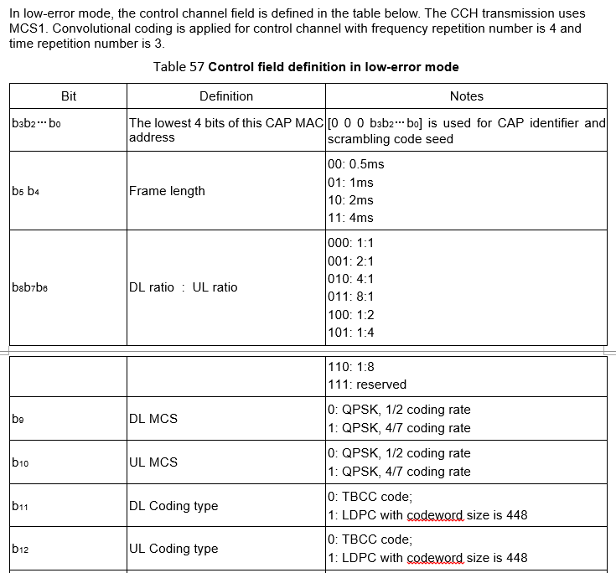

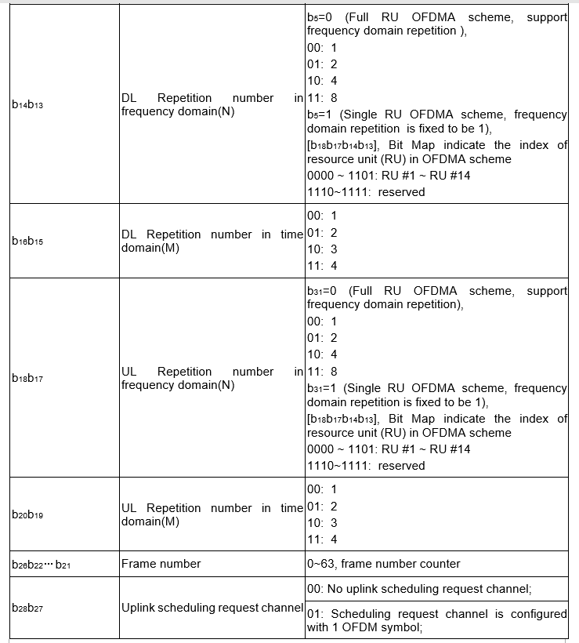

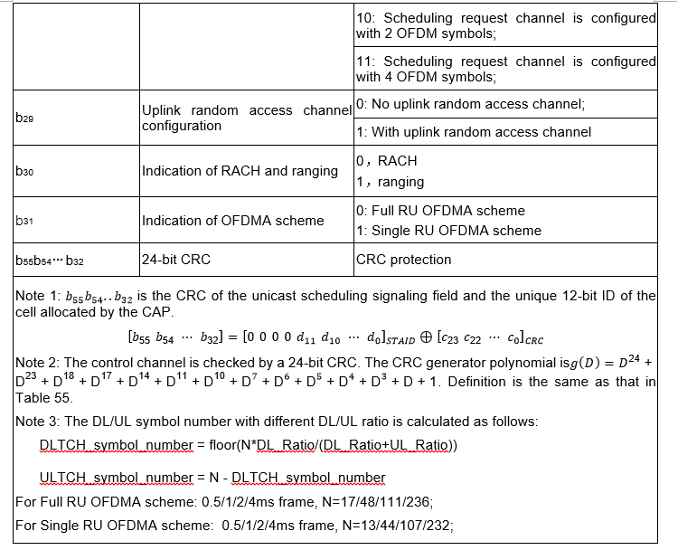

1. Mode selection depends on s-preamble detection probability.

S-preamble is used to select the normal mode/low-error mode, according to the Nufront response on April 28 which is “*The STA detects normal mode or low-error mode by short preamble, which is 9 identical 32 point sequences in normal mode and 7 identical 255 point sequences in low error mode. The two sequences are totally different sequences (Please refer to EUHT specification For example, cross/auto correlations (or other operations) can be implemented to distinguish the normal mode from low error mode.*”

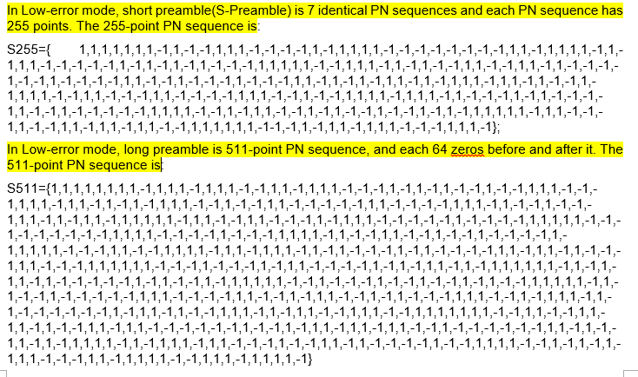

S-preamble in the low-error mode is only one and identical sequence among all the low-error mode cells, according to the EUHT specification above.

When neighbor cells are in the low-error mode and a serving cell is in the normal mode, the signal energy of s-preamble from neighbor cells is much stronger than serving cell. It leads cell edge users can’t detect the normal s-preamble in serving cell, as below results in our evaluation.

The s-preamble detection evaluation for cell edge users in eMBB

|  |  |  |
| --- | --- | --- |
|  | Serving cell in low-error mode;  Neighbor cells in normal mode | Serving cell in normal mode;  Neighbor cells in low-error mode |
| Mode detection success probability of cell edge users in serving cell | 100% | 0 |

5GMF Evaluation Group did not consider the preamble detection in its eMBB evaluation. However, even if the ideal mode selection is adopted, it is concluded form the simulation results that the EUHT technology still does not meet the average/5th percentile spectral efficiency requirement of IMT-2020 in Indoor Hotspot-eMBB, average/5th percentile spectral efficiency requirement of IMT-2020 in Dense Urban-eMBB at least for UL, and 5th percentile spectral efficiency requirements of IMT-2020 in Rural-eMBB, according to the results from all sources.

1. Neither normal nor low-error mode is good for eMBB.

S-preamble is used for the mode selection, and is a cell-level signal. Then, the mode switching is per cell, not per user. If the s-preamble is changed between “normal mode” and “low error mode”, all users in this cell have to come into the corresponding mode for receiving CRS, SICH and CCH. Hence, a cell is in one mode in one frame.

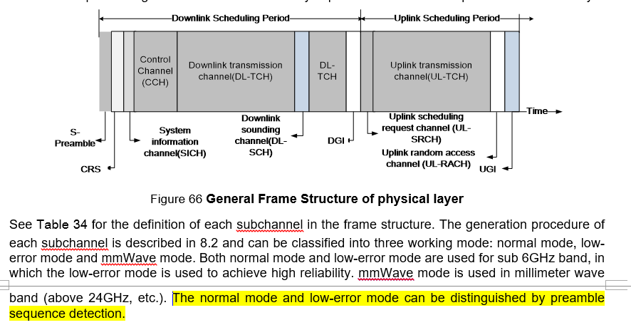

For usage of the mixture mode usage in EUHT technology, 5GMF Evaluation Group observes the followings, even without considering the impact of part B above (“Mode selection depends on s-preamble detection probability”):

* 1. When a cell is in low-error mode, the spectral efficiency in the frame(s) will be too low, considering the analysis in part A above and the characteristics of low-error mode summarised in the table below.
  2. When a cell is in normal mode, there is no repetition and low coding rate. Therefore, the operation point of normal mode is high, leading to low reliability for low geometry users, especially for Dense Urban and Rural test environments.

|  |  |  |  |
| --- | --- | --- | --- |
|  | | **Normal mode** | **Low-error mode** |
| SICH | | BPSK 1/2,  No repetition | integrated into CCH |
| CCH | | QPSK 4/7,  No repetition | Support frequency  and time domain rep |
| TCH | Modulation | BPSK, QPSK, 16QAM, 64QAM, 256QAM, 1024QAM | QPSK |
| Code rate | 1/2, 3/4, 5/8, 5/6, 7/8 | 1/2, 4/7 |
| Code length | 448, 1344, 2688, 5376 | 448 |
| Repetition | No repetition | Support frequency  and time domain rep |
| MIMO | MU-MIMO | Support up to 8 layers | Not support |
| Stream number | 1~8 | 1 |
| Code word number | Up to 2 | 1 |

Considering the above analysis and results, 5GMF Evaluation Group concludes that dynamic switching function has little benefit and would degrade the average spectral efficiency performance. It is one of reasons that EUHT technology does not meet the average/5th percentile spectral efficiency requirement.

**1.3 EUHT CA for eMBB evaluation**

5GMF Evaluation Group raised the questions about spectrum aggregation mode in Evaluation Group Discussion Area, and Nufront responded as follows.

|  |
| --- |
| **5GMF question on Feb 3, 2021**  *1. Spectrum aggregation mode*  *It is not clear to us how the Spectrum aggregation mode can be established since there seems to be lack of details in the specification (Attachment 5.4 to 5D/222: Specification of the Nufront RIT radio interface technology). Could the proponent provide more information for the Spectrum aggregation mode, e.g. elaborating signalling required for this mode?*  **Nufront Response on Feb 19, 2021** |

The sentences and figures below are almost all information which were provided in the EUHT specifications for CA. They are “stage2” description on “what”, and there is lack of “stage 3” details on “How”. The essential description for CA function is not provided in the EUHT specification.

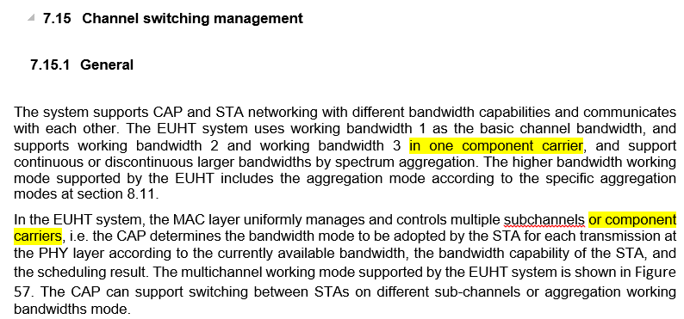

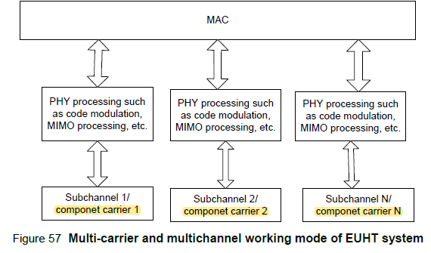

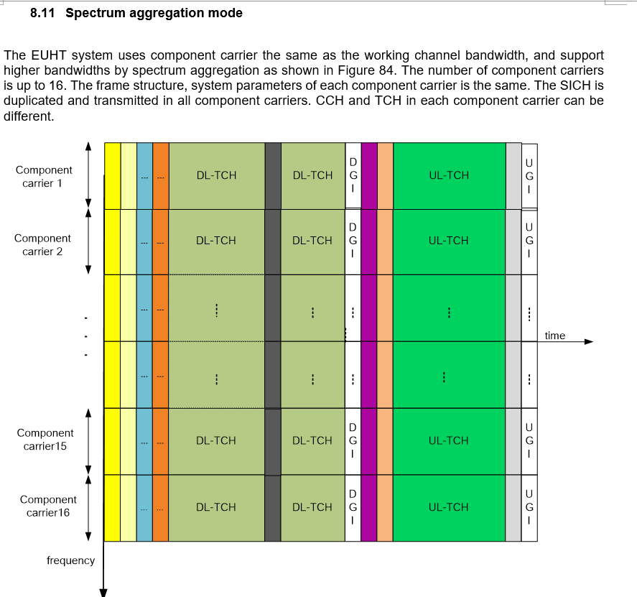

Furthermore, 5GMF Evaluation Group observes two issues for CA in EUHT technology:

1. Less of interoperability between CAP and STA in spectrum aggregation mode.

First, each CC have its own operation respectively, according to Nufront response below.

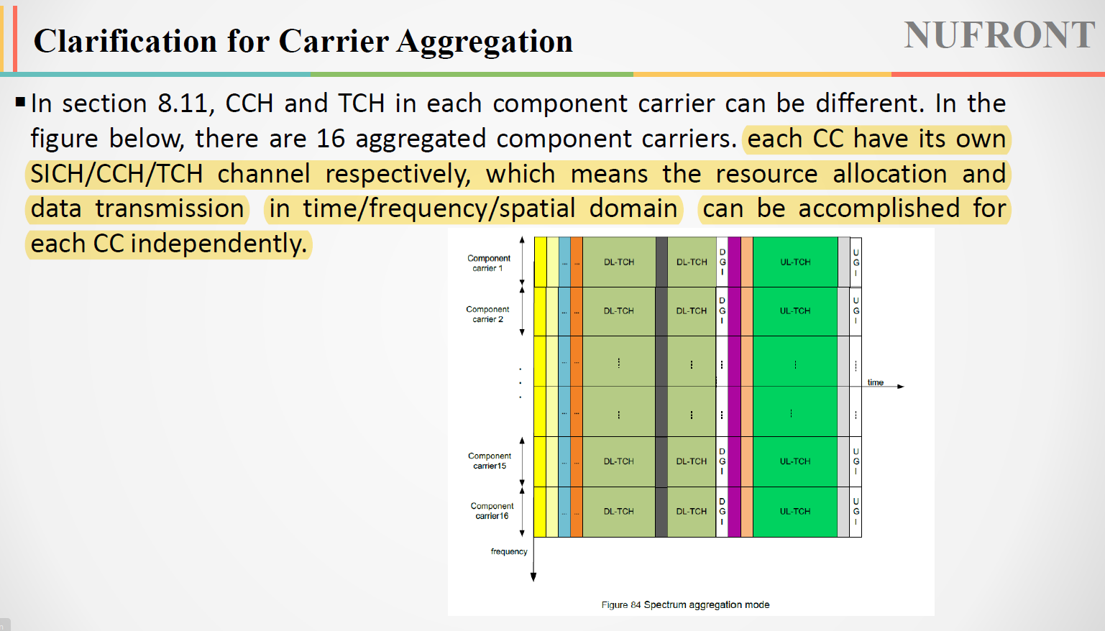

STA decides the connected CC by itself. After the aggregation mode response frame is received by STA, the STA would detect and decide which carriers are in the frequency to be used for CA. Then, the STA could independently connect multiple CCs, which are from one or multiple cells, based on the EUHT specification.

Besides, CAP did not know what and how many CCs detected and decided in the STA side. EUHT specification lacks carrier confirmation mechanism. CAP does not know which carriers are well connected by STA, since the STA does the process in each CC respectively. Therefore, there is misunderstanding for factual connected carrier information between STA and CAP, based on the EUHT CA process.

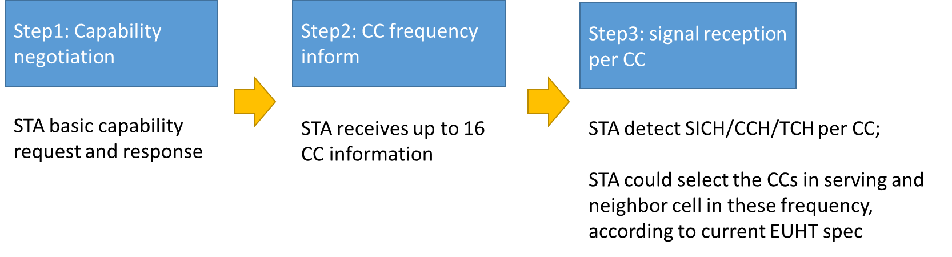

Furthermore, the data transmission on multiple CCs would occur reception issues, when some connected CCs that are unknown by CAP. For example, if a data packet is divided onto CCs that belongs to multiple cells, the cells do not know how the data packet is processed and partial data packets in other cells. In this case, the receiver only decides that they are separate packets since the data can no longer be identified as part of the packet. So the receiver cannot combine the data on these multiple CCs together.

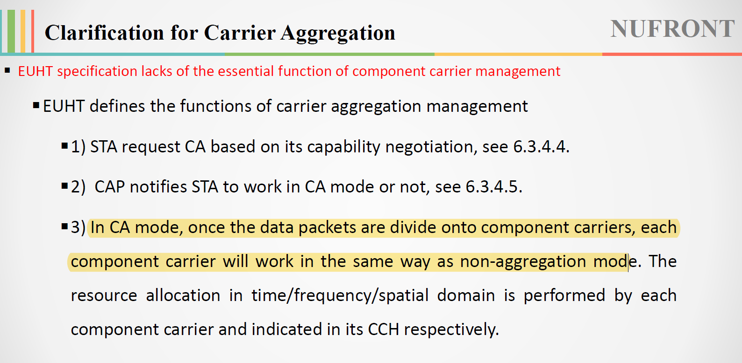

1. Handover in spectrum aggregation mode is not supported well.

According to section 7.19.2 “Handover management” in the EUHT specification, the handover is based on the one RSSI of the current cell.

Then, in CA case, there are many RSSIs of the working channel in multiple CCs. In other words, there are many RSSIs in CAP-S and many RSSIs in CAP-D during CA handover process. Since the EUHT specification has no clear handover criterion in CA mode, it is difficult to decide handover for an STA which is in spectrum aggregation mode.

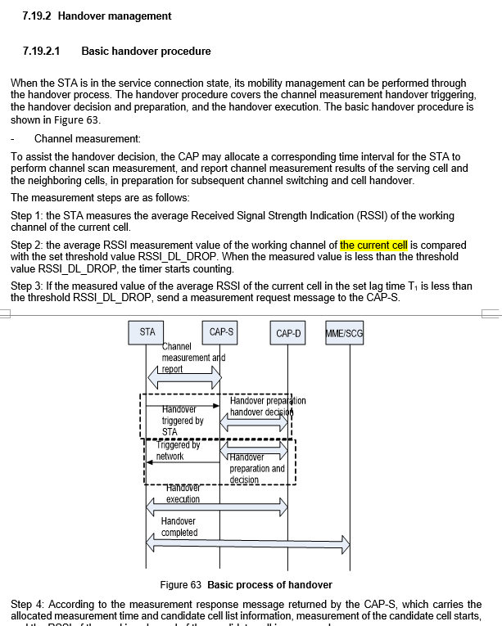

Based on the above analysis, 5GMF Evaluation Group concludes that EUHT technology cannot support spectrum aggregation mode well. 5GMF Evaluation Group assumes that EUHT technology does not meet the minimum requirements of IMT-2020 for user experience data rate, area traffic capacity and bandwidth because it does not support spectrum aggregation well.

**1.4 EUHT polluted RS in low-error mode for URLLC evaluation**

Based on EUHT specification, CRS is used for channel estimation. However, the CRS in the low-error mode consists of one unique sequence without any identification.

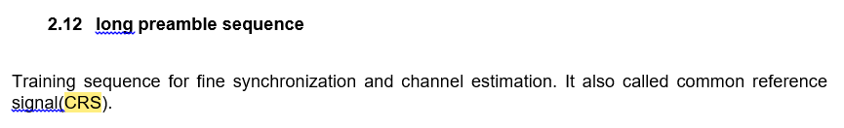

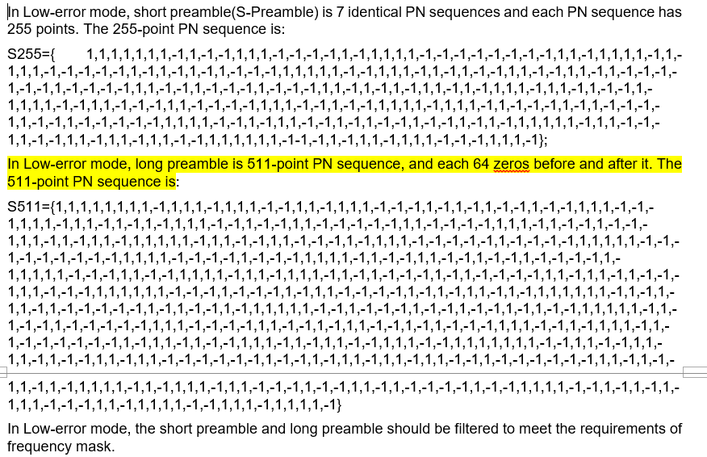

According to Report ITU-R M.2412, there are 19*3 cells in Urban Macro-URLLC test environment. All the STAs will be evaluated in the URLLC evaluation assumptions, so all of these STAs have the URLLC traffic with at least 99.999% success probability in 1 ms.

Based on the EUHT self-evaluation report, the repetition number of TCH transmission in Urban Macro-URLLC test environment assumes 12 in DL and 8 in UL. Only TCH in low-error mode can support repetition scheme, according the section 1.2 above. Therefore, EUHT technology should use low-error mode in the entire Macro-URLLC test environment for reliability evaluation.

As the analysis in part B of section 1.2, a cell is in one mode in one frame.

Therefore, all the cells in Urban Macro-URLLC test environment within EUHT technology evaluation would be in the low-error mode.

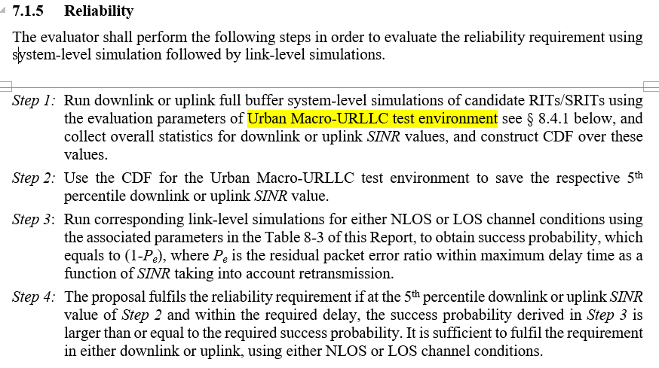

Based on the above analysis, it could be assumed that:

1: the CRS in the low-error mode is one unique sequence without any identification

2: all the cells in EUHT technology evaluation would be in the low-error mode with frame alignment.

Consequently, it can be confirmed that all the cells send the same CRS at the same time.

1. CCH under polluted CRS

As described in the section 1.1 above, CRS is used for channel estimation of CCH.



Then, the CRS transmission has different channel environment from CCH transmission.

* 1. The channel environment of CRS transmission: H serving cell + $\sum_{1}^{n}{H_serving}$
  2. The channel environment of CCH transmission: only H serving cell

For the serving cell 0, the CRS (reference signal) in the low-error mode would be polluted by signals of neighboring cells. The polluted CRS transmission would bring wrong channel estimation results. It will lead to degrade CCH performance in URLLC evaluation.

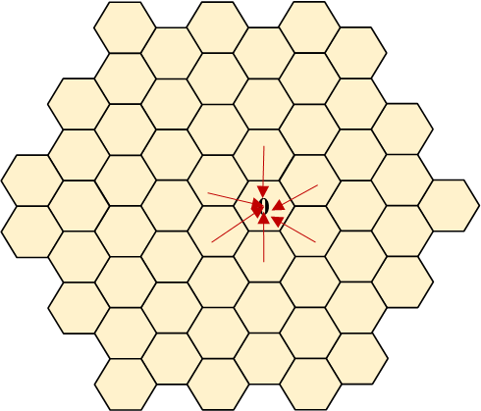

Considering the above analysis, 5GMF Evaluation Group concludes that CCH performance in URLLC evaluation is degraded by polluted CRS. And it is one of reasons that EUHT technology does not meet reliability requirement of IMT-2020 in Urban Macro-URLLC test environment.

1. DL TCH under polluted CRS

5GMF Evaluation Group assumes 12 repetition in DL-TCH transmission for the evaluation of reliability in Urban Macro-URLLC test environment, which is aligned with the self-evaluation report. Hence, both self-evaluation report and 5GMF evaluation report use Full RU OFDMA scheme in DL, since Single RU OFDMA scheme supports up to 4 time-domain repetition only.

According to the section 8.5.3 (“Traffic channel demodulation reference signal”) in the EUHT specification below, in case of full RU OFDMA scheme, long preamble (CRS) is used for channel estimation of DL-TCH and CCH. Therefore, DL-TCH will encounter the same polluted RS issue with CCH in case of Full RU OFDMA scheme.

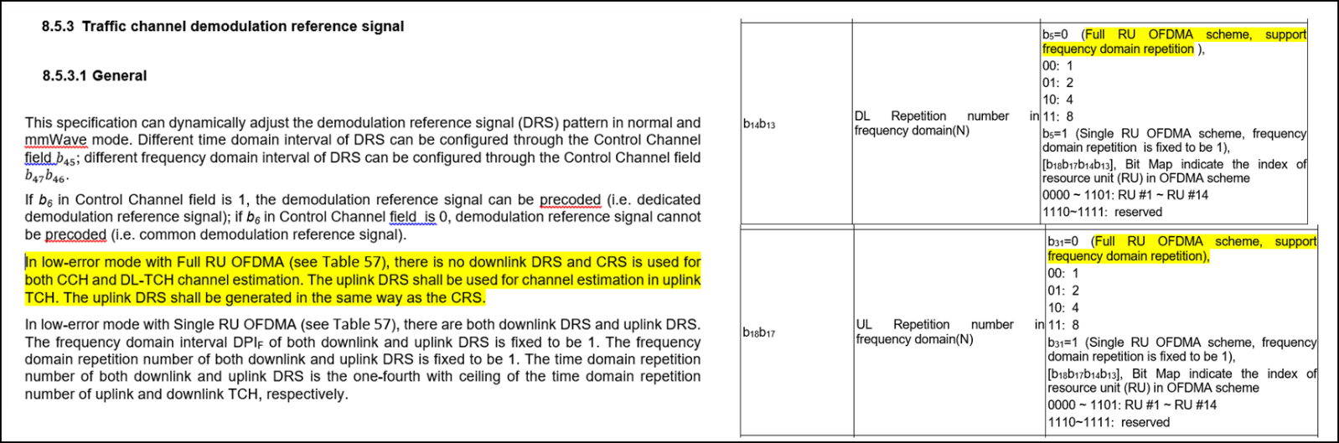

Considering the above analysis, 5GMF Evaluation Group concludes that DL TCH performance in URLLC evaluation is degraded by polluted CRS. And it is one of reasons that EUHT technology does not meet reliability requirement of IMT-2020 for DL in Urban Macro-URLLC test environment.

1. UL TCH under polluted RS

5GMF Evaluation Group assumes 8 repetition in UL-TCH transmission for the evaluation of reliability in Urban Macro-URLLC test environment, which is aligned with self-evaluation report. Hence, both self-evaluation report and 5GMF evaluation report use Full RU OFDMA scheme in UL, since Single RU OFDMA scheme supports up to 4 time-domain repetition only.

According to the section 8.5.3 (“Traffic channel demodulation reference signal”) in EUHT specification, in case of full RU OFDMA scheme, uplink RS is the same sequence with CRS and there is no time-domain RS indication in low-error mode CCH. Hence, uplink RS is in the same default position and same sequence for all the URLLC cells.

So, UL-TCH will encounter the same polluted uplink RS issue with CCH in case of Full RU OFDMA scheme.

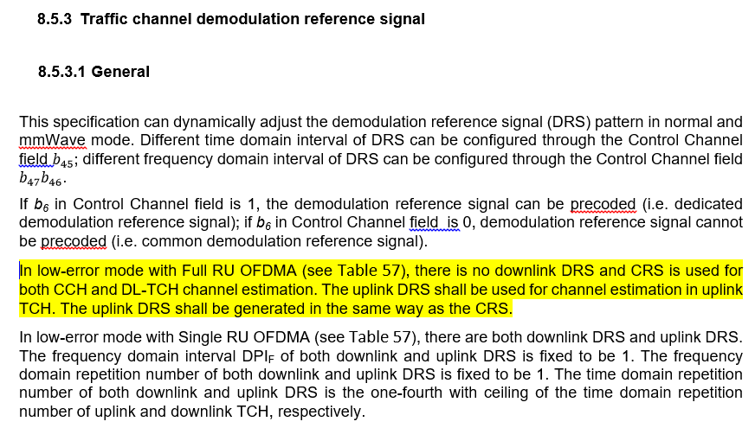







Considering the above analysis, 5GMF Evaluation Group concludes that UL TCH performance in URLLC evaluation is degraded by polluted uplink RS. And it is one of reasons that EUHT technology does not meet reliability requirement of IMT-2020 for UL in Urban Macro-URLLC test environment.

# 2 Areas requiring clarifications

**2.1 EUHT Mobility interruption time for eMBB and URLLC evaluation**

The EUHT specification is lack of essential function for mobility. The section 7.19.23 (Lossless Handover) including signal flows is all information available in the specification. There is no detailed definition of any involved signalling, process, and CN entity.

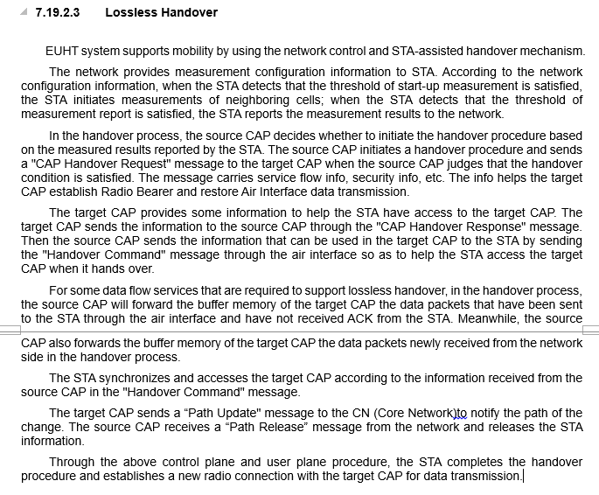

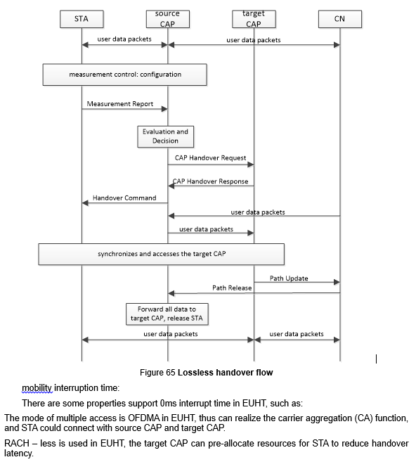

In the table below, we analyzed the EUHT specification for essential elements to achieve 0ms mobility interruption. Definitions and specifications of these signaling(messages), interfaces and entity are essential for 0ms mobility interruption time. The “No” means that the definition hasn’t been described in the EUHT specification.

The analysis of the EUHT essential elements for 0ms mobility interruption time

|  |  |  |  |
| --- | --- | --- | --- |
|  | Signaling, interface, or entity | Usage | EUHT GCS includes or not |
| 1 | Core Network entity | Essential entity for mobility | No |
| 2 | Interface between CAP and CN | Exchange data via specific data format and handover usage message | No |
| 3 | CAP Handover request message between CAP-S and CAP-D | CAP initiates the handover procedure between CAPs | No, only includes STA handover request frame |
| 4 | CAP Handover response message between CAP-S and CAP-D | CAP responses message between CAPs | No |
| 5 | Interface between CAP-S and CAP-D | Exchange data via specific data format and handover usage message | No |
| 6 | Path update message | CAP notifies the path of the change to CN | No |
| 7 | Path release message | CN notifies the path of the release to CAP | No |

Considering the analysis and table above, it is observed that the EUHT specification is not mature enough to define exchange of user information and update of path, without definition of essential messages, interfaces. and CN entity.

5GMF Evaluation Group views that it is not possible to conclude that EUHT technology meets mobility interruption time requirement of IMT-2020 for eMBB and URLLC.

**2.2 EUHT Inter-system Handover**

5GMF Evaluation Group raised the questions about inter-system handover in Evaluation Group Discussion Area, and Nufront responded as follows.

|  |
| --- |
| **5GMF question on Feb 3, 2021**  *1. Inter-System handover*  *According to “RIT/SRIT description template” in ITU-R Report M.2411-0, it is required to describe procedure and mechanism of Inter-System handover with other IMT system (section 5.2.3.2.5.1). Looking into the EUHT specification (Attachment 5.4 to 5D/222), it tells “EUHT system can support interwork with other wireless communication systems by using dual-mode terminal” (section 5.1.6.19.3). Could the proponent provide more information for mechanisms of Inter-System handover considering the system aspects?*  **Nufront Response on Feb 19, 2021** |

According to “RIT/SRIT description template” in Report ITU-R M.2411, the proponent is required to describe the intersystem handover with at least one other IMT system.

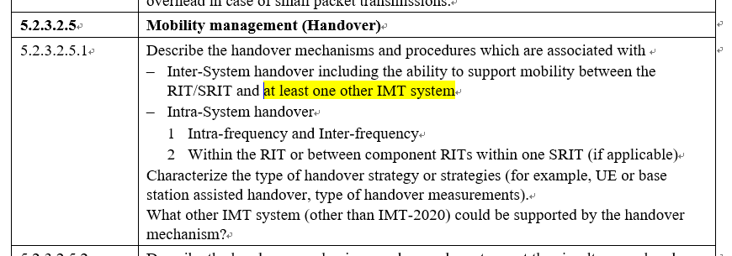

The only answer from EUHT specs is “by using dual-mode terminal”, there is not any clue about the signaling and mechanism of intersystem measurement, handover etc.

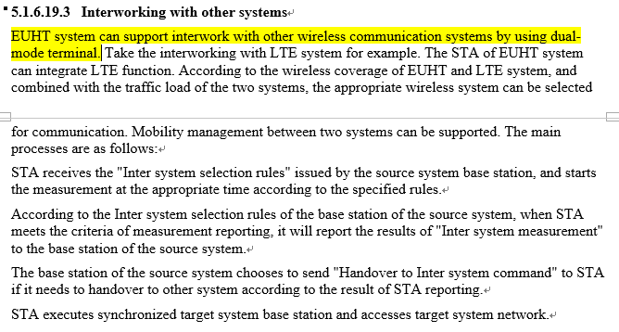

Based on above analysis, further clarification for Inter-system Handover is required by the EUHT proponent.

# 3 General questions

No specific questions that should be clarified were identified.

1. **Assessment as per Report ITU-R M.2410, ITU-R M.2411 and ITU-R M.2412**

# 1 Provision of compliance template for services (Section 5.2.4.1 of Report ITU-R M.2411-0)

|  |  |  |
| --- | --- | --- |
|  | **Service capability requirements** | **Evaluator’s comments** |
| **5.2.4.1.1** | **Support for wide range of services**  Is the proposal able to support a range of services across different usage scenarios (eMBB, URLLC, and mMTC)?: YES / 🗹NO  Specify which usage scenarios (eMBB, URLLC, and mMTC) the candidate RIT or candidate SRIT can support.(1) | As provided in chapter 6 of this evaluation report, Nufront RIT has no ability to support the usage scenarios of eMBB and URLLC. |
| (1) As defined in Report ITU-R M.2410-0. | | |

# 2 Provision of compliance template for spectrum (Section 5.2.4.2 of Report ITU-R M.2411-0)

|  |  |
| --- | --- |
|  | **Spectrum capability requirements** |
| **5.2.4.2.1** | **Frequency bands identified for IMT**  Is the proposal able to utilize at least one frequency band identified for IMT in the ITU Radio Regulations?: 🗹 YES / NO  Specify in which band(s) the candidate RIT or candidate SRIT can be deployed. |
| **As shown in Annex A-1, the following frequency bands are supported by EUHT RIT, which contains certain frequency bands identified for IMT in the ITU Radio Regulations (Edition 2016).**  **EUHT operating bands in Sub-6GHz bands**   |  |  | | --- | --- | | Uplink (UL) and Downlink (DL) operating band | Duplex Mode | | 450 - 470 MHz | TDD | | 470 - 698 MHz | TDD | | 694/698 - 960 MHz | TDD | | 1427 - 1518 MHz | TDD | | 1710 - 2025 MHz | TDD | | 2110 - 2200 MHz | TDD | | 2300 - 2400 MHz | TDD | | 2500 - 2690 MHz | TDD | | 3300 - 3400 MHz | TDD | | 3400 - 3600 MHz | TDD | | 3600 - 3700 MHz | TDD | | 4800 - 4990 MHz | TDD | |
| **5.2.4.2.2** | **Higher Frequency range/band(s)**  Is the proposal able to utilize the higher frequency range/band(s) above 24.25 GHz?: 🗹YES / NO  Specify in which band(s) the candidate RIT or candidate SRIT can be deployed.  NOTE 1 – In the case of the candidate SRIT, at least one of the component RITs need to fulfil this requirement. |
| **As shown in the table below, frequency bands above 24.25GHz are supported by EUHT RIT.**  **EUHT operating bands in mmWave bands**   |  |  | | --- | --- | | Uplink (UL) and Downlink (DL) operating band | Duplex Mode | | 26500 MHz – 29500 MHz | TDD | | 24250 MHz – 27500 MHz | TDD | | 37000 MHz – 40000 MHz | TDD | | 27500 MHz – 28350 MHz | TDD | |

# 3 Provision of compliance template for technical performance (Section 5.2.4.3 of Report ITU-R M.2411-0)

| **Minimum technical performance requirements item (5.2.4.3.x), units, and Report ITU-R M.2410-0 section reference(1)** | **Category** | | | **Required value** | **Value(2)** | **Requirement met?** | **Comments (3)** |
| --- | --- | --- | --- | --- | --- | --- | --- |
| **Usage scenario** | **Test environment** | **Downlink or uplink** |
| **5.2.4.3.1** Peak data rate (Gbit/s) *(4.1)* | eMBB | Not applicable | Downlink | 20 |  |  | Not assessed |
| Uplink | 10 |  |  |
| **5.2.4.3.2** Peak spectral efficiency (bit/s/Hz) *(4.2)* | eMBB | Not applicable | Downlink | 30 |  |  | Not assessed |
| Uplink | 15 |  |  |
| **5.2.4.3.3** User experienced data rate (Mbit/s) *(4.3)* | eMBB | Dense Urban – eMBB | Downlink | 100 | ~~Not assessed~~  0.27~18.93 | Yes 🗹 No | For evaluation configuration A and B, Channel model A/B. |
| Uplink | 50 | ~~Not assessed~~  0.0~5.05 | Yes 🗹 No |
| **5.2.4.3.4** 5th percentile user spectral efficiency (bit/s/Hz) *(4.4)* | eMBB | Indoor Hotspot – eMBB | Downlink | 0.3 | ~~0.03~0.24~~  0.03~0.24 (*) | Yes 🗹 No | For evaluation configuration of 4 GHz. Channel model A/B, 12/36 TRxP  * Re-evaluation results are within the range of the original evaluation. |
| Uplink | 0.21 | ~~0.08~0.18~~  0.08~0.18 (*) | Yes 🗹 No |
| Downlink | 0.3 | 0.01~0.06 | Yes 🗹 No | For evaluation configuration of 30 GHz. Channel model A/B, 12/36 TRxP |
| Uplink | 0.21 | 0.05~0.10 | Yes 🗹 No |
| eMBB | Dense Urban – eMBB | Downlink | 0.225 | ~~0.22~0.292~~  0.09~0.284 | Yes  No  (Inconclusive) | For evaluation configuration of 4 GHz, Channel model A/B. |
| Uplink | 0.15 | ~~0.08~0.1~~  0.08~0.202 | Yes  No  (Inconclusive) |
| Downlink | 0.225 | 0.001 | Yes 🗹 No | For evaluation configuration of 30 GHz, Channel model A/B. |
| Uplink | 0.15 | 0 | Yes 🗹 No |
| eMBB | Rural – eMBB | Downlink | 0.12 | Not evaluated |  | For evaluation configuration of 700 MHz, Channel model A/B. |
| Uplink | 0.045 | ~~Not evaluated~~  0.04~0.04 | Yes 🗹 No |
| Downlink | 0.12 | Not evaluated |  | For evaluation configuration of 4 GHz, Channel model A/B. |
| Uplink | 0.045 | ~~0.002~0.017~~  0.002~0.037 | Yes 🗹 No |
| **5.2.4.3.5** Average spectral efficiency (bit/s/Hz/ TRxP) *(4.5)* | eMBB | Indoor Hotspot – eMBB | Downlink | 9 | ~~4.93~7.35~~  4.93~7.35 (*) | Yes 🗹 No | For evaluation configuration of 4 GHz. Channel model A/B, 12/36 TRxP  * Re-evaluation results are within the range of the original evaluation. |
| Uplink | 6.75 | ~~2.71~4.09~~  2.71~4.09 (*) | Yes 🗹 No |
| Downlink | 9 | 4.77~5.42 | Yes 🗹 No | For evaluation configuration of 30 GHz. Channel model A/B, 12/36 TRxP |
| Uplink | 6.75 | 2.48~3.61 | Yes 🗹 No |
| eMBB | Dense Urban – eMBB | Downlink | 7.8 | ~~7.412~7.74~~  6.55~8.08 | Yes  No  (Inconclusive) | For evaluation configuration of 4 GHz, Channel model A/B. |
| Uplink | 5.4 | ~~3.58~3.73~~  3.58~4.42 | Yes 🗹 No |
| Downlink | 7.8 | 5.53 | Yes 🗹 No | For evaluation configuration of 30 GHz, Channel model A/B. |
| Uplink | 5.4 | 1.7 | Yes 🗹 No |
| eMBB | Rural – eMBB | Downlink | 3.3 | Not evaluated |  | For evaluation configuration of 700 MHz, Channel model A/B. |
| Uplink | 1.6 | ~~Not evaluated~~  3.14~3.16 | 🗹 Yes  No |
| Downlink | 3.3 | Not evaluated |  | For evaluation configuration of 4 GHz, Channel model A/B. |
| Uplink | 1.6 | ~~3.26~3.60~~  2.67~4.43 | 🗹 Yes  No |
| **5.2.4.3.6** Area traffic capacity (Mbit/s/m2) *(4.6)* | eMBB | Indoor-Hotspot – eMBB | Downlink | 10 | ~~Not assessed~~  0.98~7.63 | Yes 🗹 No |  |
| **5.2.4.3.7** User plane latency (ms) *(4.7.1)* | eMBB | Not applicable | Uplink and Downlink | 4 |  |  | Not assessed |
| URLLC | Not applicable | Uplink and Downlink | 1 |  |  | Not assessed |
| **5.2.4.3.8** Control plane latency (ms) *(4.7.2)* | eMBB | Not applicable | Not applicable | 20 |  |  | Not assessed |
| URLLC | Not applicable | Not applicable | 20 |  |  | Not assessed |
| **5.2.4.3.9** Connection density (devices/km2) *(4.8)* | mMTC | Urban Macro – mMTC | Uplink | 1 000 000 |  |  | Not assessed |
| **5.2.4.3.10** Energy efficiency *(4.9)* | eMBB | Not applicable | Not applicable | Capability to support a high sleep ratio and long sleep duration |  |  | Not assessed |
| **5.2.4.3.11** Reliability *(4.10)* | URLLC | Urban Macro –URLLC | Uplink | 1-10−5 success probability of transmitting a layer 2 PDU (protocol data unit) of size 32 bytes within 1 ms in channel quality of coverage edge | ~~0.24%~~  0.68%~92.37% | Yes 🗹 No | For evaluation configuration A (4 GHz), Channel model A. |
| Downlink | ~~99.531%~~  49.11%~99.531% | Yes 🗹 No | For evaluation configuration A (4 GHz), Channel model A. |
| **5.2.4.3.12** Mobility classes *(4.11)* | eMBB | Indoor Hotspot – eMBB | Uplink | Stationary, Pedestrian |  |  | Not assessed |
| eMBB | Dense Urban – eMBB | Uplink | Stationary, Pedestrian,  Vehicular (up to 30 km/h) |  |  | Not assessed |
| eMBB | Rural – eMBB | Uplink | Pedestrian, Vehicular, High speed vehicular |  |  | Not assessed |
| **5.2.4.3.13**  Mobility Traffic channel link data rates (bit/s/Hz) *(4.11)* | eMBB | Indoor Hotspot – eMBB | Uplink | 1.5 (10 km/h) |  |  | Not assessed |
|  |  | Not assessed |
| eMBB | Dense Urban – eMBB | Uplink | 1.12 (30 km/h) |  |  | Not assessed |
|  |  | Not assessed |
| eMBB | Rural – eMBB | Uplink | 0.8 (120 km/h) |  |  | Not assessed |
| 0.45 (500 km/h) |  |  |
| 0.8 (120 km/h) |  |  | Not assessed |
| 0.45 (500 km/h) |  |  | Not assessed |
| **5.2.4.3.14** Mobility interruption time (ms)  *(4.12)* | eMBB and URLLC | Not applicable | Not applicable | 0 |  |  | Not assessed |
| **5.2.4.3.15** Bandwidth and Scalability *(4.13)* | Not applicable | Not applicable | Not applicable | At least 100 MHz |  |  | Not assessed |
| Up to 1 GHz |  | Not assessed |
| Support of multiple different bandwidth values(4) |  | Not assessed |
| (1) As defined in Report ITU-R M.2410-0.  (2) According to the evaluation methodology specified in Report ITU-R M.2412-0.  (3) Proponents should report their selected evaluation methodology of the Connection density, the channel model variant used, and evaluation configuration(s) with their exact values (e.g. antenna element number, bandwidth, etc.) per test environment, and could provide other relevant information as well. For details, refer to Report ITU-R M.2412-0, in particular, § 7.1.3 for the evaluation methodologies, § 8.4 for the evaluation configurations per each test environment, and Annex 1 on the channel model variants.  (4) Refer to § 7.3.1 of Report ITU-R M.2412-0. | | | | | | | |
| Under-lined part: Evaluation results in the extended IMT-2020 evaluation process.  Strikethrough part: Evaluation results in the original Step 4 that was replaced by the updated results in the extended IMT-2020 evaluation process. | | | | | | | |

Part III

Conclusion

The followings are the evaluation summary for a RIT for IMT-2020 candidate technology in Document IMT-2020/18(Rev.1).

# 1 Summary the Final Evaluation Report

**1.1 Use of information in Report ITU-R M.2412**

Does Independent Evaluation Group confirm use of Report ITU-R M.2412 in their work?

🗹 Yes 🞎 No

**1.2 Provision of compliance templates**

Provision of compliance template for services (section 5.2.4.1 of Report ITU-R M.2411)

🗹 Yes 🞎 No

Provision of compliance template for technical performance (section 5.2.4.3 of Report ITU-R M.2411)

🗹 Yes 🞎 No

**1.3 Summary of conclusions of the evaluation report**

Does the Evaluation Report indicate that the candidate technology meet minimum service and spectrum requirements?

Service requirements: 🞎 Yes 🗹 No

Spectrum requirements: 🗹 Yes 🞎 No

Which test environments have been considered in the evaluation report? What is outcome of the evaluation?

|  |  |
| --- | --- |
| **Test environment** | **Does the evaluation report indicate that the minimum technical performance requirements are met in the test environment?** |
| 🗹 Indoor Hotspot – eMBB | 🞎 Yes 🗹 No |
| 🗹 Dense Urban – eMBB | 🞎 Yes 🗹 No |
| 🗹 Rural – eMBB | 🞎 Yes 🗹 No |
| 🞎Urban Macro – mMTC | 🞎 Yes 🞎 No |
| 🗹 Urban Macro – URLLC | 🞎 Yes 🗹 No |

**1.4 Additional evaluation methodologies and assumptions**

Have any additional evaluation methodologies or assumptions that had not been included in the Report ITU-R M.2412 been used in evaluation?

🞎 Yes 🗹 No

**Annex A  
  
Evaluation Results**

**A-1 Frequency bands identified for IMT**

**A-1.1 450-6 000 MHz**

As can be seen in Table A.1-1, the **l**lowing frequency bands are supported by NR RIT, which either contains, or part of, or overlaps certain frequency bands identified for IMT in the ITU Radio Regulations (Edition 2016).

Table A.1-1

Frequency bands of EUHT RIT (in Sub-6GHz) and IMT bands related articles in Radio Regulations

|  |  |  |  |
| --- | --- | --- | --- |
| Uplink (UL) and Downlink (DL) operating band | Duplex Mode |  | **IMT related articles (notes) in Radio Regulations\*** |
| 450 - 470 MHz | TDD |  | **460-890 MHz: 5.295** (470-608 MHz, or portions thereof) **5.296A** (470-698 MHz, or portions thereof, and 610-698 MHz, or portions thereof) **5.308A** (614-698 MHz) **5.313A** (698-790 MHz) **5.317A** (698-960 MHz in Region 2, 694-790 MHz in Region 1 and 790-960 MHz in Regions 1 and 3) |
| 470 - 698 MHz | TDD |  |
| 694/698 - 960 MHz | TDD |  |
| 1427 - 1518 MHz | TDD |  | **1 300-1 525 MHz: 5.341A** (1 427-1 452 MHz and 1 492-1 518 MHz in Region 1) **5.341B** (1 427-1 518 MHz in Region 2) **5.341C** (1 427-1 452 MHz and 1 492-1 518 MHz in Region 3 **5.346** (1 452-1 492 MHz) **5.346A** (1 452-1 492 MHz) |
| 1710 - 2025 MHz | TDD |  | **1 710-2 170 MHz: 5.384A** (1 710-1 885 MHz, 2 300-2 400 MHz and 2 500-2 690 MHz) **5.388** (1 885-2 025 MHz and 2 110-2 200 MHz) **5.388A** (1 885-1 980 MHz, 2 010-2 025 MHz and 2 110-2 170 MHz in Regions 1 and 3 and, 1 885-1 980 MHz and 2 110-2 160 MHz in Region 2) |
| 2110 - 2200 MHz | TDD |  |
| 2300 - 2400 MHz | TDD |  |  |
| 2500 - 2690 MHz | TDD |  |  |
| 3300 - 3400 MHz | TDD |  | **2 700-3 600 MHz: 5.429B** (3 300-3 400 MHz), **5.429D** (3 300-3 400 MHz), **5.429F** (3 300-3 400 MHz), **5.430A** (3 400-3 600 MHz), **5.431B** (3 400-3 600 MHz), **5.432A** (3 400-3 500 MHz), **5.432B** (3 400-3 500 MHz), **5.433A** (3 500-3 600 MHz) **3 600-4 800 MHz**: **5.434** (3 600-3 700 MHz) **4 800-5 250 MHz**: **5.441A** (4 800-4 900 MHz) **5.441B** (4 800-4 990 MHz) |
| 3400 - 3600 MHz | TDD |  |
| 3600 - 3700 MHz | TDD |  |  |
| 4800 - 4990 MHz | TDD |  |  |
|  |  |  | *Excerpted from Radio Regulations Article 1 (Edition of 2016) |

**A-2 User experienced data rate**

Simulation results of User experienced data rate can be found in an Excel file in Table A-1.

**A-3 5th percentile user spectral efficiency**

Simulation results of 5th percentile user spectral efficiency can be found in an Excel file in Table A-1.

**A-4 Average spectral efficiency**

Simulation results of Average spectral efficiency can be found in an Excel file in Table A-1.

**A-5 Area traffic capacity**

Simulation results of Area traffic capacity can be found in an Excel file in Table A-1.

**A-6 Reliability**

Simulation results of Reliability can be found in an Excel file in Table A-1.

Table A-1

Simulation items and Excel files capturing the results

| **Minimum technical performance requirements item (5.2.4.3.x), units, and Report ITU-R M.2410-0 section reference(1)** | **Category** | | | **Required value** | **Value** | | | | **Note** | **Simulation results (in Excel files)** |
| --- | --- | --- | --- | --- | --- | --- | --- | --- | --- | --- |
| **Usage scenario** | **Test environment** | **Downlink or uplink** | **Source 1** | **Source 2** | **Source 3** | **Source 4** |
| **5.2.4.3.3** User experienced data rate (Mbit/s) *(4.3)* | eMBB | Dense Urban – eMBB | Downlink | 100 | 0.27~16.67 | 18.93 | 17.33 | 3.33~6.00 |  | UserExperienceDateRate - 04 eMBB- v01-rev1.xlsx |
| Uplink | 50 | 0.00~3.33 | 3.00 | 5.05 | - |  |
| **5.2.4.3.4** 5th percentile user spectral efficiency (bit/s/Hz) *(4.4)* | eMBB | Indoor Hotspot – eMBB | Downlink | 0.3 | 0.03~0.24 | 0.237 | 0.101 | - | 4 GHz. Channel model A/B, 12/36 TRxP | SpectralEfficiency - 01 InH-eMBB-v02_.xlsx |
| Uplink | 0.21 | 0.08~0.18 | 0.173 | 0.106 | - |
| Downlink | 0.3 | 0.01~0.06 | - | - | - | 30 GHz. Channel model A/B, 12/36 TRxP |
| Uplink | 0.21 | 0.05~0.10 | - | - | - |
| eMBB | Dense Urban – eMBB | Downlink | 0.225 | 0.22~0.25 | 0.284 | 0.231 | 0.05~0.09 | 4 GHz, Channel model A/B | SpectralEfficiency - 02 DenseUrban-eMBB-v03.xlsx |
| Uplink | 0.15 | 0.08~0.1 | 0.088 | 0.202 | - |
| Downlink | 0.225 | 0.001 | - | - | - | 30 GHz, Channel model A/B |
| Uplink | 0.15 | 0 | - | - | - |
| eMBB | Rural – eMBB | Downlink | 0.12 | - | - | - | - | 700 MHz. Channel model A/B | SpectralEfficiency - 03 Rural-eMBB-v02.xlsx |
| Uplink | 0.045 | - | - | - | 0.04~0.04 |
| Downlink | 0.12 | - | - |  |  | 4 GHz. Channel model A/B |
| Uplink | 0.045 | 0.002~0.017 | - | 0.037 | 0.002 |
| **5.2.4.3.5** Average spectral efficiency (bit/s/Hz/ TRxP) *(4.5)* | eMBB | Indoor Hotspot – eMBB | Downlink | 9 | 4.93~7.35 | 7.344 | 5.56 | - | 4 GHz. Channel model A/B, 12/36 TRxP | SpectralEfficiency - 01 InH-eMBB-v02.xlsx |
| Uplink | 6.75 | 2.71~3.98 | 4.09 | 2.34 | - |
| Downlink | 9 | 4.77~5.42 | - | - | - | 30 GHz. Channel model A/B, 12/36 TRxP |
| Uplink | 6.75 | 2.48~3.61 | - | - | - |
| eMBB | Dense Urban – eMBB | Downlink | 7.8 | 7.68~7.74 | 7.411 | 8.08 | 6.42~6.55 | 4 GHz. Channel model A/B | SpectralEfficiency - 02 DenseUrban-eMBB-v03.xlsx |
| Uplink | 5.4 | 3.58~3.71 | 3.623 | 4.42 | - |
| Downlink | 7.8 | 5.53 | - | - | - | 30 GHz. Channel model A/B |
| Uplink | 5.4 | 1.70 | - | - | - |
| eMBB | Rural – eMBB | Downlink | 3.3 | - | - | - | - | 700 MHz. Channel model A/B | SpectralEfficiency - 03 Rural-eMBB-v02.xlsx |
| Uplink | 1.6 | - | - | - | 3.14~3.16 |
| Downlink | 3.3 | - | - | - | - | 4 GHz. Channel model A/B |
| Uplink | 1.6 | 3.26~3.60 | - | 4.43 | 2.67 |
| **5.2.4.3.6** Area traffic capacity (Mbit/s/m2) *(4.6)* | eMBB | Indoor-Hotspot – eMBB | Downlink | 10 | 0.98~7.63 | 0.98 | 2.50 | - |  | AreaTrafficCapacity - 05 eMBB.- v01-rev1 |
| **5.2.4.3.9** Connection density (devices/km2) *(4.8)* | mMTC | Urban Macro – mMTC | Uplink | 1 000 000 | - | - |  |  |  |  |
| - | - |  |  |  |
| **5.2.4.3.11** Reliability *(4.10)* | URLLC | Urban Macro –URLLC | Uplink | 1-10−5 success probability of transmitting a layer 2 PDU (protocol data unit) of size 32 bytes within 1 ms in channel quality of coverage edge | 92.37% | - | - | 0.68% |  | Reliability - UrbanMacro-URLLC-v03.xlsx |
| Downlink | 99.54% | - | - | 43.59% |  |
| **5.2.4.3.13**  Mobility Traffic channel link data rates (bit/s/Hz) *(4.11)* | eMBB | Indoor Hotspot – eMBB | Uplink | 1.5 (10 km/h) | - | - | - | - |  |  |
| - | - | - | - |  |
| eMBB | Dense Urban – eMBB | Uplink | 1.12 (30 km/h) | - | - | - | - |  |  |
| - | - | - | - |  |
| eMBB | Rural – eMBB | Uplink | 0.8 (120 km/h) | - | - | - | - |  |  |
| 0.45 (500 km/h) | - | - | - | - |  |
| 0.8 (120 km/h) | - | - | - | - |  |
| 0.45 (500 km/h) | - | - | - | - |  |
| Underlined part: Evaluation results in the extended imt-2020 evaluation process. | | | | | | | | | | |

**Attachments:**

**B.1 eMBB_SE**

SpectralEfficiency - 01 InH-eMBB-v02.xlsx



SpectralEfficiency - 02 DenseUrban-eMBB-v03.xlsx



SpectralEfficiency - 03 Rural-eMBB-v02.xlsx



**B.2 UserExpDataRate**

UserExperienceDateRate - 04 eMBB- v01-rev1.xlsx



**B.3 Reliability**

Reliability - UrbanMacro-URLLC-v03.xlsx



**B.4 AreaTrafficCapacity**

AreaTrafficCapacity - 05 eMBB.- v01-rev1.xlsx



_________________

1. * Submitted on behalf of The Fifth Generation Mobile Communications Promotion Forum (5GMF).