Radiocommunication Study Groups | 
Received: 31 May 2021  Subject: Wireless World Research Forum | Document 5D/659-E
 | 31 May 2021
English only

TECHNOLOGY ASPECTS
Wireless World Research Forum
Evaluation Report on the Candidate Technology Submission For IMT-2020 “EUHT” As Part of the Re-engagement
in Step 4 Evaluation
This contribution contains the evaluation report from the Independent Evaluation Group Wireless World Research Forum (WWRF) for EUHT, IMT-2020/17 Submission. Following the finalisation of Step 7 in the IMT-2020 Process, EUHT submission evaluation was granted an extension in the IMT-2020 Process, for re-engagement and re-evaluation.
The evaluation is based on the characteristics defined in ITU-R Reports M.2410-0, M.2411-0 and M.2412-0 [1] – [3] using a methodology described in Report ITU-R M.2412-0 [3].
The report is organized as follows:
Part I: Administrative Aspects of the WWRF
Part II: Technical Aspects of the work of WWRF
Part III: Conclusions
Attachment: 1

Part I
Administrative aspects of the Independent Evaluation Group

I-1 Name of the Independent Evaluation Group (IEG)
Wireless World Research Forum (WWRF).

I-2 Introduction and background of the Independent Evaluation Group
WWRF’s goal is to encourage research that will achieve unbounded communications to address key societal challenges for the future. The term “Wireless World” is used in this broad sense to address the support of innovation and business, the social inclusion and the infrastructural challenges. This will be achieved by creating a range of new technological capabilities from wide-area networks to short-range communications, machine-to-machine communications, sensor networks, wireless broadband access technologies and optical networking, along with increasing intelligence and virtualization in networks. This will support a dependable future Internet of people, knowledge and things and the development of a service universe. WWRF is the unique forum where the wireless community can tackle the key research challenges. By searching out the issues, flagging them up to opinion leaders, and then working with liaison partners to deal with them, WWRF drives the development of the Wireless World. WWRF organizes two major events each year combining inputs from industry and academic experts, the exchange of ideas and the evolution of the research agenda and technology roadmaps. WWRF’s has a strong publication programme, working with partners such as IEEE and Wiley, makes the key messages and results available to the wireless research sector. To ease standardization, WWRF disseminates and harmonizes views, and together with our major liaison partners, we initiate collaborative research, and develop the global vision.
Over the last ten years, WWRF has championed several activities focused on the wireless evolution to and beyond 5G, including workshops and special sessions, presentations, white papers and journal special issues. WWRF has been very supportive of the ITU’s evaluation process for IMT-2020 and participates as an independent evaluation group (IEG).

I-3 Method of work

I-3-1 Background
The step 4 of IMT-2020 evaluation process was conducted to identify if the candidate RIT met the requirements set by the ITU. However, the step 4 didn’t conclude the decision-making process and an extension was agreed upon, where the steps 4-7 will be carried out to ascertain if the RIT meets the ITU requirements.

I-3-2 Organizational Issues
The work was organized using the following channels:
1. Regular online meetings of the steering board
2. Weekly meetings of the technical team
3. File sharing through secure shared space
4. Workshops/Seminars organised by the WWRF
5. Monitoring of the ITU Discussion Forum.

I-4 Administrative contact details
Name & Affiliation: Dr Nigel Jefferies, WWRF Chairman.
Email: chairman@wwrf.ch

I-5 Technical contact details
Name | Affiliation | e-mail
Prof. Christos Politis | Kingston University, UK | c.politis@kingston.ac.uk
Dr. Rafay Iqbal Ansari | Kingston University, UK | rafay.ansari@kingston.ac.uk
Dr. M Arslan Usman | Kingston University, UK | m.usman@kingston.ac.uk
Mr. Nuwan Weerasinghe | Kingston University, UK | nuwan.weerasinghe@kingston.ac.uk

Part II
Technical aspects of the work of the Independent Evaluation Group

II-A What candidate technologies or portions of the candidate technologies this IEG is or might anticipate evaluating?
The IEG has evaluated the following scenario for EUHT:
• URLLC for urban macro environment (By Simulation)

II-B Confirmation of utilization of the ITU-R evaluation guidelines in Report ITU-R M.2412
The IEG has followed the ITU-R evaluation guidelines and the evaluation is conducted under the light of those guidelines.

II-C Summary of Results

II-C-1 Requirements from ITU
For any candidate technology, ITU has laid down the minimum requirements for reliability i.e. 1-10⁻⁵ success probability of transmitting a layer 2 PDU (protocol data unit) of 32 bytes within 1 ms in channel quality of coverage edge for the Urban Macro-URLLC test environment, assuming small application data (e.g. 20 bytes application data + protocol overhead)

II-C-2 Evaluation methodology
The evaluation methodology followed to evaluate the candidate technology EUHT can be found in Section 7.1.5 of Report ITU-R M.2412.

II-C-2A System-level simulation parameters and technical assumptions
Network Configuration & Layout:
We have setup the layout for EUHT system-level simulator network as per the guidelines of ITU. A brief summary of system configuration is provided in Table 1 and a network layout of one test cycle is shown in Fig. 1.
Table 1
System configuration
Parameter | Value
Number of Sites | 19
Number of Sectors per Site | 3
Frequency reuse factor | 3
Total Number of Cells | 19 * 3 = 57
Number of UE devices per Cell | 10
Total UE devices | 57 * 10 = 570
UE antenna height | 1.5 m
BS antenna height | 25 m
Inter-site distance | 500 m

Figure 1
System Level Simulation Network, Layout: Urban Macro – URLLC test environment
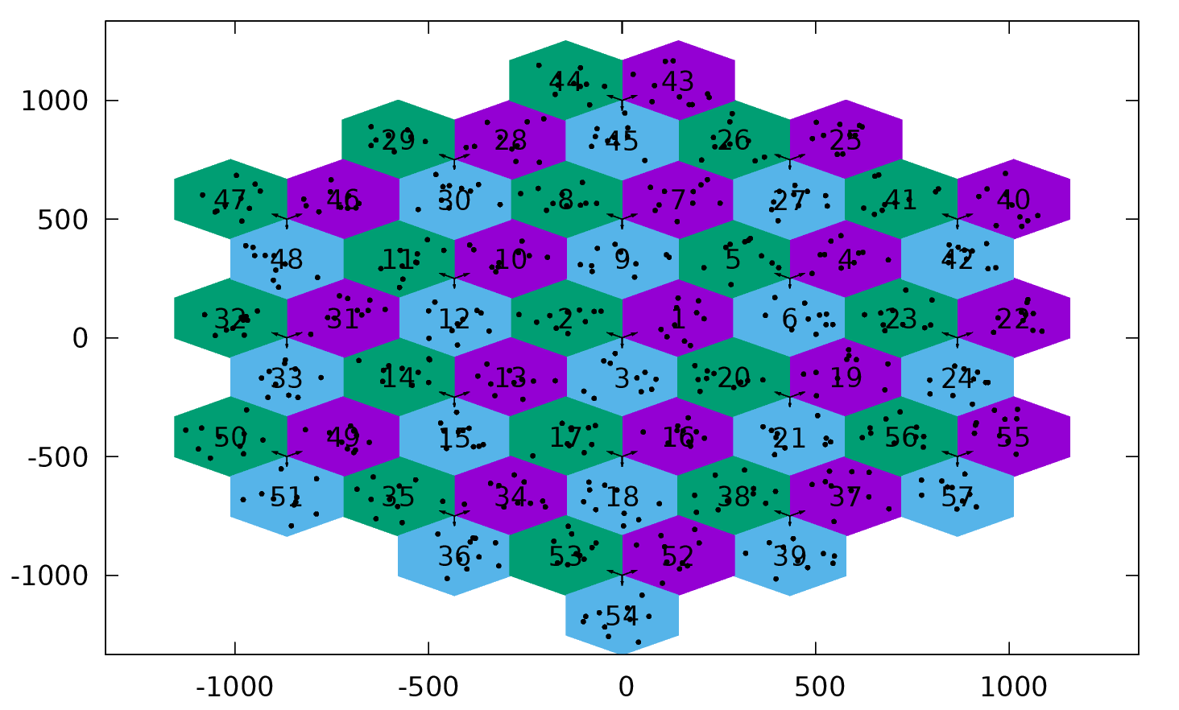
Table 2
System level Technical Assumptions & Parameters (Downlink)
Parameter | Value
Base Station noise figure | 5 dB
UE noise figure | 7 dB
BS antenna element gain | 8 dBi
UE antenna element gain | 0 dBi
Total transmit power per TRxP | 46 dBm for 10 MHz bandwidth
UE power class | 23 dBm
Thermal noise level | ‒174 dBm/Hz
Traffic model | Full buffer
Simulation bandwidth | 20 MHz
Percentage of high loss and low loss building type | 100% low loss
Number of antenna elements per TRxP | 8×2
Number of UE antenna elements | 2×1
Mechanic tilt | 90° in GCS
Electronic tilt | 99° in LCS
UE mobility model | Fixed and identical speed |v| of all UEs, randomly and uniformly distributed direction
UE speeds of interest | 3 km/h
Carrier Frequency for evaluation | 4 GHz
Numerology | 78.125 kHz SCS
Duplexing | TDD

II-C-2B Link Simulation parameters and workflow
The link level simulation parameters have been taken from the EUHT specifications provided by Nufront and have been cross verified with the Self Evaluation Report of EUHT.
Table 3
Link level simulation parameters (Downlink)
Parameter | Value
Scenario | Dense Urban
Carrier Frequency | 4 GHz (Sub 6 GHz Bands)
Bandwidth | 20 MHz
Signalling Waveform | CP-OFDM (SU-MIMO)
Subcarrier Spacing | 78.125 KHz
Delay Spread | 363ns
Cyclic Prefix | FFT Size/4
Guard Band | True
Propagation Channel | Tap Delay Line (TDL)
Mobility | True
Errors Considered | Block Error Rate (BLER)
Channel Coding | LDPC, code rate 4/7 (as per EUHT Self Evaluation Report)
Modulation | QPSK
Channel Estimation | Imperfect, Non-Ideal
Number of Transmit Antennas | 8 (as per EUHT Self Evaluation Report)
Number of Receiver Antennas | 2 (as per EUHT Self Evaluation Report)

A stepwise workflow of the simulator is explained as follows:
1 Update the receiver process: Checks the FCS in MAC layer for any required transmissions.
2 Resource grid generation: Channel Coding and Modulation
3 Waveform generation: OFDM Modulation is performed.
4 Channel modelling: Pass the waveform through a channel.
5 Perform synchronization and OFDM demodulation: Perfect or practical synchronisation is performed.
6 Perform channel estimation: Perfect or practical channel estimation is performed by using the demodulation reference signals or common reference signal. Then OFDM demodulation is performed.
7 Perform equalization and CPE compensation:
a) MMSE or ZF is used to equalize the estimated channel.
b) Estimation of the common phase error (CPE) is done using the reference symbols.
c) Correction of error in each OFDM symbol is performed using the RS symbols.
8 Precoding matrix calculation: Generate the precoding matrix for the next transmission.
9 Decode the TCH: Demodulation and descrambling of the recovered TCH symbols for all transmit and receive antenna pairs, along with a noise estimate is performed.
10 Decode DL-TCH

II-C-3 Results
The 5%-tile SINR applied for link level simulation is -2.675 dB as it can be seen in the following figure. It can be seen in Table 4 that the candidate technology does not pass the reliability requirements of ITU.
Figure 2
Downlink SINR distribution obtained from System-Level simulations
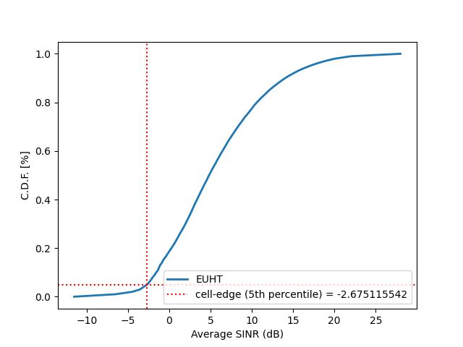

Table 4
Results for Downlink
Minimum technical performance requirements (ITU-R M.2410) | Category |  |  | Required value | Value | Meets the Requirement? | Remarks
 | Usage scenario | Test environment | Downlink or Uplink
Reliability | URLLC | Urban macro-URLLC | Downlink | 99.999% | 99.875% | No | The candidate under evaluation does not meet the reliability criteria due to the provided antenna configuration. We have provided additional remarks in the next section for further evaluation.

II-D Documentation of any additional evaluation methodologies that are or might be developed by the Independent Evaluation Group to complement the evaluation guidelines.

II-D-1 Further Performance Evaluation (Scenario: Urban-macro URLLC)
As per ITU-R M.2412 for Urban-Macro URLLC Configuration-A, up to 8 receiver antennae can be used but in the Self Evaluation Report of EUHT, NuFront shows the maximum number of receiver antennae as 2. Ideally, space-time diversity helps in reducing the BLER which means increase in number of Receiver Antennae can lead to better BLER hence increasing the probability for the candidate technology to pass the ITU requirements.
The IEG would like to work on the receiver design of the simulator and perform further simulations with various antennae configurations to observe if the candidate technology passes the reliability requirement. These follow-on results will be submitted to the ITU WP5D in the meeting in August/September 2021.

II-E Verification as per Report ITU-R M.2411 of the compliance templates and the self-evaluation for each candidate technology as indicated in A)
The verification of compliance templates and the self-evaluation is considered as per ITU-R M.2411.

II-F Assessment as per Reports ITU-R M.2410, ITU-R M.2411 and ITU-R M.2412 for each candidate technology as indicated in A)
The assessment has been carried out as per Reports ITU-R M.2410, ITU-R M.2411 and ITU-R M.2412.

II-G Questions and feedback to WP 5D and/or the proponents or other IEGs
This IEG has referred to the self-evaluation report provided by the EUHT and utilized the parameters used by the EUHT self-evaluation to cross verify the findings.

II-H Proposed next steps towards the final report
The IEG will like to perform further simulations with various antennae configurations to observe if the candidate technology passes the reliability requirement.
Part III
Conclusions
In this report, we present the methodology that we plan to adopt for evaluating the RIT for urban macro URLLC scenario. We have detailed the system and link-level simulation parameters, technical assumption and the network layout. We have provisionally concluded that the RIT does not pass the reliability requirements laid down by ITU.
The receiver design and the antenna configuration for EUHT is complex, and we are working on understanding the parameters to build the simulation model. We are also analysing the multi-antenna configuration suggested by EUHT. We are under the process of building a simulation design and our plan is to simulate different configurations before we conclude our results that will be submitted in the next ITU-WP5D meeting in August/September.

___________________

