|  |  |
| --- | --- |
| **Radiocommunication Study Groups** |  |
|  |  |
|  |  |
| Received: 31 May 2021  Source: Wireless World Research Forum | **Document 5D/658-E** |
| **31 May 2021** |
| **English only  TECHNOLOGY ASPECTS** |
| Wireless World Research Forum | |
| Evaluation REPORT ON THE CANDIDATE TECHNOLOGY SUBMISSION FOR IMT-2020 “ETSI (TC DECT) and DECT Forum Proponent” AS PART OF the re-engagement in Step 4 EVALUATION | |
|  | |

This contribution to the WP 5D #38 meeting contains the evaluation report from the Independent Evaluation Group Wireless World Research Forum (WWRF) for ETSI (TC DECT), DECT FORUM, IMT-2020/17 Submission, and in particular the DECT-2020 NR RIT component.

Following the finalization of Step 7 in the IMT-2020 Process, ETSI (TC DECT) and DECT Forum technology submission evaluation was granted an extension in the IMT-2020 Process, for re-engagement and re-evaluation.

The evaluation is based on the characteristics defined in Reports ITU-R M.2410-0, ITU-R M.2411-0 and ITU-R M.2412-0 using a methodology described in Report ITU-R M.2412-0.

The report consists of 3 Parts and a series of Annexes according to the proposed structure by ITU:

• Part I: Administrative Aspects of the WWRF

• Part II: Technical Aspects of the work of WWRF

• Part III: Conclusions

• Annex I: Additional IMT-2020 evaluation details for User-Plane Latency

• Annex II: Additional IMT-2020 evaluation details for Control-Plane Latency

• Annex III: Additional IMT-2020 evaluation details for Simulation-Based KPIs

Part I

Administrative aspects of the Independent Evaluation Group

# I-1 Name of the Independent Evaluation Group

Wireless World Research Forum (WWRF)

# I-2 Introduction and background of the Independent Evaluation Group

WWRF’s goal is to encourage research that will achieve unbounded communications to address key societal challenges for the future. The term “Wireless World” is used in this broad sense to address the support of innovation and business, the social inclusion and the infrastructural challenges. This will be achieved by creating a range of new technological capabilities from wide-area networks to short-range communications, machine-to-machine communications, sensor networks, wireless broadband access technologies and optical networking, along with increasing intelligence and virtualization in networks. This will support a dependable future Internet of people, knowledge and things and the development of a service universe. WWRF is the unique forum where the wireless community can tackle the key research challenges. By searching out the issues, flagging them up to opinion leaders, and then working with liaison partners to deal with them, WWRF drives the development of the Wireless World. WWRF organizes two major events each year combining inputs from industry and academic experts, the exchange of ideas and the evolution of the research agenda and technology roadmaps. WWRF’s has a strong publication programme, working with partners such as IEEE and Wiley, makes the key messages and results available to the wireless research sector. To ease standardization, WWRF disseminates and harmonizes views, and together with our major liaison partners, we initiate collaborative research, and develop the global vision.

Over the last ten years, WWRF has championed several activities focused on the wireless evolution to and beyond 5G, including workshops and special sessions, presentations, white papers and journal special issues.

WWRF ITU engagement

WWRF has been very supportive of the ITU’s evaluation process for IMT-2020 and participates as an independent evaluation group (IEG).

WWRF continues to work with ITU in a number of areas. WWRF was pleased to be invited, along with the other Independent Evaluation Groups (IEGs), to attend WP 5D #36e as a guest, to discuss the process for continuing evaluation of the remaining candidate IMT-2020 technologies.

WWRF is delighted to be accepted as a Sector Member of ITU in December 2020. In its capacity as ITU member WWRF is planning a number of direct contributions, including its participation as IEG in the IMT 2020 evaluation of the ETSI (DECT) and Nufront proposals.

# I-3 Method of work

## I-3-1 Background

An SRIT proposal was submitted to ITU-R WP5D by ETSI (DECT). The proposed SRIT consists of two component RITs: (a) DECT-2020 NR RIT and (b) 3GPP 5G CANDIDATE FOR INCLUSION IN IMT-2020: SUBMISSION 2 FOR IMT-2020 (RIT).

During STEP 4 of the IMT-2020 evaluation process, the proponent’s ETSI (TC DECT) & DECT FORUM submission (document IMT-2020/17 Rev.1) did not receive a complete evaluation as to whether it satisfies all the requirements for an RIT component (as mandated by ITU-R Res. **65**).

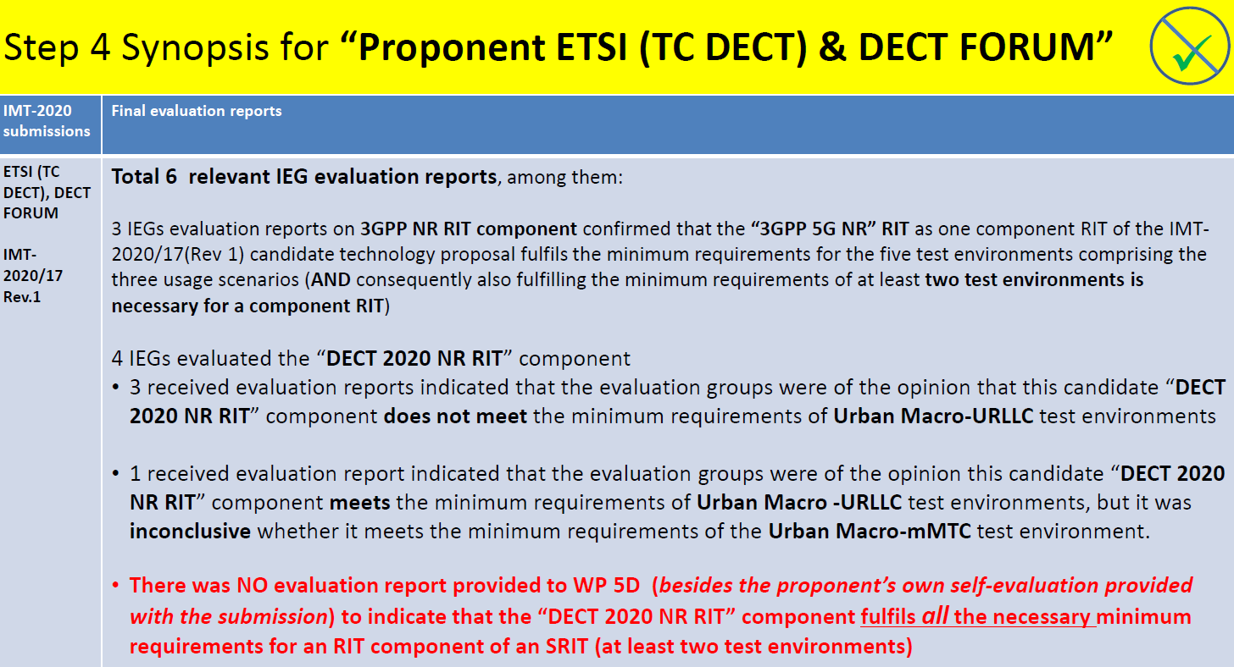

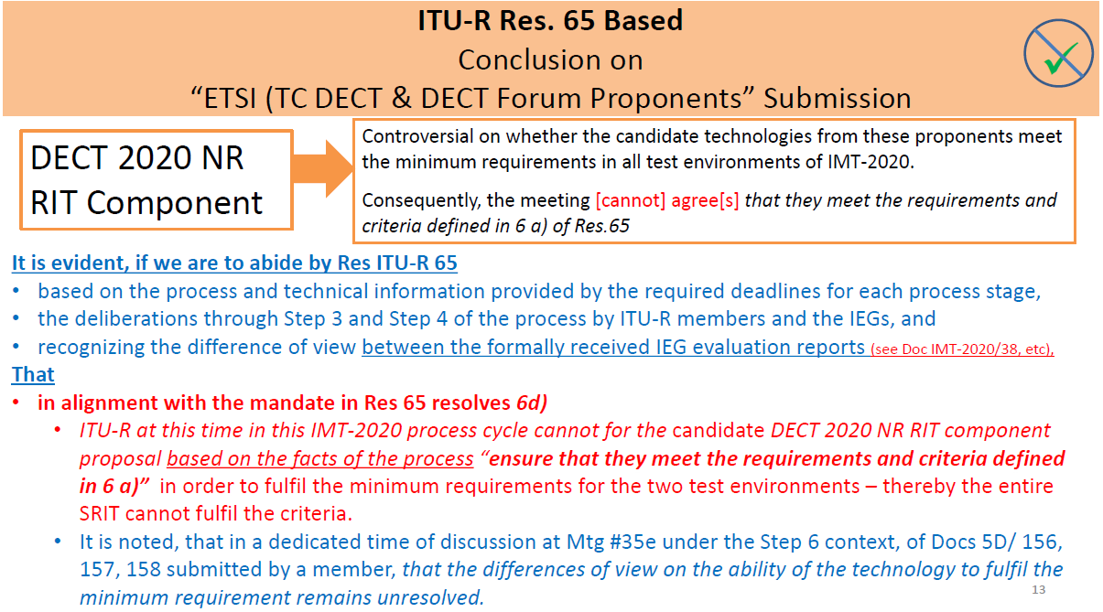

As a way forward the following was decided by WP5D (Option 2): The ETSI (TC DECT) & DECT FORUM candidate submission will carry-on in the current process (Step 4 to Step 7), under an extension, rewinding back to Step 4 (as indicated in the following figure).

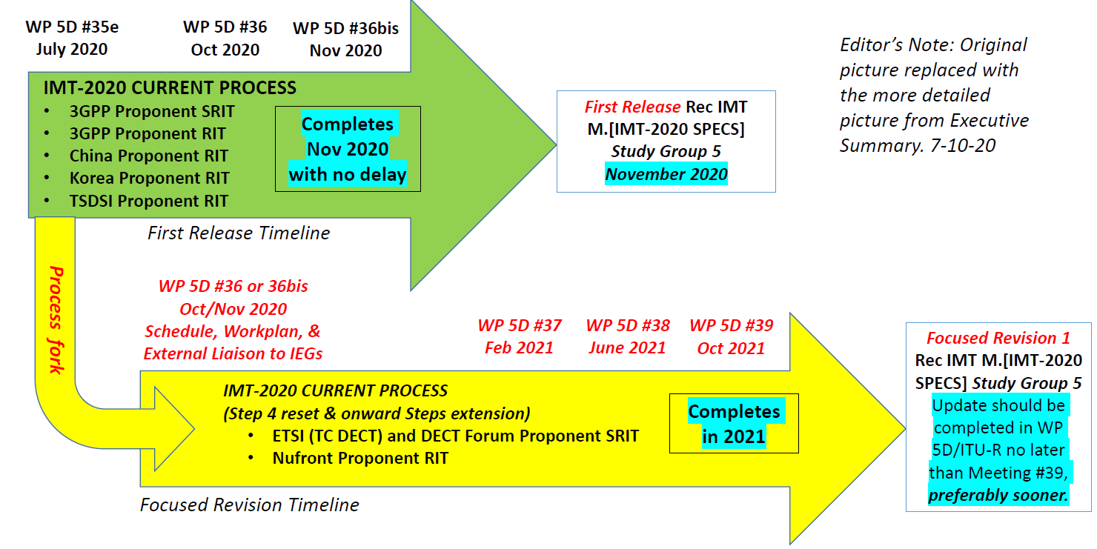

In view of the above, the WWRF IEG team is committed to contribute to this additional phase of the IMT-2020 evaluation process.

The scope of the work is to assess the IMT-2020/17 technology proposal submitted by ETSI (TC DECT) for inclusion in IMT-2020. The proposed SRIT consists of two component RITs:

• DECT-2020 NR RIT

• 3GPP 5G CANDIDATE FOR INCLUSION IN IMT-2020: SUBMISSION 2 FOR IMT-2020 (RIT)

This proposal addresses all the five test environments across the three usage scenarios (eMBB, mMTC, and URLLC) as described in Report ITU-R M.2412-0.

Within the SRIT:

• The eMBB usage scenario is addressed by the 3GPP NR component.

• the DECT-2020 NR component address two usage scenarios (mMTC and URLLC) as described in Report ITU-R M.2412.0.

The 3GPP NR component has been already evaluated by other IEGs. **Hence, this report considers** **only the DECT-2020 NR RIT component**. Since the DECT-2020 component RIT addresses URLLC and mMTC test environments, the technical performance requirements related to these test environments will only be evaluated.

## I-3-2 Organizational Issues

The work was organized using the following channels:

1) Regular phone meetings of the WWRF IEG steering board

2) Regular bi-weekly phone meetings of the technical teams

3) E-mail exchanges through a dedicated mailing list

4) Exchange of files through a shared workspace

5) Dedicated sessions in WWRF workshops

6) Monitoring of and Contribution to the ITU Discussion Forum

7) Communication with other IEGs, in particular CEG and ETSI EG through telcos and e-mail

8) Communication with the proponent through e-mail

# I-4 Administrative contact details

Name & Affiliation; Dr Nigel Jefferies, WWRF Chairman

Email: [chairman@wwrf.ch](mailto:xxxx@xxx.xx)

# I-5 Technical contact details

|  |  |  |
| --- | --- | --- |
| [Name](mailto:hakan.batikhan@turkcell.com.tr) | Affiliation | e-mail |
| Prof. Angeliki Alexiou | University of Piraeus | aalexiou@ieee.org |
| Dr. Antonis Gkotsis | University of Piraeus, Feron Technologies P.C. | antonis.gotsis@feron-tech.com |
| Dr. Konstantinos Maliatsos | University of Piraeus, Feron Technologies P.C. | konstantinos.maliatsos@feron-tech.com |

Part II

Technical aspects of the work of the Independent Evaluation Group

# II-A What candidate technologies or portions of the candidate technologies this IEG is or might anticipate evaluating?

“ETSI (TC DECT) and DECT Forum” (IMT-2020/17) submission according to the following material:

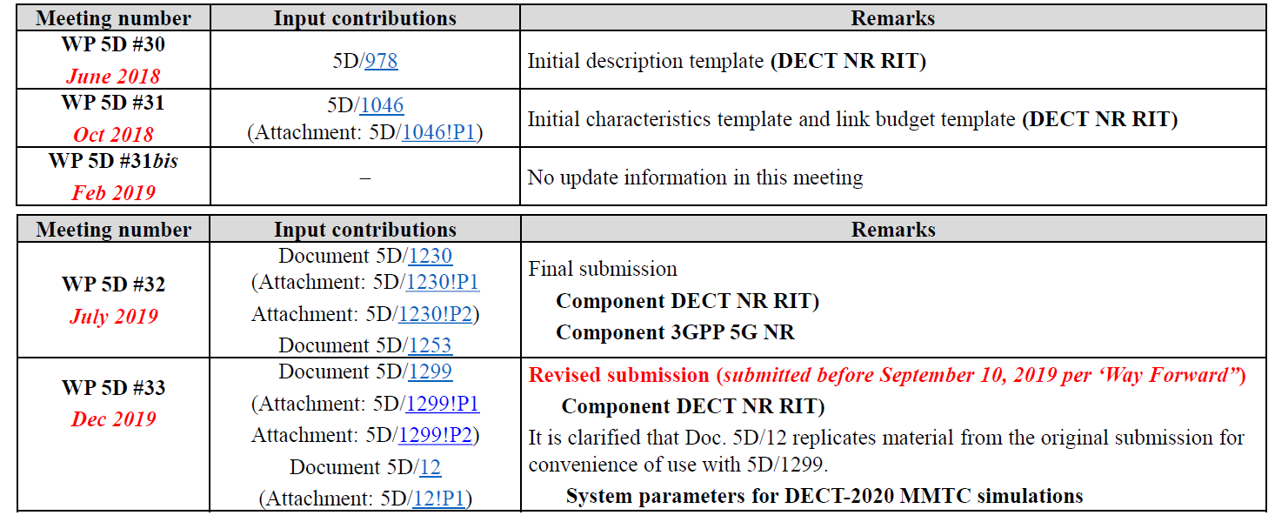

It is noted that the present evaluation work considers exclusively on the DECT-2020 NR RIT Component, since the 3GPP 5G NR component has been thoroughly evaluated by other Independent Evaluation Groups. The technical performance requirements listed in Table 1 will be assessed (Ref: Report ITU-R M.2412-0). In Table 1 we list for each addressed characteristic the assessment method used (based on ITU evaluation methodology), references to the requirements and exact methodology steps from corresponding ITU documents Reports ITU-R M.2410-0 and ITU-R M.2412-0, and references to Sections of this report containing the analysis and results of evaluation.

Table 1

Technical performance requirements assessed for DECT-2020 NR RIT component in URLLC and mMTC test environments

| Characteristic for evaluation (test-environment) | High-level assessment method | Reference to M.2410-0 Requirements Document | Reference to M.2412-0 Evaluation Document | Reference to Evaluation Methodology Analysis and Results in this Document |
| --- | --- | --- | --- | --- |
| User plane latency (URLLC) | Analytical | § 4.7.1 | § 7.2.6 | II-E-2-1, Annex I |
| Control plane latency (URLLC) | Analytical | § 4.7.2 | § 7.2.5 | II-E-2-2, Annex II |
| Mobility interruption time (URLLC) | Analytical | § 4.12 | § 7.2.7 | II-E-2-3 |
| Reliability (URLLC) | Simulation | § 4.10 | § 7.1.5 | II-E-2-4, Annex III |
| Connection density (mMTC) | Simulation | § 4.8 | § 7.1.3 | II-E-2-5, Annex III |
| Bandwidth | Inspection | § 4.13 | § 7.3.1 | II-E-2-6 |

# II-B Confirmation of utilization of the ITU-R evaluation guidelines in Report ITU‑R M.2412

The WWRF IEG and its members confirm that they have followed the ITU-R evaluation guidelines provided in the Report ITU-R [M.2412](https://www.itu.int/pub/R-REP-M.2412)-0.

# II-C Documentation of any additional evaluation methodologies that are or might be developed by the Independent Evaluation Group to complement the evaluation guidelines

For assessing characteristics using simulation, i.e., reliability and connection density, we rely on an in-house simulation tool. The developed simulator is decomposed into two main components:

● The link level simulator: implementing/simulating the radio transmission between two nodes of the system.

● The system level simulator: implementing/simulating the radio access network setup according to the specifications of the ITU evaluation guidelines (Report ITU-R M.2412 § 8.4).

It is noted that:

● Both simulator components are developed in MATLAB/Octave.

● Both simulator components are developed in-house with limited use of MATLAB communication toolbox functions – the latter mainly used for channel modelling purposes.

● In order to develop the simulator, the following documents were used as a reference:

○ Report ITU-R M.2412 Guidelines for evaluation of radio interface technologies for IMT-2020,

○ Report ITU-R M.2411 Requirements, evaluation criteria and submission templates for the development of IMT-2020,

○ TS103.636-1, DECT-2020 New Radio (NR); Part 1: Overview,

○ TS103.636-2, DECT-2020 New Radio (NR); Part 2: Radio reception and transmission requirements,

○ TS103.636-3, DECT-2020 New Radio (NR); Part 3: Physical layer,

○ TS103.636-4, DECT-2020 New Radio (NR); Part 4: MAC layer

○ 5D/1299 Submission Template

# II-D Verification as per Report ITU-R M.2411 of the compliance templates and the self-evaluation for each candidate technology as indicated in A)

No clarification on compliance templates or self-evaluation has been requested.

# II-E Assessment as per Reports ITU-R M.2410, ITU-R M.2411 and ITU-R M.2412 for each candidate technology as indicated in A)

The WWRF IEG evaluated the DECT-2020 NR RIT component, as the 3GPP 5G NR component RIT of the proposal was reviewed by other IEGs and already concluded by ITU-R WP 5D to fulfil the requirements. We provide the compliance templates for services, spectrum and technical performance (Section II-E-1) and then the minimum technical performance requirements analysis (Section II-E-2). Since the DECT-2020 component RIT addresses URLLC and mMTC test environments, the technical performance requirements related to these test environments were evaluated only.

## II-E-1 Compliance Templates

### II-E-1-1 Services

|  |  |
| --- | --- |
|  | Service capability requirements |
| **5.2.4.1.1** | **Support for wide range of services**  Is the proposal able to support a range of services across different usage scenarios (eMBB, URLLC, and mMTC)?: 🗹YES / NO  Specify which usage scenarios (eMBB, URLLC, and mMTC) the candidate RIT or candidate SRIT can support |
| **Evaluator’s Comments:**  The DECT NR 2020 RIT supports URLLC and mMTC usage scenarios.  Note: The proposed RIT component is part of an SRIT which also includes the 3GPP 5G NR component RIT. The 3GPP 5G NR is identical to the submission by 3GPP, which was concluded by ITU-R WP 5D to support eMBB, URLLC and mMTC usage scenarios. |

### II-E-1-2 Spectrum

|  |  |
| --- | --- |
|  | Spectrum capability requirements |
| **5.2.4.2.1** | **Frequency bands identified for IMT**  Is the proposal able to utilize at least one frequency band identified for IMT in the ITU Radio Regulations?: 🗹 YES / NO  Specify in which band(s) the candidate RIT or candidate SRIT can be deployed. |
| **Evaluator’s Comments:** The DECT-2020 NR physical layer is in principle suited to addressing frequency bands below 6 GHz (ETSI TS 103 636-1 V1.1.1 – 4.1). The physical layer employs Cyclic Prefix Orthogonal Frequency Division Multiplexing (CP-OFDM) combined with Time Division Multiple Access (TDMA) and Frequency Division Multiple Access (FDMA) in a Time Division Duplex (TDD) communication manner. Subcarrier spacing is defined by the subcarrier scaling factor μ, resulting either in 27 kHz, 54 kHz, 108 kHz or 216 kHz OFDM subcarriers spacing. In addition, the fourier transform scaling factor β can be set to allow different transmission bandwidths for each configuration of the subcarrier spacing. This results in the support of nominal RF bandwidth from 1,728 MHz up to 221,184 MHz (ETSI TS 103 636-1 V1.1.1 – 6.2.2). The radio channel numbering scheme enables to assign channels from 450 MHz up to 5 875 MHz organized into 17 different operating bands.  According to ETSI TS 103 636-2 V1.1.1 – 5.2, the DECT 2020 NR RIT radio devices operate in the following bands:   | **Band number** | **Receiving band (MHz)** | **Transmitting band (MHz)** | | --- | --- | --- | | 1 | 1 880 to 1 900 | 1 880 to 1 900 | | 2 | 1 900 to 1 920 | 1 900 to 1 920 | | 3 | 2 400 to 2 483,5 | 2 400 to 2 483,5 | | 4 | 902 to 928 | 902 to 928 | | 5 | 450 to 470 | 450 to 470 | | 6 | 698 to 806 | 698 to 806 | | 7 | 716 to 728 | 716 to 728 | | 8 | 1 432 to 1 517 | 1 432 to 1 517 | | 9 | 1 910 to 1 930 | 1 910 to 1 930 | | 10 | 2 010 to 2 025 | 2 010 to 2 025 | | 11 | 2 300 to 2 400 | 2 300 to 2 400 | | 12 | 2 500 to 2 620 | 2 500 to 2 620 | | 13 | 3 300 to 3 400 | 3 300 to 3 400 | | 14 | 3 400 to 3 600 | 3 400 to 3 600 | | 15 | 3 600 to 3 700 | 3 600 to 3 700 | | 16 | 4 800 to 4 990 | 4 800 to 4 990 | | 17 | 5 725 to 5 875 | 5 725 to 5 875 |   Various frequency bands identified for IMT in Rec. ITU-R M.1036-6 are used by the specific RIT  Note: The following frequency bands have been identified for IMT in all three ITU Regions: 450 – 470 MHz, 470-698 MHz, 694/98-960 MHz, 1 427-1 518 MHz, 1 710‑2 025 MHz, 2 110-2 200 MHz, 2 300-2 400 MHz, 2 500-2 690 MHz, 3 300‑3 700 MHz, 4 800-4 990 MHz |
| **5.2.4.2.2** | **Higher Frequency range/band(s)**  Is the proposal able to utilize the higher frequency range/band(s) above 24.25 GHz?:  🗹 YES / NO  Specify in which band(s) the candidate RIT or candidate SRIT can be deployed.  NOTE 1 – In the case of the candidate SRIT, at least one of the component RITs need to fulfil this requirement. |
| **Evaluator’s Comments:** The DECT-2020 NR physical layer is in principle suited to addressing frequency bands below 6 GHz (ETSI TS 103 636-1 V1.1.1 – 4.1). According to information provided in [5D/1299](https://www.itu.int/md/R15-WP5D-C-1299/en), any other frequency band may be allocated in the future to the service, including bands above 24.25 GHz.  Note: The proposed RIT component is part of an SRIT which also includes the 3GPP 5G NR component RIT. The 3GPP 5G NR is identical to the submission by 3GPP, which was concluded by ITU-R WP 5D that is able to utilize the higher frequency range/band(s) above 24.25 GHz |

### II-E-1-3 Technical Performance

KPIs related to URLLC and mMTC usage scenarios are evaluated only for the DECT 2020 NR component.

| Minimum technical performance requirements item (5.2.4.3.x), units, and Report ITU-R M.2410-0 section reference(1) | Category | | | Required value | Value(2) | Requirement met? | Comments (3) |
| --- | --- | --- | --- | --- | --- | --- | --- |
| Usage scenario | Test environment | Downlink or uplink |  |  |  |  |
| **5.2.4.3.7** User plane latency (ms) *(4.7.1)* | eMBB | Not applicable | Uplink and Downlink | 4 |  | Yes  No |  |
| URLLC | Not applicable | Uplink and Downlink | 1 | 0.198-0.975 ms | 🗹 Yes  No | Refer to Annex I for specific configurations |
| **5.2.4.3.8** Control plane latency (ms) *(4.7.2)* | eMBB | Not applicable | Not applicable | 20 |  | Yes  No |  |
| URLLC | Not applicable | Not applicable | 20 | 6.25 ms | 🗹 Yes  No | Refer to Annex II for configuration details |
| **5.2.4.3.9** Connection density (devices/km2) *(4.8)* | mMTC | Urban Macro – mMTC | Uplink | 1 000 000 | [no final results yet] | Yes  No | [Initial results indicate that the requirement is fulfilled] |
| **5.2.4.3.11** Reliability *(4.10)* | URLLC | Urban Macro –URLLC | Downlink | 1-10−5 success probability of transmitting a layer 2 PDU (protocol data unit) of size 32 bytes within 1 ms in channel quality of coverage edge | >1-10-6 for both LoS and NLoS for Configuration B with 5x4 with 1/7 frequency reuse and 1.728MHz bandwidth | 🗹 Yes  No | Refer to Section II-E-2-4 for details in examined configurations |
| **5.2.4.3.14** Mobility interruption time (ms)  *(4.12)* | eMBB and URLLC | Not applicable | Not applicable | 0 | 0 ms | 🗹 Yes  No | Refer to Section II-E-2-3 for complete analysis |
| **5.2.4.3.15** Bandwidth and Scalability *(4.13)* | Not applicable | Not applicable | Not applicable | At least 100 MHz | 221,184 MHz | 🗹 Yes  No | Refer to Section II-E-1-2 |
| Up to 1 GHz | Multiple Carriers | 🗹 Yes  No |
| Support of multiple different bandwidth values(4) | 1.728 MHz to 221.184 MHz. | 🗹 Yes  No |
| (1) As defined in Report ITU-R M.2410-0.  (2) According to the evaluation methodology specified in Report ITU-R M.2412-0.  (3) Proponents should report their selected evaluation methodology of the Connection density, the channel model variant used, and evaluation configuration(s) with their exact values (e.g. antenna element number, bandwidth, etc.) per test environment, and could provide other relevant information as well. For details, refer to Report ITU-R M.2412-0, in particular, § 7.1.3 for the evaluation methodologies, § 8.4 for the evaluation configurations per each test environment, and Annex 1 on the channel model variants.  (4) Refer to § 7.3.1 of Report ITU-R M.2412-0. | | | | | | | |

## II-E-2 Minimum Technical Performance Requirements Analysis

### II-E-2-1 User-plane latency (URLLC)

Conclusion

WWRF IEG concluded that the DECT-2020 NR RIT component from ETSI (TC DECT) and DECT Forum SRIT submission ([IMT-2020/17(Rev 1)](https://www.itu.int/md/R15-IMT.2020-C-0017/en) document) is compliant with the user-plane latency requirement of 1 ms for URLLC as specified by Report [ITU‑R M.2410](https://www.itu.int/dms_pub/itu-r/opb/rep/R-REP-M.2410-2017-MSW-E.docx), in Section 4.7.1.

Verification

The elements considered in the user-plane latency analysis of the DECT-2020 NR RIT component along with their values for 3 different numerologies (μ=1,2,4 and β=1) are given in Table 2.

Table 2

User-Plane Latency Analysis Details and Overall Results. Scenarios/Configurations which are compliant with ITU requirement of 1 ms are highlighted with green color.

|  |  |  |  |  |
| --- | --- | --- | --- | --- |
| Step | EndPoint | Delay μs (μ=1) | Delay μs (μ=2) | Delay μs (μ=4) |
| Step 1a : Tx Processing | TX-RD (Source) | 208.34 | 104.17 | 52.08 |
| Step 1b: Alignment with random access start position | TX-RD (Source) | 83.33 | 41.67 | 20.83 |
| Step 2a: LBT | TX-RD (Source) | 83.33 | 41.67 | 20.83 |
| Step 2b: Packet Transmission | TX-RD (Source) | 208.34 | 104.17 | 52.08 |
| Step 3a: Rx Processing | RX-RD (Destination) | 208.34 | 104.17 | 52.08 |
| Step 3b (only for ReTx Case): HARQ Feedback Timing | RX-RD (Destination) | 416.67 | 208.34 | 104.17 |
| Step 4a: NACK Transmission Processing | RX-RD (Destination) | 208.34 | 104.17 | 52.08 |
| Step 4b: NACK Transmission | RX-RD (Destination) | 208.34 | 104.17 | 52.08 |
| Step 4c: NACK Rx Processing & Alignment | TX-RD (Source) | 291.67 | 104.17 | 52.08 |
| Step 5a: LBT & Packet Retransmission | TX-RD (Source) | 291.67 | 145.83 | 72.92 |
| Step 5b: Re-transmission Rx Processing | RX-RD (Destination) | 208.34 | 104.17 | 52.08 |
| **Overall Latency Results (ms)** | **No HARQ** | **0.792** | **0.396** | **0.198** |
| **HARQ (average with 10% Re-Tx)** | **0.975** | **0.483** | **0.242** |
| **HARQ (max with one Re-Tx)** | 2.625 | 1.271 | **0.635** |

The overall latency value is also provided with respect to 3 metrics/scenarios: latency under no retransmission, average latency under re-transmission with target packet loss rate of 10%, and worst-case latency with one re-transmission. For the numerology of (μ,β)=(4,1) it is shown that all latency metrics are compliant with the ITU requirement, whereas for (1,1) and (2,1) numerologies latency under no-retransmission or average latency metrics are also compliant.

Further details on the analysis and the results are provided in Annex I.

### II-E-2-2 Control-plane latency (URLLC)

Conclusion

WWRF IEG concluded that the DECT-2020 NR RIT component from ETSI (TC DECT) and DECT Forum SRIT submission ([IMT-2020/17(Rev 1)](https://www.itu.int/md/R15-IMT.2020-C-0017/en) document) is compliant with the control-plane latency requirement of 20 ms as specified by Report [ITU‑R M.2410](https://www.itu.int/dms_pub/itu-r/opb/rep/R-REP-M.2410-2017-MSW-E.docx), in Section 4.7.2.

Verification

The elements considered in the control-plane latency analysis of the DECT-2020 NR RIT component along with their values for the basic numerology of (μ,β)=(1,1) are given in Table 3. The overall latency value is also provided which is shown to be compliant with the ITU requirement.

Table 3

Control-Plane Latency Analysis for DECT-2020 NR RIT Evaluation

|  |  |  |
| --- | --- | --- |
| Step | Description | Value/Comment |
| *0* | *Network/Cluster/Resource Allocation Detection* | *~ 60ms-36s\**  *\* not included in calculations since these procedures can be performed in battery-efficient idle state* |
| 1 | Delay for start using assigned random resources | 1 ms or 5ms (Depending on DECT_Delay field (of the Random Access Resource IE):  Worst-Case: 5ms |
| 2 | Association Request Transmission & Detection | 0.624 ms |
| 3 | Association Response Transmission & Detection | 0.624 ms |
|  | **Overall latency** | **6.25 ms (compliant with 20 ms requirement of ITU)** |

Further details on the analysis and the results are provided in Annex II.

### II-E-2-3 Mobility Interruption Time (URLLC)

Conclusion

WWRF IEG concluded that the DECT-2020 NR RIT component from ETSI (TC DECT) and DECT Forum SRIT submission ([IMT-2020/17(Rev 1)](https://www.itu.int/md/R15-IMT.2020-C-0017/en) document) is compliant with the mobility interruption time requirement of 0 ms as specified by Report [ITU‑R M.2410](https://www.itu.int/dms_pub/itu-r/opb/rep/R-REP-M.2410-2017-MSW-E.docx), in Section 4.7.2.

Verification

ITU defines, in the Report ITU-R M.2410 document, mobility interruption time, as the shortest time duration supported by the system during which a user terminal cannot exchange user plane packets with any base station during transitions. For the considered URLLC usage scenario, a requirement of 0 ms is defined.

In Document ETSI TS 103 636-4 V1.1.1, Medium Access Control (MAC) layer and interaction between MAC layer and physical layer and higher layers, for the DECT-2020 New Radio (NR), are specified. In each connection between two Radio Devices (RDs), one RD is in FT-mode and the other RD is in PT-mode (Section 5.1). RD mobility is based on RD reselection decision to change association from previous RD in FT mode to another RD in FT mode (Section 5.7). The re-association procedure (Section 5.8) is facilitated through the following MAC messages:

● The association request message is used by an RD to initiate communication with another RD (Section 6.4.2.4). There is a 3-bit field in the message called Setup cause, which indicates the cause of the association, where for mobility is coded as 010 (Table 6.4.2.4-2)

● For releasing the connection an Association Release message is sent (Section 6.4.2.6), containing a Release Cause field, which defines the cause of the release, i.e. mobility in this case.

Regarding re-association the following are noted (Section 5.7):

● The RD may initiate and complete association to target RD in FT mode before releasing the association from source RD in FT mode.

● The RD may fail to send Association Release message to source due to loss of radio connection.

● An RD may maintain association to multiple RDs simultaneously.

Hence, user-plane packets may be exchanged between the RD -in mobility procedure- and multiple other RDs in FT-mode simultaneously (duplicate data transmission resolved at other layers). This means that uninterrupted user-plane communication is supported, i.e. the minimum supported interruption time is 0 ms.

### II-E-2-4 Reliability (URLLC)

Conclusion

The WWRF IEG has concluded that the DECT-2020 NR RIT component from ETSI (TC DECT) and DECT Forum SRIT submission ([IMT-2020/17(Rev 1)](https://www.itu.int/md/R15-IMT.2020-C-0017/en) document) fulfils the URLLC service requirement. DECT-2020 NR RIT is able to satisfy the reliability requirements for various configurations, taking into account the guidelines and assumptions described in Report ITU‑R M.2410. Validation was performed through extensive simulation.

Verification

An End-to-End Physical Layer simulator of the DECT-2020 NR technology was developed by WWRF in MATLAB, able to perform jointly system-level and link-level experiments.

Details on the simulator, the implemented configurations and scenarios, as well as on the results can be found in Annex III.

The following table summarizes the results, indicating several cases that were able to satisfy the requirement for PER lower than 10-5 for the configurations described in the ITU-R guidelines (Report ITU-R M.2412-0).

Table 4

Simulated cases and scenarios for the evaluation of the Reliability KPIs for the DECT-2020 NR component

|  |  |  |  |
| --- | --- | --- | --- |
| Setup | 5th percentile point packet error probability | SINR threshold | Fulfilment of the requirement |
| SISO with 1/7 frequency reuse and 1.728 MHz bandwidth  (Configuration B) | approximately 0.05 for LoS  approximately 0.5 for NLoS | 3.2 dB | NO |
| 2x2 with 1/7 frequency reuse and 1.728 MHz bandwidth  (Configuration B) | <10-6 for LoS  approximately 0.05 for NLoS | 3.2 dB | YES (for LoS) |
| 5x4 with 1/7 frequency reuse and 1.728 MHz bandwidth  (Configuration B) | <10-6 for LoS (10-5 is achieved at appr. -8 dB)  <10-6 for NLoS | 3.2 dB | YES |
| 5x4x1x2 with 1/7 frequency reuse and 1.728 MHz bandwidth  (Configuration B) | <10-6 for LoS (10-5 is achieved at appr. -12 dB)  <10-6 for NLoS | 3.2 dB | YES |
| SISO with 1/3 frequency reuse and 1.728 MHz bandwidth  (Configuration B) | Nonfunctional at this SNR | -5.1 dB | NO |
| 2x2 with 1/3 frequency reuse and 1.728 MHz bandwidth  (Configuration B) | approximately 0.02 for LoS  Nonfunctional at this SNR for NLoS | -5.1 dB | NO |
| 5x4 with 1/3 frequency reuse and 1.728 MHz bandwidth  (Configuration B) | <10-6 for LoS (10-5 is achieved at appr. -8 dB)  approximately 0.005 for NLoS | -5.1 dB | YES (for LoS) |
| 5x4x1x2 with 1/3 frequency reuse and 1.728 MHz bandwidth  (Configuration B) | <10-6 for LoS (10-5 is achieved at appr. -12 dB)  approximately 10-6 for NLoS | -5.1 dB | YES |
| SISO with 1/7 frequency reuse and 3.456 MHz bandwidth  (Configuration A) | Nonfunctional at this SNR | -11.1 dB | NO |
| 2x2 with 1/7 frequency reuse and 3.456 MHz bandwidth  (Configuration A) | Nonfunctional at this SNR | -11.1 dB | NO |
| 5x4 with 1/7 frequency reuse and 3.456 MHz bandwidth  (Configuration A) | approximately 0.001 for LoS  approximately 0.2 for NLoS | -11.1 dB | NO |
| 5x4x1x2 with 1/7 frequency reuse 3.456 MHz bandwidth  (Configuration A) | <10-6 for LoS (10-5 is achieved at appr. -12 dB)  approximately 0.04 for NLoS | -11.1 dB | YES (for LoS) |

All details, as well as the SINR distributions and the Link-Level analysis for the aforementioned setups can be found in Annex III.

### II-E-2-5 Connection Density (mMTC)

Conclusion

The WWRF IEG investigations regarding the fulfilment of the Connection Density requirements are at this point inconclusive, since more time is needed for validation.

Following the ITU Evaluation Methodology, the specific KPI requires an involved system simulation procedure, which is detailed in Report ITU-R M.2412, for cellular topology only. However, the DECT-2020 NR RIT introduces a mesh network topology and system operation, where network devices can communicate directly to each other for extending the range of network and increasing the reliability of communication. Since Report ITU-R M.2412 does not address the methodological framework for mesh topologies, WWRF IEG devoted significant resources for rigorously defining all the additional aspects required for performing such an evaluation.

*[Initial results indicate that the DECT-2020 NR Component is able to satisfy the Connection Density requirements for a selected configuration with the use of multi-hop communications and a properly defined relay protocol. However, additional simulation and validation activities are required in order to finalize the WWRF IEG conclusions.]*

WWRF IEG will be able to provide the complete evaluation results for the mMTC service requirements for DECT-2020 NR technology, in time for the August 2021 “special meeting” of WP 5D, should WP 5D agrees to a deadline extension as proposed in [5D/607](https://www.itu.int/md/R19-WP5D-C-0607/en).

Verification

An End-to-End Physical Layer simulator of the DECT-2020 NR technology was developed by WWRF IEG in MATLAB, able to perform jointly system-level and link-level experiments.

WWRF IEG addressed the following issues:

• System model definition/extension including relay/forwarding nodes in addition to standard cellular UEs.

• Introduction of a simple but effective protocol for multi-hop communications

• Definition of a relay selection scheme based on channel quality conditions.

• Consideration of device-to-device channel models for relay communication, not previously considered in cellular technologies evaluation.

At this stage, WWRF IEG is confident that it has developed a system model simulator that is able to take into account the particularities of the DECT-2020 NR RIT, while remaining aligned with the evaluation guidelines defined in Report ITU-R M.2412-0.

The description of the simulator can be found in Annex III.

### II-E-2-6 Bandwidth

Conclusion

WWRF IEG concluded that the DECT-2020 NR RIT component from ETSI (TC DECT) and DECT Forum SRIT submission ([IMT-2020/17(Rev 1)](https://www.itu.int/md/R15-IMT.2020-C-0017/en) document) is compliant with the bandwidth requirement as specified by Report [ITU‑R M.2410](https://www.itu.int/dms_pub/itu-r/opb/rep/R-REP-M.2410-2017-MSW-E.docx), in Section 4.13.

Verification

ITU denotes, in the Report ITU-R M.2410 document, that the requirement for bandwidth is to be at least 100 MHz, support larger bandwidths up to 1 GHz for operation in higher frequency bands and be scalable (i.e.be able to operate with different bandwidths).

The DECT-2020 NR physical layer is in principle suited to addressing frequency bands below 6 GHz (ETSI TS 103 636-1 V1.1.1 – 4.1). The physical layer employs Cyclic Prefix Orthogonal Frequency Division Multiplexing (CP-OFDM) combined with Time Division Multiple Access (TDMA) and Frequency Division Multiple Access (FDMA) in a Time Division Duplex (TDD) communication manner. Subcarrier spacing is defined by the subcarrier scaling factor μ, resulting either in 27 kHz, 54 kHz, 108 kHz or 216 kHz OFDM subcarriers spacing. In addition, the fourier transform scaling factor β can be set to allow different transmission bandwidths for each configuration of the subcarrier spacing. This results in the support of nominal RF bandwidth up to 221,184 MHz, which fulfils the minimum requirement of 100 MHz and the scalability requirement (ETSI TS 103 636-1 V1.1.1 – 6.2.2). With the use of multiple carriers higher bandwidths may be supported.

# II-F Questions and feedback to WP 5D and/or the proponents or other IEGs

During the evaluation, the following communication has been performed:

● With other IEGs, in particular CEG and ETSI EG through telcos and e-mail, and

● With the proponent through e-mail.

Part III

Conclusion

WWRF IEG performs a complete evaluation of the DECT-2020 NR RIT component from ETSI (TC DECT) and DECT Forum SRIT submission ([IMT-2020/17(Rev 1)](https://www.itu.int/md/R15-IMT.2020-C-0017/en) document), as part of the re-engagement in Step 4 evaluation.

The main conclusions are:

1) The proposed RIT component is part of an SRIT which also includes the 3GPP 5G NR component RIT. The 3GPP 5G NR is identical to the submission by 3GPP, which was concluded by ITU-R WP 5D to support eMBB, URLLC and mMTC usage scenarios. Therefore for the RIT evaluation considered only URLLC and mMTC test environments.

2) Assessment was based on the RIT submission documents (5D/1299) and published technology specifications ETSI TS 103 636-1 to ETSI TS 103 636-1 V1.1.1), following Reports ITU-R M.2410, ITU-R M.2411 and ITU-R M.2412 guidelines.

3) The DECT NR 2020 RIT supports URLLC and mMTC usage scenarios.

4) The DECT NR 2020 RIT fulfils the requirements and parameters that are evaluated by inspection, i.e. bandwidth, spectrum, and services.

5) The DECT NR 2020 RIT fulfils the requirements that are evaluated by analysis, i.e. user-plane latency, control-plane latency and mobility interruption time.

6) The DECT-2020 NR RIT is able to satisfy the reliability requirements for various configurations, as demonstrated through simulation.

7) Investigations regarding the fulfilment of the Connection Density requirements are at this point inconclusive, since more time is needed for validation. Initial results indicate that the DECT-2020 NR Component is able to satisfy the Connection Density requirements for a selected configuration with the use of multi-hop communications and a properly defined relay protocol. However, additional simulation and validation activities are required in order to finalize the WWRF IEG conclusions.

8) WWRF IEG is committed to complete the evaluation and provide the complete evaluation results for the mMTC service requirements for DECT-2020 NR technology, in time for the August 2021 “special meeting” of WP5D, should WP5D agrees to a deadline extension as proposed in Document [5D/607](https://www.itu.int/md/R19-WP5D-C-0607/en).

Annex I

Additional IMT-2020 evaluation details for User-Plane Latency

ITU defines in the Report ITU-R M.2410 document user-plane latency as the contribution of the radio network to the time from when the source sends a packet to when the destination receives it (in ms). It is one-way time it takes to successfully deliver an application layer packet/message from the radio protocol layer 2/3 SDU ingress point to the radio protocol layer 2/3 SDU egress point of the radio for a given service in unloaded conditions, assuming the mobile station is in the active state.

The following baseline considerations hold through the analysis:

• The baseline numerology is (μ,β)=(1,1), but also (2,1) and (4,1) numerologies are considered.

• A 32-byte Transport Block is considered to be transmitted with the most robust MCS that fits to the payload, based on ETSI TS 103 636-3 V1.1.1 Table C.1-1.

• The Tx processing delay (time required for generating) a single Transport Block is one subslot (the specifications consider transmissions possible on a subslot or a slot basis).

• Given the Tx processing delay, the total time to generate and transmit a packet is one slot.

• The Rx processing delay for a single Transport Block is one subslot.

For the analysis we consider random access based transmission as introduced in ETSI TS 103 636-4, Section 5.3[1]. Resources for random access transmission (RACH) per operating channel are broadcasted in beacons by RDs. We consider the following key assumptions based on the specifications:

• The source RD has obtained random access parameters from a corresponding random access resource assignment through an announcement (ETSI TS 103 636-4, Section 5.3.2).

• After performing random access transmission the RD should receive a response within a random access response window (this is considered for receiving ACK/NACK from the destination RD).

• After transmitting to a random access resource the RD may re-initiate random access transmission procedure to same random access resources (this is considered in case of re-transmissions).

• In addition, following (ETSI TS 103 636-4, Section 5.3.1, slots indicated as random access resources are divided into multiple start positions where the transmission can be initiated. Start positions are counted from the beginning of a random access slot, and are 0, 1, 2, 3… times the duration of STF and GI field (which is $2×T_{symb}^{μ}$, where $T_{symb}^{μ}$ is the OFDM symbol time, depending on numerology). Transmissions to random access resources are controlled by Listen Before Talk (LBT) protocol, with exponential back off delay. An LBT period of 2 symbols is considered and no backoff delay (“free” resources have been selected). In addition, the first slot of a frame is available for RACH transmission (no special RACH resource slots configuration excluding any slot is employed).

• RD shall support HARQ combining based on physical layer control field signalling (ETSI TS 103 636-4, Section 5.3.2). Based on packet coding result an RD sends ACK or NACK feedback in physical control field of the frame. The processing time for creating the feedback is two subslots, resulting that feedback shall be included in transmission at subslot n+3 or next transmitted packet after that, where n indicates the subslot where the reception of the packet ended. High layer signalling can be used to delay HARQ feedback signalling.

In Figure 1 we provide a sequential diagram of the user-plane communication steps in case of a single successful transmission and one re-transmission through HARQ, which is step-by-step elaborated below.

Figure 1

User-plane communication description for random-access based transmission

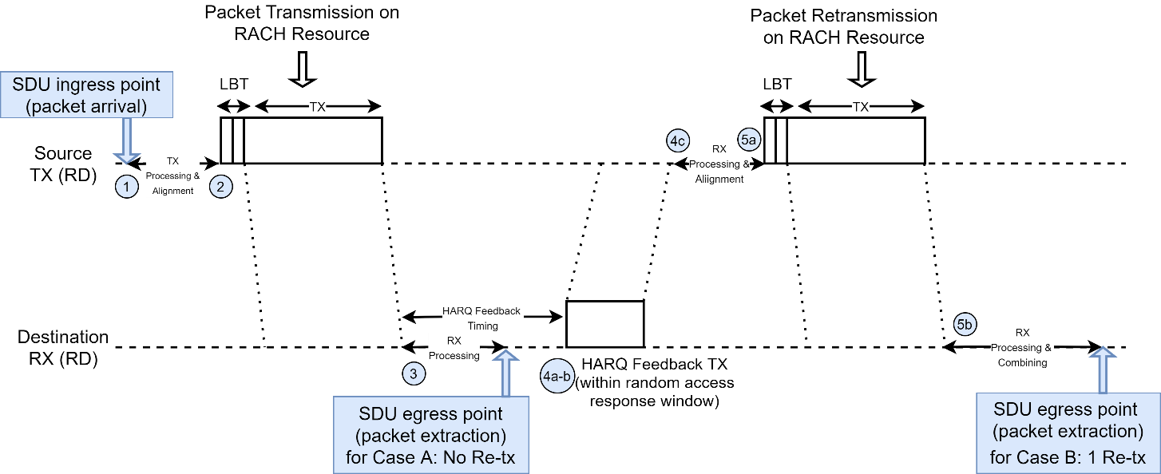

*Step 1 (Tx Processing & Alignment)*: An SDU arrives at MAC Layer of the source RD for transmission to the destination RD. The physical layer transport block is prepared with a delay of 1 subslot (5 symbols), while an additional 2-symbol delay is regarded for aligning with the beginning of the RACH resource slot start position. Note that since the alignment delay is 2-symbols long, it could be absorbed in the Tx processing time of 5 symbols. The total delay of Step 1 is 7 symbols.

*Step 2 (Packet transmission)*: The transport block is transmitted into a RACH resource with a delay of 2 symbols due to LBT and an additional 1 subslot (5 symbols) for actual transmission., i.e. 7 symbols in total.

*Step 3 (Packet reception and recovery)*: The packet arrives at the destination RD (zero propagation delay is assumed) and decoded with 1 subslot (5 symbols) delay. In case the packet is successfully recovered (Case A in Figure 1), it is forwarded to the MAC layer of the destination RD and the procedure completes. In case the packet is erroneously decoded the retransmission procedure based on ETSI TS 103 636-4, Section 5.5) is launched. According to that, a NACK packet will be sent by the destination RD within the random access response window. This requires alignment with HARQ feedback timing of 2 subslots (10 symbols). The total delay of Step 3 is thus 5 symbols for Case A and 15 symbols for Case B.

*Step 4 (NACK Transmission and Recovery)*: The negative feedback message (NACK) is processed at the destination RD side, with a delay of 1 subslot-5 symbols), then transmitted (with an additional delay of 1 subslot-5 symbols), recovered at the source RD (1 subslot-5 symbols delay) and aligned with the start position of the next RACH resource for re-transmission (2 symbols). The total delay is 17 symbols (or 15 in case Rx processing and feedback timing are synchronized).

*Step 5 (Packet Retransmission & Recovery):* The re-transmitted packet is loaded into a RACH resource as the original packet and transmitted with a delay of 1 subslot (5 symbols) after an LBT period of 2 symbols, thus with a total delay of 7 symbols. The re-transmitted packet is decoded at the destination RD side and combined with the original packet within 1 subslot (5 symbols) and forwarded to MAC layer. Thus Step 5 total delay is 12 symbols.

In Table 5, we provide the step-by-step and the overall user-plane latency evaluation results based on the prior assumptions and analysis for 3 different configurations of the subcarrier scaling factor (Table 6 provides the respective configuration parametrization).

Table 5

User-Plane Latency Analysis Details and Overall Results. Scenarios/Configurations which are compliant with ITU requirement of 1 ms are highlighted with green color.

|  |  |  |  |  |
| --- | --- | --- | --- | --- |
| Step | EndPoint | Delay μs (μ=1) | Delay μs (μ=2) | Delay μs (μ=4) |
| Step 1a : Tx Processing | TX-RD (Source) | 208.34 | 104.17 | 52.08 |
| Step 1b: Alignment with random access start position | TX-RD (Source) | 83.33 | 41.67 | 20.83 |
| Step 2a: LBT | TX-RD (Source) | 83.33 | 41.67 | 20.83 |
| Step 2b: Packet Transmission | TX-RD (Source) | 208.34 | 104.17 | 52.08 |
| Step 3a: Rx Processing | RX-RD (Destination) | 208.34 | 104.17 | 52.08 |
| Step 3b (only for ReTx Case): HARQ Feedback Timing | RX-RD (Destination) | 416.67 | 208.34 | 104.17 |
| Steb 4a: NACK Transmission Processing | RX-RD (Destination) | 208.34 | 104.17 | 52.08 |
| Step 4b: NACK Transmission | RX-RD (Destination) | 208.34 | 104.17 | 52.08 |
| Step 4c: NACK Rx Processing & Alignment | TX-RD (Source) | 291.67 | 104.17 | 52.08 |
| Step 5a: LBT & Packet Retransmission | TX-RD (Source) | 291.67 | 145.83 | 72.92 |
| Step 5b: Re-transmission Rx Processing | RX-RD (Destination) | 208.34 | 104.17 | 52.08 |
| **Overall Latency Results (ms)** | **No HARQ** | **0.792** | **0.396** | **0.198** |
| **HARQ (average with 10% Re-Tx)** | **0.975** | **0.483** | **0.242** |
| **HARQ (max with one Re-Tx)** | **2.625** | **1.271** | **0.635** |

Table 6

Configuration Settings for User-Plane Latency Analysis

|  |  |  |  |
| --- | --- | --- | --- |
| Subcarrier Scaling Factor (μ) | 1 | 2 | 4 |
| Symbol Length (us) | 41.667 | 20.8335 | 10.41675 |
| Subslot length (us) | 208.335 | 104.1675 | 52.08375 |
| STF+GI (RACH alignment) (us) | 83.334 | 41.667 | 20.8335 |
| TX/RX processing (us) | 208.335 | 104.1675 | 52.08375 |

For the overall latency evaluation we consider 3 metrics/scenarios:

• No HARQ: A scenario with idealized channel conditions, where no packet is lost, therefore user-plane latency is calculated on the basis of a single transmission by the source RD (Steps 1-3a). Based on Table 5, even in the configuration with the baseline subcarrier scaling factor (μ=1), the ITU requirement of 1 ms is satisfied.

• HARQ-average: In this scenario re-transmissions are also considered and an averaged latency for a target packet re-transmission rate of 10% is calculated. This metric is computed as: {Latency due to Steps 1/2/3b} + 10%×{Latency due to Steps 4/5}. For this metric also even in the configuration with the baseline subcarrier scaling factor (μ=1), the ITU requirement of 1 ms is satisfied.

• HARQ-max with 1 re-transmission: In this scenario the maximum latency for 1 retransmission is computed, as {Latency due to Steps 1/2/3b} + {Latency due to Steps 4/5}. As seen from Table 5, the ITU requirement for the specific scenario is fulfilled subcarrier for a subcarrier scaling factor of μ=4 only.

Annex II

Additional IMT-2020 evaluation details for Control-Plane Latency

ITU defines in the Report ITU-R M.2410 document, control-plane latency as the transition time from a most “battery efficient” state (e.g. Idle state) to the start of continuous data transfer (e.g. Active state). For the considered URLLC usage scenario, a requirement of 20 ms is defined.

Assumptions

The following baseline considerations hold through the analysis:

• The baseline numerology of (μ,β)=(1,1) is employed

• The time to transmit a single Transport Block is 1 slot (10 symbols), accounting for the random packet arrival alignment with respect to starting position of a slot/subslot (1 subslot) and an extra subslot for Tx processing (note that the specifications consider transmissions possible on a subslot or a slot basis).

• The Rx processing delay for a single Transport Block is 1 sublot (5 symbols)

• Security is used in transmission, i.e. i) the PDU content is ciphered; ii) for beacon message or unicast MAC PDU transmission, the security Info IE is added; iii) an additional MIC field with 5 octets size is calculated and amends the PDU.

• Information is encoded in a single Transport Block and the most robust MCS that fits the bit payload is selected, based on ETSI TS 103 636-3 V1.1.1 Table C.1-1.

In Table 7 we provide the physical layer parametrization applied for control-plane analysis.

Table 7

Configuration for Control-Plane Latency Analysis

|  |  |
| --- | --- |
| Parameter | Value |
| Subcarrier Scaling Factor (μ) | 1 |
| Symbol Length (us) | 41.667 |
| Subslot length (us) | 208.335 |
| TX/RX processing for 1 packet : 1 subslot (us) | 208.335 |
| Packet Transmission Time: 1 subslot (us) | 208.335 |

For control-plane analysis we consider the association signalling, which is used to initiate unicast data exchange between 2 RDs (source and destination RD), as introduced in Section 5.8. In particular, the association procedure may be grouped into 2 phases (ETSI TS 103 636-4-Figure 5.8.1-1), illustrated in Figure 2:

• A “pre-association” phase, where network is detected by the source RD along with random access resources identification. The steps needed for this phase are not included in the computation of control-plane latency budget as they can be executed during a battery-efficient idle state.

• The actual association signaling exchange phase, where the source RD makes a transition from a battery-efficient idle state to a state where it can start continuous data transfer with the destination RD. For association signaling transmission we don’t consider any delay related to LBT and RACH start position resource alignment (ETSI TS 103 636-4-Section 5.3.1) as in the user-plane latency analysis.

Figure 2

Idle to active state transition for control-plane analysis

*Network Detection and Identification of Resources Phase (“Pre-association” phase, not considered in delay budget estimation)[2]*

To enable other RDs to identify, measure and initiate association with the RD, an RD in FT mode initiates the transmission of the beacon messages (ETSI TS 103 636-4 V1.1.1 - Section 5.1.5). The network beacon message is used to announce the presence of a network and indicate the cluster beacon transmission timing, periodicity, and operating channel (ETSI TS 103 636-4 V1.1.1 - Section 6.4.2.2). The Network beacon message contains the information Network Beacon IE. The corresponding MAC PDU is formed as follows:

|  |  |
| --- | --- |
| Field | Payload (Bytes) |
| MAC Header Type | 1 |
| MAC Common header (Beacon type) | 7 |
| MAC Mux Header for Network Beacon (Option d – medium SDU) | 2 |
| Network Beacon Message IE | 12 |
| MAC Mux Header for Security Info (Option d – medium SDU) | 2 |
| MAC Security Info IE | 5 |
| MIC | 5 |

The resulted PDU Size is 272 bits and with numerology (μ,β)=(1,1) can be loaded to a transport block of 296 bits and transmitted with MCS1 (ETSI TS 103 636-3 V1.1.1- Table C.1-1). The network beacon is transmitted every 50 ms, 100 ms, 500 ms, 1000 ms, 1 500 ms, 2 000 ms, or 4 000 ms. This means that for an RD that was turned-off and is just activated in the network it takes:

• 0.417 ms (a slot) for generation and transmission of a network beacon

• 50-4 000 ms for waiting for the periodic beacon announcement (worst-case)

• 0.21 ms (a subslot) to recover the beacon

Upon detection of the network beacon message, the RD is ready to detect the Cluster beacon message (ETSI TS 103 636-4 V1.1.1 - 5.1.5). The Cluster Beacon message is used to provide frame and slot timing for the cluster, announce radio parameters and radio resources so that other RDs may communicate the RD in FT mode (ETSI TS 103 636-4 V1.1.1 - 6.4.2.3). The cluster beacon message contains the Cluster Beacon IE followed by the Random Access Resource IE, and after these IEs other optional IEs may follow. The corresponding MAC PDU is formed as follows (ETSI TS 103 636-4 V1.1.1 - 6.4.3):

|  |  |
| --- | --- |
| Field | Payload (Bytes) |
| MAC Header Type | 1 |
| MAC Common header (Beacon Type) | 7 |
| MAC Mux Header for Cluster Beacon (Option d – medium SDU) | 2 |
| Cluster Beacon Message IE | 13 |
| MAC Mux Header for RA Resource Allocation (Option d – medium SDU) | 2 |
| Random Access Resource IE | 10 |
| MAC Mux Header for Security Info (Option d – medium SDU) | 2 |
| MAC Security Info IE | 5 |
| MIC | 5 |

The resulted PDU Size is 570 bits and with numerology (β,μ)=(1,1) can be loaded to a transport block of 616 bits and transmitted with MCS3 (ETSI TS 103 636-3 V1.1.1- Table C.1-1). The Cluster Beacon period is 10 ms, 50 ms, 100 ms, 500 ms, 1 000 ms, 1 500 ms, 2 000 ms, 4 000 ms, 8 000 ms, 16 000 ms or 32 000 ms (ETSI TS 103 636-4 V1.1.1 Table 6.4.2.2-1). This means that for an RD that has just detected a network beacon it additionally takes:

• 0.417 ms (a slot) for generation and transmission of a cluster beacon

• 10-32 000 ms for waiting for the cluster periodic beacon announcement (worst-case) and detect the RACH resource

• 0.21 ms (a subslot) to recover the cluster beacon and random access resource allocation information.

Association Phase (used for calculating control plane latency)

*Step 1: Use of Assigned Resources*

Upon detecting a Random Access Resource IE, the RD can send an association request message to another RD for configuring a continuous communication transfer. To use the random resources the RD must wait for 1 ms or 5 ms. This depends on the DECT_Delay field of the Random Access Resource IE (ETSI TS 103 636-4 V1.1.1 - Section 6.4.3.4):

• If DECT_Delay is set to 0 the response window starts from subslot n+3, where n indicates the subslot where the transmission of the Random Access packet ended. i.e. 3 × 0.417/2 + 0.417 ms (for generation & transmission) ≈ 1 ms

• If DECT_Delay is set to 1 the response window starts 1/2 frames after the start of the

• frame where the Random access transmission was initiated, i.e. 5 ms (this includes the time needed for generating and transmitting the packet, which is 1 ms).

*Step 2: Association Request Transmission & Detection*

The association request message is sent on Random access resources (no backoff is assumed) and transmitted with Unicast Header, it contains always the information Association Request IE, followed by the RD capability IE (ETSI TS 103 636-4 V1.1.1 – Section 6.4.2.4), and if MAC security is applied, the MAC Security Info as well. The corresponding MAC PDU is formed as follows:

|  |  |
| --- | --- |
| Field | Payload (Bytes) |
| MAC Header Type | 1 |
| MAC Common header (Unicast Type) | 10 |
| MAC Mux Header for Association Request IE (Option d – medium SDU) | 2 |
| Association Request Message IE | 10 |
| MAC Mux Header for RD Capability IE (Option d – medium SDU) | 2 |
| RD Capability IE | 3 |
| MAC Mux Header for Security Info (Option d – medium SDU) | 2 |
| MAC Security Info IE | 5 |
| MIC | 5 |

The resulted PDU Size is 320 bits and with numerology (β,μ)=(1,1) can be loaded to a transport block of 456 bits and transmitted with MCS2 (ETSI TS 103 636-3 V1.1.1- Table C.1-1). The time it takes to generate and transmit the Association Request message is considered 1 slot (0.417 ms), while we assume an additional subslot for detecting it (0.21 ms), hence total delay for this step is 0.624 ms.

*Step 3: Association Response Transmission & Detection*

The RD in FT mode upon receiving the association request message, responds with an association response message -accept or reject- (ETSI TS 103 636-4 - 6.4.2.5). The association response message is transmitted with Unicast Header. It starts with the Association response IE, followed by the RD Capability IE, and if MAC security is applied the MAC Security Info. The corresponding MAC PDU is formed as follows:

| Field | Payload (Bytes) |
| --- | --- |
| MAC Header Type | 1 |
| MAC Common header (Unicast Type) | 10 |
| MAC Mux Header for Association Response request IE (Option d – medium SDU) | 2 |
| Association Response Message IE*  *we consider the minimum content, additional optional content may include HARQ, flows, and group resource allocation configuration | 1 |
| MAC Mux Header for RD Capability IE (Option d – medium SDU) | 2 |
| RD Capability IE | 3 |
| MAC Mux Header for Security Info (Option d – medium SDU) | 2 |
| MAC Security Info IE | 5 |
| MIC | 5 |

The resulted PDU Size is 248 bits and with numerology (β,μ)=(1,1) can be loaded to a transport block of 296 bits and transmitted with MCS1 (ETSI TS 103 636-3 V1.1.1- Table C.1-1). The time it takes to transmit the Association Response message is considered 1 slot (0.417 ms), while we assume an additional subslot (0.21 ms) for detecting it at the source RD. The source RD detects the association response message with a processing delay of 1 subslot (0.21 ms). After that time, it is ready to start a user-plane communication with the other RD in FT mode. Hence total delay for this step is 0.624 ms.

The control-plane latency analysis is summarized in Table 8, where the total latency is also provided and shown to be compliant with the respective ITU requirement.

Table 8

Control-Plane Latency Analysis for DECT-2020 NR Technology (for subcarrier scaling factor 1)

|  |  |  |
| --- | --- | --- |
| Step | Description | Value/Comment |
| *0* | *Network/Cluster/Resource Allocation Detection* | *~ 60ms-36s\**  *\* not included in calculations since these procedures can be performed in battery-efficient idle sate* |
| 1 | Delay for start using assigned random resources | 1 ms or 5 ms (Depending on DECT_Delay field (of the Random Access Resource IE): Worst-Case: 5ms |
| 2 | Association Request Transmission & Detection | 0.624 ms |
| 3 | Association Response Transmission & Detection | 0.624 ms |
|  | Overall latency | 6.25 ms (compliant with 20 ms requirement of ITU) |

Annex III

Additional IMT-2020 evaluation details for Simulation-Based KPIs

Reliability

An End-to-End Physical Layer simulator of the DECT-2020 NR technology was developed by WWRF IEG in MATLAB, able to perform jointly system-level and link-level experiments.

In the following section, the simulator, the implemented configurations and the results are presented and briefly discussed.

Channel Models:

Besides in-house developed code, the simulator integrated the following third party components:

• The ITU-R IMT-2020 Channel Model Platform developed by Beijing University of Post and Telecommunications (BUPT) and Spark-New Zealand, shared to ITU-R WP 5D Document [5D/989](https://www.itu.int/md/R15-WP5D-C-0989/en).

• The MATLAB Communication Toolbox MIMO channel, Cluster Delay Line (CDL) and Tapped Delay Line (TDL) implementations of the 3GPP TR 38.901 – Study on channel model for frequencies from 0.5 to 100 GHz – as included in the NR and Communication toolboxes of ver. R2020b.

More specifically, in the simulator, the following channel model configurations were used:

Table 9

Channel models used in Reliability evaluation

|  |  |
| --- | --- |
| Large Scale Fading | IMT-2020 BUPT channel Model |
| Small Scale Fading – Spatial characteristics | MATLAB Communication and NR Toolbox  • Geometric-Stochastic model  • Tapped Delay Line  • Cluster Delay Line |
| Selected power delay profiles | Line of Sight (LoS): TDL-v and CDL-v (ITU-R M.2412-0 Table A1-42 and A1-40)  Non-Line of Sight (NLOS): TDL-iii and CDL-iii (ITU-R M.2412-0 Table A1-41 and A1-38) |
| Propagation mode selection | Random variable depending on the distance between Tx and Rx according to Report ITU-R M.2412-0 Table A1-9 |
| Noise | Additive White Gaussian (Thermal noise level -174 dBm/Hz) |
| Mobility | According to the ITU URLLC evaluation configurations:  • 3 km/h for indoor users  • 30 km/h for outdoor users |
| Doppler | For geometric stochastic and CDL, it is geometrically modelled.  For TDL according to Report ITU-R M.2412-0 Sec. 6.2 |
| Indoor vs. Outdoor | Random variable – 80% Outdoor, 20% Indoor users according to the ITU URLLC evaluation configurations |

Notes on the channel model implementations and approaches:

• The Urban Macro channel model A (UMa_A) setup was used for all scenarios.

• The published IMT-2020 BUPT model could not be adapted to cover all simulation configurations, thus it was used only for large scale fading processes.

• For TDL, MIMO inclusion was performed with the use of the array correlation matrix. However, since both TDL and CDL approaches provided similar results, the CDL channel models were preferred due to their inherent MIMO support.

• During system-level simulation, if a User Terminal (UT) is determined to be an “indoor” or “outdoor” user for the link with the associated TRxP, then it is considered an “indoor” or “outdoor” user respectively for all its links with all TRxPs.

• On the other hand, LoS or NLoS status for each link of a UT with the TRxPs of the simulation setup is determined independently.

Simulation and PHY Configurations

• Ten users per TRxP were dropped for each run.

• Full buffer simulations were performed.

• Since reliability is enhanced with the use of low-rank modulations and low code rates, MCS-1 was selected (i.e., QPSK with ½ turbo coding) for the PDC. For the PCC, the default procedure for its generation defined in ETSI TS 103 636-3 V1.1.1 was followed. A received packet is accepted with the correct reception of both PCC and PDC.

• The numerologies that were investigated were:

Table 10

Investigated numerologies during Reliability evaluation

|  |  |  |  |
| --- | --- | --- | --- |
| (μ,β) | SCS | DFT | B |
| (1,1) | 27 kHz | 64 | 1.728 MHz |
| (1,2) | 27 kHz | 128 | 3.456 MHz |
| (2,1) | 54 kHz | 64 | 3.456 MHz |
| (2,2) | 54 kHz | 128 | 6.912 MHz |

Notes:

• Presented results mainly focus on (1,1) PHY configuration that provides the best results in terms of reliability.

• No HARQ process is applied in order to ensure that each packet is delivered with delay below 1 msec.

• For each transmission, a 32-byte PDU is considered.

• For each transmission, 40-bit PCC is assumed.

• The transmission of the PCC and PDC fits at the available resources.

Network Layout

Based on the guidelines of ITU-R M.2410-0 and ITU-R M.2412-0, the fulfilment of minimum requirements was evaluated through two configurations:

• Configuration A, at 4 GHz with overall bandwidth of 100 MHz

• Configuration B, at 700 MHz with overall bandwidth of 40 MHz

The DECT-2020 NR channel bandwidth varies from 1.728 MHz up to 193,536 MHz, however, three main operating channel bandwidth are currently considered (1.728 MHz, 3.456 MHz, and 6.912 MHz). Generally, and in order to minimize the effect of noise in the reliability investigations, the study focused on the lowest bandwidth. Therefore, in the available overall bandwidth, the number of channels is given by

$$Number Channels= \left\lfloor \frac{Overall BW}{Channel BW}\right\rfloor$$

Which means, that :

• For Configuration A and 1.728 MHz channel bandwidth, 57 channels are available.

• For Configuration B and 1.728 MHz channel bandwidth, 23 channels are available.

Two frequency reuse schemes were tested:

Figure 3

Frequency reuse schemes (cells using the same carriers are using the same colors)



• Channel reuse 3, which means that:

○ for configuration A, 19 carriers/channels are available per TRxP (19 carriers x 3 reuse factor = 57 channels), while for Configuration B, more than 7 carriers/channels are available per TRxP accordingly (7 carriers x 3 reuse factor = 21 channels)

• Channel reuse 7, which means that:

○ for configuration A, more than 8 carriers/channels are available per TRxP. (8 carriers x 7 reuse factor = 56 channels), while for Configuration B, more than 3 carriers/channels are available per TRxP accordingly.

The conventional cellular network deployment was considered with Inter-Site Distance of 500 m according to the ITU evaluation guidelines, where each base station site hosts three TRxPs, covering three sectors. For the assumed geometry, the TRxPs antenna array orientations are towards 0o (Sector 1), 120o (Sector 2), and 240o (Sector 3). Nineteen (19) sites were considered leading to 57 TRxPs and cells.

Scheduling

Multiple access in DECT-2020 NR is implemented through:

• FDMA and the available set of carrier frequencies per TRxP.

• TDMA, where user allocation is implemented in slot-by-slot basis and each frame contains 24 (uplink or downlink) slots.

A simple and generic scheduling algorithm was used in order to allocate the 10 users per TRxP into the available resources. Some notes on the implemented scheduling and duplexing scheme are the following:

• 11 slots are allocated for Uplink transmissions to the UTs.

• 11 slots are allocated for Downlink transmissions from the TRxP.

• 1 slot after Downlink and Uplink segments is kept as guard.

• Since full-buffer simulation is assumed, all resources are allocated by the scheduler.

• Each UT is allocated serially to a carrier frequency available to the TRxP.

• After the allocation of UTs to a carrier, the available uplink and downlink slots are uniformly allocated to UTs.

• No coordination between TRxPs is assumed.

• No available slot remains unused, e.g. due to increased interference levels.

• Evaluation is performed by analyzing the downlink performance.

Notes:

• Following this allocation strategy, at any given slot, each UT receives simultaneously interference by all TRxPs that attempt to communicate with the allocated UTs at their cell.

• Frequency reuse scheme 1 was not evaluated, since the interference results were definitive, showing that without joint scheduling among TRxPs, the system is not functional.

Antennas

• Isotropic antenna elements are assumed for the UTs. The inter-element spacing (if applicable) is set to 0.5λ.

• For the TRxPs, the directive antenna elements described in 3GPP TS38.901 and the Report ITU-R M.2412 Section 8.5.1 (providing directive support at a range of –500 to 500 with reference to the antenna orientation axis) are considered. The antenna elements are used for SISO, MISO and MIMO configurations.

• The URA multi-panel antenna structure was adapted as described in the Report ITU‑R M.2412 Section 8.5.1 and presented in Figure 4.

Figure 4

Assumed multi-panel URA

• Only one polarization (vertical) is considered instead of using two rotated by ±45o elements at each point (see Figure 4 vs. Figure 4 in ITU-R M.2412-0.

• The presented results at the following sections consider TRxPs that:

○ Have a single directive antenna element (vertical polarization)

○ A 2x2 URA panel (4 antennas) with directive antenna elements (vertical polarization)

○ A 5x4 URA panel (20 antennas) with directive antenna elements (vertical polarization)

○ A two-panel 5x4 URA (40 antennas at 5x4x1x2 configuration) with directive antenna elements (vertical polarization).

Receiver Operation

The modelled RX operation at the link level included the following configurations and functions:

Table 11

Receiver parameterization at the simulator

|  |  |
| --- | --- |
| Number of RX Antennas | 1 or 2 |
| RX Diversity (if applicable) | Maximal Ratio Combining (MRC) with use of the channel estimates |
| Time Synchronization | Two stage correlation process (auto-correlation coarse synchronization and preamble-based detection fine synchronization. Performance close to ideal for SINR<-8dB. |
| Frequency Synchronization | No Carrier Frequency Offset added |
| Channel Estimate | Real and Imperfect Channel Estimation - Least Squares with Time-Frequency interpolation (sinc and spline) |
| Equalization | Zero Forcing |

Beamforming techniques

If applicable, two open-loop beamforming schemes were simulated and tested in order to exploit the use of multiple antennas at the Transmitter (TRxP):

Table 12

Beamforming methods implemented in the simulator

|  |  |
| --- | --- |
| Method 1 | Direction of the LoS, where the location of the UT is assumed known at the TRxP.  Exceptional performance for LoS – however, not particularly effective in NLoS for the cdl-III channels |
| Method 2 | Maximal Ratio Transmission (MRT), where the TRxP uses the channel estimates from the Uplink to implement – assuming adjacent slots for Uplink-Downlink operation. |

Power and Frequency bands

According to the standards ETSI TS103636-1, TS103636-2 and TS103636-3, there is no distinction in the radio equipment playing the role of the Portable Termination (PT, i.e. the UT for the analysis) and the Fixed Termination (FT, i.e. the Base Station/TRxP for the analysis), the maximum transmitted power was set to 23 dBm, despite the fact that the evaluation guidelines allow higher transmission power values. It is noted that there is no change in the outcome of the evaluation due to this fact.

In ETSI TS103636-2, specific frequency bands and channelization for DECT-2020 NR are defined. The center frequency value for the evaluation experiments were set to:

• Band 15 or Band 16 – for Configuration A, corresponding to frequency bands 3 600‑3 700 MHz and 4 800-4 990 MHz. A segment of 100 MHz is selected.

• Band 6 – for Configuration B, corresponding to 698-806 MHz. A segment of 40 MHz is selected.

In Table 13, the summary of the simulator setup and its compliance with the ITU-R recommended configurations according to Report ITU-R M.2412-0 is presented.

Table 13

Reliability evaluation parameters

| Parameters | Urban Macro–URLLC | |
| --- | --- | --- |
| Reliability Evaluation | |
| Configuration A | Configuration B |
| **Baseline evaluation configuration parameters** | | |
| Carrier frequency for evaluation | Prescribed operational bands around 4 GHz. (3 600-3 700 MHz, 4 800‑4 990MHz) | 700 MHz  (698-806 MHz) |
| BS antenna height | 25 m | 25 m |
| Total transmit power per TRxP | 23 dBm for the Operational Bandwidth (1.728, 3.456 MHz).  Higher power profiles tested. | 23 dBm for the Operational Bandwidth (1.728, 3.456 MHz).  Higher power profiles tested. |
| UE power class | Downlink only evaluated.  For open-loop beamforming implementation, uplink Tx power set to 23 dBm | Downlink only evaluated.  For open-loop beamforming implementation, uplink Tx power set to 23 dBm |
| Percentage of high loss and low loss building type | 100% low loss | 100% low loss |
| **Additional parameters for system-level simulation** | | |
| Inter-site distance | 500 m | 500 m |
| Number of antenna elements per TRxP1 | 1 directional antenna, 2x2 URA with 4 directional elements, 5x4 URA with 20 directional elements, 5x4x1x2 URA multi-panel with 40 directional elements < 256 | 1 directional antenna, 2x2 URA with 4 directional elements, 5x4 URA with 20 directional elements, 5x4x1x2 URA multi-panel with 40 directional elements < 63 |
| Number of UE antenna elements | 1 or 2 isotropic | 1 or 2 isotropic |
| Device deployment | 80% outdoor,  20% indoor | 80% outdoor,  20% indoor |
| UE mobility model | Fixed and identical speed |v| of all UEs, randomly and uniformly distributed direction | Fixed and identical speed |v| of all UEs, randomly and uniformly distributed direction |
| UE speeds of interest | 3 km/h for indoor and 30 km/h for outdoor | 3 km/h for indoor and 30 km/h for outdoor |
| Inter-site interference modelling | Explicitly modelled | Explicitly modelled |
| BS noise figure | 5 dB | 5 dB |
| UE noise figure | 7 dB | 7 dB |
| BS antenna element gain | 8 dBi | 8 dBi |
| UE antenna element gain | 0 dBi | 0 dBi |
| Thermal noise level | ‒174 dBm/Hz | ‒174 dBm/Hz |
| Traffic model | Full buffer  NOTE – This is used for SINR CDF distribution derivation | Full buffer  NOTE – This is used for SINR CDF distribution derivation |
| Simulation bandwidth | Up to 100 MHz  57 channels @ 1.728 MHz | Up to 40 MHz  23 channels @ 1.728 MHz |
| UE density | 10 UEs per TRxP | 10 UEs per TRxP |
| UE antenna height | 1.5 m | 1.5 m |

The system-level simulator outcome is the derivation of the SINR Cumulative Density Function (CDF) distribution for various parameterizations. The results are presented below.

Beamforming Configuration Comparisons

System-level Configuration B is used for the comparisons among various configurations and antenna elements. The results are presented in Figure 5.

• The SISO configuration performs poorly with the 5th percentile point of the CDF and marginally exceeds 0 dB.

• The use of multiple antennas and MRT provide significant gain (approximately 10 dB @ 4Tx antennas up to 17 dB @ 40 Tx antennas).

• Simpler beamformers like “pattern steering at LoS direction” also provide significant gain, although they are relatively ineffective for NLoS channels.

|  |  |
| --- | --- |
| Setup (Configuration B @ 1.728 MHz) | 5th percentile point of the SINR CDF |
| SISO | 3.2 dB |
| 2x2 MRT | 12.2 dB |
| 5x4 LoS steering | 8.9 dB |
| 5x4 MRT | 15.35 dB |
| 5x4x1x2 LoS steering | 15.2 dB |
| 5x4x1x2 MRT | 19.4 dB |

Figure 5

Configuration B with 1.728 MHz channel bandwidth – Comparisons among beamforming and antenna setups

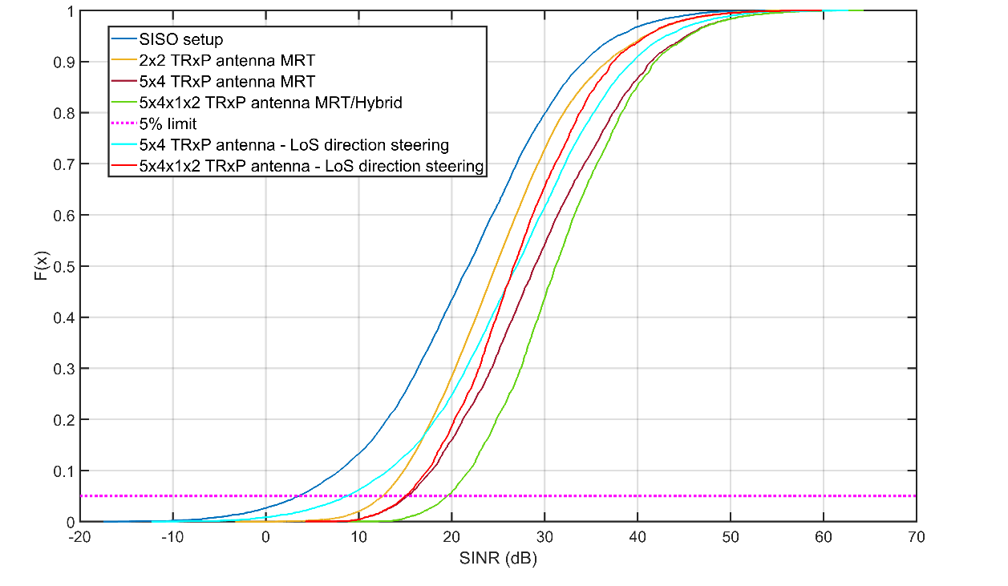

Frequency Reuse Scheme Comparisons

In Figure 6, results for frequency reuse by 1/7 vs. 1/3 are presented. The results are provided for single antenna at the TRxP and one or two isotropic antennas at the UT (for two antennas MRC diversity is employed). According to Figure 6.

• The frequency reuse scheme heavily affects the SINR distribution, with an 8 dB reduction at the 5th percentile point of the CDF.

• The use of MRC diversity provides an approximate gain of 3 dB.

|  |  |
| --- | --- |
| Setup (Configuration B @ 1.728 MHz) | 5th percentile point of the SINR CDF |
| SISO - 1/7 frequency reuse | 3.2 dB |
| 1x2 MRC - 1/7 frequency reuse | 6.0 dB |
| SISO - 1/3 frequency reuse | -5.1 dB |
| 1x2 MRC - 1/3 frequency reuse | -2.2 dB |

Figure 7

Comparison between peformance for different frequency reuse strategies – assuming a single antenna at the TRxP and one or two (MRC) antennas at the UT.

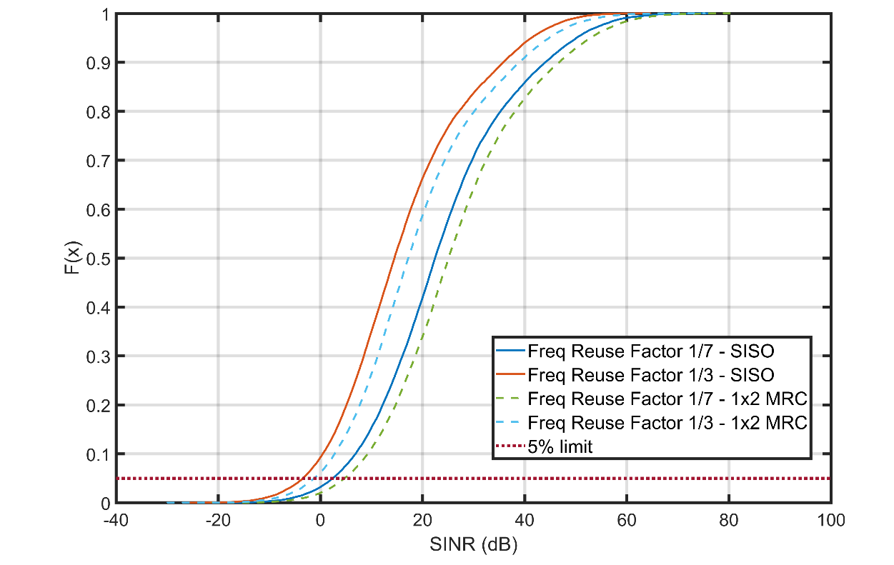

Since Figure 6 provides results for scenarios where the TRxP uses a single antenna, results from various antenna setups are provided in order to compare performance for the two frequency reuse strategies.

Figure 8

Comparison between peformance for different frequency reuse strategies and antenna configurations

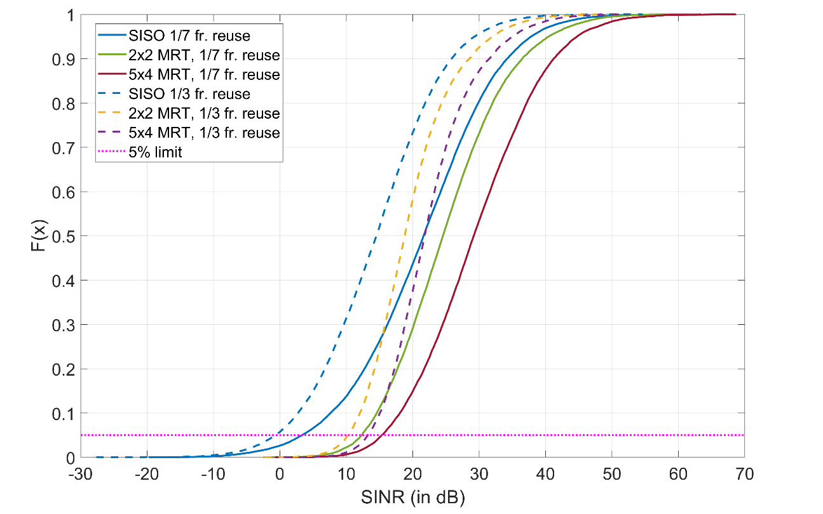

|  |  |
| --- | --- |
| Setup (Configuration B @ 1.728 MHz) | 5th percentile point of the SINR CDF |
| SISO - 1/7 frequency reuse | 3.2 dB |
| 2x2 MRT - 1/7 frequency reuse | 12.2 dB |
| 5x4 MRT - 1/7 frequency reuse | 15.35 dB |
| SISO - 1/3 frequency reuse | -5.1 dB |
| 2x2 MRT - 1/3 frequency reuse | 10.4 dB |
| 5x4 MRT - 1/3 frequency reuse | 13 dB |

Configuration Comparisons

In Figure 8, the results of the SINR distributions for experiments for the two Configurations (A and B) specified by the ITU-R guidelines.

It is clear that the 4 GHz configuration performance deteriorates, especially for low SINRs mainly due to coverage issues, as well as increased Doppler impact on the received signal.

Figure 9

Performance comparison for Configuration A vs. Configuration B and various antenna/beamforming configurations

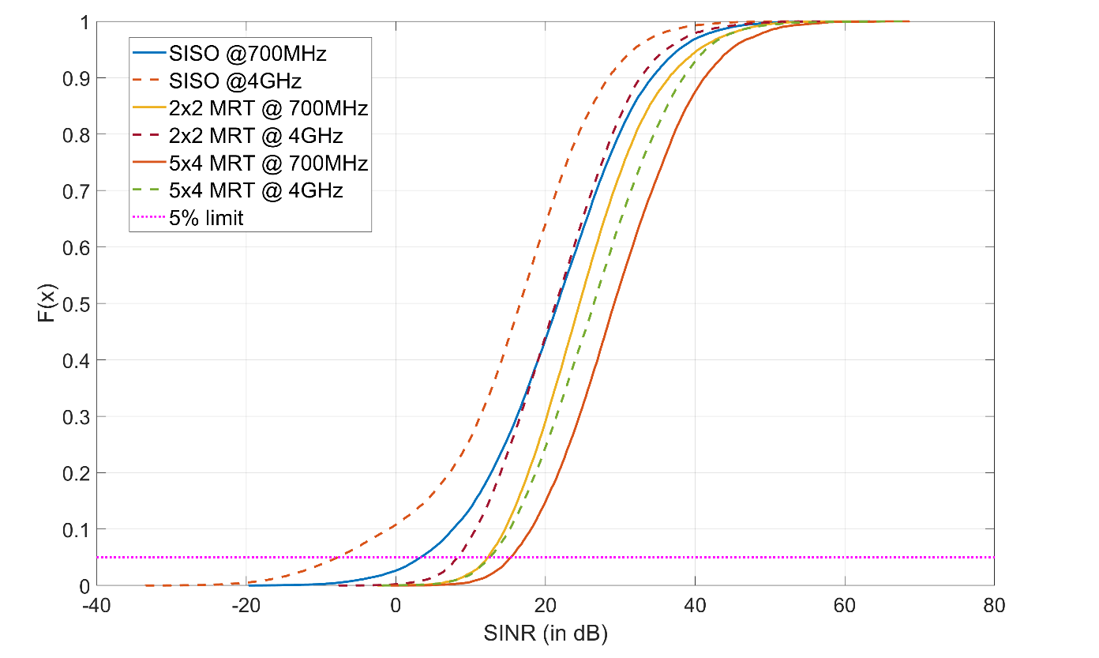

|  |  |
| --- | --- |
| Setup (@ 1.728 MHz) | 5th percentile point of the SINR CDF |
| SISO @ 700 MHz | 3.2 dB |
| 2x2 MRT @ 700 MHz | 12.2 dB |
| 5x4 MRT @ 700 MHz | 15.35 dB |
| SISO @ 4GHz | -7.1 dB |
| 2x2 MRT @ 4GHz | 7.9 dB |
| 5x4 MRT @ 4GHz | 12.3 dB |

Comparisons for different Bandwidths

In Figure 9, the results of the SINR distributions for two different channel bandwidths (1.728 MHz and 3.456 MHz) for various antenna setups and Configuration A are presented. The numerology (1,2) was used for the parameterization of the 3.456 MHz scenario.

In the specific case, the increase of the bandwidth increases the noise floor, however, there is no other significant impact, since for the selected numerology, the increase of the bandwidth is accompanied with increase of the system DFT size and cyclic prefix.

As presented in Figure 9, since the system is interference-limited, the bandwidth change has no significant impact in the SINR distribution.

Figure 10

Performance comparison for bandwidth 1.728 MHz vs. 3.456 MHz and various antenna/beamforming configurations

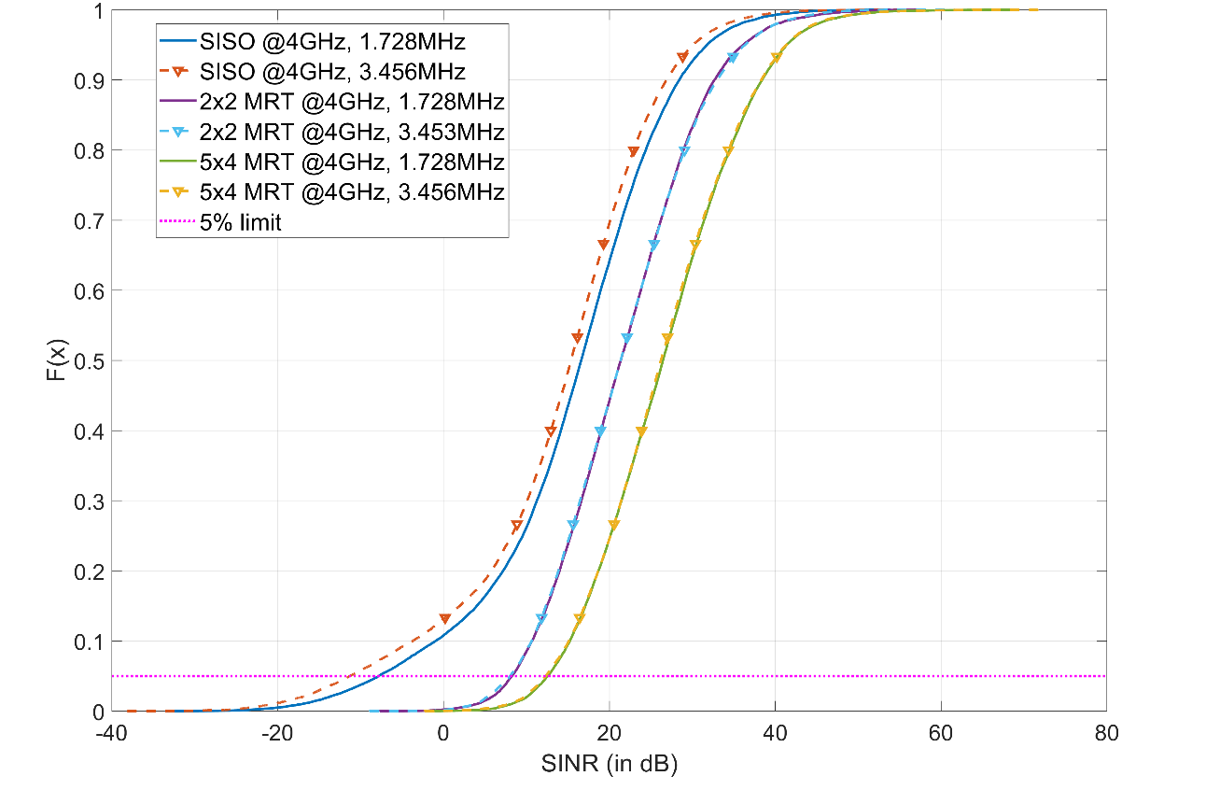

|  |  |
| --- | --- |
| Setup (Configuration A @ 4GHz) | 5th percentile point of the SINR CDF |
| SISO @ 1.728 MHz | -7.1 dB |
| 2x2 MRT @ 1.728 MHz | 7.9 dB |
| 5x4 MRT @ 1.728 MHz | 12.3 dB |
| SISO @ 3.456 MHz | -11.1 dB |
| 2x2 MRT @ 3.456 MHz | 7.79 dB |
| 5x4 MRT @ 3.456 MHz | 12.19 dB |

Link-level results

The analysis of the system-level results clearly indicate that depending on the i) configuration, ii) antenna/beamforming strategy, iii) frequency reuse strategy and iv) channel bandwidth, the SINR distribution and the 5th percentile point changes.

In order to produce general and fair results overall, it was decided to use the SISO configuration, and its corresponding SINR performance as a reference for system level. Therefore, when performing link-level simulations, for each channel instantiation, results for all investigated antenna/beamforming configurations are performed. Then, the packet error rate performance for all antenna/beamforming setups is extracted.

In Figure 10 and Figure 11 packet error rate results are presented vs the equivalent SINR of the SISO case.

Figure 11

PER vs SINR for LoS scenarios

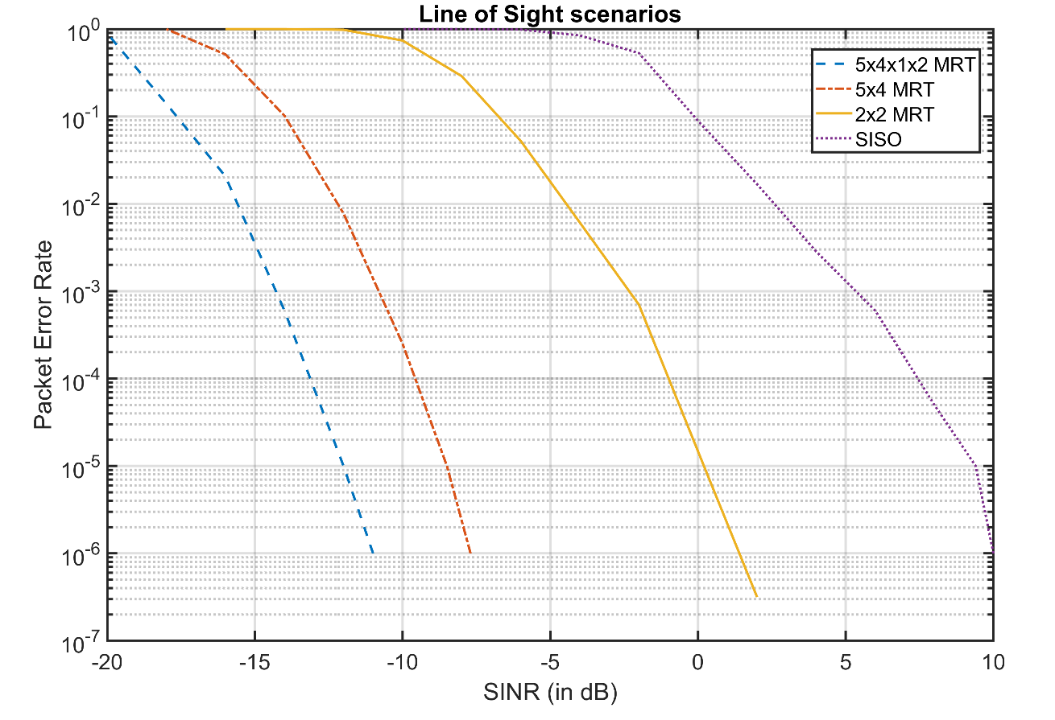

Figure 12

PER vs SNR for NLoS scenarios

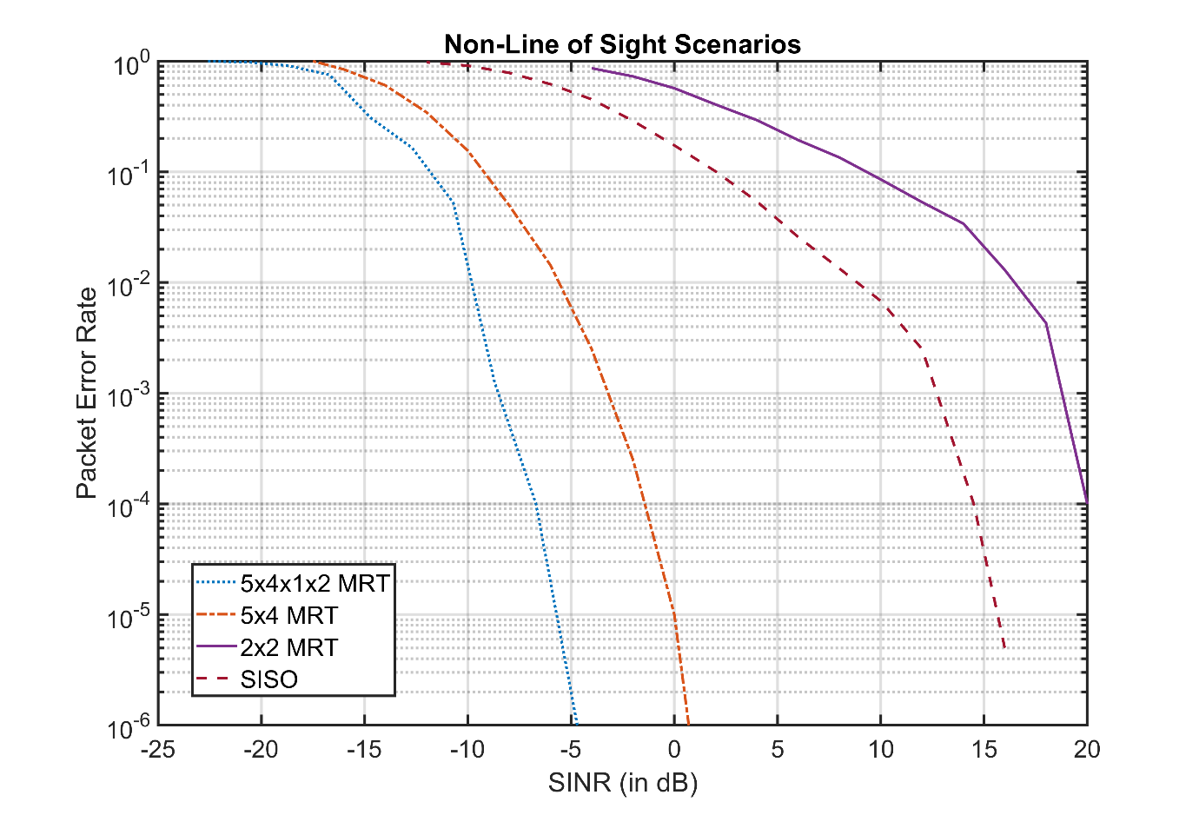

From the two figures, the fulfilment of the Packet Error Rate requirement can be checked for any SINR threshold.

The results are presented in Table 4 of Paragraph II-E-2-4. It is noticed that fulfilment of the requirement is considered achieved either through LoS or NLoS analysis.

Connection Density

An End-to-End Physical Layer simulator of the DECT-2020 NR technology was developed by WWRF IEG in MATLAB, able to perform jointly system-level and link-level experiments.

WWRF IEG addressed the following issues:

• System model definition/extension including relay/forwarding nodes in addition to standard cellular UEs.

• Introduction of a simple but effective protocol for multi-hop communications

• Definition of a relay selection scheme based on channel quality conditions.

• Consideration of device-to-device channel models for relay communication, not previously considered in cellular technologies evaluation.

At this stage, WWRF IEG is confident that it has developed a system model simulator that is able to take into account the particularities of the DECT-2020 NR RIT, while remaining aligned with the evaluation guidelines defined in Report ITU-R M.2412-0.

In the following paragraphs, a brief description of the simulator and the used methodology that was adopted by WWRF IEG for the Connection Density evaluations.

### PHY Configuration

Since the guidelines for Connection Density evaluation do not impose any throughput requirements, the considered PHY parameterization for the mMTC simulation campaigns is selected in order to maximize reliability. Thus, low-rank modulation and low core-rate FEC is selected. (QPSK with ½ turbo coding).

The numerology that is considered is:

Table 15

Adopted numerology for mMTC simulations

|  |  |  |  |
| --- | --- | --- | --- |
| (μ,β) | SCS | DFT | B |
| (1,1) | 27 kHz | 64 | 1.728 MHz |

It is noted that HARQ is included. For initial tests, 4 HARQ processes are supported.

Power and Frequency bands

As described in Annex III, “Reliability”, the transmission power profiles defined in ETSI DECT-2020 standards specify that the maximum transmitted power is 23 dB, with no distinction between the TRxP and the UT. Therefore, 23 dBm power was considered for both downlink and uplink.

In ETSI TS103636-2, specific frequency bands and channelization for DECT-2020 NR are defined. The center frequency value for the evaluation experiments were set to: Band 6 corresponding to 698-806 MHz. A segment of 8.64 MHz is selected for Configuration A. No tests have been concluded for Configuration B yet.

System Level Simulator

In Table 16, the summary of the simulator setup and its compliance with the ITU-R recommended configurations according to Report ITU-R M.2412-0 is presented.

Table 16

Connection Density evaluation parameters

| Parameters | Urban Macro–mMTC | |
| --- | --- | --- |
| Connection Density Evaluation | |
| Configuration A | Configuration B |
| **Baseline evaluation configuration parameters** | | |
| Carrier frequency for evaluation | 700 MHz  (698-806 MHz) | 700 MHz  (698-806 MHz) |
| BS antenna height | 25 m | 25 m |
| Total transmit power per TRxP | 23 dBm for the Operational Bandwidth (1.728 MHz). | 23 dBm for the Operational Bandwidth (1.728 MHz). |
| UE power class | 23 dBm | 23 dBm |
| Percentage of high loss and low loss building type | 20% high loss, 80% low loss | 20% high loss, 80% low loss |
| **Additional parameters for system-level simulation** | | |
| Inter-site distance | 500 m | 1732 m |
| Number of antenna elements per TRxP | 2 antennas (MRC reception) | 2 antennas (MRC reception) |
| Number of UE antenna elements | 1 isotropic | 1 isotropic |
| Device deployment | 80% indoor, 20% outdoor  Randomly and uniformly distributed over the area | 80% indoor, 20% outdoor  Randomly and uniformly distributed over the area |
| UE mobility model | Fixed and identical speed |v| of all UEs of the same mobility class, randomly and uniformly distributed direction. | Fixed and identical speed |v| of all UEs of the same mobility class, randomly and uniformly distributed direction. |
| UE speeds of interest | 3 km/h for indoor and outdoor | 3 km/h for indoor and outdoor |
| Inter-site interference modelling | Explicitly modelled | Explicitly modelled |
| BS noise figure | 5 dB | 5 dB |
| UE noise figure | 7 dB | 7 dB |
| BS antenna element gain | 8 dBi | 8 dBi |
| UE antenna element gain | 0 dBi | 0 dBi |
| Thermal noise level | ‒174 dBm/Hz | ‒174 dBm/Hz |

| Parameters | Urban Macro–mMTC | |
| --- | --- | --- |
| Connection Density Evaluation | |
| Configuration A | Configuration B |
| Traffic model | With layer 2 PDU (Protocol Data Unit) message size of 32 bytes:  1 message/day/device  or  1 message/2 hours/device  Packet arrival follows Poisson arrival process for non-full buffer system-level simulation | With layer 2 PDU (Protocol Data Unit) message size of 32 bytes:  1 message/day/device  or  1 message/2 hours/device  Packet arrival follows Poisson arrival process for non-full buffer system-level simulation |
| Simulation bandwidth | 8.64 MHz (5 channels of 1.728 MHz) – Frequency reuse 1/3 | 48.3 MHz (28 channels of 1.728 MHz) – Frequency reuse 1/3 |
| UE density | Not applicable for non-full buffer system-level simulation as evaluation methodology of connection density | Not applicable for non-full buffer system-level simulation as evaluation methodology of connection density |
| UE antenna height | 1.5m | 1.5 m |

Table 17

Channel model parameters for Connection Density

| Parameters | Urban Macro–mMTC  (for Connection density) | Urban Macro–URLLC  (for Reliability) |
| --- | --- | --- |
| Link-level Channel model | NLOS: TDL-iii and CDL-iii  LOS: TDL-v and CDL-iii | NLOS: TDL-iii and CDL-iii  LOS: TDL-v and CDL-iii |
| Delay spread scaling parameter (s) | Log10() =lgDS in  Table A4-9 (UMa) in Annex 1 | Log10() =lgDS in  Table A4-9 (UMa) in Annex 1 |
| AoA, AoD, ZoA angular spreads scaling parameter   (degree) | Log10() =lgASA /lgASD /lgZSA in Table A4‑9 (UMa) in Annex 1 | Log10() =lgASA /lgASD /lgZSA in Table A4‑9 (UMa) in Annex 1 |
| ZoD angular spreads scaling parameter   (degree) | Log10() =lgZSD in Table A4‑10 (UMa) in Annex 1 | Log10() =lgZSD in Table A4‑10 (UMa) in Annex 1 |

The event-based simulator that was developed for the evaluation of the Connection Density configurations is implemented in MATLAB as an addon to the DECT-2020 NR simulator used for the Reliability evaluation.

The simulator includes the multi-hop operation that is part of the DECT-2020 RIT, and its functionality is presented in Figure 12. The process is described with the following steps:

*Step 1*: A frequency reuse scheme is defined based on the available number of channels. For configuration A, since 5 channels can fit into the 10MHz overall bandwidth defined by the ITU-R guidelines, frequency reuse of factor 1/3 is selected.

*Step2*: System Level simulation using the Configuration A parameters presented in Table 16 is implemented in a network layout similar with the one described in Annex III “Reliability”. The frequency reuse factor is set to 1/3 and a full-buffer traffic model is considered in order to create a simulation scenario where all available resources are occupied. As a result, the SINR Cumulative Density Function (CDF) distribution is extracted. Since, for the Connection Density evaluations, high congestion of users is expected, the CDF can be used in order to statistically generate the SINR for each user, when performing mMTC system-level simulations.

*Step 3*: Link Level simulation is performed for the specified PHY configuration, the channel model setups described in Table 17 for a wide-range of SINRs. The packet error rate curves are calculated.

*Step 4*: The following investigation focuses on the procedures that take place in one site hosting three TRxPs. A large number of users is dropped into the cell. More specifically, for initial tests, 120,000 users are uniformly generated for each sector. (Note: In order to fulfil the connection density requirement for Configuration A, complete transmission by approximately 70,000 users is required. However, due to the stochastic generation of traffic, some users may attempt more than one transmission in the time period of interest, while other users remain silent. Through test and trial, it was found that for 120,000 generated users, the probability that at least 72,000 will attempt transmission approaches 1. It is noted that the connection density requirement for Configuration A per sector is 72,000.

*Step 5*: Through the Poisson point process, the packets are generated for all users. More specifically, 32 bytes for each are considered, and the output of the process is the time when the packet is available at the UT for transmission. In the following analysis, the DECT slot is considered as the sampling period/time granular for the simulator. Thus, new events are taken into account at a slot-by-slot basis. The transmission times are “translated” to slot indexes, that indicate when each UT is ready to transmit. The traffic generation process is described in Figure 12 (upper left flow diagram).

*Step 6:* A simple but efficient scheduler is defined. A FIFO queue is implemented at the scheduler. When a UT has data available for transmission, it requests the first available uplink slot (the UT enters the queue). All packets have the same priority (data packets, retransmissions, or relay packets). A specific number of slots is defined available for uplink transmission. For initial tests, the number of uplink slots was 5 (out of 24 slots per frame). The remaining slots are considered for downlink and periodic beacon broadcasts.

*Step 7*: A percentage of UTs are selected to also act as a relay. It is noted that according to the DECT-2020 NR RIT all UTs can be considered potential relays. However, the management of a very large population of relays is a cumbersome task for the simulator. Therefore, only a small percentage is considered available to relay. For initial tests, this value was set to 0.2% of all PTs – leading to 240 relays per sector. For the Configuration A ISD, a very dense grid of relays is defined. The PTs with the relay property is selected randomly. From now on, UTs with the relaying capability are denoted as RTs (Relay Terminals).

*Step 8*: For all UTs, the SINR for the TRxP link is generated from the SINR CDF that was extracted in Step 2 of this process.

*Step 9*: For all UTs, the SINR with all possible relays is generated from the SINR CDF that was extracted in Step 2. For more accurate results, since the RTs have different antenna configurations and heights from the TRxPs, a different SINR CDF should be extracted.

*Step 10*: The following simple but effective relaying protocol is defined:

• Upon transmission, the UT uses a simple SINR threshold to decide if the UT will attempt direct transmission towards the TRxP, or through a relay. After simulation and for the supported HARQ processes, SINRThreshold=8 dB is defined. For four HARQ processes, the MCS-1 scheme, and the considered channel models, with 8 dB SINR, the Packet Error Probability is less than 10-5. Thus, the UT enters the FIFO queue in order to access the resources[3].

• If the use of a relay is decided then the UT checks the SINR for the two-hop process by taking into account the Channel Quality Metrics that are included in the latest received beacon from the three preferable relays. For each relay, the SINR of the process is defined as the minimum SINR for all paths:

$${SINR}_{RT}=min\left[\begin{matrix}{SINR}_{UT→RT} & {SINR}_{RT→TRxP}\end{matrix}\right]$$

And the selected SINR is the one with the maximum metric for the three preferable RTs:

$$Selected Relay \hat{i}=argmax\left[{SINR}_{{RT}_{i}}\right]$$

The procedure is described for a single relay hop. However, it can easily be extended for multiple hops. Nevertheless, it is noted that preliminary results indicate that the use of a single relay should be sufficient to fulfil the requirements.

*Step 11*: The first hop of each relay is implemented in an overlay transmission mode, i.e. a slot is allocated from the scheduler for the first hop of the relaying process. In order to simplify the procedure, a specific set of slots at each frame may be defined for relay use.

*Step 12*: At this point, the main loop of the simulation engine can be executed. The logical flow is presented in Figure 12. The loop simulated the time succession of slots and frames during the time period of interest. More specifically,

• At the beginning of each frame all new UTs that have available data for transmission are inserted into the FIFO queue.

• The scheduler assigns sequentially the available resources to the UTs.

• At each slot, the allocated UT attempts transmission following the relaying protocol.

○ In case, direct communication is selected, and for the given SINR, the probability of Packet Error is calculated by the link-level simulation curves, and with the use of a random variable, it is decided if the transmission is successful or not.

○ In case of an unsuccessful transmission, the HARQ process is activated. Thus, after a time period corresponding to the HARQ feedback time, the packet will re-enter the FIFO queue and eventually re-attempt transmission.

○ If the HARQ process number is exhausted, the transmission failure is recorded.

○ If the transmission is successful, the latency from the packet generation time is calculated and if it is under 10 seconds, the transmission has succeeded. Otherwise, it is considered a failure.

○ In case of a relay, the UT waits for the allocated slot and attempts transmission towards the relay. In general, due to the high density of RTs, the first hop consists of high-SINR links with extremely low error probability. In case of an error, HARQ is activated.

○ Upon reception, the RT considers the new packet as its own and enters the FIFO queue at the scheduler. The process now is identical with the case of direct UT-TRxP communications.

○ After the completion of the second hop, the latency from the packet generation time is calculated and if less than 10 seconds, the transmission is considered successful.

*[Currently, the first results for Configuration A, 120,000 UTs per sector (which correspond to more than 1,000,000 devices per km2 density) and 0.2% RTs indicate that more than 73,000 UTs are successfully served during a 2 hour period with service outage less than 0.01%, ]*

Figure 13

Connection Density Simulation Methodology



_______________

1. The specifications also introduce a scheduled access data transfer approach in ETSI TS 103 636-4, Section 5.4.
2. Not included in the calculation of control-plane latency as it can be executed during battery-efficient state.
3. It is noted that the DECT-2020 standardized beacon messages calculate the Channel Quality from RSSI and not SINR. Initial tests indicated that there is no significant/meaningful difference in the results provided by the relay protocol.