|  |  |
| --- | --- |
| **Radiocommunication Study Groups** |  |
|  |  |
|  |  |
| Received: 19 February 2021  Source: Document 5D/TEMP/769(Rev.1)  Source: Wireless World Research Forum | **Document 5D/476-E** |
| **22 February 2021** |
| **English only**  **TECHNOLOGY ASPECTS** |
| Wireless World Research Forum (WWRF) | |
| INTERIM Evaluation REPORT ON THE CANDIDATE TECHNOLOGY SUBMISSION FOR IMT-2020 “ETSI (TC DECT) and DECT Forum Proponent” AS PART OF the re-engagement  in Step 4 EVALUATION | |
| Report with Provisional Results** | |

[1]This contribution contains the interim evaluation report from the Independent Evaluation Group Wireless World Research Forum (WWRF) for ETSI (TC DECT), DECT FORUM, IMT-2020/17 Submission. Following the finalization of Step 7 in the IMT-2020 Process, ETSI (TC DECT) and DECT Forum technology submission evaluation was granted an extension in the IMT-2020 Process, for re-engagement and re-evaluation.

The evaluation is based on the characteristics defined in Reports ITU-R M.2410-0, ITU-R M.2411‑0 and M.2412-0 [1] – [3] using a methodology described in Report ITU-R M.2412-0 [3].

The interim evaluation report reflects the structure of the final report which is planned to be submitted to Working Party (WP) 5D #38 meeting (June 2021). It consists of 3 Parts and an Annex according to the proposed structure by ITU in [4]:

* Part I: Administrative Aspects of the WWRF.
* Part II: Technical Aspects of the work of WWRF.
* Part III: Conclusions.
* Annex 1: Detailed presentation of the simulation methodology followed for the evaluation of the candidate technology.

Part I

Administrative aspects of the Independent Evaluation Group

# I-1 Name of the Independent Evaluation Group

Wireless World Research Forum (WWRF).

# I-2 Introduction and background of the Independent Evaluation Group

WWRF’s goal is to encourage research that will achieve unbounded communications to address key societal challenges for the future. The term “Wireless World” is used in this broad sense to address the support of innovation and business, the social inclusion and the infrastructural challenges. This will be achieved by creating a range of new technological capabilities from wide-area networks to short-range communications, machine-to-machine communications, sensor networks, wireless broadband access technologies and optical networking, along with increasing intelligence and virtualization in networks. This will support a dependable future Internet of people, knowledge and things and the development of a service universe. WWRF is the unique forum where the wireless community can tackle the key research challenges. By searching out the issues, flagging them up to opinion leaders, and then working with liaison partners to deal with them, WWRF drives the development of the Wireless World. WWRF organizes two major events each year combining inputs from industry and academic experts, the exchange of ideas and the evolution of the research agenda and technology roadmaps. WWRF’s has a strong publication programme, working with partners such as IEEE and Wiley, makes the key messages and results available to the wireless research sector. To ease standardization, WWRF disseminates and harmonizes views, and together with our major liaison partners, we initiate collaborative research, and develop the global vision.

Over the last ten years, WWRF has championed several activities focused on the wireless evolution to and beyond 5G, including workshops and special sessions, presentations, white papers and journal special issues.

WWRF ITU engagement

WWRF has been very supportive of the ITU’s evaluation process for IMT-2020 and participates as an independent evaluation group (IEG).

WWRF continues to work with ITU in a number of areas. WWRF was pleased to be invited, along with the other Independent Evaluation Groups (IEGs), to attend WP 5D #36*e* as a guest, to discuss the process for continuing evaluation of the remaining candidate IMT-2020 technologies.

WWRF is delighted to be accepted as a Sector Member of ITU in December 2020. In its capacity as ITU member WWRF is planning a number of direct contributions, including its participation as IEG in the IMT 2020 evaluation of the ETSI (DECT) and Nufront proposals.

# I-3 Method of work

### I-3-1 Background

An SRIT proposal was submitted to ITU-R WP 5D by ETSI (DECT). The proposed SRIT consists of two component RITs: (a) DECT-2020 NR RIT and (b) 3GPP 5G CANDIDATE FOR INCLUSION IN IMT-2020: SUBMISSION 2 FOR IMT-2020 (RIT).

During STEP 4 of the IMT-2020 evaluation process, the proponent’s ETSI (TC DECT) & DECT FORUM submission (Document [IMT-2020/17(Rev.1)](https://www.itu.int/md/R15-IMT.2020-C-0017/en)) did not receive a complete evaluation as to whether it satisfies all the requirements for an RIT component (as mandated by ITU-R Res. 65).

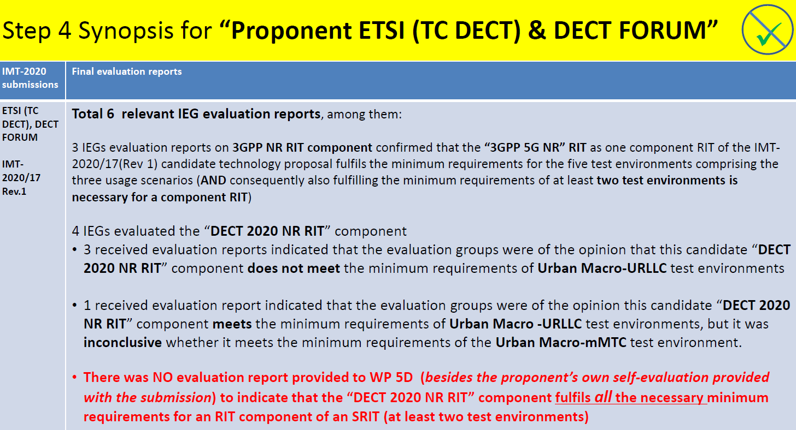

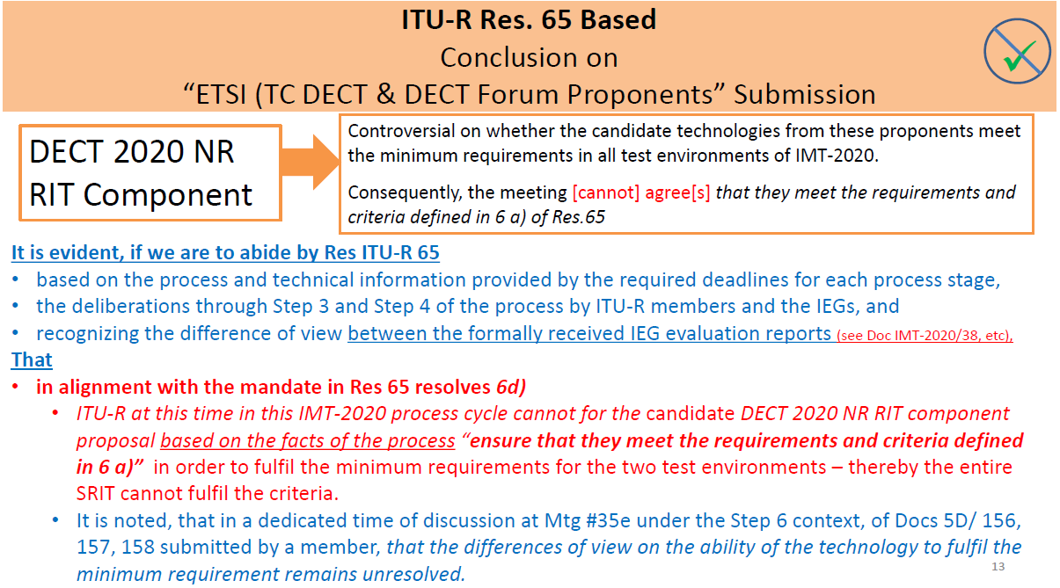

As a way forward the following was decided by WP 5D (Option 2): The ETSI (TC DECT) & DECT FORUM candidate submission will carry-on in the current process (Step 4 to Step 7), under an extension, rewinding back to Step 4 (as indicated in the following figure).

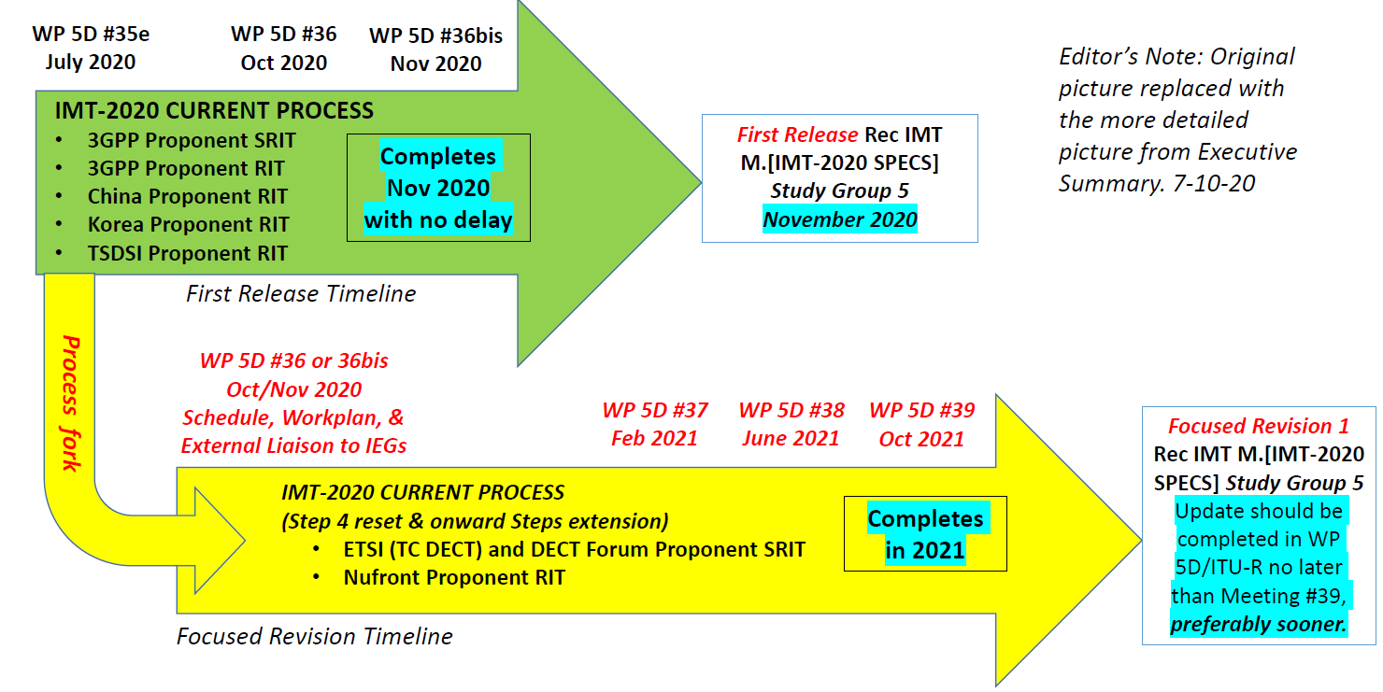

In view of the above, the WWRF IEG team is committed to contribute to this additional phase of the IMT-2020 evaluation process.

The scope of the work is to assess the IMT-2020/17 technology proposal submitted by ETSI (TC DECT) for inclusion in IMT-2020. The proposed SRIT consists of two component RITs:

* DECT-2020 NR RIT.
* 3GPP 5G CANDIDATE FOR INCLUSION IN IMT-2020: SUBMISSION 2 FOR IMT‑2020 (RIT).

This proposal addresses all the five test environments across the three usage scenarios (eMBB, mMTC, and URLLC) as described in Report ITU-R M.2412-0.

Within the SRIT:

* The eMBB usage scenario is addressed by the 3GPP NR component.
* the DECT-2020 NR component address two usage scenarios (mMTC and URLLC) as described in Report ITU-R M.2412.0.

The 3GPP NR component has been already evaluated by other IEGs. Hence, the focus will be on the DECT-2020 component RIT. Since the DECT-2020 component RIT addresses URLLC and mMTC test environments, the following technical performance requirements will be assessed (Ref: Report ITU-R M.2412-0).

Table 1

Technical Performance Requirements for URLLC and mMTC test environments

|  |  |  |  |
| --- | --- | --- | --- |
| Characteristic for evaluation (test-environment) | High-level assessment method | Evaluation methodology in this Report | Related section of Reports ITU-R M.2410-0 and  ITU-R M.2411-0 |
| User plane latency (URLLC) | Analytical/Inspection | § 7.2.6 | Report ITU-R M.2410-0, § 4.7.1 |
| Control plane latency (URLLC) | Analytical/Inspection | § 7.2.5 | Report ITU-R M.2410-0, § 4.7.2 |
| Connection density (mMTC) | Simulation | § 7.1.3 | Report ITU-R M.2410-0, § 4.8 |
| Reliability (URLLC) | Simulation | § 7.1.5 | Report ITU-R M.2410-0, § 4.10 |
| Mobility interruption time (URLLC) | Analytical/Inspection | § 7.2.7 | Report ITU-R M.2410-0, § 4.12 |

### I-3-2 Organizational Issues

The work was organized using the following channels:

1. Regular phone meetings of the steering board.
2. Regular bi-weekly phone meetings of the technical teams.
3. E-mail exchanges through a dedicated mailing list.
4. Exchange of files through a shared workspace.
5. Dedicated sessions in WWRF workshops.
6. Monitoring of the ITU Discussion Forum.

# I-4 Administrative contact details

Name & Affiliation; Dr Nigel Jefferies, WWRF Chairman

Email: [chairman@wwrf.ch](mailto:xxxx@xxx.xx)

# I-5 Technical contact details

|  |  |  |
| --- | --- | --- |
| [**Name**](mailto:hakan.batikhan@turkcell.com.tr) | **Affiliation** | **e-mail** |
| **Prof. Angeliki Alexiou** | **University of Piraeus** | [**aalexiou@ieee.org**](mailto:aalexiou@ieee.org) |
| **Dr. Antonis Gkotsis** | **University of Piraeus, Feron Technologies P.C.** | [**antonis.gotsis@feron-tech.com**](mailto:antonis.gotsis@feron-tech.com) |
| **Dr. Konstantinos Maliatsos** | **University of Piraeus, Feron Technologies P.C.** | [**konstantinos.maliatsos@feron-tech.com**](mailto:konstantinos.maliatsos@feron-tech.com) |

Part II

Technical aspects of the work of the Independent Evaluation Group

# II-A What candidate technologies or portions of the candidate technologies this IEG is or might anticipate evaluating?

“ETSI (TC DECT) and DECT Forum” (IMT-2020/17) submission according to the following material:

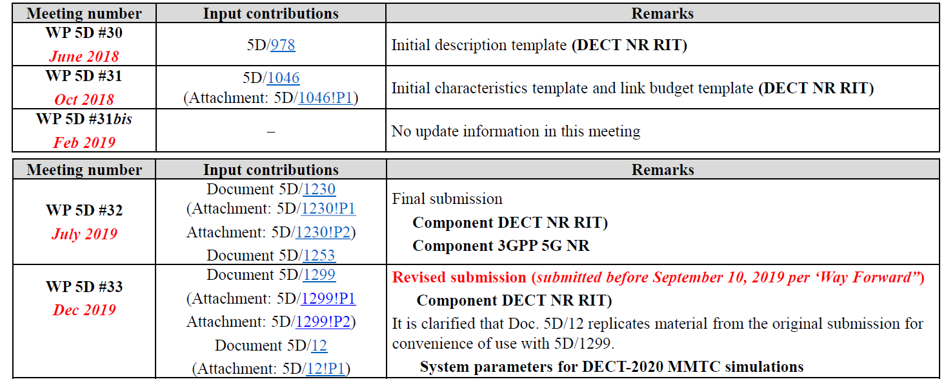

It is noted that the present evaluation work focuses exclusively on the DECT-2020 NR RIT Component, since the 3GPP 5G NR component has been thoroughly evaluated by other Independent Evaluation Groups.

# II-B Confirmation of utilization of the ITU-R evaluation guidelines in Report ITU‑R M.2412

The WWRF IEG and its members confirm that they follow the ITU-R evaluation guidelines provided in the Report ITU-R [M.2412](https://www.itu.int/pub/R-REP-M.2412)-0. The IEG verifies that the final evaluation report will include the extracted evaluations results following the specific guidelines.

# II-C Documentation of any additional evaluation methodologies that are or might be developed by the Independent Evaluation Group to complement the evaluation guidelines

For assessing characteristics using simulation, i.e., reliability and connection density, we rely on an in-house simulation tool. The developed simulator is decomposed into two main components:

* The link level simulator: implementing/simulating the radio transmission between two nodes of the system.
* The system level simulator: implementing/simulating the radio access network setup according to the specifications of the ITU evaluation guidelines (Report ITU-R M.2412 § 8.4).

It is noted that:

* Both simulator components are developed in MATLAB/Octave.
* Both simulator components are developed in-house with limited use of MATLAB communication toolbox functions – the latter mainly used for channel modelling purposes.
* An object-oriented approach is used in order to achieve modular and hierarchical design and deployment for the simulation scenarios and use cases.
* In order to develop the simulator, the following documents were used as a reference:
  + ITU-R M.2412 Guidelines for evaluation of radio interface technologies for IMT-2020,
  + ITU-R M.2411 Requirements, evaluation criteria and submission templates for the development of IMT-2020,
  + TS103.636-1, DECT-2020 New Radio (NR); Part 1: Overview,
  + TS103.636-2, DECT-2020 New Radio (NR); Part 2: Radio reception and transmission requirements,
  + TS103.636-3, DECT-2020 New Radio (NR); Part 3: Physical layer,
  + TS103.636-4, DECT-2020 New Radio (NR); Part 4: MAC layer

The analysis and evaluation focus exclusively on the DECT-2020 NR component, since the 3GPP NR component has been exhaustively evaluated and several third-party simulators can already be found publicly.

At the first stage of the evaluation process, the development was focused on the link level simulator which has been successfully completed. Currently, the system level simulator is being developed and the first version focusing on the Urban Macro-URLLC use case has been completed.

# II-D Verification as per Report ITU-R M.2411 of the compliance templates and the self-evaluation for each candidate technology as indicated in A)

This is an interim report and possible issues concerning the compliance templates, including gaps and deficiencies in the submitted compliance templates and self-evaluation reports, identified areas requiring clarification will be provided in the final report.

# II-E Assessment as per Reports ITU-R M.2410, ITU-R M.2411 and ITU-R M.2412 for each candidate technology as indicated in A)

This is an interim report, and the final assessment on a system level scale will be conducted in the final report.

**II-F Questions and feedback to WP 5D and/or the proponents or other IEGs**

The webinar presented by the proponent was attended and was much appreciated as it provided useful information for the IEG.

**II-G Proposed next steps towards the final report**

The next immediate steps towards the final report are the following:

* Performance of analytical investigations and inspections regarding User plane latency for URLLC, Control plane latency for URLLC, and Mobility interruption time for URLLC.
* Finalization of a URLLC ITU-compliant configuration and performance of large-scale experimentation in order to collect a sufficient statistical sample for the extraction of empirical CDFs. Performance of experiments for various configurations (e.g., different frequency reuse schemes, different MIMO techniques, variable number of Tx/Rx antennas, different scheduling strategies, etc.) in order to identify the configuration that offers the best performance in terms of reliability. The specific result will be used for the simulation-based evaluation of the URLLC use case.
* Configuration and parameterization of the system-level simulator for the mMTC use case. If necessary:
  + New scheduling strategies will be investigated with the objective to maximize connection density.
  + Non-full buffer simulation setups will be investigated.
  + The ITU-R guidelines will be strictly followed to setup the simulator
  + Extensive simulation will be performed for various configuration candidates that maximize connection density and the packet outage rates will be calculated in order to perform the evaluation for the specific criteria.
* The evaluation result will be positive, if all investigations (analytical and simulation) lead to satisfaction of the ITU-R requirements.

Part III

Conclusion

In this interim report, the methodology that will be used for the evaluation of the ETSI DECT SRIT and more specifically of the DECT-2020 NR Component is presented. Up to this point, the work focused on:

* The thorough review of ITU-R guidelines and recommendations, the ETSI DECT series of standards, and the Phase 1 reports.
* The design and implementation of a simulator for the performance of evaluation tests regarding the macro URLLC (reliability) and the macro mMTC (connection density) scenarios. Until the completion of the interim report:
  + A complete in-house link-level simulator for DECT-2020 NR transmission was developed and configured with a complete standard-compliant Physical Layer stack.
  + A simplified DECT-2020 NR MAC layer was developed and integrated, implementing MAC functionalities required for proper evaluation (i.e., HARQ, MIMO and MCS feedback, Power Control, Scheduling, etc.)
  + A system level simulator was compiled in a configuration that satisfies the specifications imposed by ITU-R for the macro URLLC scenario.
  + A scheduler was integrated to the system-level simulator with the objective to maximize link reliability.
  + Various configurations have been tested in order to definitely decide on whether the URLLC ITU-R requirements are satisfied.

The IEG work continues with the modification of the system-level simulator according to the ITU-R specifications for the mMTC (connection density) use case, as well as the performance of investigations and analytical calculations for the verification of the rest of evaluation characteristics (user and control plane latency, and mobility interruption time).

Annex 1

Simulation methodology and preliminary numerical results for the ETSI (TC DECT) and DECT Forum technology evaluation

Methodology

Analysis

User plane latency, control plane latency and mobility interruption time will be assessed analytically. The specifications should be thoroughly reviewed with respect to the involved radio procedures and signalling requirements. For user- and control-plane latency, the analysis will include the contribution of each sub-process/element to the overall latency. For mobility interruption time, the procedure of exchanging user plane packets with base stations during transitions shall be described based on the proposed technology including the functions and the timing involved.

Simulation

Connection density and reliability will be assessed using simulation. A two-level simulation methodology will be used, i.e. system-level simulation followed by link-level simulations. Hence, both a system-level and a link-level simulator, along with proper interfacing mechanisms should be developed for assessing the DECT-2020 NR component in Urban Macro-mMTC and Urban Macro-URLLC environments.

For system-level simulations in the test environments, the BSs/sites are placed in a regular grid, following hexagonal layout with three TRxPs each. There are two channel model variants of primary module for IMT-2020 evaluation: (1) channel model A and (2) channel model B, and either channel model A or B should be selected to evaluate the candidate RITs/SRITs. The simulator should support the following system and link level parameters/configurations, reported in Report ITU-R M.2412 (§ 8.3.4, § 8.4 – Table 5d):

* Network Layout for Urban Macro-mMTC and Urban Macro-URLLC
* Carrier frequency for evaluation
* BS antenna height
* Total transmit power per TRxP
* UE power class
* Percentage of high loss and low loss building type
* Inter-site distance
* Number of antenna elements per TRxP
* Number of UE antenna elements
* Device deployment
* UE mobility model
* UE speeds of interest
* Inter-site interference modelling
* BS noise figure
* UE noise figure
* BS antenna element gain
* UE antenna element gain
* Thermal noise level
* Traffic model
* Simulation bandwidth
* UE density
* UE antenna height
* Evaluated service profiles
* Simulation bandwidth
* Number of users in simulation
* Packet size
* Inter-packet arrival time
* Channel Model UMa_A, UMa_B.

In the course of the project a simplified system-level simulation setup will be implemented that will exploit statistical modeling of the ITU-R M.2412 setups implemented by other accredited research groups that participate in the evaluation procedure. Simple scheduling will be performed, with the selection of the configuration (MCS, MIMO setup, etc.) that favours the proposed SRIT for the given use case. Additionally, ITU channel model code published from third-parties will be used.

For **Reliability** the following methodology will be applied:

|  |
| --- |
| **Step 1: Run downlink or uplink full buffer system-level simulations of candidate RITs/SRITs using the evaluation parameters of Urban Macro-URLLC test environment see § 8.4.1 below, and collect overall statistics for downlink or uplink SINR values, and construct CDF over these values.**  **Step 2: Use the CDF for the Urban Macro-URLLC test environment to save the respective 5th percentile downlink or uplink SINR value.**  **Step 3: Run corresponding link-level simulations for either NLOS or LOS channel conditions using the associated parameters in the Table 8-3 of this Report, to obtain success probability, which equals to (1-Pe), where Pe is the residual packet error ratio within maximum delay time as a function of SINR taking into account retransmission.**  **Step 4: The proposal fulfils the reliability requirement if at the 5th percentile downlink or uplink SINR value of Step 2 and within the required delay, the success probability derived in Step 3 is larger than or equal to the required success probability. It is sufficient to fulfil the requirement in either downlink or uplink, using either NLOS or LOS channel conditions.** |

For **Connection Density** the following methodology will be applied:

|  |
| --- |
| **Step 1: Set system user number per TRxP as N.**  **Step 2: Generate the user packet according to the traffic model.**  **Step 3: Run non-full buffer system-level simulation to obtain the packet outage rate. The outage rate is defined as the ratio of the number of packets that failed to be delivered to the destination receiver within a transmission delay of less than or equal to 10s to the total number of packets generated in Step 2.**  **Step 4: Change the value of N and repeat Step 2-3 to obtain the system user number per TRxP N’ satisfying the packet outage rate of 1%.**  **Step 5: Calculate connection density by equation C = N’ / A, where the TRxP area A is calculated as A = ISD2 × sqrt(3)/6, and ISD is the inter-site distance.**  **The requirement is fulfilled if the connection density C is greater than or equal to the connection density requirement defined in Report ITU-R M.2410-0.**  **The simulation bandwidth used to fulfil the requirement should be reported. Additionally, it is encouraged to report the connection efficiency (measured as N’ divided by simulation bandwidth) for the achieved connection density.**  **The following steps are used to evaluate the connection density based on full-buffer system-level simulation followed by link-level simulation. Traffic model used in this method is defined in Table 8 3 in § 8.4 of this Report.**  **Step 1: Perform full-buffer system-level simulation using the evaluation parameters for Urban Macro-mMTC test environment, determine the uplink SINRi for each percentile i=1…99 of the distribution over users, and record the average allocated user bandwidth Wuser.**  **– In case UE multiplexing on the same time/frequency resource is modelled in this step, record the average number of multiplexed users Nmux. Nmux = 1 for no UE multiplexing.**  **Step 2: Perform link-level simulation and determine the achievable user data rate Ri for the recoded SINRi and Wuser values.**  **– In case UE multiplexing on the same time/frequency resource is modelled in this step, record the average number of multiplexed users nmux,i under SINRi . The achievable data rate for this case is derived by Ri = Zi/nmux,i, where aggregated bit rate Zi is the summed bit rate of nmux,i users on Wuser. nmux,i = 1 for no UE multiplexing.**  **Step 3: Calculate the packet transmission delay of a user as Di = S/Ri, where S is the packet size.**  **Step 4: Calculate the traffic generated per user as T = S/Tinter-arrival, where Tinter-arrival is the inter packet arrival time.**  **Step 5: Calculate the long-term frequency resource requested under SINRi as Bi = T/(Ri/Wuser).**  **Step 6: Calculate the number of supported connections per TRxP, N = W / mean(Bi). W is the simulation bandwidth. The mean of Bi may be taken over the best 99% of the SINRi conditions.**  **– In case UE multiplexing is modelled in Step 1, N = Nmux × W / mean(Bi). In case UE multiplexing is modelled in Step 2, N = W / mean(Bi/nmux,i).**  **Step 7: Calculate the connection density as C = N / A, where the TRxP area A is calculated as A = ISD2 × sqrt(3)/6, and ISD is the inter-site distance.**  **The requirement is fulfilled if the 99th percentile of the delay per user Di is less than or equal to 10s, and the connection density is greater than or equal to the connection density requirement defined in Report ITU-R M.2410-0.**  **The simulation bandwidth used to fulfil the requirement should be reported. Additionally, it is encouraged to report the connection efficiency (measured as N divided by simulation bandwidth) for the achieved connection density.** |

To accurately simulate the DECT-2020 NR component, the following radio technology transceiver components and functionalities should be implemented as part of the simulator (refer to ETSI TS 103 636; DECT-2020 New Radio (NR); Part 1 – Part 4)

* Numerologies
* Frame Structure
* Multiple access
* Error detection on the physical channels and indication to higher layers
* FEC encoding/decoding of the physical channels
* Hybrid ARQ
* Rate matching of the coded physical channel data to physical channels
* Mapping of the coded physical channel data onto physical channels
* Modulation and demodulation of physical channels
* Frequency and time synchronization
* Channel Estimation and equalization
* Multiple Input Multiple Output (MIMO) antenna processing
* Transmit Diversity (TX diversity)
* Beamforming
* Physical channels
  + Physical Control Channel (PCC)
  + Physical Data Channel (PDC)
* Layer 2 SDU packet formatting.

In the following paragraphs, details of the link level simulator are provided.

Link Level Simulator description

The Link Level simulation is performed on the physical layer (PHY) of the DECT-2020 NR standard. Structurally, PHY and MAC are implemented as discrete, distinguished classes interconnected with each other.

Link level simulation relies on the definition of two classes:

* The DECT-2020 Physical Layer configuration parameters that characterize the waveform design/transmission features for all simulated nodes. The DECT-2020 PHY class is instantiated (PHY object) during the initialization of each experiment, and the properties and methods are inherited to all generated links of the specific run.
* The DECT-2020 Transceiver class that contains all parameters, dynamic configurations, node-specific metrics and KPIs, and transmission/reception functions required for the operation of a DECT-2020 NR terminal. Depending on the simulated scenario, new DECT-2020 transceiver objects are generated and initialized through the DECT-2020 PHY object. A link is defined between two nodes-objects, and includes the complete waveform design, transmission and reception cycle. The PHY-layer, link level simulation results are stored at the transceiver variables and may be cumulatively evaluated (as a system) at the end of the experiment.

It is noted that in DECT-2020, there is no distinction between uplink and downlink – or base station and user equipment. Thus, the same methods for waveform design in the transmitter and waveform analysis in the receiver can be used regardless of the role of the specific terminal.

Figure 1

Transmitter block diagram as implemented based on DECT-2020 transceiver methods



Generally, the ITU guidelines for radio technology evaluation consider a star topology for network deployment. Thus, at least for the Urban Macro-URLLC use case, link-level evaluation is performed assuming one node as Fixed Terminal (FT – equivalent to the base station role) and one node as Portable Terminal (PT – equivalent to the user equipment). The difference between the node roles is the incorporation of scheduling functions at the MAC layer of the FT object.

The DECT-2020 Transceiver class incorporates all Tx and Rx functions – simulating as realistically as possible the operation and performance of a real-world transceiver.

In Figure 1, the transmitter operations are presented as a block diagram. Practically, each block represents one or more methods of the object. The operation of the link-level simulator transmitter can be described by the following steps:

* At object instantiation/initialization, the DECT-2020 transmitter inherits a set of properties by the DECT-2020 PHY, including:
  + Time-frequency grid parameters like frame duration, slot duration, channelization, etc.
  + Selected numerology, like subcarrier scaling factor, subcarrier spacing, FFT size, occupied subcarriers, transmission bandwidth, cyclic prefix size, etc.
  + Scenario specific information for the nodes including: number of antennas for transmission/reception, CRC type, block segmentation configurations, modulation and coding for fixed MCS tests, etc.
  + Determination of indexes for preambles and pilots (i.e., the Synchronization Training Field – STF, and the Demodulation Reference Signals – DRS) in the time-frequency grid for each sub-slot – slot – frame.
* Transmission could be performed in slot or sub-slot basis, which means that the simulator loop is performed assuming time granularity of a single slot or a single sub-slot duration, depending on the scheduling strategy. In our analysis, slot-based simulation has been performed.
* At each step (assuming slot-based transmission), three types of input are expected:
  + The scheduling/allocation information indicating the channel and time slots where transmission is performed. If the slot is not allocated for the specific node or UL/DL operation, then the transmitter is considered off (or stand-by if on HARQ triggered process). It is noted that if the node has the role of an FT (DL slot), the scheduler is running at the DECT-2020 NR MAC sublayer of the specific node.
  + Assuming that the slot is scheduled for transmission by the specific node:
    - the signalling data for the Physical Control Channel (PCC)
    - and the traffic data from the Physical Data Channel (PDC).

The data are coming from queues of the DECT-2020 NR MAC sublayer object that correspond to the specific node. PCC size is determined by the system parameterization. The initial tests performed for the Urban Macro-URLLC assume full buffers at each node, thus, in these cases, data are always available for transmission, while the actual bit payload is irrelevant.

Figure 2

Receiver block diagram as implemented based onDECT-2020 transceiver methods



* Depending on the MCS scheme, selected numerology, MIMO layers and transmission parameters, the transport block size is calculated.
* CRC is calculated for the complete transport block size.
* Based on the selected parameterization, block segmentation may by performed. In this case, CRC per block is also calculated and inserted in the data stream.
* The next step is to perform Turbo encoding for each block. The coding rate of turbo encoder is 1/3. It includes a parallel concatenated convolutional encoder, a Trellis termination module and an internal inter leaver.
* Rate matching is performed in order to fit the coded sequence to the available transport block size. The supported coding rates are (approximately) 1/2, 2/3, 3/4, and 5/6.
* The coded sequence is scrambled using the pseudo-random sequence generation specified in ETSI TS103.636-3.
* The next step is proper grouping and symbol mapping of the coded-scrambled sequence using BPSK, QPSK or QAM (various ranks from 16 to 1024) modulations.
* The symbols are assigned to points of the space-time-frequency grid corresponding to specific ODFM subcarriers, OFDM symbols, and transmission layers.
* In parallel with the transformation of the incoming traffic to points of the space-time-frequency grid, the respective process is performed for the PCC bits:
  + CRC of 16-bit length is placed at the end of the PCC sequence.
  + Specific CRC masks may be applied depending on the Tx mode of MIMO operation. The mask will allow the receiver to estimate the active transmission mode.
  + The PCC sequence is turbo-coded using the default DECT encoder with pre-defined configuration and rate matching is performed to fit the coded word to the 98 PCC-allocated subcarriers assuming a single spatial stream.
  + The PCC coded sequence is scrambled using a specific initialization sequence at the pseudo-random sequence generator.
  + Then, bit pairs are created and QPSK modulation is performed. The PCC symbols are assigned to standard-defined time-frequency points at the first spatial stream. It is noted that, if spatial multiplexing is performed, the corresponding points at the time-frequency grid of the other transmission layers are set to zero.
* MIMO operations are implemented serially: i) spatial multiplexing, ii) tx diversity and iii) beamforming. Depending on the selected configuration one MIMO option is selected, however, the developed serial configuration allows investigation of more complicated hybrid MIMO setups.
* The first stage of MIMO processing concerns – if applied in the specific case – the spatial multiplexing. Spatial multiplexing is applied on PDC, since PCC is transmitted only through the first stream.
* The second stage of MIMO processing includes the space-time block coding scheme implementing transmit diversity. According to the standard, transmit diversity is only applied to single data streams using specific periodic block coding matrices that perform antenna selection together with successive symbol combining.
* The third stage of MIMO processing includes the beamforming using a code book of 6 precoding matrices for transmission of one stream from two antennas, 28 precoding matrices for transmission of one stream from four antennas, 3 precoding matrices for transmission of two streams from two antennas, 22 precoding matrices for transmission of two streams from four antennas, 5 precoding matrices for transmission of four streams from four antennas, while no precoding is applied for 8 antenna transmission.
* The last step towards the completion of the transmitted slot is the insertion of the reference signals, i.e., the STF and the DRS. The reference signals are calculated using a predefined procedure and they may be precomputed for specific numerology.
* After the transmitted space-time-frequency grid has been prepared, OFDM modulation and cyclic prefix insertion is performed.
* The next processing steps include procedures emulating the DAC, IF/RF processes of the transmitter. These include:
  + Up-sampling and channelization depending on the transmission bandwidth. The simulator provides the possibility of evaluating the system selecting various up-sampling factors. The selection of up-sampling factor generally depends on the number of considered, available adjacent frequency domain channels for the simulation scenario. For example, let’s assume a scenario at band 5 (450-470 MHz, corresponding to configuration A for URLLC), where the first non-overlapping four channels are available at the system (n = 1, 3, 5, 6) and the system bandwidth is set to 1,728 MHz

In this case, based on ETSI TS103.636-2, the carrier frequencies are extracted from:



and the channel configuration is:

Figure 3

Channelization example



In the specific case the up-sampling factor should be 4 and the signal should be properly placed at one of the four carriers, as specified by the simulation configuration.

Up sampling includes also filtering in order to cut-off aliases. The selected filter should be selected by the experimenter, so that:

* It minimizes signal distortion, e.g., use of square root Nyquist filters at transmitter and receiver.
* It respects the adjacent channel interference requirements imposed by ETSI TS103.636-2.
  + The signal is properly scaled in order to correspond to the maximum output power – depending to the radio device power class. It is noted that if the generated signal power is unity and we match it to 1W, then for 23 dBm transmission power, we have to scale down the signal by 5 (at 200mW).
  + As a last step, the simulator allows the introduction of specific impairments according to the specifications of ETSI TS103.636-2, like:
    - Power leakage at OFF state,
    - Tx Power accuracy,
    - Frequency error/offset,

It is noted that at previous stage (symbol mapping), we can introduce transmit modulation quality error based on minimum EVM requirements specified by the standard.

In Figure 2, the receiver functions are presented as a block diagram. In the receiver chain, we include functions and operations that are not explicitly defined in the standard. Therefore, effort has been spent in order to create near-optimum processes that do not further degrade the system performance, in order to ensure fair and indisputable RIT evaluation.

More specifically, the operation of the link-level simulator receiver can be described by the following steps:

* Filtering and down-sampling is performed in order to isolate the channel of interest and place it at the baseband (a channel formation example is presented in Figure 3). In order to minimize the filtering/down-sampling distortion, the matched (to the Tx) filter is selected that satisfies the requirements imposed by the standard. In case, frequency offset impairments are included at the simulation, the possibility of frequency offset correction through filtering is provided.
* The next step includes a signal acquisition and coarse synchronization procedure which includes an autocorrelation scheme, that identifies the repetitions of the STF. It is noted that the number of repetitions depends on the used numerology. The algorithm allows the identification of the signal in very low SNR conditions (e.g., -7dB for SISO setup). The output of the procedure, if a threshold is surpassed, is a set/plateau of signal samples, where the estimated synchronization point (i.e., the first incoming signal sample) is present. The threshold is selected to ensure 0.0001 probability of missed detection (this leads to high probability of false alarm at low SNR, however, this has no impact at the transceiver operation, since the false packet will eventually be dropped). It is noted that, in order to avoid complicated procedures, we can configure the simulation nodes to look for signals only to specific slots, that are assigned to it by the scheduler.
* Through the autocorrelation results, it will be possible to estimate the frequency offset between transmitter and receiver, if we use the calculations on the estimated synchronization point – as performed in the classic works of Schmidl & Cox[2], and Shi & Serpedin[3].
* The frequency offset can be cancelled by applying a complex exponent – shifting the incoming signal at the opposite direction (, where is the frequency offset). If required, the frequency correction process can be applied at the filtering process at the beginning of the receiver chain.
* If the signal acquisition process has a positive outcome, then fine synchronization is performed. This is performed through cross-correlation techniques, since the STF is also known at the receiver. As implementation references for the coarse and the fine synchronization algorithms, two studies focusing on WLAN waveforms were used[4][5]. These were suitable since the DECT-2020 preamble structure is similar to the short preamble of the IEEE802.11 family.
* The signal is reshaped to OFDM symbols based on the estimated synchronization point, the cyclic prefix is removed and OFDM demodulation is performed.
* After moving to the frequency domain, the receiver re-generates the pilot symbols for all transmitter antenna layers. It is noted that, when DRS is transmitted at a subcarrier for a specific antenna layer, all other antenna layers are “muted”. At this stage, channel estimation is performed.
* Three channel estimation methods have been implemented:
  + - Least Squares (LS) channel estimation,
    - Linear Minimum Mean Square error (MMSE) channel estimation. For MMSE, SNR should be known or estimated. SNR estimation is possible from the STF. If unknown, MMSE degrades into LS.
    - Moving Average window channel estimation

The channel estimation algorithm may use known or estimated Doppler frequency in extrapolating the pilot channel estimates to the whole grid of the slot.

The channel estimation is performed in two steps:

* The estimates at the DRS symbols are obtained.
* The final channel estimates corresponding to the DRS symbols are treated as perfect and are interpolated/extrapolated to the whole slot by weighting them using weights that minimize the mean.

It should be noted that it is assumed that the inter-element distance of the antenna array is large enough in order to consider, uncorrelated transmission and reception. Thus, channel estimation can be performed independently at each antenna layer.

* At this point, there are available estimates for the MIMO channel between each Tx and Rx antenna element, and it is possible to proceed with the MIMO reception operations.
* If Tx diversity (space-time block coding) is performed, then we use the Maximum Likelihood detector for linear Orthogonal Space-Time block codes presented by Larsson & Stoica[6].
* If a single stream is transmitted, while reception is performed by multiple antennas, then receiver diversity can be applied. In this case, the Maximal Ratio Combining (MRC) is applied, in order to optimally exploit the multi-antenna reception.
* At this point, it is possible to separate the processing stream, to two sub-streams – one for the PCC and on for the PDC.
* Following the PCC processing path:
  + since no spatial multiplexing is performed at the time-frequency points corresponding to the PCC, the MRC can be applied.
  + Two equalization schemes are supported, MMSE (requires SNR or noise variance knowledge) and Zero Forcing (ZF). The PCC symbol estimates are extracted.
  + The symbols are fed to the QPSK de-mapper. Both hard and soft decision is supported, however, since it is desired to achieve the best possible performance, log-likelihood soft bits are extracted.
  + The reciprocal to the Tx processes of bit stream analysis is now performed, that contains:
    - De-scrambling,
    - Rate recovery for turbo decoder application (at 1/3),
    - Turbo decoding, with the use of the turbo encoder/decoder objects of the MATLAB toolboxes, properly configured according to the standard,
    - CRC check, including check of the CRC masks for MIMO transmission mode identification, as well as determination of PCC length (40 or 80 bits).
    - If CRC is correct, then the PCC is forwarded to the MAC for further processing. Otherwise, the slot is considered erroneous and a HARQ process begins.
  + PCC decoding allows the receiver to extract all signalling information relevant to the transmission.
* As far as the PDC extraction process is concerned, the following steps are followed:
  + If spatial multiplexing is used, then the following receivers are implemented:
    - MMSE and ZF linear detectors – assuming channel rank is known or can be extracted.
    - Successive interference cancellation reception, i.e., ML, ZF and MMSE V-BLAST algorithms.
  + The symbols are fed to the symbol de-mapper that supports BPSK, QPSK and QAM. The receiver knows the demodulation rank through the recovered signalling (MCS feedback). Both hard and soft decision is supported. For optimal performance, log-likelihood soft bits are used.
  + Then, depending on the MCS, turbo code rate recovery at 1/3 rate is performed.
  + The next step is to apply Turbo decoding with the use of the turbo encoder/decoder objects of the MATLAB toolboxes, properly configured according to the standard.
  + For each transport block segment, if code block segmentation has been performed, the CRC is calculated. Then, the CRC for the complete transport block is calculated. If a CRC does not check, the specific reception is dropped, and a HARQ process is initiated.
  + If PCC does not check, while PDC checks, the transport block is retained at the receiver, in order to be used in a “MAC – diversity” scheme.
* The receiver object measures specific KPIs in order to facilitate system evaluation. More specifically,
  + Bit error counter (BER calculation),
  + Packet error counter (PER calculation),
  + SNR (real and estimate),
  + Throughput
  + Latency.

Upon creation the transceiver also retains the following properties:

* Terminal role, FT or PT.
* Coordinates of the node with reference to the system-level simulator coordination system.
* Direction and speed of movement

The developed link level simulation will be used for both URLLC and mMTC evaluations.

**MAC layer implementation**

In the context of the simulator, a DECT-2020 MAC layer class is implemented. For each node, an instance of the class is generated. The implemented DECT-2020 MAC is simplified and while following the specifications of ETSI TS103.636-2, it does not implement all the functions and functionalities, if they are not needed according to the evaluation objectives. As an example:

* The DECT-2020 MAC objects produce the Physical Layer Control Field containing the scheduling and feedback information. The Physical Layer Control Field is used to generate the PCC traffic. Decoding of the information, allows the receiver to acquire knowledge of the transmission characteristics and features. MCS, Channel Quality Indicators and MIMO feedback are included.
* The DECT-2020 MAC objects control the HARQ procedure. 8 HARQ processes are supported. Based on packet coding result an RD sends ACK or NACK feedback in physical control field of the frame. The processing time for creating the feedback is two sub-slots, resulting that feedback shall be included in transmission at sub-slot *n+3* or next transmitted packet after that, where *n* indicates the sub-slot where the reception of the packet ended.
* The process where the radio device selects the index in such a manner that BLER does not exceed 10 % with indicated MCS in given channel conditions is implemented. However, depending on the scenario, the specific setting may be bypassed. For example, when investigating reliability, low-order modulation should be selected in any case.
* The cognitive radio channel selection process is implemented, where the FT selects the channel that has no or the lowest occupancy based on measurements. However, the specific functionality may be bypassed, if static channel allocation to FTs is performed (for example a 3-channel or a 7-channel reuse scheme).
* For the investigated use cases, association of terminals with specific FTs is considered established. Therefore, no association procedure functions are implemented.
* Random access procedures are not implemented since they don’t have a beneficial use for the investigated use cases.
* Security functionalities are out-of-scope for the study and they were not implemented.
* Information Elements for network and cluster beacons, association, reconfiguration, routing, neighbouring nodes, etc. are currently not taken into account. If necessary, during the finalization of the system-level configuration, the required IEs will be filled according to the standard.

If a terminal has the role of an FT, then the scheduler is also part of the MAC layer implementation. The selection of scheduling algorithms depends on the objectives of the use case. For example, in URLLC evaluations, the scheduler has the objective to optimize reliability for all links. Thus, MCS selection is low, and MIMO configurations include transmit diversity, beamforming and receive diversity in order to optimize SNR. In parallel, scheduling is performed focusing on interference control among users. The scheduler selection is part of the system level simulator.

The developed MAC layer class will be used for both URLLC and mMTC evaluations.

**Channel Model**

The radio channel for each link should be simulated according to the channel model approach provided in the ITU-R Guidelines M.2412-0. The specific approach is a 3D statistical Spatial Channel Model supporting different propagation environments (e.g., urban, rural, indoor), multi-antenna operations and frequencies between 0.5 and 100 GHz.

Initially, the IMT 2020 Simulation Platform by the Beijing University of Posts and Telecommunications[7] was used, since it was officially submitted to ITU as a compliant implementation. However, there are specific difficulties with the use of the model due to the fact that most of the code is closed and it is difficult to reconfigure.

As a second option, the 3GPP TR 38.901 model is considered. The comparison between the 3GPP TR 38.901 and the IMT-2020 models have not yet revealed any difference. If through thorough investigation, the two models prove to be identical for the considered channel conditions of the URLLC and the mMTC use cases, then the specific 3GPP TR 38.901 model will be used, and in particular the MATLAB implementation[8] [9].

Channel modelling functions include:

* Generation of large-scale propagation parameters between each Transmitter and Receivers.
* Generation of multipath, and small-scale propagation parameters (including delays, doppler frequencies, angles of arrival and departure, etc.) leading to generation of radio channel coefficients.
* The radio channel may be provided in the form of a Tapped Delay Line (TDL) or a Cluster Delay Line (CDL).
* All channels (desired and interfering) are generated and taken into account.

For the application of the radio channel:

* The link budget from the transmitter to the receiver is performed, taking into account the transmitted power, the antenna gains, the thermal noise, the system bandwidth, and the noise figure.
* The small-scale radio channel coefficients are reformed as an FIR filter and convolution is performed with the transmitted signal.
* The multiplication of the large-scale propagation losses extracted by the link budget with the filtered signal will result in the incoming signal at the receiver.

**System Level Simulation**

System Level Simulation development is a work currently in progress. However, the URLLC configuration has been thoroughly investigated and some initial system-level tests have been already performed.

Based on the ITU specifications and guidelines for URLLC:

* A star topology with coordinated, scheduled transmission is considered.
* A 19-cell scenario is considered – with a three sectoral base stations setup. The PTs are considered directly connected with the FTs.
* Four channel allocation procedures are considered:
  + 1-channel reuse plan
  + 3-channel reuse plan
  + 7-channel reuse plan
  + Cognitive channel selection using measurement.

Figure 4

The 19-cell configuration

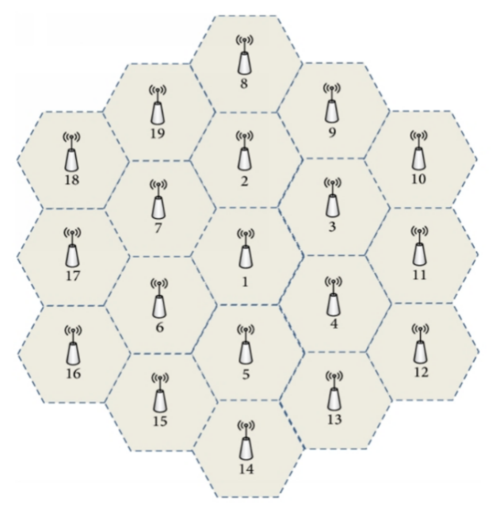

Since, no throughput requirement is specified in the URLLC scenario, time slot sharing among cells is also allowed, i.e., cells with the same carrier frequency may use different timeslots in order to furtherly improve interference isolation

The system level simulator is initialized through the following procedure.

Figure 5

System Level Simulator functional flow



Currently, the system level simulator is configured to fit the specifications provided by ITU for the URLLC setup, presented in Table 1. Since, in some cases, DECT does not support the exact specifications, effort is made to setup a suitable configuration that fulfils the requirements.

Table 1

Evaluation configurations for Urban Macro-URLLC test environments

|  |  |  |
| --- | --- | --- |
| **Parameters** | **Urban Macro–URLLC** | |
| **Reliability Evaluation** | |
| **Configuration A** | **Configuration B** |

|  |
| --- |
| **Baseline evaluation configuration parameters** |

|  |  |  |
| --- | --- | --- |
| Carrier frequency for evaluation | 4 GHz  (Supported channels 4801.172 to 4989.524 will be selected) | 700 MHz  (Supported channels 717.12 to 727.488 will be selected) |
| BS antenna height | 25 m | 25 m |
| Total transmit power per  TRxP | 49 dBm for 20 MHz bandwidth  46 dBm for 10 MHz bandwidth  (Since DECT does not support the exact configuration – an equivalent will be selected) | 49 dBm for 20 MHz bandwidth  46 dBm for 10 MHz bandwidth  (Since DECT does not support the exact configuration – an equivalent will be selected) |
| UE power class | 23 dBm | 23 dBm |
| Percentage of high loss and low loss building type | 100% low loss | 100% low loss |

|  |  |  |
| --- | --- | --- |
| **Additional parameters for system-level simulation** | | |
| Inter-site distance | 500 m | 500 m |
| Number of antenna elements per TRxP1 | Up to 256 Tx/Rx  (Use of the highest possible rand for DECT-2020) | Up to 64 Tx/Rx  (Use of the highest possible rand for DECT-2020) |
| Number of UE antenna elements | Up to 8 Tx/Rx | Up to 4 Tx/Rx |
| Device deployment | 80% outdoor, 20% indoor | 80% outdoor, 20% indoor |
| UE mobility model | Fixed and identical speed |v| of all UEs, randomly and uniformly distributed direction | Fixed and identical speed |v| of all  UEs, randomly and uniformly distributed direction |
| UE speeds of interest | 3 km/h for indoor and 30 km/h for outdoor | 3 km/h for indoor and 30 km/h for outdoor |
| Inter-site interference modelling | Explicitly modelled | Explicitly modelled |
| BS noise figure | 5 dB | 5 dB |
| UE noise figure | 7 dB | 7 dB |
| BS antenna element gain | 8 dBi | 8 dBi |
| UE antenna element gain | 0 dBi | 0 dBi |
| Thermal noise level | ‒174 dBm/Hz | ‒174 dBm/Hz |
| Traffic model | Full buffer  NOTE – This is used for SINR CDF distribution derivation | Full buffer  NOTE – This is used for SINR CDF distribution derivation |
| UE density | 10 UEs per TRxP  NOTE – This is used for SINR CDF distribution derivation | 10 UEs per TRxP  NOTE – This is used for SINR CDF distribution derivation |
| UE antenna height | 1.5 m | 1.5 m |

References-Additional Material

1. ITU-R: Minimum requirements related to technical performance for IMT-2020 radio interface(s). Report ITU-R M.2410-0, (11/2017).
2. ITU-R: Requirements, evaluation criteria and submission templates for the development of IMT-2020. Report ITU-R M.2411-0, (11/2017).
3. ITU-R: Guidelines for evaluation of radio interface technologies for IMT-2020. Report ITU-R M.2412-0, (10/2017).
4. ITU-R WP 5D: Information of the evaluation for the terrestrial components of the radio interface(s) for IMT-2020. Liaison statement to registered Independent Evaluation Groups. Document 5D/TEMP/769(Rev.1), 16 July 2019.

________________

1. ** The WWRF IEG notes that the information presented in this Interim Report is not final. The WWRF IEG reserves its right to re-visit (and revise) any portion of this Report as deemed necessary.
2. T. M. Schmidl and D. C. Cox, "Robust frequency and timing synchronization for OFDM," in IEEE Transactions on Communications, vol. 45, no. 12, pp. 1613-1621, Dec. 1997.
3. Kai Shi and E. Serpedin, "Coarse frame and carrier synchronization of OFDM systems: a new metric and comparison," in IEEE TWC, vol. 3, no. 4, pp. 1271-1284, July 2004
4. Yik-Chung Wu, Kun-Wah Yip, Tung-Sang Ng and E. Serpedin, "Maximum-likelihood symbol synchronization for IEEE 802.11a WLANs in unknown frequency-selective fading channels," in IEEE Transactions on Wireless Communications, vol. 4, no. 6, pp. 2751-2763, Nov. 2005.
5. D. Wang and J. Zhang, "Timing Synchronization for MIMO-OFDM WLAN Systems," 2007 IEEE Wireless Communications and Networking Conference, Hong Kong, China, 2007
6. Erik G. Larsson, Petre Stoica, and Girish Ganesan. 2003. Space-Time Block Coding for Wireless Communications. Cambridge University Press, USA.
7. <http://www.zjhlab.net/publications/imt-2020_cm_bupt/>
8. <https://www.mathworks.com/help/5g/ref/nrcdlchannel-system-object.html>
9. <https://www.mathworks.com/help/5g/ref/nrtdlchannel-system-object.html>