|  |  |
| --- | --- |
| **Radiocommunication Study Groups** |  |
|  |  |
|  |  |
| Received: 19 February 2021  Source: Wireless World Research Forum | **Document 5D/475-E** |
| **22 February 2021** |
| **English only** |
|  | **TECHNOLOGY ASPECTS** |
| Wireless World Research Forum | |
| Interim Evaluation Report on the Candidate Technology Submission For IMT-2020 “EUHT” As Part of the Re-engagement in Step 4 Evaluation | |
|  | |

This contribution contains the interim evaluation report from the Independent Evaluation Group Wireless World Research Forum (WWRF) for EUHT, IMT-2020/17 Submission. Following the finalisation of Step 7 in the IMT-2020 Process, EUHT submission evaluation was granted an extension in the IMT-2020 Process, for re-engagement and re-evaluation.

The evaluation is based on the characteristics defined in Reports ITU-R M.2410-0, ITU-R M.2411-0 and ITU-R M.2412-0 [1] – [3] using a methodology described in Report ITU-R M.2412-0 [3].

The interim evaluation report reflects the structure of the final report which is planned to be submitted to WP 5D #38 meeting (June 2021).

– Part I: Administrative Aspects of the WWRF

– Part II: Technical Aspects of the work of WWRF

– Part III: Conclusions.

Part I: Administrative aspects of the Independent Evaluation Group

# I-1 Name of the Independent Evaluation Group (IEG)

Wireless World Research Forum (WWRF).

# I-2 Introduction and background of the Independent Evaluation Group

WWRF’s goal is to encourage research that will achieve unbounded communications to address key societal challenges for the future. The term “Wireless World” is used in this broad sense to address the support of innovation and business, the social inclusion and the infrastructural challenges. This will be achieved by creating a range of new technological capabilities from wide-area networks to short-range communications, machine-to-machine communications, sensor networks, wireless broadband access technologies and optical networking, along with increasing intelligence and virtualization in networks. This will support a dependable future Internet of people, knowledge and things and the development of a service universe. WWRF is the unique forum where the wireless community can tackle the key research challenges. By searching out the issues, flagging them up to opinion leaders, and then working with liaison partners to deal with them, WWRF drives the development of the Wireless World. WWRF organizes two major events each year combining inputs from industry and academic experts, the exchange of ideas and the evolution of the research agenda and technology roadmaps. WWRF’s has a strong publication programme, working with partners such as IEEE and Wiley, makes the key messages and results available to the wireless research sector. To ease standardization, WWRF disseminates and harmonizes views, and together with our major liaison partners, we initiate collaborative research, and develop the global vision.

Over the last ten years, WWRF has championed several activities focused on the wireless evolution to and beyond 5G, including workshops and special sessions, presentations, white papers and journal special issues. WWRF has been very supportive of the ITU’s evaluation process for IMT-2020 and participates as an independent evaluation group (IEG).

# I-3 Method of work

## I-3.1 Background

The step 4 of IMT-2020 evaluation process was conducted to identify if the candidate RIT met the requirements set by the ITU. However, the step 4 did not conclude the decision-making process and an extension was agreed upon, where the steps 4-7 will be carried out to ascertain if the RIT meets the ITU requirements.

## I-3.2 Organizational issues

The work was organized using the following channels:

1 Regular online meetings of the steering board

2 Weekly meetings of the technical team

3 File sharing through secure shared space

4 Workshops/Seminars organised by the WWRF

5 Monitoring of the ITU Discussion Forum.

# I-4 Administrative contact details

**Name & Affiliation:** Dr Nigel Jefferies, WWRF Chairman.

**E-mail:** [chairman@wwrf.ch](mailto:chairman@wwrf.ch)

# I-5 Technical contact details

|  |  |  |
| --- | --- | --- |
| [Name](mailto:hakan.batikhan@turkcell.com.tr) | Affiliation | e-mail |
| Prof. Christos Politis | Kingston University, UK | [c.politis@kingston.ac.uk](mailto:c.politis@kingston.ac.uk) |
| Dr Rafay Ansari | Kingston University, UK | [rafay.ansari@kingston.ac.uk](mailto:rafay.ansari@northumbria.ac.uk) |
| Dr M Arslan Usman | Kingston University, UK | [m.usman@kingston.ac.uk](mailto:m.usman@kingston.ac.uk) |
| Mr Nuwan Weerasinghe | Kingston University, UK | [nuwan.weerasinghe@kingston.ac.uk](mailto:nuwan.weerasinghe@kingston.ac.uk) |

Part II: Technical aspects of the work of the Independent Evaluation Group

# II-A What candidate technologies or portions of the candidate technologies this IEG is or might anticipate evaluating?

The IEG will evaluate the following scenarios for EUHT:

– URLLC for urban macro environment (by Simulation)

– Energy Efficiency Analysis (by Inspection)

– Bandwidth Analysis (by Inspection)

– Mobility Interruption Time (by Inspection).

# II-B Confirmation of utilization of the ITU-R evaluation guidelines in Report ITU-R M.2412

The IEG is cognisant of the ITU-R evaluation guidelines and the evaluation plan is developed under the light of those guidelines.

# II-C Documentation of any additional evaluation methodologies that are or might be developed by the Independent Evaluation Group to complement the evaluation guidelines

## II-C-1 Performance Evaluation (Scenario: Urban-macro URLLC)

### II-C-1A Link Level Parameters for EUHT-PHY layer

The range of Link level simulation parameters for EUHT-PHY layer are taken from the system specifications provided by *NuFront* for EUHT and are summarised as follows. In our current link level simulation design, we are considering the Downlink only i.e., transmission of data from Base station to a single user.

Table 1

Range of simulation parameters for link level EUHT-PHY layer

|  |  |
| --- | --- |
| **Scenario** | Dense Urban |
| **Carrier frequency** | 4 GHz (Sub 6 GHz bands) |
| **Bandwidth** | 5, 10, 15, 20, 25, 30, 40 and 50 MHz (n = 1:8) |
| **Signalling waveform** | CP-OFDM (SU-MIMO) |
| **Subcarrier spacing** | 19.53 kHz, 39.0625 kHz & 78.125 kHz |
| **FFT** | 256, 512, 768, 1024, 1280, 1536, 2048, 2560 (n=1:8) |
| **Cyclic prefix** | FFT/8 (Short CP) or FFT/4 (Normal CP) |
| **Guard band** | True |
| **Propagation channel** | Tap Delay Line & Clustered Delay Line |
| **Mobility** | True |
| **Errors considered** | Bit Error Rate (BER) & Frame Error Rate (FER) |
| **Channel coding** | Low Density Parity Check & Convolutional Coding |
| **Modulation** | BPSK, QPSK, 16-QAM, 64-QAM, 256-QAM & 1024-QAM |
| **Channel estimation** | Imperfect, Non-Ideal |
| **Number of transmit antennas** | 8 |
| **Number of receiver antennas** | 2 |

### II-C-1B Description of simulation parameters

According to NuFront’s system specifications, different bandwidths are associated with different FFT sizes for example, for a bandwidth of 20 MHz an FFT size of 1024 should be used. Cyclic prefix (CP) can be used in two different forms i.e., short and normal form. For an FFT size of 256, the CP size will be 32 and 64 for short and normal form respectively. Sub-carrier spacing **19.53 kHz, 39.0625 kHz** are optional for actual product implementation, but we have considered these values for our simulation design.

There are two types of channel coding techniques that are specified in EUHT specifications, these include convolutional channel coding and low-density parity check (LDPC) channel coding. There is a vast range of different code rates that are specified, and we aim to consider them in our simulation design.

### II-C-1C Channel Modelling

The applicable channel model is based on the Channel Model Configuration A for the test environment Urban Macro-URLLC. The configuration parameters will be taken from the Annex 1 of Report ITU-R M.2412. As some parameters are defined in the terms of ranges, our aim is to model evaluations in a manner that a number of values in the range are considered as the technical performance requirement might not depend on the highest/lowest value 1.

The simulation model will consider the 4-GHz carrier frequency for evaluation. An important aspect that impacts the evaluation is the service profile, which in our case will be the ‘full buffer best effort’. The simulation bandwidth can be up to 100 MHz for 4-GHz of carrier frequency according to the evaluation criteria. However, based on the parameters provided for EUHT, the simulation bandwidth of 20 MHz will be considered with a subcarrier spacing of 78.125 kHz. The evaluation will be based on two channel conditions: non-line-of sight (NLoS) and line-of-sight (LoS). Making a distinction between the two cases is important as the tapped delay line (TDL) model for both cases is different. The self-evaluation provided by EUHT considers NLoS scenario for URLLC, hence our simulation model will consider the same. The fading distribution for the TDL is Rayleigh, with the tap delays and normalised power provided in Table A1-41 [3]. The delay spread and angular spread will be taken from the Table A4-9 (UMa) in Annex 1 [3]. The path loss and shadow fading model are provided in Table A1-3 for both LoS and NLoS scenarios. Finally, the baseline for the channel coefficient generation procedure will be the Figure A1-2 ‘Channel coefficient generation main procedure’, starting from assigning the general parameters, then moving towards small scale parameters, which results in channel coefficient generation.

Figure 1

Channel coefficient generation procedure

## II-C-2 Implementation plan

A stepwise implementation plan is provided as follows.

### II-C-2A Link level simulations

In this section, the basic flow of the link level simulator is explained. We aim to implement the Physical Downlink Shared Channel (PDSCH) and downlink shared channel (DL-SCH). The transmitter model includes PDSCH demodulation reference signals (DM-RS), PDSCH phase tracking reference signals (PT-RS), and synchronization signal (SS) bursts which are considered optional. The simulator may support both clustered delay line (CDL) and tapped delay line (TDL) propagation channels along with the channel model explained earlier. Furthermore, perfect or practical synchronization and channel estimation will be included in the design of this link level simulator. Figures 1 and 2 shown below, depict the basic flow of simulator design for both transmitter and receiver respectively.

Figure 2

EUHT-PHY layer Transmitter Design

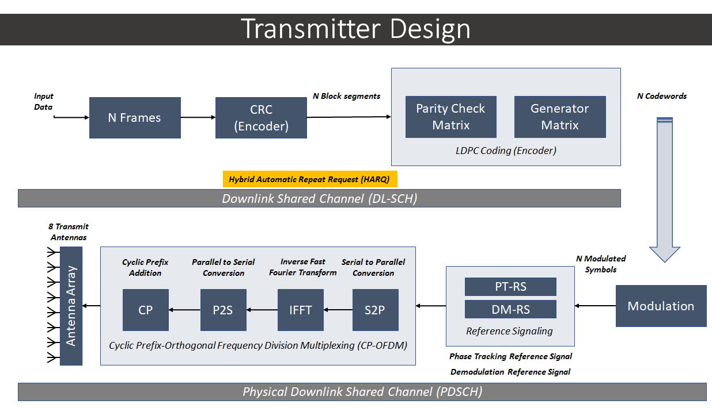

Figure 3

EUHT-PHY layer Receiver Design

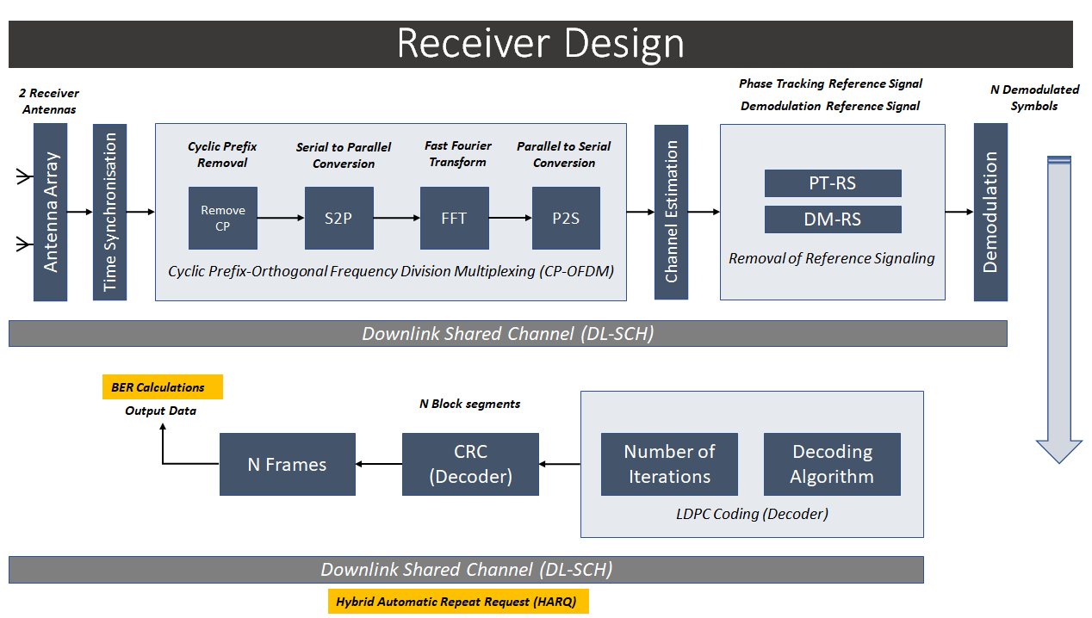

### II-C-2B Stepwise workflow of the link level simulator

A stepwise workflow of the simulator is explained as follows:

– **Update the HARQ process:** Checks the CRC for any retransmissions required.

– **Resource grid generation**: Channel Coding and Modulation

– **Waveform generation:** CP-OFDM Modulation is performed.

– **Channel modelling***:* Pass the waveform through a channel.

– **Perform synchronization and OFDM demodulation:**Perfect or practical synchronisation is performed.

– **Perform channel estimation:** Perfect or practical channel estimation is performed by using the demodulation reference signals. Then OFDM demodulation is performed.

– **Perform equalization and CPE compensation:**

• MMSE or ZF is used to equalize the estimated channel.

• Estimation of the common phase error (CPE) is done using the PT-RS symbols.

• Correction of error in each OFDM symbol is performed using the PT-RS symbols.

– **Precoding matrix calculation:** Generate the precoding matrix for the next transmission.

– **Decode the PDSCH:** Demodulation and descrambling of the recovered PDSCH symbols for all transmit and receive antenna pairs, along with a noise estimate is performed.

– **Decode DL-SCH and store the block CRC error for a HARQ process**

# II-D Verification as per Report ITU-R M.2411 of the compliance templates and the self-evaluation for each candidate technology as indicated in A)

This is an interim report and the verification of compliance templates and the self-evaluation will be conducted in the final report.

# II-E Assessment as per Reports ITU-R M.2410, ITU-R M.2411 and ITU-R M.2412 for each candidate technology as indicated in A)

This is an interim report, and the final assessment on a system level scale will be conducted in the midterm and final report.

# II-F Questions and feedback to WP 5D and/or the proponents or other IEGs

This IEG has referred to the self-evaluation report provided by the EUHT and plans to use the parameters used by the EUHT self-evaluation to cross verify the findings.

The webinar presented by the proponent was attended and was much appreciated as it provided useful information for the IEG.

**II-G Proposed next steps towards the final report**

### II-G-2A Results for the Link Level Simulator

The system level simulator design shown in Section II-C is work in progress and the next reports will include EUHT evaluation results for Link Level simulations.

### II-G-2B System Level Simulation design

The EUHT system-level simulator will be developed according to the ITU specifications. The simulator will include a 19-cell two-tier scenario as shown in Figure 4.

Figure 4

System Level Simulation Plan: 19-Cell Scenario with Two Tiers

The high-level system architecture of the proposed system level module is shown in Figure 5 as follows.

Figure 5

EUHT high level system architecture.

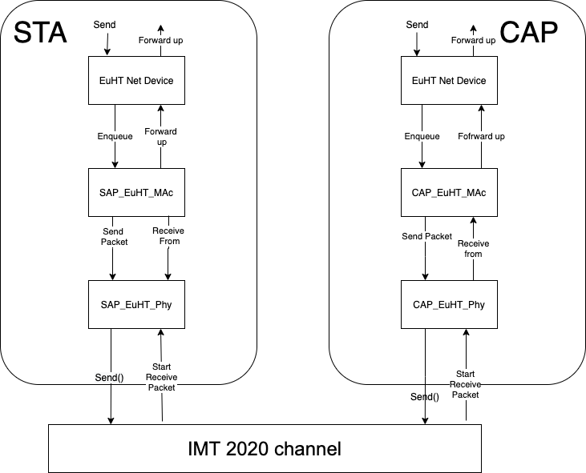

The system level simulator will only focus on evaluating the reliability of the EUHT technology. ITU-R guideline on evaluation of reliability is based on a combination of system level and link level simulations. The system level simulation will be used to determine the operation point (e.g., average SINR) from a multi-cell, multi-user environment perspective.

Following details stepwise implementation plan for the system level simulator, as well as the plan for simulator of calibration and verification.

– **EUHT NetDevice:** This will include position and mobility of device simulation as well as it performs as a coordinator with the EuhtChannel, EuhtPhy, EuhtMac.

– **EUHT Mac:** Mac layer functionality defined in EUHT specification for STA and CAP devices will be separately implemented.

– **EUHT Phy:** Physical layer functionality defined in EUHT specification for STA and CAP devices will be implemented separately such that STA_EuHt_Phy communicate with STA_EuHt_Mac, while CAP_EuHt_Phy will communicate with CAP_EuHt_Mac.

– **IMT 2020 Channel (EUHT Channel):** This will be based on 3GPP TR 38.901 [4] implementation of a channel model [5][6]. Which is a 3D statistical Spatial Channel Model supporting different propagation environments (e.g., urban, rural, indoor), multi-antenna operations and the modelling of wireless channels between 0.5 and 100 GHz.

Implementation will focus on:

a) Path loss and shadowing models (3GPP TR 38.901, Sec. 7.4.1)

b) Autocorrelation of shadow fading (3GPP TR 38.901, Sec. 7.4.4)

c) Channel condition models (3GPP TR 38.901, Sec. 7.4.2).

We compared the 3GPP TR 38.901 specification with IMT 2020 channel specification to observe only a few parameter differences. Hence, we will develop the EUHT channel based on 3GPP channel model.

– **Calibration metrics for self-evaluation:** Referring to IMT 2020 calibration guideline [7], following metrics are selected for calibration of self-evaluation:

a) DL Geometry (wideband SINR)

b) Coupling loss.

Results obtained from this simulation will be compared against simulation results shared by other evaluation groups for system level verification.

### II-G-2C Link and System Level Integration and Recommendation plan

The system level simulator will use a simplified link-level (physical layer abstraction), which will be implemented as a link-to-system-mapping, to allow a vector of per-subcarrier: signal-to-noise ratios to be distilled into a single “effective SNR” value, that can be used to determine performance using link simulation results of the channel. The link level performance curves obtained from link level simulator will be used to match a mathematical approximation of the Block Error Rate (BLER). Then error rate model implementation will be based on a table-based error rate model approach for system level simulations [8].

System level simulator will be used to run downlink/uplink full buffer scenario using the evaluation parameters of Urban Macro-URLLC test environment and collect overall statistics for downlink or uplink SINR values, and construct CDF over these values.

We will provide recommendations for the EUHT evaluation in the final report.

Part III: Conclusions

In this report, we present the methodology that we plan to adopt for evaluating the RIT for urban macro URLLC scenario. First, we highlight the implementation plan for the link-level simulations. We identify some important parameters and explain the individual modules and transmitter/receiver design involved in the implementation plan. The channel coefficient generation procedure is identified and the submission by the RIT is considered for the calibration of parameters. We also provide an initial discussion on how the link-level simulations will be connected to the system level simulations, as a direction for the next report.

References and Additional Material

[1] Report ITU-R M.2410-0, *Minimum requirements related to technical performance for IMT-2020 radio interface(s)*, 11/2017.

[2] Report ITU-R M.2411-0, *Requirements, evaluation criteria and submission templates for the development of IMT-2020*, 11/2017.

[3] Report ITU-R M.2412-0, *Guidelines for evaluation of radio interface technologies for IMT-2020*, 10/2017.

[4] 3GPP. 2018. TR 38.901. Study on channel for frequencies from 0.5 to 100 GHz. V.15.0.0 (2018-06).

[5] Menglei Zhang, Michele Polese, Marco Mezzavilla, Sundeep Rangan, Michele Zorzi, *ns‑3 Implementation of the 3GPP MIMO Channel Model for Frequency Spectrum above 6 GHz*. In Proceedings of the Workshop on ns-3 (WNS3 ‘17). 2017.

[6] Tommaso Zugno, Michele Polese, Natale Patriciello, Biljana Bojovic, Sandra Lagen, Michele Zorzi, *Implementation of a Spatial Channel Model for ns-3*. Submitted to the Workshop on ns-3 (WNS3 ‘20). 2020. Available: <https://arxiv.org/abs/2002.09341>

[7] R1-1807760, *Summary on offline discussion on URLLC evaluation method and parameters for IMT-2020 self-evaluation*, Huawei, 3GPP TSG RAN WG1#93, May, 2018.

[8] R. Patidar *et al.*, *Link-to-System Mapping for ns-3 Wi-Fi OFDM Error Models*, Proceedings of the Workshop on ns-3, June 2017. <https://dl.acm.org/doi/10.1145/3067665.3067671>

______________