Radiocommunication Study Groups | 
Received: 12 February 2020 | Document 5D/120-E
Received: 12 February 2020 | 13 February 2020
Received: 12 February 2020 | English only  TECHNOLOGY ASPECTS
Director, Radiocommunication Bureau ,
FINAL EVALUATION REPORT FOR RIT SUBMISSIONS FROM
TSDSI (IMT-2020/19) and Nufront (IMT-2020/18)
This contribution contains the final evaluation report from the Independent Evaluation Group Wireless World Research Forum (WWRF).
The evaluation targets the following RIT submissions:
• Submission received for proposals of candidate radio interface technologies from proponent 'TSDSI' under Step 3 of the IMT-2020 Process and its updates
(IMT-2020/19)
• Submission received for proposals of candidate radio interface technologies from proponent ‘Nufront’ under Step 3 of the IMT-2020 Process and its updates and its updates (IMT-2020/18)
The evaluation is based on the characteristics defined in ITU-R Reports M.2410-0, M.2411-0 and M.2412-0 ‎[1] – ‎[3] using a methodology described in Report ITU-R M.2412-0 ‎[3].
The evaluation report consists of 3 Parts according to the proposed structured by ITU in ‎[4]:
• Part I: Administrative Aspects of the WWRF
• Part II: Technical Aspects of the work of WWRF
• Part III: Conclusion
Finally, in Annex 1, numerical results for supporting the technical performance evaluation are provided.

Part I: Administrative aspects of the Independent Evaluation Group

I-1 Name of the Independent Evaluation Group
Wireless World Research Forum (WWRF)

I-2 Introduction and background of the Independent Evaluation Group
Over the last ten years WWRF has championed several activities focused on the wireless evolution to and beyond 5G, including workshops and special sessions, presentations, white papers and journal special issues.
WWRF has been very supportive of the ITU’s evaluation process for IMT-2020, and a group of interested members was formed to investigate how WWRF can participate as an independent evaluation group. Available resources dictated that WWRF was not able to provide a complete evaluation in all use cases but has concentrated on those of most importance to our members, in particular those working on developing IMT-2020 in emerging and developing markets.
The WWRF members who support the ITU’s evaluation process had several working meetings during WWRF’s regular conferences over the last 3 years. Members of the group are predominantly from universities, but also include industry representatives and independent consultants.

I-3 Method of work
The WWRF IEG has had several face-to-face and phone meetings to discuss the proposals submitted by the various proponents. The regular WWRF conferences (twice per year) have been used for this purpose. A working group (‘ITU EVAL’) and dedicated sessions within the WWRF conferences were organized.
Based on the individual studies of the IEG members and the discussions and consensus reached, the WWRF IEG decided to focus their evaluation on the Nufront and TSDSI proposals and a small project team was formed to progress this work.
To this end they have studied the various features and technologies proposed and provided an assessment by inspection, analysis and based on simulation results, where it was deemed necessary. The results and conclusions of these studies are presented in detail in this document.

I-4 Administrative contact details
Name & Affiliation; Dr Nigel Jefferies, WWRF Chairman
Email: chairman@wwrf.ch

I-5 Technical contact details

Name | Affiliation | e-mail
Prof. Angeliki Alexiou | University of Piraeus | aalexiou@ieee.org
Dr. Antonis Gkotsis | University of Piraeus, Feron Technologies P.C. | antonis.gotsis@feron-tech.com
Dr. Konstantinos Maliatsos | University of Piraeus, Feron Technologies P.C. | konstantinos.maliatsos@feron-tech.com
Prof. Christos Politis | Kingston University | c.politis@kingston.ac.uk

Part II: Technical aspects of the work of the Independent Evaluation Group

II-A What candidate technologies or portions of the candidate technologies this IEG is or might anticipate evaluating?

II-A-1 TSDSI
TSDSI submitted at ITU Meeting #31, a RIT as an IMT 2020 technology candidate. The submission was finalized at ITU Meeting #32. The candidate RIT reuses the 3GPP NR and NB-IoT technologies, along with a set of four modifications on specific 3GPP technology components, as it is reflected in the following series of documents:
• T3.9036.x,
• TSDSI STD T3.9038x,
• TSDSI STD T3.9022x, and
• TSDSI STD T3.9037x
The new features primarily target to address local (Indian) market needs and secondarily to enhance several 3GPP technologies flexibility. The TSDSI features concern the following aspects: the uplink waveform, the physical layer signals and procedures, and radio resources management.
In order to support each newly introduced feature, the necessary modifications to higher-layer 3GPP signaling elements, i.e. to the respective RRC IEs, have been also documented in the specifications.
In particular, TSDSI’s proposed RIT modifies the following 3GPP technologies and procedures:
1) The pi/2 BPSK uplink waveform implementation.
2) The configuration of resource block groups (RBGs) in frequency-domain resource allocation within the context of bandwidth partitioning.
3) The configuration of the time gap between the uplink non-codebook precoded sounding reference signals (SRS) transmission and downlink CSI-RS transmissions.
4) The configuration of uplink phase tracking reference signals (PTRS) density.

II-A-2 NuFront proposal Evaluation Scenarios
A. Scenario 1: Reliability Analysis for 4 GHz Carrier Frequency in an Urban Macro Environment (Configuration A)
In this scenario, we have considered link-level simulations that include a base-station (BS) communicating with a single user equipment (UE). The simulations are conducted for Downlink and we consider a mobility-based environment. The scenario is designed to test the EUHT’s performance in terms of reliability of data received at the user equipment. We have considered a single user multiple input multiple output (SU-MIMO) system.
B. Scenario 2: Normalized traffic channel link data rate simulation in high mobility Rural-eMBB for 4 GHz Carrier Frequency (Configuration A)
We have simulated scenarios defined in “Linear cell layout configuration for high-speed vehicular mobility at 500 km/h under Rural-eMBB test environment” (Annex 2- ITU-R M.2412-0). Single base-station (BS) communicating with 20 user equipment (UE) placed inside a train moving at a constant speed of 500 km/h. This scenario is used to calculate normalized traffic-channel link data rate for uplink (UL). Illustration of the scenario is shown in Fig. II-1.
Fig. II-1
Rural eMBB (Scenario 2)
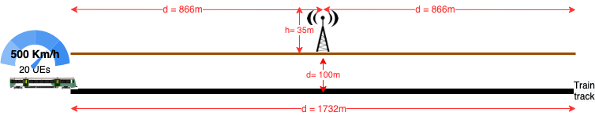

II-B Confirmation of utilization of the ITU-R evaluation guidelines in Report ITU-R M.2412
Confirmed.
The WWRF IEG has performed a partial evaluation of the TSDSI and NuFront technology proposals.

II-C Documentation of any additional evaluation methodologies that are or might be developed by the Independent Evaluation Group to complement the evaluation guidelines
TSDSI’s candidate IMT-2020 technology is based on 3GPP technologies, and in this context, the IEG focused on the analysis and evaluation on the proposed modifications. In particular, the IEG used the following means to evaluate the submission:
• Inspection of the modifications, by investigating the impact of the proposed changes to the technical specification documents and their compatibility with the corresponding 3GPP procedures
• Qualitative analysis of the proposed modifications, using as baseline the 3GPP proposal, in terms of: i) the expected spectral efficiency performance benefits; ii) the potential of making the existing technology more flexible and/or improving the use of available resources (e.g. on resource blocks grouping during scheduling); iii) the potential in overhead signaling reduction, in Layer 1 (e.g. resources required to carry reference signals) or in Layer 3 (IEs of specific RRCs)
• Quantitative analysis of the proposed modifications when deemed necessary using the following tools: i) calculations, based on closed-formulas/expressions provided by the standard specifications (e.g. calculation of L1 payload, density of complex valued symbol resources to carry reference signals, etc.); ii) internal link-level and/or system-level monte-carlo simulation tools for quantifying particular performance metrics (e.g. PAPR, resources utilization).
More details on the exact methodology and evaluation tools used per-case are reported in Section II-E.

II-D Verification as per Report ITU-R M.2411 of the compliance templates and the self-evaluation for each candidate technology as indicated in A)
Not applicable

II-E Assessment as per Reports ITU-R M.2410, ITU-R M.2411 and ITU-R M.2412 for each candidate technology as indicated in A)

II-E-1 TSDSI
The independent IEG elaborates and evaluates in a qualitative and –when possible– quantitative way using inspection, analysis and –when needed– simulation, the four proposed non-3GPP technology modifications.

pi/2 BPSK uplink waveform implementation

Description
A differentiated version of the 3GPP proposal on the use of π/2-BPSK modulation for uplink transmission (DFT-S-OFDM) is presented. The basic modification concerns the specification and application of a simple shaping filter applied to the uplink physical channels (PUSCH and PUCCH), which on the other hand is not applied in the reference signals (DMRS). Schematically, the TSDSI proposes the implementation presented in the block diagram of Figure 1.
Figure 1
TSDSI proposal for the usage of π/2 BPSK modulation in DFT-S-OFDM
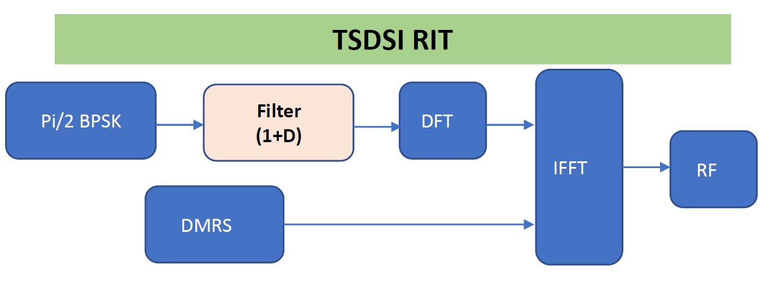
On the other hand, π/2-BPSK is optionally supported by 3GPP, and spectrum shaping can be transparently integrated in the procedure – uniformly over physical channels and reference signals. The 3GPP approach is schematically presented in Figure 2.
Figure 2
Supported implementation in 3GPP
The TSDSI proposal attempts to maintain compatibility with 3GPP and thus does not propose modification of existing π/2-BPSK signaling parameters. Thus, two new signaling elements per physical channel (PUSCH, PUCCH) are introduced in RRC to support the TSDSI-based operation.
The overall modifications related to the use of π/2-BPSK in the DFT-S-OFDM uplink, as changes in the 3GPP proposal are presented below:
38.211: Physical channels and modulation

Figure 3
Transform precoding modification and specification of spectral shaping filter
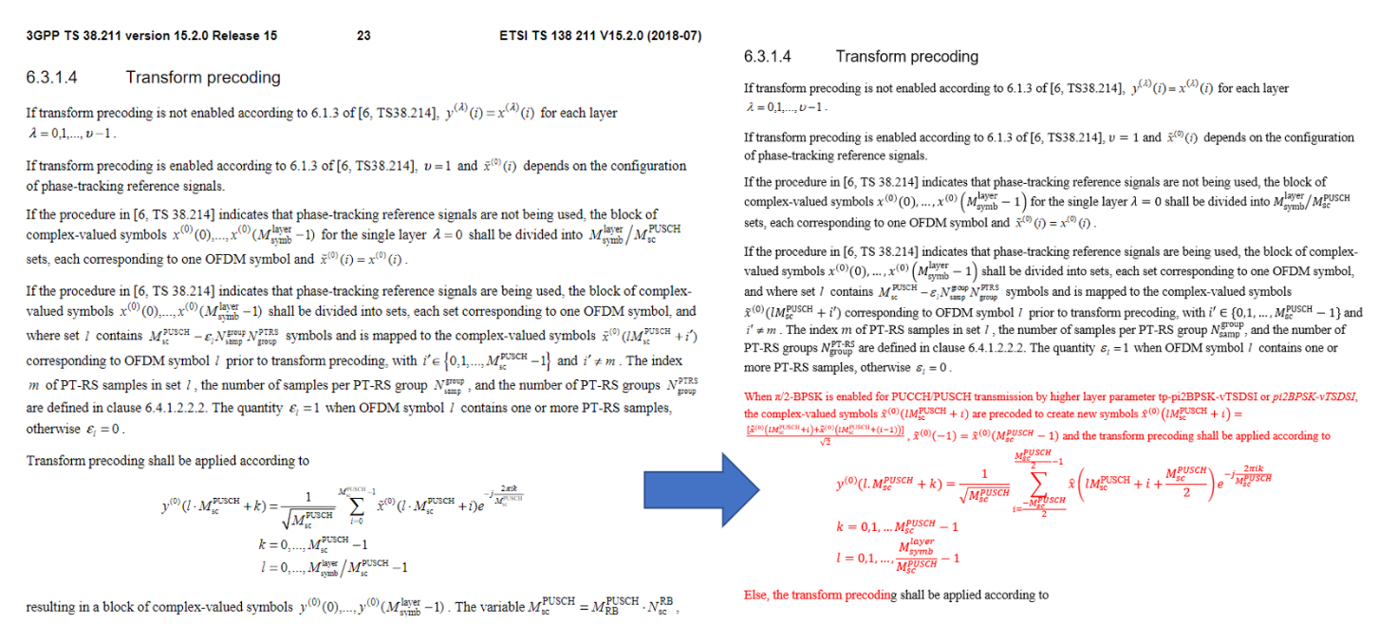
Figure 4
Reference signal and parameter β_{PUSCH,pi2BPS}
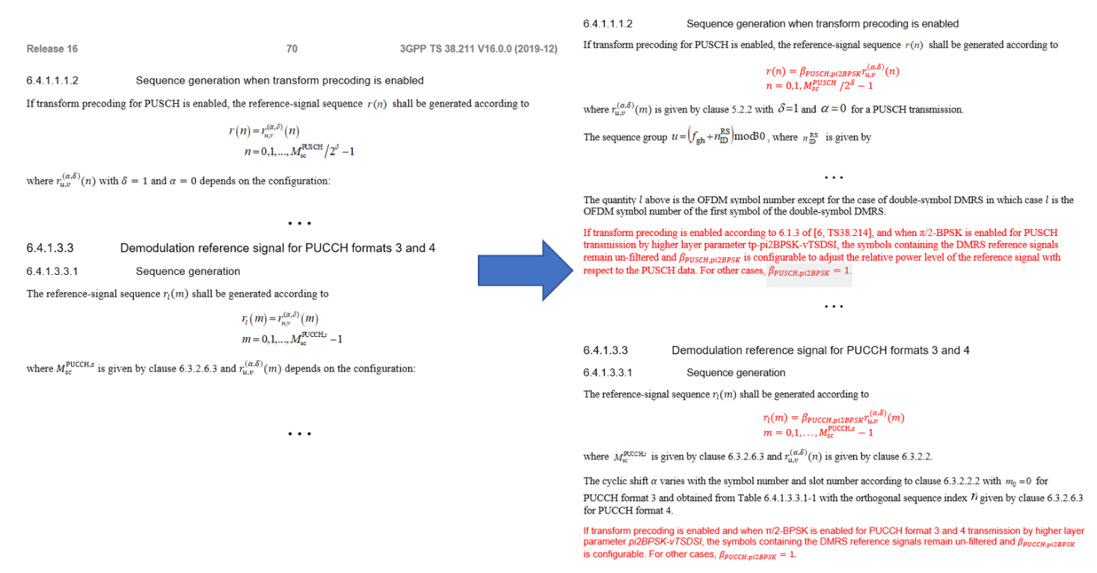
38.213: Physical layer procedures for control
Figure 5
PUCCH Formats for UCI transmission and use of π/2-BPSK
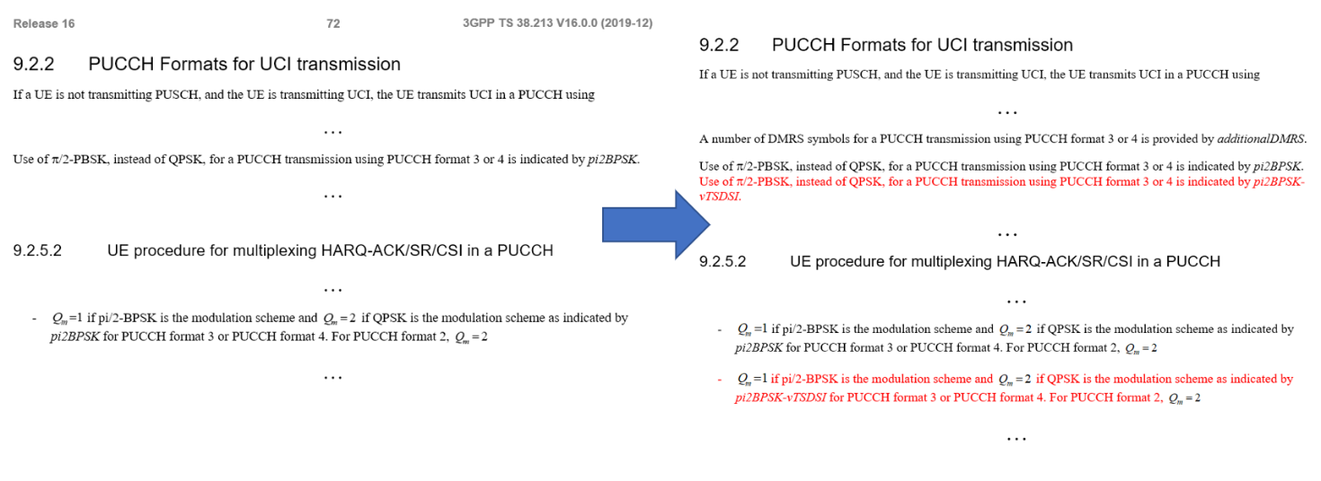
38.214: Physical layer procedures for data
Figure 6
Extra lines introduced regarding the modulation order and code rate determination for π/2-bpsk
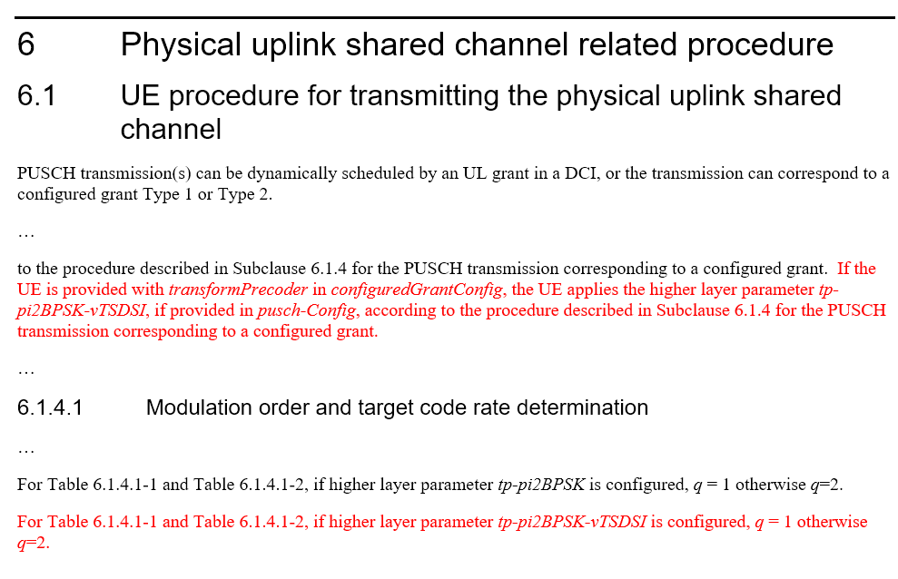

38.306: User Equipment (UE) radio access capabilities
Figure 7
Introduction of new PHY-PARAMS in 4.3.7.10 table
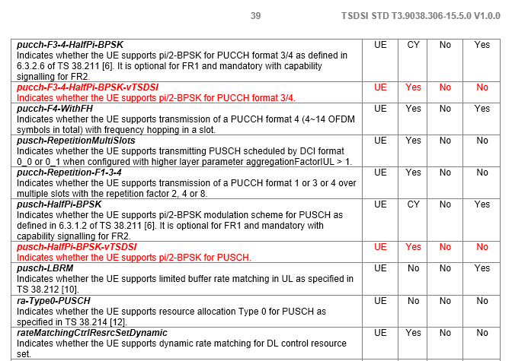

38.331: Radio Resource Control (RRC) protocol specification
Figure 8
New entries of information elements
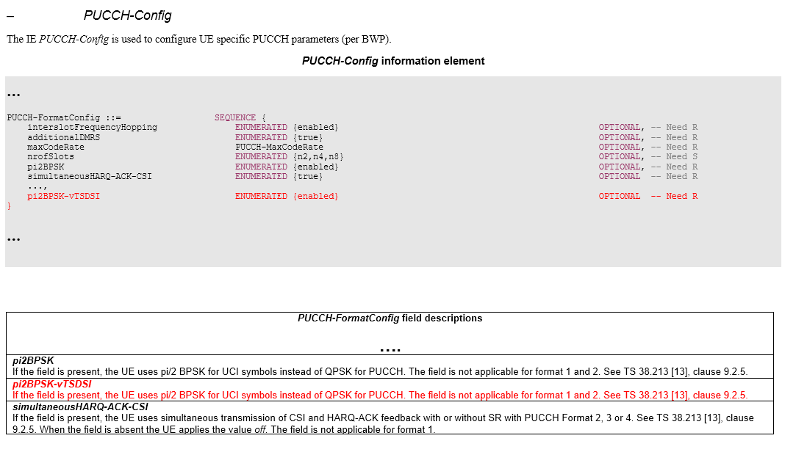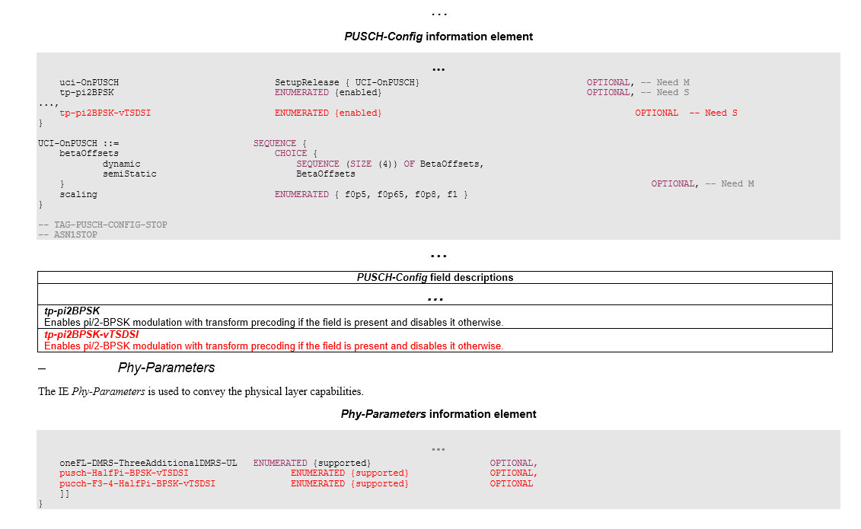
38.101-1: User Equipment (UE) radio transmission and reception
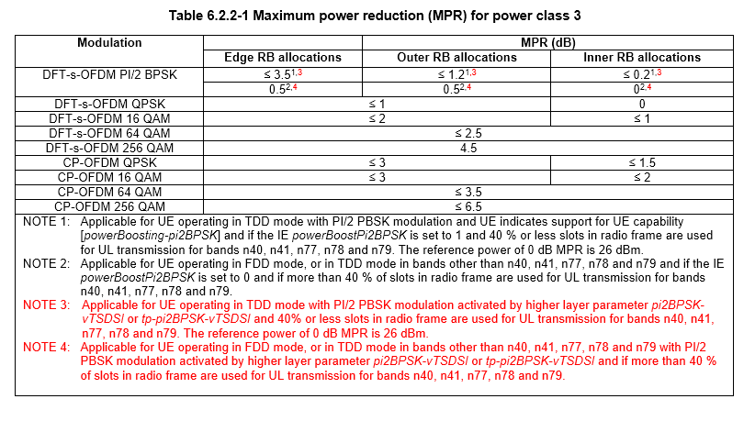
Figure 9
Inclusion of the MPR for pi/2-BPSK-vTSDSI
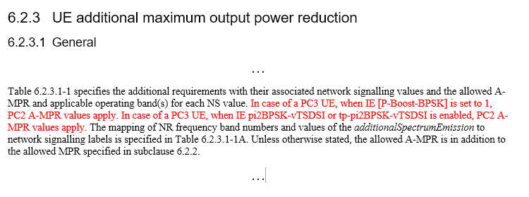
Figure 10
Tx power and requirements for pi/2 BPSK modifications
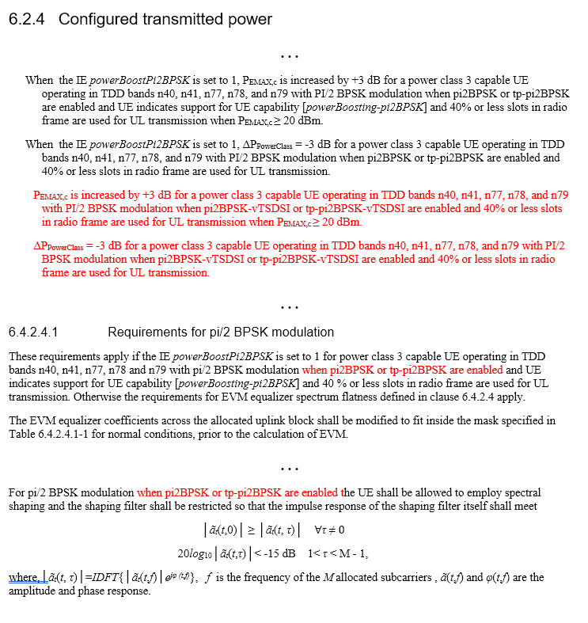

38.101-2: User Equipment (UE) radio transmission and reception
Figure 11
Minor Modification in 38.101-2
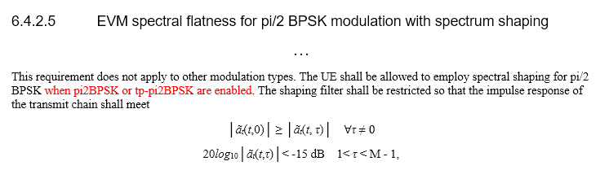

Evaluation Observations
Observation 1: The more substantial proposed modification in comparison with the 3GPP series of recommendations is that, TSDSI considers π/2-BPSK as a mandatory feature for UEs according to the new entries provided in Figure 7.
Mandatory inclusion of π/2-BPSK in the UE capabilities will provide coverage extension. However, it is noted that:
• 3GPP also supports π/2-BPSK with similar (if not identical) performance in terms of coverage and reliability for Low Mobility Large Cell (LMLC) configurations – but the feature is optional.
Observation 2: According to Figure 1, the TSDSI specification:
• Defines a specific shaping filter as provided in 38.211 document (Figure 3). The spectral response of the filter is given in Figure 12.
Figure 12
1+D TSDSI Filter Response
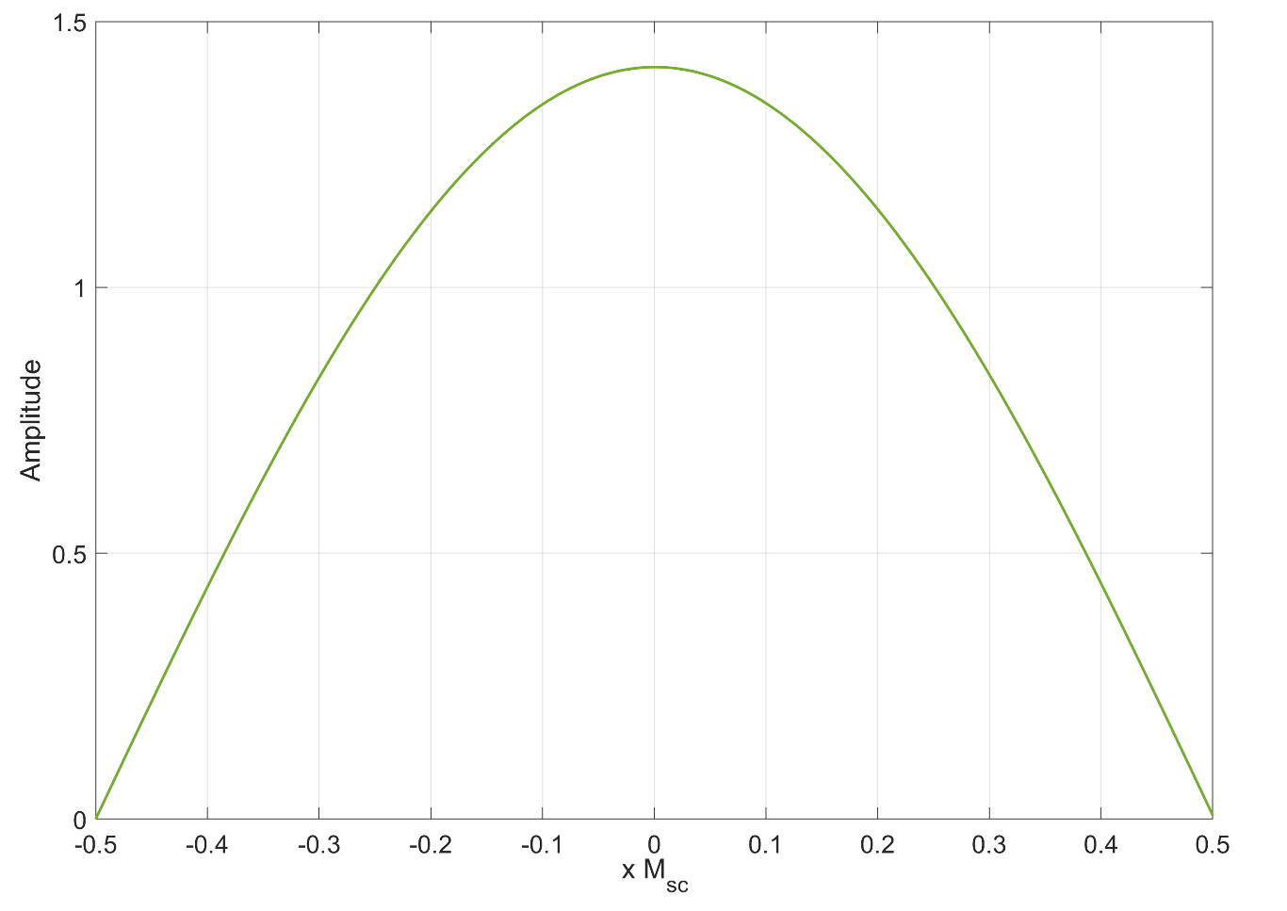
• The spectral mask is not applied on the DMRS. This means that a non-transparent filtering approach is used and that the receiver will not estimate the filter response through the reference signals. The receiver should apply compensation measures to extract the data from the shaped signal after channel equalization.
• In TSDSI version, the transmitter is not able to select a different shaping filter – depending on the radio conditions that best fits a specific scenario. Since DMRS is not filtered, there is no way for the receiver to know the use of a different spectral mask.
• In 3GPP spectral shaping is optional and it can be selected by the transmitter, with no specific standard specification.
• The fact that the DMRS is also filtered indicates that for the 3GPP version, the receiver should not have any knowledge regarding the type of spectral shaping performed by the transmitter. The effect of the filter is considered part of the channel, it is estimated through the channel estimation procedure performed through the DMRS and compensated with the use of the equalizer. This practically means that through the specific 3GPP setup, increased flexibility can be achieved.
Observation 3: The shaping filter of Figure 12 presents spectral zeros at the edges. This may lead to challenges in the receiver design in order to compensate the filter effects – since simple zero-forcing equalization may lead to significant distortion. Thus, increased receiver complexity is anticipated compared to the conventional transmission. However, it is noted that most problems may occur for high SNR values, where typically π/2-BPSK is not considered as a modulation candidate.
Observation 4: The use of the 1+D shaping filtered proposed by TSDSI does not offer any benefits regarding the Peak to Average Power Ratio (PAPR). On the contrary, the PAPR values slightly increase. Indicative simulation results are the following:
• 3GPP – no spectral shaping DFT-S-OFDM – 60MHz/30kHz fully loaded (NRB 217): PAPR=6.05dB
• TSDSI –spectral shaping DFT-S-OFDM – 60MHz/30kHz fully loaded (NRB 217): PAPR=7.47dB
• 3GPP – no spectral shaping DFT-S-OFDM – 60MHz/30kHz ~50% loaded (108/217) non-contiguous allocation of RBs: PAPR=7.04dB
• TSDSI –spectral shaping DFT-S-OFDM – 60MHz/30kHz ~50% loaded (108/217) non-contiguous allocation of RBs: PAPR=7.65dB
• 3GPP – no spectral shaping DFT-S-OFDM – 10MHz/15kHz fully loaded (NRB 52): PAPR=5.71dB
• TSDSI –spectral shaping DFT-S-OFDM – 10MHz/15kHz fully loaded (NRB 52): PAPR=7.18dB
Observation 5: The performance of the TSDSI scheme was evaluated through simulation and compared with the 3GPP proposed implementation. The following simulation parameters where considered:
Simulation Parameters:
Channel Parameter | Value
Carrier Frequency | 3.5 GHz
Pathloss model | LMLC (ITU-R M.2412-0)
BS height | 35m
UE height | 1.5m
Base Station Antennas | 18 dB gain
UE Antennas | omni

System Parameters:
Bandwidth | 60 MHz
UE transmit power | 26 dBm for pi/2 bpsk
Allocation of UEs | 10 UEs/cell
ISD | 12 km
Tx number | 1
Rx number | 2 or 4
Mode | TDD (50% Duty Cycle)
The ten users per cell are dropped in a radius of 7 km. On top of the LMLC pathloss model, the TR 38.901 Tapped Delay Line model was used to include frequency selectivity and small-scale fading.
In order to evaluate the specific modulation scheme, we run the simulation for the two waveform schemes (TSDSI vs. 3GPP with π/2-bpsk support). The scheduler uses the 38.211 MCS index table for PUSCH with transform precoding, with q = 1 for MCS indexes 0 and 1. The selection of the MCS is made for target block error rate 1% and 5% for negative SNRs. The system performance is presented in Figure 13.
Figure 13
UE throughput empirical cdf for the aforementioned simulation setup
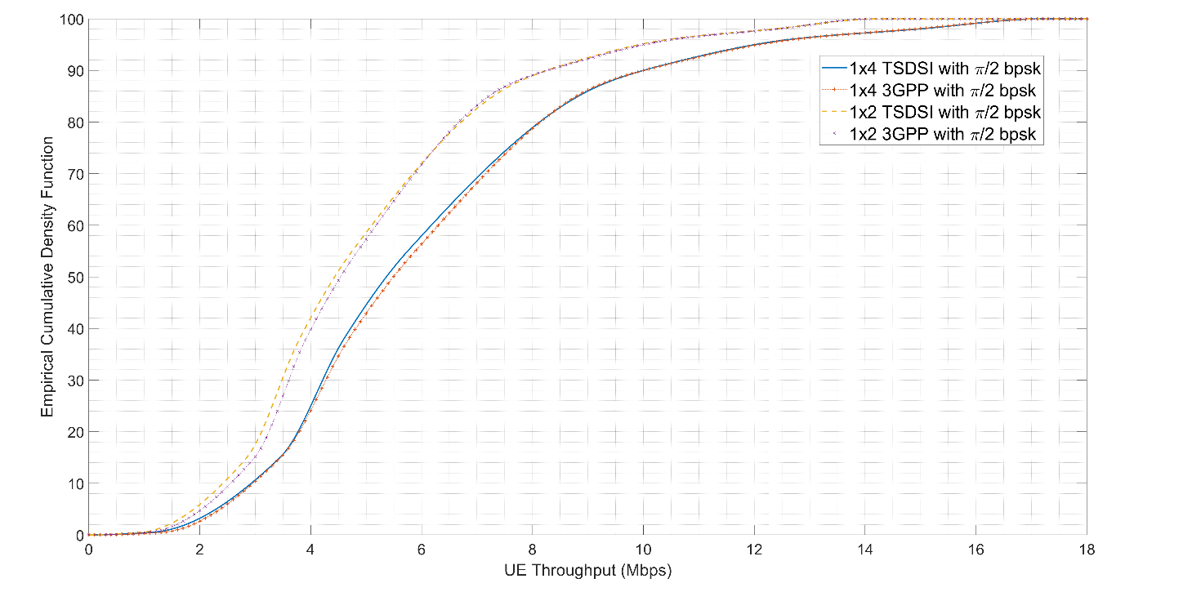
The simulation results show that both waveform designs have identical performance (slightly better performance is achieved with 3GPP).
Through the tests, no EVM gain was noticed due to the fact that DMRS remain unfiltered. In the scenario where the 1+D filter is applied at both data and reference signals according to Figure 2, an EVM gain around 1.7 dB was noticed.
Observation 6: Based on the information presented in Figure 9 and Figure 10, as well as the role of the parameter powerboosting-p2bpsk, both 3GPP and TSDSI propositions allow the same maximum transmission power of 26 dBm for π/2-BPSK. Therefore, no change in the link budget of the two specified schemes is observed.
Observation 7: The TSDSI version includes new information elements and signaling changes (included in documents 38.306-Figure 7 and 38.331-Figure 8). However, the extra signaling overhead is insignificant without any notable performance degradation.

RBG configuration within bandwidth partitioning and resource allocation contexts

Description
In downlink and uplink resource allocation type 0, frequency-domain resources, i.e. RBs, are allocated to the scheduled UEs as groups of consecutive virtual resource blocks, RBGs. 3GPP specifies the RBG size P as in Figure 14. There are two possible configurations, determined by the higher-layer parameter rbg-Size. The RBG size depends strictly on the Bandwidth Part (BWP) Size, and as the BWP size increases, larger RBG sizes P are configured for keeping overhead signaling tolerable. Bandwidth Part is configured through the RRC BWP IE, and in particular the locationAndBandwidth field as illustrated in Figure 15.
Figure 14
3GPP RBG Size P configuration
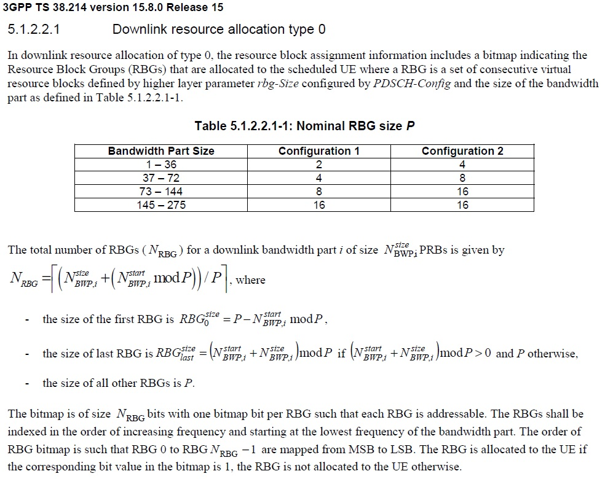

Figure 15
3GPP RRC signaling to support RBG Size P configuration
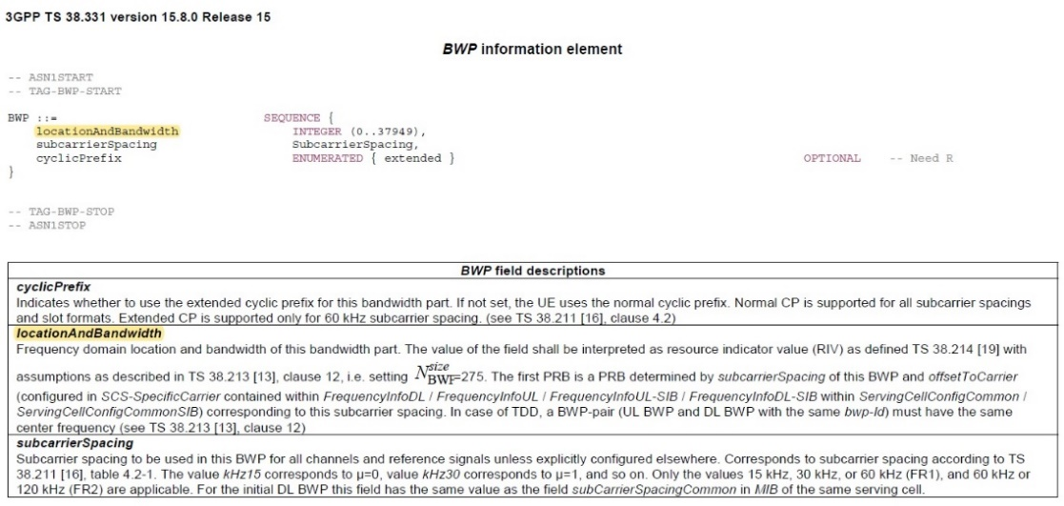
TSDSI modifies the RBG size configuration as shown in Figure 16. Differently from 3GPP, the size P may be configured independently of the bandwidth part size.
Figure 16
TSDSI RBG Size P
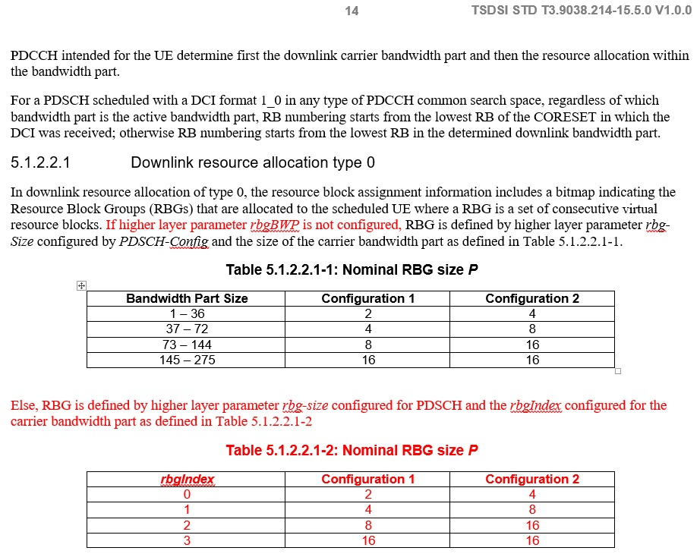
The associated RRC signaling, i.e. the IE BWP, is modified accordingly in order to support the new configuration options, as shown in Figure 17. The locationAndBandwidth element is extended in order to include 3 new sub-elements, the rgbIndex, s1, and s2AndLocation.
Figure 17
TSDSI RRC signaling to support RBG Size P configuration
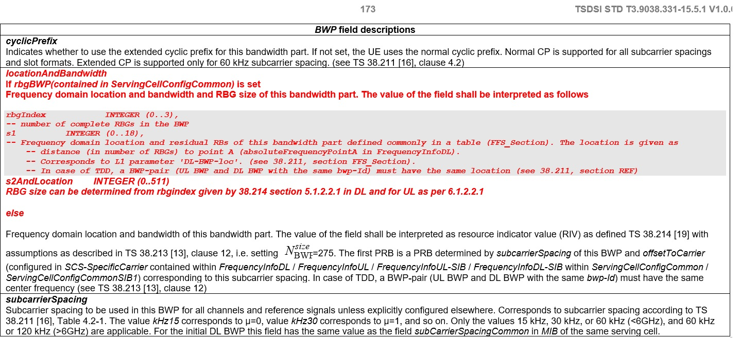

Evaluation Observations
Observation 1: TSDSI’s modification offers additional flexibility in RBG size P determination, by allowing to configure it through higher-layer signaling, independently of the Bandwidth Part Size.
Observation 2: TSDSI’s flexible RBG size P configuration has the following implications in case of smaller BWP sizes assigned to scheduled UEs:
• A smaller number of RBGs per BWP could be configured for the TSDSI proposal. For example in Configuration 1, for a BWP size of 36 RBs, 3GPP designates P=2 which corresponds to 18 RBGs, whereas in TSDSI down to 3 RBGs (for P=16) could be configured.
• Since the RBG size determines straightforwardly the size of frequency-domain resource allocation bitmap in L1 overhead signaling messages (DCI) for downlink and uplink scheduling, TSDSI’s smaller RBG sizes allow for savings in L1 signaling.
• Numerical examples for downlink and uplink DCI messages, assuming different BWP sizes and rbg-Size configurations are shown in Table 3 and Table 4 in Annex 1, where Table 1 and Table 2 provide the complete DCI message descriptions. For 3GPP, and for a given rgb-Size configuration, the size P is determined solely based on the BWP size, whereas for TSDSI the lowest possible RBG size P configuration (P=16) is selected. The results suggest a non-negligible reduction in L1 signaling, which diminishes for larger BWP sizes, as the 3GPP and TSDSI configurations become identical.
• The reduction in the number of RBGs for smaller BWP sizes as proposed by TSDSI, limits the scheduling flexibility when the BWPs are overlapping, since: i) in each slot, a lower number of UEs could be scheduled, ii) larger RBGs have higher probability to overlap, leading to suboptimal PRB utilization. The reduced scheduling flexibility may potentially result in lower achieved spectral efficiency performance levels. Example numerical results are presented in Table 7 in Annex 1, where for small BWPs (e.g. 36 RBs) the PRB utilization is reduced compared to 3GPP. The benefits on signaling are also highlighted.
Observation 3: TSDSI’s flexible RBG size P configuration has the following implications in case of larger BWP sizes assigned to scheduled UEs:
• A larger number of RBGs per BWP could be configured for the TSDSI proposal. For example in Configuration 1, for BWP size of 275 RBs, 3GPP designates P=16 which corresponds to 18 RBGs, whereas in TSDSI up to 137 RBGs (for P=2) could be configured.
• The smaller RGB sizes P proposed by TSDSI, increase scheduling flexibility due to less non-overlapping PRBs and more UEs scheduled in overlapping BWPs. Example numerical results are presented in Table 7, where for large BWPs (e.g. 275 RBs) the PRB utilization increases compared to 3GPP.
• The drawback in using smaller RBG sizes in higher bandwidth, is the significant increase in L1 overhead signaling, as larger bitmaps are required to represent frequency-domain resource allocation for uplink/downlink DCI messages. Numerical results for the increase in L1 overhead signaling, compared to 3GPP specifications, when the RBG size P is fixed to 16 are shown in Table 5 and Table 6 of Annex 1.
Observation 4: Backward compatibility with 3GPP is maintained through the newly introduced rbgBWP RRC parameter. If rbgBWP is not set, then the RBG size P configuration is identical to the 3GPP approach (fallback approach).
Observation 5: TSDSI enhances the locationAndBandwidth BWP IE with two extra elements, s1 and s2AndLocation, in order to make the BWP determination more flexible, through aligning the different BWPs starting frequency points and avoiding possible RBGs misalignment. 3GPP allows arbitrary configuration of BWPs starting frequency points, hence no extra benefit is expected to be provided from the new proposal.

Uplink non-codebook precoded SRS and NZP-CSI-RS time-gap configuration

Description
In non codebook-based uplink transmission, a UE transmits to the gNB precoded sounding reference signals (SRS). The precoder for SRSs is calculated based on associated NZP-CSI-RS resources transmitted by the gNB in previous time slots. 3GPP specifies, as in Figure 18, a minimum time-gap between
• the last symbol of the reception of the aperiodic NZP-CSI-RS resource and
• the first symbol of the aperiodic SRS transmission,
and fixes this gap to 42 OFDM symbols, equivalently 3 slots.
Figure 18
3GPP SRS precoder and NZP-CSI-RS timing-gap configuration
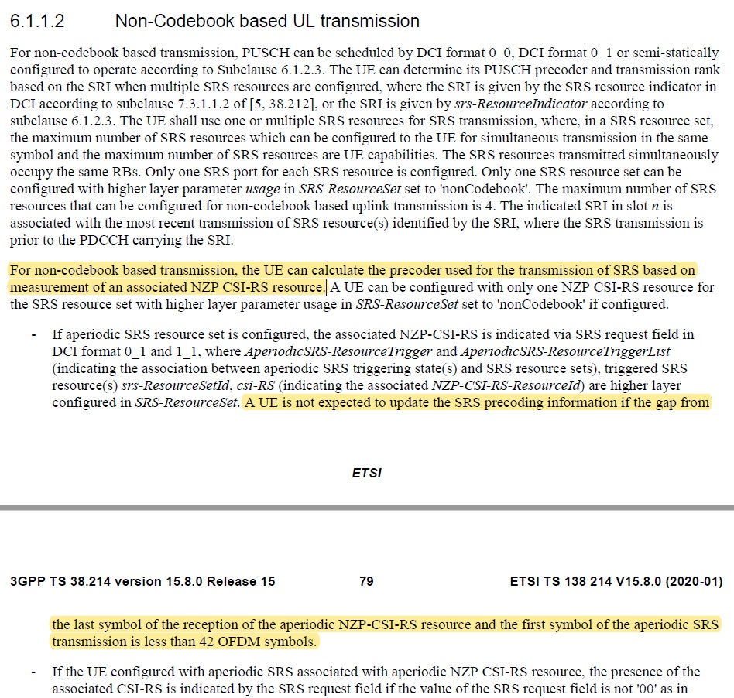
TDSI modifies the specification, by proposing a configurable timing gap, based on numerology, which is also significantly reduced compared to 3GPP, as in Figure 19. In particular, the gap is configured as 4 OFDM symbols for 15 kHz subcarrier spacing (SCS), 7 OFDM symbols for 30 kHz SCS, 14 OFDM symbols for 60 kHz SCS and 29 OFDM symbols for 120 kHz SCS.
Figure 19
TSDSI SRS precoder and NZP-CSI-RS timing-gap configuration
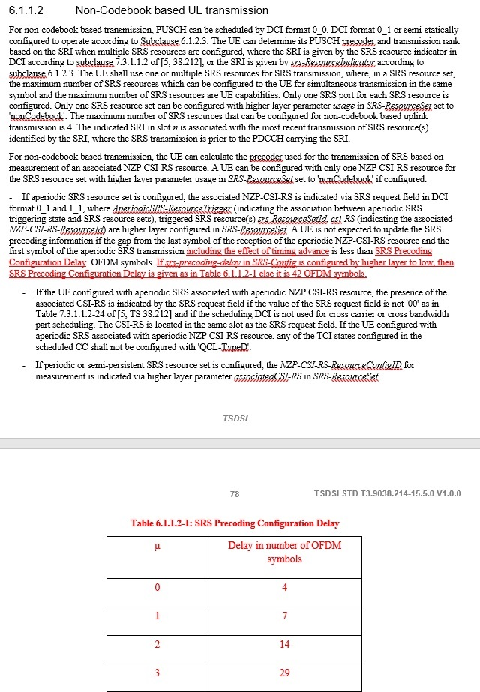
To support the modification and provide backward compatibility with 3GPP, TSDSI extends the RRC IE SRS-config, by adding an extra element, srs-precoding-delay, as in Figure 20. When the srs-precoding-delay is configured as ‘1’, the timing gap falls back to the default 3GPP configuration (i.e. 42 OFDM symbols), else if it is configured as ‘0’, it could be flexibly configured based on the numerology, as reported in Figure 19.
Figure 20
RRC enhancement to support TSDSI SRS precoder and NZP-CSI-RS timing-gap configuration
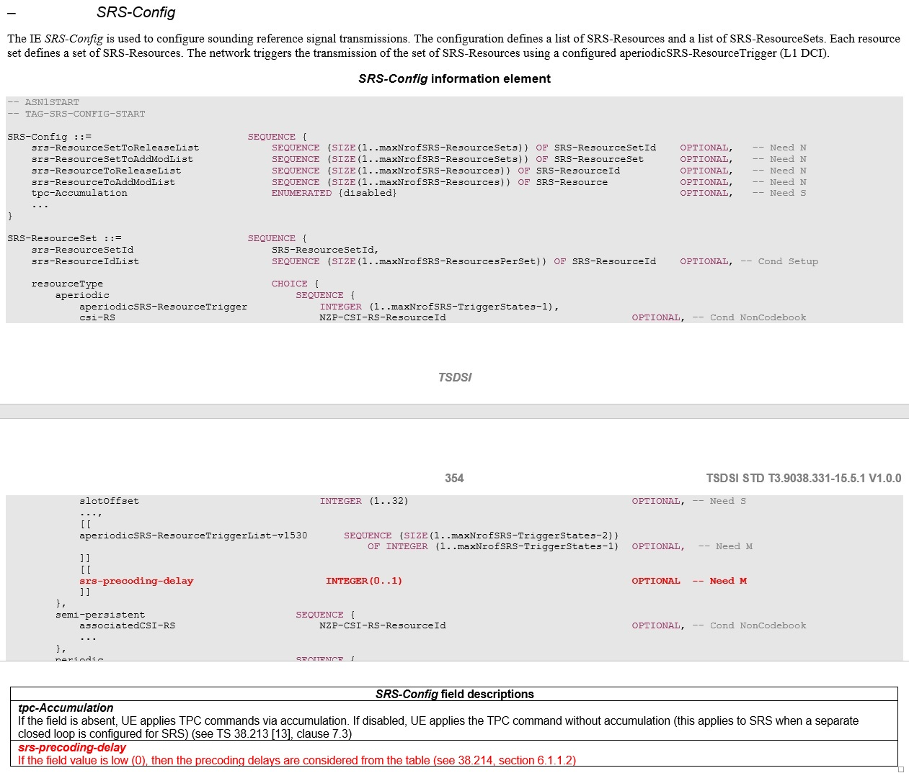

Evaluation Observations
Observation 1: TSDSI’s modification addresses high-mobility scenarios, where the channel is expected to have drastically changed within a time span of 42 OFDM symbols (i.e. 3 slots), hence the SRS precoder calculation based on NZP-CSI-RS signals may have become outdated. Reducing the time-gap from the recovery of DL CSI signals to UL SRS transmissions could improve performance as more recent channel updates are taken into account into the precoder calculations.
Observation 2: Non-codebook-based precoding is based on UE measurements and precoder indications to the network. Based on downlink measurements, performed on a set of NZP-CSI-RS resources, the UE selects a suitable precoder. In this sense, non-codebook precoding assumes channel reciprocity as the UL precoder selection depends on DL signals, hence it is applied to TDD configurations. TDD configurations in NR are described based on slot formats defined through RRC signaling, in particular through the TDD-UL-DL-ConfigCommon or the TDD-UL-DL-ConfigDedicated IEs. These IEs determine the slot format in a highly flexible way as in Figure 21 and Figure 22.
Figure 22
TDD UL-DL Configuration in RRC
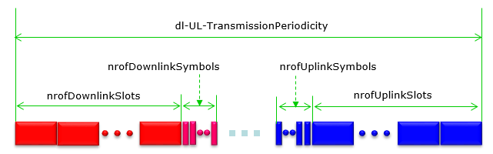
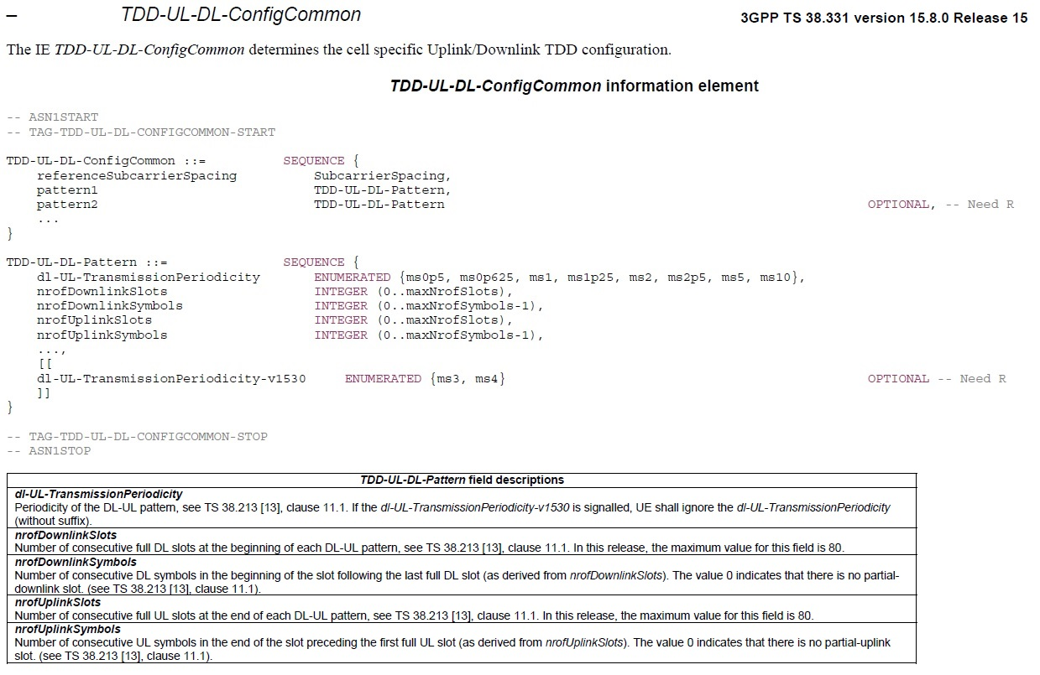
The non-codebook PUSCH transmission procedure requires the following steps:
• One DL slot carrying the NZP-CSI-RS resources used for UL channel estimation assuming channel reciprocity. The time-domain locations are provided by the higher-layer parameters
firstOFDMSymbolInTimeDomain and firstOFDMSymbolInTimeDomain2, respectively, in the CSI-RS ResourceMapping IE or the CSI-RS-ResourceConfigMobility IE and defined relative to the start of a slot.
• One or more slots for the UEs to decode the above DL signals and calculate the precoder, due to receive processing delay.
• One UL slot for the UE to transmit the precoded SRS resources. SRS resources consist of 1, 2 or 4 consecutive OFDM symbols, given by the field nrofSymbols contained in the higher layer parameter resourceMapping, within the last 6 symbols of a slot.
• One UL slot for the UE to transmit the PUSCH.
Therefore, there could be certain TDD configurations that may not support the timing-gap proposed by TSDSI. The proposed modification may limit the flexibility and eventually conflict with the selection of TDD configurations. In Figure 23, some typical TDD configurations from LTE specifications (and are potentially adopted in commercial NR deployments as well) are reported, where it is observed that the strict timing gap proposed by TSDSI may not be supported.
Figure 23
Typical TDD configurations
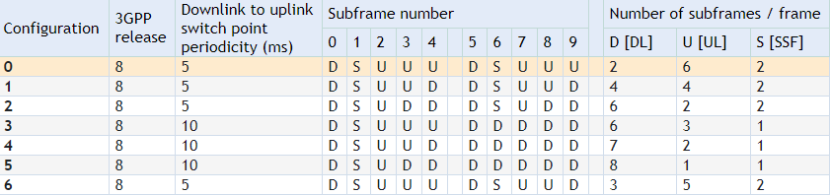
According to the described procedure, the gap from CSI-RS reception until the application of the updated precoder on uplink traffic carried by a PUSCH slot does not change, despite the fact that the respective gap between CSI-RS and SRS is reduced. This means that despite the modification, the CSI defining the precoder will be outdated at the same amount for both schemes (TSDSI vs. 3GPP). This is the gap that actually dominates the precoder performance, despite the fact that SRS transmission is timely updated.
Observation 3: Due to restrictions imposed by the TDD configuration, TSDSI’s fast precoded SRS adaptation may be appropriate for special slots with OFDM symbol-wise UL/DL switching.

Uplink PTRS density configuration

Description
3GPP has introduced in NR a new set reference signals, the phase tracking reference signals (PTRS), which were not part of the LTE technology. PTRSs can be seen as an extension to DM-RSs, intended for tracking phase variations and compensating common phase error across the transmission duration. PTRSs are present only in frequency-domain resources used for data transmission, i.e. in RBs used for PDSCH/PUSCH. Since the main purpose is to deal with phase noise, the PTRS needs to be dense in time but can be sparse in frequency. The density of PTRS in time and frequency domain is configurable to address different scenarios (e.g., different carrier frequency, modulation and coding scheme, and hardware quality), and is determined as follows:
• The density in the time-domain is linked to the scheduled MCS in a configurable way: For OFDM, the first reference symbol (prior to applying any orthogonal sequence) in a PDSCH/PUSCH allocation is repeated every L={1; 2; 4} symbol, starting with the first OFDM symbol in the allocation. The repetition counter is reset at each DM-RS position since there is no need for PTRS insertion immediately following a DM-RS occasion
• The density in the frequency domain is linked to the scheduled transmission bandwidth such that the higher the bandwidth, the lower the PTRS density in the frequency domain. For the smallest bandwidths, no PTRS is transmitted. A PTRS is repeated every second or fourth RB.
The control of used resources is done through the higher-layer PTRS-UplinkConfig IE.
In 3GPP, for the uplink case (PUSCH) with transform precoding enabled the mapping of the complex valued PTRS symbols to the time-frequency resources is performed as in Figure 24:
Figure 24
3GPP PTRS Mapping to Resources
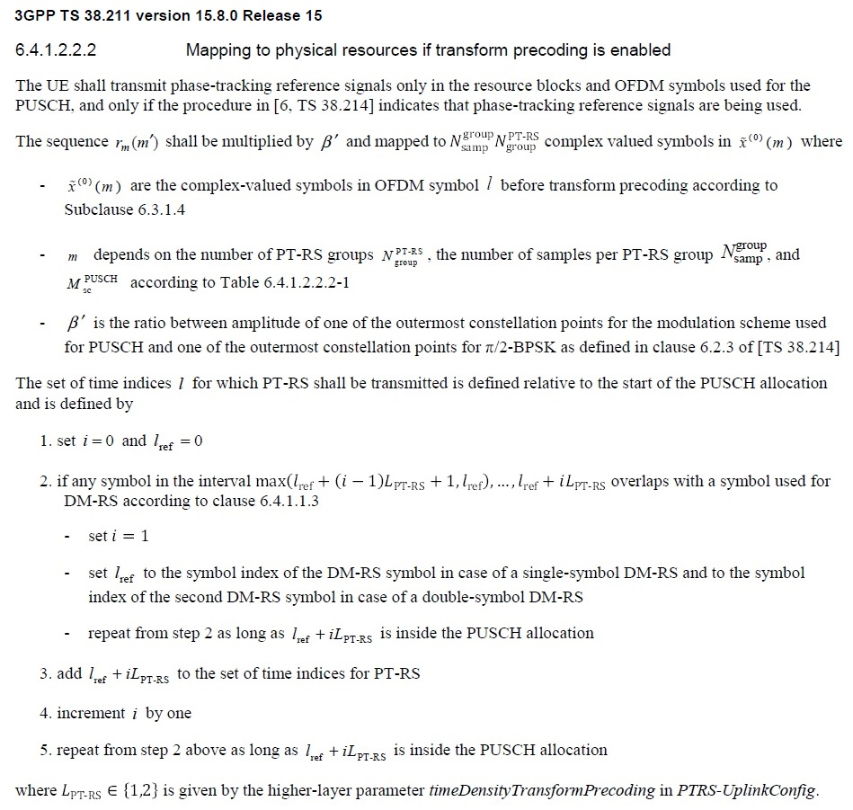
With respect to frequency-domain mapping, the PTRSs are grouped into N_{group}^{PTRS} groups, each one having N_{samp}^{group} symbols, and are spread into the PUSCH bandwidth according to the Table shown in Figure 25.
The selection of (N_{group}^{PTRS} , N_{samp}^{group}) configuration, which impacts directly the L1 overhead is based on MCS and the scheduled bandwidth as in Figure 25 and Figure 26, where the scheduled bandwidth ranges are configured through RRC as in Figure 27.
Figure 25
3GPP distribution of PTRSs in frequency domain
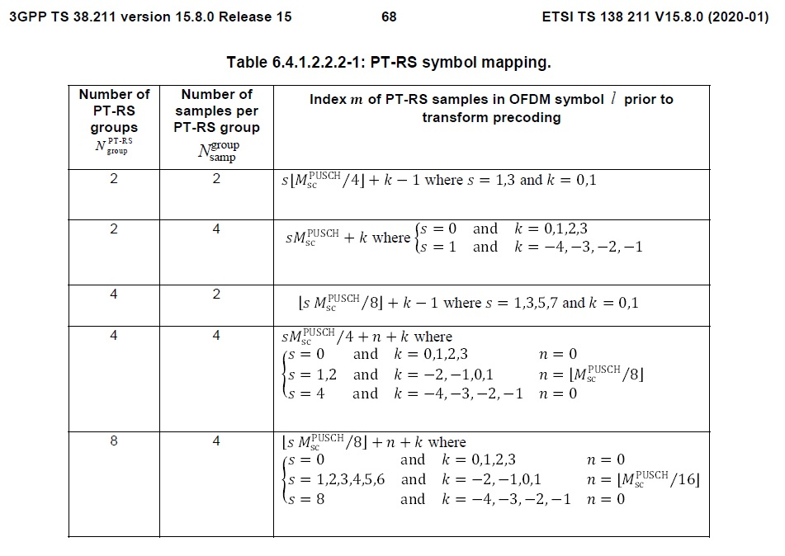
Figure 26
3GPP Configuration of PTRS group patterns
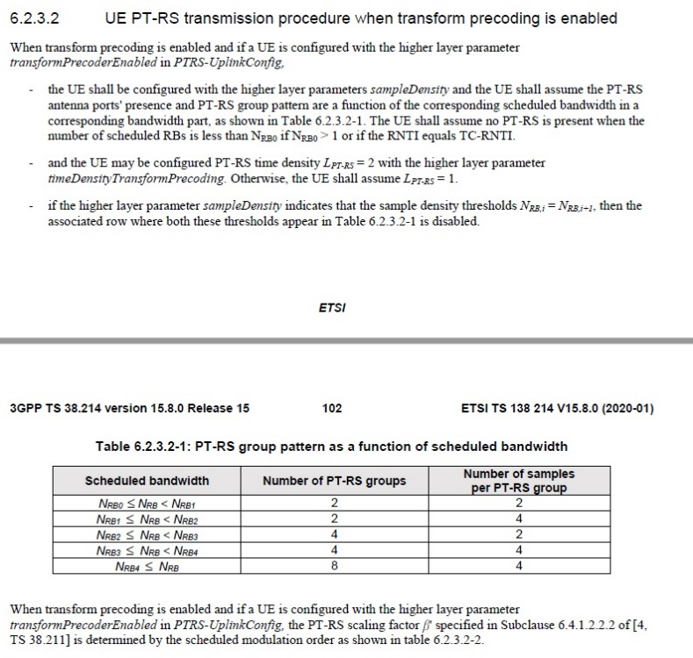
Figure 27
RRC signaling for configuring PTRS density
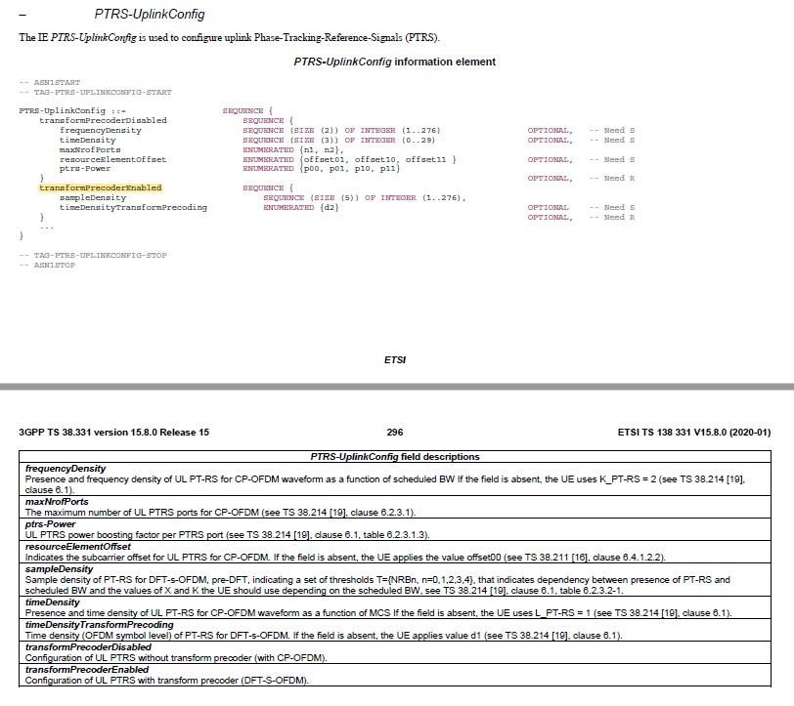
TSDSI modifies the PTRS mapping procedure, for the case of uplink transform precoding transmissions, in an attempt to reduce the signaling overhead, in two ways:
• The L1 overhead required for carrying the actual PTRS symbols will be based on a new configuration of the used frequency-domain resources.
• The L3 (RRC) overhead required to notify the UEs about the exact PTRS configuration is based on new elements.
Regarding L1 overhead, two new configurations are introduced, i.e. Config0 and Config1 (Figure 28), with their selection depending on the MCS. In addition, pre-defined NRB thresholds are introduced (Figure 29) for configuring the density of frequency resources used for the PTRSs, whereas in 3GPP these thresholds are arbitrarily configured. The procedure for resource mapping, following the new modifications is introduced in Figure 30.
Regarding L3 overhead, a new RRC, IE PTRS-UplinkConfigTransformPrecoding is introduced as in Figure 31. The specific IE is used to configure the default sample density table for PTRS with transform precoding. The modifications maintain backward compatibility with 3GPP specifications.
Figure 28
TSDSI’s modified PTRS mapping configuration based on MCS
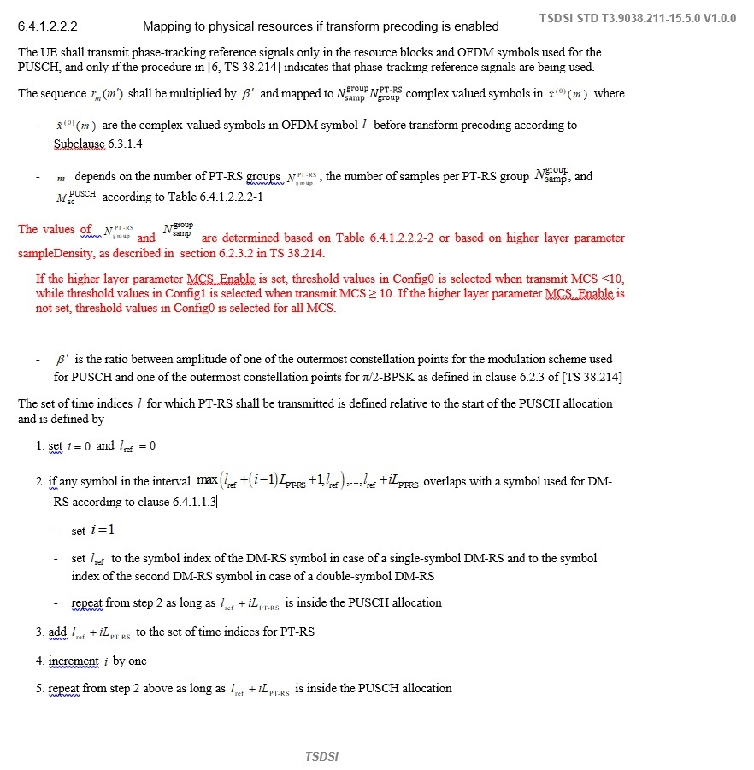

Figure 29
TSDSI’s modified PTRS mapping configuration – Thresholds definition
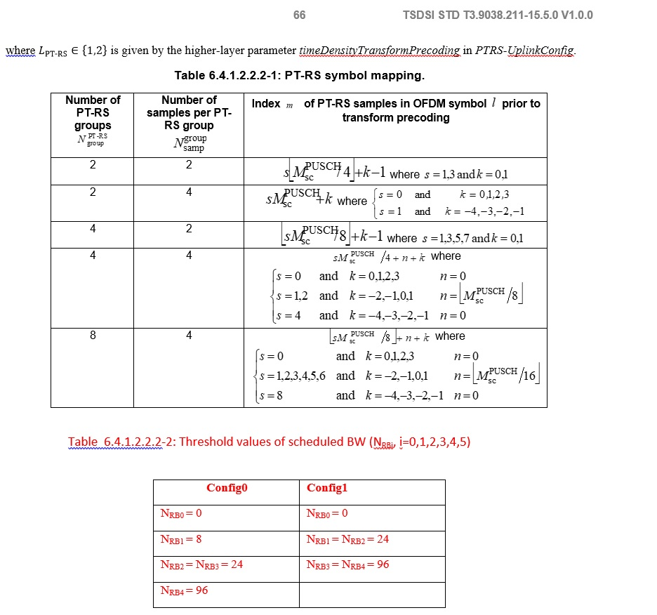

Figure 30
TSDSI’s modified PTRS mapping configuration – Procedure
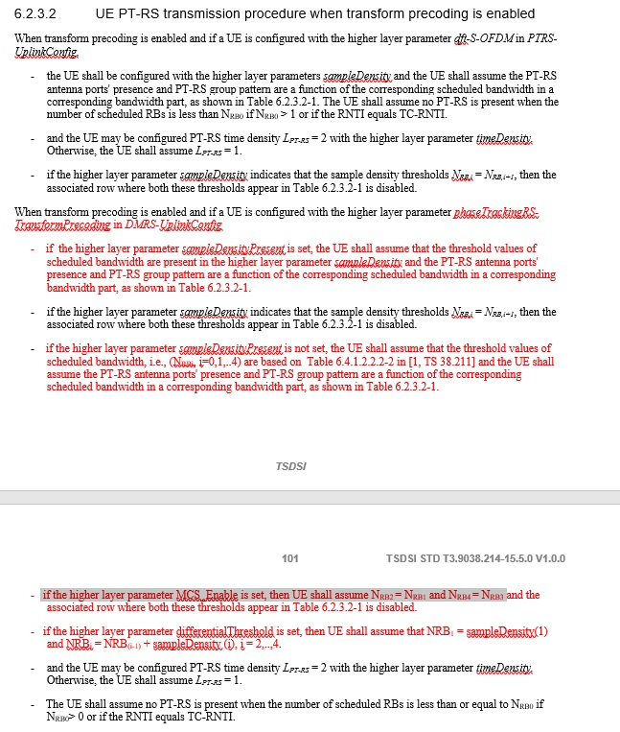

Figure 31
TSDSI’s modified PTRS mapping configuration – RRC modifications
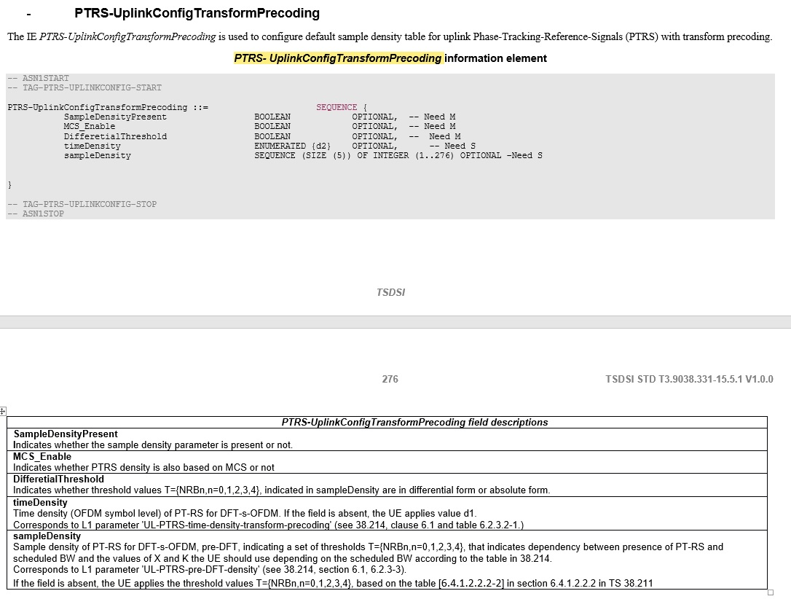

Evaluation Observations
Observation 1: TSDSI’s proposed default configuration ‘Config1’, which is enabled for higher MCSs (MCS>10) could lead to a reduction of L1 overhead compared to 3GPP as shown in the following numerical example (Figure 32). The reduction is observed in the 8 <= NPRB < 24 region where a density of 2×2=4 symbols is observed for TSDSI, instead of 2×4 = 8 symbols for 3GPP.
Figure 32
Comparison of an arbitrary 3GPP PTRS frequency density and TSDSI’s Config1 frequency density overhead
Observation 2: The reduction of the frequency density of PTRS symbols leads to higher error in the estimation of the common phase error. In order to quantify the loss in terms of performance due to the adoption of the TSDSI scheme, the previous example is considered and evaluated through simulation. More specifically,
– An uplink transport block that occupies 23 RBs is considered. The signal will be transmitted with transform precoding. MCS_Enable is set to true (for the TSDSI version).
– Through the simulation (using the TR 38.901 Tapped Delay Line models), cases where the effective average SNR was ranging from 16 dB and above where selected. Perfect synchronization and channel estimation are assumed.
– Common phase error is introduced as distortion.
– In the specific SNR range, the assumed scheduler assigns MCS from 21 to 27 (6.1.4.1-1: MCS index table for PUSCH in 38.214), i.e. 64QAM with various target coding rates.
– According to the TSDSI approach, 4 symbols will be assigned, while for the 3GPP approach 8 symbols will be assigned.
– The PTRS sequences are used to estimate phase noise and compensate for the common phase error.
– For the specific system/scheduler operation, the block error rates are calculated for the ranges of average SNR from 16-20 dB and 20-24 dB. The results are presented in the table below:

SNR Range | Block error rate  TSDSI (4 symbols) | Block error rate  3GPP (8 Symbols)
16-20 (dB) | 0.052 | 0.031
20-24 (dB) | 0.022 | 0.014
Generally, there is an increase in the estimation error, however, due to the high SNR the degradation of the performance is not significant.
Observation 3: Since 3GPP may arbitrarily configure the frequency density of the PTRS, by carefully selecting the NRB thresholds, there could be specific configurations for which TSDSI’s L1 overhead is higher than that of 3GPP. A numerical example is shown in Figure 33. For the 24 <= NPRB < 96 region, 3GPP outperforms TSDSI’s Config0 performance (4×2=8 instead of 4×4=16 symbols).
Figure 33
Comparison of an arbitrary 3GPP PTRS frequency density and TSDSI’s Config0 frequency density overhead

Observation 4: There is an ambiguity in TSDSI’s usage of the MCS_Enable RRC parameter:
• According to TSDSI STD T3.9038.214-15.5.0 V1.0.0, if the higher layer parameter MCS_Enable is set, then UE shall assume NRB2 = NRB1 and NRB4 = NRB3, which corresponds to TSDSI’s Config1 setting.
• According to TSDSI STD T3.9038.211-15.5.0 V1.0.0, if the higher layer parameter MCS_Enable is set, threshold values in Config0 are selected when transmit MCS <10, while threshold values in Config1 are selected when transmit MCS ≥ 10.
Observation 5: The configuration of default threshold values for scheduled bandwidths by TSDSI leads to savings in L3 signaling concerning PTRS-UplinkConfig IE. Extra savings are achieved with the use of the differential threshold definition, since smaller number of bits is required for specification of the PTRS positioning/density procedure.
The benefits are not evaluated by TSDSI, but they are not expected to be substantial given that each RRC configuration-reconfiguration message includes a multitude of IEs.

II-E-2 NuFront

1 Simulation Design and Parameters
In this section, we describe the simulation design for the network scenarios considered and explain the transmission flow.
A. Simulation design for URLLC Urban Macro Environment
In Fig. 2, we show the transmission flow considered for evaluation. Low Density Parity Check (LDPC) coding is applied to the input bit stream. The code rate considered for this evaluation is ½. The next block involves QPSK modulation, and the output of the modulation block is fed into the CP-OFDM block. Within the CP-OFDM block there are several sub blocks. First, the serial to parallel conversion takes place to be fed into the Inverse Fast Fourier Transform (IFFT) block. Next, a Cyclic Prefix and guard band is added and fed to the transceiver. We consider a SU-MIMO with 8 transmit antennas at the BS and 2 receive antennas at the UE. The transmitted signal is recovered at the receiver by passing it through the CP-OFDM demodulator, QPSK demodulator and finally the LDPC decoder to recover the transmitted message from the received codeword. Table 1 lists the simulation parameters considered for the evaluation. As mentioned earlier, we conduct the Link Level Simulation for downlink scenario at a carrier frequency of 4GHz with 20 MHz of bandwidth.
Figure 2
Block Diagram of URLLC evaluation for Urban Macro Environment
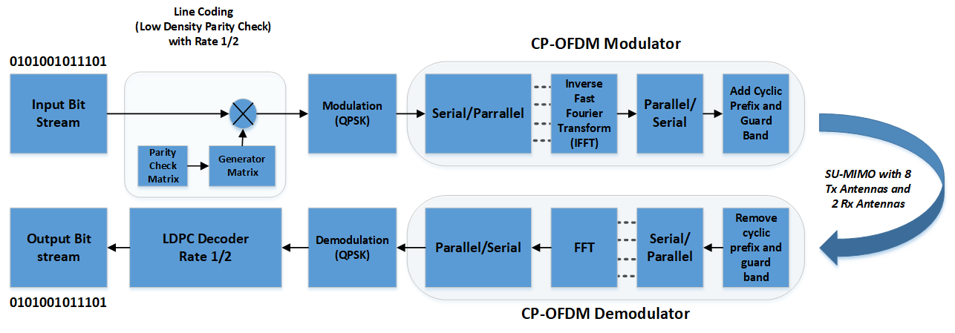
Table 1
Simulation parameters for Link Level simulation (Downlink)
Scenario | Dense Urban
Carrier Frequency | 4 GHz
Bandwidth | 20 MHz
Signalling Waveform | CP-OFDM (SU-MIMO)
Subcarrier Spacing | 78.125 KHz (Amounts to 256 subcarriers)
Cyclic Prefix | 16, 32
Guard Band | True
Transmission Channel | Tap Delay Channel
Mobility | True
Errors Considered | Bit Error Rate, Percentage of reliability
Path Loss model | NLoS
Channel Coding | LDPC with ½ Code Rate
Modulation | PSK (order 4), QPSK
Channel Estimation | Imperfect, Non-Ideal
Number of Transmit Antennas | 8 at the BS
Number of Receiver Antennas | - at the UE

B. Simulation design for high mobility Rural-eMBB for 4 GHz Carrier Frequency (Configuration A)
NS-3 simulator is an advanced network simulator that is used for Wi-Fi, LTE and 5G network simulations. One of the most common NetDevice on the NS-3 is a Wi-Fi device (WifiNetDevice), which implements the IEEE 802.11 standards and supports simulations with different versions of MAC and PHY. SpectrumWifiPhy, the new physical layer model allows for consideration of radio channel parameters, interference from other stations, or other systems. Additionally, SpectrumWifiPhy has implemented several tools to support the analysis of the physical layer of the radio channel.
We developed a model based on 802.11ac to simulate the EUHT PHY and MAC layers characteristics. 20 UEs were placed 1 m apart inside a train moving at a constant speed of 500 km/h. Each UE had an UDP client which generated constant UDP traffic that was sent to the BS.
We simulated the following modulation and coding schemes given in Table 2. Subsequently, we calculated the normalized traffic-channel link data rate. The normalized traffic-channel link data rate is the aggregate throughput of all users (the number of correctly received bits, over a certain period) divided by the channel bandwidth of a specific band and is measured in bit/s/Hz.
Table 2
Modulation and coding schemes
MCS index | SpatialStreams | Modulation type
9 | 1 | 256-QAM
9 | 2 | 256-QAM
9 | 3 | 256-QAM
9 | 4 | 256-QAM

Table 3
Simulation Parameters
 | Rural-eMBB (Configuration B)
Carrier frequency for evaluation | 4 GHz
UE speeds of interest | Fixed and identical speed 500 km/h for all UEs, where the UEs are moving in a one direction (straight train track)
User density | 20 UEs per TRxP
UE height | 2 m
BS noise figure | 5 dB
UE noise figure | 7 dB
BS antenna element gain | 8 dBi
UE antenna element gain | 0 dBi
Traffic model | Full buffer
Simulation bandwidth | 20 MHz
UE antenna height | 1.5 m
BS antenna height | 35 m
Subcarrier spacing | 78.125 kHz
Total transmit power per TRxP | 49 dBm for 20 MHz bandwidth

Part III: Conclusion

I TSDSI SRIT
The TSDSI SRIT relies on and is fully compatible with the 3GPP NR and NB-IoT proposal and -in order to further optimize the design and performance – it includes four specific modifications/enhancements, i.e.:
• A mandatory, spectrum shaped implementation of π/2-BPSK modulation using a simple 1+D filter for Uplink channels.
• A modified version for the definition of resource block group configurations and bandwidth parts.
• A scheme that reduces the time gap between NZP-CSI-RS and SRS for UE precoder adaptation.
• A modified version for determination of frequency and time density of phase tracking reference signals.
Since TSDSI SRIT includes all functionalities supported by 3GPP, its performance should be at least the same, fulfilling all ITU requirements, particularly when parameterization is done to ensure 3GPP compatibility.
By focusing on the specific proposed modifications/enhancements, the analysis presented in this report - in comparison with the 3GPP implementation counterparts- revealed the following:
• The requirement for mandatory π/2-BPSK support on all UEs will ensure higher cell range for all devices in a given LMLC environment. However, simulation showed that the technical modifications in the waveform design do not provide gains compared with the conventional 3GPP transform precoded DFT-S-OFDM π/2-BPSK modulation. Both proposals support power boost (26 dBm max). The definition of a specific spectrum shaping filter – not applied to DMRS - subtracts degrees of freedom in the definition of customized Tx filters/windows that are not known to the receiver, with no evident benefit in the achieved EVM.
• The TSDSI proposal for flexible RGB sizes, for all possible bandwidth part sizes, aims to minimize losses in spectral efficiency. The smaller RGB according to TSDSI SRIT increase scheduling flexibility and reduce spectral losses. However, the use of flexible RBG sizes in high bandwidths significantly increases signaling overhead. Moreover, the introduction of additional information elements does not improve flexibility compared to the 3GPP scheme.
• Reducing the time-gap from the recovery of DL CSI signals to UL SRS transmissions could improve performance as more recent channel updates are taken into account into the precoder calculations. However, certain TDD configurations do not support the proposed timing-gap and the proposed modification may eventually be in conflict with the selection process of TDD configurations. Additionally, despite the fact that the gap between NZP-CSI-RS and SRS may be reduced, the application of the precoder in a PUSCH transmission is not accelerated in typical TDD configurations, and thus fast adaptation (leading to performance gains) is not achieved.
• The modified version in determining the density of PTRS in the 5G slots introduces an MCS-controlled selection scheme for DFT-S-OFDM and default levels for the selection of PRTS size and density vs. NRBs along with a new information element that controls the procedure. In high SNRs, the MCS-based operation offers some L1 overhead savings (ranging from 0 to 16 PTRS symbols per PTRS-carrying OFDM symbol). However, there are configurations where the extremely flexible 3GPP version provides lower overhead. In L3, since RRC message exchange is not frequent, the signaling gains are considered insignificant.

II NuFront SRIT
- Results for Scenario 1:
The results are generated using MATLAB 2019b by following the process shown in the Flowchart in Fig. 3 and using the simulation parameters in Table1.
The evaluation strategy follows the ‘Guidelines for evaluation of radio interface technologies for IMT-2020 (ITU-R M.2412, Table 5)’ for Urban-Macro URLLC. We evaluate the network on Configuration A, as explained in Table 5 of ITU-R M.2412. The flowchart shows the transmission flow and the process with which we evaluate the BER. We evaluated the reliability based on the ITU criteria of 99.999% reliability. The iterative process is continued 10000 times and the reliability is evaluated at each iteration and compared with the ITU criteria.
Figure 3
Simulation model flowchart
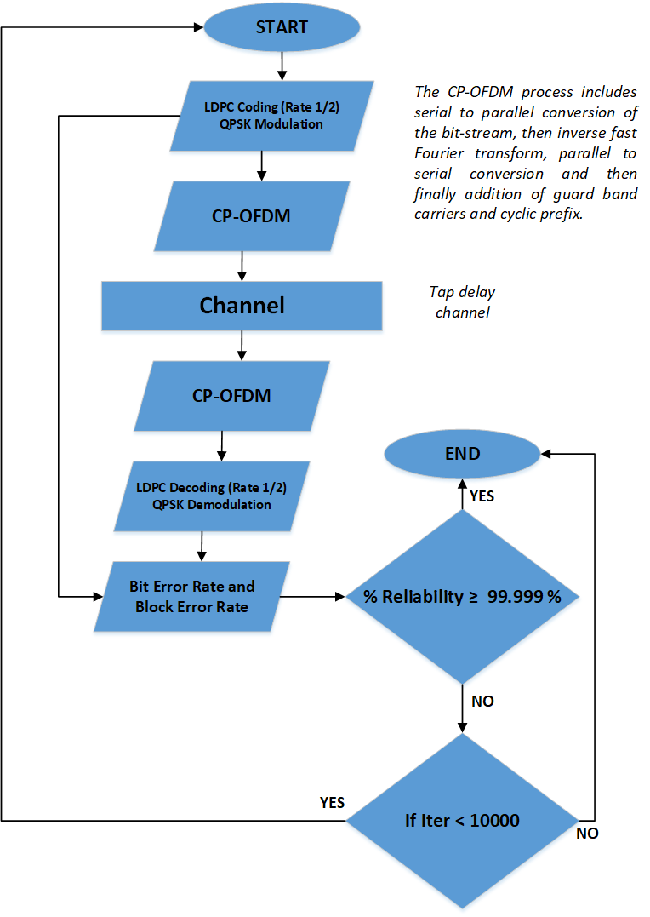
Observation 1: Table 4 shows the results for bit error rate (BER), which in turn provides us with the link reliability. Please note that this evaluation is conducted at the link level. According to our simulations, the proposed technology does not meet the ITU requirements, as the maximum achievable reliability is 99.9942%.
Table 4
Results for Reliability (Link Level Simulation)
Results | EUHT Simulation | ITU Requirements
Bit Error Rate | 0.0058/10,000 bits transmitted | -
% Reliability | 99.9942%  (maximum achievable) | 99.999%

- Results for Scenario 2:
Table 5
Results Scenario 2 Rural UL
Normalized traffic channel link data rate for EUHT in Rural - UL
No of Streams | NS-3 Simulation of EUHT | ITU Requirements  (Report ITU-R M.2410-0:TABLE 4)
1 | 0.16 bit/s/Hz | 0.45 bit/s/Hz
2 | 0.29 bit/s/Hz | 0.45 bit/s/Hz
3 | 0.42 bit/s/Hz | 0.45 bit/s/Hz
4 | 0.56 bit/s/Hz | 0.45 bit/s/Hz

Figure 4
CDF of Normalized traffic channel link data rate (Number of Streams=1)
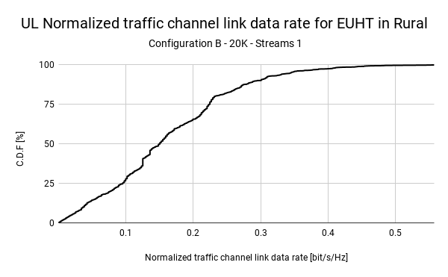
Figure 5
CDF of Normalized traffic channel link data rate (Number of streams=2)
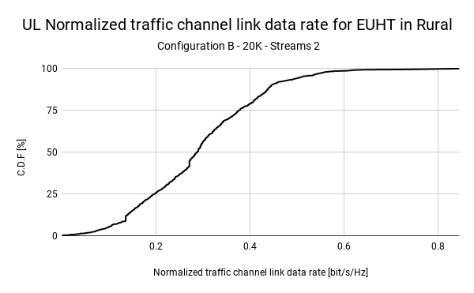
Figure 6
CDF of Normalized traffic channel link data rate (Number of Streams=3)
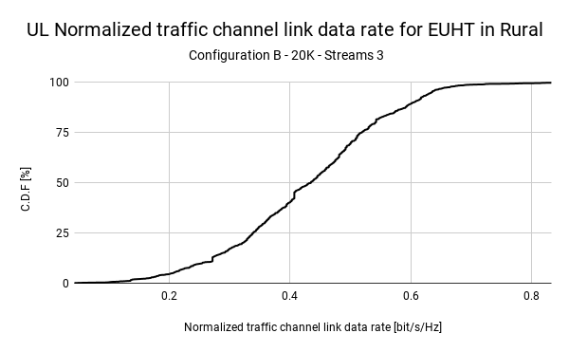

Figure 7
CDF of Normalized traffic channel link data rate (Number of Streams=4)
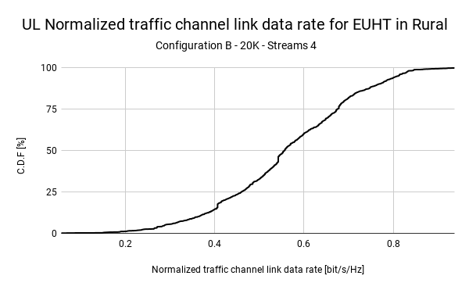

Observation 2: Only iteration with 4 streams (0.58 bit/s/Hz) is able to achieve ITU requirements (0.45 bit/s/Hz as defined in Report ITU-R M.2410-0: TABLE 4).
In summary;
• 1 streams - ITU requirements achieved only 1% of simulation time (Fig. 4)
• 2 streams - ITU requirements achieved only 10% of simulation time (Fig. 5)
• 3 streams - ITU requirements achieved 45% of simulation time (Fig. 6)
• 4 streams - ITU requirements achieved 77% of simulation time (Fig. 7)
Note: Our simulations were based on the current available information on EUHT.
If more details about EUHT PHY and MAC layers becomes available in the future, we could update our existing module in NS-3 with those details. That would allow us to carry out an accurate analysis of the behavior of EUHT and compare it against competitive technologies such as 5G NR.

Annex 1
Numerical results for supporting the TSDSI RIT Evaluation
Table 1
Downlink Format 1_1 Message Signaling Requirements
DCI Field Name | Min Size in Bits  Format 1_1 | Max Size in Bits  Format 1_1
Identifier for DCI formats | 1 | 1
Carrier indicator | 0 | 3
Bandwidth part indicator | 0 | 2
Frequency domain resource assignment
Time domain resource assignment | 0 | 4
VRB-to-PRB mapping | 0 | 1
PRB bundling size indicator | 0 | 1
Rate matching indicator | 0 | 2
ZP CSI-RS Trigger | 0 | 2
Modulation and coding scheme [TB1] | 5 | 5
New data indicator [TB1] | 1 | 1
Redundancy version [TB1] | 2 | 2
Modulation and coding scheme [TB2] | 0 | 5
New data indicator [TB2] | 0 | 1
Redundancy version [TB2] | 0 | 2
HARQ process number | 4 | 4
Downlink assignment index | 0 | 4
TPC command for scheduled PUCCH | 2 | 2
PUCCH resource indicator | 3 | 3
PDSCH-to-HARQ_feedback timing indicator | 0 | 3
Antenna ports | 4 | 6
Transmission configuration indication | 0 | 3
SRS request | 2 | 2
CBG transmission information(CBGTI) | 0 | 8
CBG flushing out information(CBGFI) | 0 | 1
DMRS sequence initialization | 1 | 1
Total #bits excluding Resource Assignment | 25 | 69

Table 2
Uplink Format 0_1 Message Signaling Requirements
DCI Field Name | Min Size in Bits  Format 0_1 | Max Size in Bits  Format 0_1
Identifier for DCI formats | 1 | 1
Carrier indicator | 0 | 3
UL/SUL indicator | 0 | 1
Bandwidth part indicator | 0 | 2
Frequency domain resource assignment
Time domain resource assignment | 0 | 4
VRB-to-PRB mapping | 0 | 1
Frequency hopping flag | 0 | 1
Modulation and coding scheme | 5 | 5
New data indicator | 1 | 1
Redundancy version | 2 | 2
HARQ process number | 4 | 4
1st Downlink assignment index | 1 | 2
2nd Downlink assignment index | 0 | 2
TPC command for scheduled PUSCH | 2 | 2
SRS Resource Indicator | 2 | 16
Precoding information and number of layers | 0 | 6
Antenna ports | 2 | 5
SRS request | 2 | 2
CSI request | 0 | 6
CBG transmission information(CBGTI) | 0 | 8
PTRS-DMRS association | 0 | 2
beta_offset indicator | 0 | 2
DMRS Sequence Initialization | 0 | 1
UL-SCH indicator | 1 | 1
Total #bits excluding Resource Assignment | 23 | 80

Table 3
L1 Overhead Signaling Savings in DCI Format 1_1 for the proposed TSDSI RBG configuration with P=16
Table 4
L1 Overhead Signaling Savings in DCI Format 0_1 for the proposed TSDSI RBG configuration with P=16
Table 5
L1 Overhead Signaling Increase in DCI Format 1_1 for the proposed TSDSI RBG configuration with P=2
Table 6
L1 Overhead Signaling Increase in DCI Format 0_1 for the proposed TSDSI RBG configuration with P=2
Table 7
Example TSDSI configurations performance for PRB Utilization and Signaling compared to 3GPP

References-Additional Material
- ITU-R: Minimum requirements related to technical performance for IMT-2020 radio interface(s). Report ITU-R M.2410-0, (11/2017).
- ITU-R: Requirements, evaluation criteria and submission templates for the development of IMT-2020. Report ITU-R M.2411-0, (11/2017).
- ITU-R: Guidelines for evaluation of radio interface technologies for IMT-2020. Report ITU-R M.2412-0, (10/2017).
- ITU-R WP 5D: Information of the evaluation for the terrestrial components of the radio interface(s) for IMT-2020. Liaison statement to registered Independent Evaluation Groups. Document 5D/TEMP/769(Rev 1), 16 July 2019.
- 3GPP TS 38.101-1, NR, User Equipment (UE) Radio Transmission and Reception; Part 1: Range 1 Standalone (version 15.8.0), January 2020.
- 3GPP TS 38.211, NR, Physical Channels and Modulation (version 15.8.0), January 2020.
- 3GPP TS 38.212, NR, Multiplexing and Channel Coding (version 15.8.0), January 2020.
- 3GPP TS 38.213, NR, Physical Layer Procedures for Control (version 15.8.0), January 2020.
- 3GPP TS 38.214, NR, Physical Layer Procedures for Data (version 15.8.0), January 2020.
- Sassan Ahmadi,”5G NR Architecture, Technology, Implementation, and Operation of 3GPP New Radio Standards,” Academic Press-Elsevier, 2019
- Erik Dahlman, Stefan Parkvall, Johan Skolld, “5G NR: The Next Generation Wireless Access Technology, “ Academic Press-Elsevier, 2018

______________

Submitted on behalf of Wireless World Research Forum.
"ns-3 | a discrete-event network simulator based on C++. https://www.nsnam.org/. Accessed 10 Feb. 2020.
(2009, October 20). Spectrum-aware channel and PHY layer modeling for ns3 .... Retrieved February 10, 2020, from https://dl.acm.org/citation.cfm?id=1698825

