|  |  |
| --- | --- |
| **Radiocommunication Advisory  Geneva, 22-24 May 2013** |  |
|  |  |
|  |  |
|  | **Addendum 2 to Document RAG13-1/1-E** |
| **29 April 2013** |
| **English only** |
| Director, Radiocommunication Bureau | |
| PLANNING OF REGIONAL RADIOCOMMUNICATION SEMINARS | |

# 1 Objective

The objective of this document is to address the relevance of the current model used by the BR for planning and conducting radiocommunication seminars. This model includes World Radiocommunication Seminars (WRS), held every two years, complemented with Regional Radiocommunication Seminars (RRS) and also a diversity of subregional communication seminar and/or workshop, held in response to particular requests from member states. The document evaluates the possibility of a complementing approach, aimed at forming a plan for RRS in a three-year term (inter-WRCs), periodically targeting the three ITU RR Regions, and also the relevant subregions, in coordination with the corresponding ITU regional office.

# 2 Background

Radiocommunication seminars have been organized on the basis of every other year world events (WRS), complemented with some sporadic regional events (RRS). The table below depicts past RRS, since 1999.

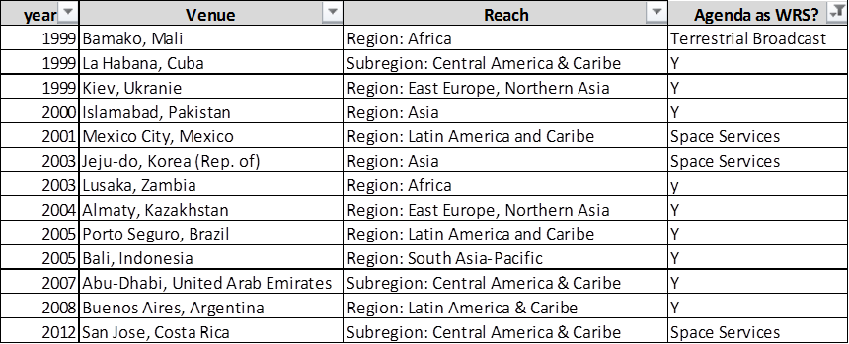

As illustrated, the agendas of RRSs used to be quite similar to those of the WRS, in some cases complementing it to meet regional specific topics. It can also be noted that usually every year an RSS was held, but since 2008, there have been no RRSs, except for the Costa Rica event in November 2012, in response to a request from that country's administration. The following table summarizes the regional presence of such seminars:

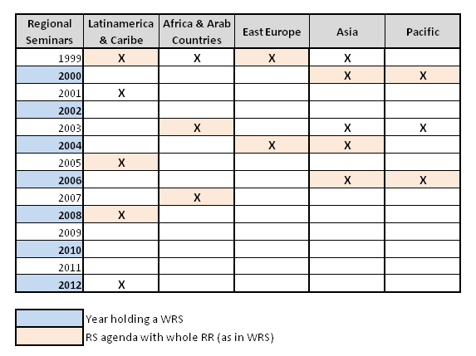

In addition, it can be seen in the following table:

1) that some regional conferences were devoted to specific radio services;

2) that here is not a periodic presence in all ITU RR Regions during regional seminars.



This highlights the uneven geographical distribution of regional events; it also shows that sometimes regional events overlap with a WRS, while in some years no regional seminar was held.These situations can be overcome throughout a periodic cycle for such events.

# 3 Past WRS attendance

The following set of tables is based on the participants’ registration databases, summarizing the countries participation during the last WRS: 2008, 2010, 2012; it was distributed by subregions and regions. *Presence %* indicates the % of countries from a given subregion (or region) being present during the respective WRS, while % WRS indicates the portion it represents with respect to the total for each WRS.



As illustrated by the numbers in the tables above, regional and subregional participations are quite dissimilar. The following set of figures depicts these numbers:

## 3.1 Geographic relative presence

The following figures show the geographical participation on the different WRS, referenced to its particular geographic area; bars are shown by year: 2008, 2010, 2012, to better view their trends; it has been depicted by: subregion, BDT region, RR Region:

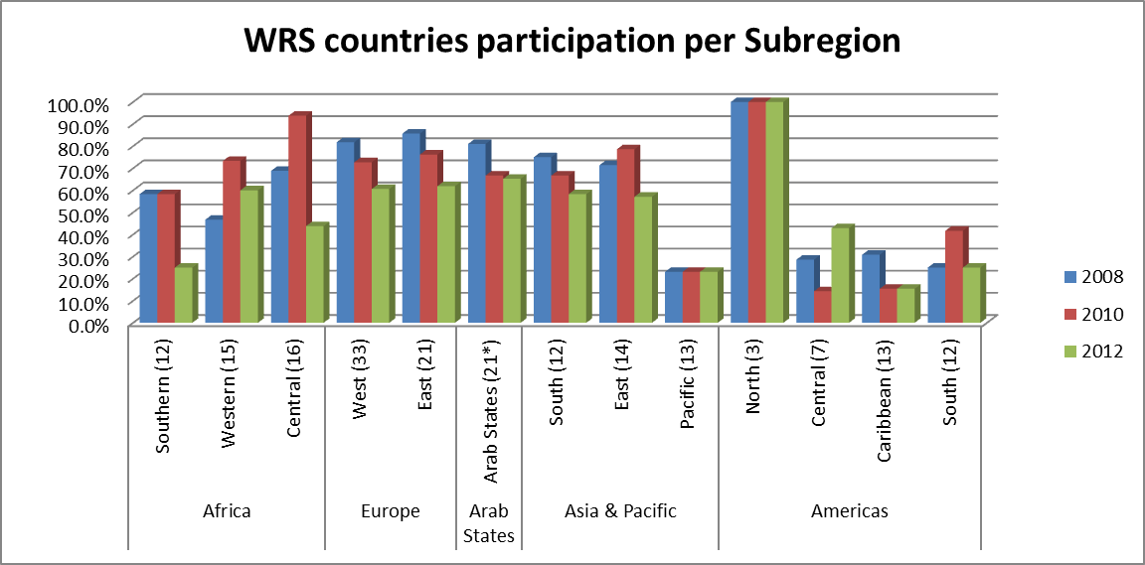

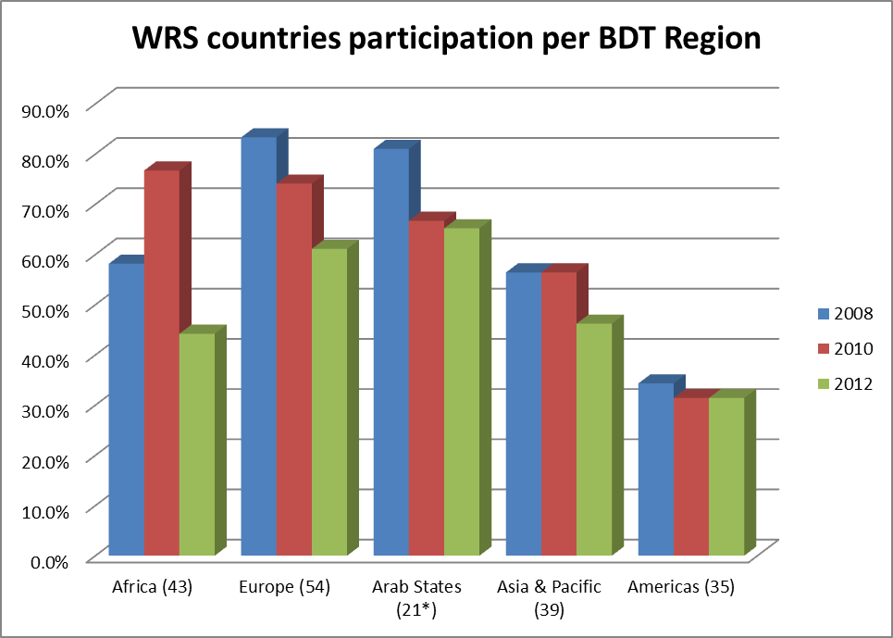

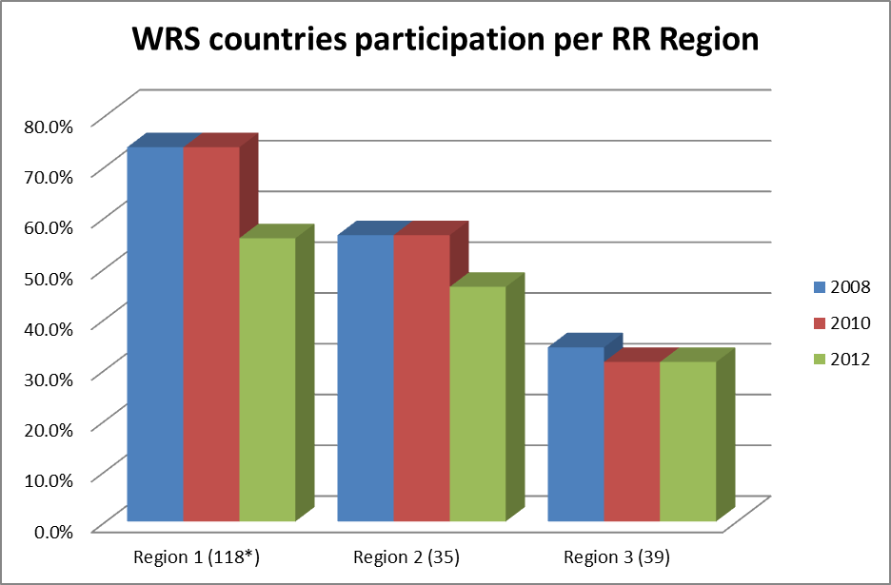

## 3.2 WRS relative participation

The figures below show the WRS % distribution of participating countries. Bars are shown by year: 2008, 2010, 2012, to better view their trends; it has been depicted by subregion, BDT region, and RR Region:

*\*(Arab countries includes in 2012: South Soudan, and Res. 99)*

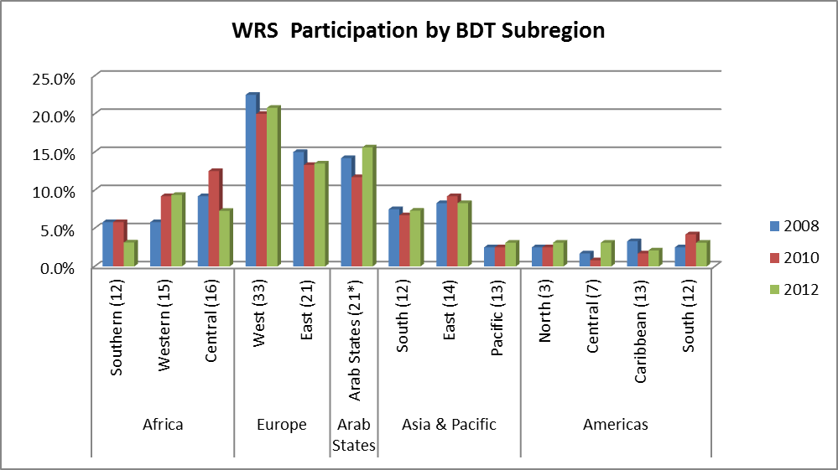

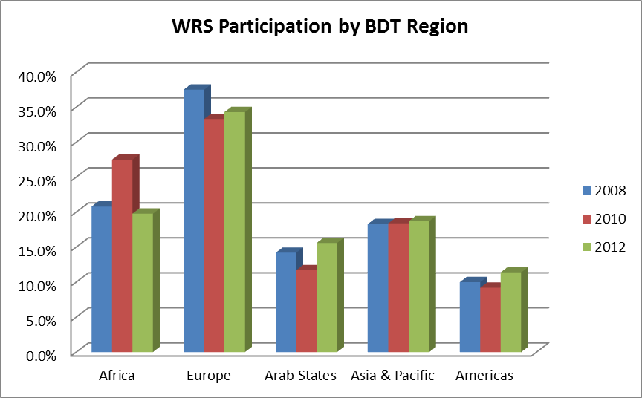

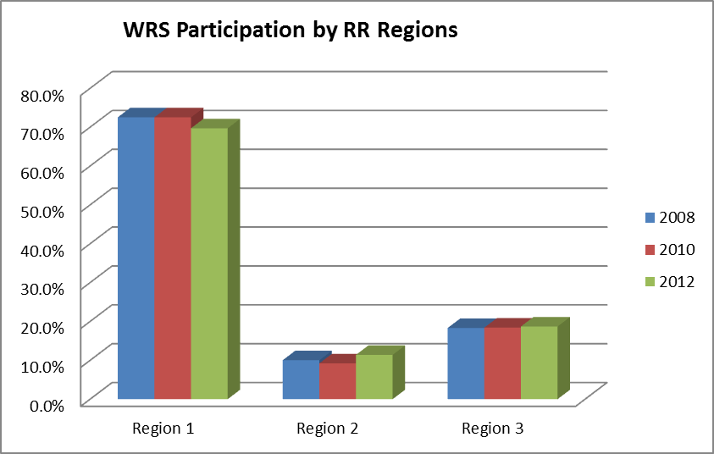

It can be deeper understood when reviewing the % of countries not being present during WRS, and the list of those not attending any of them (since 2008), as follows:



**Amount and % of countries not coming since 2008**



A review of the above figures raises relevant considerations, such as:

– very low presence of countries from Pacific and Latin America subregions;

– mid presence from African countries, with high rotation of countries from event to event;

– high presence of countries from RR Region 1.

This behaviour shows the inverse ratio between geographic distance (with respect to venue: Geneva), and participation in WRS. It could be due to higher venue cost (air ticket and per diem) and longer journey times for farther away countries, while countries from Region 1, especially from Europe, benefit from reduced cost and trip times, due to their proximity. This problem is getting worse by the fact that farther regions have lower GDP per capita; hence, they face a double hurdle: higher venue costs and lower economic capacity.

# 4 Proposed alternative approach

The current approach could therefore be improved by implementing a complementing plan, based on regional periodic cycles, with potential advantages both for BR and ITU members, as follows:

1) More frequent regional presence, benefiting more people from each region, and also more possibilities for updating particular issues

2) Possibility of “*tailored*” agendas more focused on spectrum management particularities in each specific region, and common hurdles and challenges, rather than a one-size-fits-all approach

3) Subsidiarily, workshops can be designed to consider specific RR Region concerns

4) Cost reduction for participants coming from countries in the vicinity of the host country, would result in a larger regional audience

5) Logistic cost reductions: savings in translations, interpretation, travelling and accommodation costs

6) Better opportunities to actively involve each region's centres of excellence in these seminars

7) Better planning and budgeting of radio seminars

8) Reducing the need for the membership to request regional seminars with short notice, as a result of a proactive planned agenda, known in advance by Sector members and the ICT community.

# 5 Survey

In order to validate these considerations, a survey was performed after WRS-12, to obtain feedback from participants. It contained two parts, one for the opinion of the WRS and another related to the possibility of RRS. The main results were:

– radio seminars being of great interest to ITU-R members;

– their content is very pertinent and useful for them;

– its duration is quite adequate, but they prefer more time for workshops and less for ITU-R basic concepts;

– they agree with a regional seminar yearly in their own region;

– also they agree with the idea of complementing the seminar with a session devotes to spectrum-related topics, and its associated regional trends and challenges;

– they approve the proposal of explaining basic ITU-R concepts as a web tutorial before the seminar.

Annex 1 contains details of these surveys.

# 6 Main drivers

To implement this initiative, the main drivers to be kept in mind are:

1) *Browsing all ITU Regions yearly:* that guarantees a permanent BR activity worldwide, giving the space onto each region to a timely and well-focused assistance to members on the discussion of relevant spectrum-related topics

2) *Looking at regions and subregions*: agendas of regional seminars will be adapted correspondingly. It allows better training according to local needs

3) *Building on ITU regional and area offices presence*: allow support of such offices for the process of preparation (agenda, and logistic), promotion and holding of the event, having better feedback both for more relevant topics for the event agenda, an also of results to be considered for next editions

4) *Involving regional centres of excellence*: this can provide good human talent locally, and also a good means for promoting the events and enlarging the sectorial outreach in each region.

5) *Integrating previous online tutorials*: the regional seminars can better respond to local needs, if the agenda allows for in-depth discussions of important challenges facing or coming to each region. Hence, previous tutorials guarantee that attendees have achieved a minimal background about ITU-R and the Radio Regulations, allowing to delete these items on the agenda, making room for more in-depth specific topics discussions, with space to all stakeholders.

# 7 Regional structure

To implement the three-year cycle, the regions and areas could be bundle as follows:

***1 Region 1:***

*1.1 Europe (CEPT)*

*1.2 Europe and Central Asia (CIS)*

*1.3 Arab Countries*

*1.4 Africa*

***2 Region 2:***

*2.2 North America (including Mexico)*

*2.3 Central America and Caribbean*

*2.4 South America*

***3 Region 3:***

*3.1 East and South-East Asia*

*3.2 South Asia*

*3.3 Pacific*

Thus, this geographical distribution results in three Regions (the ITU RRs) and ten subregions, that matches pretty well with the ITU regional and area offices; then, one event could be held every year in each ITU RR Region, selecting each year a different subregion into each. To adjust this model, the West Africa area will add to EME region, to have three areas per sector. The following table shows an example of this cycle:

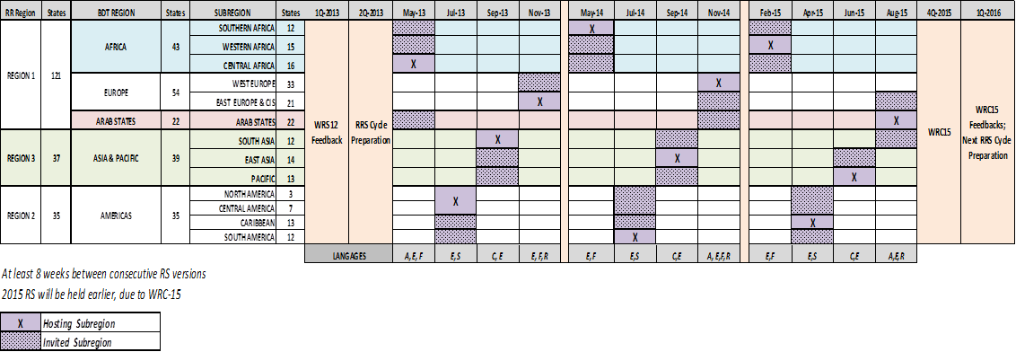

Then, as depicted on the table above, a yearly presence in every ITU Region can be achieved, and each subregion will be visited during the three-year cycle. This agenda outlines the time periods necessary for the preparation and performance of the WRC-15, (from 2 to 27 November 2015). It also guarantees at least eight weeks of time interval between consecutive RRS, avoiding overlapping in preparation of each RRS, and giving adequate time for feedback from previous events.

# 8 Agenda structure

The five-day schedule (Monday to Friday) seems to be very well accepted, therefore it would be retained. Nonetheless, it could be necessary and useful to have more time for discussions regarding specific topics of interest on the region. To solve this timeline shortness, it is proposed that lectures about the most basic aspects, e.g.: ITU and ITU-R structure, WRC, RAG, RRB, BR, RA, SG, WP, fundamentals of RR and RoP, Table of Allocations, MIFR, glancing ITU-R series, etc., can be implemented as a “*Tutorial*”, via web tools. A good understanding of this pre-seminar web tutorial concepts is required to be able to actively participate in the seminar.

As the topics to be treated on this basic tutorial experience very few changes in the short or mid-term, issued certificates could have a validity of four to six years; when a new basic tutorial be issued with relevant content changes, we could also provide a tutorial version for “*updating*” to be taken by certificates holders. Regional centres of excellence could be actively involved in this strategy, perhaps there could be a lecture course on under or postgraduate curricula. Then, providing that audience has this minimal previous background, the agenda of the seminar can deal with more detailed topics, and pertinent updating.

An example of the agenda structure is as follows:



Remote participation can be also offered (excepting workshops).

Finally, regarding the intersectoral discussions vis-a-vis appropriate naming for ITU events, in this case, perhaps an accurate one should be: “*Regional Radio Regulations Seminar and Workshop*”.

# 9 RRS in 2013

Attending several manifestations of interest for hosting these RRS, the organization of two events are in progress:

1) RRS for Americas: at Asuncion, Paraguay, from 15 to 19 July; hosted by CONATEL; Workshop both for Terrestrial and Space Services; Forum “Regional Harmonization of Digital Dividend”; Seminar and Forum in Spanish, with translation into English

2) RRS for Africa: at Yaounde, Cameroon, September 2013; hosted by MINPOSTEL; Workshop both for Terrestrial and Space Services; Forum “Regional Implementation of GE06 Agreements”; Seminar and Forum in French, with translation into English

3) RRS for Asia: in preliminary discussion with potential hosting administrations, foreseen date later than October 2013.

Annex 1





