Radiocommunication Study Groups | 
Source: Document 5A/TEMP/157  Subject: Recommendation ITU-R M.1076 | Annex 11 to  Document 5A/421-E
 | 29 November 2013
 | English only
Annex 11 to Working Party 5A Chairman’s Report
Preliminary draft Revision of Recommendation ITU-R M.1076
Wireless communication systems for persons with impaired hearing

(1994)

Summary of revision
[Editor’s note: To be filled in]
Scope
This Recommendation provides the technical and operational characteristics for wireless accessibility of hearing aids to public, home and personal audio services operating in the land mobile service.
The ITU Radiocommunication Assembly,
considering

a) that many forms of hearing impairment cannot be satisfactorily improved by audio amplification only;
b) that a number of means have been used to transfer speech signals to the listener’s hearing device. These means include infrared radiation, use of the magnetic induction internal to current loops, including operation at audio frequencies, VHF and UHF radio and the external induction field of a radiating antenna;

c) that some 10% of people suffer from mild to severe hearing loss;

d) that users of aids for hearing impaired (hearing aids including assistive listening devices) are found worldwide;
e) that personal uses include access to mobile phone and personal audio applications;
f) that home usage includes access to broadcast television, broadcast radio, emergency notification and alarms;
g) that public usage include access to points of sales, counters, public address systems in areas such as airports, train stations, religious places, theatres, events and cinemas;
h) that the practical application of infrared systems and audio frequency induction loops to communicate with persons with impaired hearing should also be considered for some applications,

noting
a) that for public use it may be beneficial to have a standardized wireless system, operating on globally harmonized tuning range;
b) that administrations should carefully consider suitable harmonized frequency ranges for the operation of wireless systems for hearing impaired person,
recommends
that the technical and operational characteristics for radiocommunication systems for persons with impaired hearing given in Annexes 1 and 2should be used;

ANNEX 1
Operational Characteristics

1 System concepts

Historically, hearing aids consisted of little more than basic “miniature audio amplifiers” placed in or behind their ear(s) solely boosting the incoming sounds. As semiconductor technology has evolved and become miniaturised, hearing impaired people enjoy extremely sophisticated digital systems incorporating a range of communication capabilities.
State-of-the-art technology uses specialized Digital Signal Processing (DSP) technology that is advanced enough to fulfil the stringent mechanical (ultra miniature) and power consumption
(only one small single cell battery) requirements that are specified for modern hearing aid devices. DSPs manipulate the incoming sound spectrum mathematically, converting it into a digital representation; programmable software then manipulates this digital representation to achieve:
– background noise reduction;
– correction of user specific deficiencies;
– enhancement of sound cues and other listening parameters used by the brain to reconstruct normal hearing.
Hearing aids contribute to user safety, comfort and enjoyable listening experience. However, real life offers an incredible richness in different listening environments in some of which even the most sophisticated hearing instruments show only a limited benefit. Examples of acoustic environments or listening situations where the performance of conventional hearing instruments can substantially be improved by applying additional communication devices are the following:
– reverberant environments such as big churches or lecture halls;
– communication over larger distances, e.g. in a lecture or in a classroom;
– communication on the telephone, especially cell phones.
– situations with large background noise levels (e.g. rooms, halls and areas with multi-talker speech; engine noise inside or outside of trains and busses, etc).
In these environments the application of assistive listening systems (ALS) based on wireless communication technologies offer substantial additional benefits and significantly improve speech intelligibility. The advent of digital broadcasting is now displacing some of the frequencies where these wireless ALS's have traditionally operated.
In North America and Europe, approximately 1 person in 10 has some form of hearing loss, from mild to severe. Today only 20 % of these people are assisted by hearing aid technology.
The binaural rate (wearing two hearing aids: one left and one right) is ~75 % to 80 % in
North America, ~60 % in Europe and 10 % to 12 % in the rest of the world. Reasons for such low adoption rates in general vary from negative stigma associated with wearing cosmetically non-appealing devices to high cost and certain types of hearing losses that could not be corrected.
Recent progress made in binaural hearing health revealed that having for example the right hearing aid being able to communicate with the left hearing aid and vice versa helps achieve another level of breakthrough in restoring someone's hearing. This also directly contributes to the safety of that person's listening environment, for example directionality of sounds can be better perceived,
in cases such as an approaching ambulance or fire truck which cannot be seen but only heard,
is physically located. In some instances where one ear is totally impaired, sounds captured from that side of the head can be relayed to the other ear and processed such as that person experiences full 360° hearing again.
A major role of allowing the hearing impaired to communicate and also enjoy similar experiences to those with normal hearing has been played by the Telecoil system which is in world-wide use. Unfortunately these are difficult or impossible to install in large public places such as airports and train stations and are both expensive to install and maintain. Also building owners are often reluctant to allow them to be installed. In addition they only supply a single low quality voice channel. This lack of flexibility and cost have given rise to an explosion of radio based systems for most teaching, especially sports coaching and domestic use where multiple channels are required.
Hearing aids can be described as body worn therapeutic medical devices used to provide improved medical treatment of a patient. Therefore, they are subject to the very same constraints as all other body worn medical devices:
– They perform therapeutic tasks aimed a treating, curing, hence bettering patient's lives.
– They are installed / worn in and around the body.
– They are subject to severe power consumption constraints, due to their discreet mechanical size, that commands very small source of energy (single cell battery).
– A harmonized, worldwide deployable tuning range would facilitate the use of these devices for international travellers in public areas.
– These devices rely on the radio spectrum to be optimized in terms of energy spent for range and link robustness achieved, hence a low noise floor and minimal interference band, where body tissue absorption and spectrum usage density are taken into account.
– If these devices are exposed to an environment of high emissions the user could experience pain and possible damage to the ear drum and/or other physical incapacity.

1.1 Induction-Loop system (often referred to as Telecoil)
Inductive systems rely on coupling an audio amplifier, e.g. for the microphone of a speaker in
a lecture hall or a teacher in a classroom, directly to an induction loop system which basically directly transmits the rather low frequency audio signal as a radiated time varying magnetic field. Induction loop systems use a large coil antenna integrated in the floor of a large room for radiating the magnetic field. Once properly installed, and given that the listener's hearing aids include “T” coils, an IL system is undoubtedly the most convenient and possibly the most cost effective ALS. To hear the audio, all a person has to do is enter the looped area and switch his/her personal hearing aids to the telecoil position. As long as the person's hearing aids include “T” coils, he or she always has an assistive device “receiver” available
However this technology also has some technical drawbacks which limit the range of application of this technology. The physics of inductive coupling requires the receiving coil (T-Coil) to be perpendicularly oriented to the field of the sending coil or induction loop. This is sometimes difficult to achieve because the orientation of the induction loop is fixed and the orientation of the T-Coil depends on how it is built into the hearing instrument and the person's orientation. Furthermore, the inductive transmission strongly depends on the distance between sender and receiver which sometime results in a weak signal. The receiver also always has to remain within the loop in order to receive a signal. External interferences (from power lines or fluorescent lights, computer monitors copiers, fax machines, cell phones, etc.) creating background noises or distortions in the hearing instrument, are difficult to remove. Next, in school environments, several different systems are required for different classrooms. When applying two different systems in neighbouring classrooms it often is difficult to avoid spill over from one induction loop system to the next although recently technological progress has been made for reducing this problem. Furthermore, induction loop systems are not portable and can only be applied where they have been pre-installed.

1.2 VHF and UHF systems
Current systems employing VHF and UHF FM (sub 2 GHz) radio transmission are capable of providing communication over distances greater than those using the radio
induction-field system, as they employ transmission via a radiation field which decays less rapidly with distance than does an induction field. As a consequence, VHF and UHF radio transmission systems require that each transmission in any locale, such as a school classroom and its environs, be assigned a separate frequency channel.
VHF and UHF reception is generally less susceptible to interference from natural and man-made noise than is reception at lower frequencies and systems employing VHF and UHF radio transmission will be useful in many circumstances to avoid local problems of interference which affect the operation of the radio induction-field system.
Radiocommunication systems intended only for short-range communication are capable of producing high field strengths at their required working distances, without radiating significant levels of power. Exploitation of the resulting possibilities of shared spectrum usage can result in improved spectrum utilization, and may allow large numbers of channels to be made available, for example to satisfy the requirements of large schools for any children with impaired hearing which is increasingly a requirement of national legislation and an objective for children above five weeks old in many countries.
Equipment takes a number of physical forms from add on receivers for behind the ear systems to belt mounted units and necklace units. Currently narrow band FM systems predominate for teaching systems with Bluetooth connectivity for mobile phones and some domestic equipment using radio LAN technology for connection to multimedia terminals.
Scarcity of spectrum has meant that the narrow band fixed frequency channel equipment using
a 100% duty cycle is not suitable for sharing with other services or SRD’s therefore development of more spectrum efficient techniques such as frequency hopping and control from a remote database are currently under development. One such system is shown below.
Overview of the system
Wireless audio systems considered here transmit speech or audio from a microphone, over a digital radio link, to a receiver> An assistive listening system for use by the hearing impaired in public spaces such as airports, Railway stations, churches and theatres, where the transmitter is connected to the audio programme or public address system and the receiver is worn by deaf users, or integrated into users’ hearing aids.
The use of digital technology, e.g. with 4GFSK modulation and low bit-rate audio coding, provides a balance between the need for good audio quality (a requirement to maintain intelligibility and minimise user fatigue), spectrum efficiency and range. These systems can work well between 150 MHz and about 2 GHz.
Depending on available spectrum and coexistence requirements, systems to operate in approximately 200 kHz, 400 kHz and 600 kHz occupied bandwidth are outlined. The transmitter and receiver duty cycle is inversely proportional to the bandwidth, which means that the amount of spectrum resource used is roughly independent of the bandwidth, but the receiver power consumption is proportional to the duty cycle.
This means that a 600 kHz system would allow receivers to consume approximately 1/3 the power of a 200 kHz system, which is highly beneficial in power-limited applications such as hearing aids. Wider bandwidth also decreases end-to-end delay, which is of benefit to many audio applications where the audio must maintain lip-sync with the talker in order to maximise intelligibility.
Below are given technical parameters for wireless communication systems for access of hearing impaired people to public services. The most appropriate channel bandwidth/parameters set should be chosen in accordance with coexistence requirements for the radio frequency band in which such a system would be realized.
200 kHz system
Channel bandwidth | 200 kHz
Frequency tolerance | ±0.005% (transmitter)  ±0.005% (receiver)
Transmitter radiated power (ERP) | 10 mW
Transmitter field strength @30m | 88 dBμV/m
Transmitter out of band emission @30m | 70 dBμV/m, 100 kHz from carrier, narrowband  40 dBμV/m, 1 MHz from carrier, wideband
Transmitter modulation (indicative) | 4GFSK @120 kbit/s, ±40 kHz maximum deviation (outer symbols), BT = 0.5
Transmitter duty cycle (indicative) | 30-50% for one audio channel
Receiver sensitivity, direct inject | –80 dBm or better
Receiver selectivity | 30 dB minimum, adjacent channel  40 dB minimum, alternate channel, image channel and above
Receiver blocking rejection | 50 dB minimum, ±2 MHz separation
Example transmitter mask (max hold)  (note measurement noise floor at –55 dBm)  Nominal 200 kHz bandwidth | 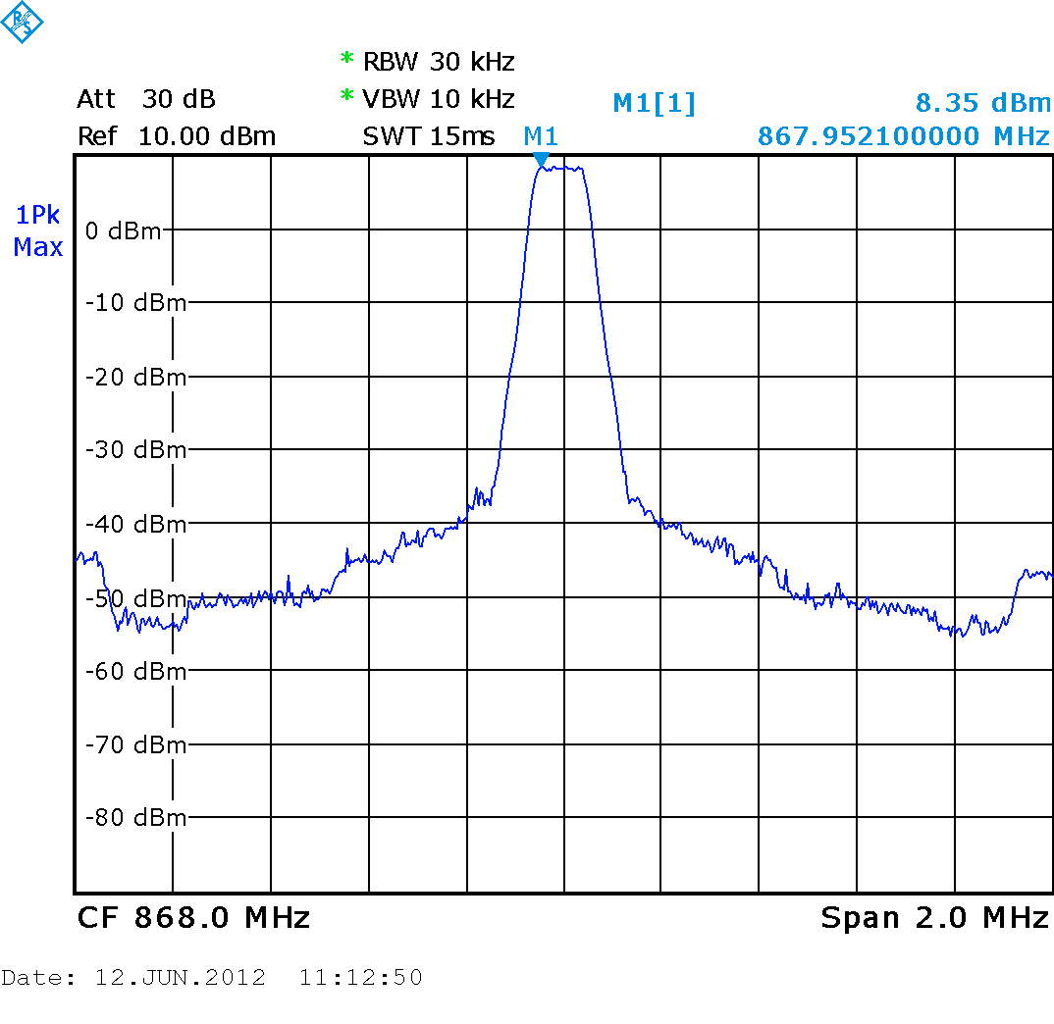  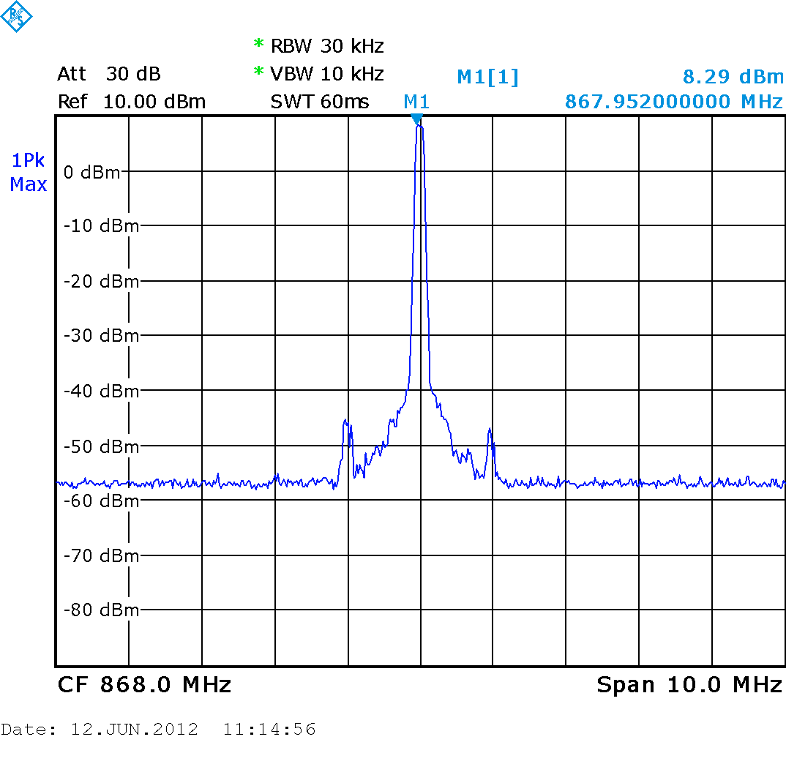
Example transmitter mask  (average and max hold)  (note measurement noise floor at –55 dBm)  Nominal 200 kHz bandwidth | 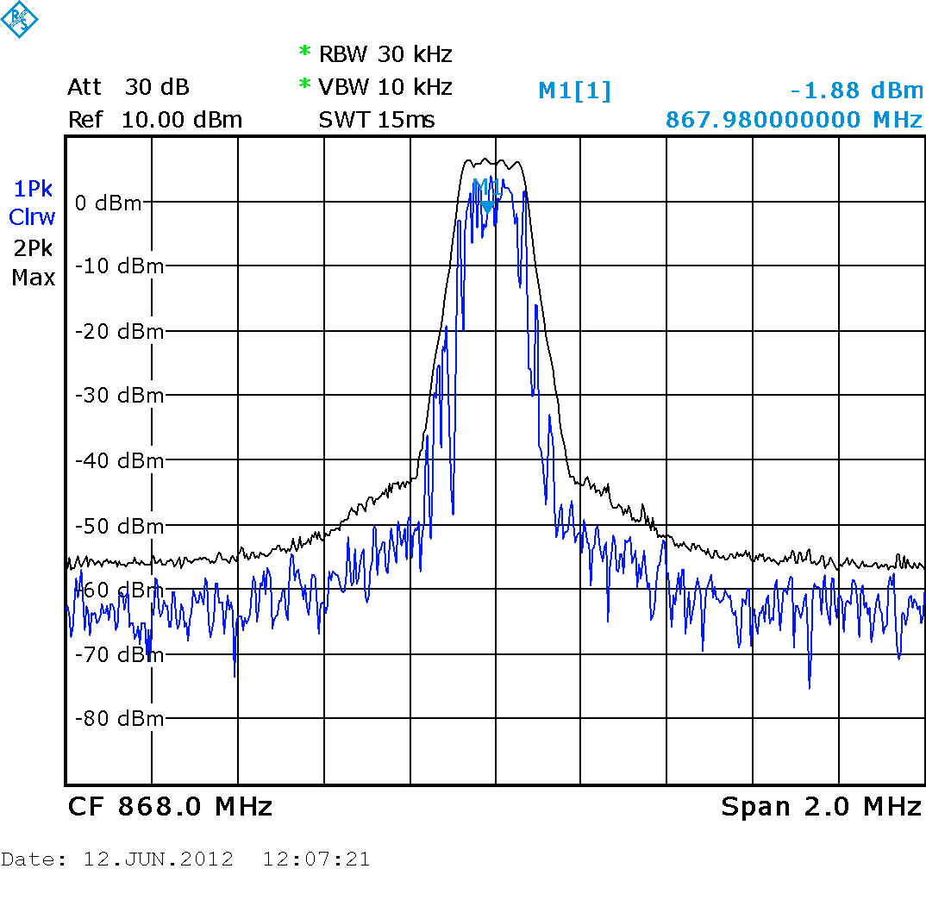  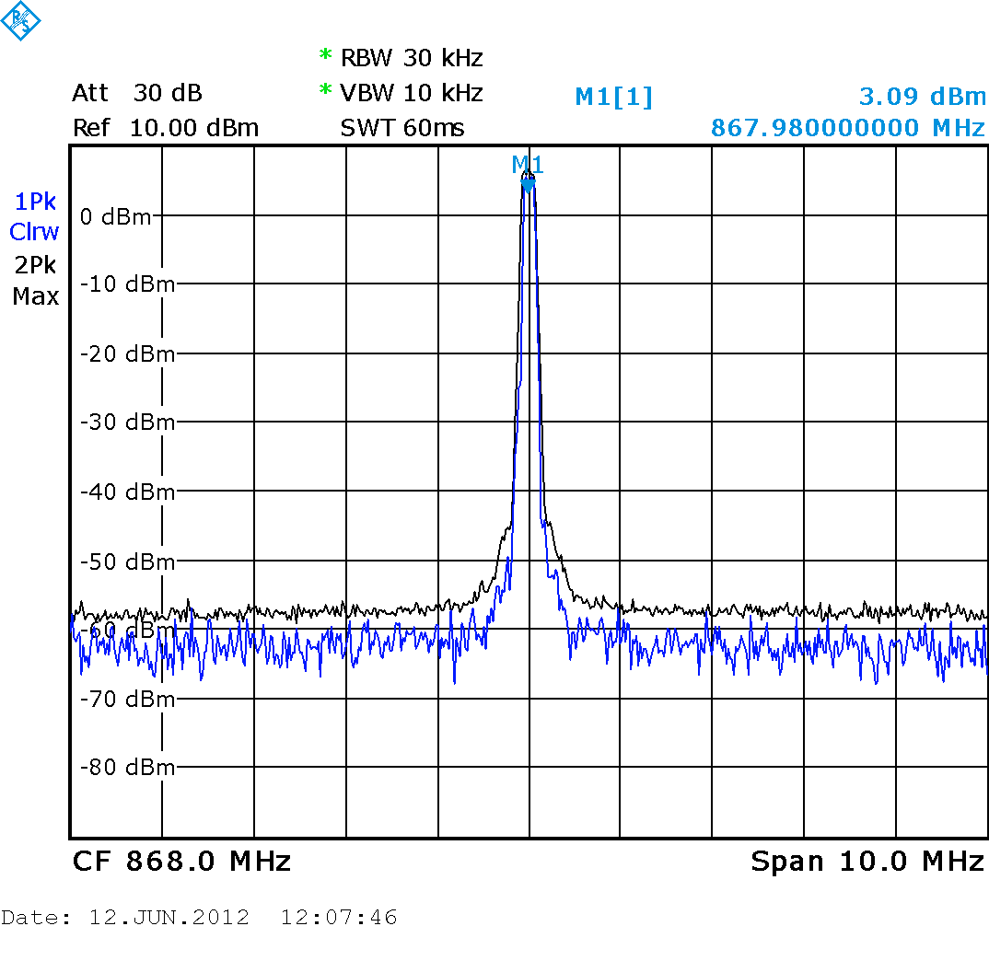
400 kHz system
Channel bandwidth | 400 kHz
Frequency tolerance | ±0.005% (transmitter)  ±0.005% (receiver)
Transmitter radiated power (ERP) | 10 mW
Transmitter field strength @30m | 88 dBμV/m
Transmitter out of band emission @30m | 70 dBμV/m, 200 kHz from carrier, narrowband  40 dBμV/m, 1 MHz from carrier, wideband
Transmitter modulation (indicative) | 4GFSK @250 kbit/s, ±80 kHz maximum deviation (outer symbols), BT = 0.5
Transmitter duty cycle (indicative) | 15-25% for one audio channel
Receiver sensitivity, direct inject | –80 dBm or better
Receiver selectivity | 30 dB minimum, adjacent channel  40 dB minimum, alternate channel, image channel and above
Receiver blocking rejection | 50 dB minimum, ±2 MHz separation
Example transmitter mask  (average and max hold)  (note measurement noise floor at -55 dBm)  Nominal 400 kHz bandwidth | 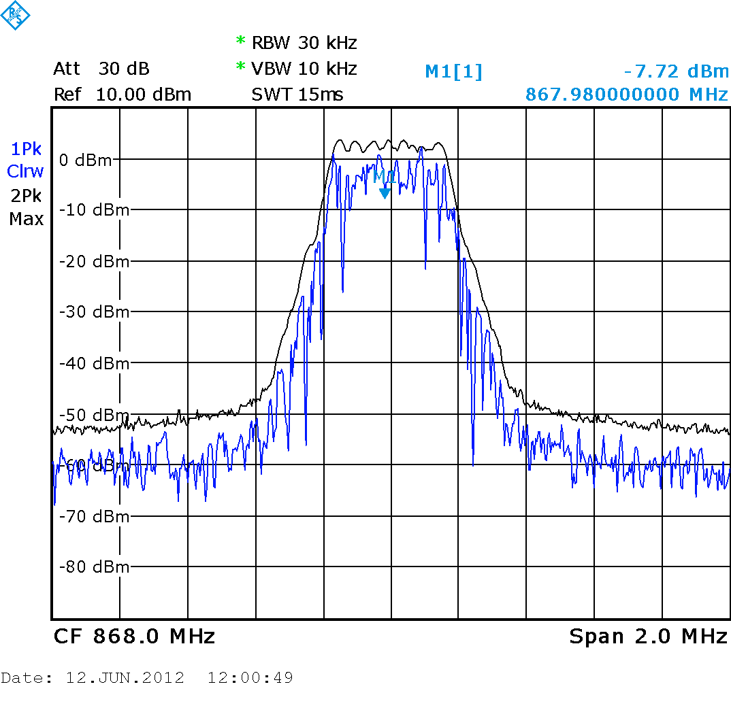  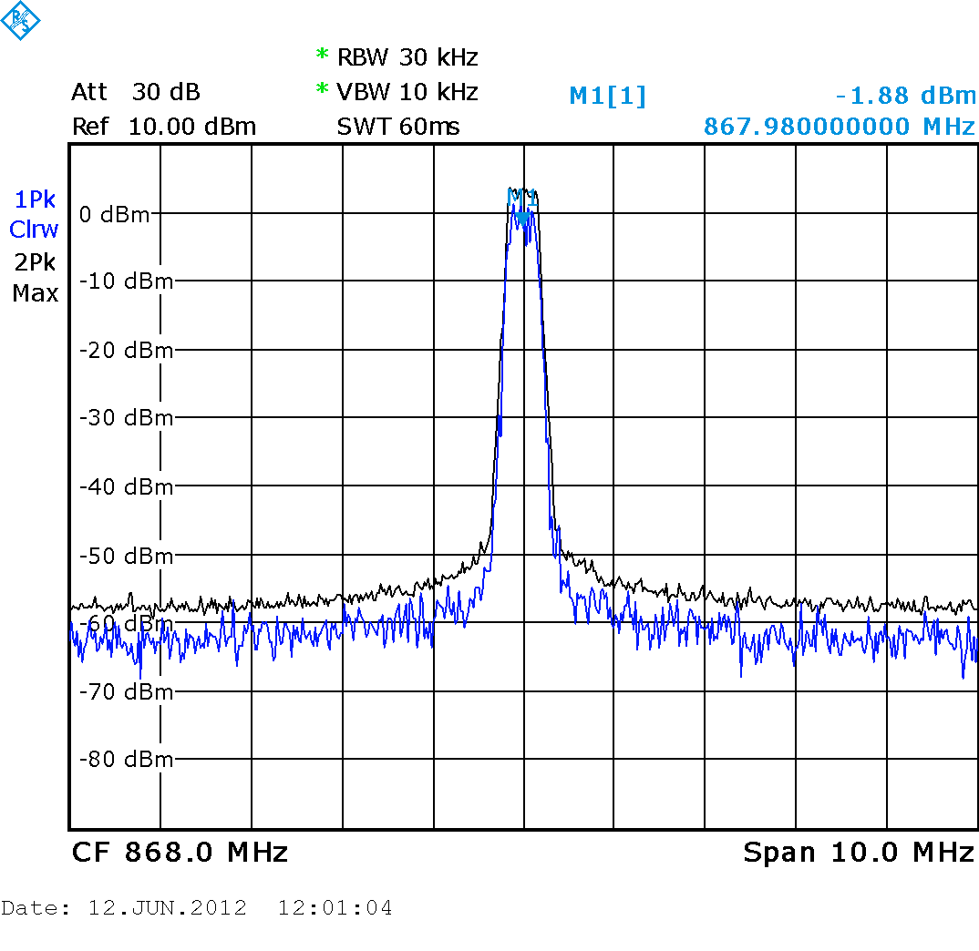
600 kHz system
Channel bandwidth | 600 kHz
Frequency tolerance | ±0.005% (transmitter)  ±0.005% (receiver)
Transmitter radiated power (ERP) | 10 mW
Transmitter field strength @30m | 88 dBμV/m
Transmitter out of band emission @30m | 70 dBμV/m, 300 kHz from carrier, narrowband  40 dBμV/m, 1 MHz from carrier, wideband
Transmitter modulation (indicative) | 4GFSK @500 kbit/s, ±120 kHz maximum deviation (outer symbols), BT = 0.5
Transmitter duty cycle (indicative) | 10-20% for one audio channel
Receiver sensitivity, direct inject | –80 dBm or better
Receiver selectivity | 30 dB minimum, adjacent channel  40 dB minimum, alternate channel, image channel and above
Receiver blocking rejection | 50 dB minimum, ±2 MHz separation
Example transmitter mask  (average and max hold)  (note measurement noise floor at –55 dBm)  Nominal 600 kHz bandwidth | 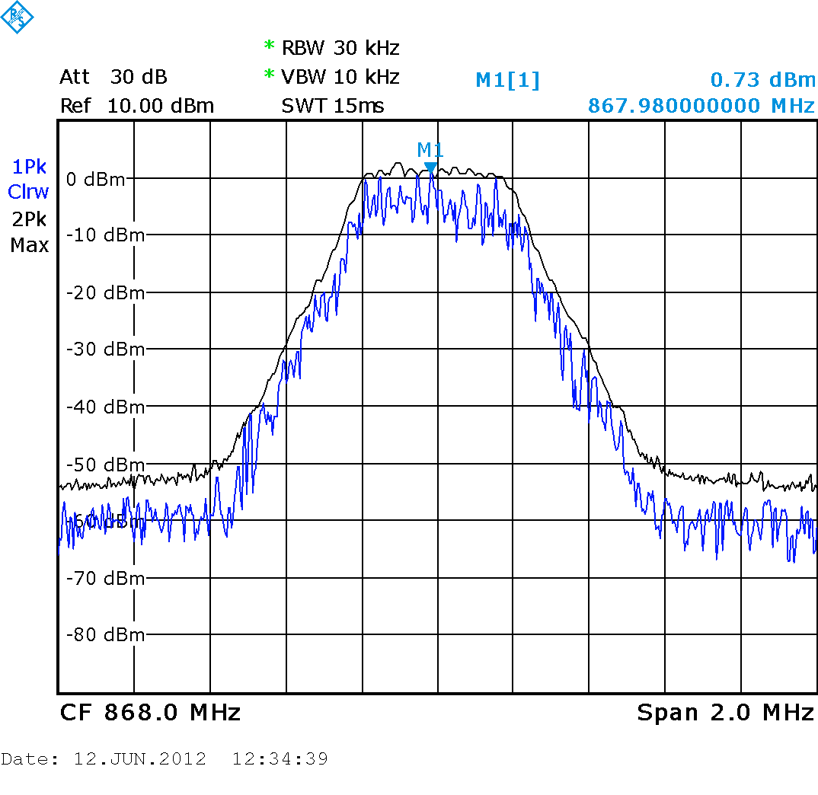  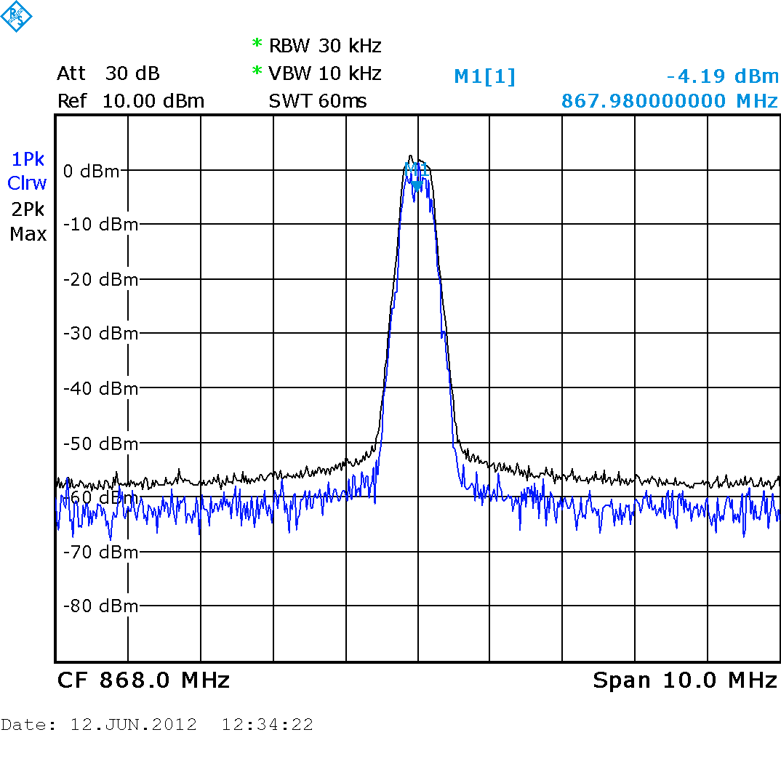
ANNEX 2
Technical characteristics

1 HF radio systems

1.1 3-11 MHz (Not implemented in all regions)

Channel bandwidth | 300-400 kHz
Frequency tolerance | <± 1%
Transmitter field strength @10 m | < –20 dBμA/m
Transmitter modulation (indicative) | FSK @300 kbit/s
Transmitter duty cycle (indicative) | 30-50% for one audio channel

2 VHF and UHF radio systems
In some parts of the world, systems have successfully shared various frequency bands in the range 169-220 MHz for many years, with the type of radio services to which these frequency bands are allocated by the Radio Regulations. With the introduction of ALD systems for public spaces which can be controlled from a database better sharing with broadcast services could be expected.

2.1 72-76 MHz (Not implemented in all regions)
Antenna length and man-made noise are an issue.
Channel bandwidth:

50 kHz for a narrow-band device
200 kHz for a wideband device
Frequency tolerance: ± 0.005% (transmitter)
Frequency stability: ± 0.005% (receiver)
Field strength produced at 30 m: Not to exceed 8 000 µV/m
Transmitter radiated power: 1 170 µW (calculated from above)
Modulation requirements for FM: 20 kHz maximum (narrow-band)
75 kHz maximum (wideband)
Out-of-band emissions: ± 25 kHz or more from carrier, no more than 150 µV/m
at 30 m for narrow-band
± 150 kHz or more from carrier, no more than 150 µV/m
at 30 m for wideband
Receiver selectivity: 40 dB minimum, adjacent channel
Receiver image rejection: 40 dB minimum

2.2 169 MHz band (Europe and Japan only)
Analogue FM fixed channel system with 100% Duty Cycle
Channel bandwidth: <50 kHz
Transmitter radiated power: 10 mW or <500mW Public Systems (Europe only), individual Licence required
Spurious emissions (transmitter): 4 nW (41-68, 87.5-118, 162-230, 470-872 MHz)
(250 nW elsewhere below 1 000 MHz)
20 nW (above 1 000 MHz)
Spurious emissions (receiver): 2 nW (100 kHz-1 000 MHz)
20 nW (1 000-4 000 MHz)

2.3 173-175 MHz (in some European countries)
Analogue FM fixed channel system with 100% Duty Cycle
Channel bandwidth: <50 kHz
Frequency tolerance: ± 5 kHz
Transmitter radiated power: 2-10 mW
Spurious emissions (transmitter): 4 nW (41-68, 87.5-118, 162-230, 470-872 MHz)
(250 nW elsewhere below 1 000 MHz)
20 nW (above 1 000 MHz)
Spurious emissions (receiver): 2 nW (100 kHz-1 000 MHz)
20 nW (1 000-4 000 MHz)

2.4 174-216 MHz (Europe)
Analogue FM fixed channel system with 100% Duty Cycle
Channel bandwidth: <50 kHz
Frequency tolerance: ± 5 kHz
Transmitter radiated power: 10 - 50 mW
Spurious emissions (transmitter): 4 nW (41-68, 87.5-118, 162-230, 470-872 MHz)
(250 nW elsewhere below 1 000 MHz)
20 nW (above 1 000 MHz)
Spurious emissions (receiver): 2 nW (100 kHz-1 000 MHz)
20 nW (1 000-4 000 MHz)

2.5 216-217 MHz (USA )
Analogue FM fixed channel system with 100% Duty Cycle
Channel bandwidth: <50 kHz
Frequency tolerance: ± 5 kHz
Transmitter radiated power: 100 mW

Spurious emissions (transmitter): 4 nW (41-68, 87.5-118, 162-230, 470-872 MHz)
(250 nW elsewhere below 1 000 MHz)
20 nW (above 1 000 MHz)
Spurious emissions (receiver): 2 nW (100 kHz-1 000 MHz)
20 nW (1 000-4 000 MHz)

2.6 217-220 MHz (Korea), 218-220 MHz (China)
{ Editors note: Korea may provide furthet information regarding frequency band use as standards used at the nexy meeting}

Analogue FM fixed channel system with 100% Duty Cycle
Channel bandwidth: <50 kHz
Frequency tolerance: ± 5 kHz
Transmitter radiated power: 10 mW
Spurious emissions (transmitter): 4 nW (41-68, 87.5-118, 162-230, 470-872 MHz)
(250 nW elsewhere below 1 000 MHz)
20 nW (above 1 000 MHz)
Spurious emissions (receiver): 2 nW (100 kHz-1 000 MHz)
20 nW (1 000-4 000 MHz)

2.7 863-865 MHz Europe only
Specification ETSI EN 301 357
FM fixed channel system with 100% Duty Cycle
Channel bandwidth: <200 KHz
Transmitter radiated power: 10 mW
Spurious emissions (transmitter): 4 nW (41-68, 87.5-118, 162-230, 470-872 MHz)
(250 nW elsewhere below 1 000 MHz)
20 nW (above 1 000 MHz)
Spurious emissions (receiver): 2 nW (100 kHz-1 000 MHz)
20 nW (1 000-4 000 MHz)

Football and horse riding are some of the many sports now using this equipment for coaching.
Many schools require in excess of 25 channels.
http://www.access-board.gov/research/interference.htm http://www.fda.gov/Radiation-EmittingProducts/RadiationEmittingProductsandProcedures/HomeBusinessandEntertainment/CellPhones/ucm116327.htm

