QUESTIONNAIRE ON SPECTRUM REQUIREMENTS FOR THE FUTURE OF SOUND AND TELEVISION BROADCASTING

|  |  |
| --- | --- |
| **Name of the Administration:** | **Switzerland (Confederation of)** |
| **Contact person:** | **Heinrich Sidler** |
| E-mail address: | **heinrich.sidler@bakom.admin.ch** |
| Telephone number: | **+41 58 327 56 21** |

|  |  |
| --- | --- |
| **Name of the Sector Member:** |  |
| **Contact person:** |  |
| E-mail address: |  |
| Telephone number: |  |
| **What best describes your organisation?**  Commercial broadcaster/Public service broadcaster/ Service provider/ Other (please describe) |  |
| **The geographical area over which you operate:** |  |

**SECTION ONE – Television broadcasting**

1) a) Is your country still using analogue television?

b) If yes, has analogue television switch-off commenced?

c) If your country has any plans to switch-off analogue television:

i) When is the analogue switch-off process expected to be completed?

ii) How much extra spectrum will be required during the transition phase to digital terrestrial television broadcasting?

**Reply:**

1. No
2. –
3. –

2) a) Please indicate how many analogue television transmitters are in operation in your country and in which bands.

b) What channel bandwidths are used for analogue television?

c) What is the spectrum requirement for analogue television in your country?

A proposed format for responses to question 2a) and 2b) is provided in Annex 1

**Reply:**

1. None
2. –
3. None

3) a) What is the percentage of viewer uptake of terrestrial television in your country?

b) If possible, please also provide details of the number or proportion of users who receive television primarily by terrestrial means by:

i) Fixed roof top antenna, or  
ii) Portable indoor antenna.

**Reply:**

1. <5%
2. Details are not available.

4) If your country has switched or is considering switching to digital terrestrial television broadcasting

a) What system standard is your country using or considering adopting   
(as specified in Recommendations ITU-R BT.1306 and BT.1877)?

b) When did your country start or when is it proposing to start the introduction of digital terrestrial television services?

c) Please provide further detail on the number of multiplexes in use, their technical specifications, the percentage of geographic area or population they cover or are intended to cover and the total spectrum use.

A proposed format for detailed responses is provided in Annex 2

**Reply:**

1. System B standard (DVB-T)
2. 7.2003
3. See table below:

|  |  |  |  |  |  |  |  |  |  |  |  |  |
| --- | --- | --- | --- | --- | --- | --- | --- | --- | --- | --- | --- | --- |
| **Country** | **No of multi-plexes** | **System & modulation** | **FEC** | **GI** | **Reception mode[1]** | **Capacity per multiplex (Mb/s)** | **Current percentage population coverage** | **Intended percentage population coverage** | **Content per multiplex** | **Total capacity (Mb/s)** | **Total spectrum bandwidth used or intended for implementation (MHz)** | **Any additional comments (e.g. duration of licences)** |
| **SUI** | *1* | *DVB-T, 16-QAM* | *5/6* | *1/4* | *portable outdoor/ fixed* | *16.6* | *80%/98.0%* | *80%/98.0%* | *4-5 SD MPEG2* | *16.6* | *88* | *Public service (nationwide) licensed until 2017* |
| *2* | *DVB-T, 64-QAM* | *3/4* | *1/16* | *fixed* | *26.4* | *70%* | *70%* | *10-11 SD MPEG2* | *52.8* | *16-40  depending on the location* | *Private services  (regional/local distribution)  licensed until 2023* |

5) a) What frequencies/channels are currently used or intended to be used by digital terrestrial television broadcasting in your country? Please distinguish between those in use and those intended to be used?

b) Please indicate how many digital terrestrial television transmitters are currently used or intended to be used and in which bands.

c) What channel bandwidth is used or intended to be used for digital terrestrial television in your country?

A proposed format for responses to question 5b) and 5c) is provided in Annex 1

**Reply:**

1. see the figure and the table below:  
   (MUX1 – MUX 3 are currently in use)

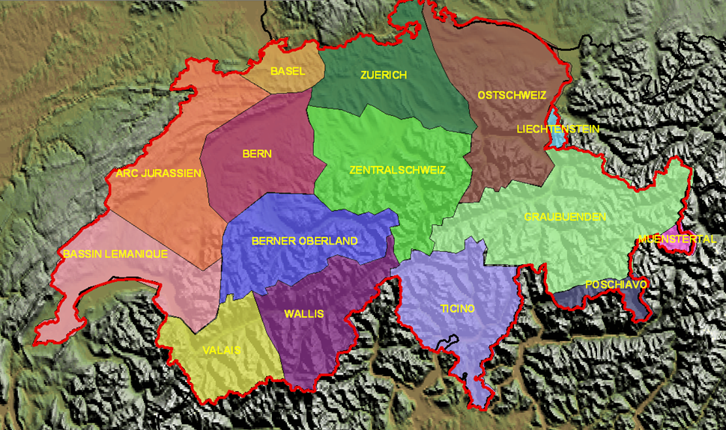

|  |  |  |  |  |  |  |  |
| --- | --- | --- | --- | --- | --- | --- | --- |
|  | |  | |  | |  | |
| Area | | MUX1 | | MUX2 | | MUX3 | |
| Basel | | 31 | |  | |  | |
| Zuerich | | 32 | |  | |  | |
| Ostschweiz | | 34 | |  | |  | |
| Graubuenden | | 52 | | 51, 55, 56, 57, 58 | | 51, 55, 56, 57, 58 | |
| Ticino | | 39 | |  | |  | |
| Wallis | | 45 | |  | |  | |
| Valais | | 54 | |  | |  | |
| Bassin Lemanique | | 34 | |  | |  | |
| Arc Jurassien | | 56 | |  | |  | |
| Bern | | 48 | |  | |  | |
| Zentralschweiz | | 32 | |  | |  | |
| Berner Oberland | | 49 | |  | |  | |
| Muenstertal | | 52 | | 57, 58 | | 57, 58 | |
| Poschiavo | | 24 | | 57, 58 | | 57, 58 | |
|  | |  | |  | |  | |
|  | |  | |  | |  | |
|  | | 470-694 MHz | |  | |  | |
|  | |  | |  | |  | |
|  | | 694-790 MHz | |  | |  | |

1. and c) see the table below:

|  |  |  |  |  |  |  |
| --- | --- | --- | --- | --- | --- | --- |
| **Country** | **Band** | | **Number of Transmitting Stations\*** | | | |
| **Analogue Radio**)(Q11b & Q11c) | **Digital Radio** (Q13d & Q13h) | **Analogue TV** (Q2a & Q2)b | **Digital TV** (Q5b & Q5c) |
| **Channel bandwidth (MHz)** | | *VHF II 300kHz* | *1.5MHz* |  | *8MHz* |
| **SUI** | **LF** | 148.5-283.5 kHz |  |  |  |  |
| **MF** | 525-526.5 kHz |  |  |  |  |
| **MF** | 526.5-1606.5 kHz |  |  |  |  |
| **MF** | 1606.5-1705 kHz |  |  |  |  |
| **HF** | 2.3-26.1 MHz** |  |  |  |  |
| **VHF I** | 47-50 MHz |  |  |  |  |
|  | 50-54 MHz |  |  |  |  |
|  | 54-68 MHz |  |  |  |  |
|  | 68-72 MHz |  |  |  |  |
|  | 76-87.5 MHz |  |  |  |  |
| **VHF II** | 87.5-108 MHz | *1286* |  |  |  |
| **VHF III** | 174-216 MHz |  | *76* |  |  |
| **VHF III** | 216-230 MHz |  | *179* |  |  |
| **UHF IV** | 470-694 MHz |  |  |  | *152* |
| **UHF V** | 694-790 MHz |  |  |  | *180* |
| **UHF V** | 790-890 MHz |  |  |  |  |
| **UHF V** | 890-960 MHz |  |  |  |  |
|  | 1452-1492 MHz |  |  |  |  |
|  | 11.7-12.5 GHz |  |  |  |  |
|  | 12.5-12.7 GHz |  |  |  |  |
|  | 40.5-42.5 GHz |  |  |  |  |
|  | 74-76 GHz |  |  |  |  |
| * Transmitting stations please include “main stations” and “relay stations.” Please use parenthesis to indicate stations that have still to be brought into use  ** The bands 3900-3950D, 3950-4000D kHz; the bands for tropical broadcasting: 2300-2498, 3200-3400D, 4750-4995 D, 5005-5060D kHz and the Article 12 Bands 5 900-5 950D, 5 950-6 200, 7 200-7 300, 7 300-7 400D, 7 400-7 450, 9 400-9 500D, 9 500-9 900, 11 600-11 650D, 11 650-12 050, 12 050-12 100D, 13 570-13 600D, 13 600-13 800, 13 800-13 870D, 15 100-15 600, 15 600-15 800D, 17 480-17 550D, 17 550-17 900, 18 900-19 020D, 21 450-21 850, 25 670-26 100.  D Resolution 517 (Rev.WRC-07) applies. In the HF bands subject to Article 12 see also No. 5.134. | | | | | | |

6) a) Are the terrestrial television frequency bands also shared with other primary services in your country?

b) If yes, please give details of those systems and their spectrum use.

**Reply:**

1. Yes
2. Mobile service in the band 790-862 MHz.   
   The bands of VHF I are exclusively used by land mobile or mobile service (no broadcasting allocation).

7) a) Are the terrestrial television frequency bands also shared with secondary services used for the support of broadcasting such as SAB/SAP (services ancillary to broadcasting/production), or other types of services such as radio astronomy or wind-profile radar?

b) If yes, please give details of those systems and their spectrum use.

**Reply:**

1. Yes
2. See the figure below:

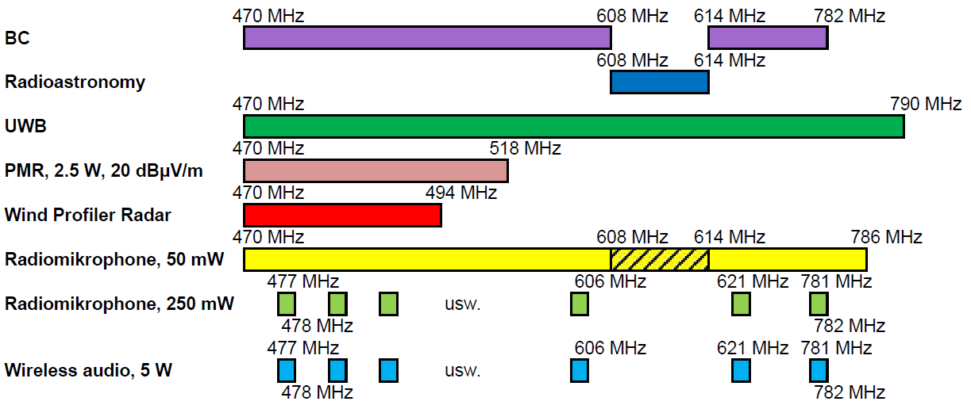

8) a) Does your country foresee a requirement for new and enhanced services, including multimedia and data applications, HD, 3D, and UHD television, on the terrestrial television platform?

b) If yes, please give indicative details of the number and nature of services planned, and if known, the expected timeframe for their introduction.

**Reply:**

1. No, HDTV services are not planned today
2. –

9) a) Are there plans in your country to launch more multiplexes in the future?

b) If yes, how many more and when? Please also indicate the expected timeframe for their introduction.

**Reply:**

1. No
2. –

10) a) What is the amount of spectrum your country foresees will be required for terrestrial television broadcasting, taking into consideration the responses to Questions 5, 6, 7, 8, and 9? Please indicate the modes of transmission that will be used, and timeframes.

**Reply:**

1. The discussions are on-going to assess this issue.

**SECTION TWO – Sound broadcasting**

11) a) What analogue sound broadcasting standards are used in your country and what bands are they operating in?

b) Please indicate how many analogue radio transmitters are in operation in your country and in which bands.

c) What channel bandwidths do they use?

A proposed format for responses to question 11b) and 11c) is provided in Annex 1

**Reply:**

1. FM sound broadcasting, operating in VHF band II
2. and c) see the table at reply of question 5

12) a) Is additional spectrum required for growth in the analogue sound broadcasting platform in your country?

b) If yes, how much additional spectrum is required?

**Reply:**

1. No
2. –

13) a) Is your country considering introducing, or has it already introduced digital sound broadcasting?

b) If yes, which system standards are used or are being considered for adoption (as specified in Recommendations ITU-R BS.1114, BS.1514, BS.1615)?

c) When did your country start or when does it propose to start digital sound broadcasting?

d) What channel bandwidths is your country using or considering using?

e) What frequencies are currently used or intended to be used by digital sound broadcasting in your country? Please distinguish between those in use and those intended to be used.

f) What is the percentage of the population that is covered by digital sound broadcasting by direct reception in your country?

g) What additional spectrum was required or is considered to be required for the transition to digital sound broadcasting?

h) Please indicate how many digital radio transmitters are currently used or intended to be used and in which bands.

i) What is the spectrum requirement for digital sound broadcasting in your country?

j) If your country has introduced digital sound broadcasting, how long will it continue to use analogue sound broadcasting?

A proposed format for responses to question 13d) and 13h) is provided in Annex 1

**Reply:**

1. Yes
2. Digital System A (T-DAB/DAB+)
3. 12.2005
4. see the table at reply of question 5
5. see the figure and the table below:  
     
   

|  |  |  |  |  |
| --- | --- | --- | --- | --- |
| Area | Ensemble 1 (nationwide) | Ensemble 2  (regional distribution) | Ensemble 3  (regional distribution) | Ensemble 4  (local distribution) |
| Basel | **12C** | **7D** | **7A** | 10A |
| Zürich | **12C** | **7D** | **7A** | **9A** |
| Ostschweiz | **12C** | **7D** | **9D** | 7B |
| Graubünden | **12D** | **7D** | 11D | 7C |
| Münstertal | **12D** | 7D | 9A | 11D |
| Poschiavo | **12A** | 7D | 10A | 11D |
| Ticino | **12A** | 8D | 10A | 10C |
| Wallis | **12C** | 7D | 11C | 9D |
| Valais | **12A** | **10B** | 10C | 10D |
| Bassin Lémanique | **12A** | **10B** | 10C | **10D** |
| Arc Jurassien | **12A** | **10B** | 10C | 10D |
| Bern | **12C** | **7D** | **8B** | 11A |
| Zentralschweiz | **12C** | **7D** | 7A | 5D |
| Berner Oberland | **12C** | **7D** | 8B | 8C |

frequency blocks in bold letters are currently in use; the others are intended to be used

1. 95% - 99%
2. There was so far no need for additional spectrum as the digital sound broadcasting has started in the VHF band, which was not used by analogue TV and stayed empty, while analogue radio is being continuing in other bands.
3. see the table at reply of question 5
4. The GE06 Plan entries in the VHF band III are considered sufficient to satisfy the spectrum requirements of the digital sound broadcasting.
5. This issue has not been assessed yet.

14) a) Are the terrestrial sound broadcasting bands also shared with other primary services in your country?

b) If yes, please give details of those systems and their spectrum use.

**Reply:**

1. Yes
2. In the LF band (148.5 – 283.5 kHz), ARNS is allocated at 255 - 283.5 kHz.

15) a) Are the terrestrial sound broadcasting bands also shared with secondary services e.g., used for the support of broadcasting such as SAB/SAP (services ancillary to broadcasting/production), or other types of services such as radio astronomy or wind-profile radar?

b) If yes, please give details of those systems and their spectrum use.

**Reply:**

1. Yes
2. Secondary services used within the broadcasting bands are as follows:

**LF** (148.5 – 283.5 kHz):   
SRD/Active medical implants: 9 – 315 kHz,  
Wideband SRD /Inductive applications: 148.5 – 5000 kHz

**MF** (526.5 – 1606.5 kHz):   
Wideband SRD /Inductive applications: 148.5 – 5000 kHz  
SRD /Inductive applications: 400 – 600 kHz  
SRD/Active animal implantable devices: 315 – 600 kHz,   
Wideband SRD /Railway applications: 984 – 7484 kHz, 516 – 8516 kHz

**HF** (3.95 – 26.1 MHz):   
*Broadcasting allocations are as follows: 3.95 – 4 MHz, 5.9 – 6.2 MHz, 7.2 –7.45 MHz, 9.4 – 9.9 MHz, 11.6 – 12.1 MHz, 13.57 – 13.87 MHz, 15.1 – 15.8 MHz, 17.48 – 17.9 MHz, 18.9 – 19.02 MHz, 21.45 – 21.85 MHz, 25.67 – 26.1 MHz.  
Secondary services sharing these Broadcasting bands:*Wideband SRD/Inductive applications: 3.95 – 26.1 MHz  
Wideband SRD/Railway applications: 984 – 7484 kHz, 516 – 8516 kHz and   
7.3 – 23 MHz  
Tests and development: 7345 kHz  
SRD /Inductive applications: 7400-8800 kHz  
Wideband SRD/ Active animal implantable devices: 12.5 – 20 MHz  
Various fixed services (e.g. Security, UNO, CICR): 18.9 – 19.02 MHz  
fixed and land mobile service (RR 5.136, 5.143, 5.143B): 5900-5950 kHz,   
 7300-7350 kHz, 7350-7450 kHz  
fixed service (RR 5.146, 5.147): 9400-9500 kHz, 11600-11650 kHz, 12050-12100 kHz, 15600-15800 kHz, 17480-17550 kHz and 18900-19020 kHz,  
 9775-9900 kHz, 11650-11700 kHz and 11975-12050 kHz  
fixed and mobile service (RR 5.151): 13570-13600 kHz and 13800-13870 kHz

**VHF I** (47 – 72 MHz, 76 – 87.5 MHz):   
There is no broadcasting allocation within the VHF I bands, the primary services at VHF I are exclusively land mobile or mobile service. The bands are shared with various secondary services such as wind profiler radars, UWB-Applications (GPR/WPR ) and Amateur.

**VHF II** (87.5 – 108 MHz) and **VHF III** (174 – 230 MHz) see the figure below:

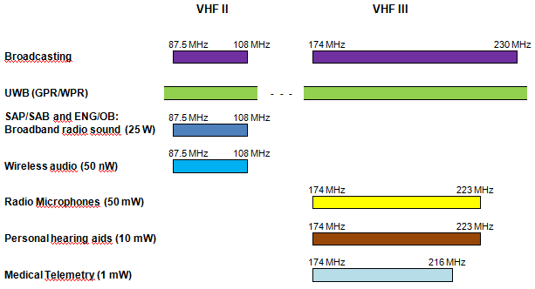

16) a) What is the amount of spectrum your country foresees will be required for terrestrial sound broadcasting, taking into consideration the responses to the previous questions? Please indicate the modes of transmission that will be used, and timeframes.

**Reply:**

1. 56 MHz for T-DAB (DAB+)

**SECTION THREE –Multimedia broadcasting**

17) a) Is your country considering introducing or has already introduced multimedia broadcasting?

b) If yes which system standards is your country using or considering using (as specified in Recommendations ITU-R BT.1833 and BT.2016)?

c) In which Bands?

d) When did your country start or when does it propose to start digital multimedia broadcasting?

e) What are the current and proposed population coverages for digital multimedia broadcasting in your country?

f) What is the spectrum requirement for multimedia broadcasting in your country?

g) If your country has introduced digital multimedia broadcasting, please provide further information to describe the system, its implementation and any limitations on its operation.

**Reply:**

1. No current plans to introduce multimedia broadcasting
2. -
3. -
4. -
5. -
6. -
7. -

1. E.g. fixed, portable outdoor/mobile, portable indoor.