ITU Regulations for Ka-band Satellite Networks
By Jorn Christensen, Ph. D., AsiaSat

1. Introduction
This paper gives an overview of the ITU regulations that apply to Ka-band satellite networks that operate in the geostationary satellite orbit (GSO) or a non-geostationary satellite orbit (non-GSO). The satellite services provided by either GSO or non-GSO satellite networks of interest for this paper are the Fixed-Satellite Service (FSS), Broadcasting-Satellite Service (BSS) and the Mobile-Satellite Service (MSS). The concept of the Ka-band is not defined in the Radio Regulations (RR) but for the purposes of this paper will be considered as the frequency range from 17.3 to 31 GHz.

2. Overview of ITU Frequency Allocation for Ka-bands.
The ITU divides the world into 3 Regions:
Region 1: Europe, Middle East, Russia and Africa;
Region 2: The Americas
Region 3: Asia, Australia and Oceania
The Table of Frequency Allocations contained in Article 5 of the Radio Regulations (RR) allocates frequency bands in each of the three ITU Regions to radiocommunication services based on various service categories as defined in the RR. Many allocations have footnotes that specify, inter alia, operating constraints either technical or operational. Annex 1 shows a simplified view of the Ka-band portion of the Table of Frequency Allocations with an emphasis on allocations to satellite services. Terrestrial and satellite services may not share well. An administration in adopting its national Table of Frequency Allocations may choose to favour one or the other of the co-primary services that are allocated to the same spectrum and that may not share well. Almost all the Ka-band that is allocated to satellite services is also allocated to the terrestrial Fixed Service (FS) and many countries have licensed LMDS services in the Ka-band. The Ka-band is subject to many different footnotes for different services. These footnotes limit the amount of spectrum available for a particular type of Ka-band satellite service – see Annex 1.

3. GSO versus non-GSO Satellite Networks
The great majority of commercial communications satellite networks are GSO networks. One disadvantage of a non-GSO satellite network is that all satellites in the constellation must be launched in order to provide continuous service. The number of satellites needed to provide continuous coverage depends on the altitude of the satellites – the lower the altitude the more satellites are required to provide continuous service. Therefore the capital costs of launching a non-GSO constellation is usually very large. Since it takes time to build up a customer base it is likely that for many years there may not be enough income to even service the debt. In addition, the environment for LEO satellites is very harsh and the lifespan of a LEO satellite is typically only around 7 years as compared with around 15 years for a GSO satellite. Therefore, LEO satellites require a more frequent replacement.
In the late 1990s two non-GSO satellite networks were proposed to provide consumer Internet connectivity: Teledesic and Skybridge. They were never launched due mainly to the initial large capital costs to implement the networks, absence of reasonably priced consumer terminals and the difficulty of suitable installation sites since the earth station had to have a clear view of most of the sky in order to “see” the non-GSO satellites.

4. GSO FSS Ka-band Satellite Networks
In the last 5 years many satellite operators have launched or are planning to launch so-called High Throughput Satellites (HTS) operating in the Ka-band. (See Annex 3 for examples.) The first commercial HTS was IPSTAR (Thaicom-4) operating in the Ku-band. The main application for these satellites is fast Internet connectivity. The satellite antenna of these HTSs are characterized by many small beams (up to about 200) with high gain which allows for closing the link to relatively small user terminals. These satellite antennas also allow for multiple frequency re-use resulting in a throughput in the range of 100s of Gigabits per second (Gbps). The small diameter earth station antennas require adequate spacing of the GSO satellites in order to avoid interference.
4.1 Ka-band Frequencies for HTS
Most HTS typically file for 3.5 GHz bandwidth in the following Ka-bands:
27.5 – 31 GHz uplink
17.7 – 21.2 GHz downlink
As seen in Annex 1 this range of frequencies is subject to various regulatory procedures. One way to divide these bands is as follows:
a) Bands identified for High-Density FSS
RR No. 5.516B gives the bands identified for high-density fixed-satellite service (HDFSS). These bands allow for the deployment of uncoordinated FSS earth stations under a blanket license. The only bands that include all Regions are:
29.5 – 30 GHz (uplink) (500 MHz)
19.7 – 20.2 GHz (downlink) (500 MHz)
On the downlink the following Regional identifications for HDFSS are made in RR No. 5.516B:
17.3-17.7 GHz (space-to-Earth) in Region 1,
18.3-19.3 GHz (space-to-Earth) in Region 2,
In Regions 1 and 3 the use of the band 17.3-18.1 GHz by geostationary-satellite systems in the fixed-satellite service (Earth-to-space) is limited to feeder links (i.e. Earth-to-space) for the broadcasting-satellite service (RR No. 5.516). However, in Region 1 the band 17.3-17.7 GHz (400 MHz) may also be used for FSS downlink provided that it does not claim protection from from the broadcasting-satellite service feeder-link earth stations. Nor shall it put any limitations or restrictions on the locations of the broadcasting-satellite service feeder-link earth stations anywhere within the service area of the feeder link (see RR No. 5.516A). This is not a serious restriction since there are a very limited number of BSS feeder link stations
b) Bands used by many administrations for FS including LMDS
In all three ITU Regions in most of the FSS Ka-band the FS is co-primary. Another band preferred for FSS is the 1.1 GHz band:
27.5 – 28.6 GHz
17.7 – 18.8 GHz
However, many administrations have services such as local multipoint distribution services (LMDS) in this band. This service does not share well with HDFSS.
c) Bands where GSO and non-GSO satellite networks have equal rights
In general, from RR No. 22.2:
22.2 § 2 1) Non-geostationary-satellite systems shall not cause unacceptable interference to and, unless otherwise specified in these Regulations, shall not claim protection from geostationary-satellite networks in the fixed-satellite service and the broadcasting-satellite service operating in accordance with these Regulations. No. 5.43A does not apply in this case. (WRC-07)
However, in the following two bands GSO and non-GSO satellite networks have equal rights:
- 500 MHz band originally intended for Teledesic:
  - – 29.1 GHz (uplink), 18.8 – 19.3 GHz (downlink)
The O3B non-GSO network is planned to operate in this band. The OB3 network does not suffer from the usual non-GSO disadvantages given above due the fact that the service area which is the area +/- 45° North and South latitude can be covered continuously by a relatively small constellation of initially 6 satellites in equatorial orbit. In addition, the service is not intended for direct delivery to consumers but for telecom operators who can afford the more expensive tracking antennas needed. The telecom operators will re-sell the service to consumers.
- 400 MHz band for non-GSO feeder links (Iridium):
29.1 – 29.5 GHz, 19.3 – 19.7 GHz
Iridium operates in the L-band on the service link and in the Ka-band on the feeder link.
In the bands a) and b) above RR No. 9.11A applies which means that a new network whether GSO or non-GSO must coordinate with earlier filed GSO and non-GSO networks as well as other primary services operating in the band.
d) Bands where equivalent pfd (epfd) applies
The epfd limits were introduced by SkyBridge at WRC-97 and adopted by WRC-2000. The SkyBridge non-GSO satellite network was intended to operate in the Ku-band but WRC-2000 adopted epfd limits for portions of both the C-, Ku- and Ka-bands. Presently there are no satellites operating using this concept.
The concept is based on re-using GSO frequencies by a non-GSO constellation outside the GSO by avoiding the GSO by about +/- 10°. Annex 1 shows the Ka-bands that are subject to epfd (up and down) limits. These limits define the maximum permissible interference that non-GSO FSS systems can cause to GSO FSS networks. The epfd limits are given in Article 22 for different antenna sizes for different percentages of time. The epfd (up and down) values were calculated so that they would increase the unavailability by no more than 10% on the most sensitive links. The links used for this calculation were engineered to be very sensitive and did not represent typical links. Therefore, in reality, a non-GSO FSS system will cause even less than a 10% increase in unavailability on a GSO FSS link i.e. the values are so low that they will have a negligible effect on the GSO FSS links.
e) Military bands
Although they are not identified as such in the RR, the following bands are used by the military.
30 – 31 GHz (uplink)
20.2 – 21.2 GHz (downlink)
It may be possible for a commercial operator to provide services to the military. For example, the Ka-band payload of the Inmarsat Global Xpress™ satellites can be toggled back and forth between military and commercial frequencies. Each satellite will also carry multiple steerable beams capable of directing capacity in real time to the location where it is needed. This capability has been incorporated with the military in mind for use that includes unmanned aerial vehicles (UAV). Inmarsat hopes to sell services to the military. A few administrations will not allow commercial operators to file for the military bands.
4.2 Frequency Coordination Challenges for Ka-band HTS
The greatest challenge in coordinating a new Ka-band HTS network is the large number of filings already submitted. Therefore, a prospective operator may have to wait several years before its filings will have some priority. The general frequency coordination process is given in Annex 2. Another challenge for HTS is obtaining landing rights in the various countries covered by the satellite. This must be done on a country-by-country basis.

5. WRC-12 Decisions Affecting the Ka-band
5.1 New BSS Ka-band Allocations
WARC-92 allocated the 21.4 – 22 GHz band to the broadcasting-satellite service in Regions 1 and 3 with an effective date of 1 April 2007 and subject to the interim procedures of Resolution 525 (Rev. WRC-07) which, inter alia, called for access on a first- come-first-served basis even though according to the RR allocations to the BSS must be planned. Due to the many filings submitted WRC-12 adopted special provisions to be applied only once in order to try to guarantee all administrations access to this spectrum. These procedures include queue jumping and stricter Resolution 49 information.
5.1.1 Planned use of 21.4 – 22 GHz band
Some of the uses foreseen for the 21.4 – 22.0 GHz band include ultra-high definition television and large-screen digital imagery. A more likely use is multi-channel DTH TV both HD and SD. With very efficient video compression schemes such as MPEG-4 it is now possible to transmit HD TV directly to the consumer at a reasonable cost. There has been a drastic reduction in the price of flat screen TVs which are now very popular and more consumers want HDTV.
Presently there are no operating satellites in the new 21.4 – 22 GHz BSS band but satellites using this band are being planned. DTH TV to the consumer requires downlink only whereas the main function of the HTS is to provide two-way Internet connectivity. Due to the proximity in frequency the bands used by the HTS satellites and the bands to be used by the new Ka-band BSS, both these bands can more easily be accommodated on the same satellite. Also, the multi-beam satellite antenna pattern of a HTS could be used for one-way DTH TV. Such use would facilitate local-into-local satellite transmissions as is presently being done in the Ku-band in the US.
Annex 1
Simplified summary of Ka-band satellite frequency allocations
for communication satellite networks

UPLINK DOWNLINK
27.0 GHz----------------------------------------------------- ----17.3 GHz

FSS uplink in In Regions 1 and 3 band 17.3-18.1 GHz
Region 2 and 3 only limited to feeder links for BSS. However
17.3-17.7 GHz FSS downlink Region 1
- GHz------------------------------------------------------17.7 GHz

epfd limits on downlink only 17.8 – 18.6 GHz has epfd limits
(lower band) GSO FSS (1.1 GHz)
in US: lower 600 MHz LMDS and FS
(Other countries are also making allocations to the LMDS and FS)
in US: GSO FSS: 28.1 - 28.6 GHz, 18.3 – 18.8 GHz (500 MHz)
(eg. Spaceway)

28.6 GHz------------------------------------------------------18.8 GHZ
9.11A 9.11A
500 MHz non-GSO FSS

29.1 GHz------------------------------------------------------19.3 GHz
9.11A 9.11A
400 MHz for feeder links for non-GSO MSS
(eg. Iridium)
29.5 GHz------------------------------------------------------19.7 GHz
epfd limits epfd limits
(upper band) GSO FSS (500 MHz)
(eg. Spaceway)
30.0 GHz------------------------------------------------------20.2 GHz

1 GHz for FSS (government/military)

31.0 GHz------------------------------------------------------21.2 GHz

24.65 GHz-----------------------------------------------------21.4 GHz

BSS in Regions 1 and 3

25.25 GHz-----------------------------------------------------22.0 GHz

Jorn Christensen
March 24, 2012

Annex 2
General ITU regulatory concepts for satellites
operating in the unplanned bands

The unplanned Fixed-Satellite Service (FSS) bands are accessed on a first-come, first-served basis in accordance with Articles 9 and 11 of the ITU Radio Regulations (RR). Successful coordination of a satellite network gives international recognition to the use of frequencies by this network at a given orbital location. There are generally three types of submissions to the ITU required for coordinating and registering a satellite network and they are as follows:
- Advanced Published Information (API)
- Coordination Request (CR)
- Notification and Resolution 49 (due diligence) information
First the API for the satellite network must be submitted. The CR can be submitted with or after the API but it is not considered receivable until 6 months after the receipt of the API.
The priority of a satellite network is established by the date of publication of the CR for the network provided that the Radiocommunication Bureau Findings are “Favourable”. If the Findings are “Unfavourable”, the priority date is not established until the reason for the “Unfavourable” Finding is removed. A Finding is “Unfavourable” if the frequency assignments are not in conformity with all applicable provisions of the Radio Regulations. It is therefore important to check that a submitted CR receives a “Favourable” Finding upon publication.
The frequency assignments of a satellite network must be “brought into use” no later than 7 years after the receipt of the API; otherwise, the network is deleted from the ITU files and no longer taken into account. Also, the CR must be submitted no later than two years after the submission of the API or the network will be deleted.
Once a satellite network has been coordinated and notified and “brought into use” it establishes an international recognition to operate at the filed orbital location using the filed frequencies with the parameters coordinated and notified. If the satellite subsequently has a failure or is drifted to another orbital location the administration responsible for the satellite network must suspend the frequency assignments of that satellite. The rights are retained as long as the suspended frequency assignments are brought back into use within 2 years.

Annex 3
Examples of High Throughput Satellite Networks

- Russian Communications Satellite Company (www.eng.rscc.ru)
The Russian Satellite Communication Company (RSCC) was founded in 1967 and is among the ten largest world satellite operators in terms of satellites and orbital slots. RSCC operates geostationary satellite in the orbital arc from 14 West to 140 East and cover the whole territory of Russia, the CIS, Europe, the Middle East, Africa, the Asia Pacific region, North and South America, and Australia.
The Express AM5 and AM6 Satellites

From:
http://www.satlaunch.net/2011/05/express-am5-coveragefootprint-maps.html

Express AM5 Ka-band spot beams
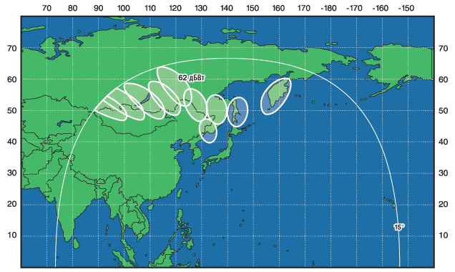

From:
http://www.satlaunch.net/2011/05/express-am6-coveragefootprint-maps.html

Express AM6 Ka-band spot beams
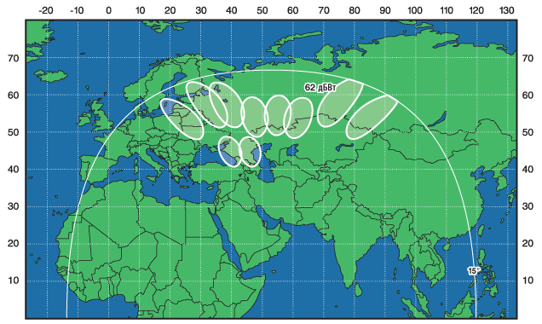

- IPSTAR (www.ipstar.com)
Thaicom Public Company Limited (formerly named Shin Satellite) is headquartered in Bangkok. It was founded on 7th November 1991 by Shin Corporation Plc. (“SHIN”), which was granted a 30-year Build-Transfer-Operate concession from Thailand’s Ministry of Transport and Communications (now transferred to “Ministry of Information and Communication Technology”) to operate the country’s first communications satellite. The concession expires in 2021.
2.1 THAICOM 4 (IPSTAR) Satellite
THAICOM 4 (IPSTAR) was launched in 2005 and is owned and operated by Thaicom. It was the first commercial high throughput satellite (HTS) launched. The satellite was designed for two-way communications over an Internet Protocol (IP) platform and has a maximum throughput of 45 Gbps. The satellite has 87 downlink Ku-band spot beams. The satellite also carries 10 Ka-band uplink transponders. When launched in 2005 it was the heaviest commercial communication satellite launched to date weighing 6505 kg.
2.2 IPSTAR Service
The IPSTAR service has a download speed up to 5 Mbps and an upload speed up to 4 Mbps and therefore is only a second generation broadband VSAT system. IPSTAR now has frequency licenses in 14 countries in Asia Pacific area, allowing operators and service providers to provide broadband Internet access via satellite. With its many gateway stations (presently 18) IPSTAR can provide access to high-capacity ground networks with affordable bandwidth. A wide-band data link from the gateway to the user terminal employs an Orthogonal Frequency Division Multiplexing (OFDM) with a Time Division Multiplex (TDM) overlay. These forward channels employ highly efficient transmission methods, including Turbo Product Code (TPC) and higher order modulation (L-codes) for increased system performance.
In the terminal-to-gateway direction (or return link), the narrow-band channels employ the same efficient transmission methods. These narrow-band channels operate in different multiple-access modes based on bandwidth-usage behavior, including ALOHA and TDMA for STAR return link waveform.
Thaicom has started to sell bulk satellite capacity and announced in May 2011 a contract with Malaysia’s Measat satellite operator for capacity on IPSTAR. Under the 10-year contract Measat will purchase access to seven IPSTAR spot beams delivering a total of 3.3 Gbps. Thaicom has stated that this represents 7 percent of the satellite’s total capacity. The bandwidth will be marketed in Malaysia as Measat 5.
IPSTAR satellite beams
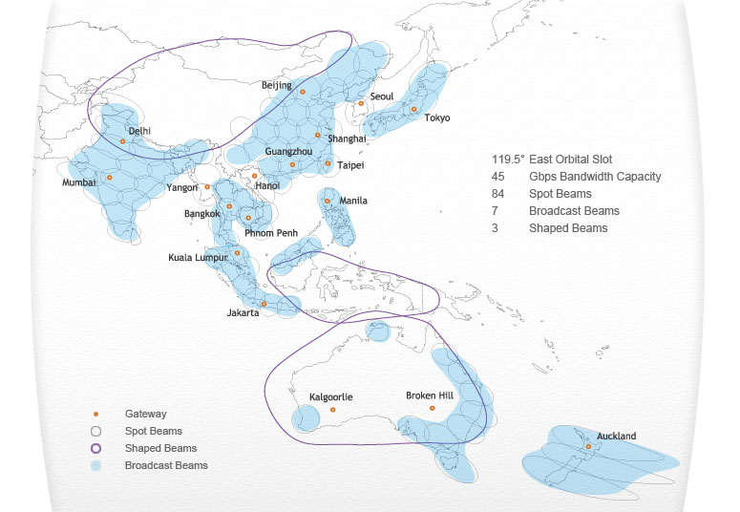

3. ViaSat Inc. (www.viasat.com)
ViaSat was principally a satellite terminal manufacturer but it has over the years expanded its activities. ViaSat now owns WildBlue, the successful US Ka-band satellite broadband service provider. WildBlue’s growth was stunted shortly after launch due to a lack of in-orbit capacity covering high-demand areas in the United States. To address this shortfall in capacity ViaSat embarked on the ViaSat-1 project.
3.1 Anik F2 and WildBlue Satellites
WildBlue’s current service uses the U.S. Ka-band beams on Canada-based Telesat’s Anik F2 satellite as well as the WildBlue-1 satellite. WildBlue provides service to about 450,000 customers in North America. In general, beams directed to high-population areas in the U. S. are full while the beams pointed at U.S. rural areas can accommodate more customers. It has been estimated that a fully flexible WildBlue-1 satellite that could direct capacity where needed could accommodate about 650,000 customers. The beams of ViaSat-1 are of different sizes as determined by demand based on the experience of WildBlue-1. (See spot beam diagram of ViaSat-1 in Section 3.2 below.)
Spot beams of Anik F2 and WildBlue (WB-1)
ViaSat-1 Ka-band spot beams

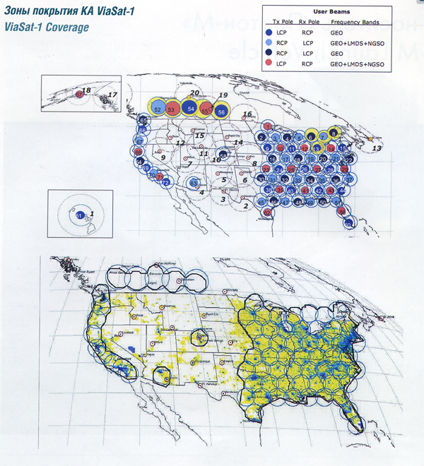

4. HUGHES (www.hughes.com)
Hughes Network Systems, LLC (HUGHES) provides broadband satellite networks globally to large enterprises, governments, small businesses, and consumers. Hughes has manufactured and shipped more than 2.5 million terminals to customers in over 100 countries.
4.1 Spaceway 3 Satellite (http://www.spaceway.com)
The Spaceway 3 satellite was launched in August, 2007. It is used by HughesNetTM to form the basis for its next generation service. The Spaceway 3 satellite employs Ka-band, onboard digital processing, packet switching and spot-beam technology for direct site-to-site connectivity at rates from 512 Kbps up to 16 Mbps. The maximum throughput of the satellite is 10 Gbps.
Spaceway 3 spot beam coverage of North America

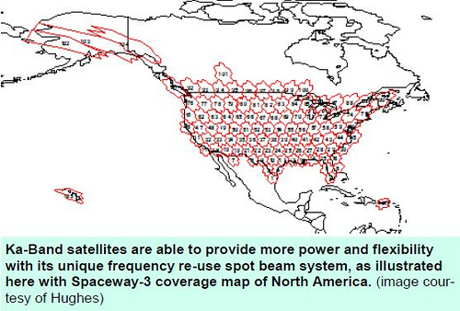

4.2 Jupiter 1 Satellite (also known as Echostar 17)
Hughes Network Systems, LLC (HUGHES) announced in June 2009 that it will launch a next-generation, high throughput satellite called Jupiter 1 in the first half 2012 to expand its HughesNetTM broadband Internet service across North America. Designed to deliver over 100 Gbps throughput, the new Hughes satellite will utilize an enhanced version of the IPoS standard.
The satellite will employ multi-spot beams (about 80), bent pipe Ka-band architecture and will provide additional capacity for HughesNetTM service in North America. Its capabilities will augment the Spaceway 3 satellite system which Hughes put into commercial service in April, 2008. Space Systems/Loral will manufacture Jupiter 1 which will be based on its SSL-1300 platform. The satellite will be designed for a service life of 15 years or more

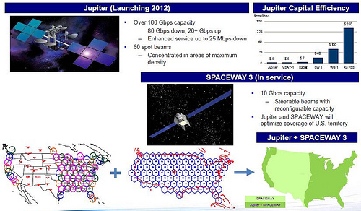

5. Eutelsat (www.eutelsat.com)
Eutelsat is a European satellite operator and one of the three top operators in the world for the supply of fixed satellite services. (The two others are SES and Intelsat.) Eutelsat operates a fleet of 29 satellites with satellites in 20 positions on the geostationary satellite orbit providing service to Europe, the Middle East, Africa and a large part of Asia and the Americas. The Group is based in Paris and employs a workforce of 660 people.
5.1 Eutelsat KA-SAT
The Eutelsat KA-SAT was launched on December 26, 2010 and following IOTs was moved into 9°E. The KA-SAT is the first High Throughput Satellite (HTS) in Europe and was built by EADS Astrium. Its payload produces 82 narrow spotbeams covering Europe, parts of North Africa and parts of the Middle East. The network employs ten ground stations to connect to the Internet backbone. The narrow spot beams enable frequency re-use of up to 20 times and the total throughput is over 70 Gbps. The KA-SAT satellite provides additional capacity for the Eutelsat Tooway™ consumer broadband service targeted at users located beyond range of ADSL networks.
KA-SAT is intended to help Eutelsat offer triple-play services by combining broadband services in the Ka-band with the reception of TV channels in the Ku-band. The KA-SAT was originally planned for launch into 13ºE. However, the satellite was finally placed at 9°E possibly to facilitate the design of dual-feed antennas transmitting and receiving broadband services in the Ka-band from 9°E, and receiving television in the Ku-band from Eutelsat’s HOT BIRD™ neighbourhood at 13°E.
Launch date: 26 December, 2010
Launch details: Proton Breeze M
Satellite construction: EADS Astrium
Frequencies:
27.5 – 30.0 GHz (uplink)
17.7 – 20.2 GHz (downlink)
The ground network uses ViaSat’s SurfBeam® technology. (See Section 13 below.) KA-SAT also opens opportunities for cost effective satellite newsgathering using lightweight transportable uplink antennas. Broadcasters and video service providers can also take advantage of the Ka-band spotbeam coverage of KA-SAT to deliver content in a single beam for regional and local television and corporate TV networks.

The KA-SAT coverage area shown below can be obtained from the Eutelsat web site at:
http://www.eutelsat.com/satellites/9e_ka-sat_popd.html
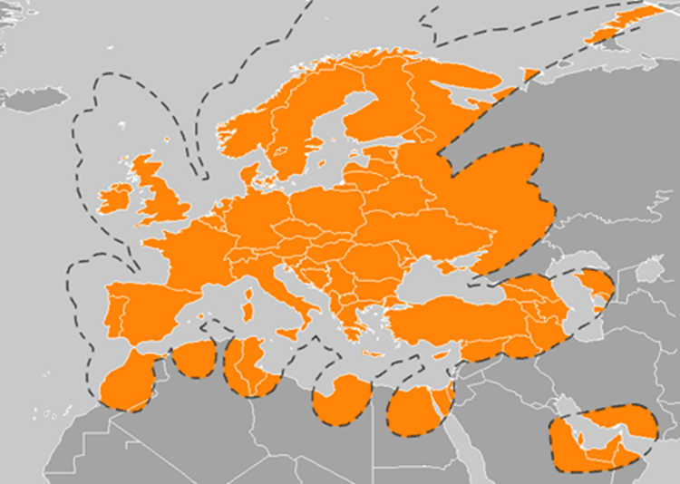

From Wikipedia:


KA-SAT coverage over Europe and the Mediterranean Basin
(different colors show frequency reuse)

6. Al Yah Satellite Communications Company (Yahsat) (www.yahsat.ae)
Yahsat is a United Arab Emirates-based satellite communications company. It is a wholly owned subsidiary of the Abu Dhabi government’s strategic investment and development vehicle Mubadala Development Company. In August 2007, Yahsat awarded a contract to a joint Astrium–Thales Alenia Space team to provide a dual (military and commercial) satellite communications system. The total value of the contract is US$1.7 billion. The Yahsat system consists of two large satellites, Yahsat 1A and Yahsat 1B delivered on orbit and the associated ground infrastructure.
Astrium and Thales Alenia Space are jointly responsible for the overall system. Astrium, the leading partner, is the prime contractor for the ground segment, in charge of the overall system and network management, and will supply the spacecraft platforms and integrate the satellites. Thales Alenia Space is the prime contractor for the space segment. The ground antennas will be provided by Astrium and Thales.
6.1 Yahsat 1A and 1B Satellites
Yahsat 1A was launched on 22 April, 2011 into 52.5º E.
Yahsat 1B is scheduled to be launched in April, 2012 into 50.5º E.
Satellite Characteristics:
Launch mass (kg): 6000
Manufacturer: EADS Astrium
Model (bus): Eurostar-3000
Expected lifetime: 15 yrs.
Yahsat 1A
C-band: 8 x 36 MHz + 6 x 54 MHz transponders.
Ku-band BSS: 25 x 33 MHz transponders.
Ka-band: 21 x 54 MHz government/military transponders
Yahsat 1B (total throughput 15 Gbps)
Ka-band: 25 x 110 MHz commercial transponders
Ka-band: 21 x 54 MHz government/military transponders

For coverage of both satellites see: www.yahsat.ae/coverage.htm.

7. Inmarsat Global Xpress (www.inmarsat.com)
In August 2010 Inmarsat awarded Boeing a contract to build a constellation of three Inmarsat-5 satellites. These satellites are part of a US$1.2 billion global satellite broadband network called Inmarsat Global Xpress™ with planned service starting in 2014. The service includes high-speed inflight broadband to airliners. The Ka band service will be supported by the integration of an L-band Fleet Broad Band (FBB) backup service. In this way reliability will not be compromised in case of heavy rain fades at the Ka-band. The intent is that Global Xpress™ will to a large extent replace C- and Ku-band VSAT services across the globe – maritime, land, aviation and government.
The payload of the Global Xpress™ satellites can be toggled back and forth between a commercial and military Ka-band payload (different frequencies). Each satellite will also carry multiple steerable beams to direct capacity in real time to the exact location where it is needed. This capability has been incorporated with the military in mind for use that includes unmanned aerial vehicles (UAV). Inmarsat hopes the sell services to the military including the Pentagon.
7.1 Inmarsat Satellites
The Inmarsat-5 satellites are being built by Boeing and are based on its 702HP spacecraft platform. The Inmarsat-5 F1 is scheduled for completion and launch in 2013 with full global coverage by the end of 2014. The satellites will be launched by ILS from Kazakhstan. The satellites will operate at the Ka-band. Each Inmarsat-5 satellite antenna will provide 89 smaller Ka-band beams covering the portion of the Earth visible from its orbital location.
World coverage of three Inmarsat-5 satellites

