|  |  |  |
| --- | --- | --- |
| **3rd African Group Preparatory Meeting for WRC-12  Geneva, 9 November 2011** | |  |
|  |  | |
|  |  | |
|  | **Document WRC12ATU11/INFO/1-E** | |
| **13 Octobre 2011** | |
| **English** | |

|  |
| --- |
| INFORMATION FOR PARTICIPANTS |

Page

1 General 2

2 Place of the meetings 2

3 Registration 2

4 Identification badges 2

5 Documentation 2

6 Working hours 2

7 Meeting rooms 2

8 Accessing ITU’s wireless facilities 2

9 Publications 2

10 Other services 2

11 Travel agency 2

12 Parking 2

13 Duty Free Shop 2

14 Public transport 2

15 Social and medical services 2

Annex 1 – Accessing ITU’s wireless facilities 6

1 General 2

2 Steps to connect to the Wireless Network in ITU: (SSID: ITUwifi) 2

3 Best practices for making the most efficient use of network resources 2

4 Buying external wireless cards 2

Page

5 Printers 2

6 Miscellaneous 2

Annex 2 – ITU Circulation Plan 9

Annex 3 – CICG Circulation Plan 10

# 1 General

The meetings will take place on 9 November 2011.

# 2 Place of the meetings

The meeting will be held in room 1 of the “Centre International des Conférences de Genève” (CICG) building (see Annex 3 to this document).

# 3 Registration

The ITU-R Delegate Registration Desk is located in the entrance of the ITU Montbrillant Building (see Annex 2 to this document). Delegate/participants may register from 8:00 hours from 7 to 9 November 2011. Please note that the confirmation of registration sent to each delegate/participant by e-mail must be presented, together with photo identification, in order to receive a badge.

# 4 Identification badges

At the time of registration, delegates/participants will receive a photo identification badge, which must be worn at all times when on the ITU and CICG premises. Please note that unannounced delegates/participants will receive a temporary badge at the time of registration. Official badges will be delivered to delegate pigeonholes (ITU Montbrillant building) during the afternoon.

# 5 Documentation

The 3rd African Group Preparatory Meeting for WRC-12will be conducted in “paperless” environment, i.e. meeting documents will be available on the website (<http://www.itu.int/ITU-R/go/wrc-12-atu-11>).

# 6 Working hours

Subject to the agreement of the meeting, it is proposed that the working hours be the following:

**09:30 - 12:30 hours and 14:00 - 17:00 hours**

It is also suggested that a break of 15 to 20 minutes be taken at a suitable moment, ideally at 10:50 hours in the morning and at 15:20 hours in the afternoon.

# 7 Meeting rooms

The meeting will be held in Room 1 of the CICG building.

If necessary, meeting rooms could be reserved through the appropriate service (Office V.247 (ITU Varembé building), telephone 5746), which will post notice of meetings on the electronic display.

**Participants are urged to keep themselves regularly informed of the dates and place of meetings by consulting these screens and the ITU-R Meeting Session web page at:** [**http://www.itu.int/events/ExtWebDailyagenda.asp?sector=ITU-R**](http://www.itu.int/events/ExtWebDailyagenda.asp?sector=ITU-R)**.**

It has been observed that small groups in particular, frequently require only half a morning or half an afternoon to transact their business and it is therefore suggested that, when possible, meeting rooms be booked accordingly. Complete mornings or afternoons can be reserved when required.

# 8 Accessing ITU’s wireless facilities

See Annex 1 for information on connecting to the ITU’s wireless facilities.

# 9 Publications

ITU publications may be obtained at the ITU Bookshop located in the entrance hall of the ITU Tower (see Annex 2 to this document).

# 10 Other services

a) The Telecommunication Centre is located in the second basement of the ITU Tower and will be open Monday to Friday from 08:30 to 12:30 and 13:30 to 17:30 hours. Participants will be able to make charged telephone calls and send charged fax messages.

Participants can receive calls or messages directly at the ITU on the following numbers:

National telephone: (022) 730 51 25 (ITU Montbrillant or second basement Tower)

International telephone: +41 22 730 51 25

Facsimile: (ITU) +41 22 733 72 56

b) A post office is situated to the left of the CICG entrance, 15 rue de Varembé.

c) A bank, where currency can be exchanged, is situated close to the entrance of the ITU Tower, at 17 Chemin Louis-Dunant.

d) The ITU cafeterias, situated on the ground floor between the Varembé and Montbrillant buildings and on the 15th floor of the Tower serve meals, light snacks and refreshments.  
The Bar/Café on Level 0 and Cafeteria on Level 1 of the CICG building will be open during the Meeting.

e) PCs are available in thesecondbasement of the ITU Tower and on the second floor of the Montbrillant building.

# 11 Travel agency

**American Express**, travel agency (**ground floor of the ITU Tower**, extensions 5168 / 5170) is at the disposal of participants as regards any request for excursions, hotel reservations, confirmation of tickets, etc.

# 12 Parking

Parking restrictions are in force in the streets adjacent to the ITU and the CICG. To avoid fines, participants are advised to respect these restrictions, particularly in the area adjacent to the CICG main entrance.

# 13 Duty Free Shop

Participants can obtain a duty free shopping card by completing the appropriate form (available at the BR participant registration desk) and returning it to the desk. Tax free cards are issued within 24 hours. Notification of receipt of the card will be conveyed to the participant in his/her pigeonhole at which time the card may be collected.

# 14 Public transport

Several bus and tram lines, with stops in the vicinity of the ITU (Place des Nations or Rue de Vermont), provide transport to various parts of Geneva. Most hotels provide free bus/tram tickets.

# 15 Social and medical services

The ITU has a service which may be used by participants needing to contact their family or a repatriation service as a matter of urgency. It operates from Office T.062 of the Tower building, extension 5380.

The services of a nurse are available to participants between 08:30 and 12:30 hours and 14:00 and 17:30 hours. The medical service is on ground floor of the Varembé building (V.16). In case of emergency, call 5397/5399 or BIP 6060.

The following medical services in Geneva are open 24 hours a day:

Hôpital de la Tour Tels.: 022 719 6000 / 719 6111

Avenue Jean-Daniel Maillard

Meyrin

Emergency Service Tel.: 022 372 33 11

Hôpital Cantonal

24, rue Micheli-du-Crest

Annex 1

Accessing ITU’s wireless facilities

# 1 General

New wireless antennas have been installed making wireless coverage available for all Conference Rooms, Meeting Rooms, Staff Areas and Public Areas on ITU campus.

The new wireless SSID "**ITUwifi**" is available everywhere enabling the ITU participants to use the benefits of the Internet connection anywhere on the ITU premises (e.g. to work and to hold small meetings/forums in any staff room, lobbies, cafeteria etc…).

After connecting to the "ITUwifi" SSID, please open your web browser to log in to the network. The user credentials to log in are as follows:

– TIES Users: Use TIES username (e.g. janedoe) and password or the username and password printed on the identification badge as shown below



passworder ID

username

– Participants who do not have TIES account: Use the username and password printed on the identification badge;

– ITU Visitors: Use "Visitor account", which could be provided by the ITU event coordinator or any ITU staff from the NGS system at <https://ngs.itu.int>.

**NOTE – Re-authentication for subsequent Log Ins will only be necessary if your device has been disconnected from ITUwifi for more than 24 hours.**

The new wireless system supports only devices based on IEEE 802.11a/g/n protocols. The older 802.11b-only devices are no longer supported.

# 2 Steps to connect to the Wireless Network in ITU: (SSID: ITUwifi)

**Step 1: Connect**

– In Windows 7, click on the WiFi icon in your tray to see a list of the available WiFi networks.

– In Windows XP, click on your wireless network card icon and choose **View Wireless Networks** for a similar list.

– Choose the "**ITUwifi**" SSID from the list, then click on the **Connect** button.

– Upon receiving a valid IP address you would be prompted to authenticate.

– Right-click on the "**ITUwifi**" profile and select Properties, on Connection tab, you can select "Connect automatically when this network is in range" item. This will auto-connect you to "**ITUwifi**" SSID.

S**tep 2: Log In**

Open a web browser (such as Internet Explorer or Firefox or Opera) and try to browse to an external site (a page you have not used recently in your cache). You will see a web authentication page. Here you have to log in using your credentials as indicated in Section 1 above.

# 3 Best practices for making the most efficient use of network resources

1) Check to see if your laptop has 802.11a/g/n capability. If it does not, purchase an 802.11a/g/n card and have it configured before you arrive. We encourage you to use 5 GHz band of 802.11a/n in large meetings as it has more channel capacity.

2) Ensure that your user account has administrative privileges. Should you require help onsite, the ITU Service Desk staff will only be able to help you if you have administrative rights on your laptop.

3) You are kindly requested to test your wireless connection well before the opening session.

4) If a wired connection is available to you in the meeting room, please use it. Remember to turn off your wireless radio. By doing so, you free up capacity for other participants.

5) Download the meeting documents before entering the meeting room.

6) By default the wireless radio is always on, even when you are not surfing the Internet. Turn it off to free up capacity and reduce interference to others.

7) Refrain from using peer-to-peer connections.

8) Enable DHCP so that your laptop will obtain the IP address and other network parameters automatically.

9) Users are responsible for protecting their data, identity and activities. To be more secure, please use end-to-end encryption such as VPN, HTTPS. Use firewall software and updated virus and malware scanners.

10) Set up smtp.itu.int as your outgoing (SMTP) server.

11) Ensure that your Internet browser’s proxy setting is either removed or set to ”automatically detect settings”.

12) Disable any SOCKS configurations.

# 4 Buying external wireless cards

Most laptops come with 802.11a/g/n built-in cards nowadays. However if you have an older machine that needs an external card, we recommend “**Wi-Fi Alliance compatible 802.11a/g/n” wireless cards.**

Look for the card with one of the following logo:



Please check that your card’s model number is mentioned at <http://www.wi-fi.com> before you buy the card.

Please note that all IEEE 802.11a or 802.11g standard compliant cards are not necessarily Wi-Fi compliant, whereas Wi-Fi compliant cards are IEEE 802.11a or 802.11g or 802.11n or both compliant.

# 5 Printers

Participant printers are labelled with print queue name, server name and IP address. They are shown in the table below.

|  |  |
| --- | --- |
| Printer name | Location |
| \\delprint\hpdelg1 | Varembé building rooms G1/G2 (3rd floor) |
| \\delprint\hpdelg3 | Varembé building room G3 (3rd floor) |
| \\delprint\hpdel2ss | CyberCafé in 2nd basement of the Tower building (Note: two printers on same queue) |
| \\delprint\hpdelm2_ps | CyberCafé in 2nd floor of the Montbrillant building |
| \\delprint\hpdelm1 | Montbrillant building near meeting rooms (1st floor) |
| \\delprint\hpdelt1 | Tower building near rooms T.101 and T.103 (1st floor) |
| \\delprint\HProomE | Varembé building room E (1st floor ) |

The following options can be used to connect to participant printers:

1) Do start > Run and enter \\delprint. A list of available printers are displayed, select as required. If you are prompted for authentication, use the same as for ITU WiFi.

2) Install a local printer using the IP address.

# 6 Miscellaneous

The ITU TIES Internet Services is a service of the ITU Information Services Department.

If you have any questions or problems, please contact the ITU IS Service Desk:

Room: V 29 (Varembé building)

Phone: +41 22 730 6666

Fax: +41 22 730 5337

Internet e-mail: [servicedesk@itu.int](mailto:servicedesk@itu.int)

Postal mail: International Telecommunication Union

###### Information Services Department Place des Nations CH-1211 Geneva 20 Switzerland

Annex 2

Please find attached a plan of the ITU buildings. This plan can also be found electronically on: <http://www.itu.int/aboutitu/itu-plan.pdf>

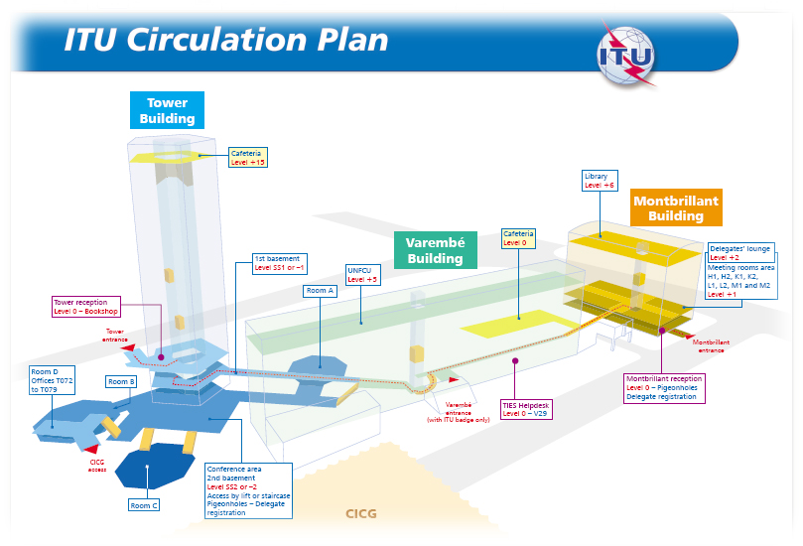

Annex 3

Please find attached a plan to access Room 1 at level 1 of the CICG building.  
Plans of other CICG levels can also be found electronically on: <http://www.cicg.ch/en/level-0/>



