|  |  |
| --- | --- |
| **Radiocommunication Study Groups** |  |
|  |  |
|  |  |
| Source: Document 4A/TEMP/174  Reference: Documents 4A/65, 123, 197 (Annex 11), 202, 250, 278 (Annex 9), 327 and 5C/193 | **Annex 8 to Document 4A/368-E** |
| **28 April 2010** |
| **English only** |
| Annex 8 to Working Party 4A Chairman’s Report | |
| WORKING DOCUMENT TOWARDs A PRELIMINARY DRAFT NEW RECOMMENDATION ITU‑R [SF].[StatMeth] | |
| Methodology for calculating the interference received by the fixed service from space-to-Earth emissions for frequency bands above about 17 GHz | |

Summary

This preliminary draft new Recommendation provides a methodology to calculate the statistics of interference received by the fixed service from space-to-Earth emissions for frequency bands above about 17 GHz. The results are obtained by using the appropriate atmospheric data, the deployment characteristics of a fixed service system in a given area, and the characteristics of space-based satellite network. This methodology can be used for sharing studies and interference assessment between the fixed‑satellite or broadcasting-satellite service and the fixed service sharing the same frequency band above about 17 GHz.

At the March/April 2010 meeting of Working Party 4A, the working document towards a preliminary draft new Recommendation (Annex 9 to Document 4A/278) was updated (see the Attachment to this document) and it was decided to liaise this document to Working Party 5C to seek its views, as it had achieved a sufficient level of maturity.

It is planned that future revisions of this methodology will include the use of integrated water vapour content (IWVC) once the more detailed data is made available on the SG 3 bank.

Administrations are invited to review the working document in the Attachment and provide comments at the July 2010 meeting of WP 4A.

**Attachment:** 1

Attachment

WORKING DOCUMENT TOWARDS A PRELIMINARY DRAFT NEW RECOMMENDATION ITU‑R [SF].[StatMeth]

Methodology for calculating the interference received by the fixed service  
from space-to-Earth emissions for frequency bands above about 17 GHz

Scope

This Recommendation provides a methodology to calculate the statistics of interference received by the fixed service from space-to-Earth emissions using appropriate atmospheric data, the deployment characteristics of a fixed service system in a given area, and the characteristics of space-based satellite network. This methodology can be used for sharing studies and interference assessment between the fixed‑satellite/broadcasting satellite services and the fixed service sharing the same frequency band above about 17 GHz.

The ITU Radiocommunication Assembly,

considering

a) that emissions from space stations in the fixed-satellite service (FSS) or broadcasting‑satellite service (BSS) sharing the same spectrum as the fixed service (FS) may produce interference in receiving FS stations;

b) that levels of interference calculated using a statistical approach may lead to a more efficient use of the spectrum compared to a worst-case analysis;

c) that interference assessment depends not only on the characteristics of FS systems and the characteristics of FSS and BSS systems, but also on the characteristics of interference and those of the interference paths;

d) that existing minimum path attenuation calculation methods do not allow for different levels of interference to be calculated for different locations even though local parameters influence the path attenuation;

e) that path attenuation due to atmospheric gases at low angles of arrival (particularly below 5°) can exhibit variation over time and from location to location at frequencies above about 17 GHz;

f) that sharing methodologies should take into consideration the operational requirements and characteristics of systems being used and planned for use in these frequency bands;

g) that such an interference evaluation methodology may have application in bands above about 17 GHz to assist administrations in performing sharing studies,

noting

a) that Recommendation ITU‑R P.835-4 uses local surface water vapour density, terrain elevation and temperature databases to develop atmospheric profiles, which are needed when implementing the path attenuation due to atmospheric gases using Recommendation ITU‑R P.676‑8;

b) that comparative evaluation of the impact of interference into networks having the same characteristics at different locations can be made using the driest month value of the surface water vapour density, or the 80th percentile surface water vapour density, or the cumulative distributions of annual interference and requires the use of local climatic information and detailed fixed service deployment characteristics;

c) that comparative evaluation of the impact of interference into networks having different characteristics at the same location can be made using the driest month value of the surface water vapour density, or the 80th percentile surface water vapour density, or the cumulative distributions of annual interference and requires the use of local climatic information and detailed fixed service deployment characteristics,

recommends

**1** that the methodology described in Annex 1 should be used to evaluate the impact of interference from fixed-satellite service or broadcasting satellite service systems to digital systems in the fixed service operating in frequency bands above about 17 GHz, also taking into account the annual variation of surface water vapour density using local data;

**2** that method a) in Annex 1 should be used for calculating the minimum attenuation on the interference path for arriving at the maximum expected levels of interference to the fixed service;

**3** that method b) in Annex 1 should be used for calculating the potential of interference to fixed service receivers using the 80th percentile of surface water vapour density to determine the path attenuation on the interference path when calculating interference statistics, the results of which can be compared against interference criteria when used in the context of determining whether sufficient protection of the fixed service is achieved;

**4** that method c) in Annex 1 should be used for characterizing the annual variation of path attenuation on the interference path for calculating the levels of interference to the fixed service, in accordance with the comparative evaluations described in *notings* b) or c).

Annex 1  
  
Description of statistical *I*/*N* calculation methodology

# 1 Introduction

The “statistical methodology” described below provides an estimate of the potential interference received by the fixed service from space-to-Earth emission from BSS and FSS satellites operating in frequency bands above about 17 GHz bands. The step-by-step procedure is described in § 5[1].

The implementation of this methodology requires a series of inputs specifying the parameters of the interfering satellite systems, the parameters of fixed service and the local geoclimatic parameters at the location where the interference may be received. These parameters are further elaborated on in § 2.

# 2 Required input parameters

## 2.1 Frequency (GHz)

The frequency in GHz is required. The value should be greater than 17 GHz as there is little annual variation in attenuation due to atmospheric gases below 17 GHz.

## 2.2 FS deployment area

The methodology requires locations (“test points”) distributed uniformly throughout a geographic area where the FS terminals are or may be deployed. For each test point, the following is required:

• Latitude (+N/-S°);

• Longitude (+E/-W°);

• Ground elevation above mean sea level.

## 2.3 Topographical database

A topological database of the FS area being studied is used to determine the values of local climatic parameters and the ground elevation at each of the test points. In the absence of an appropriate topographical data base, the topographical information contained in Recommendation ITU-R P.1511 may be used.

## 2.4 FS system parameters

– FS receiver feeder system loss.

– FS receiver antenna gain.

– FS receiver elevation angle.

– FS orbital avoidance angle in degrees (for GSO interference) if applicable[2].

– FS deployment statistics: The probability distribution of certain combinations of FS receiver elevation ranges with the accompanying antenna gain ranges in that network.  
(The sum of the probabilities associated with each elevation angle and antenna gain combinations must add up to 1.)

– FS antenna polarization.

## 2.5 BSS/FSS system parameters

– For GSO, the orbital location(s) on the GSO arc. For the non‑GSO, provide the orbital and operational characteristics.

– The satellite power flux density over the FS area being considered. This could be either a single value, a function based on elevation angle or a GIMS plot over the FS deployment area.

– The polarization of transmitting space stations.

## 2.6 Simulation parameters (for use in computer simulations)

– The range of *I/N* values to be considered.

– The resolution of *I/N* results calculation. The resolution or step size of the *I/N* should be equivalent to the desired accuracy (which is derived from the FS antenna beamwidth) for the results to be most meaningful. The minimum and maximum *I/N* values and the measurement resolution allow the determination of the number of *I/N* bins[3].

– For the non-GSO scenario (including HEO), the range and step-size of the time period considered.

# 3 Output

The output of the methodology is the number of occurrences of calculated interference within the range of each *I/N* bin.

# 4 *I/N* Calculation

The *I*/*N* level at the input of an FS receiver is given by:



where:

*pfd* = power flux-density of the interference in the direction of its source (dBW/m²/MHz) at the Earth’s surface;

*GRx FS* (φ) = relative gain of receiving FS antenna in the direction of interference φ degrees off its bore-sight axis (dBi) in accordance with Recommendation ITU‑R F.1245-1 or other applicable ITU-R Recommendations;

*G1m²* = gain of a 1 m² antenna at the frequency of interest (dBi);

*Nth* = receiver thermal noise (dBW/MHz);

*Lf* = receiver feeder system loss (dB);

*Lbs* = beam spreading loss on the interference signal in accordance with § 2.3.2 of Annex 1 to Recommendation ITU‑R P.618-10;

*Latm* (ρ) = attenuation due to atmospheric gases in accordance with Recommendation ITU‑R P.676‑8 and other ITU-R Recommendations;

*Lp* = polarization advantage (dB).

*Editor’s Note: The impact of the scintillation and multi-path path mechanisms which may impact the calculation of attenuation on the interference path may need to be taken into account in the calculation of interference into the fixed service. It should be noted that in each of the four Appendices contained in the working document toward the PDN Report, none of the illustrative examples of the results of studies took any of these other propagation effects into account. One study (Document* [*4A/328*](http://www.itu.int/md/R07-WP4A-C-0328/en)*) attempted to combine the propagation mechanism of atmospheric absorption together with the propagation mechanisms of scintillation and multipath fading. The advice of Working Parties 3J and 3M has been sought (see* [*Document 3J/106*](http://www.itu.int/md/R07-WP3J-C-0106/en)*) on the approach used in that study for combining these propagation mechanisms. The inclusion or not of any of these propagation effects in the interference calculation may need to be revisited once the reply has been received.*

# 5 Steps in the methodology

1) Select method to characterize slant path attenuation

*Editor’s Note: The method for the determination of attenuation due to atmospheric gases is specific to the estimation of slant path attenuation using Annex 1 of Recommendation ITU‑R P.676-8 in combination with the surface water vapour density as specified in Annex 1 of Recommendation ITU-R P.836-4 assuming the standard atmospheric profiles in Recommendation ITU-R P.835-4. Working Party 3J is in the process of making available more detailed data files for columnar water vapour content in the Study Group 3 data bank. It is intended to replace the method for estimating the interference path attenuation (due to atmospheric gases) statistics with Annex 1 of Recommendation ITU-R P.676-8 in combination with the columnar water vapour density as specified in Annex 2 of Recommendation ITU-R P.836-4. For further information on this method, please consult Appendix 1 to Annex 1 of the working document towards a preliminary draft new Report ITU-R [SF].[STATMETH]. Using this method, the use of standard atmospheric profiles in Recommendation ITU-R P.835-4 to calculate slant path attenuation will not be necessary.*

For each location calculate the atmospheric loss on the interference path. This can be done using one of three options (methods a, b or c) listed below:

method a) Characterize path in accordance with minimum attenuation (worst case, highest interference calculation) (*recommends 2*)

For each test point, determine the value of the surface water vapour density that corresponds to the driest month.

method b) Use 80th percentile surface water vapour density to calculate path attenuation associated with “long-term” interference calculation (*recommends 3*)

For each test point, determine the value of the surface water vapour density that is exceeded for 80% of the time at that location.

method c) Characterize path in accordance with annual variation of path attenuation (*recommends 4*)

For each test point4, determine the probability distribution function of the surface water vapour density by dividing the range of possible values of SWVD into *N* equal increments and determining the weighting of each of the *N* values. The calculation steps   
(2 to 4) following are repeated for each of the possible SWVD values.

2) Account for the direction(s) of interference source(s)

For each test point, select *M* equally separated azimuths around the site. The value of *M* should be larger for FS stations having highly directional antennas. In cases where orbital avoidance is practiced, an azimuth direction may be excluded by the methodology if the FS beam intersects a pre-defined avoidance arc from the GSO.

3) Account for the orientation of FS receivers

At each possible orientation of the FS receiver, calculate the *I/N*:

a) For the non-GSO scenario (including HEO), the I/N is calculated at individual time steps. For each time step, the aggregate interference is calculated from all visible non‑GSO satellites. The I/N for each time step is then equally weighted with the *I/N* calculated at all other time steps over the simulation period.

b) For the GSO case, the aggregate interference from all visible GSO satellites is calculated.

4) Account for the distribution of FS receivers over a larger area

For each test point representing an “incremental area” within a larger evaluation region, calculate the relative proportion that the area represents and apply the weighting factors derived to the results obtained for each of the test points. Note, in the case of calculation option 1b), extensive simulation has shown for a 25,000 km² evaluation region, that a weighted average value of 80th percentile surface water vapour density and ground height (amsl) (for the entire region) may optionally be used to obtain a very similar result.

5) Weight interference statistics in accordance with FS deployment statistics

Repeat steps 1 to 4 for all possible combinations of FS antenna gain/elevation angle in the deployment scenario. Weight the results obtained in accordance with the selected deployment scenario.

6) Compile I/N statistics

Generate cumulative distribution function (CDF) for I/N taking into account:

1) Characteristics of the interference path,

2) Direction(s) of interference source(s),

3) Orientation of FS receivers,

4) Distribution of FS receivers over a larger area, and

5) FS deployment statistics.

FIGURE 1

Top level flowchart of the statistical methodology process

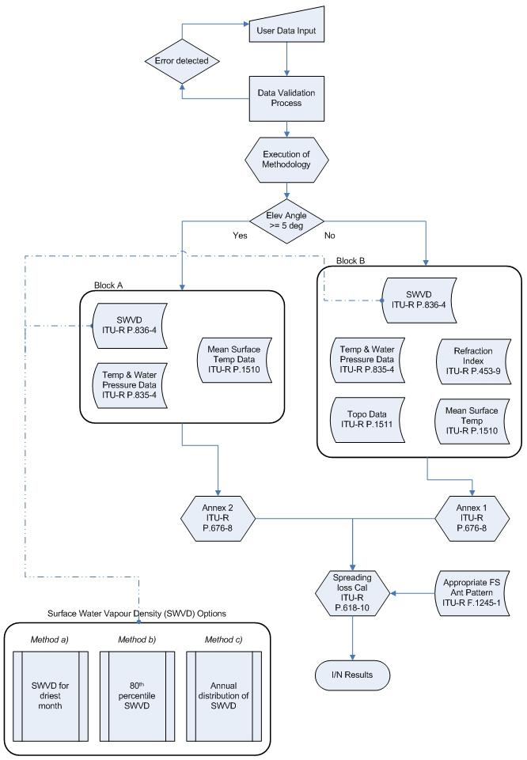

*Editor’s Note: The current implementation of the path attenuation losses using Rec. ITU-R P.836-4 in Block A will be modified once the methodology is modified to use the more detailed integrated water vapour content (IWVC) data (to be made available in the SG 3 bank in the near future).*

1. Top level overview of the statistical methodology is provided in Figure 1.
2. See, for example, Table21-1 of the *Radio Regulations*.
3. “Bins” referred to in § 2.6 are a convenient method for storing the results of interference simulations. An occurrence of interference within a “bin” is recorded when the calculated level of interference falls within the range of the *I*/*N* bin. This quantization of interference levels permits digitization of interference and simplifies the collection of interference statistics.