Radiocommunication Study Groups | 
Source: Document 4A/TEMP/173  Reference: Documents 4A/278 (Annex 5), 294, 319, 321 and 5A/419 | Annex 5 to  Document 4A/368-E
 | 28 April 2010
 | English only
Annex 5 to Working Party 4A Chairman’s Report
Preliminary draft new report ITU-R S.[BWA-FSS]
Studies on compatibility of broadband wireless access (BWA) systems and
fixed-satellite service (FSS) networks in the 3 400-4 200 MHz band
Working Party 4A (WP 4A) received at its March/April 2010 meeting a liaison statement (Document 4A/294) from Working Party 5A (WP 5A) containing, amongst others, information on antenna patterns to be used for BWA base stations and parameters to be used in the propagation model that is based on Recommendation ITU-R P.452-13. Further, reference was made to a study performed by the WiMAX Forum (Document 5A/419).
A further contribution was received from SES WORLD SKIES (Document 4A/319) containing two studies based on the proposed parameters by WP 5A, and elements for a reply to the liaison statement from WP 5A. WP 4A also received a contribution from USA (Document 4A/321) with elements for a reply to the liaison statement from WP 5A, and a proposed update of the preliminary draft new Report ITU-R S.[BWA-FSS].
Based on the above elements, and discussions during the March/April 2010 WP 4A meeting, the PDN Report ITU-R S.[BWA-FSS] has been updated as follows:
- Annex A has been updated with the newly provided BWA base station antenna pattern parameters and propagation model parameters.
- Annex B has been updated with the newly provided studies that are based on the agreed parameters in Annex A. At this stage the studies have been incorporated almost entirely, and there might be room for further optimization of the summaries. Further, the studies previously contained in this Annex have been removed as they are now superseded by the new studies based on the agreed parameters.
- The body of the Report has been updated to take account of the above changes. Note that the main conclusions of this Report have not changed.
The Attachment to this document contains the revised preliminary draft new Report.
WP 4A encourages contributions to further advance this work with a view to upgrading this Report to a Draft New Report at its next meeting.

Attachment: 1
Attachment
PRELIMINARY DRAFT NEW REPORT ITU-R S.[BWA-FSS]
Studies on compatibility of broadband wireless access (BWA) systems and
fixed-satellite service (FSS) networks in the 3 400-4 200 MHz band

Executive summary
The 3 400-4 200 MHz band is heavily used by the fixed-satellite service (FSS) for space-to-Earth transmissions. Some administrations are introducing broadband wireless access (BWA) systems in all or portions of this frequency band. As BWA is being introduced, harmful interference and loss of service for FSS receivers has been reported. This Report primarily examines the possibility of compatibility between BWA and FSS networks in the range 3 400-4 200 MHz. In addition, in the studies carried out, there are reported cases covering interference not just for BWA in overlapping frequency bands (in-band) but in non-overlapping bands (out-of-band) as well.
Appendix 7 of the Radio Regulations defines the methodology for calculating coordination contours around FSS receiving earth stations inside which coordination is required for terrestrial services. Such contours typically extend 400-1 000 km from the earth station. Implementation of BWA networks in a country will require international coordination with any country that has filed FSS earth stations whose coordination contour overlaps the service area of the BWA network.
Different types of FSS receive earth stations need to be considered in the compatibility studies. This includes earth stations deployed ubiquitously, earth stations without individual licensing or registration, individually-licensed earth stations, telemetry earth stations, and feeder link earth stations for mobile-satellite systems.
Three possible types of interference have been identified and considered in this report, namely: 1) co-frequency emissions from BWA causing in-band interference to FSS systems, 2) unwanted (out-of-band) emissions from the BWA transmitters, and 3) signals from nearby BWA transmitters causing overload to FSS earth station receivers operating in adjacent bands.
A set of parameters have been established that served as the basis for the compatibility studies. These are parameters concerning BWA base station and terminal station parameters, BWA and FSS antenna patterns, and FSS Earth Station parameters. Further a common set of propagation parameters to be used in the propagation model of Recommendation ITU-R P.452-13 have been set.
A summary of the compatibility studies that were done based on the above parameters are presented in this Report.
The results of these studies indicate that in order to provide protection to FSS earth station receivers, some separation distance between the stations of the BWA network and the FSS earth station receivers is required. The magnitude of the separation distance depends on the parameters of the networks, the protection criteria of concerned satellite networks and the deployment of the two services and whether the two services operate in the same or in adjacent frequency bands. With the assumptions used in the studies, it was observed that when no particular shielding or blocking with respect to the interfering signal could be guaranteed, the required separation distances would be in excess of 100 km for co-frequency interference case, and in the order of a few kilometres when BWA signal was not overlapping in frequency with the FSS signal.
Overall, from the studies reported in this document, it can be concluded that co-frequency operation of BWA systems and FSS receive earth stations in the same geographic area is not feasible. Separation distances of several kilometres, typically 100 km or more, are required to ensure protection of FSS earth stations. Therefore, BWA deployment would, on one hand, be severely limited by the need to protect existing FSS earth stations, and would, on the other hand, impose severe limitations on the deployment of future FSS earth stations.
Operation of BWA in a band adjacent to that used by FSS may cause interference to receive earth stations through two different mechanisms: (i) LNB saturation; and (ii) out-of-band emissions from BWA transmitters that fall within the FSS band. Mitigation techniques may be employed to reduce the likelihood of LNB saturation, e.g. installation of a pass band filter at the front end of the FSS earth station and/or reduction of the BWA power. It has been verified that when a BWA system operates in a band immediately next to the FSS band, the effectiveness of the pass band filter is very limited. In this scenario, it would be essential for higher power BWA signals to be accommodated as far as possible from the edge of the FSS band, leaving spectrum closer to the FSS band for the use of BWA signals with lower power. The potential for interference caused by out-of band emissions generated by BWA transmitters could be reduced by limiting the level of such emissions.
While the retrofit of FSS earth stations with band pass filters at the LNB could improve the situation with regard to reducing the earth station’s susceptibility to interference, such techniques would be costly and could negatively impact the system margin of the earth station, and in any case may be impractical due to the large number of earth stations already deployed throughout the 3 400-4 200 MHz band.
When the FSS earth stations are individually licensed or registered such that the locations of the stations are known and the location of the BWA base stations and user terminals can be controlled, mitigation techniques to protect the FSS earth stations can be achieved by means of ensuring a minimum separation distance, taking into account specific site shielding and propagation conditions as a means to control and reduce the interference.
When the BWA stations and/or FSS earth stations are deployed in a ubiquitous manner and/or without individual licensing or registration, the locations of the stations are not known and hence, no minimum separation distance can be guaranteed. In this case, compatibility of BWA networks operating within any part of the 3 400-4 200 MHz range and FSS networks operating in this same range is not likely feasible within the same geographical area.
Finally, deployment of BWA in any portion of the 3 400-4 200 MHz band will likely impose considerable limitations on future deployment of FSS earth stations in the entire 3 400-4 200 MHz band.

1 Introduction
The 3 400-4 200 MHz band is allocated worldwide on a primary basis to the fixed-satellite service (FSS) and is heavily used for space-to-Earth FSS transmissions. There are primary allocations to the mobile service and to the fixed service within the 3 400-4 200 MHz band. Some administrations are introducing broadband wireless access (BWA) systems in all or portions of this frequency band.
This Report examines the possibility of compatibility between BWA and FSS networks in the range 3 400-4 200 MHz. In addition, the potential of the FSS receiving harmful levels of interference from BWA systems that are out-of-band are investigated.

2 Regulatory status of the services having allocations in the 3 400-4 200 MHz band
The ITU-R Radio Regulations define radiocommunication services and allocate different services to different frequency bands. Administrations are free to select a subset of these allocations for use in their own national spectrum allocations.

2.1 Definitions
Some selected definitions in Article 1 of the Radio Regulations relevant for BWA and FSS applications include the following. The numbers correspond to their number in the Radio Regulations:
1.20 Fixed service: A radiocommunication service between specified fixed points.
1.21 Fixed-satellite service: A radiocommunication service between earth stations at given positions, when one or more satellites are used; the given position may be a specified fixed point or any fixed point within specified areas; in some cases this service includes satellite-to-satellite links, which may also be operated in the inter-satellite service; the fixed-satellite service may also include feeder links for other space radiocommunication services.
1.24 Mobile service: A radiocommunication service between mobile and land stations, or between mobile stations (CV).
1.26 Land mobile service: A mobile service between base stations and land mobile stations, or between land mobile stations.
1.63 Earth station: A station located either on the Earth’s surface or within the major portion of the Earth’s atmosphere and intended for communication:
– with one or more space stations; or
– with one or more stations of the same kind by means of one or more reflecting satellites or other objects in space.
1.66 Fixed station: A station in the fixed service.
1.67 Mobile stations: A station in the mobile service intended to be used while in motion or during halts at unspecified points.
1.69 Land station: A station in the mobile service not intended to be used while in motion.
1.71 Base stations: A land station in the land mobile service.
1.73 Land mobile station: A mobile station in the land mobile service capable of surface movement within the geographical limits of a country or continent.

2.2 Table of frequency allocations
Table 1 is an excerpt of Article 5 of the Radio Regulations that are relevant to the 3 400-4 200 MHz frequency band.

TABLE 1 (excerpt of ITU RR Article 5, 2008 Edition)
Allocation to services
Region 1 | Region 2 | Region 3
3 400-3 600  FIXED  FIXED-SATELLITE  (space-to-Earth)  Mobile 5.430A  Radiolocation  5.431 | 3 400-3 500  FIXED  FIXED-SATELLITE (space-to-Earth)  Amateur  Mobile 5.431A Radiolocation 5.433  5.282 5.432 | 3 400-3 500  FIXED  FIXED-SATELLITE (space-to-Earth)  Amateur  Mobile ADD 5.432B  ADD 5.432A  Radiolocation 5.433  5.282 .432
 | 3 500-3 700  FIXED  FIXED-SATELLITE (space-to-Earth)  MOBILE except aeronautical mobile  Radiolocation 5.433 | 3 500-3 600  FIXED  FIXED-SATELLITE (space-to-Earth)  MOBILE except aeronautical mobile ADD 5.433A  Radiolocation 5.433  5.435
3 600-4 200  FIXED  FIXED-SATELLITE  (space-to-Earth)  Mobile | 5.435 | 3 600-3 700  FIXED  FIXED-SATELLITE (space-to-Earth)  MOBILE except aeronautical mobile  Radiolocation 3  5.435
 | 3 700-4 200  FIXED  FIXED-SATELLITE (space-to-Earth)  MOBILE except aeronautical mobile | 3 700-4 200  FIXED  FIXED-SATELLITE (space-to-Earth)  MOBILE except aeronautical mobile

5.430A Different category of service: in Albania, Algeria, Germany, Andorra, Saudi Arabia, Austria, Azerbaijan, Bahrain, Belgium, Benin, Bosnia and Herzegovina, Botswana, Bulgaria, Burkina Faso, Cameroon, Cyprus, Vatican, Côte d'Ivoire, Croatia, Denmark, French Overseas Departments and Communities in Region 1, Egypt, Spain, Estonia, Finland, France, Gabon, Georgia, Greece, Guinea, Hungary, Ireland, Iceland, Israel, Italy, Jordan, Kuwait, Lesotho, Latvia, Macedonia, Liechtenstein, Lithuania, Malawi, Malta, Morocco, Mauritania, Moldova, Monaco, Mongolia, Montenegro, Mozambique, Namibia, Niger, Norway, Oman, Netherlands, Poland, Portugal, Qatar, Syria, Congo, Slovakia, Czech Rep., Romania, United Kingdom, San Marino, Senegal, Serbia, Sierra Leone, Slovenia, South Africa, Sweden, Switzerland, Swaziland, Togo, Chad, Tunisia, Turkey, Ukraine, Zambia and Zimbabwe, the band 3 400-3 600 MHz is allocated to the mobile, except aeronautical mobile, service on a primary basis subject to agreement obtained under No. 9.21 with other administrations and is identified for International Mobile Telecommunications (IMT). This identification does not preclude the use of this band by any application of the services to which it is allocated and does not establish priority in the Radio Regulations. At the stage of coordination the provisions of Nos. 9.17 and 9.18 also apply. Before an administration brings into use a (base or mobile) station of the mobile service in this band it shall ensure that the power flux-density (pfd) produced at 3 m above ground does not exceed −154.5 dBW/(m² ⋅ 4 kHz) for more than 20 per cent of time at the border of the territory of any other administration. This limit may be exceeded on the territory of any country whose administration has so agreed. In order to ensure that the pfd limit at the border of the territory of any other administration is met, the calculations and verification shall be made, taking into account all relevant information, with the mutual agreement of both administrations (the administration responsible for the terrestrial station and the administration responsible for the earth station), with the assistance of the Bureau if so requested. In case of disagreement, the calculation and verification of the pfd shall be made by the Bureau, taking into account the information referred to above. Stations of the mobile service in the band 3 400-3 600 MHz shall not claim more protection from space stations than that provided in Table 21-4 of the Radio Regulations (Edition of 2004).This allocation is effective from 17 November 2010. (WRC-07)
5.432A In Korea (Rep. of), Japan and Pakistan, the band 3 400-3 500 MHz is identified for International Mobile Telecommunications (IMT). This identification does not preclude the use of this band by any application of the services to which it is allocated and does not establish priority in the Radio Regulations. At the stage of coordination the provisions of Nos. 9.17 and 9.18 also apply. Before an administration brings into use a (base or mobile) station of the mobile service in this band it shall ensure that the power flux-density (pfd) produced at 3 m above ground does not exceed −154.5 dBW/(m² ⋅ 4 kHz) for more than 20 per cent of time at the border of the territory of any other administration. This limit may be exceeded on the territory of any country whose administration has so agreed. In order to ensure that the pfd limit at the border of the territory of any other administration is met, the calculations and verification shall be made, taking into account all relevant information, with the mutual agreement of both administrations (the administration responsible for the terrestrial station and the administration responsible for the earth station), with the assistance of the Bureau if so requested. In case of disagreement, the calculation and verification of the pfd shall be made by the Bureau, taking into account the information referred to above. Stations of the mobile service in the band 3 400-3 500 MHz shall not claim more protection from space stations than that provided in Table 21-4 of the Radio Regulations (Edition of 2004). (WRC-07)
5.432B Different category of service: in Bangladesh, China, India, Iran (Islamic Republic of), New Zealand, Singapore and French Overseas Communities in Region 3, the band 3 400-3 500 MHz is allocated to the mobile, except aeronautical mobile, service on a primary basis, subject to agreement obtained under No. 9.21 with other administrations and is identified for International Mobile Telecommunications (IMT). This identification does not preclude the use of this band by any application of the services to which it is allocated and does not establish priority in the Radio Regulations. At the stage of coordination the provisions of Nos. 9.17 and 9.18 also apply. Before an administration brings into use a station of the mobile service in this band it shall ensure that the power flux-density (pfd) produced at 3 m above ground does not exceed −154.5 dBW/(m² ⋅ 4 kHz) for more than 20 per cent of time at the border of the territory of any other administration. This limit may be exceeded on the territory of any country whose administration has so agreed. In order to ensure that the pfd limit at the border of the territory of any other administration is met, the calculations and verification shall be made, taking into account all relevant information, with the mutual agreement of both administrations (the administration responsible for the terrestrial station and the administration responsible for the earth station) with the assistance of the Bureau if so requested. In case of disagreement, the calculation and verification of the pfd shall be made by the Bureau, taking into account the information referred to above. Stations of the mobile service in the band 3 400-3 500 MHz shall not claim more protection from space stations than that provided in Table 21-4 of the Radio Regulations (2004 edition). This allocation is effective from 17 November 2010. (WRC-07)
5.433A In Bangladesh, China, Korea (Rep. of), India, Iran (Islamic Republic of), Japan, New Zealand, Pakistan and French Overseas Communities in Region 3, the band 3 500-3 600 MHz is identified for International Mobile Telecommunications (IMT). This identification does not preclude the use of this band by any application of the services to which it is allocated and does not establish priority in the Radio Regulations. At the stage of coordination the provisions of Nos. 9.17 and 9.18 also apply. Before an administration brings into use a station of the mobile service in this band it shall ensure that the power flux-density (pfd) produced at 3 m above ground does not exceed −154.5 dBW/(m² ⋅ 4 kHz) for more than 20 per cent of time at the border of the territory of any other administration. This limit may be exceeded on the territory of any country whose administration has so agreed. In order to ensure that the pfd limit at the border of the territory of any other administration is met, the calculations and verification shall be made, taking into account all relevant information, with the mutual agreement of both administrations (the administration responsible for the terrestrial station and the administration responsible for the earth station), with the assistance of the Bureau if so requested. In case of disagreement, the calculation and verification of the pfd shall be made by the Bureau, taking into account the information referred to above. Stations of the mobile service in the band 3 500-3 600 MHz shall not claim more protection from space stations than that provided in Table 21-4 of the Radio Regulations (Edition of 2004). (WRC-07)
5.431A Different category of service: in Argentina, Brazil, Chile, Costa Rica, Cuba, Dominican Republic, El Salvador, Guatemala, Mexico, Paraguay, Suriname, Uruguay, Venezuela and French Overseas Departments and Communities in Region 2, the band 3 400-3 500 MHz is allocated to the mobile, except aeronautical mobile, service on a primary basis, subject to agreement obtained under No. 9.21. Stations of the mobile service in the band 3 400-3 500 MHz shall not claim more protection from space stations than that provided in Table 21-4 of the Radio Regulations (Edition of 2004). (WRC-07)

2.3 Coordination contours to protect FSS receive earth station
International protection of specific FSS earth stations and their coordination is governed by RR Nos. 9.17, 9.18, and in certain cases 9.21. The thresholds/conditions that trigger coordination are those specified in RR Appendix 5, together with the method of calculation for coordination contours completed in accordance with Appendix 7 of the Radio Regulations.
These coordination contours may extend far into other countries. It is up to each administration to decide which stations within its own territory it wishes to protect in accordance with the RR. For example, if an administration wishes to ensure the protection of specific receiving FSS earth stations located within its territory from transmitting terrestrial stations located in the adjacent countries and within the coordination area of the earth station(s), those earth stations should be registered to ITU through the coordination and notification procedure under the provisions of RR Articles 9 and 11.
Particularly, as specified in RR No. 9.6, an administration intending to bring into use terrestrial services whose territory falls within the coordination contours of the earth stations under the coordination or notification procedure or notified under RR Articles 9 and 11, shall effect coordination with the administrations responsible for notifying these earth stations.
BWA networks in one country will need to be coordinated with all other countries having earth stations with coordination contours overlapping with the intended service area of the BWA network. Depending upon the specific terrain, BWA networks may need to be coordinated with FSS earth stations. Typically coordination distances range between 400 to 1 000 km.
The coordination area is not an exclusion zone within which the sharing of frequencies between the earth station and terrestrial stations or other earth stations is prohibited, but rather a means for determining the area within which more detailed calculations need to be performed. A more detailed analysis may show that sharing within the coordination area is possible since the procedure for the determination of the coordination area is based on conservative assumptions with regard to the interference potential (see § 1.1 of Appendix 7 of the Radio Regulations). Through the bilateral coordination process, it may be possible to identify one or more possible mechanisms to mitigate the interference to acceptable levels (e.g. site shielding, BWA antenna pointing or other considerations) resulting in smaller separation distances.
Calculation of a minimum coordination distance to protect an FSS earth station needs to take into account additional propagation effects (diffraction, building/terrain scattering etc.) not taken into account in the propagation model of RR Appendix 7. Minimum distances are usually in excess of 100 km depending on the latitude of the earth station. This means that regardless of the location of the earth station, the coordination contour will never be smaller than about 100 km in any direction.
Table 2 below with the associated figures provides two examples of coordination contours around earth stations that are available using data from the ITU Master Register. These contours have been derived using the RR Appendix 7 methodology and criteria.
TABLE 2
 | Earth station information |  |  | Satellite information
 | Name | Longitude | Latitude | Satellite name | Longitude (nominal)
1 | SI RACHA 2 | 100 E 56 11 | 13 N 06 02 | INTELSAT5 INDOC1 | 63
2 | AGARTALA | 91 E 16 00 | 23 N 48 00 | INSAT-1B | 74

3 FSS systems in the 3 400-4 200 MHz band
Representative FSS technical characteristics for use in BWA/FSS compatibility studies are provided in Table A-1 of Annex A to this Report.
The band 3 400-4 200 MHz has been used by the FSS for space-to-Earth links (downlinks) since the 1970’s. The technology is mature and equipment is available at low cost. This, together with the wide coverage beams possible in this band, has lead to satellites in this band being an important part of the telecommunications infrastructure in many developing countries. As of 2008 there are more than 160 geostationary satellites worldwide operating in all or part of the band 3 400-4 200 MHz. {Editor’s Note: potentially the numbers referring to 2008 could be revised and updated for 2010, if necessary}. Most of these satellites operate in the 3 625-4 200 MHz band. Nearly two out of three of commercial satellites manufactured in 2006 used FSS allocations in this part of the spectrum. In addition, many satellites that operate in other bands have their telemetry operations (telemetry, tracking and ranging) in the 3 400-4 200 MHz range, especially for the purposes of Launch and Transfer Orbit Operations. This band, in particular the lower part of the band, is also used for feeder links to satellites in the mobile-satellite service.
The low gaseous atmospheric absorption combined with lower attenuation due to rain in bands below 7 GHz enables highly reliable space-to-Earth communication links with wide service area coverage, particularly in, but not limited to, geographical areas with severe rain fade conditions. As higher frequencies (i.e. 10-12 GHz or 19-20 GHz) are subject to severe rain fade conditions in many countries, the 3 400-4 200 MHz band is the only downlink band where FSS services can be provided efficiently with high availability and reliability. Also, for areas where the population is low and scattered (e.g. the islands in the Pacific) the wide coverage beams of satellites in this band may be one of the few options economically available. For these reasons, this band is the band of choice in many regions for a multitude of services, including very small aperture terminal (VSAT) networks, internet providers, point-to-multipoint links, satellite news gathering, TV and data broadcasting to satellite master antenna television (SMATV) and direct-to-home (DTH) receivers. In many countries receive only earth stations or VSAT terminals are not individually licensed and their number, location or detailed characteristics are not typically available. Due to their wide coverage characteristics, satellites operating in this band have been extensively employed for disaster relief operations.

3.1 Examples of FSS deployments
FSS earth stations are deployed, in varying degrees, all around the world in the band 3 400-4 200 MHz. Some examples of such deployment are provided below.
- Information obtained from Intelsat and SES New Skies in mid-2006 showed that in Europe there were approximately 830 earth stations operating to Intelsat satellites and 251 earth stations operating to SES New Skies satellites, for a total of 1081 Earth stations using the band 3 400-4 200 MHz. Updated information from the same sources showed that by late-2008 the total number had increased to 1 431, an increase of 350 registered earth stations in this band over the short two year period. Figure C1 of Annex C to this Report provides a map showing this 2008 census.

- One major satellite operator has more than 9 900 registered earth stations, in its data base, deployed across the globe operating in the 3 400-4 200 MHz band. The location of these earth stations is shown in Figures C1 through C4 of Annex C to this Report. These figures do not include receive only FSS earth stations such as TVRO (“Television Receive-Only”) terminals which may amount to several thousand more terminals.
- In Brazil, in the band 3 700-4 200 MHz there are more than 8 000 nationally registered earth stations pointing to one of the Brazilian satellites and 12 000 nationally registered earth stations pointing to one of the non-Brazilian satellites that cover the country, plus an equal number of earth stations in the 3 625-3 700 MHz band (see Figure C5 of Annex C). There are also an estimated 20 million TVRO terminals deployed across the country.
- A provider of television programming in the USA delivers programming via satellite directly to the general public in areas that are outside the coverage area of its terrestrial television stations. As of December 2005, there were approximately 122 000 receive-only earth stations that received programming from that provider in that country.
- Members of one Broadcasting Association utilize more than 31 000 earth stations in North America to reach over 66 million cable television households.
- In the Russian Federation, there are approximately 6 000 nationally registered earth stations that receive transmissions in the 3 400-4 200 MHz band. These figures do not include TVRO earth stations that are deployed across the country.
- In the Russian Federation there are more than 20 satellite networks operating in the band 3 400-4 200 MHz with global and semi-global coverage. These are the EXPRESS, YAMAL, and STATSIONAR networks.

3.2 Types of FSS receive earth stations:
There are four different types of FSS receive earth stations:
a) Earth stations deployed ubiquitously and/or without individual licensing or registration
- These earth stations are typically deployed in large numbers and their specific locations are not known.
b) Individually licensed earth stations
- The location of these earth stations is known so that site shielding and other mitigation techniques can possibly be implemented. International protection is provided to specific earth stations (i.e. at specific geographic locations) which are filed and coordinated pursuant to Article 9 of the Radio Regulations.
c) Telemetry earth stations
- These earth stations are part of the control system for the satellite and are responsible for its safe operation. This type of earth station can tolerate very little interference. However, there are very few earth stations of this type and just like other individually licensed earth stations, their specific location is known and can be taken into account to possibly mitigate the interference.

d) Feeder links for mobile-satellite systems
- A number of mobile-satellite operators use a portion of the 3 400-4 200 MHz band for their feeder links. Because of the nature of the service, a very high degree of availability is required and very little interference can be tolerated. However, again these are a limited number of earth stations in known locations and case-by-case measures to reduce the interference can be implemented.

3.3 Unregistered earth stations
For earth station terminals that both transmit and receive, records of their key features such as antenna size and geographical location are kept by the operators of the satellites serving them, for example Intelsat and SES New Skies. Similar data is recorded by the licensing authorities of the countries in which the terminals are located. However in most countries licences are not required for terminals which receive but do not transmit, such as TV receive-only earth stations (TVROs), and hence the great majority of such terminals are not included in either industrial or governmental data-bases. Thus it is not possible to state reliably the number of unregistered earth station terminals operating in Europe in 3 400-4 200 MHz.
It should be noted that in the United States and Canada, receive only earth stations are not required to obtain a license or register. However, unregistered receive stations do not receive protection from other services. Receive only earth stations may optionally seek protection on a licensed basis in the 3 700-4 200 MHz band.
Although the number of users that have acquired TVROs to take advantage of the extensive availability of 3 400-4 200 MHz-band TV carriers is unknown, it is likely to be a considerable number.

3.4 Conclusions on satellite use of the 3 400-4 200 MHz band
Bearing in mind that the Earth station data does not include non-registered terminals, such as TVROs, from the figures in Annex C it is reasonable to conclude that the use of the 3 400-4 200 MHz band by satellite services is extensive and exhibited an increase in the number of user terminals from 2006 to 2008 (see Figure C1 of Annex C). However Figure C4 of Annex C indicates a much lower density of Earth stations in several countries in the band 3 400-3 625 MHz, which could facilitate sharing between BWA applications and registered FSS Earth stations in this sub-band. It should also be noted that some countries have even no registered Earth stations in this band. This is likely reflective of national allocations decisions. At the technical level this still may not address the situation of non-registered stations.

4 Broadband wireless access (BWA) systems in the 3 400-4 200 MHz band
Representative BWA technical characteristics for use in BWA/FSS compatibility studies are provided in Table A-2 (Base station parameters) and Table A-3 (Terminal station parameters) of Annex A to this Report. Further, the description of the BWA base station omnidirectional antenna is given in Figure A-1 of the same Annex. Figures A-2 to A-4 describe the BWA base station sectoral antenna.
In broad terms, wireless access is an end-user radio connection(s) to core networks. Broadband wireless access applications have connection capabilities that are higher than the primary rate – e.g. 1 544 kbit/s (T1) or 2 048 kbit/s (E1). Fixed wireless access (FWA) is an application in which the location of the end-user termination and the network access point to be connected to the end-user are fixed, whereas mobile wireless access is an application in which the location of the end-user termination is mobile. For nomadic wireless access (NWA), the location of the end-user termination may be in different places but it is stationary while in use.
A number of BWA systems and applications, based on different standards, are available and the suitability of each depends on usage (fixed, nomadic and/or mobile), and performance and geographic requirements, among others. These standards are found in Recommendations ITU-R F.1763 (“Radio interface standards for broadband wireless access systems in the fixed service operating below 66 GHz”) and ITU-R M.1801 (“Radio interface standards for broadband wireless access systems, including mobile and nomadic applications, in the mobile service operating below 6 GHz”). Both of these Recommendations cover nomadic applications, which can operate in either fixed or mobile service allocations. Moreover, advances in technologies have greatly enabled the convergence of broadband and mobile.
In countries where wired infrastructure is not well established, wireless systems like BWA or FSS can be more easily deployed to deliver services to population bases in dense urban environments as well as those in more remote areas. Some users may only require broadband Internet access for short ranges whereas others users may require broadband access over longer distances. Moreover, these same users may require that their BWA applications be nomadic, mobile, fixed or a combination of all three.

5 Possible types of interference to the FSS
Three possible types of interference have been identified as follows:
a) Co-frequency emissions from BWA
- Due to the long distance to the satellite and the power limitations of the satellite, the incoming power flux density at the earth station location is very low. Terrestrial (e.g. BWA) equipment which is much closer to the earth station can produce significantly higher power levels at the input to the FSS receiver than the desired satellite signal.
b) Unwanted emissions (either out-of-band or spurious) from BWA
- Due to the very low level of the incoming FSS signals and the potentially high level of out-of-band emissions that may be generated by the BWA transmitters (due to limited BWA output filtering), the BWA emissions in one part of the band can create interference in non-overlapping parts of the 3 400-4 200 MHz band used by the FSS. More stringent requirements for filtering of the BWA transmissions may reduce the impact on FSS reception, but will make BWA equipment more expensive.
c) Signals from nearby BWA transmitters causing FSS receiver overload to FSS earth station receivers operating in adjacent bands
- FSS earth station LNAs and LNBs are optimized for the reception of very low level satellite signals, and hence have low noise figures and relatively low dynamic range. Typically, an LNA/LNB will be saturated with a total input power of around –50 dBm. Accordingly, the LNA/LNBs will start to show a non-linear behavior, creating intermodulation products and suppression of carriers at a total incoming power about 10 dB below the 1 dB compression point at an input signal level of about –60 dBm.
Typically LNAs and LNBs receive throughout the entire 3 400-4 200 MHz band. LNAs and LNBs specified for reception of only the 3 700-4 200 MHz band normally operate over the entire 3 400-4 200 MHz and have the bandwidth defining filtering only at IF (Intermediate Frequency). Therefore, terrestrial signals in any part of the 3 400-4 200 MHz band can be received by the LNA/LNB and affect the operating point of the LNA/LNB. Because of the potentially high signal power levels from BWA or other allocated services, such as high power radiolocation in the 3 400-3 600 MHz band, received by the FSS earth stations, the FSS receiver could be driven into their non-linear operating range, thus preventing FSS reception.
Bandpass filters that can be mounted between the FSS receive antenna and the LNA/LNB to filter out signals outside the wanted frequency band (e.g. 3 700-4 200 MHz) are available. Field trials have indicated that an out-of-band BWA signal can be reduced by about 10 dB. Such filters will however reduce the figure of merit (G/T) for the FSS earth station and may necessitate the use of a larger earth station antenna. Some earth stations, in particular smaller earth stations also commonly have the LNB and the feedhorn molded together in one unit. In this case, insertion of a filter in between them is not possible. The cost of inserting filters also would add considerably to the cost of many antenna installations.

6 Sharing and compatibility studies and results
Annex A to this report contains, apart from the BWA and FSS parameters to be used in the compatibility studies, also the parameters to be used in the propagation model of Recommendation ITU-R P.452-13.
Several sharing studies, based on the parameters contained in Annex A, have been conducted with regard to the interference potential of BWA systems into FSS networks operating in the 3 400-4 200 MHz band. Studies to this extent are summarized in Annex B.
To ensure protection of the FSS earth station, the studies documented in Annex B show that FSS receive earth stations in all cases need to be physically separated or shielded from BWA base stations and user terminals. The separation distance depends on the system parameters in the various scenarios. The interference situation may be worsened when the actual interference scenario is considered. In particular this section considers BWA stations working in the 3 400-3 600 MHz band. Based on the sharing and compatibility studies, the worst-case separation between the BWA transmitters and FSS earth stations working in the 3 400-4 200 MHz band is summarized as follows:

6.1 Sharing between FSS and BWA (Co-frequency emission problem)
Interference may be caused by BWA operating in portions of the band 3 400-3 800 MHz to FSS systems receiving satellite signals in the same frequencies. The studies conducted indicate that separation distances of tens of kilometres, even in excess of 100 km in some cases, will be required if no shielding arrangement can be implemented at the earth stations. It should be noted that these values reflect the long-term protection criterion only. In the co-frequency case, short-term protection criterion should also be considered. In this case the required separation distances will be much greater. The actual separation distance depends on the parameters of the stations and the actual scenario involved.

6.2 Compatibility of FSS with interference resulting from unwanted BWA emissions (Unwanted emission problem)
Unwanted emissions from BWA operating in portions of the 3 400-3 800 MHz band can affect FSS systems intending to receive signals in the adjacent frequency band of 3 800-4 200 MHz In the case where BWA equipment with out-of-band emissions conforming to European standards are deployed, separation distances of a few kilometres between BWA transmitters and FSS receiving stations would be required. If additional filtering can be implemented at the BWA base stations to

reduce the levels of unwanted emissions and if the use of outdoor BWA terminal stations is prohibited, the distance may be shortened. For specific earth stations, clutter loss and shielding effects can also be taken into account to further reduce the separation distance.

6.3 FSS receiver overload (FSS Receiver “saturation” problem)
Signals from nearby BWA equipment transmitting in portions of the 3 400-3 800 MHz band can cause the overload of FSS receivers because their LNB typically receives over the entire 3 400-4 200 MHz range. Although there may be a number of technical solutions (e.g. BWA filtering, shielding, etc.) available in principle to minimize/overcome the problem, the most practical solution may be to add a bandpass filter in front of the FSS receiver (if possible, given the physical configuration of the earth station); however the costs of such a measure could be prohibitively expensive. For those FSS systems not equipped with a band pass filter, separation distances of several kilometres would be required. Some administrations have no required separation or coordination distance for OoB emissions.

7 Methods and techniques to enhance sharing and compatibility

7.1 Individually licensed/registered FSS earth stations at specific locations
Where there is a low density deployment of FSS earth stations that are individually licensed or registered such that the locations of the stations are known, there is a reasonable probability that coordination of the BWA network and FSS earth stations could be achieved. This outcome is most probable in those administrations where it has been previous practice to coordinate with terrestrial point-to-point links and as a consequence there is little or no deployment of FSS earth stations in urban areas. This coordination can normally be facilitated by a combination of natural terrain features and local shielding at either or both ends of potential interference paths, along with frequency coordination and power reduction if necessary. According to the studies described, BWA systems within an area of several to over 100 kilometres around existing licensed earth stations operating in the same frequencies may cause interference to the latter. In order to minimize any impact, BWA operators should carry out careful coordination on a case-by-case basis such that harmful in-band interference would not be caused to these earth stations. Attenuation due to local clutter could reduce the separation distances, however, the studies in Annex B assumed local clutter parameters, and the outcome was that “exclusion zones” still exist around earth stations where BWA services cannot be provided in the band.

7.2 BWA stations and/or FSS earth stations deployed in a ubiquitous manner and/or without individual licensing or registration
Protection by separation distance is only meaningful for fixed BWA stations. However, when the BWA stations are deployed in a ubiquitous manner and/or without individual licensing or registration, the locations of the stations are not known and no minimum separation distance can be guaranteed. Compatibility between FSS and BWA would be difficult in general. If no practical solution can be identified to prevent the risk of interference by mobile BWA stations to FSS systems, it may be necessary to limit the operations of one service or introduce band segmentation.

7.3 Possible techniques to avoid LNB saturation
To overcome interference due to the saturation and out-of-band emission problems which may potentially affect all FSS systems with LNA/LNBs operating in the 3 400-4 200 MHz range the following mitigation techniques may be considered:
- retrofit the interfered-with FSS earth station with an LNB band pass filter;
- ensure that outdoor use of BWA terminal stations is coordinated via a combination of e.i.r.p. limits and detailed coordination of BWA coverage areas.

7.4 Examples of National Regulatory/Technical solutions
Annex D provides example(s) of national implementations of BWA.
Example D-1 provides details of the sharing arrangements between BWA and FSS in the 3 400-4 200 MHz band in Australia. In Australia, which does not share any national borders, the technical rules for sharing, including FSS Earth station and BWA base station filtering characteristics, are controlled by the Administration, which improves the sharing situation. This situation might not be true for other Administrations where additional measures may be required to protect the FSS in the 3 400-4 200 MHz band.
The arrangements detailed in Example D-1 may be appropriate for a nation with no national borders but may not be reflective of the more general or common case where national cross-border coordination is required. Furthermore, although the sharing arrangements can fully account for existing FSS systems at the time of deployment, it will likely limit the future deployment of FSS stations in locations where BWA is licensed due to the quasi omni-directional nature of the BWA base station emissions.
The main licensing rules detailed in Example D-1 to ensure that BWA services in the 3 575-3 700 MHz band will be compatible with existing licensed FSS earth stations in the 3 600-4 200 MHz band may be summarized as follows:
- BWA will be licensed in regional and remote areas of Australia. Exclusion zones will apply around defined areas, such as major cities, in order to preserve future planning options in these areas.
- Regional and remote BWA base station transmitters must meet a number of minimum performance characteristics; including an e.i.r.p. density mask above 3 700 MHz (see Table 1 and Figure 1 of Annex D).
- Regional and remote BWA base station transmitters will not be licensed within 20 km of an existing licensed FSS earth station operating in the adjacent Standard C band (see Table 3 of Annex D).
- FSS earth station receivers will be assumed to meet a number of minimum performance characteristics (in addition to their licence requirements) (see Table 2 of Annex D).
- Regional and remote BWA frequency assignments will be undertaken using additional coordination specific information (see Table 3 of Annex D).

8 Conclusions
Based on the studies that form the basis of this Report, the following conclusions are reached regarding the compatibility of BWA and FSS in the 3 400-4 200 MHz band:
a) BWA networks may operate within the fixed or mobile services depending on the type of technology and licensing regime adopted in individual administrations. BWA user terminals deployed at unknown locations (i.e. without individual licensing of fixed user terminals, ubiquitously deployed, nomadic or mobile) and the associated base stations would operate in the mobile service. BWA user terminals deployed at fixed, specified locations, and their associated gateway stations would operate in the fixed service.
b) Appendix 7 of the Radio Regulations defines the methodology for calculating coordination contours around FSS receive earth stations within which coordination is required for terrestrial services. Such contours typically extend 100-1 000 km from the earth station. Implementation of BWA networks in a country will require international coordination with any country that has filed FSS earth stations whose coordination contour overlaps the service area of the BWA network.
c) Sharing and compatibility studies and field trials referenced in this Report have been performed in relation to the co-existence of BWA networks being deployed in portions of the 3 400-3 800 MHz band and FSS networks in the bands 3 400-4 200 MHz. Three different types of interference were identified in these studies and tests:
- in-band interference - BWA interfering with FSS in overlapping frequency bands;
- out-of-band emissions (i.e. unwanted emissions of BWA (out-of-band due to spectrum roll-off and spurious emissions) ) interfering with FSS in other parts of the 3 400-4 200 MHz band;
- FSS receiver saturation - BWA power levels affecting the operating point of the FSS receiver LNA or LNB such that it is driven into saturation or non-linear operation.
d) The studies indicate that to provide protection to FSS receive earth stations, some separation distance between the stations of the BWA network and the FSS receive earth stations is required. The magnitude of this separation distance depends on the parameters of the networks, the protection criteria of concerned satellite networks and the deployment of the two services and if the two services operate in the same or in adjacent frequency bands. With the assumptions used in the studies, it was shown that when no particular shielding or blocking with the respect to the interfering signal can be guaranteed, the approximate required separation distances would be as follows:
- co-frequency: in excess of 100 km;
- out-of-band emissions: a few km;
- FSS receiver saturation: a few to several km.
e) When the FSS earth stations are individually licensed or registered such that the locations of the stations are known and the location of the BWA base stations and user terminals can be controlled, mitigation techniques to protect the FSS earth stations can be achieved by means of ensuring a minimum separation distance, taking into account specific site shielding and propagation conditions as a means to control and reduce the interference.
f) When the BWA stations and/or FSS earth stations are deployed in a ubiquitous manner and/or without individual licensing or registration, the locations of the stations are not known and hence, no minimum separation distance can be guaranteed. Compatibility of BWA networks operating within any part of the 3 400-4 200 MHz range and FSS networks operating in this same range is not feasible within the same geographical area.

g) The retrofit of FSS earth stations with band pass filters at the LNB could improve the situation with regard to reducing the earth station susceptibility to interference, however such measures may not be possible due to the specific design of the LNB/feed horn, would be costly and could reduce performance of the earth station, and in any case may be impractical due to the large number of earth stations already deployed in the 3 400-4 200 MHz band.
h) Deployment of BWA in any portion of the 3 400-4 200 MHz band would likely pose limitations on future deployment of FSS earth stations in the entire 3 400-4 200 MHz band.
Annex A
FSS and BWA system parameters

Table A-1
Representative FSS characteristics for use in BWA/FSS
Compatibility studies in the 3 400-4 200 MHz band

FSS system parameters
Frequency | 3 400-4 200 MHz
Bandwidth | 40 kHz-72 MHz
Earth station antenna radiation patterns | Appendix 8 of Radio Regulations  Recommendation ITU-R S.465  Recommendation ITU-R BO.1213
Antenna diameters (m) | 1.2, 1.8, 2.4, 3.0, 4.5, 8, 16, 32
Noise temperature (including the contributions of the antenna, feed and LNA/LNB referred to the input of the LNA/LNB receiver) | 100 K for small antennas (1.2-3 m)  70 K for large antennas (4.5 m and above)
Antenna elevation angle | 5-85 degrees
Short-term and long-term max. permissible Interference level | Recommendations ITU-R S.1432-1, ITU-R SF.558 and ITU-R SF.1006

Table A-2
Representative BWA characteristics for use in BWA/FSS
Compatibility studies in the 3 400-4 200 MHz band – Base station parameters
 | BWA BS
 | Case 1 |  | Case 2 |  | Case 3
Deployment scenario | Specific cellular deployment rural with expected nomadic  BWA use |  | Typical cellular  deployment rural |  | Typical cellular  deployment urban
 | System A | System B | System A | System B | System A | System B
TX peak output power (dBm) | 43 | 43 | 35 | 35 | 32 | 32
Channel bandwidth (MHz) | 7 ⁽¹⁾ | 1.25 | 7 ⁽¹⁾ | 1.25 | 7 ⁽¹⁾ | 1.25
Feeder loss (dB) | 3 | 1 | 3 | 1 | 3 | 1
Power control (dB) | >10 | TBD⁽²⁾ | >10 | TBD⁽²⁾ | >10 | TBD⁽²⁾
Peak antenna gain (dBi) | 17 | 17 | 17 | 17 | 9 | 9
Antenna gain pattern | Rec. ITU-R F.1336 | Rec. ITU-R F.1336 | Rec. ITU-R F.1336 | Rec. ITU-R F.1336 | Rec. ITU-R F.1336 | Rec. ITU-R F.1336
Antenna 3 dB beamwidth (deg) | 60 and 90 (sectorized) | 60 and 90 (sectorized) | 60 and 90 (sectorized) | 60 and 90 (sectorized) | Omni-directional | 60 and 90 (sectorized)
Antenna downtilt (deg)⁽³⁾ | 0-8  (1 deg) | 0-8  (1 deg) | 0-8  (2 deg) | 0-8  (2 deg) | 0-8  (4 deg) | 0-8  (4 deg)
Antenna height a.g.l. (m) | 50 | 50 | 30 | 30 | 15 | 15
e.i.r.p. (dBm) | 57 | 59 | 49 | 51 | 38 | 40
Unwanted emissions⁽⁴⁾ | TBD | TBD | TBD | TBD | TBD | TBD
Polarization | Linear | Linear | Linear | Linear | Linear | Linear
⁽¹⁾ Typical bandwidths are 5, 7 and 10 MHz. For these studies, 7 MHz is assumed as a representative value.
⁽²⁾ Studies could begin without this information. The information will be provided at a later stage.
⁽³⁾ A range of values is indicated, recognizing that the value for each situation depends on the actual deployment scenario taking into account the topology of the terrain. In parentheses, a typical value is given for use in the compatibility studies.
⁽⁴⁾ Information on unwanted emissions is currently being prepared and will be provided to WP 5A as soon as available. Pending specific information from the responsible external organization, the mask in Attachment 1 to this Annex may be used on an interim basis.
Table A-3
Representative BWA characteristics for use in BWA/FSS
Compatibility studies in the 3 400-4 200 MHz band – Terminal station parameters
 |  | BWA TS
 |  | Fixed-outdoor |  | Fixed-indoor | Nomadic |  | Mobile
 |  | System A | System B | System A | System A | System B | System A | System B
TX peak output power (dBm) |  | 26⁽¹⁾ | 26 | 26⁽¹⁾ | 22⁽¹⁾ | 23 | 20⁽¹⁾ | 23
Channel bandwidth (MHz) |  | 7 | 1.25 | 7 | 7 | 1.25 | 7 | 1.25
Feeder loss (dB) |  | 1⁽²⁾ | 1 | 1⁽²⁾ | 1⁽²⁾ | 0 | 1⁽²⁾ | 0
Power control (dB) |  | 0-45  ⁽³⁾ | 0-76  (18 dB)⁽⁴⁾ | 0-45⁽³⁾ | 0-45⁽³⁾ | 0-73  (16 dB) ⁽⁴⁾ | 0-45⁽³⁾ | 0-73  (16 dB) ⁽⁴⁾
Peak antenna gain (dBi) |  | 17 | 17 | 5 | 5 | 0 | 0 | 0
Antenna gain pattern |  | Rec. ITU-R F.1245 | Rec. ITU-R F.1245 | Omni | Omni | Omni | Omni | Omni
Antenna 3 dB beamwidth (deg) |  | 24° | 24° | n/a | n/a | n/a | n/a | n/a
Antenna height a.g.l. (m) |  | 10 | 10 | 1.5 | 1.5 | 5 | 1.5 | 1.5
e.i.r.p. (dBm) |  | 42 | 42 | 30 | 26 | 23 | 19 | 23
Unwanted emissions |  | See Att.2⁽⁵⁾ | TBD⁽⁶⁾ | See  Att. 2⁽⁵⁾ | See Att. 2⁽⁵⁾ | TBD⁽⁶⁾ | See Att. 2⁽⁵⁾ | TBD⁽⁶⁾
Number of  co-channel TSs per BS |  | 10 users for uplink activity factor of 38% in a 5 ms frame⁽⁷⁾ | 16 with 40% activity factor; 1 for fixed to fixed link communication with activity factor of 50% | 10 users for uplink activity factor of 38% in a 5 ms frame⁽⁷⁾ | 10 users for uplink activity factor of 38% in a 5 ms frame⁽⁷⁾ | 16 with 40% activity factor | 10 users for uplink activity factor of 38% in a 5 ms frame⁽⁷⁾ | 60 with 40% activity factor
⁽¹⁾ System A numbers for transmit peak output power are representative numbers, as this system covers a range of power classes.
⁽²⁾ This value is the maximum feeder loss.
⁽³⁾ The 45 dB is based on the minimum dynamic range requirements.
⁽⁴⁾ A range of values is indicated, with a typical value given in parenthesis for use in the studies.
⁽⁵⁾ The unwanted emission recommendation here is relevant to 3.4-3.8 GHz range.
⁽⁶⁾ Information on unwanted emissions is currently being prepared and will be provided to WP 5A as soon as available.
⁽⁷⁾ Uplink activity factor for TDD mode is defined by the ratio of uplink subframe over the entire frame, that is uplink plus downlink subframes.

Antenna patterns for use with BWA
The detailed description of omnidirectional antenna pattern is in Section 2.1 of Recommendation ITU-R F.1336-2. It is also considered that the antenna is with improved side-lobe performance. So, the parameter k is set to 0. Figure A-1 shows the omnidirectional base station antenna pattern to be used.
Figure A-1
Omnidirectional base station antenna pattern in the vertical plane
The detailed description of sectoral antenna pattern is in Section 3.1 of Recommendation ITU-R F.1336-2. It is assumed that the antenna is with improved side-lobe performance. So, the parameter k is set to 0. Figure A-2 shows the base station sectoral antenna vertical pattern at the horizontal bore-sight. Figure A-3 shows the base station sectoral antenna vertical pattern at the horizontal 45 degrees relative to the bore-sight. Figure A-4 shows the base station sectoral antenna horizontal pattern at the vertical bore-sight.
Figure A-2
Base station sectoral antenna vertical pattern at horizontal bore-sight
Figure A-3
Base station sectoral antenna vertical pattern at horizontal 45 degrees
relative to the bore-sight
figure A-4
Base station sectoral antenna horizontal pattern at vertical bore-sight
Propagation model parameter for use in the compability studies
TABLE A-4
Values of parameters for the use of Recommendation ITU-R P.452-13

Parameter | Scenario | Value | Unit | Description
d_{k} | Rural for BS | 0.025 | km | Distance from nominal clutter point to rural BS antenna; same distance for the interfered-with ES
d_{k} | Urban for BS | 0.02 | km | Distance from nominal clutter point to urban BS antenna; same distance for the interfered-with ES
d_{k} | Outdoor for TS | 0.02 | km | Distance from nominal clutter point to fixed-outdoor TS antenna; same distance for the interfered-with ES
d_{k} | Indoor for TS | 0.02 | km | Distance from nominal clutter point to fixed-indoor TS antenna; same distance for the interfered-with ES
h_{a} | Rural for BS | 9 | m | Nominal clutter height above local ground level for rural BS antenna
h_{a} | Urban for BS | 20 | m | Nominal clutter height above local ground level for urban BS antenna
h_{a} | Outdoor for TS | 12 | m | Nominal clutter height above local ground level for fixed-outdoor TS antenna
h_{a} | Indoor for TS | 12 | m | Nominal clutter height above local ground level for fixed-indoor TS antenna
h_{a} | Diameter = 32 m | 30 | m | Nominal clutter height above local ground level for 32 m ES antenna
h_{a} | Diameter = 8 m | 8 | m | Nominal clutter height above local ground level for 8 m ES antenna
h_{a} | Diameter = 1.2 m | 8 | m | Nominal clutter height above local ground level for 1.2 m ES antenna
L_{P} |  | 8 | dB | Penetration loss, applied to fixed-indoor TS case
f |  | 3.6 | GHz | Carrier frequency
p |  | 20 | % | Required time percentage for which the calculated basic transmission loss is not exceeded
φ_{t,} φ_{r} |  | 40 | degree | Latitude of station
ψ_{t}, ψ_{r} |  | −100 | degree | Longitude of station
h_{g} |  | 20 | m | Smooth-Earth surface above sea level
h_{m} |  | 10 | m | Terrain roughness parameter which is the maximum height of the terrain above the smooth-Earth surface in the section of the path
d_{tm} |  | 0.9d | km | Longest continuous land (inland and coastal) section of the great-circle path, d is the distance between TX and RX
d_{lm} |  | 0.8d | km | Longest continuous inland section of the great-circle path, d is the distance between TX and RX
d_{lt},d_{lr} |  | 0.25d | km | For a transhorizon path, distance from TX and RX to their respective horizons. For a LOS path, each is set to the distance from the terminal to the profile point identified as the principal edge in the diffraction method for 50% time, d is the distance between TX and RX. In this study, this parameter is set to 0.25d
θ_{t}, θ_{r} |  | 17.45 | mrad | For a transhorizon path, transmit and receive horizon elevation angles respectively. For a LOS path, each is set to the elevation angle of the other terminal. In this study, these are set to +1 degree
θ |  | θ_{t}+ θ_{r} +10³d/α_{e} | mrad | Path angular distance. α_{e} is the median value of effective Earth radius
d_{b} |  | 0 | km | Aggregate length of the path sections over water
γ_{o+}γ_{w}(ρ) |  | 0.008 | dB/km | Read from Figure 5 in Recommendation ITU-R P.676-7 (for simplicity)
∆N |  | 50 |  | Refractive index lapse-rate over the first 1 km of the atmosphere, read from Figures 11 and 12 in Recommendation ITU-R P.452.13
h₁ |  | 15 | m | The first edge height above ground level
h₂ |  | 20 | m | The second edge height above ground level
h₃ |  | 15 | m | The third edge height above ground level
d₁ |  | 0.25d | km | Distance between TX and the first edge
d₂ |  | 0.5d | km | Distance between TX and the second edge
d₃ |  | 0.75d | km | Distance between TX and the third edge
N₀ |  | 310 |  | Sea-level surface refractivity, read from Figure 13 in Recommendation ITU-R P.452-13
t |  | 10 | ºC | Annual average temperature
Pressure |  | 1013.25 | hPa | Standard pressure

With respect to the clutter parameters referenced in the Table above, it should be noted that Recommendation ITU-R P.452-13 indicates that “where there are doubts as to the certainty of the clutter environment, the additional loss should not be included”.
Further, the nominal clutter height for the 8 m and 1.2 m FSS Earth Station antenna may not be reasonable to use when these antennas are operating at low elevation angles towards the spacecraft. Operations at low elevations require site surveys to make sure that there are no obstacles in the path between the spacecraft and the earth station. And therefore the nominal clutter height would logically be lower.
- Attachment 1
Spectrum masks for BWA base stations
The spectrum mask shown in this Annex is an extract of EN 302 326-2 (Clause 5.3.4.1 Transmitter spectrum density masks) and may be used on an interim basis until specific information is provided by external organizations.

Table
Power spectrum reference points
Breakpoint from figure | P(0) |  | P(1) | P(2) | P(3) | P(4) | P(5) | P(6)
Frequency/Channel separation (F/Chs) | 0 |  | 0.5 | 0.5 | 0.71 | 1.06 | 2 | 2.5
Attenuation | 0 dB |  | 0 dB | –8 dB | –32 dB | –38 dB | –50 dB | –50 dB
Attachment 2
Spectrum emission mask for terminal station equipment
operating in the band 3 400-3 800 MHz

Emission mask for 7 MHz channel bandwidth
The spectrum emission mask of the terminal station applies to frequency offsets between 3.5 MHz and 17.5 MHz on both sides of the terminal station centre carrier frequency. The out-of-channel emission is specified as power level measured over the specified measurement bandwidth relative to the total mean power of the terminal station carrier measured in the 7 MHz channel.
1) The terminal station emission shall not exceed the levels specified in Table 1. Assuming specific power classes, relative requirements of Table 1 can be converted to absolute values for testing purposes.
2) In additions, for centre carrier frequencies within 3 650-3 700 MHz range, all emission levels shall not exceed –13 dBm/MHz.
Table 1
Spectrum emission mask requirement for 7 MHz channel bandwidth
Frequency offset Δf | Minimum requirement | Measurement bandwidth
3.5 MHz to 4.75 MHz |  | 30 kHz
4.75 to 10.5 MHz |  | 1 MHz
10.5 to 11.9 MHz |  | 1 MHz
11.9 to 17.5 MHz | –49.0 dBc | 1 MHz
NOTE 1 – Δf is the separation between the carrier frequency and the centre of the measuring filter.
NOTE 2 – The first measurement position with a 30 kHz filter is at Δf equals to 3.515 MHz;
the last is at Δf equals to 4.735 MHz.
NOTE 3 – The first measurement position with a 1 MHz filter is at Δf equals to 5.25 MHz;
the last is at Δf equals to 17 MHz. As a general rule, the resolution bandwidth of the measuring equipment should be equal to the measurement bandwidth. To improve measurement accuracy, sensitivity and efficiency, the resolution bandwidth can be different from the measurement bandwidth. When the resolution bandwidth is smaller than the measurement bandwidth, the result should be integrated over the measurement bandwidth in order to obtain the equivalent noise bandwidth of the measurement bandwidth.
NOTE 4 – Note that equivalent PSD type mask can be derived by applying 10*log ((7 MHz)/
(30 kHz)) = 23.7 dB and 10*log((7 MHz)/(1 MHz))= 8.5 dB scaling factor for 30 kHz
and 1 MHz measurement bandwidth respetively.

Annex B
Summary of studies

1 Introduction
This Annex contains summaries of studies that have been provided to WP 5A (WiMAX Forum) and WP 4A (SES WORLD SKIES), based on the BWA and FSS parameters as contained in Annex A. Further, these studies all took into account the propagation parameters as contained in that same Annex A. Where these studies have taken different assumptions, it will be reflected in the relevant summaries.
Attachment 1 contains a summary of a study by the Wimax Forum.
Attachment 2 and Attachment 3 contain summaries of studies by SES WORLD SKIES.
The references to the full version of these studies are Document 5A/419 for the WiMAX Forum study, and Document 4A/319 for the SES WORLD SKIES studies.

Attachment 1
Summary of study by the WiMAX Forum
(source: Document 5A/419)

1 Introduction
This study provides for a selection of these deployment scenarios based on the parameters available in Annex A of this Report
The propagation models in Recommendation ITU-R P.452-13 are used in this study. The assumptions on the parameters can be found in Annex A of this Report.

2 Compatibility study’s methodology and assumptions
In the deterministic case, for each deployment scenario, the minimum separation distance between BWA BS/TS and FSS ES is derived according to the FSS ES receiver tolerance. The path loss has to meet the following equation
.
The separation distance, d, keeps increasing until the following equation is met,
where:
PL(d): Path loss between BWA BS/TS and FSS ES
AP_{TX}(d): Normalized BWA BS/TS antenna pattern
AP_{RX}(d): Normalized FSS ES antenna pattern
TX: BWA BS/TS TX power
G_{TxMax}: BWA BS/TS maximum antenna gain
TX_{FL}: BWA BS/TS transmitter feeder loss
G_{RxMax}: FSS ES maximum antenna gain
ACLR: BWA BS/TS adjacent channel leakage ratio; set to 0 for co-channel case
L_{p}: Penetration loss, only applied to fixed-indoor TS case
I_{tolerance}: Maximum interference FSS ES can tolerate.

2.1 FSS system parameters
The FSS system parameters used in this study are chosen from Table A-1 in Annex A of this report. The table below summarizes the FSS system parameters.
Table 2.1.1
FSS system parameters
Frequency | 3 400 - 4 200 MHz  (3 600 MHz is used in calculation)
Bandwidth | 40 kHz – 72 MHz  (7 MHz is used in calculation)
Earth station antenna radiation patterns | Recommendation ITU-R S.465
Antenna diameter in meters | 1.2 | 8 | 32
Maximum antenna gain in dBi | 32.8 | 47.7 | 59.8
Antenna center height in meters | 5 | 5 | 25
Noise temperature (including the contributions of the antenna, feed and LNA/LNB referred to the input of the LNA/LNB receiver) | 100 K | 70 K | 70 K
Antenna elevation angle | 5 to 85 degrees
Short-term and long-term maximum permissible Interference level | Recommendations ITU-R SF.1006

2.2 FSS earth station maximum permissible interference
Recommendation ITU-R SF.1006 recommends a method to estimate the level of maximum permissible interference at the input of FSS earth station. The long-term (20% of the time) maximum permissible interference level is given by
dBW
where,
k: Boltzmann’s constant: 1.38×10⁻²³ J/K
T_{r}: noise temperature of receiving system in K
B: reference bandwidth in Hz (bandwidth of concern to the FSS system over which the interference power can be averaged)
J: ratio (in dB) of the permissible long-term interfering power from any one interfering source to the thermal noise power in the FSS system
W: a thermal noise equivalence factor (in dB) for interfering emissions in the reference bandwidth.
In this contribution it is assumed that FSS systems use digital modulation, so J is -10 dB and W is 0 dB. The table below gives the levels of maximum permissible interference.
Table 2.2.1
Level of maximum permissible interference
k | T_{r} | B | J | W | M_{s} | N_{L} | P_{r}(20%) | P_{r}(0.005%)
1.38×10⁻²³ J/K | 100 K | 7000000 Hz | -10 dB | 0 dB | 2 dB | 1 dB | -120.2 dBm | -111.5 dBm
1.38×10⁻²³ J/K | 70 K | 7000000 Hz | -10 dB | 0 dB | 2 dB | 1 dB | -121.7 dBm | -113.0 dBm
The interfering BWA system is assumed to have a bandwidth of 7 MHz.

2.3 FSS ES antenna pattern
The antenna pattern for FSS ES in this study is described in Recommendation ITU-R S.465-5.

2.4 BWA system parameters
A BWA system can be deployed in different scenarios. For the case of this study, Base Stations are categorized as specific cellular rural deployment, typical cellular rural deployment, or typical cellular urban deployment. Terminal Stations are used in fixed-outdoor, fixed-indoor, nomadic, or mobile deployments. Two tables in Annex A of this Report summarize the BWA system parameters. This study focuses on some of these scenarios. The BWA system parameters and scenarios related to this study are provided in the following table.
Table 2.4.1
BWA system parameters
 | Base station |  | Terminal station
Deployment scenario | Specific cellular deployment rural | Typical cellular deployment urban | Fixed-outdoor | Fixed-indoor
TX peak output power (dBm) | 43 | 32 | 26 | 26
Channel bandwidth (MHz) | 7 | 7 | 7 | 7
Feeder loss (dB) | 3 | 3 | 1 | 1
Peak antenna gain (dBi) | 17 | 9 | 17 | 5
Antenna gain pattern | Rec. ITU-R F.1336 | Rec. ITU-R F.1336 | Rec. ITU-R F.1245 | Omni
Antenna 3 dB beamwidth (degree) | 60° (sectorized) | Omni-directional | 24° | n/a
Antenna downtilt (degree) | 1 | 4 | n/a | n/a
Antenna height a.g.l. (m) | 50 | 15 | 10 | 1.5
e.i.r.p. (dBm) | 57 | 38 | 42 | 30
Unwanted emissions | TBD | TBD | See Att. 2⁽⁵⁾ | See Att. 2⁽⁵⁾

2.5 BWA base station antenna pattern
Two BWA base station antenna patterns are used in this study, which are described in Recommendation ITU-R F.1336-2. The antenna for specific cellular rural deployment is a sectoral antenna with 60° three-dB beamwidth, while the antenna for typical cellular urban deployment is considered omni-directional.
The Figures in Annex A of this Report provide the details of the antenna patterns used.

2.6 BWA terminal station antenna pattern
For fixed-outdoor terminal station, the antenna pattern described in Recommendation ITU-R F.1245 is assumed in this study. For fixed-indoor terminal station, the antenna is considered to be omni-directional. Figure 2.6.1 shows the antenna pattern for fixed-out door terminal station.
Figure 2.6.1
Fixed-outdoor terminal station sectoral antenna horizontal pattern

2.7 BWA base station and terminal station out-of-band emission
Annex A of this Report has spectrum masks for BWA base station and terminal station. In this study, adjacent channel leakage ratio (ACLR) of base station and terminal station is derived from their spectrum masks. Since spectrum mask is the least requirement for out-of-band emission, the ACLR values derived from spectrum masks are pessimistic and represent absolute worst case scenarios that hardly occur in actual equipment. The ACLR values of actual equipment are usually far better than these derived values. The following table gives the derived ACLR values for base station and terminal station. ACLR1, ACLR2, and ACLR3 are for the first adjacent channel, the second adjacent channel, and the third and beyond adjacent channels, respectively.
Table 2.7.1
BWA base station and terminal station ACLR values
 | ACLR1 in dB | ACLR2 in dB | ACLR3 in dB
Base station | 22.0 | 47.8 | 50.0
Terminal station | 22.2 | 40.0 | 49.0
Note that derived ACLR values here are much smaller than the ACLR values used in the Recommendation ITU-R M.2109.

2.8 Propagation models
The propagation models in Recommendation ITU-R P.452-13 are used in this study. These models are fairly complicated and use certain equations in Recommendation ITU-R P.676-7. For the sake of brevity, equestions are not reproduced in this contribution.
Table A-4 in Annex A of this Report summarizes the values of the propagation model parameters used in this study.

3 Results
Figure 3.1 illustrates the assumption of horizontal locations and horizontal pointing directions of interfering and interfered-with systems.
Figure 3.1
BWA BS/TS and FSS ES horizontal pointing positions
BWA BS/TS directional
FSS ES
0º
90º
180º
180º
BWA BS/TS omni-directional
FSS ES
180º
In each figure in this section, there are four curves; “co-channel” indicates two systems are deployed on the same channel, “1st adj ch” indicates two systems are deployed on the adjacent channels without any guard band, “2nd adj ch” indicates two systems are deployed with 7 MHz guard band, “3rd and beyond adj” indicates that there are guard band of 14 MHz or larger between these two systems.

3.1 BWA rural BS interfering with 32 m FSS ES
The following three figures show the minimum required distance in km between BWA rural BS and 32 m FSS ES with 5º, 25º, and 50º elevation pointing direction, respectively. The BS antenna horizontal pointing direction is from 0º to 180º.

3.2 BWA rural BS interfering with 8 m FSS ES
The following three figures show the minimum required distance in km between BWA rural BS and 8 m FSS ES with 5º, 25º, and 50º elevation pointing direction, respectively. The BS antenna horizontal pointing direction is from 0º to 180º.

3.3 BWA rural BS interfering with 1.2 m FSS ES
The following three figures show the minimum required distance in km between BWA rural BS and 1.2 m FSS ES with 5º, 25º, and 50º elevation pointing direction, respectively. The BS antenna horizontal pointing direction is from 0º to 180º.

3.4 BWA urban BS interfering with 32 m FSS ES
The following figure shows the minimum required distance in km between BWA urban BS and 32 m FSS ES with 5º to 85º elevation pointing direction.

3.5 BWA urban BS interfering with 8 m FSS ES
The following figure shows the minimum required distance in km between BWA urban BS and 8 m FSS ES with 5º to 85º elevation pointing direction.

Note that distances below 100 meters are not considered in the calculation of required separation distances.

3.6 BWA urban BS interfering with 1.2 m FSS ES
The following figure shows the minimum required distance in km between BWA urban BS and 1.2 m FSS ES with 5º to 85º elevation pointing direction.

Note that distances below 100 meters are not considered in the calculation of required separation distances.

3.7 BWA fixed-outdoor TS interfering with 32 m FSS ES
The following three figures show the minimum required distance in km between BWA fixed-outdoor TS and 32 m FSS ES with 5º, 25º, and 50º elevation pointing direction, respectively. The TS antenna horizontal pointing direction is from 0º to 180º.

Note that distances below 100 meters are not considered in the calculation of required separation distances.

3.8 BWA fixed-outdoor TS interfering with 8 m FSS ES
The following three figures show the minimum required distance in km between BWA fixed-outdoor TS and 8 m FSS ES with 5º, 25º, and 50º elevation pointing direction, respectively. The TS antenna horizontal pointing direction is from 0º to 180º.
Note that distances below 100 meters are not considered in the calculation of required separation distances.

3.9 BWA fixed-outdoor TS interfering with 1.2 m FSS ES
The following three figures show the minimum required distance in km between BWA fixed-outdoor TS and 1.2 m FSS ES with 5º, 25º, and 50º elevation pointing direction, respectively. The TS antenna horizontal pointing direction is from 0º to 180º.

Note that distances below 100 meters are not considered in the calculation of required separation distances.

3.10 BWA fixed-indoor TS interfering with 32 m FSS ES
The following figure shows the minimum required distance in km between BWA fixed-indoor TS and 32 m FSS ES with 5º to 85º elevation pointing direction.

Note that distances below 100 meters are not considered in the calculation of required separation distances.

3.11 BWA fixed-indoor TS interfering with 8 m FSS ES
The following figure shows the minimum required distance in km between BWA fixed-indoor TS and 8 m FSS ES with 5º to 85º elevation pointing direction.

Note that distances below 100 meters are not considered in the calculation of required separation distances.

3.12 BWA fixed-indoor TS interfering with 1.2 m FSS ES
The following figure shows the minimum required distance in km between BWA fixed-indoor TS and 1.2 m FSS ES with 5º to 85º elevation pointing direction.

Note that distances below 100 meters are not considered in the calculation of required separation distances.

4 Conclusions
Successful coexistence of BWA systems and FSS systems in the 3 400-4 200 MHz band depends on their channel allocations and their deployment scenarios, as well as on the propagation environments. The results in this study highlight the cases where they can coexist versus the cases that other measures need to be taken to facilitate coexistence.
“BWA rural BS interfering with 32 m FSS ES” For co-channel allocation the minimum required distance can be as large as 150 km when their antennas point to each other horizontally and the FSS ES antenna elevation angle is only 5º. This is the worst scenario in this study. The minimum required distance reduces, as the gap between their channel allocations becomes larger or as the FSS ES antenna elevation angle increases or as the BS antenna points away from the FSS ES. The minimum required distance can be as small as 4 km, when the BS antenna points 180º away from FSS ES and the FSS ES elevation angle is higher than 48º with 14 MHz channel allocation gap.
“BWA rural BS interfering with 8 m FSS ES” For co-channel allocation the minimum required distance can be as large as 96 km when their antennas point to each other horizontally and the FSS ES antenna elevation angle is only 5º. The minimum required distance reduces, as the gap between their channel allocations becomes larger or as the FSS ES antenna elevation angle increases or as the BS antenna points away from the FSS ES. The minimum required distance can be as small as 500 m.
“BWA rural BS interfering with 1.2 m FSS ES” For co-channel allocation the minimum required distance can be as large as 70 km when their antennas point to each other horizontally and the FSS ES antenna elevation angle is only 5º. The minimum required distance reduces, as the gap between their channel allocations becomes larger or as the FSS ES antenna elevation angle increases or as the BS antenna points away from the FSS ES. The minimum required distance can be as small as 300 m.
“BWA urban BS interfering with 32 m FSS ES” For co-channel allocation the minimum required distance can be as large as 84 km when the FSS ES antenna elevation angle is only 5º. The minimum required distance reduces, as the gap between their channel allocations becomes larger or as the FSS ES antenna elevation angle increases. The minimum required distance can be as small as 2 km.
“BWA urban BS interfering with 8 m FSS ES” For co-channel allocation the minimum required distance can be as large as 39 km when the FSS ES antenna elevation angle is only 5º. The minimum required distance reduces, as the gap between their channel allocations becomes larger or as the FSS ES antenna elevation angle increases. The minimum required distance can be less than 1 km for most cases and it can be even smaller than 100 m for many cases.
“BWA urban BS interfering with 1.2 m FSS ES” The minimum required distance is 12 km when these two systems are deployed co-channel and when the FSS ES antenna elevation angle is only 5º. For most of the other cases the minimum required distance is less than 1 km and it can be even smaller than 100 m for many cases.
“BWA fixed-outdoor TS interfering with 32 m FSS ES” For co-channel allocation the minimum required distance can be as large as 95 km when their antennas point to each other horizontally and the FSS ES antenna elevation angle is only 5º. The minimum required distance reduces, as the gap between their channel allocations becomes larger or as the FSS ES antenna elevation angle increases or as the BS antenna points away from the FSS ES. The minimum required distance can be less than100 m for some cases.
“BWA fixed-outdoor TS interfering with 8 m FSS ES” For co-channel allocation the minimum required distance can be as large as 47 km when their antennas point to each other horizontally and the FSS ES antenna elevation angle is only 5º. The minimum required distance reduces, as the gap between their channel allocations becomes larger or as the FSS ES antenna elevation angle increases or as the BS antenna points away from the FSS ES. The minimum required distance can be less than 1 km for most cases and it is less than 100 m for some cases.
“BWA fixed-outdoor TS interfering with 1.2 m FSS ES” For co-channel allocation the minimum required distance can be as large as 18 km when their antennas point to each other horizontally and the FSS ES antenna elevation angle is only 5º. For most of the other cases, the minimum required distance can be less than 1km and it is less than 100 m for some cases.
“BWA fixed-indoor TS interfering with 32 m FSS ES” For co-channel allocation the minimum required distance can be as large as 27 km when the FSS ES antenna elevation angle is only 5º. The minimum required distance reduces, as the gap between their channel allocations becomes larger or as the FSS ES antenna elevation angle increases. The minimum required distance can be less than 100 m for most cases.
“BWA fixed-indoor TS interfering with 8 m FSS ES” For co-channel allocation the minimum required distance can be as large as 500 m when the FSS ES antenna elevation angle is very small. For most of the other cases the minimum required distance is less than 100 m.
“BWA fixed-indoor TS interfering with 1.2 m FSS ES” The minimum required distance is 200 m when these two systems are deployed co-channel and when the FSS ES antenna elevation angle is only 5º or 6º. For all other cases the minimum required distance is less than 100 m.

Attachment 2
Summary of study by the SES WORLD SKIES
(source: Document 4A/319 Annex 1)
Evaluation of WiMAX Forum study with BWA antenna
patterns and propagation model parameters

1 Introduction

This document evaluates the results from the WiMAX Forum study by comparing them with results from simulations performed with a commercial off-the-shelf (COTS) software tool that has the capability for implementing all of the BWA and FSS characteristics, as well as the BWA base station antenna patterns and Recommendation ITU-R P.452-13.

2 Evaluation of parameters used in Recommendation ITU-R P.452-13

The software tool used for the simulations in this document has an implementation of Recommendation ITU-R P.452-13. Most of the parameters that are used for this recommendation can be manually configured. However, as the software tool makes use of actual terrain data, when

available, not all the parameters related to a number of parameters can be manually configured. The table below details for every parameter, as contained in Table A-4 of Annex A of this Report, whether the implementation of the Recommendation ITU-R P.452-13 allowed for manual configuration of this parameter. In the case it was not possible, additional explanatory comments will be given.
TABLE A-1
Overview of configurable parameters for Recommendation ITU-R P.452-13
Parameter | Scenario | Value | Unit | Configurable | Comment
d_{k} | Rural for BS | 0.025 | km | Yes
d_{k} | Urban for BS | 0.02 | km | Yes
d_{k} | Outdoor for TS | 0.02 | km | Yes
d_{k} | Indoor for TS | 0.02 | km | Yes
h_{a} | Rural for BS | 9 | m | Yes
h_{a} | Urban for BS | 20 | m | Yes
h_{a} | Outdoor for TS | 12 | m | Yes
h_{a} | Indoor for TS | 12 | m | Yes
h_{a} | Diameter = 32 m | 30 | m | Yes
h_{a} | Diameter = 8 m | 8 | m | Yes
h_{a} | Diameter = 1.2 m | 8 | m | Yes
L_{P} |  | 8 | dB | Yes
f |  | 3.6 | GHz | Yes | Configurable independent of Rec. ITU-R P.452-13 implementation
p |  | 20 | % | Yes
φ_{t,} φ_{r} |  | 40 | degree | Yes | Configurable independent of Rec. ITU-R P.452-13 implementation
ψ_{t}, ψ_{r} |  | −100 | degree | Yes | Configurable independent of Rec. ITU-R P.452-13 implementation
h_{g} |  | 20 | m | No | The software has a standard implementation of the smooth earth model. If terrain data is available, the height information from the terrain data will be used
h_{m} |  | 10 | m | No | The software will either use smooth earth, or, terrain data, when available
d_{tm} |  | 0.9d | km | No | Automatically determined by the software based on available terrain data
d_{lm} |  | 0.8d | km | No | Automatically determined by the software based on available terrain data
d_{lt},d_{lr} |  | 0.25d | km | No | Automatically determined by the software based on available terrain data
θ_{t}, θ_{r} |  | 17.45 | mrad | No | Automatically determined by the software based on available terrain data and resulting geometry
θ |  | θ_{t}+ θ_{r} +10³d/α_{e} | mrad | No | Automatically determined by the software based on available terrain data and resulting geometry
d_{b} |  | 0 | km | No | Automatically determined by the software based on available terrain data
γ_{o+}γ_{w}(ρ) |  | 0.008 | dB/km | No | Automatically derived by software based on carrier frequency
∆N |  | 50 |  | Yes
h₁ |  | 15 | m | No | Automatically determined by the software based on available terrain data
h₂ |  | 20 | m | No | Automatically determined by the software based on available terrain data
h₃ |  | 15 | m | No | Automatically determined by the software based on available terrain data
d₁ |  | 0.25d | km | No | Automatically determined by the software based on available terrain data
d₂ |  | 0.5d | km | No | Automatically determined by the software based on available terrain data
d₃ |  | 0.75d | km | No | Automatically determined by the software based on available terrain data
N₀ |  | 310 |  | Yes
t |  | 10 | ºC | Yes
Pressure |  | 1013.25 | hPa | Yes

In summary, it can be stated that the software tool allows for configuration of all parameters except those related to the terrain, as they are directly derived from available terrain data. If terrain data is not available, the software will assume a smooth earth.

3 Set-up of simulations

As the software tool will not enable manual determination of certain aspects of Recommendation ITU-R P.452-13, simulations have been set up for the BWA base station scenarios as was done in the WiMAX Forum study, with the difference that 2 different cases will be studied. One case is assuming smooth earth, and the other case is assuming the use of actual terrain data.
It is recognized that there is a large variety of different terrain types available. As one example, the terrain data around the proposed geographical point of 100W longitude and 40N latitude will be taken. The terrain database used has a resolution of 1 m vertically and 1 km horizontally. For the simulation a grid of FSS earth stations is assumed around the BWA base station at 1 km intervals.

Figure A-1 depicts the details of the type of terrain that was used, together with contours indicating the distance from the BWA base station in the center of the plots, in 25 km intervals, from 25 km up to 125 km distance. The plots contained in the analysis results will not show the actual terrain in order to make those plots more readable.
Figure A-1
Details of terrain characteristics assumed in simulations

Simulations are run based on the scenarios identified in Table A-2, assuming the parameters as identified in Table A-3 and Table A-4. It should be noted that this study takes into account the BWA base stations, but not the BWA terminal stations. Further, it is important to note that this study is only considering the long term protection criteria as reflected in Recommendation ITU-R SF.1006.
The results from the WiMAX Forum study are derived from the plots as depicted in their study, where distances derived have been rounded to the nearest 5 km. Those results are then compared the results from the simulations performed in this study.
TABLE A-2
Overview of simulation scenarios
Scenario | BWA Antenna | FSS Antenna | Terrain
1a | Specific Rural Sectoral | 32 m | Smooth Earth
1b | Specific Rural Sectoral | 8 m | Smooth Earth
1c | Specific Rural Sectoral | 1.2 m | Smooth Earth
2a | Specific Rural Sectoral | 32 m | Actual Terrain
2b | Specific Rural Sectoral | 8 m | Actual Terrain
2c | Specific Rural Sectoral | 1.2 m | Actual Terrain
3a | Typical Urban Omnidirectional | 32 m | Smooth Earth
3b | Typical Urban Omnidirectional | 8 m | Smooth Earth
3c | Typical Urban Omnidirectional | 1.2 m | Smooth Earth
4a | Typical Urban Omnidirectional | 32 m | Actual Terrain
4b | Typical Urban Omnidirectional | 8 m | Actual Terrain
4c | Typical Urban Omnidirectional | 1.2 m | Actual Terrain
Table A-3
FSS system parameters
Frequency | 3 400-4 200 MHz  (3 600 MHz is used in calculation)
Bandwidth | 40 kHz-72 MHz  (7 MHz is used in calculation)
Earth station antenna radiation patterns | Recommendation ITU-R S.465
Antenna diameter in meters | 1.2 | 8 | 32
Maximum antenna gain in dBi | 31.2 | 47.7 | 59.8
Antenna center height in meters | 5 | 5 | 25
Noise temperature (including the contributions of the antenna, feed and LNA/LNB referred to the input of the LNA/LNB receiver) | 100 K | 70 K | 70 K
Antenna elevation angle | 5 to 85 degrees
Short-term and long-term maximum permissible Interference level | Recommendations ITU-R SF.1006 (this study only considers the long-term levels)

Table A-4
BWA base station system parameters
 | Base station
Deployment scenario | Specific cellular deployment rural | Typical cellular deployment urban
TX peak output power (dBm) | 43 | 32
Channel bandwidth (MHz) | 7 | 7
Feeder loss (dB) | 3 | 3
Peak antenna gain (dBi) | 17 | 9
Antenna gain pattern | Rec. ITU-R F.1336 | Rec. ITU-R F.1336
Antenna 3 dB beamwidth (degree) | 60° (sectorized) | Omni-directional
Antenna downtilt (degree) | 1 | 4
Antenna height a.g.l. (m) | 50 | 15
e.i.r.p. (dBm) | 57 | 38
Unwanted emissions | TBD | TBD
The WiMAX Forum derives values for the adjacent channel leakage ratio (ACLR) based on the spectrum masks as defined in Annex A of this Report. In this study, the same values for ACLR are assumed.
Due to the small difference between the values for the second and third adjacent channels, this study will only take into account the results for the first and second adjacent channels.
Further, in this study, for the BWA specific rural sectoral antenna case (Scenarios 1 and 2), not all azimuth angles between 0° and 180° were studied, as was done in the WiMAX Forum study, but a subset of this range. The azimuth angles studied were 0°, 90° and 180°. It is believed that these values allow for adequate comparison with the results obtained in the WiMAX Forum study. Figure A-2 depicts the geometrical scenarios studied under Scenarios 1 and 2.
Figure A-2
Geometric azimuth configurations studied under Scenarios 1 and 2
As for Scenarios 3 and 4, for the BWA typical urban omnidirectional antenna, where the azimuth aspect of the antennas is not relevant, not all elevation angles for the FSS earth stations are studied, but the same subset of elevation angles that were used in Scenarios 1 and 2, i.e. 5°, 25° and 50° elevation

4 Results of simulation
This section contains the results of the simulations and a comparison with the results from the WiMAX Forum study. The same assumed set of parameters was used to enable a comparison of the results of the two studies. However, Section 5 will contain a discussion on some of the parameters that were assumed in this study.

4.1 Scenario 1 (BWA sectoral antenna, smooth earth)

Table A-5 to Table A-7 in this section show the comparison of the results from the WiMAX Forum study with the results of the simulation done for this particular contribution, when a smooth earth is assumed. The tables also show the difference between the two results. All distances are in kilometres. The results are generally rounded to the nearest 5 km point, except for the cases when the separation distance was about 1 km. When the distance was below 1 km, a separation distance of 0 km is indicated.
Table A-5
Comparison of result for separation distances for Scenario 1a
Scenario 1a: BWA Sectoral Antenna,
FSS 32 m Antenna
 | Elevation | 5 |  |  | 25 |  |  | 50
 | Azimuth | 0 | 90 | 180 | 0 | 90 | 180 | 0 | 90 | 180
WiMAX Forum | Co-channel | 150 | 130 | 90 | 110 | 85 | 65 | 95 | 75 | 60
WiMAX Forum | 1st adjacent | 110 | 80 | 60 | 75 | 60 | 40 | 65 | 50 | 35
WiMAX Forum | 2nd adjacent | 60 | 50 | 35 | 45 | 30 | 15 | 40 | 20 | 5
SES WORLD SKIES | Co-channel | 100 | 75 | 65 | 75 | 60 | 50 | 70 | 55 | 40
SES WORLD SKIES | 1st adjacent | 70 | 55 | 45 | 55 | 40 | 20 | 50 | 30 | 10
SES WORLD SKIES | 2nd adjacent | 50 | 25 | 5 | 20 | 5 | 1 | 10 | 1 | 0
Delta | Co-channel | -50 | -55 | -25 | -35 | -25 | -15 | -25 | -20 | -20
Delta | 1st adjacent | -40 | -25 | -15 | -20 | -20 | -20 | -15 | -20 | -25
Delta | 2nd adjacent | -10 | -25 | -30 | -25 | -25 | -14 | -30 | -19 | -5

Table A-6
Comparison of result for separation distances for Scenario 1b
Scenario 1b: BWA Sectoral Antenna,
FSS 8 m Antenna
 | Elevation | 5 |  |  | 25 |  |  | 50
 | Azimuth | 0 | 90 | 180 | 0 | 90 | 180 | 0 | 90 | 180
WiMAX Forum | Co-channel | 95 | 70 | 50 | 70 | 50 | 25 | 60 | 40 | 20
WiMAX Forum | 1st adjacent | 60 | 40 | 25 | 40 | 20 | 10 | 30 | 15 | 5
WiMAX Forum | 2nd adjacent | 30 | 15 | 5 | 10 | 5 | 1 | 10 | 1 | 0
SES WORLD SKIES | Co-channel | 75 | 60 | 45 | 55 | 40 | 30 | 50 | 35 | 20
SES WORLD SKIES | 1st adjacent | 50 | 35 | 25 | 35 | 20 | 5 | 30 | 10 | 5
SES WORLD SKIES | 2nd adjacent | 30 | 10 | 5 | 5 | 1 | 0 | 5 | 1 | 0
Delta | Co-channel | -20 | -10 | -5 | -15 | -10 | 5 | -10 | -5 | 0
Delta | 1st adjacent | -10 | -5 | 0 | -5 | 0 | -5 | 0 | -5 | 0
Delta | 2nd adjacent | 0 | -5 | 0 | -5 | -4 | -1 | -5 | 0 | 0
Table A-7
Comparison of result for separation distances Scenario 1c
Scenario 1c: BWA Sectoral Antenna,
FSS 1.2 m Antenna
 | Elevation | 5 |  |  | 25 |  |  | 50
 | Azimuth | 0 | 90 | 180 | 0 | 90 | 180 | 0 | 90 | 180
WiMAX Forum | Co-channel | 70 | 50 | 30 | 45 | 35 | 15 | 35 | 20 | 10
WiMAX Forum | 1st adjacent | 40 | 20 | 10 | 20 | 10 | 5 | 15 | 5 | 1
WiMAX Forum | 2nd adjacent | 15 | 5 | 5 | 5 | 1 | 1 | 10 | 1 | 0
SES WORLD SKIES | Co-channel | 75 | 55 | 40 | 55 | 40 | 25 | 45 | 35 | 20
SES WORLD SKIES | 1st adjacent | 50 | 35 | 25 | 35 | 20 | 5 | 30 | 10 | 5
SES WORLD SKIES | 2nd adjacent | 25 | 10 | 5 | 5 | 1 | 0 | 5 | 1 | 0
Delta | Co-channel | 5 | 5 | 10 | 10 | 5 | 10 | 10 | 15 | 10
Delta | 1st adjacent | 10 | 15 | 15 | 15 | 10 | 0 | 15 | 5 | 4
Delta | 2nd adjacent | 10 | 5 | 0 | 0 | 0 | -1 | -5 | 0 | 0

Generally speaking it can be observed that the separation distances calculated are of the same order of magnitude.
However, when comparing the three scenarios in more detail, it seems that the results for Scenario 1b (FSS earth station size of 8 m) are most similar to the results from the WiMAX Forum study. Results from Scenario 1a (FSS earth station size of 32 m) differ in the sense that the separation distances as calculated in the WiMAX Forum study are larger, and the separation distances for Scenario 1c (FSS earth station size of 1.2 m) are lower.

4.2 Scenario 2 (BWA sectoral antenna, actual terrain data)
As indicated in section 3, in order to show an example of the impact of terrain on the simulation results, it was decided to assume the terrain data available at the proposed geographical coordinates in the WP 5A liaison statement. It is realised that this will entail one example out of the many, but it was believed to be a valuable addition to this study, also taking into account that the terrain around the chosen coordinates is relatively smooth.
In this simulation, a grid of earth stations, 300 m apart, was created around the BWA base station. From every location, the earth station’s azimuth was pointing towards the BWA base station, but the elevation was fixed at predetermined values. Also the pointing of the BWA sectoral antenna was configurable, so that it could be pointed at all times towards the FSS earth station, 90 degrees and 180 degrees away from the FSS Earth Station. This set of simulations will then give an indication of variations of separation distances around a BWA base station. The results of the simulations are shown in Figure A-3 for Scenario 2a, Figure A-4 for Scenario 2b and Figure A-5 for Scenario 2c. Each Figure contains three contours. The black contour corresponds to the co-channel case, the blue contour corresponds to the 1st adjacent channel case and the dark red contour corresponds to the 2nd adjacent channel case. Further, on the figure a scale for the distance with respect to the BWA base station is reflected. Lines are drawn in 25 km intervals, from 25 km to 125 km separation distance.

Figure A-3
Results for Scenario 2a : 32 m FSS Earth station
 | Azimuth = 0° (w.r.t. FSS e/s) | Azimuth = 90° (w.r.t. FSS e/s) | Azimuth = 180° (w.r.t. FSS e/s)
Elevation = 5° | 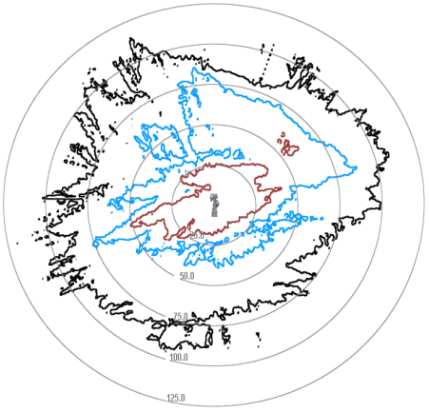 | 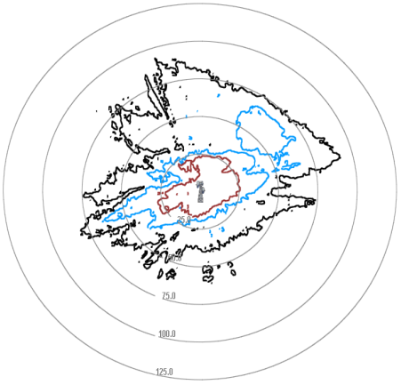 | 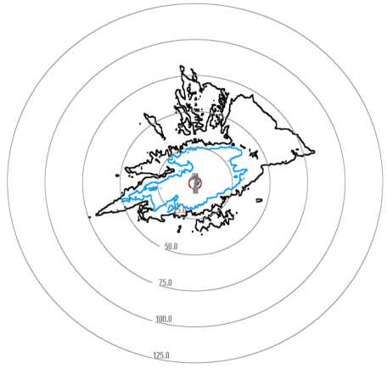
Elevation = 25° | 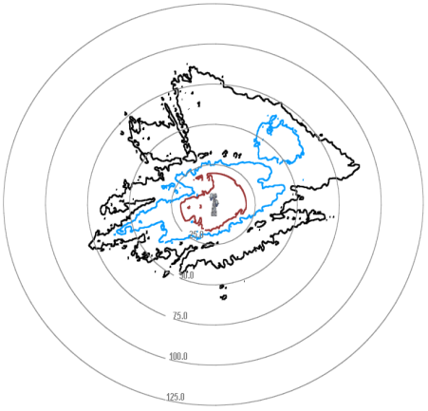 | 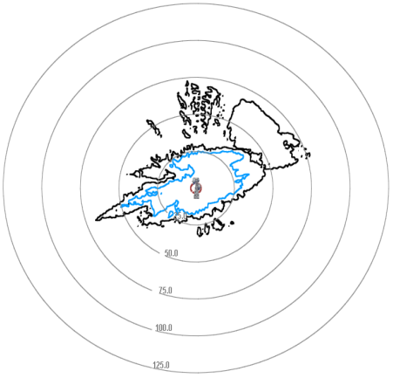 | 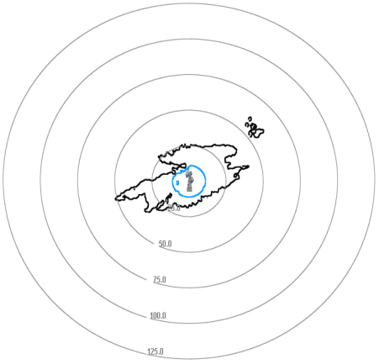
Elevation = 50° | 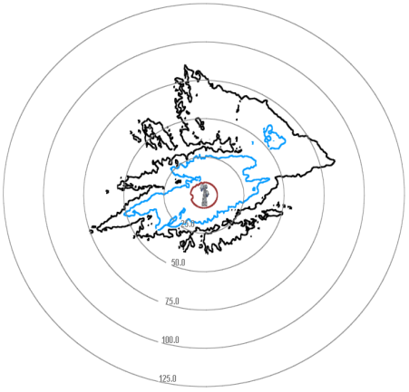 | 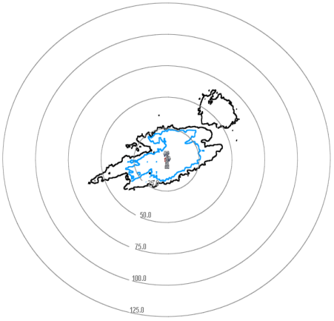 | 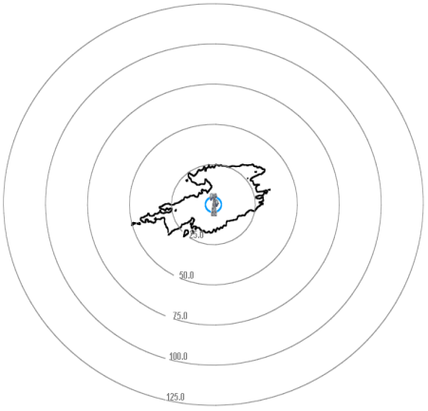

Figure A-4
Results for Scenario 2b : 8 m FSS Earth station
 | Azimuth = 0° (w.r.t. FSS e/s) | Azimuth = 90° (w.r.t. FSS e/s) | Azimuth = 180° (w.r.t. FSS e/s)
Elevation = 5° | 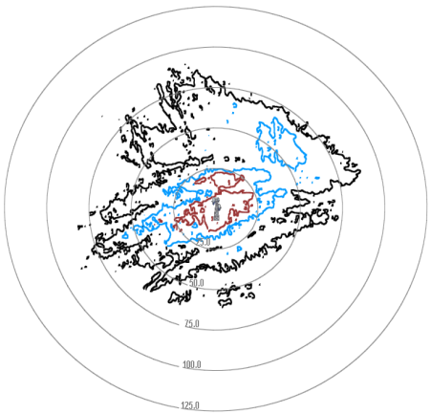 | 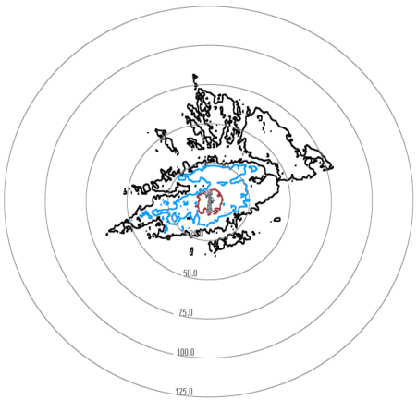 | 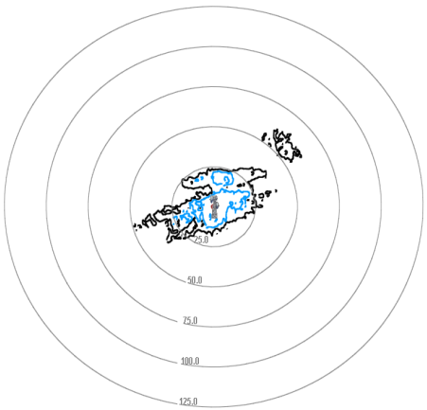
Elevation = 25° | 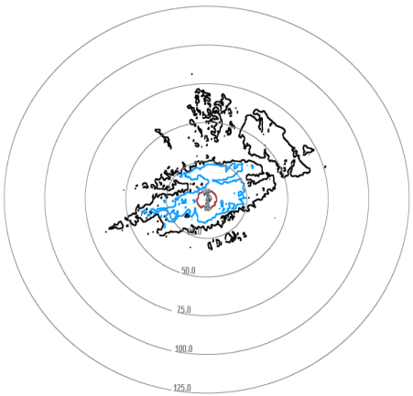 | 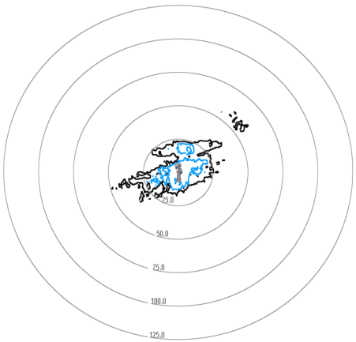 | 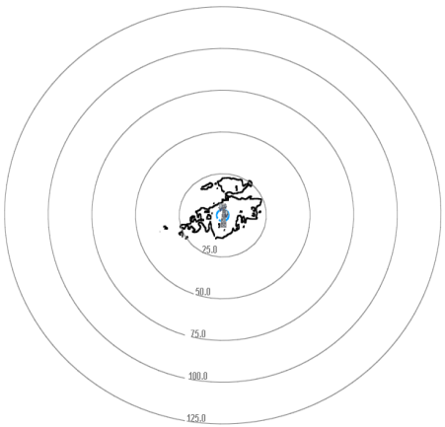
Elevation = 50° | 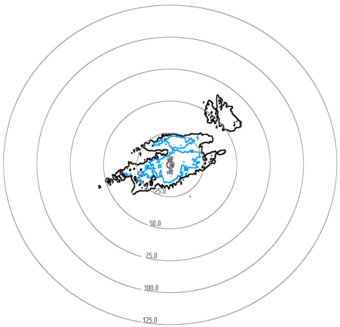 | 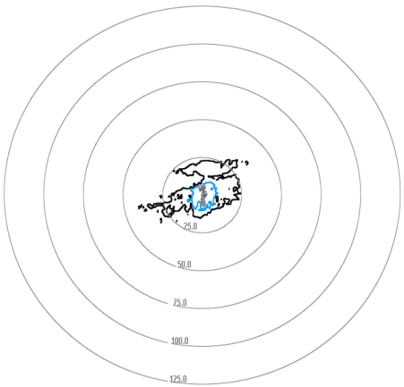 | 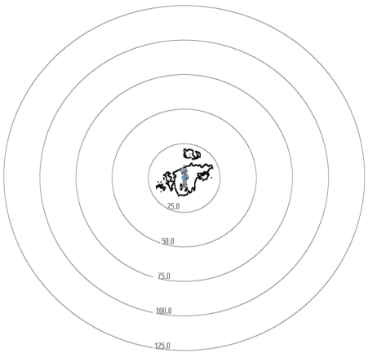

Figure A-5
Results for Scenario 2c : 1.2 m FSS Earth station
 | Azimuth = 0° (w.r.t. FSS e/s) | Azimuth = 90° (w.r.t. FSS e/s) | Azimuth = 180° (w.r.t. FSS e/s)
Elevation = 5° | 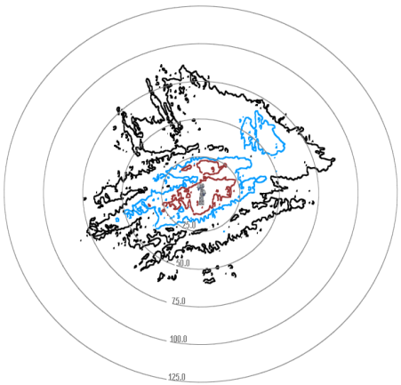 | 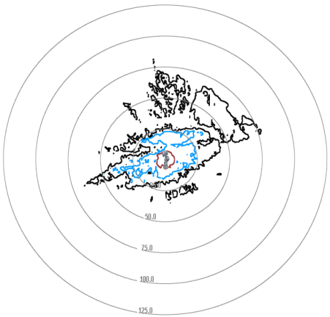 | 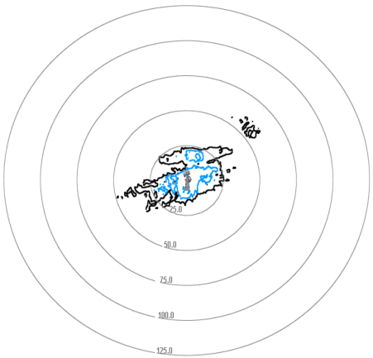
Elevation = 25° | 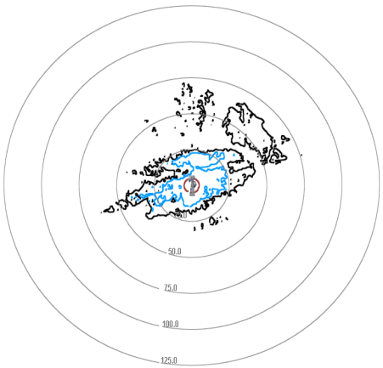 | 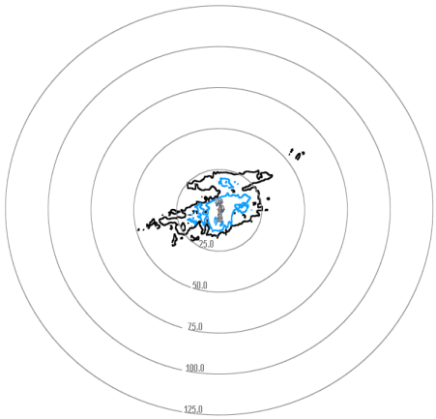 | 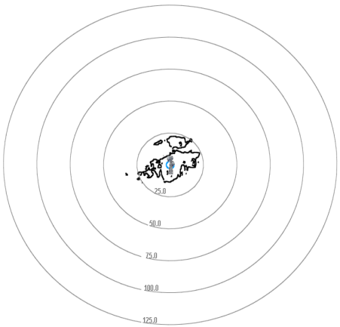
Elevation = 50° | 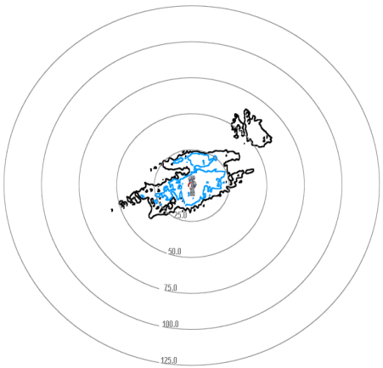 | 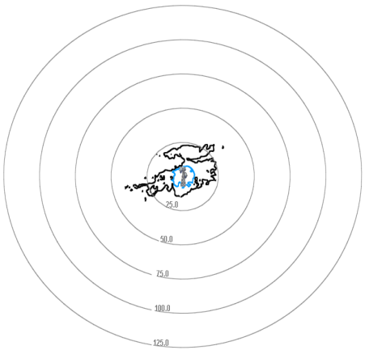 | 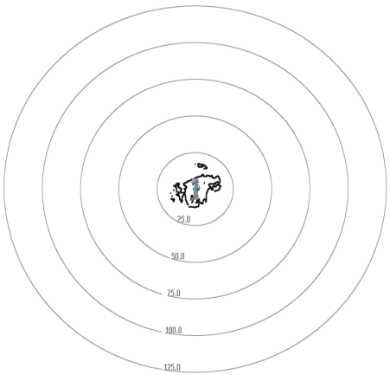

It is difficult to draw clear conclusions from the results with an example of real terrain data. However, comparing the variation of separation distances due to the terrain, with the separation distances calculated based on the smooth earth model (i.e. comparing Scenario 1 with Scenario 2), it can be concluded that the results from Scenario 1 do not seem overly conservative nor too optimistic.

4.3 Scenario 3 (BWA omnidirectional antenna, smooth earth)
With respect to the use of the omnidirectional urban base station antenna, Table A-8 to Table A-10 depict the comparison of the results of the studies for Scenarios 3a, 3b and 3c.
Table A-8
Comparison of result for separation distances Scenario 3a
 |  | Scenario 3a: BWA Omnidirectional Antenna, FSS 32 m Antenna
 | Elevation | 5 | 25 | 50
WiMAX Forum | Co-channel | 85 | 60 | 50
WiMAX Forum | 1st adjacent | 50 | 30 | 20
WiMAX Forum | 2nd adjacent | 20 | 5 | 1
SES WORLD SKIES | Co-channel | 55 | 40 | 35
SES WORLD SKIES | 1st adjacent | 35 | 25 | 10
SES WORLD SKIES | 2nd adjacent | 10 | 1 | 0
Delta | Co-channel | -30 | -20 | -15
Delta | 1st adjacent | -15 | -5 | -10
Delta | 2nd adjacent | -10 | -4 | -1
Table A-9
Comparison of result for separation distances Scenario 3b
 |  | Scenario 3b: BWA Omnidirectional Antenna, FSS 8 m Antenna
 | Elevation | 5 | 25 | 50
WiMAX Forum | Co-channel | 40 | 10 | 5
WiMAX Forum | 1st adjacent | 5 | 1 | 0
WiMAX Forum | 2nd adjacent | 0 | 0 | 0
SES WORLD SKIES | Co-channel | 35 | 20 | 15
SES WORLD SKIES | 1st adjacent | 20 | 10 | 5
SES WORLD SKIES | 2nd adjacent | 5 | 1 | 0
Delta | Co-channel | -5 | 10 | 10
Delta | 1st adjacent | 15 | 9 | 5
Delta | 2nd adjacent | 5 | 1 | 0

Table A-10
Comparison of result for separation distances Scenario 3c
 |  | Scenario 3c: BWA Omnidirectional Antenna, FSS 1.2 m Antenna
 | Elevation | 5 | 25 | 50
WiMAX Forum | Co-channel | 10 | 1 | 0
WiMAX Forum | 1st adjacent | 1 | 0 | 0
WiMAX Forum | 2nd adjacent | 0 | 0 | 0
SES WORLD SKIES | Co-channel | 35 | 20 | 15
SES WORLD SKIES | 1st adjacent | 15 | 5 | 5
SES WORLD SKIES | 2nd adjacent | 5 | 1 | 0
Delta | Co-channel | 25 | 19 | 15
Delta | 1st adjacent | 14 | 5 | 5
Delta | 2nd adjacent | 5 | 1 | 0

Comparison of results for Scenario 3 shows a similar conclusion w.r.t. comparison of results for Scenario 1, i.e. the case with the 8 m FSS earth station is the case for which the results of this paper with those of the WiMAX Forum show the most commonalities. For the 32 m FSS earth station case, the separation distances calculated in this contribution are lower, and for the 1.2 m FSS earth station case they are higher.

It is interesting to note though, that for the 8 m and 1.2 m FSS earth station case, for 50 degrees elevation, the results of the simulation in this study clearly show that the separation distances are not negligible for the co-channel case and 1st adjacent channel case, when comparing with the results from the WiMAX Forum study.

4.4 Scenario 4 (BWA omnidirectional antenna, actual terrain data)
For the simulations based on actual terrain data for Scenario 4, a similar approach was taken as for Scenario 2. However, as in this case the BWA base station antenna is omnidirectional, it was not necessary to make separate plots for different azimuth angles. The results for the simulations can be found in Figure A-6.

Figure A-6
Results for Scenario 4
 | 32m Earth Station | 8m Earth Station | 1.2m Earth Station
Elevation = 5° | 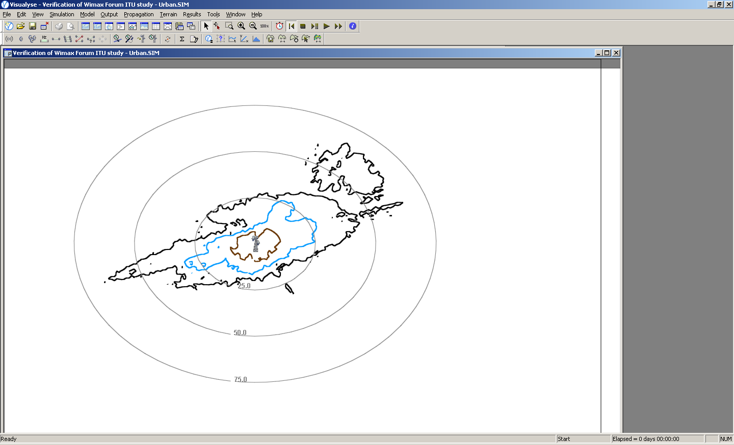 | 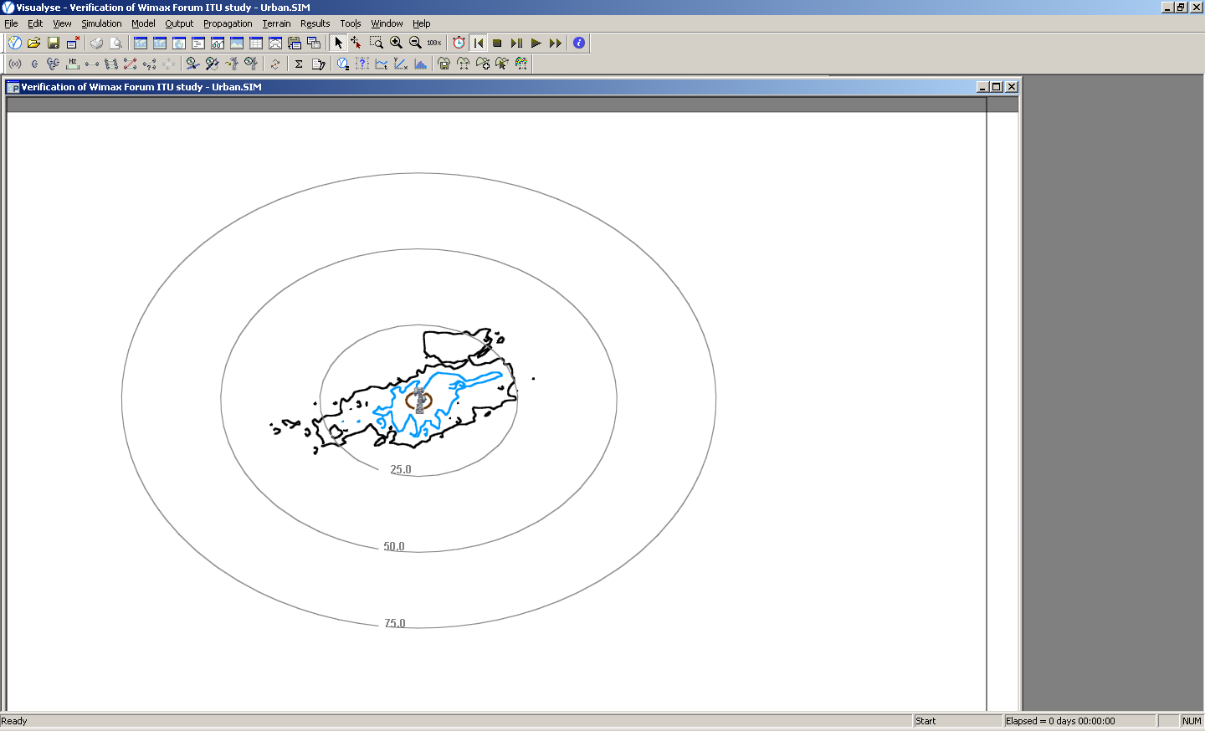 | 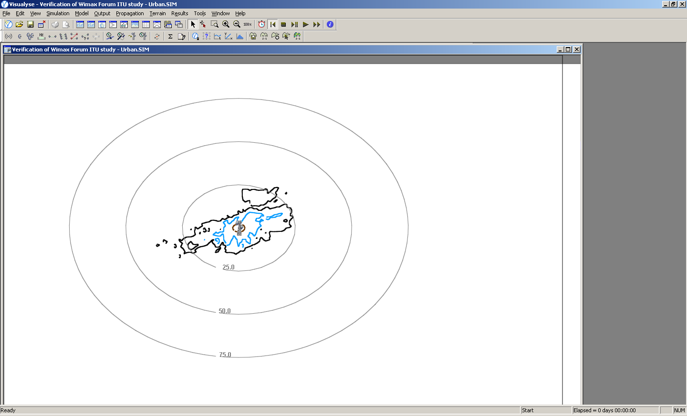
Elevation = 25° | 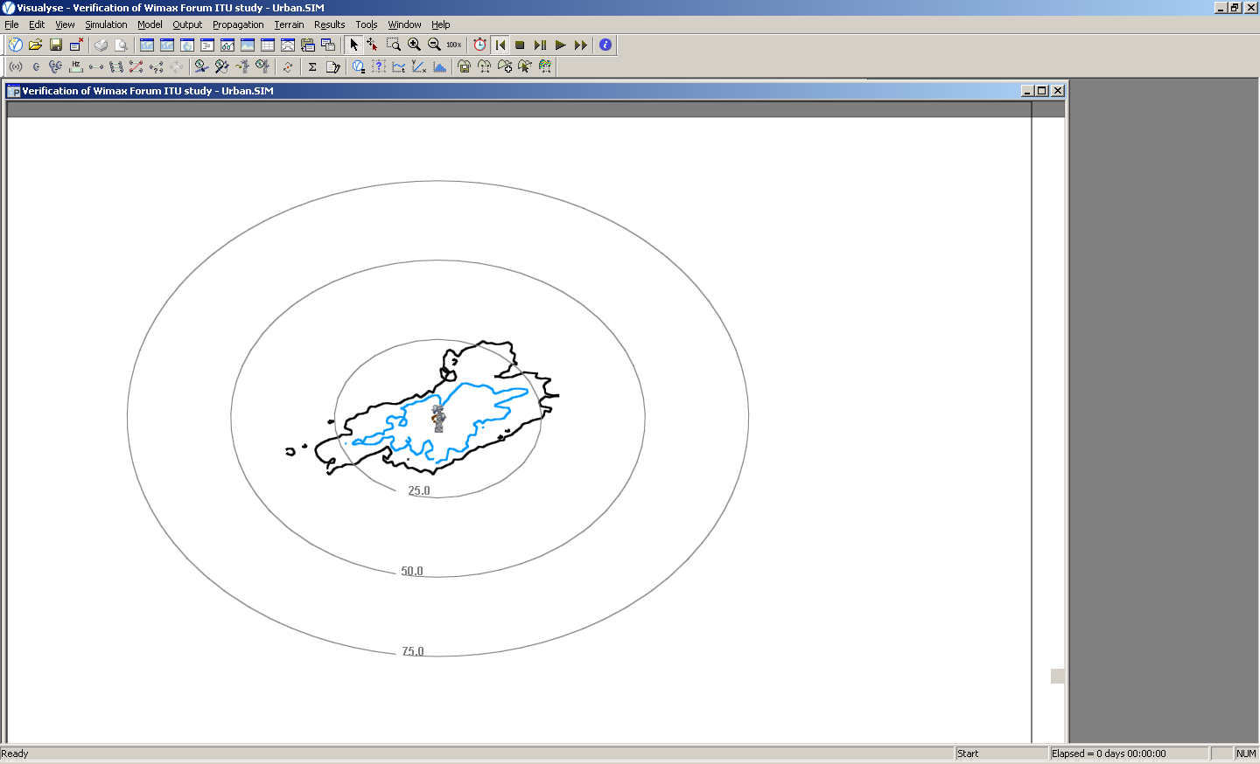 | 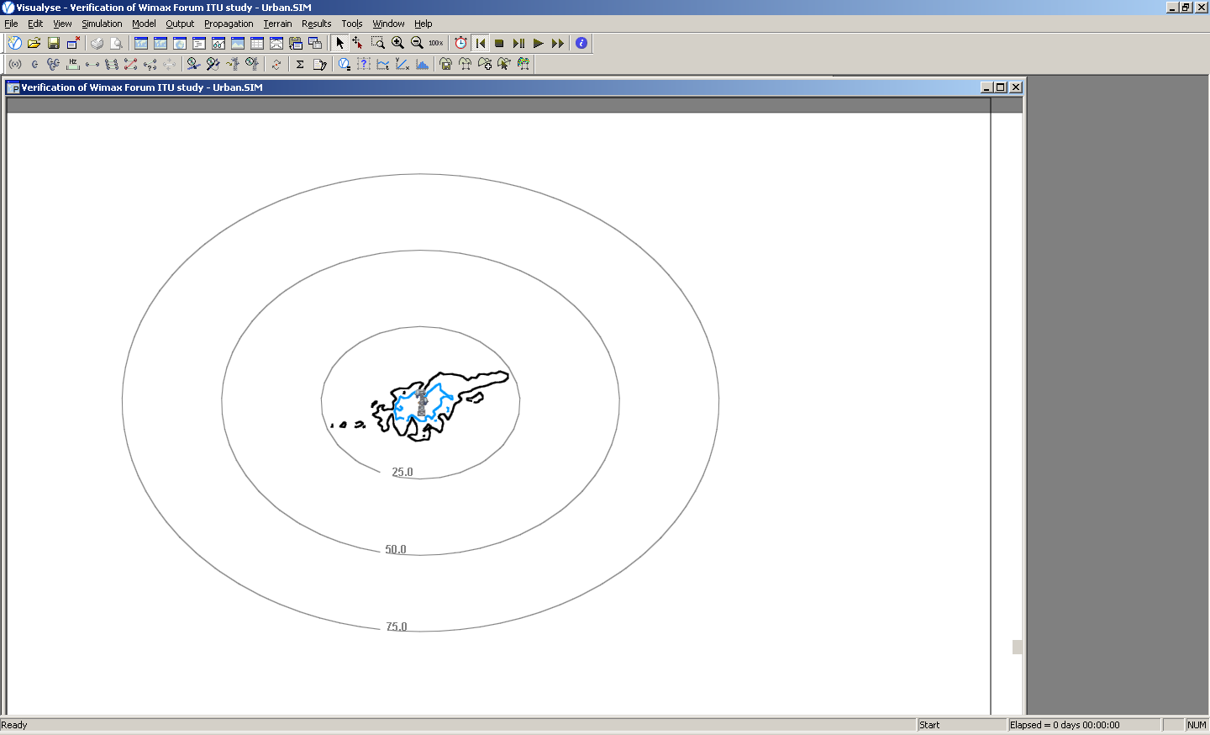 | 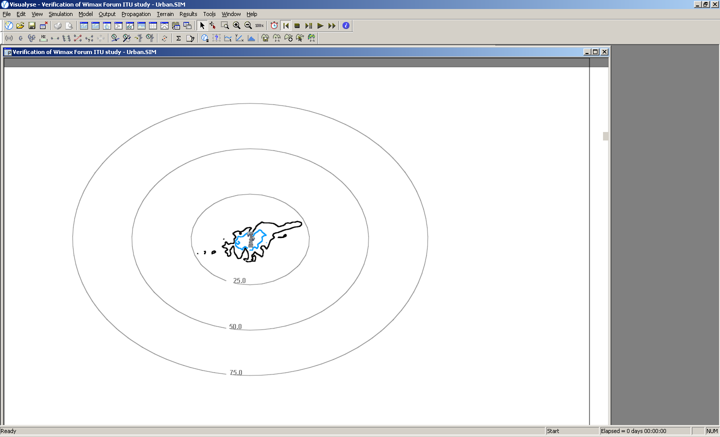
Elevation = 50° | 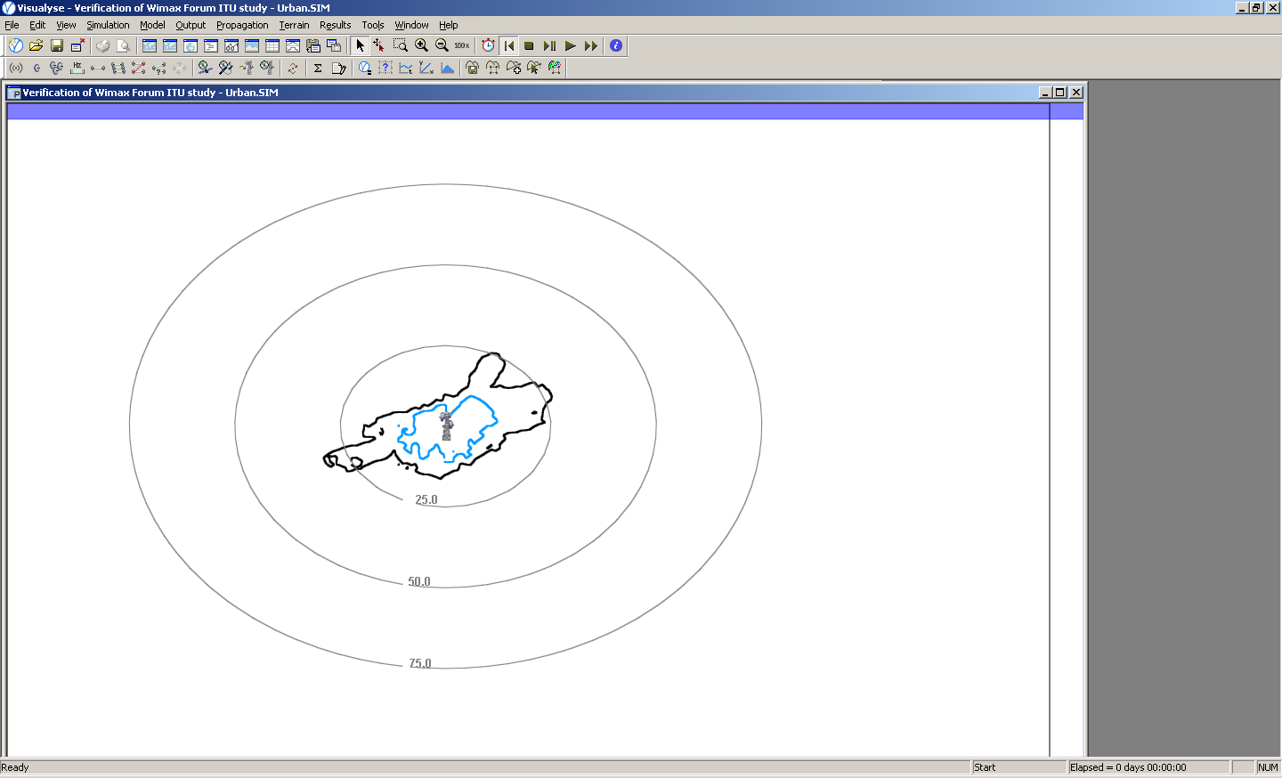 | 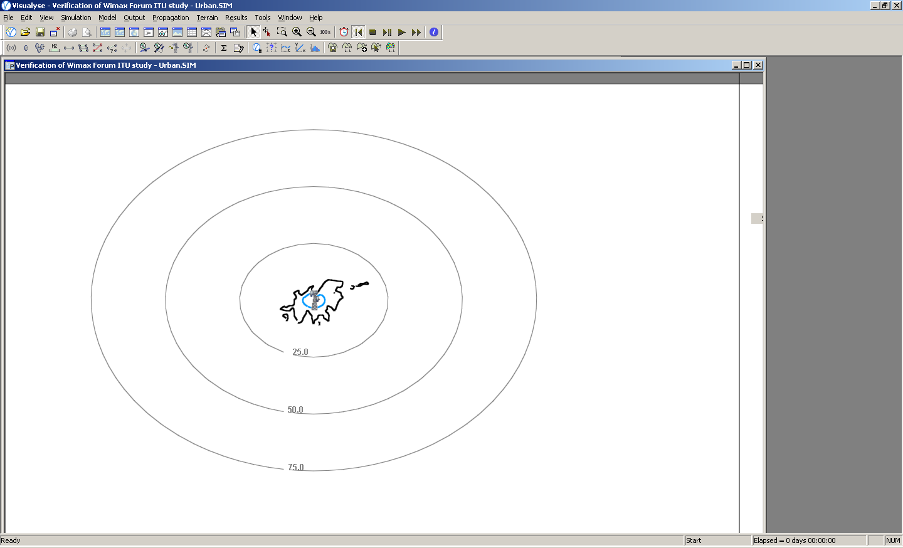 | 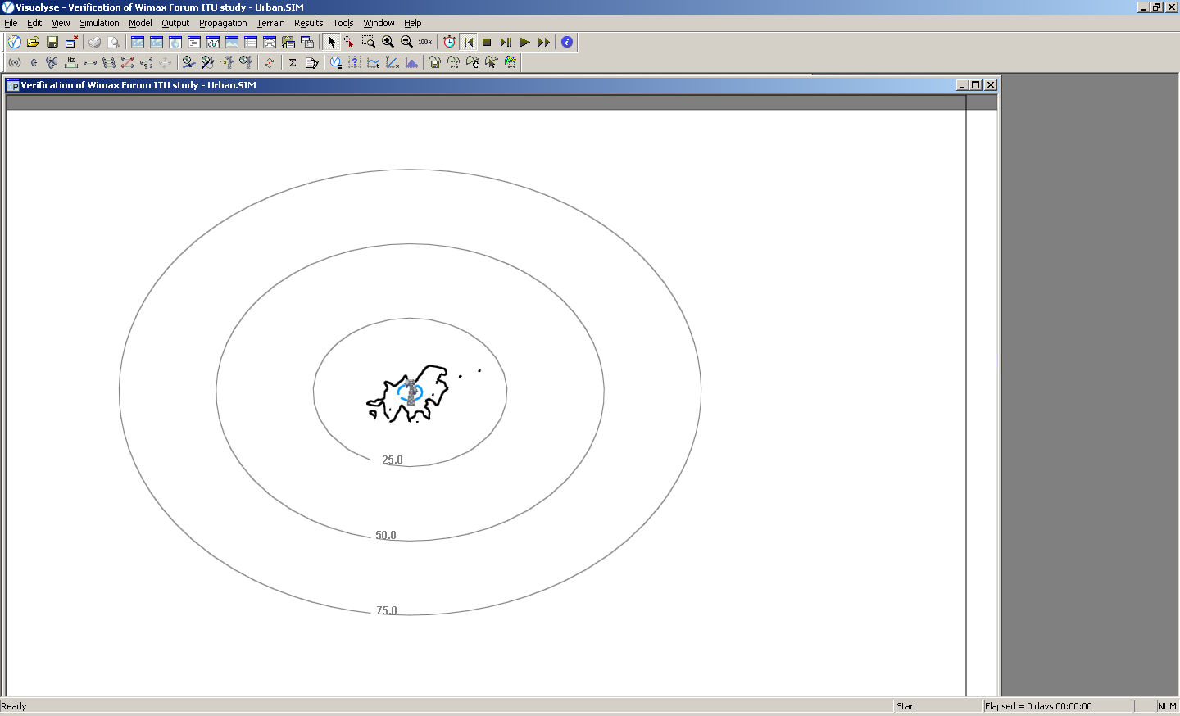

As was the case for Scenario 2, no clear conclusions can be drawn from the results with one example of real terrain data. However, comparing the variation of separation distances due to the terrain, with the separation distances calculated based on the smooth earth model (i.e. comparing Scenario 3 with Scenario 4), it can be concluded that the results from Scenario 3 do not seem overly conservative nor too optimistic.

5 Discussion of assumptions

This section will provide a discussion on a number of assumed parameters, such as the clutter parameters, sectoral antenna use, and aggregate interference scenarios, together with potential impacts that they have on the simulation results.

5.1 Clutter parameters

The model for calculating the clutter loss is described in Section 4.5 of Recommendation ITU-R P.452-13. It is indicated that clutter losses can be calculated at both the transmitting and receiving end of an (un)wanted link in situations where the clutter scenario is known. The calculation predicts a maximum additional loss of 20 dB at either end of the path. The recommendation goes on to say that where there are doubts as to the certainty of the clutter environment, the additional loss should not be included.

The expression to calculate the loss due to protection from local clutter is :
dB

Where:
A_{h}: loss due to clutter (dB)
d_{k} : distance (km) from nominal clutter point to the antenna
h: antenna height (m) above local ground level
h_{a}: nominal clutter height (m) above local ground level.

Table A-11 shows the results of the calculated clutter losses, based on the above expression, for the parameters as contained in Table A-4 of Annex A of this Report.
Table A-11
Results for clutter loss calculations
 | Antenna | h (m) | h_{a} (m) | d_{k} (km) | A_{h} (dB)
Scenario 1+2 | BWA Specific Rural Sectoral | 50 | 9 | 0.025 | -0.3
Scenario 1+2 | FSS Earth Station 32m | 25 | 30 | 0.025 | 1.2
Scenario 1+2 | FSS Earth Station 8m | 5 | 8 | 0.025 | 9.7
Scenario 1+2 | FSS Earth Station 1.2m | 5 | 8 | 0.025 | 9.7
Scenario 3+4 | BWA Typical Urban Omnidirectional | 15 | 20 | 0.020 | 3.3
Scenario 3+4 | FSS Earth Station 32m | 25 | 30 | 0.020 | 1.2
Scenario 3+4 | FSS Earth Station 8m | 5 | 8 | 0.020 | 9.7
Scenario 3+4 | FSS Earth Station 1.2m | 5 | 8 | 0.020 | 9.7

If the above assumed clutter parameters are compared with the table on nominal clutter heights and distances as depicted in Recommendation ITU-R P.452-13, it seems that the Specific Rural Sectoral antenna is assuming a suburban clutter category and the Typical Urban Omnidirectional antenna is assuming an urban clutter category.

The nominal clutter height of 30 m assumed for the 32 m FSS Earth Station seems not to correspond to any of the nominal clutter categories. The maximum nominal clutter height amongst the nominal categories is 25 m, which corresponds to a dense urban category. Based on this it would be more reasonable to assume a clutter height of 9 m, as was the case for the Specific Rural Sectoral antenna. The impact is that A_{h} would be about 1.5 dB less for the this case

The nominal clutter height for the 8 m and 1.2 m FSS Earth Station antenna seem not reasonable to use when these antennas are operating at low elevation angles towards the spacecraft. Operations at low elevations require site surveys to make sure that there are no obstacles in the path between the spacecraft and the earth station. Therefore, it is proposed to use a nominal clutter height that is equal to the antenna height for elevations up to 20 degrees elevation. The impact of this would be that A_{h} would be about 10 dB less for these cases.

Simulations have been done studying the impact of the above on the separation distances in the low elevation scenarios. The results show that the separation distances would be about 10 km more in this case.

Use of sectorized antennas
The studies in Scenarios 1 and 2 have assumed the use of a BWA sectoral antenna, with azimuth angles (w.r.t. the FSS earth station) ranging from 0° to 180° (see Figure A-2). Unfortunately, in the BWA parameters provided so far by WP 5A, there is no information on the frequency reuse factors or patterns.
For the sectorized antennas with a beamwidth of 60°, as used in this study, it is reasonable to assume that the frequency could be reused at 0°, 120°, and 240° azimuth angles. This would mean that the conclusions of the analysis, based on the case of an azimuth angle of 180° are not relevant, and that the maximum elevation angle studied should be 120°.
A further important aspect is that frequency reuse in sector antennas leads to an aggregation of the interference environment, and will lead to larger separation distances than in the case of a single sector antenna per BWA base station.
In order to quantify this effect one simulation has been reproduced, employing three sectoral antennas on one base station. For the example, the FSS earth station size of 8m was chosen, together with a smooth earth assumption (basically Scenario 1b). Table A-12 shows the results for the nominal case (these numbers can also be found in Table A-7) and the case where the base station is deploying 3 sector antennas, 120° apart in azimuth, operating co-frequency. As reference the 8 m FSS earth station antenna was chosen as those results seemed to match best those of the WiMAX Forum study.

Table A-12
Results of effect of multiple sector antennas
 |  | Scenario 1b: BWA Sectoral Antenna, FSS 8 m Antenna
 |  | Sensitivity w.r.t. multi sector antennas
 | Elevation | 5 |  |  | 25 |  |  | 50
 | Az. Sector 1 | 0 | 90 | 180 | 0 | 90 | 180 | 0 | 90 | 180
 | Az. Sector 2 | -120 | -30 | 60 | -120 | -30 | 60 | -120 | -30 | 60
 | Az. Sector 3 | 120 | -150 | -60 | 120 | -150 | -60 | 120 | -150 | -60
Single Sector | Co-channel | 75 | 60 | 45 | 55 | 40 | 30 | 50 | 35 | 20
Single Sector | 1st adjacent | 50 | 35 | 25 | 35 | 20 | 5 | 30 | 10 | 5
Single Sector | 2nd adjacent | 30 | 10 | 5 | 5 | 1 | 0 | 5 | 1 | 0
Multi Sector | Co-channel | 75 | 70 | 65 | 55 | 55 | 45 | 50 | 45 | 40
Multi Sector | 1st adjacent | 50 | 45 | 40 | 35 | 30 | 25 | 30 | 25 | 20
Multi Sector | 2nd adjacent | 30 | 20 | 15 | 5 | 5 | 1 | 5 | 5 | 1
Delta | Co-channel | 0 | 10 | 20 | 0 | 15 | 15 | 0 | 10 | 20
Delta | 1st adjacent | 0 | 10 | 15 | 0 | 10 | 20 | 0 | 15 | 15
Delta | 2nd adjacent | 0 | 10 | 10 | 0 | 4 | 1 | 0 | 4 | 1

From the results it can be seen that for the 0° azimuth angle case there is no impact on the separation distance as the antenna pointing directly towards the FSS Earth Station is the dominating interferer compared to the other two sector antennas. However, for the other azimuth cases there is a clear impact on the separation distances needed. For the co-channel and 1st adjacent channel cases, the impact ranges from 10 to 20 km. For the 2nd adjacent channel the impact is in between 1 and 10 km.
As the impact of the aggregation of the sectoral antennas on one base station is significant, it would be important to understand the exact nature of the frequency reuse patterns that are planned for BWA systems in the band 3 400-4 200 MHz.

Aggregate effect from multiple cells

Urban BWA deployment is typically done in a cell like structure where it is of interest to the BWA operator to reuse its assigned frequencies to the maximum extend possible. In the case of an urban BWA deployment with omnidirectional antennas, such as the ones studied under Scenarios 3 and 4 under this study, frequency reuse will most likely be achieved by reusing the same frequencies in difference cells. It is important to assess the impact of the aggregate effect on the required separation distances with respect to FSS earth stations where multiple BWA base stations reuse the same frequency in an urban environment.

Figure A-7 depicts a cell shaped frequency reuse scenarios, where three frequencies, F1, F2 and F3 are reused throughout the network. The distance d is the distance between the base stations in the network. From this the distance between two co-frequency base stations can be defined as being d√3.

Figure A-7
Typical frequency reuse pattern in cell structure

In order to determine whether there would be any impact due to the aggregate interference, it is important to understand the typical value for d, i.e. what is the typical distance between BWA bases stations in an urban environment, and what kind of frequency reuse pattern should be assumed.

6 Conclusions

The aim of this study was to evaluate the results from the WiMAX Forum study by comparing them with results from simulations performed with a commercial off-the-shelf (COTS) software tool that has the capability for implementing all of the BWA and FSS characteristics, as well as the BWA base station antenna patterns and Recommendation ITU-R P.452-13, by assuming the same assumptions, as far as was possible. This study is only considering the long term protection criteria as reflected in Recommendation ITU-R SF.1006. Short term effects might need to be evaluated separately.

Exact comparison is not straightforward as different assumptions with respect to the terrain have been taken, however, generally speaking, it seems that results obtained in both studies achieve results for needed separation distances that are within same order of magnitudes.

This study also discussed some of the assumptions more in detail, such as the assumed clutter parameters and possible impact of aggregation of multiple co-frequency sector antennas on one base station, and aggregate interference due to frequency re-use in different cells.

From the above it became clear that it is not obvious to assume general parameters for clutter, as different geometrical scenarios might require different parameters. Also, Recommendation ITU-R P.452-13 states clearly that “where there are doubts as to the certainty of the clutter environment, the additional loss should not be included”. Studies have indicated that impact of clutter can be significant.

Also, it was shown that the aggregate effect of multiple co-frequency sector antennas per BWA base station can be significant (addition required separation distances of 20 km have been calculated), and that this effect would also not allow to study azimuth angles of up to 180 degrees.
Attachment 3
Summary of study by the SES WORLD SKIES
(source: Document 4A/319 Annex 2)
Update of simulations done in relation to WiMAX
measurements in The Netherlands

1 Assumptions for simulation
During a measurement campaign that took place in The Netherlands in 2009, a DVB test carrier was put op on the SES WORLD SKIES NSS-806 satellite, located at 40.5°W, at a center downlink frequency of 3 533.5 MHz. Table B-1 details the specifics of this carrier.
Table B-1
Carrier details of satellite signal used in measurement campaign
Item | Value | Unit
Carrier frequency | 6 558.5/3 533.5 | MHz
Carrier polarisation | LHCP/RHCP | -
Datarate | 6144 | Mbps
Symbol Rate | 4445 | msym/s
Modulation | QPSK
FEC | ¾ | -
RS | 188/204 | -
Required Eb/No | 5.5 | dB

The receive equipment consisted of a 2.4 m fly-away antenna (Gigasat FA240), which was equipped with a Norsat LNB (3.4-4.2 GHz, LO 5 150 MHz) and C-band circular feed. The LNB was connected to a DVB MPEG2 decoder and a Rhode & Schwarz spectrum analyzer.
The satellite receive antenna was set up at different distances from Amsterdam, The Netherlands, in order to assess a BWA signal and the effect it had on the test signal from the satellite. The BWA system deployed in Amsterdam is based on the WiMAX standard.
The full details of the measurement results can be found in Document 4A/159. A theoretical model was set up to simulate the interference environment for a satellite earth station operating around a WiMAX transmitter which is set up in the Amsterdam area.
An analysis has been made of the required separation distances assuming two different BWA base station types. These BWA base station types, and their assumed parameters, are depicted in Table B-2. These parameters studies are the same as those contained in a study provided by the WiMAX Forum, of which there is a summary in this same Report.
Table B-2
BWA base station parameters assumptions for use in study
 | Base station
Deployment scenario | Specific cellular deployment rural | Typical cellular deployment urban
TX peak output power (dBm) | 43 | 32
Channel bandwidth (MHz) | 7 | 7
Feeder loss (dB) | 3 | 3
Peak antenna gain (dBi) | 17 | 9
Antenna gain pattern | Rec. ITU-R F.1336 | Rec. ITU-R F.1336
Antenna 3 dB beamwidth (degree) | 60° (sectorized) | Omni-directional
Antenna downtilt (degree) | 1 | 4
Antenna height a.g.l. (m) | 50 | 15
e.i.r.p. (dBm) | 57 | 38
Azimuth Angle (deg) | 0°, 90°, 180°, 270° | Not applicable
Unwanted emissions | Not studied | Not studied
The assumption for the detailed antenna pattern parameters are those as indicated Figures A-1 to A-4 of Annex A of this Report. For the BWA base station employing a sectoral antenna, different pointing directions in terms of azimuth will be assumed. The azimuth angles are 0°, 90°, 180° and 270° respectively.
The assumption for the FSS earth station are based on the parameters actual used during the measurements in terms of antenna height above ground level, antenna size, and elevation towards the actual satellite it was operating to. Table B-3 repeats the assumptions used in this study.
Table B-3
FSS system parameters
Frequency | 3 600 MHz is used in calculation
Bandwidth | 7 MHz is used in calculation
Earth station antenna radiation patterns | Recommendation ITU-R S.465
Antenna diameter in meters | 2.4
Maximum antenna gain in dBi | 37.8
Antenna center height in meters | 2
Noise temperature (including the contributions of the antenna, feed and LNA/LNB referred to the input of the LNA/LNB receiver) | 100 K
Antenna elevation angle | 17.1 degrees
Short-term and long-term maximum permissible Interference level | Recommendations ITU-R SF.1006 (In this study only the long-term protection level is taken into account)

The satellite earth station was modelled to be a 2.4 m antenna complying with antenna pattern Rec. ITU-R S.465, with a noise temperature of 100K at an elevation and azimuth corresponding to pointing to a satellite at 40.5W (i.e. 17.1 degrees). The height above ground was assumed to be 2 m.
The exact parameters within used in the propagation model are assumed as far as possible to be the same as those indicated in Table A-4 of Annex A of this Report, including the clutter parameters, based on Recommendation ITU-R P.452-13. However, as the simulation software is implementing this recommendation based on actual terrain data, the terrain characteristics cannot be modelled manually.
The simulation software is using a terrain database having a resolution of 1 m vertically and 1km horizontally, and assumes the WiMAX base station to be at a fixed location, and the satellite earth station simulated at 1km intervals. As indicated, path loss is derived by the algorithms in Recommendation ITU-R P.452-13.
The interference can be modelled as follows:
I = e.i.r.p._{WIMAX}(φ₁) – L + G(φ₂) [dBW/MHz]
Where:
I = Interference [dBW/MHz]
e.i.r.p._{WIMAX}(φ₁) = e.i.r.p. in direction of horizon of WiMAX base station [dBW/MHz]
L = Path Loss [dB]
G(φ₂) = Satellite earth station antenna gain in direction of the WiMAX transmitter [dBi].
The protection criterion for the long term interference to be observed is for the I/N ratio not to exceed -10 dB for more than 20% of the time.

2 Simulation results
Figure B-2 to Figure B-5 show the results for the case of a BWA specific cellular deployment rural case, for azimuth pointings of 0°, 90°, 180° and 270° respectively. Note that only the contours for I/N of -10 dB are indicated. These contours are represented by the purple line on the map. The source of all maps used in this document is Google Maps.
Figure B-2
Simulation results BWA rural sectoral antenna (Azimuth : 0°)
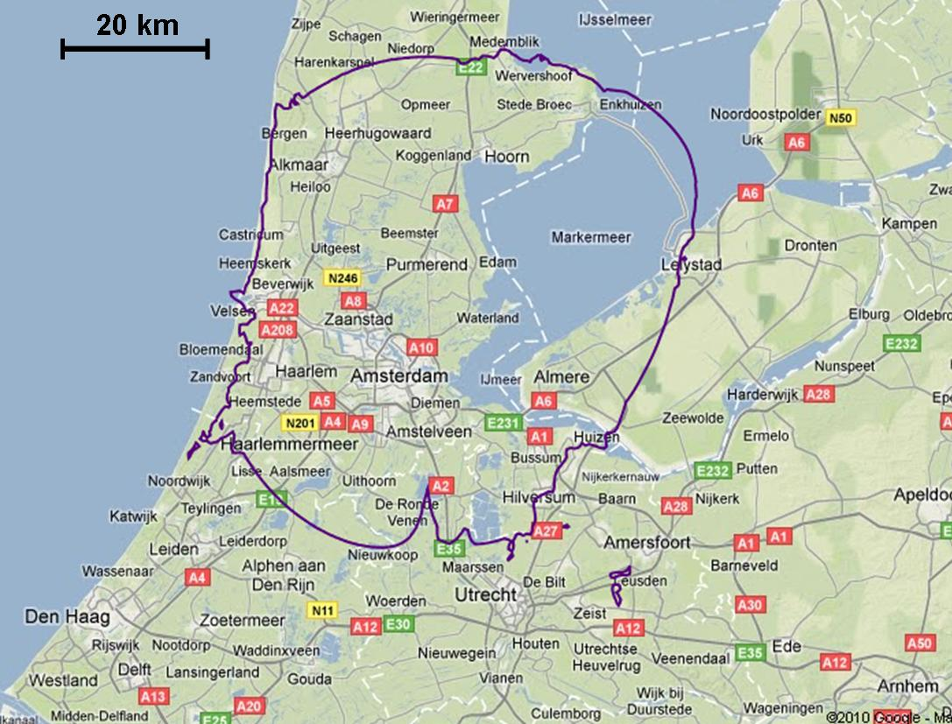
Figure B-3
Simulation results BWA rural sectoral antenna (Azimuth : 90°)
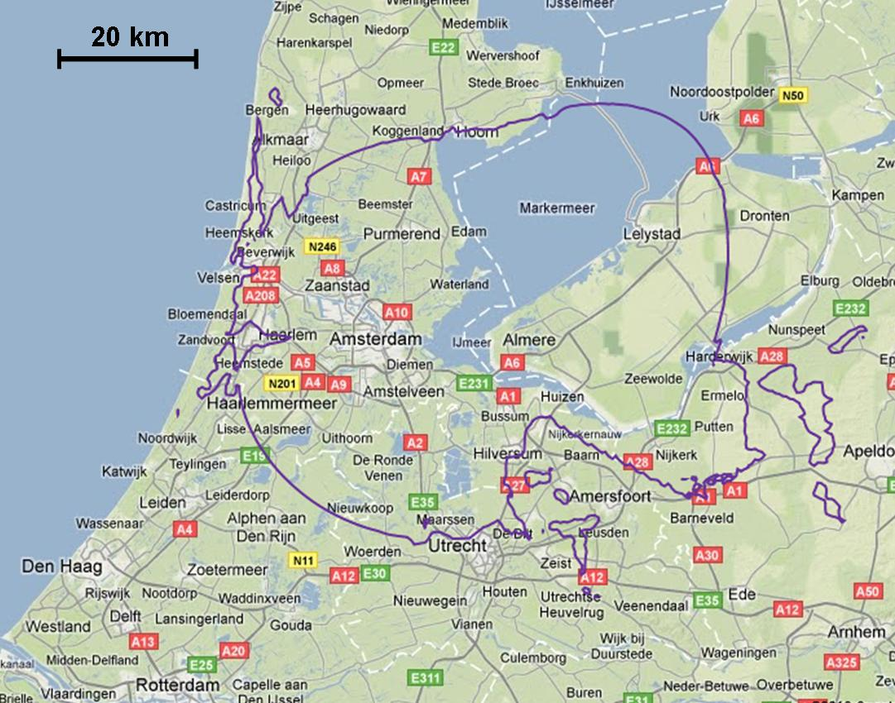
FIGURE B-4
Simulation results BWA rural sectoral antenna (Azimuth : 180°)
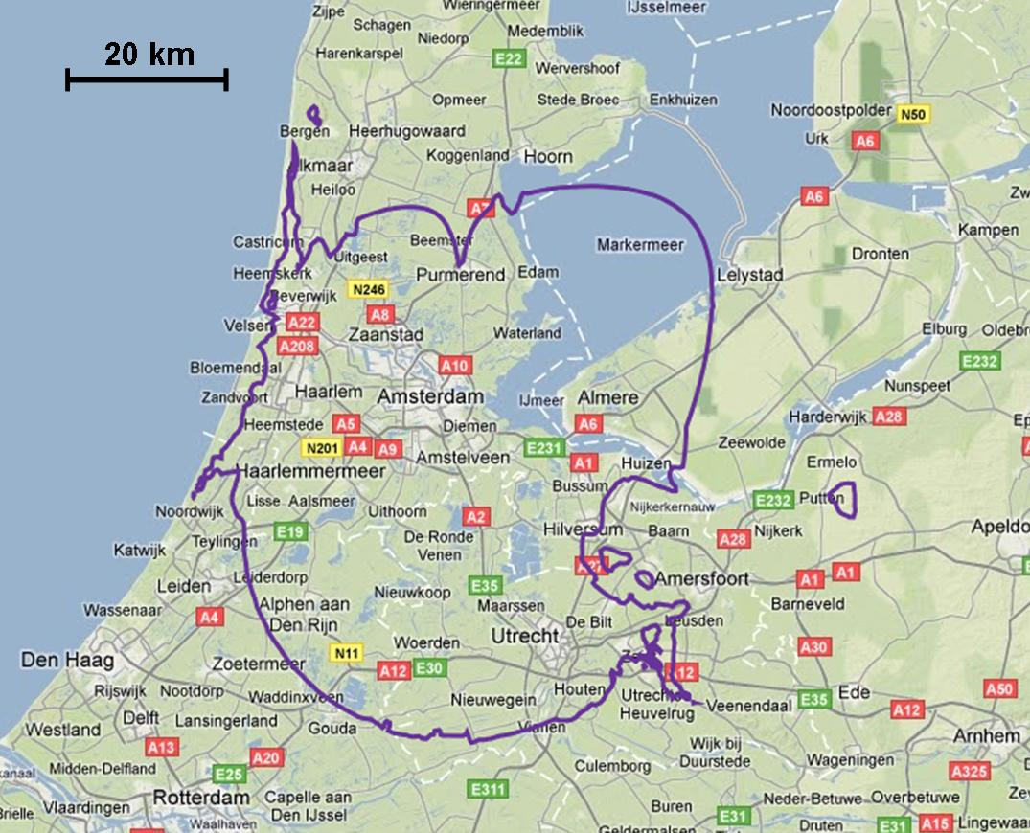

Figure B-5
Simulation results BWA rural sectoral antenna (Azimuth : 270°)
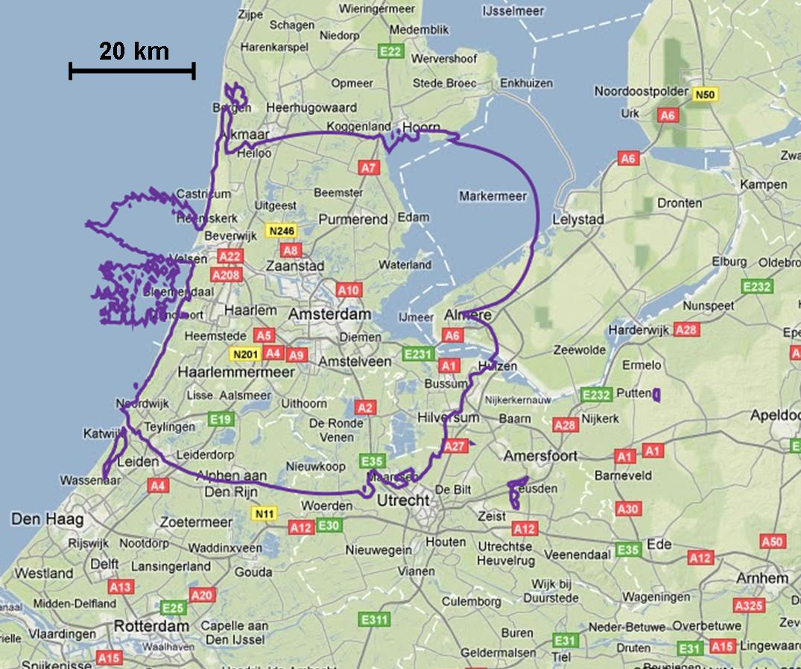

The contours shown in these results are different from the ones in the original study. However it is fair to say that they are in the same order of magnitude, even for different azimuth pointing angles of the sector antenna. They would also be in line with the results from the actual measurements done, i.e. covering the cases where clear interference was observed.
Figure B-6 shows the result for the case of a BWA typical cellular deployment urban case.
Figure B-6
Simulation results BWA urban omnidirectional antenna
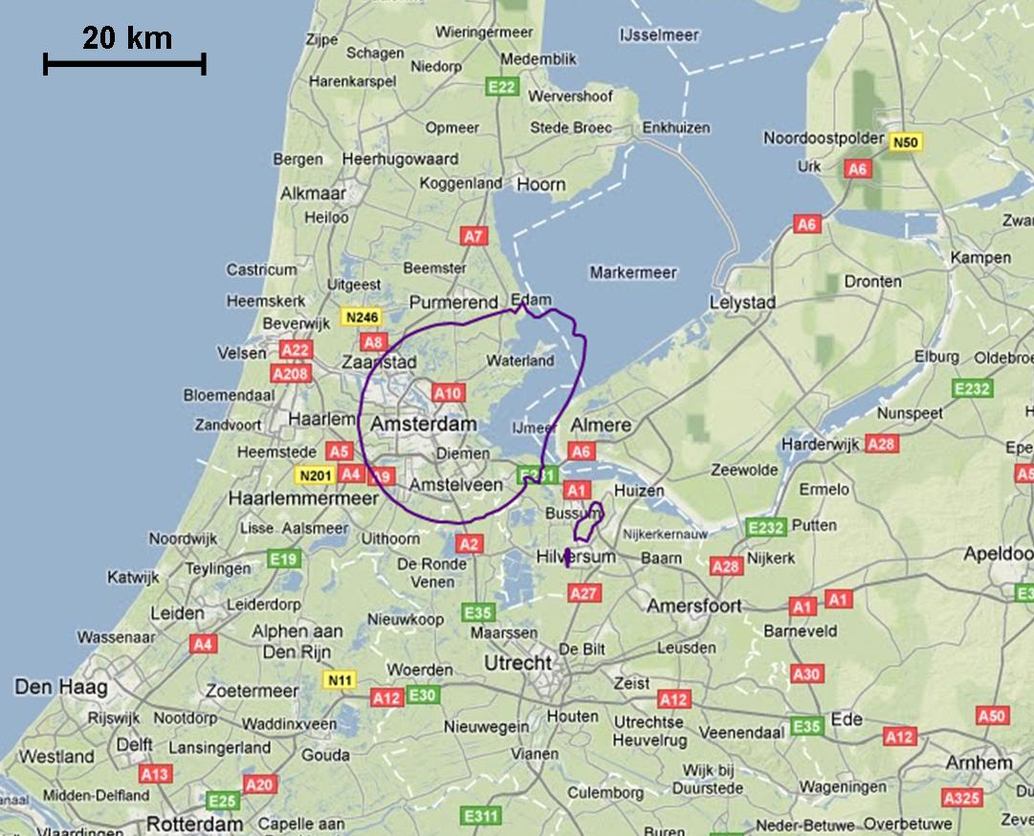

As expected, the contours related to the BWA omnidirectional antenna, used as a typical urban case, show shorter separation distances than in the case of the BWA sector antennas used in the specific rural case. However, although the actual BWA system deployed would have to be a typical urban system, as its targeted market is the city of Amsterdam, the contours shown in the plot do not match with the measurements performed during the campaign.

3 Conclusions
A measurement campaign was set-up in order to make use of the presence of this operational WiMAX system, and to analyse the potential impact it can have on FSS signal reception in the same operating band.
In this study, the theoretical part of the analysis was updated based on the latest BWA base station and antenna parameters, as well as propagation model parameters as contained in Annex A of this report.
- Based on the results, it would seem that the WiMAX system that was deployed in Amsterdam, was using BWA base station parameters that were more in line with the parameters based on a specific rural cellular case than with the parameters based on a typical urban cellar case.

Annex C
FIGURE c1
Earth stations¹ in Europe operating to satellites of Intelsat and SES New Skies
in the band 3 400-4 200 MHz at the end of 2008
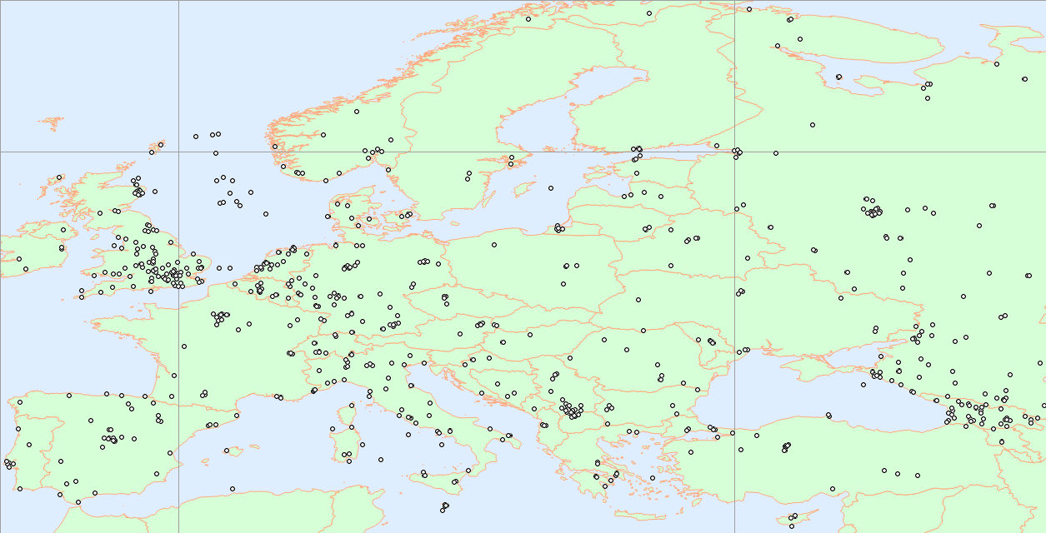
End 08 – 1431 terminals, 715 sites
Mid-06 – 1081 terminals, 694 sites
Average growth rate: 13% per year.
¹ The sites shown are those registered by Intelsat and SES New Skies. Additionally many TVRO earth stations exist but are unrecorded and thus unable to be shown here. Furthermore the map does not show earth stations served in this band by other satellite operators.

FIGURE C2
Locations of earth stations registered with several satellite operators and receiving in the 3 700-4 200 MHz band
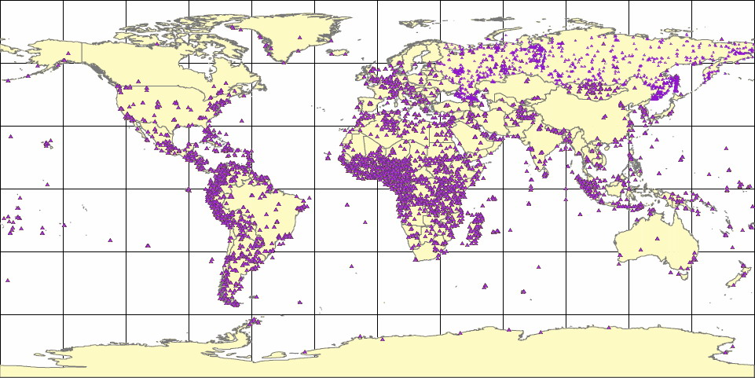
- Denotes a site that may include one or more stations.
FIGURE c3
Locations of earth stations registered with several satellite operators and receiving in the 3 625-3 700 MHz band
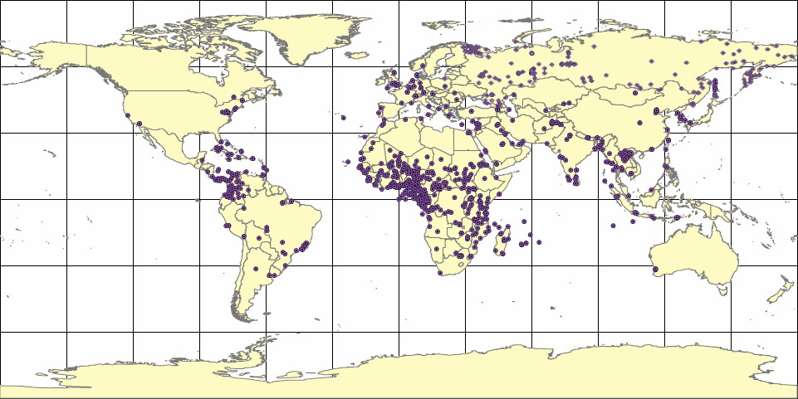
Denotes a site that may include one or more stations.
FIGURE C4
Locations of earth stations registered with several satellite operators and receiving in the 3 400-3 625 MHz band
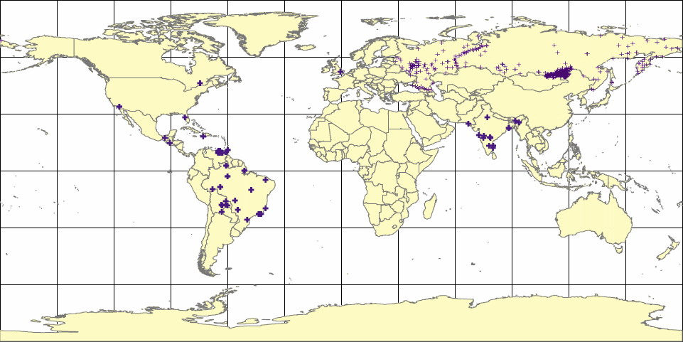
Denotes a site that may include one or more stations.
FIGURE C5
FSS earth stations registered in Brazil (sites using 3 625-4 200 MHz)
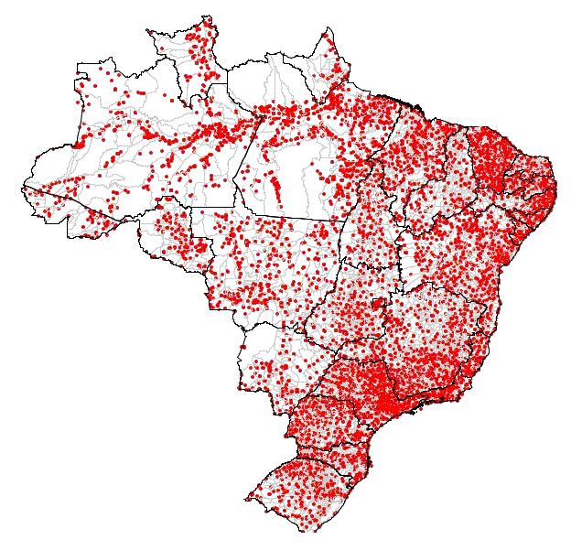

Annex D
Examples of national implementations
Example D-1
FSS/BWA sharing arrangements in the 3 400-4 200 MHz band in Australia

Example D-1 provides details of the sharing arrangements between BWA and FSS in the 3 400-4 200 MHz band in Australia. In Australia, which does not share any national borders, the technical rules for sharing, including FSS earth station and BWA base station filtering characteristics, are controlled by the Administration, which improves the sharing situation. This situation might not be true for other Administrations where additional measures may be required to protect the FSS in the 3 400-4 200 MHz band.
The arrangements detailed in Example D-1 may be appropriate for a nation with no national borders but may not be reflective of the more general or common case where national cross-border coordination is required. Furthermore, although the sharing arrangements can fully account for existing FSS systems at the time of deployment, it will likely limit the future deployment of FSS stations in locations where BWA is licensed due to the quasi omni-directional nature of the BWA base station emissions.

1 Introduction
In early 2010 Australia plans to introduce terrestrial broadband wireless access (BWA) services to the 3 575-3 700 MHz part of the Extended-C band. BWA will be licensed to operate in regional and remote areas of Australia. To ensure protection of urban based FSS earth stations the major capital cities have been specifically excluded.
This decision follows a long period of careful analysis into whether BWA could harmoniously share with other co-frequency and adjacent frequency national services, particularly FSS s-to-E downlinks in the 3 400-4 200 MHz band. As Australia does not share any national borders this is essentially a domestic licensing issue.
In this contribution Australia wishes to advise the ITU-R of the arrangements that will apply to ensure compatible sharing in this important frequency band. Minimum performance characteristics of the new BWA services and of incumbent FSS downlinks in the Extended-C and Standard-C bands are included, together with a short summary of the main sharing criteria. Further details can be obtained at:
http://www.acma.gov.au/WEB/STANDARD/pc=PC_100424
Australia proposes that the preliminary draft new Report ITU-R S.[BWA-FSS] contained Annex 5 to Document 4A/197, the Chairman’s Report from the meeting of Working Party 4A (27 April - 5 May 2009), be suitably updated to reflect the planned Australian sharing arrangements.

2 Summary of the main sharing rules
To ensure that BWA services in the 3 575-3 700 MHz band will be compatible with licensed FSS earth stations in the 3 600-4 200 MHz band a defined frequency coordination process, together with BWA deployment restrictions will apply. In summary, the main licensing rules will be:
− BWA will be licensed in regional and remote areas of Australia. Exclusion zones will apply around defined areas, such as major cities, in order to preserve future planning options in these areas.
− Regional and remote BWA base station transmitters must meet a number of minimum performance characteristics; including an e.i.r.p. density mask above 3 700 MHz (see Table 1 and Figure 1).
− Regional and remote BWA base station transmitters will not be licensed within 20 km of an existing licensed FSS earth station operating in the adjacent Standard C band (see Table 3).
− FSS earth station receivers will be assumed to meet a number of minimum performance characteristics (in addition to their licence requirements) (see Table 2).
− Regional and remote BWA frequency assignments will be undertaken using additional coordination specific information (see Table 3).
Table 1
BWA base station transmitter characteristics and deployment constraints
Parameter | Explanatory comments | Requirement
Duplex mode |  | TDD
Smart antenna gain |  | Coordinate to highest achievable antenna gain
Antenna polarisation discrimination | Potential losses due to polarisation discrimination can be taken into account in cases of main beam coupling.  Mixed polarisation refers to the use of two orthogonally polarised signals. | BWA Tx ES Rx: dB loss  Mixed Circular: 0 dB  Mixed Linear: 3 dB  Linear Circular: 3 dB  Linear Linear (Co-polar): 0 dB  Linear Linear (Cross-polar): As specified by antenna data.
e.i.r.p. density limits (dBm/MHz) | Lower limits apply > 3 670 MHz to reduce out-of-band (OOB) emissions into the  3 700-4 200 MHz band and offer greater protection to earth stations against saturation. | 3 575-3 670 MHz = 51 dBm/MHz  3 670-3 700 MHz = 30 dBm/MHz
Emission masks | A band edge mask at the  3 700 MHz frequency boundary is needed to reduce OOB emissions into the  3 700-4 200 MHz band. | - All transmitters are to adhere to relevant emission masks stated in ETSI EN 302 326.  - At, and above, the 3 700 MHz boundary, base stations must meet the mask of Figure 1.
Main deployment constraints | Deployment constraints are proposed in addition to coordination criteria. These are created to reduce the chance of interference from base stations (and user terminals) into earth stations operating in the 3 700-4 200 MHz band. | - No transmitters may be placed inside exclusion areas.  - No user terminal transmitters are to be deployed within a 2 km radius of an earth station operating in the 3 700-4 200 MHz band–unless agreement can be reached with the earth station licensee.

Figure 1
Band edge emission limits for BWA services
Table 2
FSS earth station receiver characteristics
Parameter | Explanatory comments | Unit | Value
Reference bandwidth | To allow for per MHz coordination. | MHz | 1
Antenna gain | Value to be taken from licence. | dBi | -
Antenna pattern | Recommendation ITU-R S.465 | dBi | -
Antenna feeder losses | Follows review of existing licensee’s data. | dB | 0
Antenna height | Value to be taken from licence | m | -
Minimum elevation angle | Follows review of existing licensee’s data | degrees | 5
System temperature | Follows review of existing licensee’s data. | K | 70
Noise floor | Calculation | dBW/MHz | -150.1
Protection criteria (I/N) | Based on Recommendations ITU-R S.1432 and ITU-R SF.1006:  - ST = Short term (0.0017% time)  - LT = Long Term (20% time) | dB | ST = -1.3  LT = -10
Onset of non-linear operation level | Follows review of existing licensee’s data. | dBm | -65  (single entry)
Assumed filter (band pass or notch) attenuation | Protection requirements have been developed assuming specific filter performance as mentioned here.  The fitting of filters is not mandatory; however, earth stations operating in the 3 700-4 200 MHz band are not afforded protection from harmful interference occurring from BWA stations operating in the 3 575-3 700 GHz band. | dB | 3 670-3 700 MHz 0  < 3 670 MHz 15
Table 3
Frequency coordination requirements
Parameter | Explanatory comments | Requirement
Co-channel cull distance | This is the minimum BWA-FSS separation distance for which coordination is required (to protect earth stations in regional and remote areas). | 150 km – BWA in 3 670-3 700 MHz  200 km – BWA in 3 600-3 670 MHz
Frequency cull range | This is the frequency range for which co-channel and adjacent channel coordination is required. | Co-channel: 3 600-3 700 MHz  Adjacent channel*: 3 575-3 700 MHz  *refers to FSS in the 3700-4200 MHz band
Adjacent channel separation distance | This is the separation distance required between BWA base stations and FSS earth stations in order to affect adjacent channel coordination.  Note that a minimum 20 km separation distance applies in all adjacent band sharing cases. | Note that a minimum 20 km separation distance applies in all adjacent band sharing cases.  Case 1: Interference into 3 700-4 200 MHz  - Guard band < 10 MHz: A BWA base station wishing to deploy within 100 km of an earth station operating in the 3 700-4 200 MHz band is required to undergo adjacent channel coordination, assuming an NFD (net filter discrimination) of 20 dB and a minimum allowable separation distance of 20 km.  - Guard band ≥ 10 MHz: a minimum 20 km separation is required.  Case 2: Interference into 3 600-3 700 MHz  - Guard band ≥ 10 MHz: Coordination not required as exclusion zones will provide enough protection.  - Guard band < 10 MHz: A BWA base station wishing to deploy within 150 km of an earth station operating in the  3 600-3 700 MHz band is required to undergo coordination. Both adjacent channel interference (assuming NFD of 20 dB) and protection against the onset of non-linear operations (assuming 20 MHz channel and no additional filtering losses) analysis is required.
Propagation model |  | Recommendation ITU-R P.452 - clear sky conditions.
Assignment priority |  | BWA assignments to be made from lowest available frequency up.

3 Summary and conclusion
Australia will soon be introducing BWA services to the 3 575-3 700 MHz part of the Extended-C band. The new BWA services will be permitted to operate outside Exclusion Zones, typically defined around major cities in Australia, and only where it can be demonstrated that compatibility will exist with licensed FSS earth stations in the area.
In addition BWA base stations will not be licensed within 20 km of an existing licensed FSS earth station using the Standard-C frequency band. Other frequency coordination requirements will also apply.

The characteristics of BWA can be fixed, mobile or nomadic.
The terms “licensed” and “registered” are used throughout this Report to refer to stations for which location coordinates are known so their protection may be possible.
Source: Report ITU-R M.2109 on “Sharing studies between IMT-Advanced systems and geostationary satellite networks in the fixed-satellite service in the 3 400-4 200 and 4 500-4 800 MHz frequency bands”.
Section 2 of the ACMA Spectrum Planning Discussion Paper 02/09 on the ‘Release of the 3.6 GHz band for Wireless Access Services (WAS)’ http://www.acma.gov.au/webwr/_assets/main/lib310829/spp2009-02_release_of_3.6ghz_band_for_was-disc_paper.pdf.
Recommendation ITU-R BO.1213 was used in some studies in Annex B, however it is recognized that antenna patterns with appropriate frequencies range applicability should be used for future studies.
The break points in the mask are for primary equipment type of OFDMA (EqC-PET = O) and equivalent modulation order of 6 (EqC-EMO = 6) in EN 302 326-2.
This expression is reproduced from expression (47) in Section 4.5.3 in Recommendation ITU-R P.452-13.
This table is Table 4 in Section 4.5.3 in Recommendation ITU-R P.452-13.
Many TVRO earth stations exist but are unrecorded and thus unable to be shown here.
Many TVRO earth stations exist but are unrecorded and thus unable to be shown here.
Many TVRO earth stations exist but are unrecorded and thus unable to be shown here.
Many TVRO earth stations exist but are unrecorded and thus unable to be shown here.
Section 2 of the ACMA Spectrum Planning Discussion Paper 02/09 on the ‘Release of the 3.6 GHz band for Wireless Access Services (WAS)’ http://www.acma.gov.au/webwr/_assets/main/lib310829/spp2009-02_release_of_3.6ghz_band_for_was-disc_paper.pdf.
Additional deployment constraints can be found at: http://www.acma.gov.au/webwr/_assets/main/lib310829/rali_fx19_draft_update.pdf
Additional frequency coordination requirements can be found at: http://www.acma.gov.au/webwr/_assets/main/lib310829/rali_fx19_draft_update.pdf

