|  |  |
| --- | --- |
| **Radiocommunication Study Groups** |  |
|  |  |
|  |  |
| Received: 15 March 2010  Subject: Documents 4A/159, 4A/278 (Annex 5),  4A/294, 5A/419 | **Document 4A/319-E** |
| **17 March 2010** |
| **English only** |
| SES WORLD SKIES | |
| Studies on compatibility of broadband wireless  access systems and fixed-satellite service  networks in the 3 400-4 200 mhz band | |
|  | |

# 1 Introduction

Working Party 4A (WP 4A) is developing together with Working Party 5A (WP 5A) a Report on Studies on compatibility of broadband wireless access (BWA) systems and fixed-satellite service (FSS) networks in the 3 400-4 200 MHz band, also referred to as PDN Report ITU-R S.[BWA‑FSS]. The latest version of this report is contained in the Chairman’s Report of WP 4A meeting of September 2009 (Annex 5 to Document [4A/278](http://www.itu.int/md/R07-WP4A-C-0278/en)).

Section 1.5 of Annex B of the PDN Report ITU-R S.[BWA-FSS] contains a summary of the measurement of an operational BWA system in the band 3 500-3 580 MHz and the impact it can have on FSS reception in the same band, which includes also a theoretical simulation of the interference environment studied. The source of this study was Document [4A/159](http://www.itu.int/md/R07-WP4A-C-0159/en).

In the PDN Report, a number of representative characteristics both FSS and BWA have been established. Further, WP 5A, in its most recent liaison statement (Document [4A/294](http://www.itu.int/md/R07-WP4A-C-0294/en)) provided detailed information on the antenna patterns to be used for the BWA base stations. Also, in the liaison statement a number of parameters are proposed to be used in conjunction with Recommendation ITU-R P.452-13.

The liaison statement also refers to a study provided by the WiMAX Forum, which is contained in Document [5A/419](http://www.itu.int/md/R07-WP5A-C-0419/en), and which makes use of the indicated antenna parameters for the BWA base stations and the proposed parameters for Recommendation ITU-R P.452-13.

With this background, the objectives of this contribution are the following:

1. Evaluation of the WiMAX Forum study contained in Document 5A/419, with respect to the parameters used for the antenna patterns and propagation models (contained in Annex A).
2. Update of the study contained in Section 1.5 of Annex B of the PDN Report ITU-R S.[BWA-FSS] with the updated parameters for BWA base stations and the parameters for the propagation model in Recommendation ITU-R P.452-13 (contained in Annex B).
3. Proposal for a liaison statement to WP 5A in reply to their liaison statement contained in Document 4A/294 (contained in Annex C).

**Annexes:** 3

Annex A  
  
Evaluation of WiMAX Forum study with BWA antenna   
patterns and propagation model parameters

# 1 Introduction

Working Party 5A (WP 5A), in its liaison statement contained in Document 4A/294, invites Working Party 4A (WP 4A) for any comments on the study provided by the WiMAX Forum that can be found in Document 5A/419. That study makes use of the BWA and FSS characteristics as contained in PDN Report ITU-R S.[BWA-FSS], the proposed BWA base station antenna patterns, and the parameters proposed to be used in conjunction with Recommendation ITU-R P.452-13.

This document will evaluate the results from the WiMAX Forum study by comparing them with results from simulations performed with a commercial off-the-shelf (COTS) software tool that has the capability for implementing all of the BWA and FSS characteristics, as well as the BWA base station antenna patterns and Recommendation ITU-R P.452-13.

# 2 Evaluation of parameters used in Recommendation ITU-R P.452-13

The software tool used for the simulations in this document has an implementation of Recommendation ITU-R P.452-13. Most of the parameters that are used for this recommendation can be manually configured. However, as the software tool makes use of actual terrain data, when available, not all the parameters related to a number of parameters can be manually configured. The table below details for every parameter, as proposed by WP 5A, whether the implementation of the Recommendation ITU-R P.452-13 allowed for manual configuration of this parameter. In the case it was not possible, additional explanatory comments will be given.

Table A-1

Overview of configurable parameters for Recommendation ITU-R P.452-13

| Parameter | Scenario | Value | Unit | Configurable | Comment |
| --- | --- | --- | --- | --- | --- |
| *dk* | Rural for BS | 0.025 | km | Yes |  |
| Urban for BS | 0.02 | Yes |  |
| Outdoor for TS | 0.02 | Yes |  |
| Indoor for TS | 0.02 | Yes |  |
| *ha* | Rural for BS | 9 | m | Yes |  |
| Urban for BS | 20 | Yes |  |
| Outdoor for TS | 12 | Yes |  |
| Indoor for TS | 12 | Yes |  |
| Diameter = 32 m | 30 | Yes |  |
| Diameter = 8 m | 8 | Yes |  |
| Diameter = 1.2 m | 8 | Yes |  |
| *LP* |  | 8 | dB | Yes |  |
| *f* |  | 3.6 | GHz | Yes | Configurable independent of Rec. ITU-R P.452-13 implementation |
| *p* |  | 20 | % | Yes |  |
| φ*t,* φ*r* |  | 40 | degree | Yes | Configurable independent of Rec. ITU-R P.452-13 implementation |
| ψ*t,* ψ*r* |  | −100 | degree | Yes | Configurable independent of Rec. ITU-R P.452-13 implementation |
| *hg* |  | 20 | m | No | The software has a standard implementation of the smooth earth model. If terrain data is available, the height information from the terrain data will be used |
| *hm* |  | 10 | m | No | The software will either use smooth earth, or, terrain data, when available |
| *dtm* |  | 0.9d | km | No | Automatically determined by the software based on available terrain data |
| *dlm* |  | 0.8d | km | No | Automatically determined by the software based on available terrain data |
| *dlt,dlr* |  | 0.25d | km | No | Automatically determined by the software based on available terrain data |
| θ*t,* θ*r* |  | 17.45 | mrad | No | Automatically determined by the software based on available terrain data and resulting geometry |
| θ |  | θt+ θr +103d/αe | mrad | No | Automatically determined by the software based on available terrain data and resulting geometry |
| *db* |  | 0 | km | No | Automatically determined by the software based on available terrain data |
| γ*o+*γ*w*(ρ) |  | 0.008 | dB/km | No | Automatically derived by software based on carrier frequency |
| *∆N* |  | 50 |  | Yes |  |
| *h1* |  | 15 | m | No | Automatically determined by the software based on available terrain data |
| *h2* |  | 20 | m | No | Automatically determined by the software based on available terrain data |
| *h3* |  | 15 | m | No | Automatically determined by the software based on available terrain data |
| *d1* |  | 0.25d | km | No | Automatically determined by the software based on available terrain data |
| *d2* |  | 0.5d | km | No | Automatically determined by the software based on available terrain data |
| *d3* |  | 0.75d | km | No | Automatically determined by the software based on available terrain data |
| *N0* |  | 310 |  | Yes |  |
| *t* |  | 10 | ºC | Yes |  |
| *Pressure* |  | 1013.25 | hPa | Yes |  |

In summary, it can be stated that the software tool allows for configuration of all parameters except those related to the terrain, as they are directly derived from available terrain data. If terrain data is not available, the software will assume a smooth earth.

# 3 Set-up of simulations

As the software tool will not enable manual determination of certain aspects of Recommendation ITU-R P.452-13, simulations have been set up for the BWA base station scenarios as was done in the WiMAX Forum study, with the difference that 2 different cases will be studied. One case is assuming smooth earth, and the other case is assuming the use of actual terrain data.

It is recognized that there is a large variety of different terrain types available. As one example, the terrain data around the proposed geographical point of 100W longitude and 40N latitude will be taken. The terrain database used has a resolution of 1 m vertically and 1 km horizontally. For the simulation a grid of FSS earth stations is assumed around the BWA base station at 1 km intervals.

Figure A-1 depicts the details of the type of terrain that was used, together with contours indicating the distance from the BWA base station in the center of the plots, in 25 km intervals, from 25 km up to 125 km distance. The plots contained in the analysis results will not show the actual terrain in order to make those plots more readable.

Figure A-1

Details of terrain characteristics assumed in simulations

Terrain heights

Simulations are run based on the scenarios identified in Table A-2, assuming the parameters as identified in Table A-3 and Table A-4. It should be noted that this study takes into account the BWA base stations, but not the BWA terminal stations. Further, it is important to note that this study is only considering the long term protection criteria as reflected in Recommendation ITU-R SF.1006.

The results from the WiMAX Forum study are derived from the plots shown in Document 5A/419, where distances derived have been rounded to the nearest 5 km. Those results are then compared the results from the simulations performed in this study.

Table A-2

Overview of simulation scenarios

| **Scenario** | **BWA Antenna** | **FSS Antenna** | **Terrain** |
| --- | --- | --- | --- |
| 1a | Specific Rural Sectoral | 32 m | Smooth Earth |
| 1b | 8 m |
| 1c | 1.2 m |
| 2a | Specific Rural Sectoral | 32 m | Actual Terrain |
| 2b | 8 m |
| 2c | 1.2 m |
| 3a | Typical Urban Omnidirectional | 32 m | Smooth Earth |
| 3b | 8 m |
| 3c | 1.2 m |
| 4a | Typical Urban Omnidirectional | 32 m | Actual Terrain |
| 4b | 8 m |
| 4c | 1.2 m |

Table A-3

FSS system parameters

|  |  |  |  |
| --- | --- | --- | --- |
| Frequency | 3 400-4 200 MHz  (3 600 MHz is used in calculation) | | |
| Bandwidth | 40 kHz-72 MHz  (7 MHz is used in calculation) | | |
| Earth station antenna radiation patterns | Recommendation ITU-R S.465 | | |
| Antenna diameter in meters | 1.2 | 8 | 32 |
| Maximum antenna gain in dBi | 31.2 | 47.7 | 59.8 |
| Antenna center height in meters | 5 | 5 | 25 |
| Noise temperature (including the contributions of the antenna, feed and LNA/LNB referred to the input of the LNA/LNB receiver) | 100 K | 70 K | 70 K |
| Antenna elevation angle | 5 to 85 degrees | | |
| Short-term and long-term maximum permissible Interference level | Recommendations ITU-R SF.1006 (this study only considers the long-term levels) | | |

Table A-4

BWA base station system parameters

|  |  |  |
| --- | --- | --- |
|  | Base station | |
| Deployment scenario | Specific cellular deployment rural | Typical cellular deployment urban |
| TX peak output power (dBm) | 43 | 32 |
| Channel bandwidth (MHz) | 7 | 7 |
| Feeder loss (dB) | 3 | 3 |
| Peak antenna gain (dBi) | 17 | 9 |
| Antenna gain pattern | Rec. ITU-R F.1336 | Rec. ITU-R F.1336 |
| Antenna 3 dB beamwidth (degree) | 60° (sectorized) | Omni-directional |
| Antenna downtilt (degree) | 1 | 4 |
| Antenna height a.g.l. (m) | 50 | 15 |
| e.i.r.p. (dBm) | 57 | 38 |
| Unwanted emissions | TBD | TBD |

The WiMAX Forum derives values for the adjacent channel leakage ratio (ACLR) based on the spectrum masks as defined in Annex A of the PDN Report ITU-R S.[BWA-FSS]. Those values are repeated in Table A-5 below for the BWA base stations that are used in the simulations in this study. ACLR1, ACLR2 and ACLR3 are for the first adjacent channel, the second adjacent channel and third and beyond adjacent channels respectively.

Table A-5

BWA base station ACLR values

|  |  |  |  |
| --- | --- | --- | --- |
|  | **ACLR1 in dB** | **ACLR2 in dB** | **ACLR3 in dB** |
| BWA Base Station | 22.0 | 47.8 | 50.0 |

Due to the small difference between the values for the second and third adjacent channels, this study will only take into account the results for the first and second adjacent channels.

Further, in this study, for the BWA specific rural sectoral antenna case (Scenarios 1 and 2), not all azimuth angles between 0° and 180° were studied, as was done in the WiMAX Forum study, but a subset of this range. The azimuth angles studied were 0°, 90° and 180°. It is believed that these values allow for adequate comparison with the results obtained in the WiMAX Forum study. Figure A-2 depicts the geometrical scenarios studied under Scenarios 1 and 2.

Figure A-2

Geometric azimuth configurations studied under Scenarios 1 and 2



As for Scenarios 3 and 4, for the BWA typical urban omnidirectional antenna, where the azimuth aspect of the antennas is not relevant, not all elevation angles for the FSS earth stations are studied, but the same subset of elevation angles that were used in Scenarios 1 and 2, i.e. 5°, 25° and 50° elevation

# 4 Results of simulation

This section contains the results of the simulations and a comparison with the results from the WiMAX Forum study. The same assumed set of parameters was used to enable a comparison of the results of the two studies. However, Section 5 will contain a discussion on some of the parameters that were assumed in this study.

## 4.1 Scenario 1 (BWA sectoral antenna, smooth earth)

Table A-6 to Table A-8 in this section show the comparison of the results from the WiMAX Forum study with the results of the simulation done for this particular contribution, when a smooth earth is assumed. The tables also show the difference between the two results. All distances are in kilometres. The results are generally rounded to the nearest 5 km point, except for the cases when the separation distance was about 1 km. When the distance was below 1 km, a separation distance of 0 km is indicated.

Table A-6

Comparison of result for separation distances for Scenario 1a

|  |  |  |  |  |  |  |  |  |  |  |
| --- | --- | --- | --- | --- | --- | --- | --- | --- | --- | --- |
|  |  | **Scenario 1a: BWA Sectoral Antenna,  FSS 32 m Antenna** | | | | | | | | |
|  | Elevation | 5 | | | 25 | | | 50 | | |
|  | Azimuth | 0 | 90 | 180 | 0 | 90 | 180 | 0 | 90 | 180 |
| WiMAX Forum | Co-channel | 150 | 130 | 90 | 110 | 85 | 65 | 95 | 75 | 60 |
| 1st adjacent | 110 | 80 | 60 | 75 | 60 | 40 | 65 | 50 | 35 |
| 2nd adjacent | 60 | 50 | 35 | 45 | 30 | 15 | 40 | 20 | 5 |
| SES WORLD SKIES | Co-channel | 100 | 75 | 65 | 75 | 60 | 50 | 70 | 55 | 40 |
| 1st adjacent | 70 | 55 | 45 | 55 | 40 | 20 | 50 | 30 | 10 |
| 2nd adjacent | 50 | 25 | 5 | 20 | 5 | 1 | 10 | 1 | 0 |
| Delta | Co-channel | -50 | -55 | -25 | -35 | -25 | -15 | -25 | -20 | -20 |
| 1st adjacent | -40 | -25 | -15 | -20 | -20 | -20 | -15 | -20 | -25 |
| 2nd adjacent | -10 | -25 | -30 | -25 | -25 | -14 | -30 | -19 | -5 |

Table A-7

Comparison of result for separation distances for Scenario 1b

|  |  |  |  |  |  |  |  |  |  |  |
| --- | --- | --- | --- | --- | --- | --- | --- | --- | --- | --- |
|  |  | **Scenario 1b: BWA Sectoral Antenna,  FSS 8 m Antenna** | | | | | | | | |
|  | Elevation | 5 | | | 25 | | | 50 | | |
|  | Azimuth | 0 | 90 | 180 | 0 | 90 | 180 | 0 | 90 | 180 |
| WiMAX Forum | Co-channel | 95 | 70 | 50 | 70 | 50 | 25 | 60 | 40 | 20 |
| 1st adjacent | 60 | 40 | 25 | 40 | 20 | 10 | 30 | 15 | 5 |
| 2nd adjacent | 30 | 15 | 5 | 10 | 5 | 1 | 10 | 1 | 0 |
| SES WORLD SKIES | Co-channel | 75 | 60 | 45 | 55 | 40 | 30 | 50 | 35 | 20 |
| 1st adjacent | 50 | 35 | 25 | 35 | 20 | 5 | 30 | 10 | 5 |
| 2nd adjacent | 30 | 10 | 5 | 5 | 1 | 0 | 5 | 1 | 0 |
| Delta | Co-channel | -20 | -10 | -5 | -15 | -10 | 5 | -10 | -5 | 0 |
| 1st adjacent | -10 | -5 | 0 | -5 | 0 | -5 | 0 | -5 | 0 |
| 2nd adjacent | 0 | -5 | 0 | -5 | -4 | -1 | -5 | 0 | 0 |

Table A-8

Comparison of result for separation distances Scenario 1c

|  |  |  |  |  |  |  |  |  |  |  |
| --- | --- | --- | --- | --- | --- | --- | --- | --- | --- | --- |
|  |  | **Scenario 1c: BWA Sectoral Antenna,  FSS 1.2 m Antenna** | | | | | | | | |
|  | Elevation | 5 | | | 25 | | | 50 | | |
|  | Azimuth | 0 | 90 | 180 | 0 | 90 | 180 | 0 | 90 | 180 |
| WiMAX Forum | Co-channel | 70 | 50 | 30 | 45 | 35 | 15 | 35 | 20 | 10 |
| 1st adjacent | 40 | 20 | 10 | 20 | 10 | 5 | 15 | 5 | 1 |
| 2nd adjacent | 15 | 5 | 5 | 5 | 1 | 1 | 10 | 1 | 0 |
| SES WORLD SKIES | Co-channel | 75 | 55 | 40 | 55 | 40 | 25 | 45 | 35 | 20 |
| 1st adjacent | 50 | 35 | 25 | 35 | 20 | 5 | 30 | 10 | 5 |
| 2nd adjacent | 25 | 10 | 5 | 5 | 1 | 0 | 5 | 1 | 0 |
| Delta | Co-channel | 5 | 5 | 10 | 10 | 5 | 10 | 10 | 15 | 10 |
| 1st adjacent | 10 | 15 | 15 | 15 | 10 | 0 | 15 | 5 | 4 |
| 2nd adjacent | 10 | 5 | 0 | 0 | 0 | -1 | -5 | 0 | 0 |

Generally speaking it can be observed that the separation distances calculated are of the same order of magnitude.

However, when comparing the three scenarios in more detail, it seems that the results for Scenario 1b (FSS earth station size of 8 m) are most similar to the results from the WiMAX Forum study. Results from Scenario 1a (FSS earth station size of 32 m) differ in the sense that the separation distances as calculated in the WiMAX Forum study are larger, and the separation distances for Scenario 1c (FSS earth station size of 1.2 m) are lower.

## 4.2 Scenario 2 (BWA sectoral antenna, actual terrain data)

As indicated in section 3, in order to show an example of the impact of terrain on the simulation results, it was decided to assume the terrain data available at the proposed geographical coordinates in the WP 5A liaison statement. It is realised that this will entail one example out of the many, but it was believed to be a valuable addition to this study, also taking into account that the terrain around the chosen coordinates is relatively smooth.

In this simulation, a grid of earth stations, 300 m apart, was created around the BWA base station. From every location, the earth station’s azimuth was pointing towards the BWA base station, but the elevation was fixed at predetermined values. Also the pointing of the BWA sectoral antenna was configurable, so that it could be pointed at all times towards the FSS earth station, 90 degrees and 180 degrees away from the FSS Earth Station. This set of simulations will then give an indication of variations of separation distances around a BWA base station. The results of the simulations are shown in Figure A-3 for Scenario 2a, Figure A-4 for Scenario 2b and Figure A-5 for Scenario 2c. Each Figure contains three contours. The black contour corresponds to the co-channel case, the blue contour corresponds to the 1st adjacent channel case and the dark red contour corresponds to the 2nd adjacent channel case. Further, on the figure a scale for the distance with respect to the BWA base station is reflected. Lines are drawn in 25 km intervals, from 25 km to 125 km separation distance.

Figure A-3

Results for Scenario 2a : 32 m FSS Earth station

|  |  |  |  |
| --- | --- | --- | --- |
|  | Azimuth = 0° (w.r.t. FSS e/s) | Azimuth = 90° (w.r.t. FSS e/s) | Azimuth = 180° (w.r.t. FSS e/s) |
| Elevation = 5° |  |  |  |
| Elevation = 25° |  |  |  |
| Elevation = 50° |  |  |  |

Figure A-4

Results for Scenario 2b : 8 m FSS Earth station

|  |  |  |  |
| --- | --- | --- | --- |
|  | Azimuth = 0° (w.r.t. FSS e/s) | Azimuth = 90° (w.r.t. FSS e/s) | Azimuth = 180° (w.r.t. FSS e/s) |
| Elevation = 5° |  |  |  |
| Elevation = 25° |  |  |  |
| Elevation = 50° |  |  |  |

Figure A-5

Results for Scenario 2c : 1.2 m FSS Earth station

|  |  |  |  |
| --- | --- | --- | --- |
|  | Azimuth = 0° (w.r.t. FSS e/s) | Azimuth = 90° (w.r.t. FSS e/s) | Azimuth = 180° (w.r.t. FSS e/s) |
| Elevation = 5° |  |  |  |
| Elevation = 25° |  |  |  |
| Elevation = 50° |  |  |  |

It is difficult to draw clear conclusions from the results with an example of real terrain data. However, comparing the variation of separation distances due to the terrain, with the separation distances calculated based on the smooth earth model (i.e. comparing Scenario 1 with Scenario 2), it can be concluded that the results from Scenario 1 do not seem overly conservative nor too optimistic.

## 4.3 Scenario 3 (BWA omnidirectional antenna, smooth earth)

With respect to the use of the omnidirectional urban base station antenna, Table A-9 to Table A-11 depict the comparison of the results of the studies for Scenarios 3a, 3b and 3c.

Table A-9

Comparison of result for separation distances Scenario 3a

|  |  |  |  |  |
| --- | --- | --- | --- | --- |
|  |  | **Scenario 3a: BWA Omnidirectional Antenna, FSS 32 m Antenna** | | |
|  | Elevation | 5 | 25 | 50 |
| WiMAX Forum | Co-channel | 85 | 60 | 50 |
| 1st adjacent | 50 | 30 | 20 |
| 2nd adjacent | 20 | 5 | 1 |
| SES WORLD SKIES | Co-channel | 55 | 40 | 35 |
| 1st adjacent | 35 | 25 | 10 |
| 2nd adjacent | 10 | 1 | 0 |
| Delta | Co-channel | -30 | -20 | -15 |
| 1st adjacent | -15 | -5 | -10 |
| 2nd adjacent | -10 | -4 | -1 |

Table A-10

Comparison of result for separation distances Scenario 3b

|  |  |  |  |  |
| --- | --- | --- | --- | --- |
|  |  | **Scenario 3b: BWA Omnidirectional Antenna, FSS 8 m Antenna** | | |
|  | Elevation | 5 | 25 | 50 |
| WiMAX Forum | Co-channel | 40 | 10 | 5 |
| 1st adjacent | 5 | 1 | 0 |
| 2nd adjacent | 0 | 0 | 0 |
| SES WORLD SKIES | Co-channel | 35 | 20 | 15 |
| 1st adjacent | 20 | 10 | 5 |
| 2nd adjacent | 5 | 1 | 0 |
| Delta | Co-channel | -5 | 10 | 10 |
| 1st adjacent | 15 | 9 | 5 |
| 2nd adjacent | 5 | 1 | 0 |

Table A-11

Comparison of result for separation distances Scenario 3c

|  |  |  |  |  |
| --- | --- | --- | --- | --- |
|  |  | **Scenario 3c: BWA Omnidirectional Antenna, FSS 1.2 m Antenna** | | |
|  | Elevation | 5 | 25 | 50 |
| WiMAX Forum | Co-channel | 10 | 1 | 0 |
| 1st adjacent | 1 | 0 | 0 |
| 2nd adjacent | 0 | 0 | 0 |
| SES WORLD SKIES | Co-channel | 35 | 20 | 15 |
| 1st adjacent | 15 | 5 | 5 |
| 2nd adjacent | 5 | 1 | 0 |
| Delta | Co-channel | 25 | 19 | 15 |
| 1st adjacent | 14 | 5 | 5 |
| 2nd adjacent | 5 | 1 | 0 |

Comparison of results for Scenario 3 shows a similar conclusion w.r.t. comparison of results for Scenario 1, i.e. the case with the 8 m FSS earth station is the case for which the results of this paper with those of the WiMAX Forum show the most commonalities. For the 32 m FSS earth station case, the separation distances calculated in this contribution are lower, and for the 1.2 m FSS earth station case they are higher.

It is interesting to note though, that for the 8 m and 1.2 m FSS earth station case, for 50 degrees elevation, the results of the simulation in this study clearly show that the separation distances are not negligible for the co-channel case and 1st adjacent channel case, when comparing with the results from the WiMAX Forum study.

## 4.4 Scenario 4 (BWA omnidirectional antenna, actual terrain data)

For the simulations based on actual terrain data for Scenario 4, a similar approach was taken as for Scenario 2. However, as in this case the BWA base station antenna is omnidirectional, it was not necessary to make separate plots for different azimuth angles. The results for the simulations can be found in Figure A-6.

Figure A-6

Results for Scenario 4

|  |  |  |  |
| --- | --- | --- | --- |
|  | 32m Earth Station | 8m Earth Station | 1.2m Earth Station |
| Elevation = 5° |  |  |  |
| Elevation = 25° |  |  |  |
| Elevation = 50° |  |  |  |

As was the case for Scenario 2, no clear conclusions can be drawn from the results with one example of real terrain data. However, comparing the variation of separation distances due to the terrain, with the separation distances calculated based on the smooth earth model (i.e. comparing Scenario 3 with Scenario 4), it can be concluded that the results from Scenario 3 do not seem overly conservative nor too optimistic.

# 5 Discussion of assumptions

This section will provide a discussion on a number of assumed parameters, such as the clutter parameters, sectoral antenna use, and aggregate interference scenarios, together with potential impacts that they have on the simulation results

## 5.1 Clutter parameters

The model for calculating the clutter loss is described in Section 4.5 of Recommendation ITU-R P.452-13. It is indicated that clutter losses can be calculated at both the transmitting and receiving end of an (un)wanted link in situations where the clutter scenario is known. The calculation predicts a maximum additional loss of 20 dB at either end of the path. The recommendation goes on to say that *where there are doubts as to the certainty of the clutter environment, the additional loss should not be included.*

The expression to calculate the loss due to protection from local clutter is[1] :

 dB

Where:

Ah: loss due to clutter (dB)

dk : distance (km) from nominal clutter point to the antenna

h: antenna height (m) above local ground level

ha: nominal clutter height (m) above local ground level.

Table A-12 shows the results of the calculated clutter losses, based on the above expression, for the parameters as proposed in the LS from WP 5A (Document 4A/294).

Table A-12

Results for clutter loss calculations

|  |  |  |  |  |  |
| --- | --- | --- | --- | --- | --- |
|  | **Antenna** | **h (m)** | **ha (m)** | **dk (km)** | **Ah (dB)** |
| Scenario 1+2 | BWA Specific Rural Sectoral | 50 | 9 | 0.025 | -0.3 |
| FSS Earth Station 32m | 25 | 30 | 0.025 | 1.2 |
| FSS Earth Station 8m | 5 | 8 | 0.025 | 9.7 |
| FSS Earth Station 1.2m | 5 | 8 | 0.025 | 9.7 |
| Scenario 3+4 | BWA Typical Urban Omnidirectional | 15 | 20 | 0.020 | 3.3 |
| FSS Earth Station 32m | 25 | 30 | 0.020 | 1.2 |
| FSS Earth Station 8m | 5 | 8 | 0.020 | 9.7 |
| FSS Earth Station 1.2m | 5 | 8 | 0.020 | 9.7 |

If the above assumed clutter parameters are compared with the table[2] on nominal clutter heights and distances as depicted in Recommendation ITU-R P.452-13, it seems that the Specific Rural Sectoral antenna is assuming a suburban clutter category and the Typical Urban Omnidirectional antenna is assuming an urban clutter category.

The nominal clutter height of 30 m assumed for the 32 m FSS Earth Station seems not to correspond to any of the nominal clutter categories. The maximum nominal clutter height amongst the nominal categories is 25 m, which corresponds to a dense urban category. Based on this it would be more reasonable to assume a clutter height of 9 m, as was the case for the Specific Rural Sectoral antenna. The impact is that Ah would be about 1.5 dB less for the this case

The nominal clutter height for the 8 m and 1.2 m FSS Earth Station antenna seem not reasonable to use when these antennas are operating at low elevation angles towards the spacecraft. Operations at low elevations require site surveys to make sure that there are no obstacles in the path between the spacecraft and the earth station. Therefore, it is proposed to use a nominal clutter height that is equal to the antenna height for elevations up to 20 degrees elevation. The impact of this would be that Ah would be about 10 dB less for these cases.

Simulations have been done studying the impact of the above on the separation distances in the low elevation scenarios. The results show that the separation distances would be about 10 km more in this case.

## Use of sectorized antennas

The studies in Scenarios 1 and 2 have assumed the use of a BWA sectoral antenna, with azimuth angles (w.r.t. the FSS earth station) ranging from 0° to 180° (see Figure A-2). Unfortunately, in the BWA parameters provided so far by WP 5A, there is no information on the frequency reuse factors or patterns.

For the sectorized antennas with a beamwidth of 60°, as used in this study, it is reasonable to assume that the frequency could be reused at 0°, 120°, and 240° azimuth angles. This would mean that the conclusions of the analysis, based on the case of an azimuth angle of 180° are not relevant, and that the maximum elevation angle studied should be 120°.

A further important aspect is that frequency reuse in sector antennas leads to an aggregation of the interference environment, and will lead to larger separation distances than in the case of a single sector antenna per BWA base station.

In order to quantify this effect one simulation has been reproduced, employing three sectoral antennas on one base station. For the example, the FSS earth station size of 8m was chosen, together with a smooth earth assumption (basically Scenario 1b). Table A-13 shows the results for the nominal case (these numbers can also be found in Table A-7) and the case where the base station is deploying 3 sector antennas, 120° apart in azimuth, operating co-frequency. As reference the 8 m FSS earth station antenna was chosen as those results seemed to match best those of the WiMAX Forum study.

Table A-13

Results of effect of multiple sector antennas

|  |  |  |  |  |  |  |  |  |  |  |
| --- | --- | --- | --- | --- | --- | --- | --- | --- | --- | --- |
|  |  | **Scenario 1b: BWA Sectoral Antenna, FSS 8 m Antenna** | | | | | | | | |
|  |  | **Sensitivity w.r.t. multi sector antennas** | | | | | | | | |
|  | Elevation | 5 | | | 25 | | | 50 | | |
|  | Az. Sector 1 | 0 | 90 | 180 | 0 | 90 | 180 | 0 | 90 | 180 |
|  | Az. Sector 2 | -120 | -30 | 60 | -120 | -30 | 60 | -120 | -30 | 60 |
|  | Az. Sector 3 | 120 | -150 | -60 | 120 | -150 | -60 | 120 | -150 | -60 |
| Single Sector | Co-channel | 75 | 60 | 45 | 55 | 40 | 30 | 50 | 35 | 20 |
| 1st adjacent | 50 | 35 | 25 | 35 | 20 | 5 | 30 | 10 | 5 |
| 2nd adjacent | 30 | 10 | 5 | 5 | 1 | 0 | 5 | 1 | 0 |
| Multi Sector | Co-channel | 75 | 70 | 65 | 55 | 55 | 45 | 50 | 45 | 40 |
| 1st adjacent | 50 | 45 | 40 | 35 | 30 | 25 | 30 | 25 | 20 |
| 2nd adjacent | 30 | 20 | 15 | 5 | 5 | 1 | 5 | 5 | 1 |
| Delta | Co-channel | 0 | 10 | 20 | 0 | 15 | 15 | 0 | 10 | 20 |
| 1st adjacent | 0 | 10 | 15 | 0 | 10 | 20 | 0 | 15 | 15 |
| 2nd adjacent | 0 | 10 | 10 | 0 | 4 | 1 | 0 | 4 | 1 |

From the results it can be seen that for the 0° azimuth angle case there is no impact on the separation distance as the antenna pointing directly towards the FSS Earth Station is the dominating interferer compared to the other two sector antennas. However, for the other azimuth cases there is a clear impact on the separation distances needed. For the co-channel and 1st adjacent channel cases, the impact ranges from 10 to 20 km. For the 2nd adjacent channel the impact is in between 1 and 10 km.

As the impact of the aggregation of the sectoral antennas on one base station is significant, it would be important to understand the exact nature of the frequency reuse patterns that are planned for BWA systems in the band 3 400-4 200 MHz.

## Aggregate effect from multiple cells

Urban BWA deployment is typically done in a cell like structure where it is of interest to the BWA operator to reuse its assigned frequencies to the maximum extend possible. In the case of an urban BWA deployment with omnidirectional antennas, such as the ones studied under Scenarios 3 and 4 under this study, frequency reuse will most likely be achieved by reusing the same frequencies in difference cells. It is important to assess the impact of the aggregate effect on the required separation distances with respect to FSS earth stations where multiple BWA base stations reuse the same frequency in an urban environment.

Figure A-7 depicts a cell shaped frequency reuse scenarios, where three frequencies, F1, F2 and F3 are reused throughout the network. The distance d is the distance between the base stations in the network. From this the distance between two co-frequency base stations can be defined as being d√3.

Figure A-7

Typical frequency reuse pattern in cell structure

Cell Reuse Pattern

In order to determine whether there would be any impact due to the aggregate interference, it is important to understand the typical value for d, i.e. what is the typical distance between BWA bases stations in an urban environment, and what kind of frequency reuse pattern should be assumed.

# 6 Conclusions

The aim of this study was to evaluate the results from the WiMAX Forum study by comparing them with results from simulations performed with a commercial off-the-shelf (COTS) software tool that has the capability for implementing all of the BWA and FSS characteristics, as well as the BWA base station antenna patterns and Recommendation ITU-R P.452-13, by assuming the same assumptions, as far as was possible. This study is only considering the long term protection criteria as reflected in Recommendation ITU-R SF.1006. Short term effects might need to be evaluated separately.

Exact comparison is not straightforward as different assumptions with respect to the terrain have been taken, however, generally speaking, it seems that results obtained in both studies achieve results for needed separation distances that are within same order of magnitudes.

This study also discussed some of the assumptions more in detail, such as the assumed clutter parameters and possible impact of aggregation of multiple co-frequency sector antennas on one base station, and aggregate interference due to frequency re-use in different cells.

From the above it became clear that it is not obvious to assume general parameters for clutter, as different geometrical scenarios might require different parameters. Also, Recommendation ITU-R P.452-13 states clearly that “*where there are doubts as to the certainty of the clutter environment, the additional loss should not be included*”. Studies have indicated that impact of clutter can be significant.

Also, it was shown that the aggregate effect of multiple co-frequency sector antennas per BWA base station can be significant (addition required separation distances of 20 km have been calculated), and that this effect would also not allow to study azimuth angles of up to 180 degrees.

If one compares the conclusions of the WiMAX Forum studies, and the results obtained in this study, it seems clear that the general conclusions on the compatibility between BWA and FSS in the band 3 400-4 200 MHz, as they are contained in the main body of the PDN Report, with respect to separation distances that are required, are still valid, and would require no change.

Annex B  
  
Update of simulations done in relation to WiMAX   
measurements in The Netherlands

Section 1.5 of Annex B of the PDN Report ITU-R S.[BWA-FSS] contains a summary of the measurements of an operational BWA system in the band 3 500-3 580 MHz and the impact it can have on FSS reception in the same band, which includes also a theoretical simulation of the interference environment studied. The source of this study was Document [4A/159](http://www.itu.int/md/R07-WP4A-C-0159/en).

The above information became part of the PDN Report before the agreed BWA and FSS parameters to be used in the sharing studies were finalised. Since this is now the case for the majority of the parameters, and since also clarification has been provided on BWA antenna pattern parameters, it was believed that it was beneficial for the PDN Report to update the part of the study that contained a theoretical assessment of the measurement results.

This document therefore will repeat the assumptions on the FSS earth station used in the measurements and the theoretical analysis, give a summary the BWA parameters that will be used in the updated study, and provide a comparison of the results with respect to the initial study.

It is proposed to update the material presented in this document as an Annex to the PDN Report “Studies on compatibility of broadband wireless access (BWA) networks and fixed-satellite service (FSS) networks in the 3 400-4 200 MHz band”.

# 1 Assumptions for simulation

During the measurement campaign A DVB test carrier was put op on the SES WORLD SKIES NSS-806 satellite, located at 40.5°W, at a center downlink frequency of 3 533.5 MHz. Table B-1 details the specifics of this carrier.

Table B-1

Carrier details of satellite signal used in measurement campaign

|  |  |  |
| --- | --- | --- |
| **Item** | **Value** | **Unit** |
| Carrier frequency | 6 558.5/3 533.5 | MHz |
| Carrier polarisation | LHCP/RHCP | - |
| Datarate | 6144 | mbps |
| Symbol Rate | 4445 | msym/s |
| Modulation | QPSK |  |
| FEC | ¾ | - |
| RS | 188/204 | - |
| Required Eb/No | 5.5 | dB |

The receive equipment consisted of a 2.4 m fly-away antenna (Gigasat FA240), which was equipped with a Norsat LNB (3.4-4.2 GHz, LO 5 150 MHz) and C-band circular feed. The LNB was connected to a DVB MPEG2 decoder and a Rhode & Schwarz spectrum analyzer.

The satellite receive antenna was set up at different distances from Amsterdam, The Netherlands, in order to assess the BWA signal and the effect it had on the test signal from the satellite. The BWA system deployed in Amsterdam is based on the WiMAX standard.

As indicated, a theoretical model was set up to simulate the interference environment for a satellite earth station operating around a WiMAX transmitter which is set up in the Amsterdam area.

The update of the previous theoretical assessment consists of analysing the required separation distances assuming two different BWA base station types. These BWA base station types, and their assumed parameters, are depicted in Table B-2. These parameters studies are the same as those contained in a study provided by the WiMAX Forum, which is contained in Document [5A/419](http://www.itu.int/md/R07-WP5A-C-0419/en).

Table B-2

BWA base station parameters assumptions for use in study

|  |  |  |
| --- | --- | --- |
|  | Base station | |
| Deployment scenario | Specific cellular deployment rural | Typical cellular deployment urban |
| TX peak output power (dBm) | 43 | 32 |
| Channel bandwidth (MHz) | 7 | 7 |
| Feeder loss (dB) | 3 | 3 |
| Peak antenna gain (dBi) | 17 | 9 |
| Antenna gain pattern | Rec. ITU-R F.1336 | Rec. ITU-R F.1336 |
| Antenna 3 dB beamwidth (degree) | 60° (sectorized) | Omni-directional |
| Antenna downtilt (degree) | 1 | 4 |
| Antenna height a.g.l. (m) | 50 | 15 |
| e.i.r.p. (dBm) | 57 | 38 |
| Azimuth Angle (deg) | 0°, 90°, 180°, 270° | Not applicable |
| Unwanted emissions | Not studied | Not studied |

The assumption for the detailed antenna pattern parameters are those as indicated in the liaison statement from WP 5A (Document [4A/294](http://www.itu.int/md/R07-WP4A-C-0294/en)). For the BWA base station employing a sectoral antenna, different pointing directions in terms of azimuth will be assumed. The azimuth angles are 0°, 90°, 180° and 270° respectively.

The assumption for the FSS earth station are based on the parameters actual used during the measurements in terms of antenna height above ground level, antenna size, and elevation towards the actual satellite it was operating to. Table B-3 repeats the assumptions used in this study.

Table B-3

FSS system parameters

|  |  |
| --- | --- |
| Frequency | 3 600 MHz is used in calculation |
| Bandwidth | 7 MHz is used in calculation |
| Earth station antenna radiation patterns | Recommendation ITU-R S.465 |
| Antenna diameter in meters | 2.4 |
| Maximum antenna gain in dBi | 37.8 |
| Antenna center height in meters | 2 |
| Noise temperature (including the contributions of the antenna, feed and LNA/LNB referred to the input of the LNA/LNB receiver) | 100 K |
| Antenna elevation angle | 17.1 degrees |
| Short-term and long-term maximum permissible Interference level | Recommendations ITU-R SF.1006 (In this study only the long-term protection level is taken into account) |

The satellite earth station was modelled to be a 2.4 m antenna complying with antenna pattern Rec. ITU‑R S.465, with a noise temperature of 100K at an elevation and azimuth corresponding to pointing to a satellite at 40.5W (i.e. 17.1 degrees). The height above ground was assumed to be 2 m.

The exact parameters within used in the propagation model are assumed as far as possible to be the same as those indicated in the liaison statement from WP 5A, including the clutter parameters, based on Recommendation ITU-R P.452-13. However, as the simulation software is implementing this recommendation based on actual terrain data, the terrain characteristics cannot be modelled manually.

The simulation software is using a terrain database having a resolution of 1 m vertically and 1km horizontally, and assumes the WiMAX base station to be at a fixed location, and the satellite earth station simulated at 1km intervals. As indicated, path loss is derived by the algorithms in Recommendation ITU-R P.452-13.

The interference can be modelled as follows:

I = e.i.r.p.WIMAX(φ1) – L + G(φ2) [dBW/MHz]

Where:

I = Interference [dBW/MHz]

e.i.r.p.WIMAX(φ1) = e.i.r.p. in direction of horizon of WiMAX base station [dBW/MHz]

L = Path Loss [dB]

G(φ2) = Satellite earth station antenna gain in direction of the WiMAX transmitter [dBi].

The protection criterion for the long term interference to be observed is for the I/N ratio not to exceed -10 dB for more than 20% of the time.

# 2 Simulation results

Figure B-1 first depicts the result as obtained in the original study (Document [4A/159](http://www.itu.int/md/R07-WP4A-C-0159/en)). This will provide for reference and comparison with the results based on the new BWA base station and propagation model parameters. Note that only the contours for I/N of -10 dB are indicated. These contours are represented by the purple line on the map. The source of all maps used in this document is Google Maps.

Figure B-1

Simulation results in original study (Document 4A/159)

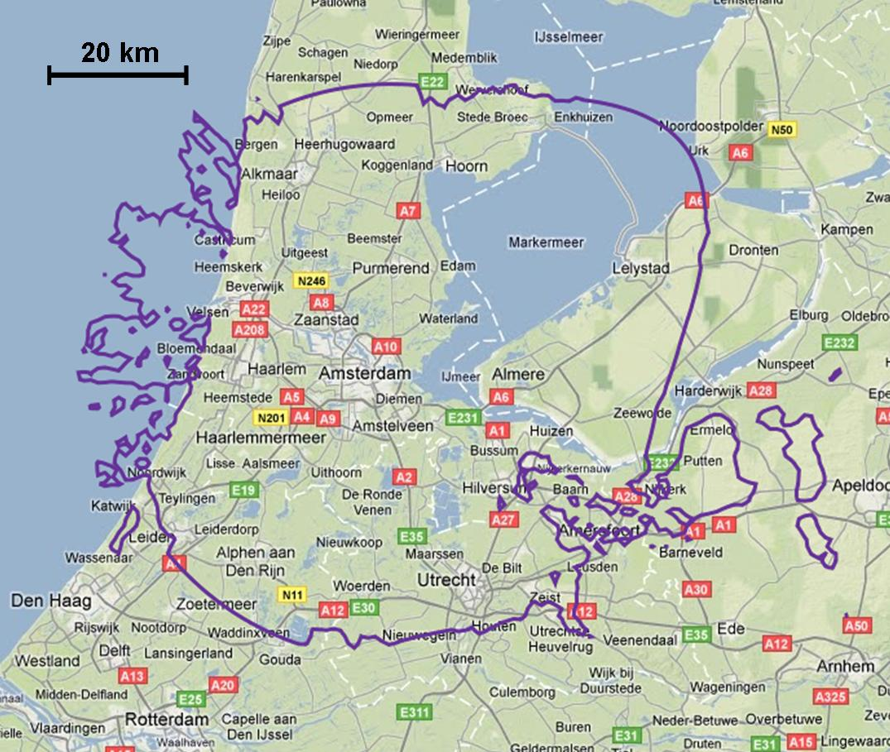

Figure B-2 to Figure B-5 show the results for the case of a BWA specific cellular deployment rural case, for azimuth pointings of 0°, 90°, 180° and 270° respectively.

Figure B-2

Simulation results BWA rural sectoral antenna (Azimuth : 0°)

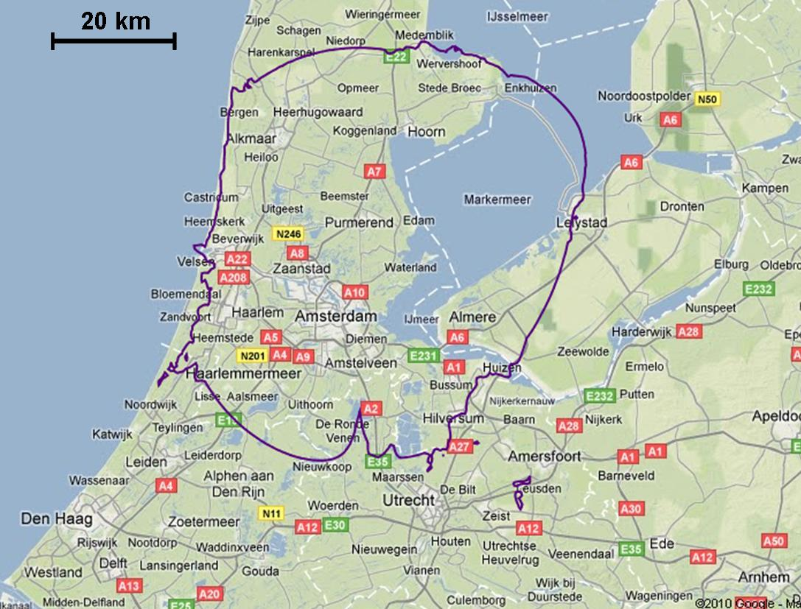

Figure B-3

Simulation results BWA rural sectoral antenna (Azimuth : 90°)

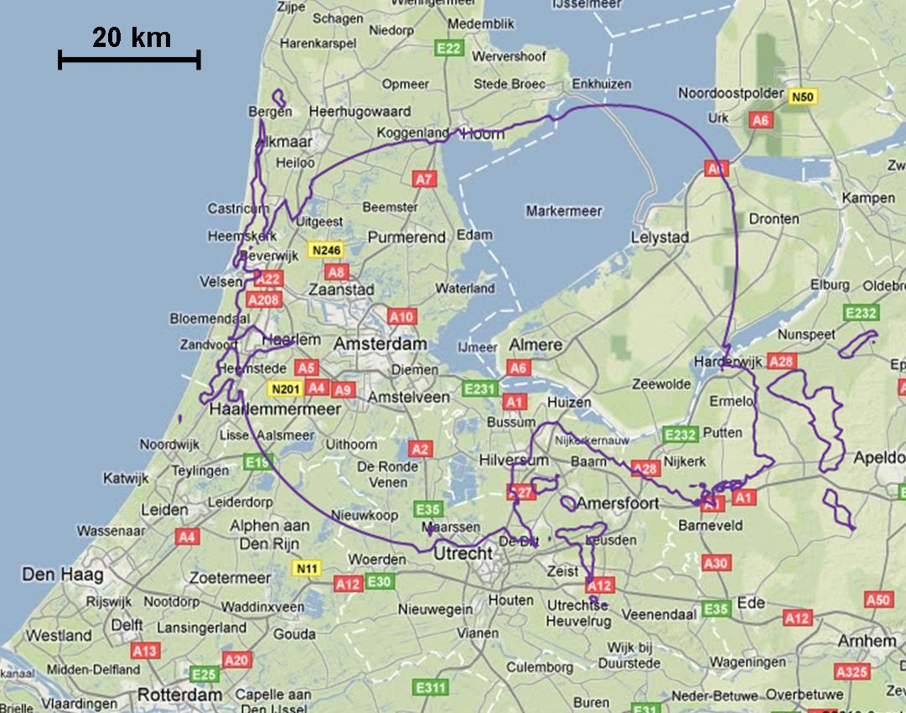

Figure B-4

Simulation results BWA rural sectoral antenna (Azimuth : 180°)

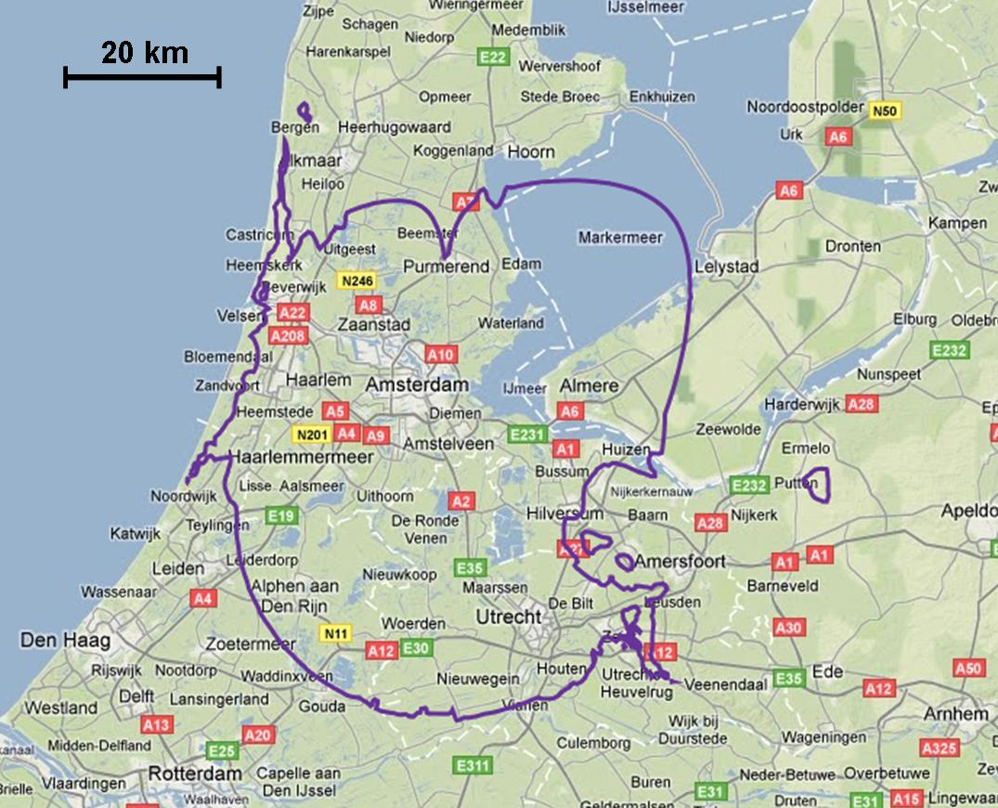

Figure B-5

Simulation results BWA rural sectoral antenna (Azimuth : 270°)

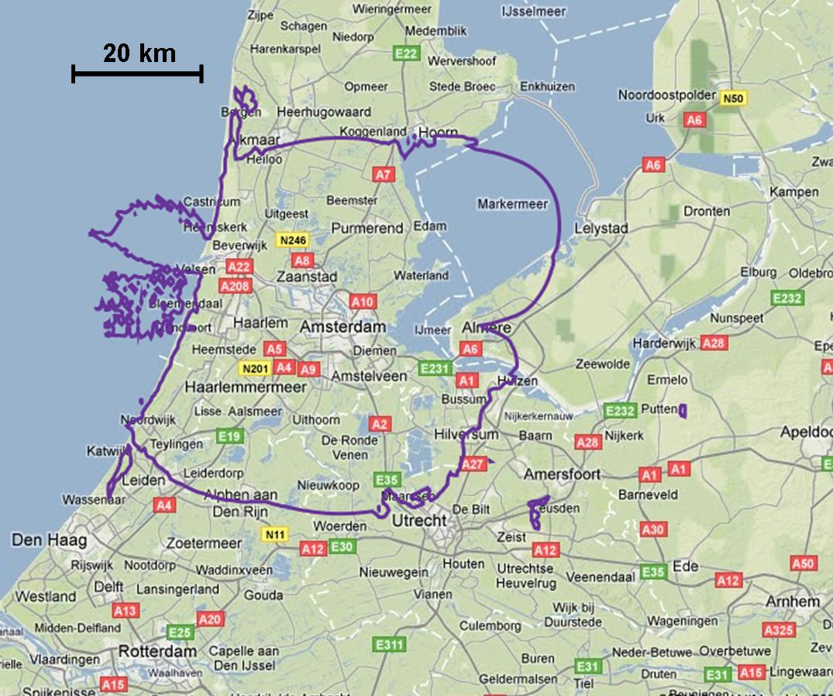

The contours shown in these results are different from the ones in the original study. However it is fair to say that they are in the same order of magnitude, even for different azimuth pointing angles of the sector antenna. They would also be in line with the results from the actual measurements done, i.e. covering the cases where clear interference was observed.

Figure B-6 shows the result for the case of a BWA typical cellular deployment urban case.

Figure B-6

Simulation results BWA urban omnidirectional antenna

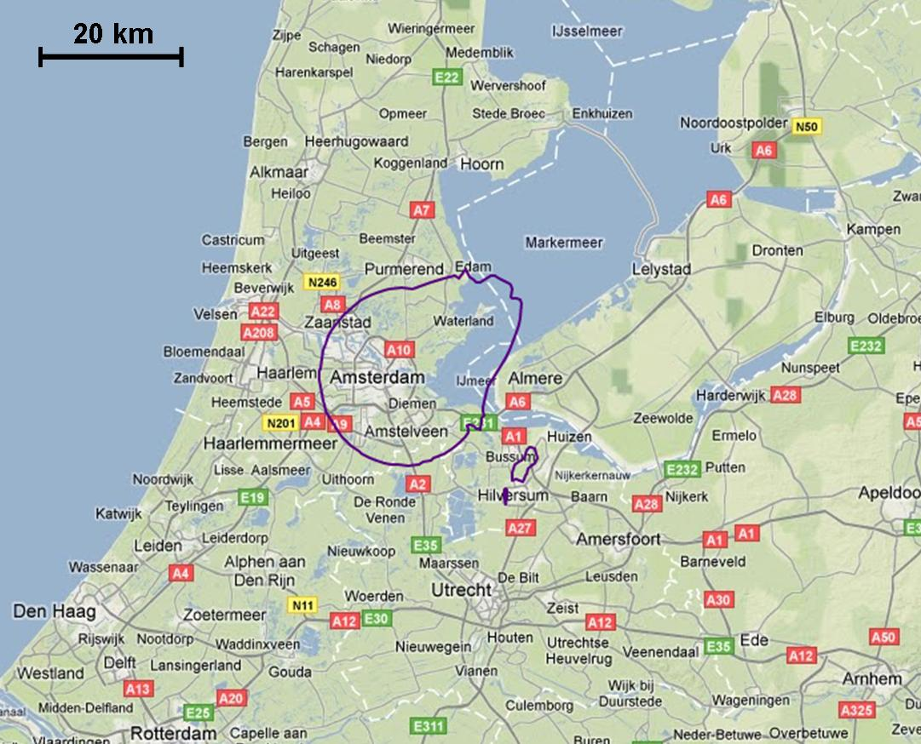

As expected, the contours related to the BWA omnidirectional antenna, used as a typical urban case, show shorter separation distances than in the case of the BWA sector antennas used in the specific rural case. However, although the actual BWA system deployed would have to be a typical urban system, as its targeted market is the city of Amsterdam, the contours shown in the plot do not match with the measurements performed during the campaign.

# 3 Conclusions

In the original study, a measurement campaign was set-up in order to make use of the presence of this operational WiMAX system, and to analyse the potential impact it can have on FSS signal reception in the same operating band.

In this study, the theoretical part of the analysis was updated based on the latest BWA base station and antenna parameters, as well as propagation model parameters as proposed by WP 5A.

Based on the results, it would seem that the WiMAX system that was deployed in Amsterdam, was using BWA base station parameters that were more in line with the parameters based on a specific rural cellular case than with the parameters based on a typical urban cellar case.

Annex C  
  
Draft Liaison statement to working Party 5A   
  
Compatibility of broadband wireless access systems and fixed-satellite   
service networks in the 3 400-4 200 MHz band

# 1 Introduction

Working Party 4A (WP 4A) thanks Working Party 5A (WP 5A) for its most recent liaison statement (Document [4A/294](http://www.itu.int/md/R07-WP4A-C-0294/en)). In this document, WP 4A will be commenting on a number of issues as they were raised in WP 5A’s liaison statement.

# 2 Clarification of antenna patterns

In its liaison statement WP 5A is providing WP 4A with the requested clarification as to which antenna patterns in Recommendation ITU-R F.1336 should be used for broadband wireless access (BWA). WP 4A wants to thank WP 5A for the clarification on the parameters to be used and the plots for both the omnidirectional and sectoral antenna patterns and will take these antenna patterns into account for their future studies

# 3 Propagation model parameters

WP 5A is recommending the use of the propagation models in Recommendation ITU-R P.452-13 in the compatibility studies, and is proposing in detail a number of parameters to use in this same Recommendation.

WP 4A has reviewed the proposed parameters, and is of the view that they should be used in the studies as much as is feasible, taking into account the following:

* In doing studies, different administrations employ different tools in doing so. It might be that certain tools have a very detailed implementation Recommendation ITU-R P.452-13, where every parameter can be modelled individually, but it is also possible that there are tools which have an implementation of Recommendation ITU-R P.452-13, where not every parameter can be configured individually. Further, there are tools that can only implement Recommendation ITU-R P.452-13 based on actual terrain data. In the view of WP 4A, both categories of tools can be used in developing studies for inclusion in the preliminary draft new Report, as long as the assumptions used in each study are clearly specified.
* The proposed parameters from WP 5A indicate a fixed latitude and longitude for the transmitting and receiving stations. It is not fully clear to WP 4A if this would mean that studies that would include the use of actual terrain data, would need to focus on this specific geographic area also.
* The fixed values related to the terrain characteristics would seem to limit the scope of the studies to one specific terrain characteristic. WP 4A sees value in also assessing the impact of actual terrain data in their studies.
* The use of clutter parameters should be done with great care, as Recommendation ITU-R P.452-13 clearly states that “*where there are doubts as to the certainty of the clutter environment, the additional loss should not be included*”. Therefore, WP 4A believes that the proposed clutter parameters should not be used for generally applicable studies.
* Some information is still lacking in order to determine aggregate interference effects. WP 4A is therefore looking for detailed information concerning frequency reuse on multiple sectorized antennas on one BWA station, and the way in which the same frequencies are re‑used in a cell like typical BWA system deployment.

# 4 Updated study from WiMAX Forum

WP 5A is drawing WP 4A’s attention to a recent study performed by the WiMAX Forum, which used the up-to-date set of characteristics for BWA. WP 5A thinks that this study would be a good reference point for further developing the studies between WP 4A and WP 5A. WP 5A indicates that it would appreciate any comment from WP 4A on it.

WP 4A understands that the study referred to above is contained in Document [5A/417](http://www.itu.int/md/R07-WP5A-C-0417/en) (“Input on working document towards preliminary draft new Report ITU-R S.[BWA-FSS]”).

WP 4A appreciates greatly the effort that has gone into this study and believes that it can be a valuable addition to the PDN Report and agrees that the new study should replace the previous study done by the WiMAX Forum as was contained in the PDN Report.

Further, WP 4A received a contribution with an extensive review of the WiMAX Forum study and believes that both documents could provide a valuable reference for further studies.

*[Editors note: It is proposed to update the preliminary draft new Report with the study contained in Annex A, and make reference to it accordingly in the final version of the liaison statement.]*

# 5 Other issues

WP 4A also received a contribution containing an update of the theoretical part of the measurement study as was done by SES WORLD SKIES in The Netherlands. WP 4A has updated the PDN Report to replace the theoretical part of the original study with the relevant parts of the new contribution.

*[Editorial note: The updated preliminary draft new Report is to be attached during the WP 4A meeting itself, after the meeting has agreed how it will be revised.]*

_________________

1. This expression is reproduced from expression (47) in Section 4.5.3 in Recommendation ITU-R P.452-13.
2. This table is Table 4 in Section 4.5.3 in Recommendation ITU-R P.452-13.