INTERNATIONAL TELECOMMUNICATION UNION
 | WRC-03 | WORLD  RADIOCOMMUNICATION  CONFERENCE | Corrigendum 1 to  Document 13-E
 | WRC-03 | WORLD  RADIOCOMMUNICATION  CONFERENCE | 26 May 2003
 | WRC-03 | WORLD  RADIOCOMMUNICATION  CONFERENCE | Original: English/  French/  Spanish
GENEVA, 9 JUNE – 4 JULY 2003 |  |  | Original: English/  French/  Spanish
PLENARY MEETING
European common proposals for the
work of the conference
The following updated Sections 21, 24, 27, 30, 35, 37, 40, 42 and 43 and Annexes 1, 2 and 3 supersede the corresponding ones in Document 13.
New material in Sections 27, 30 and 37 is provided in italics.

21 Agenda item 1.21 – Progress of the studies on terrestrial wireless interactive multimedia applications
In Resolution 737 (WRC-2000), ITU-R was invited to pursue its studies to facilitate the development of common, worldwide allocations or identification of spectrum suitable for new terrestrial wireless interactive multimedia technologies and applications. It was also invited to review regulatory methods and appropriate means of worldwide spectrum identification in order to facilitate the harmonization of emerging terrestrial wireless interactive multimedia systems for the instant and flexible implementation of universal personal services.
WRC-03 will, according to agenda item 1.21, consider the progress of the ITU-R studies and take decisions on further actions to be taken in order to be able to take appropriate decisions at WRC-07.
Taking the findings of JTG 1-6-8-9 into consideration, it is proposed to make some modifications to Resolution 737 (WRC-2000).

24 Agenda item 1.24 – 13.75-14 GHz
The ITU-R studies have identified a method (described as Method B in Section 1.4.3 of the CPM Report) in order to maintain the delicate balance between the services involved in sharing the band 13.75-14 GHz. This method is based on reducing the current limit on the minimum antenna size of FSS earth stations to 1.2 m and adding technical conditions which would adequately manage the interference caused by FSS earth stations into radiolocation, radionavigation and space research services.
Among these conditions, a single entry pfd limit (specified in the RR on a mandatory basis but not subject to compliance verification by BR) was left unspecified in the CPM Report: X dB(W/(m² · 10 MHz)) not to be exceeded for more than Y% of the time.
The adoption of this method (Method B) is proposed by Europe, with the values proposed in the CPM Report, and X = –113 dB(W/(m² · 10 MHz)), and Y = 0.5%. It is also proposed that all new limits established by WRC-03 only apply to antennas with a diameter smaller than 4.5 m.
The technical considerations used for the derivation of the values of X and Y are also provided for information.

27 Agenda item 1.27 – Appendices 30 and 30A and associated provisions
Europe considers that efforts should be pursued in order to promote equitable access to and efficient use of the 12 GHz bands by the BSS and the FSS. Europe, therefore, supports the technical assumptions developed by ITU-R (i.e. the range of antenna sizes and associated temperatures, a noise increase criterion of 6% and improved antenna patterns), and proposes that 60 cm and Recommendation ITU-R BO.1213 be the minimum size of antennas and the associated antenna pattern, respectively, to be taken into account in deriving the relevant pfd masks for Appendix 30. Also, concerning the sharing criteria contained in Appendix 30A, Europe proposes the harmonization of interregional criteria through a common ΔT/T criterion of 6%.
Europe also proposes that Annex 3 of Appendix 30 be replaced by Appendix 7, with appropriate parameters, for determining the need for a coordination of transmitting terrestrial or FSS earth stations with BSS receiving earth stations.
With respect to the use of BSS feeder-link assignments for GSO FSS (Earth-to-space) in the bands 14.5-14.8 GHz and 17.3-18.1 GHz, Europe considers that the situation is clear from a regulatory point of view and does not require any modification to the current Radio Regulations.
Europe also proposes that No. 5.491 be reflected in the table of Article 5 itself, as a primary allocation to the fixed-satellite service (space-to-Earth) in Region 3 in the band 12.2-12.5 GHz, and that No. 5.491 be suppressed, in line with Resolution 26 (Rev.WRC-97).
As grouping of networks in one orbital location is a necessity to enable administrations to modify the technical parameters of their assignments in the Plan or List, and as the continued application of this concept will have no impact upon any assignment in the Plan or the List, Europe considered that such grouping needs to, and should, be retained as it exists at present.
The Report of the Director of the Bureau to WRC-03 lists a number of inconsistencies related to Appendices 30 and 30A that would need to be fixed. In Sub-Parts B and D of Part 27, Europe proposes modifications to these Appendices in order to solve some of these inconsistencies.
At WRC-2000, the general conditions for the replanning of Appendices 30 and 30A were decided on the basis of a compromise which proposed in particular that, in applying the procedures for inclusion in the List of a new or modified assignment, “a provision similar to S11.41 should also be included to allow recording in the List (or in the MIFR) on a provisional basis”. This resulted in the addition of provisions 4.1.18 to 4.1.20 of Article 4 of Appendix 30. The discussions in the Special Committee and the CPM identified several difficulties with these provisions and possible solutions to them. In Sub-Part C of Part 27, Europe proposes to adopt Option 3 of Section 3.2.3.1 of the CPM Report and rely on technical/regulatory steps to ensure that:
a) The application of § 4.1.18 against an assignment which is subject to a Plan does not result in any reduced protection from interference caused by future comers.
b) If interference in excess of the applicable Annex 1 levels is caused to an assignment in the Plan, which was the basis of a disagreement, and is operated in conformity with the Plan, the administration using the frequency assignment included in the List under § 4.1.18 shall, upon receipt of advice thereof, immediately eliminate this interference.
c) When requesting the application of § 4.1.18, the notifying administration undertakes to meet the requirements of § 4.1.20 and provide to the administration in respect of which § 4.1.18 has been applied, with a copy to the Bureau, a description of the steps by which it undertakes to meet these requirements.
It is considered that the above steps respond to the difficulties raised in the CPM Report in relation to maintaining the provisions of § 4.1.18 to 4.1.20 in Appendices 30 and 30A.
It is also considered that, amended as proposed, these provisions would fully protect the Regions 1 and 3 Plans and Lists, hence not affect their integrity, nor the integrity of non-planned services in Regions 1 and 3. For this reason, it is therefore proposed that the applicability of provisions 4.1.18 to 4.1.20, as amended, be confirmed in respect of the services of Region 2. For reciprocity reasons, Region 2 may also wish to consider adopting similar provisions to be included in § 4.2 of Appendices 30 and 30A in order to facilitate modifications to the Region 2 Plans.

30 Agenda item 1.30 – Advance publication, coordination and notification of satellite networks, Resolution 86 (Minneapolis, 1998)
At the present time there is nothing in the Radio Regulations which indicates which version of the RR is to be used by the Bureau when processing notices. This is particularly important when there is a considerable backlog and there could be 2-3 years difference between the date of submission of the notice and the date of processing of it by the Bureau. The Bureau presently uses the version in effect as of the date of receipt of the notice. Europe proposes to reflect this in the Radio Regulations.
Europe has noted a possible problem in No. 9.5D with the inclusion of the reference to both No. 9.1 and No. 9.2 and is proposing a minor change to No. 9.5D.
Europe is proposing to include in the Radio Regulations the substance of the Rule of Procedure dealing with the application of No. 9.21.
Appendix 5 indicates which assignments are to be taken into consideration by later filings, but does not include assignments that have been recorded under No. 11.41. Europe is submitting a proposal to correct this deficiency.
Europe is proposing to include the limits of Resolution 34 into Article 21 and consequently suppress Resolution 34.
Some changes are proposed to Resolution 49 (Rev.WRC-2000) which include the changes suggested by the CPM as well as the requirement for administrations to update the data previously published.
Resolution 86 (Rev.Marrakesh, 2002) requested WRC-03 to determine the scope and the criteria to be used for the implementation of this resolution. To this end, Europe is proposing a draft resolution for WRC-03, which includes six elements.
Through Resolution 88 (Rev.Marrakesh, 2002), PP-02 agreed on the date of entry into force (1 August 2003) for the provisions of WRC-2000 dealing with the consequences of non-payment of the cost recovery fees and requested WRC-03 to implement this decision. To this effect, Europe is proposing some changes to these footnotes and a draft Resolution.
Resolution [COM5/6] (Marrakesh, 2002) requests WRC-03 to develop some principles on the development of the Rules of Procedure by the RRB. Europe is proposing some additions to Article 13 to include some steps to be applied by the RRB, BR and administrations in the development of the Rules of Procedure. These steps are intended to increase the transparency of the work of the RRB and based on the positive experience of webcasting at PP-02, to require the RRB meetings to be webcasted.
In order to provide the possibility for an administration to retain its rights despite launch problems, Europe proposes to separate the other cases listed after No. 11.44B from those regarding an extension of the date of bringing into use, due to a launch failure or to a launch delay beyond the control of the administration.
As an answer to the decision of the Council in Resolution 1182 on the backlog in the processing of satellite network filings, the RRB adopted a provisional revision to the Rules of Procedure for No. 9.36 extending the application of the coordination arc to the unplanned BSS bands as well as other bands for the FSS. Europe proposes that WRC-03 confirm this revision by adopting consequential changes to Appendix 5, as outlined in the CPM text. Europe also proposes to adopt a Resolution requesting studies for possible extension of the coordination arc concept to other frequency bands and other services.
Europe also proposes to adopt a Resolution requesting studies leading to the rationalization of Articles 9 and 11 relating respectively to coordination and notification procedures, with a view to facilitate their reading and their application by administrations and the Bureau.
Finally, Europe proposes the removal of duplications and inconsistencies identified in Appendix 4 as a result of the ITU-R studies (see § 3.4.1. of the CPM Report).

35 Agenda item 1.35 – Report of the Director of the Radiocommunication Bureau on the results of the analysis in accordance with Resolution 53 (Rev.WRC-2000)
In response to Resolution 53, the Bureau is expected to provide WRC-03 with Tables identifying administrations/networks/beams that may be affected, or may affect Regions 1 and 3 Plan assignments, as a result of its compatibility analysis.
Meanwhile, ITU-R has been progressing towards new sharing criteria that are expected to significantly reduce the number of necessary coordinations. Also, following the adoption of a new Rule of Procedure on No. 9.35, the assignments identified by the Bureau’s analysis have not been examined with respect to their conformity with No. 11.31, which may result in undue coordination requirements.
Europe is making proposals aimed at addressing all these aspects in a satisfactory manner.

37 Agenda item 1.37 – Satellite networks using highly elliptical orbits
Europe proposes that satellite networks using HEOs continue to be considered as non-GSOs, hence subject to the same regulatory provisions as other types of non-GSOs, such as MEOs and LEOs. Europe also considers that there is no need to define HEO in the Radio Regulations.
Concerning the sharing between non-GSO systems using HEOs and GSO networks, Europe proposes:
– In the band 1 467-1 492 MHz, which is allocated worldwide to the BSS (sound) and complementary terrestrial broadcasting (sound) service, and subject to Resolution 528, to replace the application of No. 22.2 by the application of Nos. 9.12, 9.12A and 9.13 for coordination among non-GSO and GSO BSS (sound) systems.
– No regulatory change (NOC) in the bands allocated to MSS below 3 GHz (No. 9.11A applies and no special measures are needed to facilitate the development of HEO systems).
– In the bands 3 400-4 200 MHz and 5 725-6 725 MHz, inclusion of epfd limits in Article 22 in order to ensure an appropriate sharing environment between geostationary-satellite networks and non-geostationary-satellite systems. The proposed limits correspond to a 1% noise increase into typical GSO FSS links.
– No regulatory change (NOC) in the bands: 10.7-11.7 GHz (space-to-Earth), 11.7-12.2 GHz (space-to-Earth) in Region 2, 12.2-12.75 GHz (space-to-Earth) in Region 3, 12.5-12.75 GHz (space-to-Earth) in Region 1, 12.75-13.25 GHz (Earth-to-space), 13.75-14.5 GHz (Earth-to-space), 17.8-18.6 GHz (space-to-Earth), 27.5-28.6 GHz (Earth-to-space) and 29.5-30 GHz (Earth-to-space).
– In the bands 19.7-20.2 GHz, where current limits may be too stringent for HEOs, a review of these limits is required.
Concerning sharing with terrestrial services, Europe supports the adoption of appropriate technical criteria and associated regulatory provisions wherever required to ensure the protection of terrestrial services from HEOs, in particular in the following bands: 620-790 MHz, 1 452-1 492 MHz, 2 310-2 360 MHz and 2 520-2 670 MHz.
In the bands 3.4-4.2 GHz, 10.7-12.75 GHz and 17.7-19.7 GHz, which are shared between HEO FSS and FS, Europe supports the modification of Article 21 to include, on a provisional basis, new pfd limits to be applied to HEO satellites and to be further confirmed by WRC-07. For the 37.5-42.5 GHz band, it is proposed to further study whether the Article 21 pfd limits for non-GSO systems (see the ECP on agenda item 1.32) could also be applied to HEO satellites.

40 Agenda item 2 – Revised ITU-R Recommendations incorporated by reference
Taking into account the suggestion in Section 6.2 of the CPM Report, Europe proposes amendments to Resolution 27 (Rev.WRC-2000) in order to provide more precise direction regarding when and where to introduce new instances of incorporation by reference, and to allow administrations to submit proposals to future conferences to amend editorially those references to ITU-R Recommendations of a non-mandatory character with a view to referring to “the most recent version” of the Recommendations with necessary justification.

42 Agenda item 7.1 – Report of the Director of the Radiocommunication Bureau and Resolution 80 (Rev.WRC-2000)
Noting Section 3.5.3 of the Report of the Director of the Bureau to WRC-03, which addresses several matters related to the application of provisions of Appendix 30B, Europe proposes to reduce the time-limits for sending comments following the publication of the calculations made by the Bureau, in line with the current Rules of Procedure, and to correct the inconsistencies contained in the current provisions relating to the regulatory time-limits for bringing into use and for notifying an assignment after its successful application of the procedures of Article 6 of Appendix 30B.
Also, in the context of Appendix 30B, Europe proposes to amend Resolution 49 (Rev.WRC-2000) to solve the inconsistency mentioned in Section 3.6.4 of the Report of the Director of the Bureau.
Europe also proposes to modify the definition of a geostationary satellite in Article 1 of the Radio Regulations, noting the lack of precision of the current definition.
Finally, Europe proposes two mutually exclusive approaches in order to clarify the application of Resolution 77 (WRC-2000), while allowing an equitable treatment of Region 2 FSS, on the one hand, and Regions 1 and 3 BSS, on the other hand, in respect of terrestrial services. The proposals made are linked with those made under agenda item 1.27 in relation to § 4.1.18 to 4.1.20 of Appendices 30 and 30A (Part 27C).

43 Agenda item 7.2 – Agenda for future WRCs
Europe proposes the suppression of Resolution 801 (WRC-2000) and its replacement by a new resolution recommending to the Council the adoption, for WRC-07, of an agenda comprising 21 items in its main part (resolves 1). Details are provided for each of the proposed items in order to identify, in particular, the scope of the studies required, the ITU-R groups involved and the potential difficulties.
With regard to subsequent conferences, Europe also proposes that WRC-03 adopts a Resolution for a preliminary agenda for WRC-10, containing five specific items.

Annexes: 3
Annex 1
List of CEPT coordinators WRC-03
WRC-03 agenda item | Issue | CEPT Coordinator | Picture | E-mail address
 |  | Overall coordination: François Rancy, F | 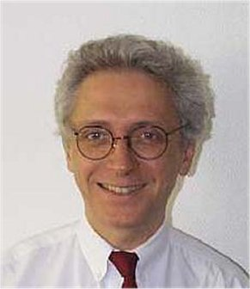 | francy@compuserve.com
1.1 | Country footnotes | Alfred Goetschi, SUI | 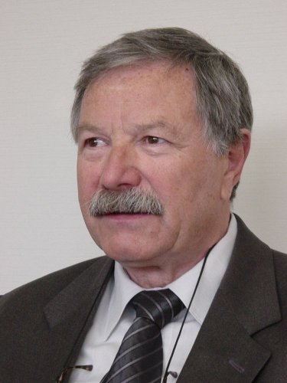 | alfred.goetschi@bakom.admin.ch
1.2 | New modulation techniques for HFBC | G.O. Towler, G |  | geoff.towler@ra.gsi.gov.uk
1.3 | Harmonized bands for public protection, emergency situations and disaster relief | Enrico Tosato, I | 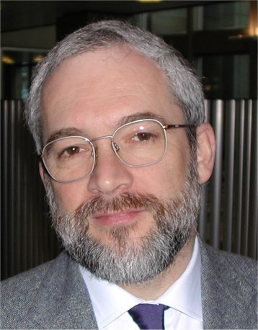 | e.tosato@interbusiness.it

WRC-03 agenda item | Issue | CEPT Coordinator | Picture | E-mail address
1.4 | Review of FSS (non-GSO MSS feeder uplinks) and ARNS allocations at 5 091-5 150 MHz | Torsten Jacob, D |  | torsten.jacob@dfs.de
1.5 | New allocations to MS, FS, EESS and SRS and review of RLS at 5 150-5 725 MHz | Steve Bond, G |  | stephenbond1@compuserve.com
1.6 | Non-GSO MSS feeder-link protection at 5 150-5 250 MHz | Steve Bond, G |  | stephenbond1@compuserve.com
1.7 | Amateur and amateur-satellite services | Jaap Steenge, HOL | 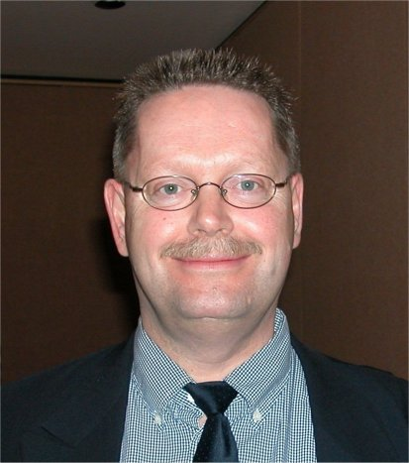 | jaap.steenge@at-ez.nl
1.8 | Unwanted emissions  1.8.1 | Yves Ollivier, F | 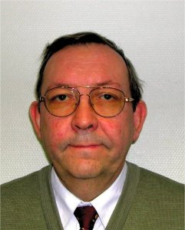 | ollivier@anfr.fr

WRC-03 agenda item | Issue | CEPT Coordinator | Picture | E-mail address
 | 1.8.2 | Willem Baan, HOL |  | baan@astron.nl
1.9 | Deletion of Appendix 13 and Resolution 331 (Rev.WRC-97) | Trond Olsen, NOR |  | Trond.olsen@npt.no
1.10 | Maritime mobile | Trond Olsen, NOR |  | Trond.olsen@npt.no
1.11 | AMSS secondary allocation at 14-14.5 GHz | Anthony Baker, HOL | 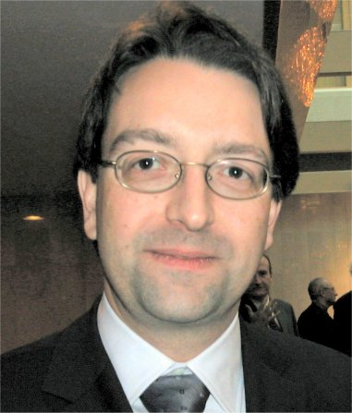 | abaker@newskies.com
1.12 | Allocations to space science services | Angel Diez de Frutos, E |  | Angel.diez@setsi.mcyt.es

WRC-03 agenda item | Issue | CEPT Coordinator | Picture | E-mail address
1.13 | HAPS | Pekka Ollikainen, FIN | 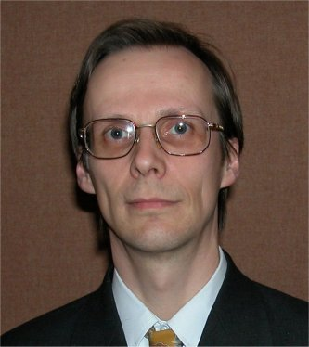 | Pekka.Ollikainen@ficora.fi
1.14 | Harmful interference in maritime mobile and aeronautical mobile (R) and review of HF/MF channels for digital use | Antonio Di Rauso, I | 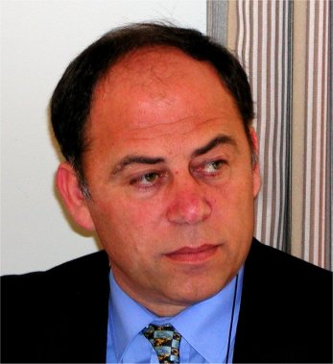 | Antonio.dirauso@istsupcti.it
1.15 | RNSS sharing conditions | Hugues de Bailliencourt, F |  | bailliencourt@anfr.fr
1.16 | Worldwide allocations around 1.4 GHz for feeder links to non-GSO MSS under 1 GHz | Titus Spoelstra, HOL |  | spoelstra@astron.nl
1.17 | Upgrade of radiolocation to primary at 2 900-3 100 MHz | Holger Lüschow, D | 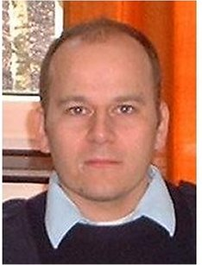 | holger.lueschow@bundeswehr.org

WRC-03 agenda item | Issue | CEPT Coordinator | Picture | E-mail address
1.18 | Primary allocation to FS at 17.3-17.7 GHz in Region 1 | Benoist Deschamps, F |  | deschamps@anfr.fr
1.19 | Misapplication of non-GSO FSS single entry limits | Antonio Coimbra, POR | 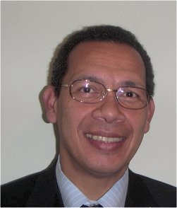 | antonio.coimbra@anacom.pt
1.20 | Additional allocations to MSS under 1 GHz | Petri Lehikoinen, FIN | 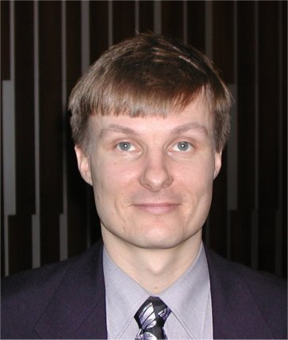 | Petri.lehikoinen@ficora.fi
1.21 | Terrestrial wireless interactive multimedia applications | Jan-Erik Lejerkrans, S | 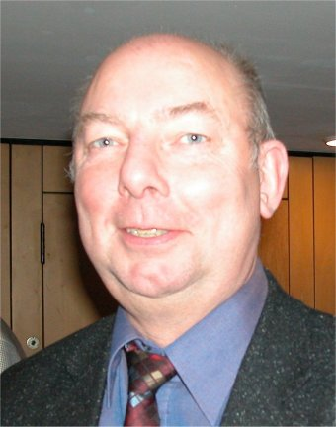 | Jan-erik.lejerkrans@pts.se
1.22 | IMT-2000 and beyond | Pasi Toivonen, FIN |  | pasi.toivonen@ficora.fi

WRC-03 agenda item | Issue | CEPT Coordinator | Picture | E-mail address
1.23 | Realignment of amateur, amateur-satellite and BS around 7 MHz | Jan Verduijn, HOL |  | Jan.verduijn@at-ez.nl
1.24 | 13.75-14 GHz | Jean Chartier, F | 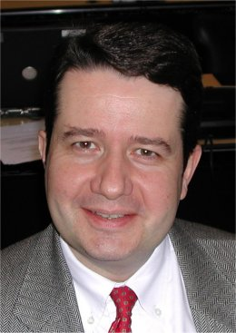 | chartier@anfr.fr
1.25 | HDFSS above 17.3 GHz | Benoist Deschamps, F |  | deschamps@anfr.fr
1.26 | Earth stations on board vessels | Anders Frederich, S |  | anders.frederich@telia.com
1.27 | Review of Appendix 30/30A procedures and sharing criteria | Cristina Garcia de Miguel, E |  | mcgarcia@hispasat.es

WRC-03 agenda item | Issue | CEPT Coordinator | Picture | E-mail address
1.28 | RNSS differential correction signals at 108-117.975 MHz | John Shaw, G |  | john.shaw@ra.gsi.gov.uk
1.29 | Non-GSO/GSO sharing | Fernando Guerra, POR | 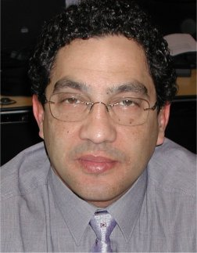 | fernando.guerra@anacom.pt
1.30 | Resolution 86 (PP-98) | Gary Brooks, LUX | 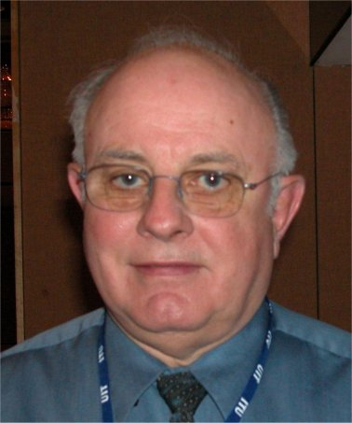 | gbrooks@ca.inter.net
1.31 | MSS allocations at 1-3 GHz | Victor Glushko, RUS | 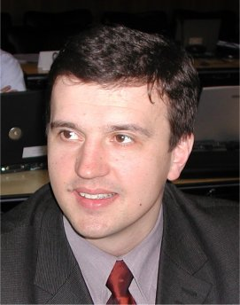 | npf@geyser.ru
1.32 | Sharing at 37.5-43.5 GHz | Marc Le Dévendec, F | 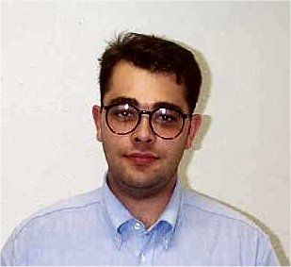 | mledevendec@compuserve.com

WRC-03 agenda item | Issue | CEPT Coordinator | Picture | E-mail address
1.33 | HAPS within IMT-2000 | Antonio Loureiro, POR | 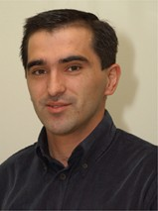 | antonio.loureiro@anacom.pt
1.34 | Non-GSO BSS (sound) sharing with IMT-2000 at 2 630-2 655 MHz | Chris Cheeseman, G |  | chris.cheeseman@bt.com
1.35 | Report of the Director, BR on the results of Resolution 53 (Rev.WRC-2000) analysis | Cristina Garcia de Miguel, E |  | mcgarcia@hispasat.es
1.36 | HFBC allocations at 4-10 MHz | Jan Verduijn, HOL |  | Jan.verduijn@at-ez.nl

WRC-03 agenda item | Issue | CEPT Coordinator | Picture | E-mail address
1.37 | Highly elliptical orbit systems | Kumar Singarajah, LUX  (HEO BSS sound) | 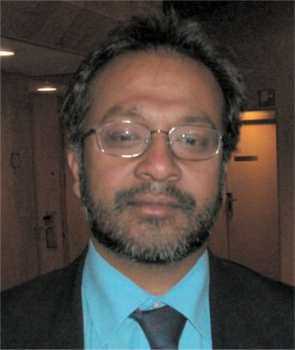 | ksingarajah@globalradio.lu
 |  | Philippe Tristant, F  (other HEO) | 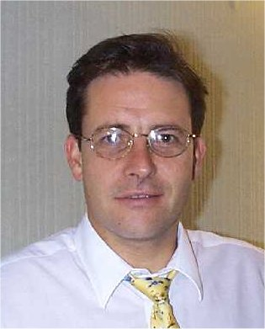 | tristant@anfr.fr
1.38 | EESS at 420-470 MHz | Björn Rommen, HOL |  | bjorn.rommen@esa.int
1.39 | FSS requirements for TT&C below 17 GHz for networks with service links above 17 GHz
2 | Revised ITU-R Recommendations incorporated by reference | John Shaw, G |  | John.shaw@ra.gsi.gov.uk

WRC-03 agenda item | Issue | CEPT Coordinator | Picture |  | E-mail address
3 | Consequential changes to the RR | François Rancy, F |  |  | francy@compuserve.com
4 | Review of Resolutions and Recommendations of previous conferences | John Shaw, G |  |  | John.shaw@ra.gsi.gov.uk
5 | Radiocommunication Assembly report | François Rancy, F |  |  | francy@compuserve.com
6 | Urgent action by ITU-R study groups in preparation for the next WRC | François Rancy, F |  |  | francy@compuserve.com
7.1 | Report of the Director, BR on the activities of ITU-R | Resolution 80:  Anders Frederich, S |  |  | anders.frederich@telia.com
7.1 | Report of the Director, BR on the activities of ITU-R | Other issues:  Gilles Taillefer, F |  |  | taillefer@anfr.fr
WRC-03 agenda item | Issue | CEPT Coordinator | Picture |  | E-mail address
7.2 | Agendas of future conferences | Joachim Strick, D | 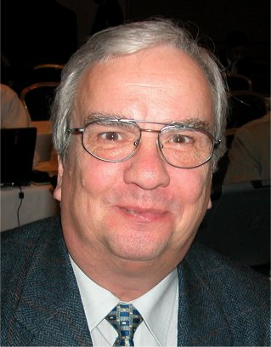 |  | strick@bmwi.bund.de
ANNEX 2
Structure of the European Common Proposals to WRC-03 and
correspondence with WRC-03 agenda items
Document | Title | Agenda items
Main document | European Common Proposals for the work of the Conference | All
Addendum 1 | Review of countries’ footnotes | 1.1
Addendum 2 | New modulation techniques in HFBC | 1.2
Addendum 3 | Harmonized bands for Public Protection and Disaster Relief (PPDR) | 1.3
Addendum 4 | Use of the band 5 091-5 150 MHz by the FSS | 1.4
Addendum 5 | Allocations in the frequency range 5 150-5 725 MHz | 1.5
Addendum 6 | Protection of MSS feeder links in the band 5 150-5 250 MHz | 1.6
Addendum 7 | Amateur services | 1.7
Addendum 8 | Issues related to unwanted emissions,  boundary between spurious and out-of-band emissions | 1.8.1
Addendum 8 | Issues related to the protection of passive services | 1.8.2
Addendum 9 | Maritime distress and safety | 1.9
Addendum 10 | Exhaustion of the maritime mobile service identity numbering resource (Resolution 344 (WRC-97)) | 1.10
Addendum 11 | AMSS (Earth-to-space) secondary allocation at 14 GHz | 1.11
Addendum 12 | Allocations to space science services | 1.12
Addendum 13 | HAPS outside IMT-2000 bands | 1.13
Addendum 14 | Maritime mobile and aeronautical mobile (R) services | 1.14

Document | Title | Agenda items
Addendum 15 | Radionavigation-satellite service | 1.15
Addendum 16 | Non-GSO MSS feeder links around 1.4 GHz | 1.16
Addendum 17 | Radiolocation at 2 900-3 100 MHz | 1.17
Addendum 18 | Allocation to the fixed service at 17 GHz | 1.18
Addendum 19 | Misapplication of the non-GSO FSS single entry limits in Article 22 | 1.19
Addendum 20 | Additional allocations for non-GSO MSS below 1 GHz | 1.20
Addendum 21 | Terrestrial wireless interactive multimedia applications | 1.21
Addendum 22 | Future development of IMT-2000 and systems beyond IMT-2000 | 1.22
Addendum 23 | Realignment of the allocations at 7 MHz | 1.23
Addendum 24 | Sharing conditions in the band 13.75-14 GHz | 1.24
Addendum 24 (Add.1) | Sharing conditions in the band 13.75-14 GHz  Technical considerations, for information | 1.24
Addendum 25 | High density systems in the fixed-satellite service | 1.25
Addendum 26 | Earth stations on board vessels | 1.26
Addendum 27 | Appendices 30 and 30A and associated provisions  Sub-Part 27A | 1.27
Addendum 27 (Add.1) | Appendices 30 and 30A and associated provisions  Sub-Parts 27B, 27C and 27D | 1.27
Addendum 28 | RNSS differential correction signals at 108-117.975 MHz | 1.28
Addendum 29 | Sharing between non-GSO and GSO systems | 1.29
Addendum 30 | Resolution 86 (Minneapolis, 1998)  Sub-Parts 30A to 30I | 1.30
Addendum 30 (Add.1) | Resolution 86 (Minneapolis, 1998)  Sub-Parts 30J to 30M | 1.30
Addendum 31 | New allocations to the mobile-satellite service | 1.31
Addendum 32 | Sharing at 37.5-43.5 GHz | 1.32
Addendum 33 | HAPS within IMT-2000 bands | 1.33
Addendum 34 | Resolution 539 (WRC-2000) | 1.34
Addendum 35 | Report of the Director, BR on the results of Resolution 53 (Rev.WRC-2000) analysis | 1.35
Addendum 36 | HF broadcasting from about 4 MHz to 10 MHz | 1.36
Addendum 37 | Satellite networks using highly elliptical orbits (Sub-Part 37A) | 1.37
Addendum 37 (Add.1) | Satellite networks using highly elliptical orbits (Sub-Parts 37B and 37C) | 1.37

Document | Title | Agenda items
Addendum 38 | EESS (active) at 420-470 MHz | 1.38
Addendum 39 | FSS TT&C requirements below 17 GHz | 1.39
Addendum 40 | Revised ITU-R Recommendations incorporated by reference | 2
Addendum 41 | Report of the Director, BR on the activities of the ITU-R | 7.1
Addendum 42 | Agendas of future conferences | 7.2
Annex 3
List of co-signatures of the European Common Proposals
(ECPs) for WRC-03
(To be provided on 1 June 2003)

__________________

