INTERNATIONAL TELECOMMUNICATION UNION
 | WRC-03 | WORLD  RADIOCOMMUNICATION  CONFERENCE | Addendum 1 to  Addendum 24 to  Document 13-E
 | WRC-03 | WORLD  RADIOCOMMUNICATION  CONFERENCE | 5 May 2003
 | WRC-03 | WORLD  RADIOCOMMUNICATION  CONFERENCE | Original: English/  French/  Spanish
GENEVA, 9 JUNE – 4 JULY 2003 |  |  | Original: English/  French/  Spanish
PLENARY MEETING
Information Document
european common proposals
Derivation of the single entry power flux-density limits applicable to FSS earth stations with antenna diameter smaller than 4.5 m at 13.75-14 GHz

Technical considerations used for the derivation of the single entry power flux-density limits applicable to FSS earth stations with antenna diameter smaller than 4.5 m (values X and Y) are provided hereafter for information.

1 Rationale
i) to review the factors which influence the degree of protection needed for the radars;
ii) to determine contours identifying the minimum sizes of the “quasi-non-deployment zones” which would allow given values of X and Y to be met. In this context the term “quasi-non-deployment zone” means a strip of land immediately inside the country’s border, or along the coast, within which FSS earth stations using the band 13.75-14 GHz could either not be deployed, or could be deployed with sufficient local site-shielding to meet X and Y.
A trade-off between i) and ii) leads to suitable values for X and Y.

2 Definition of the coastline
Europe proposes the use of widely accepted terminology embodied in the United Nations Convention on the Law of the Sea, as the proper definition of “coastline”. In the 1982 United Nations Convention on the Law of the Sea (hereinafter “Convention”) the baseline is the recognized line along the coast for measuring the breadth of the territorial sea and other maritime zones.
Europe is not in favour of the term “normal baseline”, which is currently used in the CPM Report in relation to agenda item 1.24. The “normal baseline” is only a part of the total system to determine the “baseline”. In Article 5 of the Convention the low-water line is described as the normal baseline, but the variety of geographical circumstances makes that in practise the low-water line, not the baseline for most coasts. This is recognized by the Convention and particular rules are laid down for special geographical circumstances. Therefore all the rules in relation to the determination of the baseline as laid down in the Convention need to be taken into account to actually determine the baseline.
Europe proposes to use the term “baseline as defined in United Nations Convention on the Law of the Sea 1982 (coastline)”, which makes clear that the coastline is equal to the baseline.

3 Ranges of X and Y
The low end of the range is determined by coordination trigger values proposed by JTG 4-7-8 in the case of sharing between a fixed radar terminal and a fixed earth station, i.e. an I/N ratio of –6 dB at the input to the radar receiver not to be exceeded for more than 0.01% of the time. As agreed in the JTG 4-7-8, X is calculated at the coastline with the radar antenna pointing landward, assuming a given value of I/N received by a radar antenna at the territorial waters boundary. Based on a configuration #2 radar antenna with a gain of 37.5 dBi in the direction of the interference, radar system noise N of 2 300 K, an I/N of –6 dB at the territorial waters boundary, 6 dB transmission loss between the coast and that boundary, and 0.5 dB increase in system noise when pointing radar antenna toward land, X_{low} works out to be about per 10 MHz. Y_{low} is 0.01% of time.
The high end of the range of X is determined by allowing for a 6 dB increase in the interference level and also allowing for the fact that the gain of a configuration #1 radar antenna in the direction of the interference is about 29.1 dBi, i.e. 8.4 dB lower than in the case of a configuration #2 antenna. Thus X_{high} works out to be about –103 dB(W/m²).
The overall probability of a ship’s radar being adversely impacted by interference exceeding X is the joint probability of several events, i.e. involving the probability of the propagation loss being sufficiently low (p_{p}), the probability of the ship being in the vicinity of the worst point on the coast for the FSS earth station concerned (p_{s}), the probability of the earth station being active (i.e. transmitting) (p_{a}), and the probability of a radar target within the range limit being on a bearing near to that of the earth station (p_{t}). Simple analyses suggest that each of these probabilities is relatively low, and assuming no correlation the joint probability would be p_{p} × p_{s} × p_{a} × p_{t}. Whilst there may be a degree of correlation between p_{s} and p_{t}, it follows that even a value as high as 0.1 for p_{p} would correspond to the probability of adverse impact being very much smaller than 0.1. Since it is the variation in propagation loss which causes the interference level to vary, Y is equivalent to p_{p}. Hence the value selected for Y_{high} was 10% of time.

4 Impact of X on radar system
The I/N threshold value of –6 dB had been selected in order to limit the reduction in the range of a radar system due to interference to about 5%. The range is understood to be the maximum distance from the radar terminal for which targets can reliably be acquired and tracked. On the basis that the level of the reflected signal received by a radar terminal is inversely proportional to the fourth power of the distance to the target, and that in the absence of interference the limit of the range occurs when the received signal is equal to the system noise level, we may write:

10 log[(i + n)/n] = 10 log[1/(1 – r)]⁴

where:
i: the level of interference (I = 10 log(i))
n: the system noise level (N = 10 log(n))
100 r %: the range reduction.
Transposing this equation yields r = 1 – (1 + 10^{0.1(I/N)})^{–0.25}. Since it has been shown above that X = –118 dBW/m² at the coast corresponds to an I/N of –6 dB at the territorial waters boundary for radar beam configuration #2, the value of X corresponding to the same level of interference in the case of radar beam configuration #1 is some 8 dB higher, i.e. . Thus the fact that X is directly proportional to I/N allows the above equation to be used to plot the range reduction as a function of X for each beam configuration, and this is done in Fig. 1.

5 Derivation of contours to identify “quasi-non-deployment zones”
The factors affecting the minimum distance from the coast at which an earth station must be placed in order to just meet a given value of X, and hence the sizes of quasi-non-deployment zones, are:
a) the value of Y (i.e. the percentage of time for which X may be exceeded);
b) the climate and the nature of the terrain between earth station and coast;
c) the angle between the principal axis of the earth station’s antenna and the minimum-loss path to the coast;
d) the e.i.r.p. of the earth station within a 10 MHz sub-band in the band 13.75-14 GHz.
From Factors a), b), c) and d), the single-entry pfd (X) may be calculated from:
X = e.i.r.p. (in 10 MHz) – maximum earth station antenna gain + antenna gain in the direction of the radar – path loss exceeded for all but Y% of time – 10 log(λ²/4π) dB(W/m²)
Hence, by fixing the e.i.r.p. for representative antenna sizes, the value of X is simply determined by the path loss. The e.i.r.p. values given in the following Table were selected for the present analysis. They are based on a review of the e.i.r.p. and bandwidths of 14 GHz carriers in the responses to Circular CA/90 issued by BR on behalf of JTG 4-7-8, and on e.i.r.p. corresponding to various sizes of antenna with Recommendation ITU-R S.1428 radiation patterns just meeting the off-axis e.i.r.p. density requirements of Recommendation ITU-R S.728.

Diameter range (m) | > 4.5 | 3.1-4.5 | 2.1-3.1 | 1.5-2.1 | 1.2-2.5
Reference diameter (m) | 9.0 | 4.5 | 2.4 | 1.8 | 1.2
e.i.r.p. in 10 MHz E (dBW) | 72 | 65 | 55 | 50 | 44
On-axis gain, G_{M} (dBi) | 60.5 | 54.4 | 49.0 | 46.5 | 43.0

Since the range of X in § 3 above is from –118 to –103 dB(W/m²), it was convenient to take four values of path loss spanning a similar range for which the off-axis e.i.r.p. levels resulting from c) and d) above would yield values of X within that range, i.e. path losses of 163 dB, 158 dB, 153 dB and 148 dB. By using the above expression, with the assumption of a discrimination angle of 30°, curves relating X with the diameter of the earth station antenna are plotted in Fig. 2, which also gives curves for intermediate values of path loss.

6 Impact of contours on FSS
Each contour defines the zone between itself and the coastline within which the deployment of FSS earth stations would be constrained. Hence a contour is unlikely to be acceptable to the FSS community if it is either wholly or in part at too great a distance from the coastline. There are a number of factors that affect the severity of this constraint, e.g. the size of the country, the population distribution, the types of FSS application to be provided, the terrain, etc., and these vary from country to country.

7 Determination of acceptable values for X and Y
In Fig. 1 it can be seen that values of X toward the high end correspond to rather large reductions in radar range. On the other hand, values of X toward the low end correspond to large path losses, as may be seen in Fig. 2, and hence to large quasi-non-deployment zones.
Based on these considerations and on simulation results presented in Attachments 1 and 2, a single-entry interference corresponding to a value of –113 dB(W/(m² · 10 MHz)) not exceeded for more than 0.5% of the time at the coastline would:
a) reduce the range of a radar at the territorial waters boundary, in the direction of the earth station concerned, by only 3% for a configuration #1 radar or by 14% for a configuration #2 radar, for << 0.5% of the time; and
b) allow the great majority of FSS earth stations with antenna diameters > 1.2 m to be deployed without site-shielding in all but an acceptably small proportion of the land mass of a typical country with non-hilly terrain, a typical country with medium terrain, and a typical country with hilly terrain, all in temperate zones.
The percentage of time for which a radar terminal would actually have its range reduced by the earth station’s emission would be the percentage of time for which a coincidence of the following four situations occurs: the propagation loss is less than a given value, the ship is at the territorial boundary and on or close to the minimum path-loss bearing, the earth station is transmitting, and a radar target is within range and on or close to the bearing of the earth station. Thus if Y was 0.5%, the radar range would be reduced for << 0.5% of the time.
ATTACHMENT 1
First set of simulations
The propagation data and algorithms in Recommendations ITU-R P.452 and ITU-R P.526 have been used to evaluate the loss exceeded for any given percentage of time over any great-circle path on the earth’s surface, given the terrain height profile for that path. Software incorporating the GLOBE terrain database, given the geographical coordinates of the path, determines whether it is a line-of-sight or trans-horizon path, and then calculates the path loss exceeded for a given percentage of time by the methods in those Recommendations. In the present case the heights of the radar and FSS antennas were assumed to be 36 m and 1.2 m, respectively.
By constructing a computer model of a given geographical area including a coastline, containing a large number of equally-spaced FSS earth stations inland and radar terminals at small intervals along the coastline, it was possible to compute the loss on the path between each earth station and each radar terminal. Then, by selecting the minimum loss path from each earth station, the worst-case single entry interference path to the coast (and its loss) was identified for that earth station. Finally, by considering all earth stations for which the worst-case path losses were nearest to a given value, a contour corresponding to that value could be plotted on a map of the area concerned. The numbers of earth stations and radar terminals included in the three models constructed to date are:
medium terrain (Southern England) – 1 058 earth stations – 79 radar terminals – 83 582 paths;
non-hilly terrain (Mississippi) – 2 956 earth stations – 154 radar terminals – 455 224 paths;
hilly terrain (Southern Turkey) – 2 400 earth stations – 125 radar terminals – 300 000 paths.
In this manner contour maps were produced for each of the three example terrain areas. Each map contains four contours corresponding to minimum path losses to the coast of 148 dB, 153 dB, 158 dB and 163 dB not exceeded for a given percentage of time. The land between any one of the contours and the coastline is the quasi-non-deployment zone corresponding to the path loss associated with that contour.
Contours for 0.5% of the time are given in Figs. 3 to 5.

FIGURE 3
148 dB
153 dB
157 dB
163 dB

163 dB
Southern England
30 km
50°N
0°E
Plymouth
Torquay
Exeter
Taunton
Salisbury
Bournemouth
Southampton
Portsmouth
Brighton
Guildford
Tunbridge Wells
Contours for a medium hilly terrain and 0.5% of the time
FIGURE 4
Contours for a non-hilly terrain and 0.5% of the time
100 km
Mississippi Basin
Shreveport
30°N
90°W
Monroe
Vicksburg
Jackson
Montgomery
Columbus
Alexandria
Houston
Baton Rouge
New Orleans
Mobile
Tallahassee
148 dB
153 dB
157 dB
163 dB
FIGURE 5
Contours for a hilly terrain and 0.5% of time
50 km
Karaman
36°N
30°E
Southern Turkey
Nazilli
Konya
Antalya
Mut
Adana
Sevhan
Maras
Antioch
148 dB
153 dB
157 dB
163 dB
ATTACHMENT 2
Second set of simulations
The analysis was based on typical parameters to be used for VSAT type of operations, i.e. antenna diameter of 1.2 m, input power density of –50 dB(W/Hz) and an operating bandwidth of 300 kHz.
Geographical terrains within Europe have been considered. The coastline of The Netherlands has been chosen as an example of a flat terrain. The coastline around Monaco is taken as an example of hilly terrain, and the area around the Polish city of Gdansk was deemed interesting since it provides an example of a “hybrid” terrain of both flat and hilly terrain areas.
Based on the latitude and coastline direction information of these different terrain areas, an assessment can be made for the off-axis angle θ to be used in the analysis. It was found that the off-axis gain in the direction of the coastlines can be set to –10 dBi.
With the help of simulation software, a computer model can be created for each geographical terrain of interest, where a large number of FSS earth stations are uniformly deployed over land. The distances between these earth stations are typically less than 9 km. The height of the FSS earth stations above the terrain was taken to be 4 m. Further, at the coastline, radar terminals are deployed at distances of less than 10 km apart. The height of the radiolocation stations above the sea level was taken to be 36 m.
Contours for 0.5% of the time are given in Figs. 6 to 8.

FIGURE 6
Contours for a medium hilly terrain and 0.5% of the time
FIGURE 7
Contours for a non-hilly terrain and 0.5% of the time
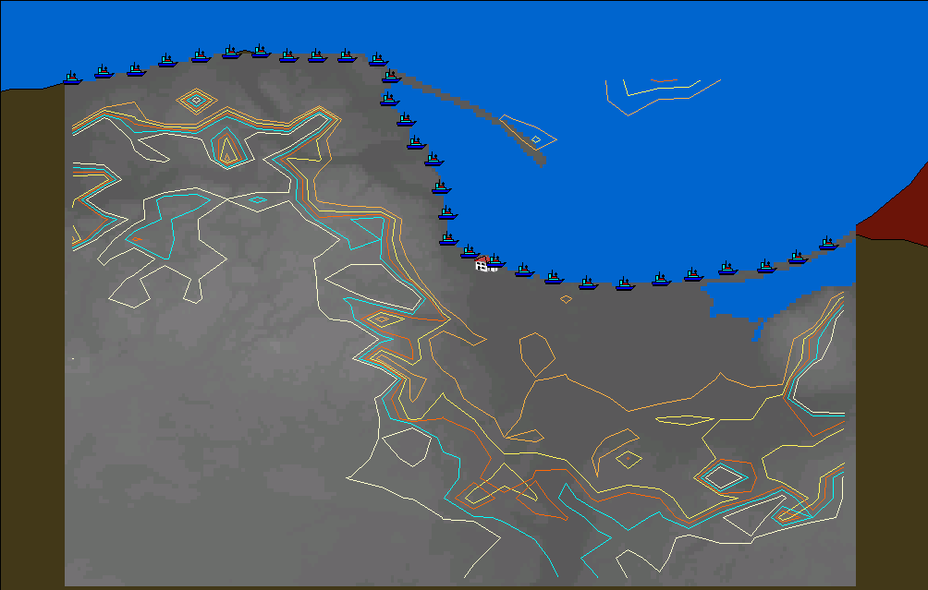
25km
25km
-126.0
-111.2
-105.2
-115.2
-120.0
Pologne (Gdansk)
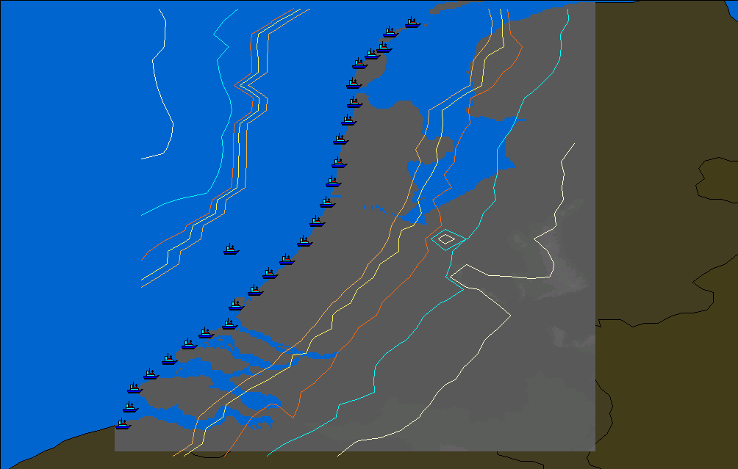
25km
25km
-126.0
-111.2
-105.2
-115.2
-120.0
The Netherlands
FIGURE 8
Contours for a hilly terrain and 0.5% of time
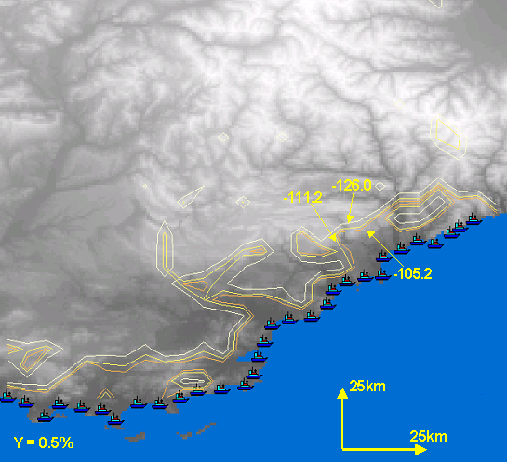
Monaco
ATTACHMENT 3
Radiolocation antenna configurations
(Source: Document JTG 4-7-8/29)

The two radiolocation antenna configurations used in assessing interference between FSS and the radiolocation service are as follows:
Configuration #1
For this assessment, Beam 1F shall be considered as the sole beam being used by the radiolocation station.
Configuration #1 – Search main beam patterns
Antenna  position | El beamwidth (degrees) | El beam  centre (degrees) | Gain  (dB) | Az beamwidth (degrees)
1F | 10 | 4.5 | 31.5 | 2.2

Configuration #2
For this assessment, Beam 1F shall be considered as the sole beam being used by the radiolocation station.
Configuration # 2 – Search main beam patterns

Antenna  position | El beamwidth  (degrees) | El beam centre  (degrees) | Gain  DB | Az beamwidth  (degrees)
1F | 2.5 | 0 | 37.5 | 2.2

The gain patterns for the two configurations of beam element 1F may be expressed in graphical form as shown hereafter.

_________________

This gain was estimated assuming that the interference arrives at 0° elevation and the radar beam, which has 4.5° elevation and a vertical beamwidth of 10°, has a parabolic roll-off; hence G = 31.5 – 12(4.5/10)² = 29.1 dBi.
Using Recommendation ITU-R S.1428 the gain of the earth station in the direction of the radar would be –7.9 dBi for the 1.2 m and 1.8 m antennas and –10.3 dBi for the others.

