INTERNATIONAL TELECOMMUNICATION UNION
 | WRC-03 | WORLD  RADIOCOMMUNICATION  CONFERENCE | Document 13-E
 | WRC-03 | WORLD  RADIOCOMMUNICATION  CONFERENCE | 25 March 2003
 | WRC-03 | WORLD  RADIOCOMMUNICATION  CONFERENCE | Original: English/  French/  Spanish
GENEVA, 9 JUNE – 4 JULY 2003
PLENARY MEETING
EUROPEAN COMMON PROPOSALS FOR THE
WORK OF THE CONFERENCE
This contribution presents the European common proposals for WRC-03. These have been developed by the CEPT Conference Preparatory Group (CPG). As in past conferences, the intent of these proposals is to provide timely and effective response to emerging radiocommunication needs while maximizing efficient use of the spectrum, protecting current services and their expected development, and enabling equitable access to frequencies by all countries and systems.
The European administrations welcome the opportunity offered by WRC-03 for in-depth discussions with the other ITU administrations on the issues included in this conference agenda. To this effect, coordinators have been designated for each agenda item to act as point of contact with the other administrations to contribute to the efforts of the Conference in arriving at decisions that can be supported by all ITU countries. Annex 1 to this contribution provides the list of European coordinators for each of the WRC-03 agenda items.
The main part of this contribution contains a summarized presentation of the European common proposals. The detailed proposals are provided in 43 addenda to this contribution, one per agenda item of the conference. The table of contents for these addenda is provided in Annex 2. The table of co-signatures by European administrations is provided in Annex 3.

1 Agenda item 1.1 – Deletion of country names from footnotes of Article 5
Europe is not making common proposals under this agenda item.

2 Agenda item 1.2 – New modulation techniques for HFBC
Europe supports the introduction of digital modulation techniques into the HF broadcasting bands and considers that digital modulation should be introduced into the HF bands as soon as practicable. However, Europe also considers that there should not be a timetable set at this point in time for the cessation of analogue AM DSB transmissions.
A definitive date for the availability of the WARC-92 extension bands could help to promote the introduction of digital modulation techniques by giving more flexibility to resolve the scheduling difficulties that may arise during the transition from AM DSB to digitally modulated emissions.

3 Agenda item 1.3 – Harmonized bands for PPDR
Europe supports the identification of the band 380-470 MHz as frequency tuning range for the public protection and disaster relief (PPDR) by a Resolution. This will allow administrations to determine as appropriate, given their national conditions and requirements at a national level, how much spectrum and where within the frequency tuning range, can be made available for future advanced public protection and disaster relief applications.
Within this frequency tuning range administrations are urged to use, to the maximum extent possible, the band 380-385/390-395 MHz as a core global harmonized band for permanent public protection activities.
It is recognized that frequencies for disaster relief operations falling within the frequency tuning range could be planned and used for other purposes in normal time.
Additional frequency tuning ranges for public protection and disaster relief need further studies on the operational and spectrum requirements. Therefore an agenda item needs to be included in the agenda of WRC-07.

4 Agenda item 1.4 – Non-GSO MSS feeder links and ARNS at 5 GHz
Following “Method C” of the CPM Report, Europe proposes the suppression of Resolution 114 (WRC-95), the postponement to 2018 of the date at which the current allocation to MSS feeder link will become secondary, and keeping to 2008 the date to which no new assignments shall be made to stations providing feeder links of non-geostationary mobile-satellite systems.

5 Agenda item 1.5 – MS, FS, EESS, SRS and RLS at 5 GHz
Europe proposes new primary allocations to the mobile service in the bands 5 150-5 350 and 5 470-5 725 MHz for the implementation of wireless access systems including RLANs ensuring the implementation of mitigation techniques to protect the existing primary services and the radiolocation service. For the band 5 150-5 250 MHz, this proposal is linked to the outcome of WRC-03 discussions on agenda item 1.6.
Europe considers that a possible new allocation to the fixed service in Region 3 in the band 5 250-5 350 MHz should ensure protection of the Earth exploration-satellite (active) and space research services in this band and should not prevent the worldwide primary allocation to the mobile service as proposed above.
Europe proposes an additional primary allocation to EESS (active) in the frequency range 5 460-5 570 MHz subject to no additional constraints to the worldwide primary allocation to the mobile service proposed above. Furthermore, Europe will not oppose any proposal for an allocation to SRS (active) within the frequency range 5 460-5 570 MHz.
Europe proposes the upgrade of the status of the radiolocation service in the frequency range 5 350-5 650 MHz. In the band 5 470-5 650 MHz the upgrade is also seen as a consequence to the worldwide primary allocation to the mobile service proposed above. In the band 5 460-5 570 MHz the upgrade is also seen as a consequence to the worldwide primary allocation to EESS proposed above.

6 Agenda item 1.6 – Protection of non-GSO MSS feeder links at 5 150-5 250 MHz

Europe proposes the following regulatory measures in order to allow the successful introduction of mobile applications in this band, whilst ensuring the protection of the MSS feeder links:
– the transmission limits and indoor usage restrictions for RLANs contained in Recommendation ITU-R M.1454 should be inserted in the Radio Regulations;
– a resolution inviting the ITU-R to continue work on regulatory mechanisms and further mitigation techniques to avoid incompatibility which may result from aggregate interference from a possible prolific growth in the number of RLAN devices.

7 Agenda item 1.7 – Amateur and amateur-satellite services

7.1 Agenda item 1.7.1 – Possible revision of Article 25
For the sake of simplification and to better reflect present requirements, Europe proposes modifications and deletions for some articles, in particular for Nos. 25.1, 25.2, 25.2.A, 25.3, 25.7, 25.8 and 25.11. Europe also proposes to recognize the contribution of radio amateurs to disaster mitigation through modifications to Article 25.
Regarding the mandatory requirement for the testing of Morse code skills for those seeking to operate an amateur station below 30 MHz, Europe proposes to amend No. 25.5 in such a way that administrations may waive the mandatory Morse code requirement.
With respect to Recommendation ITU-R M.1544, Europe opposes to incorporate this Recommendation in No. 25.6, because of possible national legal implications. Furthermore, Europe considers that the Recommendation already has proved its validity in practice and that support via the Radio Regulations is not required.

7.2 Agenda item 1.7.2 – Review of the provisions of Article 19 concerning the formation of call signs in the amateur services
Article 19 currently limits the issuance of amateur call signs. To offer administrations the flexibility to occasionally issue temporary call signs, Europe proposes to modify No. 19.68 to allow four trailing characters and to add No. 19.69A to allow temporary use of more than four trailing characters in special occasions such as national and international championships, conferences, anniversaries etc. Europe further proposes to suppress No. 19.49 as it prohibits certain call sign combinations commencing with a digit.
Europe furthermore proposes to add No. 19.82A regarding the insertion of amateur and experimental stations into Section IV (identification of stations using radiotelephony). Apparently amateur and experimental stations have been missing from this section because of an omission.

7.3 Agenda item 1.7.3 – Review of the terms and definitions of Article 1 to the extent required as a consequence of changes made in Article 25
Europe proposes not to change any provision in the RR as a consequence of the proposals to Article 25.

8 Agenda item 1.8 – Unwanted emissions

8.1 Agenda item 1.8.1 – Boundary between spurious and out-of-band emissions
Europe proposes to amend Article 1 and Appendix 3 to take into account the most recent ITU-R studies identifying the unwanted emissions to which the limits of Appendix 3 Section II apply, by providing specific exceptions from the general 2.5 B_{n} boundary based on Recommendations ITU-R SM.1539 and ITU-R 1541 (Method A in the CPM Report).

8.2 Agenda item 1.8.2 – Protection of passive services from unwanted emissions
In the case of terrestrial services, the ITU-R “band-by-band” studies have shown that the EESS (passive) protection criteria are met in some bands without restrictions on the deployment of terrestrial systems or in other bands using appropriate mitigation techniques. These mitigation techniques should not place any unacceptable constraints on the terrestrial services concerned. It is proposed that WRC-03 consider whether the results of these “band-by-band” studies are appropriate to be included within the Radio Regulations. It is additionally proposed to identify bands where further work is needed and where regulatory measures may be needed at WRC-07.
For the protection of radio astronomy, the compatibility analysis with active services has shown that any potential interference as a result of unwanted emissions from terrestrial services can be resolved on a national basis. However in some cases there are discrepancies between levels of unwanted emissions specified in the design phase of space stations and the requirements of the radio astronomy service in order to meet their protection requirements. Based on the results of ITU-R studies, Europe proposes to specify limits for some bands where studies in the DNR [BbB] have concluded that the RAS protection criteria may be met and that the limits would not unduly constrain the development of active services. In some other bands it is proposed to set up threshold levels. It is additionally proposed to identify bands where further work is needed and where regulatory measures may be needed at WRC-07.

9 Agenda item 1.9 – Maritime distress and safety
Europe proposes no change to Appendix 13, but a number of amendments are proposed to Resolution 331 (WRC-97) in order to reflect the developments that have occurred after 1997. To clarify that safety messages transmitted by coast stations should only be announced by DSC if sent outside the scheduled broadcast timetable, Europe proposes a suitable amendment to Article 33.
The international use of Morse telegraphy for distress and safety communications at the frequency 500 kHz ceased on 1 February 1999. International operator certificates for Morse telegraphy are therefore no longer needed. Europe accordingly proposes appropriate amendments to Articles 47 and 55.

10 Agenda item 1.10

10.1 Agenda item 1.10.1 – Exhaustion of the maritime mobile numbering resource
Europe proposes amendments to Article 19 in order to:
– remove any ambiguity from Article 19 and ITU Recommendations which could be interpreted as a requirement for future mobile service and mobile-satellite service systems to imbed the MMSI within their numbering space;
– permit administrations to demonstrate use of 80% of assigned MID resources without requiring certain government vessels, which may require anonymity, to be published in List V; and
– make provision for the creation of special group calls which include all coast stations in the world (00 MID 0000) where the MID would be a special reserved MID = 999 and could also be used for other applications where an MID assigned to particular administrations may not be appropriate.
Europe further proposes amendments to Resolution 344 (WRC-97) in order to provide authority to the Director of the Radiocommunication Bureau to manage the allotment and distribution of the MID resource within the MMSI numbering format, and to continue active monitoring of the use of the MID and MMSI resources and make a status report to each WRC.

10.2 Agenda item 1.10.2 – Shore-to-ship communication
Europe proposes editorial amendments to Resolution 348 (WRC-97) in order to reflect technical and organizational developments that have occurred since 1997.

11 Agenda item 1.11 – Secondary allocation to the mobile-satellite service (Earth-to-space) in the band 14-14.5 GHz
Europe proposes a secondary allocation to the aeronautical mobile-satellite service (Earth-to-space) in the 14-14.5 GHz band by removing the phrase “except aeronautical mobile-satellite” from the current MSS secondary allocation, and the suppression of Resolution 216 (WRC-2000).
In addition, Europe recognizes that some CEPT administrations operate fixed service or radio astronomy systems in the 14.25-14.5 GHz band and accepts that some of these administrations will propose to WRC-03, on a national basis, country footnotes that would specify the necessary protection in the Radio Regulations as detailed in DNR ITU-R M.[AMSS] in order to make the technical and operational constraints imposed to AMSS stations that could impact the stations on their territory.

12 Agenda item 1.12 – Allocations to space science services
Europe proposes:
– A primary allocation to the space research service (Earth-to-space) in the band 7 145-7 235 MHz, with the sub-band 7 145-7 190 MHz restricted to deep space operations.
– The suppression of the ISS allocation in the range 32-32.3 GHz.
– An additional primary allocation to the space research service (space-to-Earth) in the band 25.5-27 GHz. Furthermore, Europe will oppose the upgrading of the existing secondary allocation to the space research service in the 14.8-15.35 GHz band.
– To replace the current restrictions for active spaceborne sensors in 35.5-36 GHz. (RR 5.551A) by a limit of –73.3 dBW/m² in any 2 GHz band for angles greater than 0.8° from the sensor beam centre, through a new footnote.
– To make no new allocation to space science services in the band 36-37 GHz, but to adopt a Resolution requesting the ITU-R to conduct sharing analyses between passive services and the fixed and mobile services in the band 36-37 GHz, and to define sharing criteria.
– To make no change to the space research service (space-to-Earth) allocation in the band 37-38 GHz.

13 Agenda item 1.13 – HAPS
The general aim of Europe is the protection of existing services in the bands studied for the introduction of HAPS, i.e. in the bands 3-32 GHz and around 47 GHz. Generally, Europe considers there is no need for additional identification of frequency bands for HAPS.
Under Resolution 122 (Rev.WRC-2000), power-density levels from HAPS shall be limited in order to protect passive satellite-sensing applications, which operate globally in the 31 GHz band.
Under Resolution 734 (WRC-2000), no studies have been performed and the introduction of HAPS in the 3-18 GHz range is not supported. Therefore, Europe considers there is no need to change current allocations for the possible introduction of HAPS and proposes the deletion of Resolution 734.

14 Agenda item 1.14 – Harmful interference in the MMS and AM(R)S and review of MF/HF channels for digital use
Europe proposes modifications to Article 52 and a new Resolution. These proposals contain the minimum modifications required in the Radio Regulations and its appendices in order to:
– maintain the WRC-2000 decision making the frequencies 12 290 kHz and 16 420 kHz exclusive for distress and safety communications;
– permit MRCCs to use these two frequencies for limited general calling for safety-related communications, subject to certain safeguards;
– support the development and the introduction of digital technology to supplement or replace existing analogue technology in the maritime MF and HF bands.
Furthermore, Europe proposes a new resolution and modifications to Appendix 17 to facilitate the introduction of digital technology in the Morse telegraphy and NBDP bands between 1 605 and 27 500 kHz, whilst maintaining the provisions for the use of Morse telegraphy within these bands.

15 Agenda item 1.15 – Radionavigation-satellite service (RNSS)
Under this agenda item, WRC-03 will have to take major decisions for the future of the radionavigation-satellite service. The European proposals on this issue are aimed at allowing a clear regulatory framework enabling the timely development of RNSS in the bands allocated by WRC-2000 to the RNSS downlinks, under conditions that ensure equitable access to all RNSS systems and a fully protected environment to the radiolocation, aeronautical radionavigation, radionavigation and radio astronomy services.
The European Union is developing a European radionavigation-satellite system, Galileo, the space segment of which will be implemented by the European Space Agency. It is being designed as an independent, global, civil-controlled system, which will be used, together with other RNSS systems,
as the basis for the second-generation global navigation-satellite system, GNSS-2. Galileo will provide open service and safety of life service, both services being free of charge and two levels of controlled access services (commercial and secured service). The combined use of several RNSS systems will improve performance for the benefit of users worldwide.
a) Resolution 604: RNSS (space-to-Earth) in the band 5 010-5 030 MHz
Europe supports the inclusion in the Radio Regulations, through a new Resolution, of limits on unwanted emissions in terms of pfd for GSO RNSS networks and epfd for non-GSO RNSS systems.

b) Resolution 605: RNSS (space-to-Earth) in the band 1 164-1 215 MHz
Europe supports the adoption of an aggregate epfd limit of –121.5 dB(W/(m²/MHz)) to protect ARNS. The compliance with this limit is proposed to be ensured cooperatively through consultation meetings by administrations operating RNSS. Moreover, it is proposed to ensure that all potential RNSS system operators are given full visibility of the process but that only real systems are taken into account in the calculation of the aggregate epfd.
In addition to the aggregate limit, Europe proposes the application of pfd limits per RNSS satellite, in order to ensure the equitable sharing of the power/frequency resource between the different RNSS systems. The proposed values are:
–118 dB(W/m²) in the band 1 164-1215 MHz
–129 dB(W/m²) in any 1 MHz.
c) Resolution 606: RNSS (space-to-Earth) in the band 1 215-1 300 MHz
Europe proposes to ensure the protection to the radiolocation and aeronautical radionavigation services through the addition of these services in footnote No. 5.329, at the same level as the radionavigation service, in the entire band 1 215-1 300 MHz.
d) Coordination between RNSS in the band 1 164-1 300 MHz, 1 559-1 610 MHz and 5 010-5 030 MHz.
Finally, Europe is of the view that full coordination under Article 9 should apply retroactively in all RNSS downlink frequency bands. This coordination process will enable discussions to take place under clear conditions between administrations having or planning RNSS systems, in order to ensure the compatibility of these systems.

16 Agenda item 1.16 – Allocations to non-GSO MSS feeder links around 1.4 GHz
Europe does not support new allocations under this agenda item and proposes the suppression of Resolution 127 (WRC-2000).

17 Agenda item 1.17 – Upgrading of radiolocation status at 2 900-3 100 MHz
Europe supports the unconstrained upgrade to primary status of the allocation to the radiolocation service in the frequency range 2 900-3 100 MHz.

18 Agenda item 1.18 – Primary allocation to the fixed service at 17.3-17.7 GHz in Region 1
In line with the single Method of Section 4.2.3 of the CPM Report, Europe proposes that no primary allocation be made to the fixed service in the band 17.3-17.7 GHz.

19 Agenda item 1.19 – Misapplication of the non-GSO FSS single-entry limits
In line with the conclusions of the CPM, Europe considers that no further study or regulatory action is necessary on this matter and therefore proposes the suppression of Resolution 135 (WRC-2000).

20 Agenda item 1.20 – Allocations to non-GSO MSS below 1 GHz
Europe proposes NOC to the Table of Frequency Allocations below 1 GHz for non-GSO MSS, and the suppression of Resolution 214 (Rev.WRC-2000).

21 Agenda item 1.21 – Progress of the studies on terrestrial wireless interactive multimedia applications
There is no European Common Proposal on this agenda item at this time.

22 Agenda item 1.22 – IMT-2000 and systems beyond IMT-2000
Prerequisite studies for the identification of spectrum (market estimates, appropriate methodology to estimate spectrum needs, spectrum forecasts, identification of candidate frequency bands, including the compatibility studies) are not finalized. Europe therefore proposes to make no change to the Table of Frequency Allocations of the Radio Regulations at WRC-03 under this agenda item, but to revise Resolution 228 as included in the CPM Report, i.e. identifying the requirements for further work in the ITU-R on the spectrum-related issues. It is also proposed that the spectrum requirements for the future development of IMT-2000 and systems beyond IMT-2000 be considered by WRC-07.

23 Agenda item 1.23 – Realignment of the allocations to the amateur, amateur-satellite and broadcasting services around 7 MHz
Europe supports the realignment, involving the minimum necessary shift in allocation blocks in order to limit the economic impact on users. The sharing of frequency bands by amateur and broadcasting services on a regional or interregional basis is undesirable and should therefore be avoided.
Europe therefore proposes a globally harmonized allocation of 300 kHz to the amateur service, that could partly be shared with the fixed and land-mobile services. Europe also proposes a globally harmonized allocation of a block of 250 kHz to the broadcasting service.
Europe considers that consequential changes in the allocations around 7 MHz must take into account the need of the fixed and mobile services operating in this frequency range and should be made only on a balanced basis between all services involved. Within this process, the upgrading of the secondary land mobile service to a mobile except aeronautical mobile (R) primary status should also be considered.
Europe recognizes the impact of a major frequency realignment and therefore proposes a two stage process, with an early access for the radio amateur service in the band 7 100-7 200 kHz.
Europe also proposes that further consideration of HF allocations at WRC-07 exclude re-examination of the decisions of WRC-03 under this agenda item.

24 Agenda item 1.24 – 13.75-14 GHz
There is no European Common Proposal on this agenda item at this time.

25 Agenda item 1.25 – HDFSS
In line with Method B of Section 4.3.3.2 of the CPM Report, Europe proposes that the following bands be made available for HDFSS applications on a global basis: 19.7-20.2 GHz (downlink), 39.5-40.5 GHz (downlink), 27.5-27.8285 GHz (uplink), 28.4445-28.8365 GHz (uplink), 29.4525-29.5 GHz (uplink), 29.5-30 GHz (uplink).
With a view to making them available for HDFSS by the application of Method B of Section 4.3.3.2 of the CPM Report, Europe also proposes that the following bands be allocated to the FSS (space-to-Earth) on a primary basis: 17.3-17.7 GHz in Regions 1 and 3 and 47.5-47.9 GHz, 48.2-48.54 GHz and 49.44-50.2 GHz in the three regions.
Generally, Europe does not support that bands shared with terrestrial services be made available on a global basis for HDFSS applications. In particular, the following bands are not proposed to be made available for HDFSS applications on a global basis: 17.7-19.7 GHz (downlink), 37-39.5 GHz (downlink), 40.5-42.5 GHz (downlink), 27.8285-28.0525 GHz/28.8365-29.0605 GHz (uplink), 28.0525-28.4445 GHz/29.0605-29.4525 GHz (uplink).
With regard to the coordination, notification and recording of a large number of earth stations of the FSS, Europe does not support any change to the applicable regulatory provisions in the Radio Regulations.

26 Agenda item 1.26 – Earth stations on board vessels
ESV operation bears a great potential of interference to the fixed service applications in these bands and could constrain the FS development in the associated downlink bands if protection from the FS were to be requested. Therefore, the use of ESVs in the uplink bands 5 925-6 425 MHz and 14-14.5 GHz can be allowed only if it does not have the potential to cause harmful interference to the fixed service, and that ESVs are not allowed to claim protection from the FS in the downlink 4 and 11 GHz bands. To this end, Europe proposes the following:
– To attach a footnote to the FSS allocations in the 5 925-6 425 MHz and 14-14.5 GHz to introduce a new resolution replacing Resolution 82 (WRC-2000) and giving the operational and technical provisions under which ESVs will be able to operate.
– For consistency, to attach a footnote to the frequency band 14-14.5 GHz with similar constraints on the use of MMSS ship earth stations.
– To introduce a footnote allowing administrations, if they so wish, to waive the need for prior agreement from them when operating ESVs in the 14-14.5 GHz band or in sub-bands thereof.

27 Agenda item 1.27 – Appendices 30 and 30A and associated provisions
Europe considers that efforts should be pursued in order to promote equitable access to and efficient use of the 12 GHz bands by the BSS and the FSS. Europe, therefore, supports the technical assumptions developed by ITU-R (i.e. the range of antenna sizes and associated temperatures, a noise increase criterion of 6% and improved antenna patterns), and proposes that 60 cm and Recommendation ITU-R BO.1213 be the minimum size of antennas and the associated antenna
pattern, respectively, to be taken into account in deriving the relevant pfd masks for Appendix 30. Also, concerning the sharing criteria contained in Appendix 30A, Europe proposes the harmonization of interregional criteria through a common ΔT/T criterion of 6%.
Europe also proposes that Annex 3 of Appendix 30 be replaced by Appendix 7, with appropriate parameters, for determining the need for a coordination of transmitting terrestrial or FSS earth stations with BSS receiving earth stations.
With respect to the use of BSS feeder-link assignments for GSO FSS (Earth-to-space) in the bands 14.5-14.8 GHz and 17.3-18.1 GHz, Europe considers that the situation is clear from a regulatory point of view and does not require any modification to the current Radio Regulations.
Europe also proposes that No. 5.491 be reflected in the table of Article 5 itself, as a primary allocation to the fixed-satellite service (space-to-Earth) in Region 3 in the band 12.2-12.5 GHz, and that No. 5.491 be suppressed, in line with Resolution 26 (Rev.WRC-97).
As grouping of networks in one orbital location is a necessity to enable administrations to modify the technical parameters of their assignments in the Plan or List, and as the continued application of this concept will have no impact upon any assignment in the Plan or the List, Europe considered that such grouping needs to, and should, be retained as it exists at present.

28 Agenda item 1.28 – Use of the band 108-117.975 MHz for the transmission of radionavigation satellite differential correction signals by ICAO standard ground-based systems
Europe supports the purpose of this agenda item to introduce GBAS in the band 108-117.975 MHz, in order to provide RNSS differential correction signals, which will significantly benefit aviation worldwide. The GBAS specification is such that existing services in the band will remain protected.
Europe also supports the introduction of systems providing surveillance functions in air traffic management (VHF Digital Link Mode 4, VDL Mode4) provided that compatibility with existing uses, in and adjacent to the band 108-117.975 MHz, can be achieved without placing any additional constraints on the other services involved, particularly the broadcasting service in the lower adjacent band.
In line with Method B of the CPM Report, Europe therefore proposes the adoption of a footnote to the Table of Frequency Allocations that will permit the use of the band 108-117.975 MHz on a global basis by ICAO standard systems that support navigation and surveillance functions through a data link, on the condition that priority and protection be given to the aeronautical radionavigation service. The proposed footnote also references a resolution that lays down the minimum criteria for such systems operating in this band in terms of the compatibility requirements with, and the protection of, the broadcasting service, including the limitation on use below 112 MHz pending further technical studies.

29 Agenda item 1.29 – Sharing between non-GSO and GSO systems
Concerning Resolution 136 (WRC-2000), Europe considers it premature to take any regulatory or procedural measures until further studies based on more realistic parameters have been conducted on the sharing arrangements between GSO FSS networks and non-GSO FSS systems in the frequency range 37.5-50.2 GHz. Europe therefore proposes to modify Resolution 136 to call for additional studies to be completed for a future competent conference and to give guidance on the scope of these studies.
Concerning Resolution 78 (WRC-2000), Europe considers the existing procedures contained in Sections V and VI of Article 15 as appropriate to address cases of infringements of the operational or additional operational epfd limits contained in Article 22 for non-GSO FSS systems. Europe also considers that these procedures may be used together with an ITU-R Recommendation (Method A1 of the CPM Report) and that there is no need to incorporate that Recommendation by reference in the Radio Regulations. Therefore Europe proposes no change to the Articles 15 and 22 of Radio Regulations under this agenda item.

30 Agenda item 1.30 – Advance publication, coordination and notification of satellite networks, Resolution 86 (Minneapolis, 1998)
At the present time there is nothing in the Radio Regulations which indicates which version of the RR is to be used by the Bureau when processing notices. This is particularly important when there is a considerable backlog and there could be 2-3 years difference between the date of submission of the notice and the date of processing of it by the Bureau. The Bureau presently uses the version in effect as of the date of receipt of the notice. Europe proposes to reflect this in the Radio Regulations.
Europe has noted a possible problem in No. 9.5D with the inclusion of the reference to both No. 9.1 and No. 9.2 and is proposing a minor change to No. 9.5D.
Europe is proposing to include in the Radio Regulations the substance of the Rule of Procedure dealing with the application of No. 9.21.
Appendix 5 indicates which assignments are to be taken into consideration by later filings, but does not include assignments that have been recorded under No. 11.41. Europe is submitting a proposal to correct this deficiency.
Europe is proposing to include the limits of Resolution 34 into Article 21 and consequently suppress Resolution 34.
Some changes are proposed to Resolution 49 (Rev.WRC-2000) which include the changes suggested by the CPM as well as the requirement for administrations to update the data previously published.
Resolution 86 (Rev.Marrakesh, 2002) requested WRC-03 to determine the scope and the criteria to be used for the implementation of this resolution. To this end, Europe is proposing a draft resolution for WRC-03, which includes six elements.
Through Resolution 88 (Rev.Marrakesh, 2002), PP-02 agreed on the date of entry into force (1 August 2003) for the provisions of WRC-2000 dealing with the consequences of non-payment of the cost recovery fees and requested WRC-03 to implement this decision. To this effect, Europe is proposing some changes to these footnotes and a draft Resolution.
Resolution [COM5/6] (Marrakesh, 2002) requests WRC-03 to develop some principles on the development of the Rules of Procedure by the RRB. Europe is proposing some additions to Article 13 to include some steps to be applied by the RRB, BR and administrations in the development of the Rules of Procedure. These steps are intended to increase the transparency of the work of the RRB and based on the positive experience of webcasting at PP-02, to require the RRB meetings to be webcasted.

31 Agenda item 1.31 – Additional allocations to MSS at 1-3 GHz
The 1.5/1.6 GHz band MSS allocations are heavily used today, leaving little scope for further expansion in these bands. The experience at the Region 1 and 3 1.5/1.6 GHz band Operators’ Review Meeting has confirmed that the 1.5/1.6 GHz band MSS spectrum is congested. Europe proposed allocations to the MSS in the bands 1 518-1 525 MHz (space-to-Earth) and 1 683-1 690 MHz (Earth-to-space) at WRC-2000. However, these allocations were not made mainly due to a requirement for additional sharing studies in the band 1 518-1 525 MHz. On the basis of the results of the studies carried out by ITU-R in response to Resolutions 226 (WRC-2000) and 227 (WRC-2000), Europe proposes:
– allocations to MSS (space-to-Earth) in Regions 1 and 3 in the band 1 518-1 525 MHz and to MSS (Earth-to-space) in the three regions in the band 1 668-1 675 MHz, associated with regulatory measures to ensure an appropriate sharing environment with other allocated services;
– in order to harmonize the MSS allocations in the three Regions, suppression of the existing allocations to MSS in Region 2 in the bands 1 492–1 518 MHz and 1 675-1 710 MHz.

32 Agenda item 1.32-37.5-43.5 GHz band
Concerning Resolution 84 (WRC-2000) Europe supports the agreement reached within ITU-R and in particular the current limits included in Article 21-4 for both GSO and non-GSO satellites in the bands 37.5-40 GHz and 40.5-42.5 GHz for FSS, MSS and BSS, which have been recently confirmed within ITU-R.
Concerning Resolution 128 (WRC-2000), and on the basis of the relevant ITU-R Recommendations (RA.769, RA.1513 and S.[Doc. 4/55(Rev.1)]), Europe supports the specification of revised RAS protection levels in the whole 42.5-43.5 GHz band and for all types of observations from both GSO and non-GSO satellites operating in the band 42-42.5 GHz. Since agenda item 1.8.2 also deals with this issue on a more general basis, depending on its outcome, it may be needed to align accordingly the outcome under agenda item 1.32.

33 Agenda item 1.33 - High-altitude platform stations within IMT-2000
In accordance with No. 5.388A, in Regions 1 and 3, the bands 1 885-1 980 MHz, 2 010-2 025 MHz and 2 110-2 170 MHz and, in Region 2, the bands 1 885-1 980 MHz and 2 110-2 160 MHz may be used by high-altitude platform stations as base stations to provide International Mobile Telecommunications-2000 (IMT-2000), in accordance with Resolution 221 (WRC-2000).
ITU-R studies have shown that a limited relaxation (by 4.5 dB) of the pfd threshold could be afforded for the specific case of the protection of IMT-2000 mobile reception.
In order to avoid interference from HAPS into IMT-2000 stations, transmission from HAPS should be limited to the bands 2 110-2 170 MHz in Regions 1 and 3 or 2 110-2 160 MHz in Region 2.
HAPS are currently not subject to any coordination under Article 9. Coordination between HAPS and other terrestrial systems and services is purely on a bilateral basis without any action from the Bureau. It is proposed to modify this framework to ensure that administrations notifying HAPS commit themselves in applying the resolution and the associated limits. This would give regulatory clarity for all IMT-2000 operators.
It was implicitly understood at WRC-2000 that No. 11.3 is creating an obligation for HAPS to be notified. It is proposed to make explicit this obligation, in order to ensure the effectiveness of the bilateral coordination.

34 Agenda item 1.34 – Non-GSO BSS (sound) in the band 2 630-2 655 MHz
The use of the band 2 630-2 655 MHz in certain Regions 1 and 3 countries by non-geostationary satellites in the broadcasting-satellite service (sound) is currently subject to the conditions of Resolution 539. These conditions include the requirement to operate with a minimum elevation angle over the service area of 40º. The resolution also explicitly requires to seek the agreement of any administration having a primary allocation to terrestrial services in the same frequency band on whose territory the power flux-density exceeds the provisional values specified within the resolution.
Within Europe, in accordance with the results of the last conference, the band 2 500-2 690 MHz has been identified for future use by IMT-2000. It is therefore necessary to ensure that future deployment of terrestrial IMT-2000 systems in this 2 630-2 655 MHz portion of the additional IMT-2000 band is fully safeguarded. In particular, the foreseen time-frame for IMT-2000 deployment in this band would not be compatible with the 3 year time-frame within the Article 9 coordination procedures alone.
Following detailed and extensive technical and regulatory studies within ITU-R, Europe is proposing the regulatory “Method 1”, together with the “Mask B” satellite pfd levels, as contained in the CPM Report. The European proposals, taken directly from the CPM Report, integrate the provisions of Resolution 539 into the main body of the Radio Regulations, including transitional provisions with respect to the implementation of the new limits. It is accordingly proposed to suppress the Resolution.

35 Agenda item 1.35 – Report of the Director of the Radiocommunication Bureau on the results of the analysis in accordance with Resolution 53 (Rev.WRC-2000)
There is no European Common Proposal on this agenda item at this time.

36 Agenda item 1.36 – Adequacy of the frequency allocations for HF broadcasting from about 4 MHz to 10 MHz
Europe supports the case for additional spectrum for HF broadcasting in the range 4 to 10 MHz and has identified a number of bands from where such additional spectrum should be sought. These essentially repeat the European proposals to WARC-92.
Europe therefore proposes that WRC-03 adopts a resolution inviting the ITU-R to carry out technical studies on this matter and to bring the results of these studies to the attention of WRC-07, so that WRC-07 may conclude on additional spectrum requirements for the broadcasting service by making sufficient allocations from the following preferred bands: 4 500-4 650 kHz, 5 060-5 250 kHz, 5 840-5 900 kHz, 7 350-7 650 kHz, 9 290-9 400 kHz and 9 900-9 940 kHz.
Europe also considers that changes in the allocations below 10 MHz should take into account the need of the fixed and mobile services operating in this frequency range and should be made only on a balanced basis between all the services involved.

37 Agenda item 1.37 – Satellite networks using highly elliptical orbits
Europe proposes that satellite networks using HEOs continue to be considered as non-GSOs, hence subject to the same regulatory provisions as other types of non-GSOs, such as MEOs and LEOs. Europe also considers that there is no need to define HEO in the Radio Regulations.
Concerning the sharing between non-GSO systems using HEOs and GSO networks, Europe proposes:
– No regulatory change (NOC) in the bands allocated to MSS below 3 GHz (No. 9.11A applies and no special measures are needed to facilitate the development of HEO systems).
– No regulatory change (NOC) in the bands: 10.7-11.7 GHz (space-to-Earth), 11.7-12.2 GHz (space-to-Earth) in Region 2, 12.2-12.75 GHz (space-to-Earth) in Region 3, 12.5-12.75 GHz (space-to-Earth) in Region 1, 12.75-13.25 GHz (Earth-to-space), 13.75-14.5 GHz (Earth-to-space), 17.8-18.6 GHz (space-to-Earth), 27.5-28.6 GHz (Earth-to-space) and 29.5-30 GHz (Earth-to-space).
– In the bands 19.7-20.2 GHz, where current limits may be too stringent for HEOs, a review of these limits is required.
Concerning sharing with terrestrial services, Europe supports the adoption of appropriate technical criteria and associated regulatory provisions wherever required to insure the protection of terrestrial services from HEOs, in particular in the following bands: 620-790 MHz, 1 452-1 492 MHz, 2 310-2 360 MHz, 2 520-2 670 MHz.
In the bands 3.4-4.2 GHz, 10.7-12.75 GHz and 17.7-19.7 GHz, which are shared between HEO FSS and FS, Europe supports the modification of Article 21 to include, on a provisional basis, new pfd limits to be applied to HEO satellites and to be further confirmed by WRC-07. For the 37.5-42.5 GHz, it is proposed to further study whether the Article 21 pfd limits for non-GSO systems (see the ECP on agenda item 1.32) could also be applied to HEO satellites.

38 Agenda item 1.38 – Earth exploration-satellite service (active) at 420-470 MHz
Europe proposes a secondary allocation to the EESS (active) in the band 432-438 MHz subject to the operational constraints and provisions set out in draft revision of Recommendation ITU-R SA.1260, in order to protect the existing services in this band.

39 Agenda item 1.39 – Spectrum requirements for FSS TT&C below 17 GHz
Europe does not support additional allocations for TT&C nor any regulatory or procedural action under this agenda item.

40 Agenda item 2 – Revised ITU-R Recommendations incorporated by reference
There is no ECP at this stage.

41 Agenda item 4 – Resolution 95 (Rev.WRC-2000)
There is no ECP at this stage.

42 Agenda item 7.1 – Report of the Director of the Radiocommunication Bureau and Resolution 80 (Rev.WRC-2000)
There is no ECP at this stage.

43 Agenda item 7.2 – Agenda for future WRCs
There is no ECP at this stage.

Annexes: 3

Annex 1
List of CEPT coordinators WRC-03

WRC-03 agenda item | Issue | CEPT Coordinator | Picture | E-mail address
 |  | Overall coordination:  François Rancy, F | 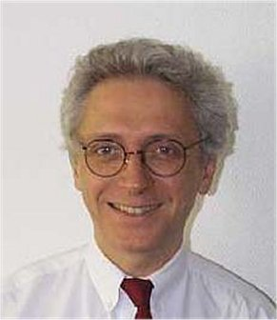 | francy@compuserve.com
1.1 | Country footnotes | Alfred Goetschi, SUI | 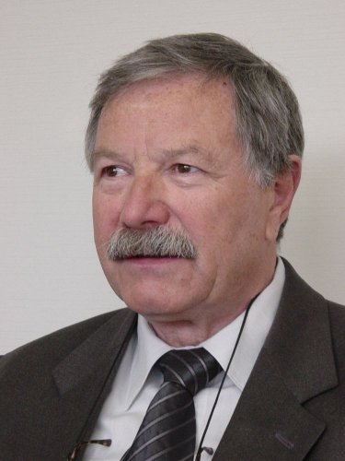 | alfred.goetschi@bakom.admin.ch
1.2 | New modulation techniques for HFBC | G.O. Towler, G |  | geoff.towler@ra.gsi.gov.uk
1.3 | Harmonized bands for public protection, emergency situations and disaster relief | Enrico Tosato, I |  | e.tosato@interbusiness.it
1.4 | Review of FSS (non-GSO MSS feeder uplinks) and ARNS allocations at 5 091-  5 150 MHz | [TBD] |  | [TBD]
1.5 | New allocations to MS, FS, EESS and SRS and review of RLS at 5 150-5 725 MHz | Steve Bond, G |  | stephenbond1@compuserve.com
1.6 | Non-GSO MSS feeder-link protection at 5 150-  5 250 MHz | Steve Bond, G |  | stephenbond1@compuserve.com
1.7 | Amateur and amateur-satellite services | Jaap Steenge, HOL | 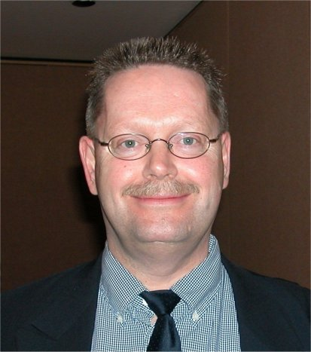 | jaap.steenge@at-ez.nl
1.8 | Unwanted emissions  1.8.1 | Yves Ollivier, F | 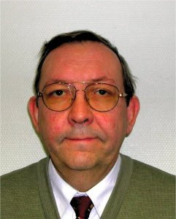 | ollivier@anfr.fr
 | 1.8.2 | Willem Baan, HOL |  | baan@astron.nl
1.9 | Deletion of Appendix 13 and Res. 331 (Rev.WRC-97) | Trond Olsen, NOR |  | Trond.olsen@npt.no
1.10 | Maritime mobile | Trond Olsen, NOR |  | Trond.olsen@npt.no
1.11 | AMSS secondary allocation at 14-14.5 GHz | Anthony Baker, HOL | 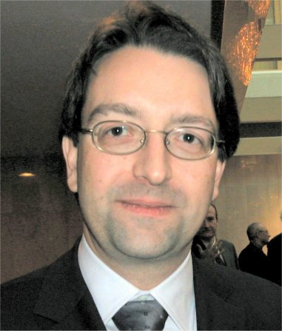 | abaker@newskies.com
1.12 | Allocations to space science services | Angel Diez de Frutos, E |  | Angel.diez@setsi.mcyt.es
1.13 | HAPS | Pekka Ollikainen, FIN | 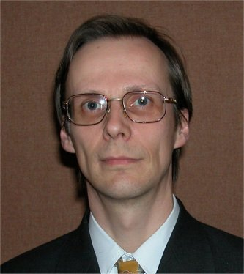 | Pekka.Ollikainen@ficora.fi
1.14 | Harmful interference in maritime mobile and aeronautical mobile (R) and review of HF/MF channels for digital use | Antonio Di Rauso, I | 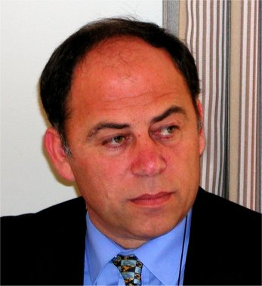 | Antonio.dirauso@istsupcti.it
1.15 | RNSS sharing conditions | Hugues de  Bailliencourt, F |  | bailliencourt@anfr.fr
1.16 | Worldwide allocations around 1.4 GHz for feeder links to non-GSO MSS under 1 GHz | Titus Spoelstra, HOL |  | spoelstra@astron.nl
1.17 | Upgrade of radiolocation to primary at 2 900-3 100 MHz | Holger Lüschow, D | 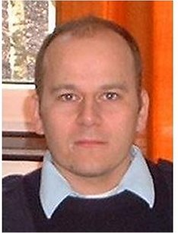 | holger.lueschow@bundeswehr.org
1.18 | Primary allocation to FS at 17.3-17.7 GHz in Region 1 | Benoist Deschamps, F | 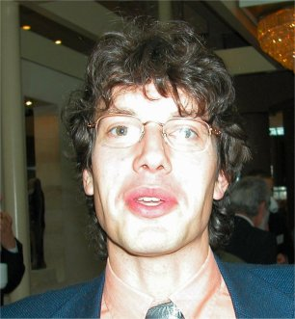 | deschamps@anfr.fr
1.19 | Misapplication of non-GSO FSS single entry limits | Antonio Coimbra, POR | 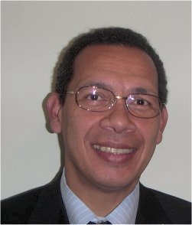 | antonio.coimbra@anacom.pt
1.20 | Additional allocations to MSS under 1 GHz | Petri Lehikoinen, FIN | 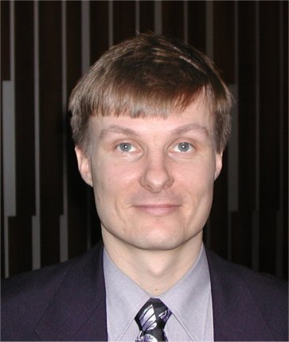 | Petri.lehikoinen@ficora.fi
1.21 | Terrestrial wireless interactive multimedia applications | Jan-Erik Lejerkrans, S | 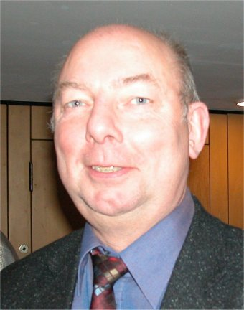 | Jan-erik.lejerkrans@pts.se
1.22 | IMT-2000 and beyond | Pasi Toivonen, FIN |  | pasi.toivonen@ficora.fi
1.23 | Realignment of amateur, amateur-satellite and BS around 7 MHz | Jan Verduijn, HOL | 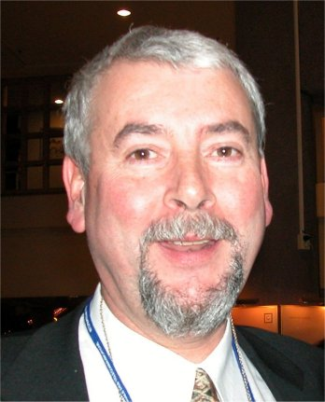 | Jan.verduijn@at-ez.nl
1.24 | 13.75-14 GHz | Jean Chartier, F | 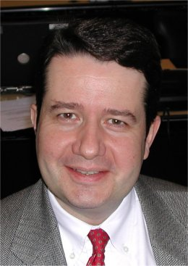 | chartier@anfr.fr
1.25 | HDFSS above 17.3 GHz | Benoist Deschamps, F |  | deschamps@anfr.fr
1.26 | Earth stations on-board vessels | Anders Frederich, S |  | anders.frederich@telia.com
1.27 | Review of Appendix 30/30A procedures and sharing criteria | Cristina Garcia de Miguel, E |  | mcgarcia@hispasat.es
1.28 | RNSS differential correction signals at 108-117.975 MHz | John Shaw, G |  | john.shaw@ra.gsi.gov.uk
1.29 | Non-GSO/GSO sharing | Fernando Guerra, POR | 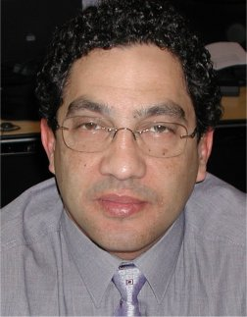 | fernando.guerra@anacom.pt
1.30 | Resolution 86 (PP-98) | Gary Brooks, LUX | 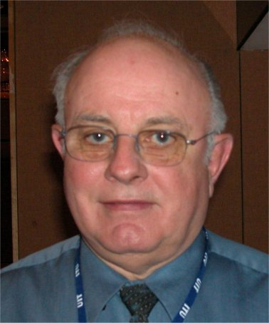 | gbrooks@ca.inter.net
1.31 | MSS allocations at 1-3 GHz | Victor Glushko, RUS | 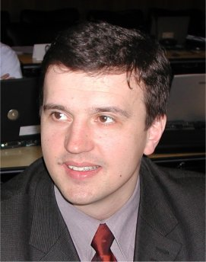 | npf@geyser.ru
1.32 | Sharing at 37.5-43.5 GHz | Philippe Tristant, F | 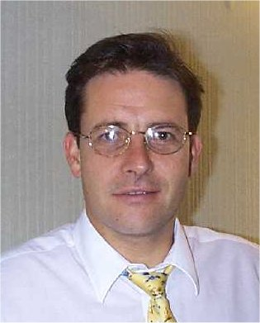 | tristant@anfr.fr
1.33 | HAPS within IMT-2000 | Sofie Maddens Toscano, POR |  | sofie@esoterica.pt
1.34 | Non-GSO BSS (sound) sharing with IMT-2000 at 2 630-2 655 MHz | Chris Cheeseman, G |  | chris.cheeseman@bt.com
1.35 | Report of the Director, BR on the results of Resolution 53 (Rev.WRC-2000) analysis | Cristina Garcia de Miguel, E |  | mcgarcia@hispasat.es
1.36 | HFBC allocations at 4-10 MHz | Geoff Towler, G |  | Geoff.towler@ra.gsi.gov.uk
1.37 | Highly Elliptical Orbit Systems | Kumar Singarajah, LUX  (HEO BSS sound) | 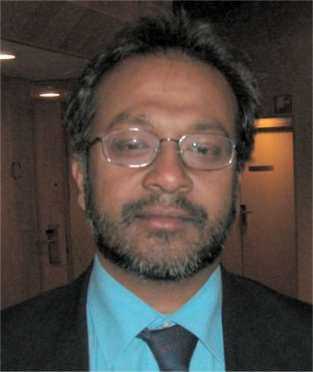 | ksingarajah@globalradio.lu
 |  | Jean Chartier, F  (other HEO) |  | chartier@anfr.fr
1.38 | EESS at 420-470 MHz | Björn Rommen, HOL |  | bjorn.rommen@esa.int
1.39 | FSS requirements for TT&C below 17 GHz for networks with service links above 17 GHz | [TBD] |  | [TBD]
2 | Revised ITU-R Recommendations incorporated by reference | John Shaw, G |  | John.shaw@ra.gsi.gov.uk
3 | Consequential changes to the RR | François Rancy, F |  | Francy@compuserve.com
4 | Review of resolutions and recommendations of previous conferences | John Shaw, G |  | John.shaw@ra.gsi.gov.uk
5 | Radio Assembly report | François Rancy, F |  | Francy@compuserve.com
6 | Urgent action by ITU-R study groups in preparation for the next WRC | François Rancy, F |  | Francy@compuserve.com
7.1 | Report of the Director, BR on the activities of ITU-R | Anders Frederich, S |  | anders.frederich@telia.com
7.2 | Agendas of future conferences | Joachim Strick, D | 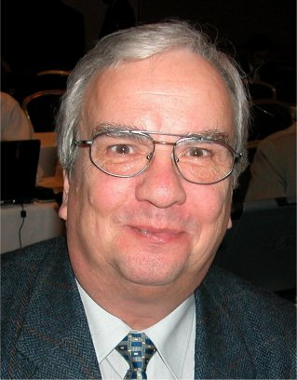 | strick@bmwi.bund.de
ANNEX 2
Structure of the European common proposals to WRC-03 and
correspondence with WRC-03 agenda items
Document | Title | Agenda items
Main document | European common proposals for the work of the Conference | All
Addendum 1 | Review of countries’ footnotes | 1.1
Addendum 2 | New modulation techniques in HFBC | 1.2
Addendum 3 | Harmonized bands for Public Protection and Disaster Relief (PPDR) | 1.3
Addendum 4 | Use of the band 5 091-5 150 MHz by the FSS | 1.4
Addendum 5 | Allocations in the frequency range 5 150-5 725 MHz | 1.5
Addendum 6 | Protection of MSS feeder links in the band 5 150-5 250 MHz | 1.6
Addendum 7 | Amateur services | 1.7
Addendum 8 | Issues related to unwanted emissions,  boundary between spurious and out-of-band emissions | 1.8.1
Addendum 8 | Issues related to the protection of passive services | 1.8.2
Addendum 9 | Maritime Distress and Safety | 1.9
Addendum 10 | Exhaustion of the maritime mobile service identity numbering resource (Resolution 344 (WRC-97)) | 1.10
Addendum 11 | AMSS (Earth-to-space) secondary allocation at 14 GHz | 1.11
Addendum 12 | Allocations to space science services | 1.12
Addendum 13 | HAPS outside IMT-2000 bands | 1.13
Addendum 14 | Maritime mobile and aeronautical mobile (R) services | 1.14
Addendum 15 | Radionavigation-satellite service | 1.15
Addendum 16 | Non-GSO MSS feeder links around 1.4 GHz | 1.16
Addendum 17 | Radiolocation at 2 900-3 100 MHz | 1.17
Addendum 18 | Allocation to the fixed service at 17 GHz | 1.18
Addendum 19 | Misapplication of the non-GSO FSS single-entry limits in Article 22 | 1.19
Addendum 20 | Additional allocations for non-GSO MSS below 1 GHz | 1.20
Addendum 21 | Terrestrial wireless interactive multimedia applications | 1.21
Addendum 22 | Future development of IMT-2000 and systems beyond IMT-2000 | 1.22
Addendum 23 | Realignment of the allocations at 7 MHz | 1.23
Addendum 24 | Sharing conditions in the band 13.75-14 GHz | 1.24
Addendum 25 | High density systems in the fixed-satellite service | 1.25
Addendum 26 | Earth stations on-board vessels | 1.26
Addendum 27 | Appendices 30 and 30A and associated provisions | 1.27
Addendum 28 | RNSS differential correction signals at 108-117.975 MHz | 1.28
Addendum 29 | Sharing between non-GSO and GSO systems | 1.29
Addendum 30 | Resolution 86 (Minneapolis, 1998) | 1.30
Addendum 31 | New allocations to the mobile-satellite service | 1.31
Addendum 32 | Sharing at 37.5-43.5 GHz | 1.32
Addendum 33 | HAPS within IMT-2000 bands | 1.33
Addendum 34 | Resolution 539 (WRC-2000) | 1.34
Addendum 35 | Report of the Director, BR on the results of Resolution 53 (Rev.WRC-2000) analysis | 1.35
Addendum 36 | HF broadcasting from about 4 MHz to 10 MHz | 1.36
Addendum 37 | Satellite networks using highly elliptical orbits | 1.37
Addendum 38 | EESS (active) at 420-470 MHz | 1.38
Addendum 39 | FSS TT&C requirements below 17 GHz | 1.39
Addendum 40 | Revised ITU-R Recommendations incorporated by reference | 2
Addendum 41 | Review of resolutions and recommendations of previous conferences | 4
Addendum 42 | Report of the Director, BR on the activities of the ITU-R | 7.1
Addendum 43 | Agendas of future conferences | 7.2

Annex 3
List of co-signatures of the European Common Proposals
(ECPs) for WRC-03
(shaded columns indicate that CEPT has no proposal at this time)
Addendum n° | 1 | 2 | 3 | 4 | 5 | 6 | 7 | 8 | 8 | 9 | 10 | 11 | 12 | 13
Agenda Item | 1.1 | 1.2 | 1.3 | 1.4 | 1.5 | 1.6 | 1.7 | 1.8.1 | 1.8.2 | 1.9 | 1.10 | 1.11 | 1.12 | 1.13
Part |  |  |  |  |  |  |  | 8A | 8B
AUT |  | 1 | 1 | 1 | 1 | 1 | 1 | 1 | 1 | 1 | 1 | 1 | 1 |  | 1
BEL |  | 1 | 1 | 1 | 1 | 1 | 1 | 1 | 1 | 1 | 1 | 1 | 1 |  | 1
BUL |  | 1 | 1 | 1 | 1 | 1 | 1 | 1 | 1 | 1 | 1 | 1 | 1 |  | 1
CZE |  | 1 | 1 | 1 | 1 | 1 | 1 | 1 | 1 | 1 | 1 | 1 | 1 |  | 1
D |  | 1 |  | 1 | 1 | 1 | 1 | 1 | 1 | 1 | 1 | 1 | 1 |  | 1
DNK |  | 1 | 1 | 1 | 1 | 1 | 1 | 1 | 1 | 1 | 1 | 1 | 1 |  | 1
E |  | 1 | 1 | 1 | 1 | 1 | 1 | 1 | 1 | 1 | 1 | 1 | 1 |  | 1
EST |  | 1 | 1 | 1 | 1 | 1 | 1 | 1 | 1 | 1 | 1 | 1 | 1 |  | 1
F |  | 1 | 1 | 1 | 1 | 1 | 1 | 1 | 1 | 1 | 1 | 1 | 1 |  | 1
FIN |  | 1 | 1 | 1 | 1 | 1 | 1 | 1 | 1 | 1 | 1 | 1 | 1 |  | 1
G |  | 1 | 1 | 1 | 1 | 1 | 1 | 1 |  | 1 | 1 | 1 | 1 |  | 1
HNG |  | 1 | 1 | 1 | 1 | 1 | 1 | 1 | 1 | 1 | 1 | 1 | 1
HOL |  | 1 | 1 | 1 | 1 | 1 | 1 | 1 | 1 | 1 | 1 | 1 | 1 |  | 1
I |  | 1 | 1 | 1 | 1 | 1 | 1 | 1 | 1 | 1 | 1 | 1 |  |  | 1
IRL |  | 1 | 1 | 1 | 1 | 1 | 1 | 1 | 1 | 1 | 1 | 1 | 1 |  | 1
ISL |  | 1 | 1 | 1 | 1 | 1 | 1 | 1 | 1 | 1 | 1 | 1 | 1 |  | 1
LIE |  | 1 | 1 | 1 | 1 | 1 | 1 | 1 | 1 | 1 | 1 | 1 | 1 |  | 1
LTU |  | 1 | 1 | 1 | 1 | 1 | 1 | 1 | 1 | 1 | 1 | 1 | 1 |  | 1
LUX |  | 1 | 1 | 1 | 1 | 1 | 1 | 1 | 1 | 1 | 1 | 1 | 1 |  | 1
LVA |  | 1 | 1 | 1 | 1 | 1 | 1 | 1 | 1 | 1 | 1 | 1 | 1 |  | 1
NOR |  | 1 | 1 | 1 | 1 | 1 | 1 | 1 | 1 | 1 | 1 | 1 | 1 |  | 1
POL |  | 1 | 1 | 1 | 1 | 1 | 1 | 1 | 1 | 1 | 1 | 1 | 1 |  | 1
POR |  | 1 | 1 | 1 | 1 | 1 | 1 | 1 | 1 | 1 | 1 | 1 | 1 |  | 1
RUS |  | 1 |  | 1 |  | 1 | 1 | 1 |  | 1 | 1 | 1 |  |  | 1
S |  | 1 | 1 | 1 | 1 | 1 | 1 | 1 | 1 | 1 | 1 | 1 | 1 |  | 1
SUI |  | 1 | 1 | 1 | 1 | 1 | 1 | 1 | 1 | 1 | 1 | 1 | 1 |  | 1
SVK |  | 1 | 1 | 1 | 1 | 1 | 1 | 1 | 1 | 1 | 1 | 1 | 1 |  | 1
SVN |  | 1 | 1 | 1 | 1 | 1 | 1 | 1 | 1 | 1 | 1 | 1 | 1 |  | 1
TUR |  | 1 | 1 | 1 | 1 | 1 | 1 | 1 | 1 | 1 | 1 | 1 | 1 |  | 1
Total |  | 29 | 27 | 29 | 28 | 29 | 29 | 29 | 27 | 29 | 29 | 29 | 27 |  | 28

Addendum n° | 14 | 15 | 15 | 15 | 16 | 17 | 18 | 19 | 20 | 21 | 22 | 23 | 24 | 25
Agenda Item | 1.14 | 1.15 | 1.15 | 1.15 | 1.16 | 1.17 | 1.18 | 1.19 | 1.20 | 1.21 | 1.22 | 1.23 | 1.24 | 1.25
Part |  | 15A | 15B | 15C
AUT | 1 | 1 | 1 | 1 | 1 | 1 | 1 | 1 | 1 |  | 1 | 1 |  | 1
BEL | 1 | 1 | 1 | 1 | 1 | 1 | 1 | 1 | 1 |  | 1 | 1 |  | 1
BUL | 1 | 1 | 1 | 1 | 1 | 1 |  | 1 | 1 |  | 1 | 1
CZE | 1 | 1 | 1 | 1 | 1 | 1 | 1 | 1 | 1 |  | 1 | 1 |  | 1
D | 1 | 1 | 1 | 1 | 1 | 1 | 1 |  | 1 |  | 1 | 1 |  | 1
DNK | 1 | 1 | 1 | 1 | 1 | 1 | 1 | 1 | 1 |  | 1 | 1 |  | 1
E | 1 | 1 | 1 | 1 | 1 | 1 | 1 | 1 | 1 |  | 1
EST | 1 | 1 | 1 | 1 | 1 | 1 | 1 | 1 | 1 |  | 1 | 1 |  | 1
F | 1 | 1 | 1 | 1 | 1 | 1 | 1 | 1 | 1 |  | 1 |  |  | 1
FIN | 1 | 1 | 1 | 1 | 1 | 1 | 1 | 1 | 1 |  | 1 | 1 |  | 1
G | 1 | 1 | 1 | 1 | 1 | 1 | 1 | 1 | 1 |  | 1 |  |  | 1
HNG | 1 | 1 | 1 | 1 | 1 | 1 | 1 | 1 | 1 |  | 1 | 1 |  | 1
HOL | 1 | 1 | 1 | 1 | 1 | 1 | 1 | 1 | 1 |  | 1 | 1 |  | 1
I | 1 | 1 | 1 | 1 | 1 | 1 |  | 1 | 1 |  | 1
IRL | 1 | 1 | 1 | 1 | 1 | 1 | 1 | 1 | 1 |  | 1 | 1 |  | 1
ISL | 1 | 1 | 1 | 1 | 1 | 1 | 1 | 1 | 1 |  | 1 | 1 |  | 1
LIE | 1 | 1 | 1 | 1 | 1 | 1 | 1 | 1 | 1 |  | 1 | 1 |  | 1
LTU | 1 | 1 | 1 | 1 | 1 | 1 |  | 1 | 1 |  | 1 | 1
LUX | 1 | 1 | 1 | 1 | 1 | 1 | 1 | 1 | 1 |  | 1 | 1
LVA | 1 | 1 | 1 | 1 | 1 | 1 | 1 | 1 | 1 |  | 1 | 1 |  | 1
NOR | 1 | 1 | 1 | 1 | 1 | 1 | 1 | 1 | 1 |  | 1 | 1 |  | 1
POL | 1 | 1 | 1 | 1 | 1 | 1 | 1 | 1 | 1 |  | 1 | 1 |  | 1
POR | 1 | 1 | 1 | 1 | 1 | 1 | 1 | 1 | 1 |  | 1 |  |  | 1
RUS | 1 |  |  | 1 | 1 | 1 | 1 | 1 | 1 |  | 1
S | 1 | 1 | 1 | 1 | 1 | 1 | 1 | 1 | 1 |  | 1 | 1 |  | 1
SUI | 1 | 1 | 1 | 1 | 1 | 1 | 1 | 1 | 1 |  | 1 | 1 |  | 1
SVK | 1 | 1 | 1 | 1 | 1 | 1 | 1 | 1 | 1 |  | 1 | 1 |  | 1
SVN | 1 | 1 | 1 | 1 | 1 | 1 | 1 | 1 | 1 |  | 1 | 1 |  | 1
TUR | 1 | 1 | 1 | 1 | 1 | 1 | 1 | 1 | 1 |  | 1 |  |  | 1
Total | 29 | 28 | 28 | 29 | 29 | 29 | 26 | 28 | 29 |  | 29 | 22 |  | 23

Addendum n° | 26 | 27A | 27B | 28 | 29 | 30 | 31 | 32 | 33 | 34 | 35 | 36 | 37A | 37B
Agenda Item | 1.26 | 1.27 | 1.27 | 1.28 | 1.29 | 1.30 | 1.31 | 1.32 | 1.33 | 1.34 | 1.35 | 1.36 | 1.37 | 1.37
Part |  | 27A | 27B |  |  |  |  |  |  |  |  |  | 37A | 37B
AUT | 1 | 1 |  | 1 | 1 | 1 | 1 | 1 |  | 1
BEL | 1 | 1 |  | 1 | 1 | 1 | 1 | 1 | 1 | 1 |  | 1 | 1
BUL | 1 | 1 |  | 1 | 1 |  | 1 | 1 | 1 | 1 |  | 1 | 1
CZE | 1 | 1 |  | 1 | 1 | 1 | 1 | 1 | 1 | 1 |  | 1 | 1
D | 1 | 1 |  | 1 | 1 | 1 | 1 |  | 1 | 1 |  | 1 | 1
DNK | 1 | 1 |  | 1 | 1 | 1 | 1 | 1 | 1 | 1 |  | 1 | 1
E |  | 1 |  | 1 | 1 | 1 | 1 | 1 | 1 | 1 |  | 1 | 1
EST | 1 | 1 |  | 1 | 1 | 1 | 1 | 1 | 1 | 1 |  | 1 | 1
F | 1 | 1 |  | 1 | 1 | 1 | 1 | 1 | 1 | 1 |  | 1 | 1
FIN | 1 | 1 |  | 1 | 1 | 1 | 1 | 1 | 1 | 1 |  | 1 | 1
G |  | 1 |  | 1 | 1 | 1 | 1 | 1 | 1 | 1 |  |  | 1
HNG | 1 | 1 |  | 1 | 1 | 1 | 1 | 1 | 1 | 1 |  | 1 | 1
HOL | 1 | 1 |  | 1 | 1 | 1 | 1 | 1 | 1 | 1 |  | 1
I |  | 1 |  | 1 | 1 | 1 |  | 1 | 1 | 1 |  |  | 1
IRL |  | 1 |  | 1 | 1 | 1 | 1 | 1 | 1 | 1 |  | 1 | 1
ISL | 1 | 1 |  | 1 | 1 | 1 | 1 | 1 | 1 | 1 |  | 1 | 1
LIE | 1 | 1 |  | 1 | 1 |  | 1 | 1 | 1 | 1 |  | 1
LTU |  |  |  | 1 | 1 |  | 1 | 1 | 1 | 1 |  | 1
LUX | 1 | 1 |  | 1 | 1 | 1 | 1 | 1 | 1 | 1 |  | 1
LVA | 1 | 1 |  | 1 | 1 | 1 | 1 | 1 | 1 | 1 |  | 1 | 1
NOR | 1 | 1 |  | 1 | 1 | 1 | 1 | 1 | 1 | 1 |  | 1 | 1
POL | 1 | 1 |  | 1 | 1 | 1 | 1 | 1 | 1 | 1 |  | 1 | 1
POR |  | 1 |  | 1 | 1 | 1 | 1 | 1 | 1 | 1 |  | 1 | 1
RUS |  |  |  |  | 1 |  | 1 | 1 | 1 | 1
S | 1 | 1 |  | 1 | 1 | 1 | 1 | 1 | 1 | 1 |  | 1 | 1
SUI | 1 | 1 |  | 1 | 1 |  | 1 | 1 | 1 | 1 |  | 1
SVK | 1 | 1 |  | 1 | 1 | 1 | 1 | 1 | 1 | 1 |  | 1 | 1
SVN | 1 | 1 |  | 1 | 1 | 1 | 1 | 1 | 1 | 1 |  | 1 | 1
TUR |  | 1 |  | 1 | 1 | 1 |  | 1 | 1 | 1 |  | 1 | 1
Total | 21 | 26 |  | 27 | 28 | 23 | 26 | 27 | 27 | 28 |  | 24 | 21

Addendum n° | 38 | 39 | 40 | 41 | 42 | 43 | Total
Agenda Item | 1.38 | 1.39 | 2 | 4 | 7.1 | 7.2
Part
AUT | 1 | 1 |  |  |  |  | 35
BEL |  | 1 |  |  |  |  | 37
BUL | 1 | 1 |  |  |  |  | 35
CZE | 1 | 1 |  |  |  |  | 38
D | 1 | 1 |  |  |  |  | 35
DNK | 1 | 1 |  |  |  |  | 38
E | 1 | 1 |  |  |  |  | 35
EST | 1 | 1 |  |  |  |  | 38
F | 1 | 1 |  |  |  |  | 37
FIN | 1 | 1 |  |  |  |  | 38
G | 1 | 1 |  |  |  |  | 34
HNG | 1 | 1 |  |  |  |  | 37
HOL | 1 | 1 |  |  |  |  | 37
I |  | 1 |  |  |  |  | 30
IRL | 1 | 1 |  |  |  |  | 37
ISL | 1 | 1 |  |  |  |  | 38
LIE | 1 | 1 |  |  |  |  | 36
LTU | 1 | 1 |  |  |  |  | 32
LUX | 1 | 1 |  |  |  |  | 36
LVA | 1 | 1 |  |  |  |  | 38
NOR | 1 | 1 |  |  |  |  | 38
POL | 1 | 1 |  |  |  |  | 38
POR | 1 | 1 |  |  |  |  | 36
RUS | 1 | 1 |  |  |  |  | 24
S | 1 | 1 |  |  |  |  | 38
SUI | 1 | 1 |  |  |  |  | 36
SVK | 1 | 1 |  |  |  |  | 38
SVN | 1 | 1 |  |  |  |  | 38
TUR | 1 | 1 |  |  |  |  | 35
Total | 27 | 29 |  |  |  |  | 38

_______________

Frequency tuning range: a range of frequencies over which radio equipment is capable of being tuned.

