
 | INTERNATIONAL TELECOMMUNICATION UNION
 | RADIOCOMMUNICATION  STUDY GROUPS  14th MEETING OF WORKING PARTY 8F  Shanghai, 13-20 October 2004 | Document 8F/INFO/21-E
 |  | 8 October 2004
 |  | English only
TOUR PROGRAM FOR saturday, 16 oCTOBER 2004

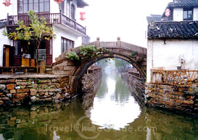
An Ancient Township on Water
Zhouzhuang, one of the most famous water townships in China, situated in Kunshan City which is only 30 kilometers (18 miles) southeast of Suzhou. It is noted for its profound cultural background, the well preserved ancient residential houses, the elegant watery views and the strong local colored traditions and customs. In the Spring and Autumn Period (770 - 476 BC), Zhouzhuang was a part of the fief Yaocheng and called Zhenfengli. After being donated to Full Fortune (Quanfu) Temple by Zhou Digong, a very devout Buddhist, in 1086 during the Northern Song Dynasty (960 - 1127), Zhouzhuang got its present name as a memorial of the donor.
In an area of half a square kilometer (124 acres), 60 percent of the Zhouzhuang's structures were built during the Ming and Qing Dynasties, which is from 1368 to 1911. Taking the most convenient form of transport in Zhouzhuang, a gondola, we will present some of the breathtaking sights one by one.
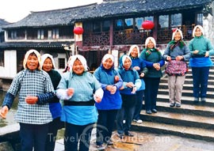
Twin Bridges (Shuang qiao): Zhouzhuang is surrounded and divided by lakes and rivers, 14 stone bridges cross the rivers, showing distinctive views of the water-town. Twin Bridges which comprise Shide Bridge and Yongan Bridge are the most famous and is considered the symbol of Zhouzhuang. Built in Wanli era (1573 - 1619) of the Ming Dynasty, Twin Bridges is in the northeast of the town. Shide Bridge is east-west and has a round arch, while Yongan Bridge is north-south and the bridge arch is square. Crossing the two crisscross rivers (Yinzi Creek and Nabeishi River) and connecting at the middle, Twin Bridges look like a Chinese old-style Chinese key. In 1984, 38 canvases of the notable painter, Chen Yifei, were exhibited in a New York gallery of Armand Hammer, chairman of Occidental Petroleum Corporation. "Memory of Hometown" which depicts Twin Bridges was one of the items on display and has gained the world's attention for Zhouzhuang. The painting was chosen to be the first-day cover of the United Nations' postage stamp in 1985.

Date: October 16, 2004
Departure Time: 9:00 am SHARP
Gather at: Hotel’s Lobby (Sofitel Jinjiang Oriental Pudong Shanghai)
Program:

TIME | CONTENTS | PLACE
09:00—10:30 | Shanghai → Zhouzhuang
10:30—12:00 | Twin Bridge、 Taoist Temple、Shen House
12:00—13:30 | Lunch | Zhou Zhuang Hotel
13:30—16:30 | Tour in Zhou Zhuang
16:30—18:00 | Zhou Zhuang – Shanghai

Attractions:

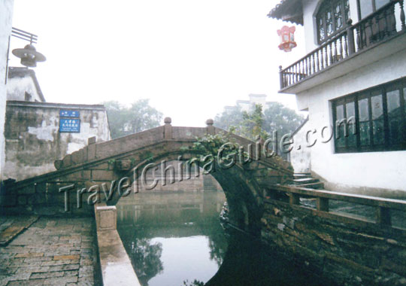
Twin Bridges (Shuang qiao): Zhouzhuang is surrounded and divided by lakes and rivers, 14 stone bridges cross the rivers, showing distinctive views of the water-town. Twin Bridges which comprise Shide Bridge and Yongan Bridge are the most famous and is considered the symbol of Zhouzhuang. Built in Wanli era (1573 - 1619) of the Ming Dynasty, Twin Bridges is in the northeast of the town. Shide Bridge is east-west and has a round arch, while Yongan Bridge is north-south and the bridge arch is square. Crossing the two crisscross rivers (Yinzi Creek and Nabeishi River) and connecting at the middle, Twin Bridges look like a Chinese old-style Chinese key. In 1984, 38 canvases of the notable painter, Chen Yifei, were exhibited in a New York gallery of Armand Hammer, chairman of Occidental Petroleum Corporation. "Memory of Hometown" which depicts Twin Bridges was one of the items on display and has gained the world's attention for Zhouzhuang. The painting was chosen to be the first-day cover of the United Nations' postage stamp in 1985.

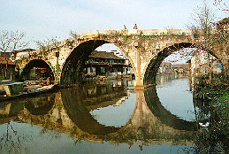
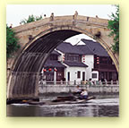
Fuan Bridge: Located at the eastern end of Zhongshi Jie, Fuan Bridge was built in 1355 during the Yuan Dynasty. The unique trait of the Fuan is the consummate combination of the single-arch bridge and the bridge towers which have , are used as tearooms, restaurants and stores, and are good places to appreciate the views while
taking a rest.

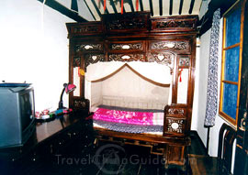
Zhang House: Built by Xu's family in the Zhengtong era (1436 - 1449) of the Ming Dynasty and bought by Zhang's family in the early Qing Dynasty. Located to the south of the Twin Bridges, Zhang House has more than 70 rooms and takes up about 1,800 square meters (less than half an acre). With Ruojing River flowing through, Zhang House is a dapper and graceful residential house; has a tranquil courtyard and pond. Deep halls all represent the life of the quondam owner.

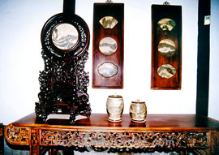
Milou Tower: Once called the De's Tavern, Milou Tower perches next to Zhenfeng Bridge which is at the southwest corner of Zhouzhuang. It is famous for being a rallying place of the literators in old times. Numerous poets, songs and stories about Milou Tower are wide spread and make it more charming.

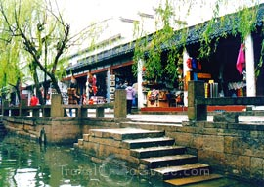
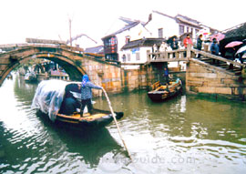
Chengxu Taoist Temple: Standing on Zhongshi Street which is opposite to Puqing Bridge, Chengxu Taoist Temple was built during 1086 - 1093 of the Song Dynasty and also known as Sanctity Hall (Shengtang Hall). After several periods of expansion, it is one of the most famous Taoist temples in Wuzhong Region. In an area of 1,500 square meters (1,800 square yards), simple but majestic Shengdi and Doumu halls, Yuhuang, Wenchang and Shengdi pavilions are really elaborate works and masterpieces of Taoist architectures.
The preceding sight-seeing sites are just a little part of the pretty attractions of Zhouzhuang. Besides these historic sights, the local folklore, traditions and legends of this water township, such as the dragon boat race, the granny tea or the Wansan home-style banquet which are formed from the immemorial civilization and history are also the indispensable elements for an unforgettable tour

Remarks
- Mineral water will be served in the bus
- Lunch—Menu: Chinese feature meal.
- If you miss any of your accompanied people, please contact your guide Mr(s).xxx
- Please check and return the R.S.V..P slip to the Local Secretariat, where you’ll be given tickets for the programs you want to attend until 14:00 PM, 14, October, Thursday
- Please prepare the rain gear in case of the rain day.

*Last Name |  |  | *First Name: |  |  | Nationality.
Pigeon hole No.: |  |  |  |  | *Room No:
Meal Type | Vegetarian □ |  |  | Or not □
E-mail Address:
Any Partners: |  | Yes □ Persons( ) No □

