Received: 14 April 2004
 | INTERNATIONAL TELECOMMUNICATION UNION
 | RADIOCOMMUNICATION  STUDY GROUPS | Document 6-9/INFO/1-E
 | RADIOCOMMUNICATION  STUDY GROUPS | 15 April 2004
 | RADIOCOMMUNICATION  STUDY GROUPS | English only
United Kingdom1
EDCF TECHNICAL MODULE - 2003 REPORT

The attached report is provided to you on an information only basis.

If, however you have any comments or queries about the attached report please contact:

Dr Charles Sandbank,
DTI, Business Relations 2 - Broadcasting Technology & Equipment,
2.114, 151 Buckingham Palace Road
London SW1W 9SS.
Telephone +44 207 215 1825 E mail Charles.Sandbank@dti.gsi.gov.uk

Attachment
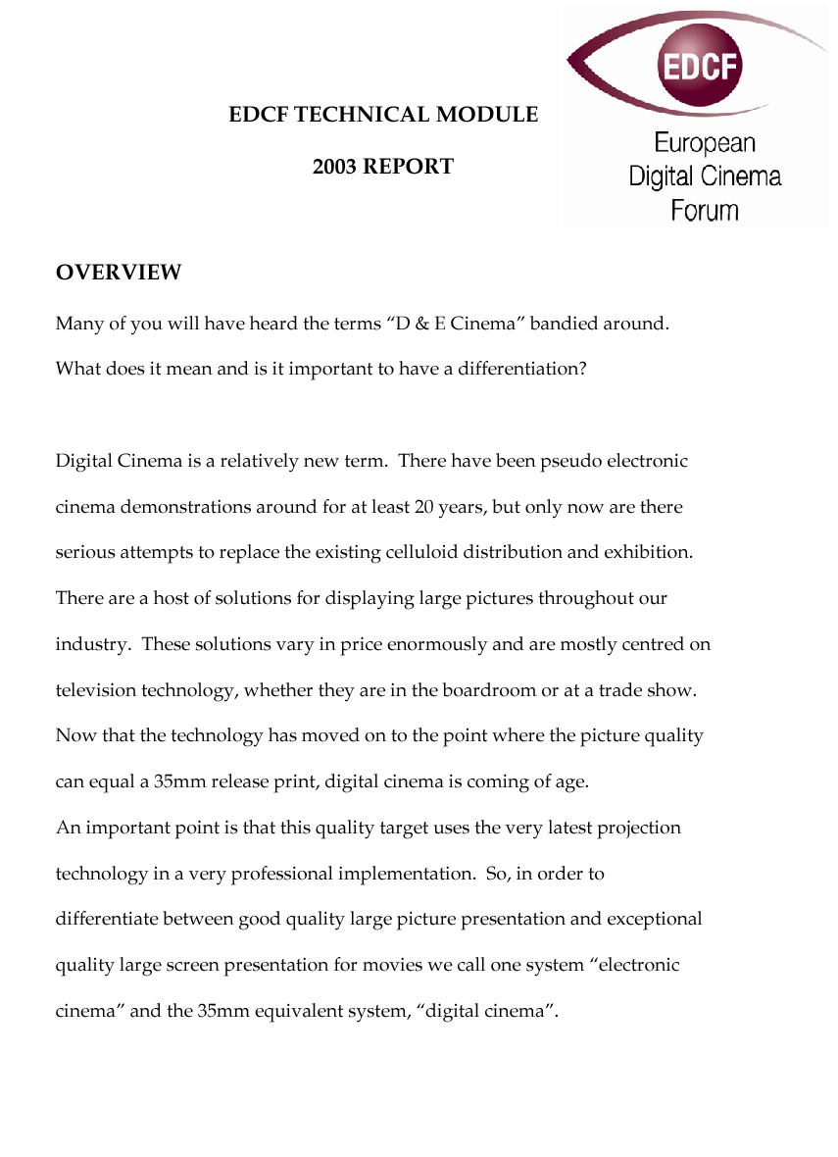
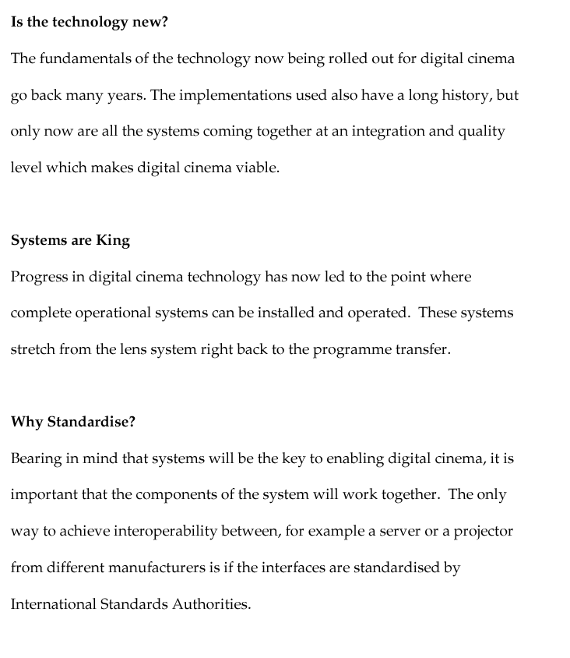
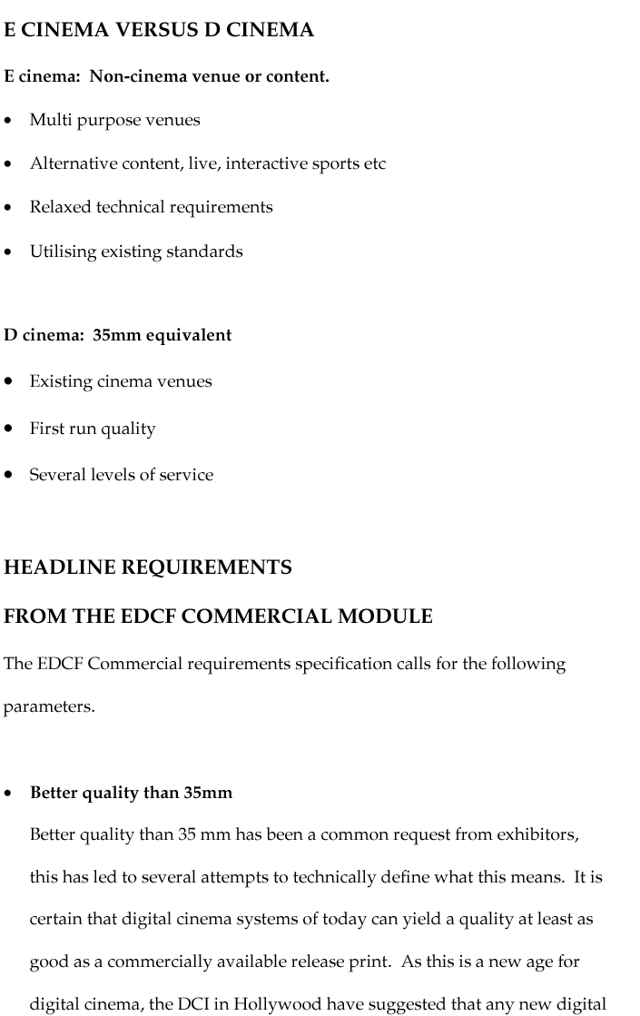
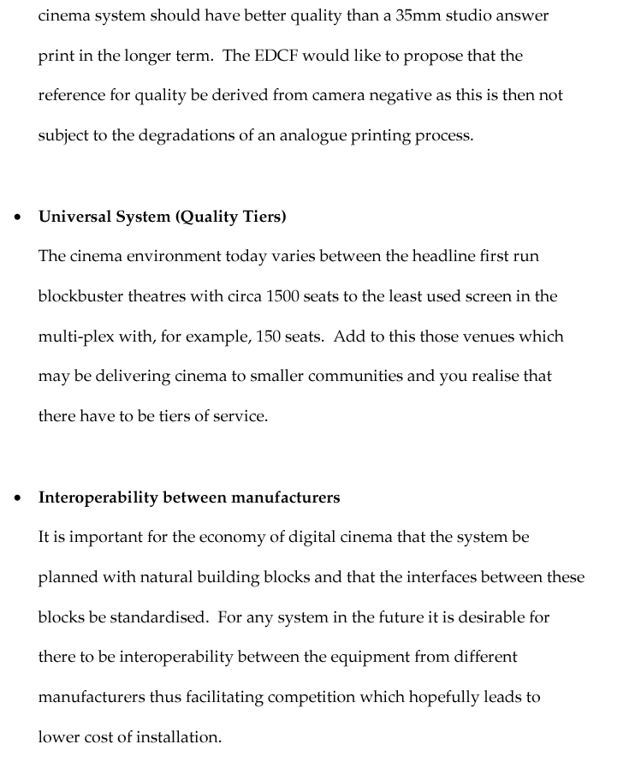
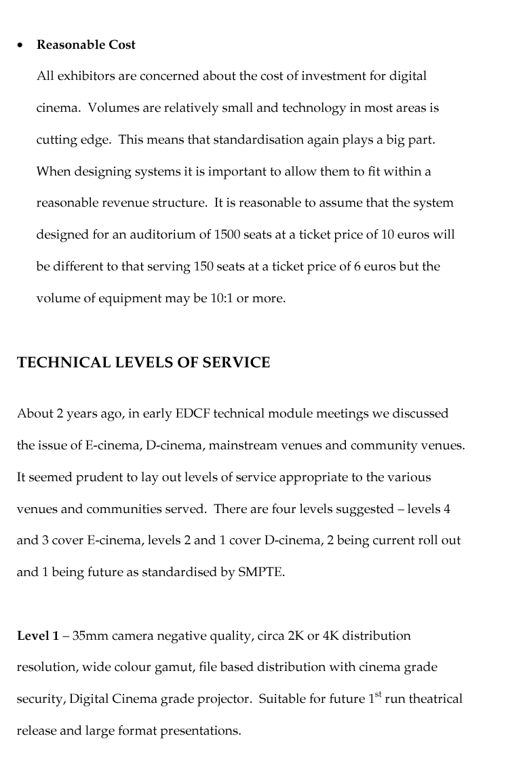
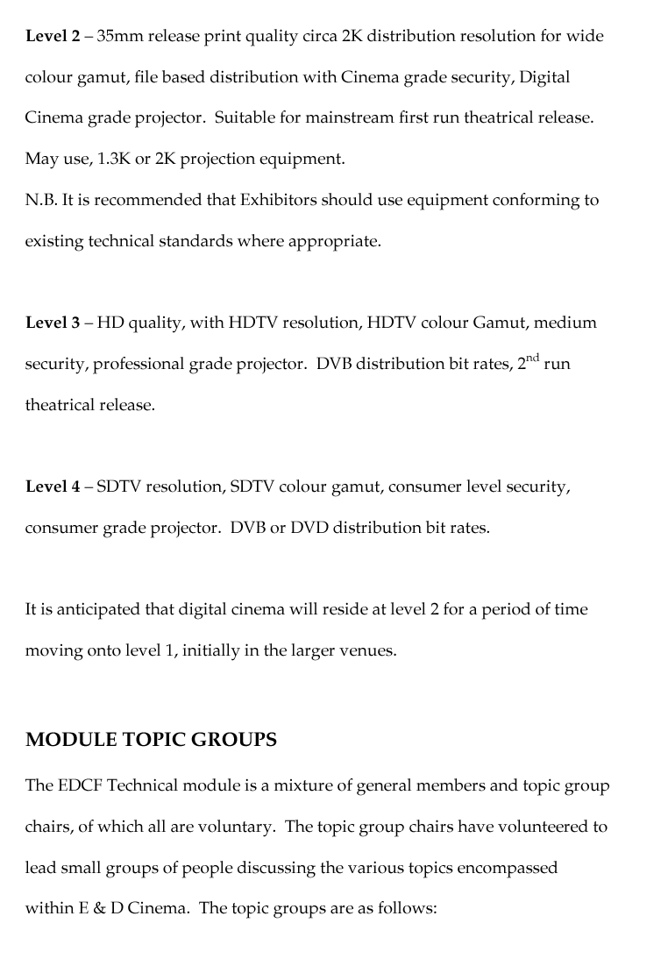
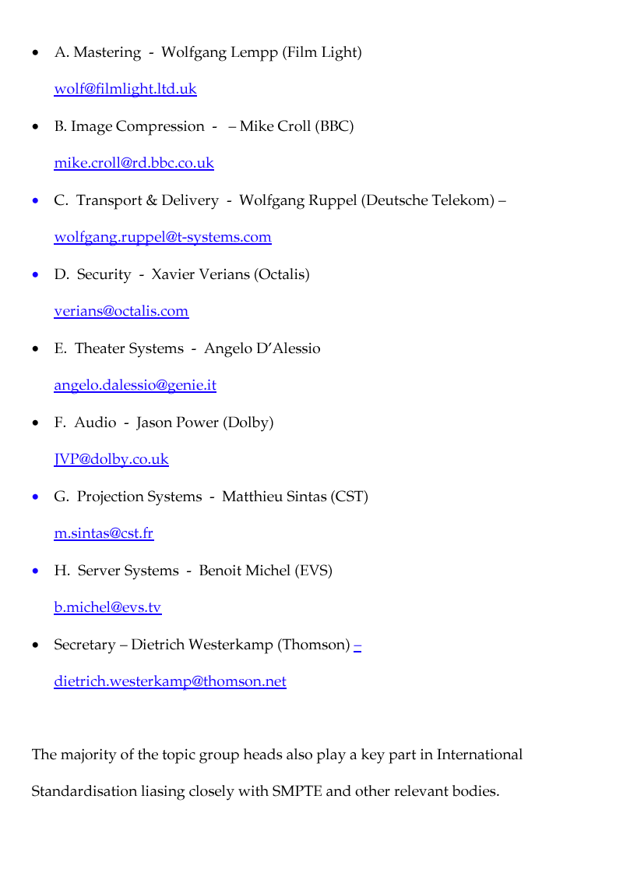
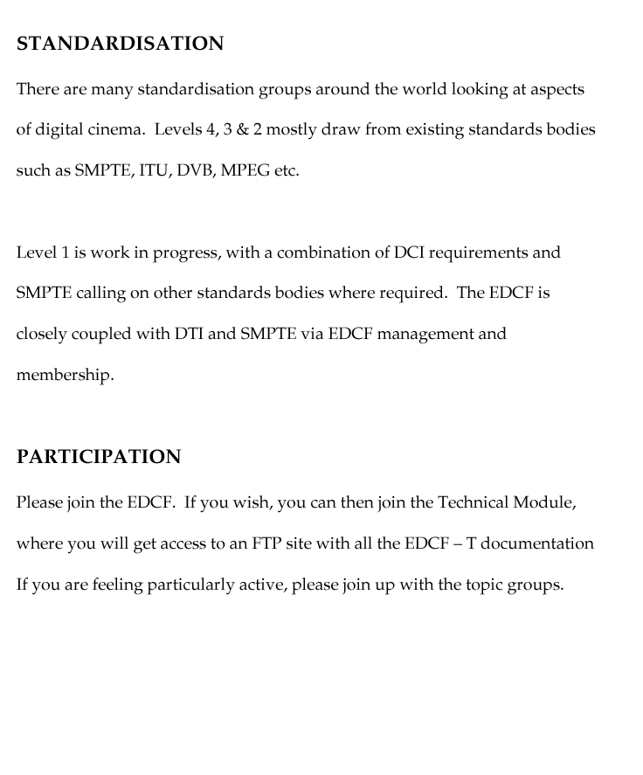
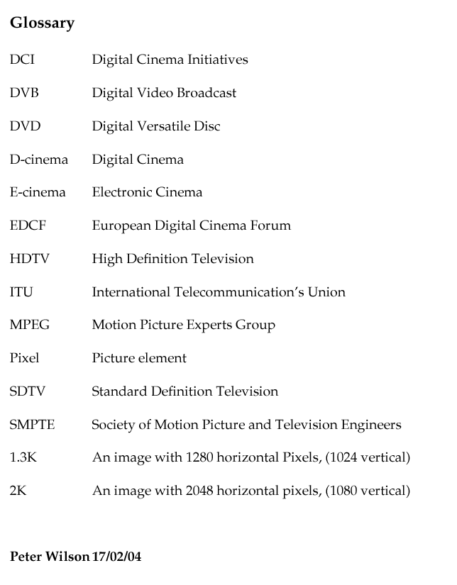
_____________________

1 submitted on behalf of the European Digital Cinema Forum

