INTERNATIONAL TELECOMMUNICATION UNION
Radiocommunication Bureau
(Direct Fax N°. +41 22 730 57 85)

Circular Letter  8/LCCE/126 | 17 March 2004
To Administrations of Member States of the ITU and
Radiocommunication Sector Members participating in the
work of Working Party 8F of Radiocommunication Study Group 8
Subject: Thirteenth meeting of Working Party 8F on IMT-2000 and systems beyond IMT-2000

Introduction
By means of this Circular Letter, we wish to announce that the 13th meeting of ITU-R Working Party 8F will take place in Berlin, Federal Republic of Germany, at the kind invitation of the German Administration, from 16 to 23 June 2004.
Place of the meeting
The meeting will take place at the:
ESTREL Hotel
Sonnenallee 225
Berlin, Germany
Tel.: + (49) 30 6831 22522
Fax: + (49) 30 6831 2345
Internet: www.estrel.com
For further information see Annex 2.
Programme of the meeting
In accordance with Resolution ITU-R 1-4, § 2, the meeting agenda (see Annex 1) will comprise the examination of the Questions assigned to the Working Party.
Services directly connected with meeting activities, such as delegate registration, document distribution, etc., will be located at the meeting place. Registration will commence at 08:30 hours on the opening day. The opening session will commence at 10:00 hours.
The draft agenda for the meeting is contained in Annex 1. The Questions assigned may be found on: http://www.itu.int/ITU-R/publications/download.asp?product=que08&lang=e. Working Party 8F will conduct its work in English.
Contributions
Contributions in response to the work of Working Party 8F are invited*. Contributions will be processed and dispatched in accordance with Resolution ITU-R 1-4 and posted on the web. As decided at the last meeting of Working Party 8F, the deadline for submitting contributions is Monday, 7 June 2004, 08:00 hours Geneva time. Documents received after this deadline will be forwarded to the next meeting of the Working Party.
According to the ITU-R patent policy (Annex 1 to Resolution ITU-R 1-4), contributions containing a proposal for a Recommendation should draw the attention to any known patent or to any known pending patent application relating to systems or technologies considered in the proposal.
Copies of each contribution should be sent to the Study Group Department, Radiocommunication Bureau, for processing, to the Chairman of the Working Party and to the Chairman and Vice-Chairmen of Radiocommunication Study Group 8. The pertinent addresses can be found on:
http://www.itu.int/ITU-R/study-groups/index.asp (see Chairmen and Vice-Chairmen)
Participants are encouraged to submit contributions by electronic mail to:
rsg8@itu.int
Documentation
Contributions to this meeting are stored on the ITU web site at:
http://www.itu.int/md/meetingdoc.asp?lang=e&type=sfolders&parent=r03-wp8f-c
A USB memory device containing all of the contributions will be provided to each participant at the start of the meeting. A CD-ROM containing all of the contributions and temporary documents will also be provided to each participant before the final plenary session.
Wireless LAN facilities will be provided in the main meeting rooms and a cyber cafe facility will also be provided.
Participants are encouraged to use electronic working methods and to bring their laptops (equipped with a CD-ROM drive, a WLAN-card and a USB socket) with them to the meeting. Please note that only a limited number of paper copies of the documents will be available at the meeting.
Participation
In order to make the necessary arrangements, it is requested that the intended participation of your representative(s) be advised no later than one month before the opening of the meeting by means of the annexed form (Annex 3) (to be photocopied as required).

Valery Timofeev
Director, Radiocommunication Bureau

Annexes: 3

Distribution:

– Administrations of Member States and Radiocommunication Sector Members participating in the work of Working Party 8F of Radiocommunication Study Group 8
– Chairman and Vice-Chairmen of Radiocommunication Study Group 8
– ITU-R Associates participating in the work of Radiocommunication Study Group 8
– Secretary General of the ITU, Director of the Telecommunication Standardization Bureau, Director of the Telecommunication Development Bureau
Annex 1
Draft agenda for the 13th meeting of Working Party 8F
(Berlin, 16-23 June 2004)

1 Opening of the meeting
2 Approval of the agenda
3 Report on the 12th meeting of Working Party 8F (Doc. 8F/193)
4 Reports from Liaison and Special Rapporteurs
5 Proposed method of work
6 Assignment of contributions
7 Consideration of documents
8 Future work
9 Other business

Contributions for the 13th meeting of WP 8F
In accordance with the WP 8F work plan, contributions on the following topics are specifically sought for the 13th meeting:

WG Services
1) Inputs to complete the service view document and prepare for its dispatch.
2) Further development of the methodology working document, particularly the algorithm and the identification and the definition of parameters.
3) Further development of the market report.

WG Spectrum
1) Comments on the structure and contents of the draft candidate frequency bands questionnaire.
2) Related to the Revision of Recommendation ITU-R M.1036, further comments from ITU members on the questionnaire included in Circular Letter 8/LCCE/124 (Annex 1) and on frequency arrangements options in 2 500-2 690 MHz band are welcomed.
WG Technology
1) Inputs for the update of Recommendation ITU-R M.1457 to revision 5.
2) Inputs to the work on the report of radio aspects.
3) Inputs to the work on IMT.SDR, and on the form of PDNR IMT.SDR

Terminology
1) Inputs addressing the issue of if / how to progress the terminology work.

S. BLUST
Chairman, Working Party 8F

Annex 2
(English only)
Additional information on the 13th meeting of Working Party 8F
(Berlin, 16-23 June 2004)

1 Meeting information
Meeting venue
ESTREL Hotel & Convention Center
Sonnenallee 225
Berlin - Neukölln
Germany
Tel: + (49) 30 6831 22522
Fax: + (49) 30 6831 2345
Internet: www.estrel.com

Computer facilities
Wireless LAN facilities will be provided in all meeting rooms and Internet cafe facilities will be freely accessible.

Hotel reservation
All hotel reservations are handled by:
ESTREL Hotel Berlin
Key-Word: Bundesministerium 1606/04
Fax: + (49) 30 6831 2345
mailto:reservierung@estrel.com
250 rooms are available at this hotel, as specified in the following categories. NOTE: Hotel rooms should be reserved as soon as possible, but not later than 30 April 2004 in order to get special rates. Please use the hotel reservation form attached.

ESTREL Hotel Berlin (rates)
Room Type | WP 8F Rate | Breakfast
Standard Single Room | Euro 115 | Euro 14.50 per person extra
Standard Twin Room | Euro 126 | Euro 14.50 per person extra
- The above rates already include Service Charge and V.A.T.
Lunch is not included in the price, however, you may purchase lunch at the Estrel Hotel
in several restaurants (German, Italian, Far Eastern, Asian or rustic) or take a gastronomic trip around the hotel (information of places to eat will be supplied at the WP 8F information desk).
- The valid dates for the above rates are 14-26 June 2004.

2 Transportation
Despite the fact that public transportation is very well developed in Berlin (subway, tram, bus, suburban trains (S-Bahn)) taxi is recommended as the most convenient transportation between all the airports (Tegel, Tempelhof and Schoenefeld) and the meeting venue.
Airport | Duration | Prize
Tegel (TXL) | 20 Minutes | Ca. 30 Euro
Schoenefeld (SFL) | 15 Minutes | Ca. 25 Euro
Tempelhof (THF) | 10 Minutes | Ca. 15 Euro

3 Flight arrangements
There are many flights available to and from Berlin daily from 06:00 to 22:00 local time. However most of transcontinental flights may terminate at Frankfurt/Main or Munich. In that case it might be appropriate to continue your journey to one of the three Berlin airports (Tegel, Schoenefeld or Tempelhof), all of which are located within the city limits.
We would like to suggest the following homepage as a reference for possible flights that may be suitable:
http://www.berlin-airport.de/PubEnglish/index.html

4 Electricity
Electric supply voltage is 220 Volt (Central European sockets).

5 Language
German is spoken but English is also applicable in the hotels and restaurants, shops and other major organizations and touring places.

6 Tipping
For restaurants and hotels a tip of 10% is recommended, but not obligatory.

7 Social events
A welcome reception will be held on the evening of Wednesday 16th June 2004. Additional events will be advised during the meeting.

8 Contact point
For any further information you may require or if you need a personal invitation letter from the German Administration for your travel authorisation, please contact:
Ms. Rita Buschmeyer
Ministry of Economics and Labour
Scharnhorststr. 36
Federal Republic of Germany
Tel: + (49) 30 2014 6056
Fax: + (49) 30 2014 6065
mailto:rita.buschmeyer@bmwa.bund.de
General information
I’m delighted that you would like to become better acquainted with our city. Berlin is very diverse, and so is the information we offer on the following two pages in the form of short facts, photos, and graphics. I’m sure that once you’ve seen it you’ll agree with me: Berlin is really special!
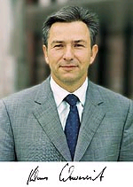
We hope you enjoy our city, and we look forward to seeing you in Berlin.
Klaus Wowereit - Governing Mayor
_________
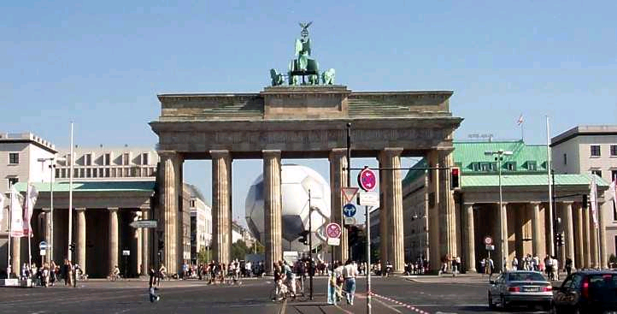
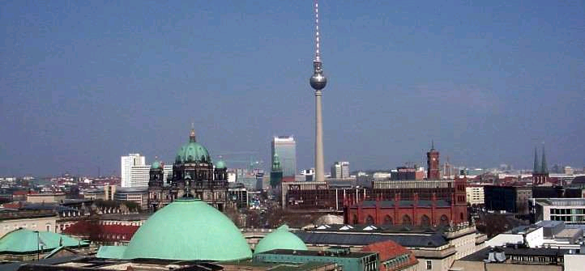
The new Berlin presents itself to visitors as an open city again. Brandenburg Gate – once a symbol of the divided Germany – has again become the emblem of the German capital.
Around it, the new centre of Berlin is rising up, a unique urban setting in which the old joins with the new, and the future of the city becomes visible.
Berlin is the capital and the biggest city of Germany. It has a population of about 3.5 million and extends over 889 square kilometers. It is located in central Europe, longitude 13:25 E,
latitude 52:32 N, 34 m above sea level, at the rivers Spree and Havel. The local time zone is Central European Time (MEZ or MET, one hour in advance of GMT, i.e., MEZ = GMT+1) with daylight savings time in the summer (MESZ = GMT+2).
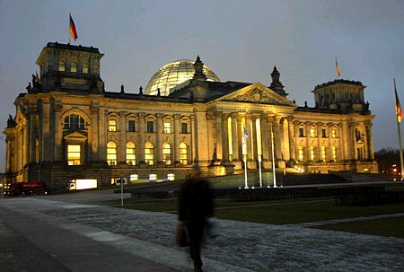
In an area of about 889 square kilometres – as large as Munich, Stuttgart and Frankfurt am Main together – Berlin unites a large number of urban districts, centres and boroughs which are completely different in character. In the inner part of the city, the buildings of the Kulturforum on the southern edge of the Tiergarten and the modern office and shopping complex on Potsdamer Platz link the western city around Kurfürstendamm with the eastern city in the historical centre of Berlin between Brandenburg Gate and Alexanderplatz. To the north of the Tiergarten, new buildings are being built for the federal government and the parliament in the meander of the Spree. The parliament has its seat in the Reichstag building, which has been remodelled.
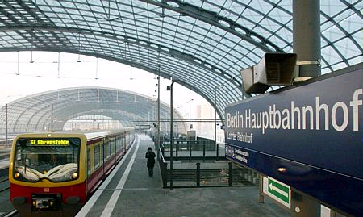
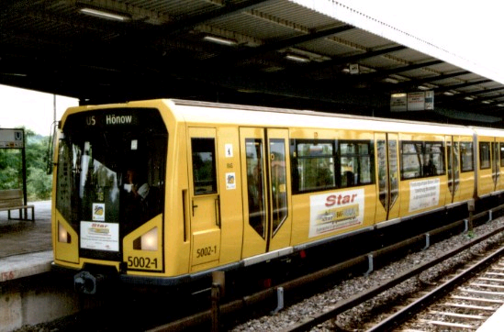
The ring of the S-Bahn (urban and suburban) railway encloses the most densely developed area of the city. Green areas such as the Tiergarten, Treptow Park, Friedrichshain and numerous other parks and gardens, along with about 400,000 trees along the streets of the city, ensure a favourable climate in the central districts.
The Berlin cultural scene with its volume, variety, liveliness and attractiveness contributes significantly to the unmistakable profile of the city. The seventeen state museums of the Stiftung Preussischer Kulturbesitz (Prussian Cultural Foundation) form the largest museum complex of the whole continent. Berlin is Germany’s most important theatrical city. Berlin currently has three opera houses, over 150 theatres and stage companies, 800 choirs, about 170 museums and collections, about 300 communal and private galleries, over 250 public libraries, 265 cinemas and numerous other cultural institutions.
And happenings such as the Love Parade, the first and largest event of its kind in the world which has attracted Techno fans to Berlin since 1992, help to gain Berlin an international reputation as a city of culture.
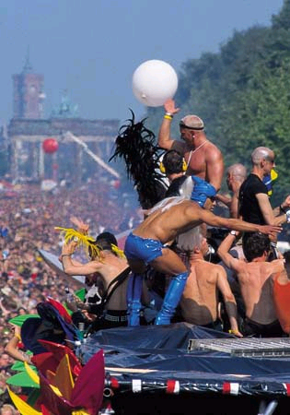
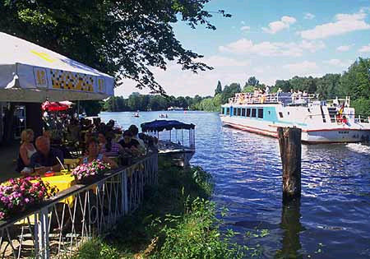
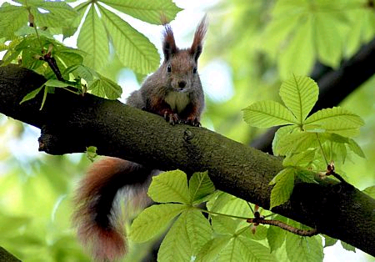
In a big city, good environmental conditions are an important prerequisite for a high quality of life.

9 Passport and visa regulations
Delegates are advised to check with the German Embassy in their own country if a visa is required for their visit to Germany or not. If an invitation letter or official document is required for visa application, please contact Ms. Rita Buschmeyer; mailto:rita.buschmeyer@bmwa.bund.de with such necessary information as name, nationality, organization/company, sex, date of birth, address (home, office), ID number, passport (number, date of issue and expiry), telephone, fax, e-mail. Delegates are also urged to process their visa requests at the earliest date possible.

10 Currency
The EURO is the official currency. 1 US $ is around 0.82 EURO (10 March 2004). Major credit cards are welcomed at most business places.

11 Business hours
Banks are open from 09:00 to 18:00, Monday to Friday.
Most department stores are open from 09:00 to 20:00, with the exception of Sunday.
Opening hours of retail stores are similar to that of department stores, but they may differ, depending on the store.
Hotel reservation form

Please type or print clearly. Retain a copy for your records. Please send this form to:
Hotel Estrel Berlin
Key: Bundesministerium 1606/04
Fax: + (49) 30 6831 2345
E-mail: reservierung@estrel.com
Hotel reservation should be booked a.s.a.p. but not later than 30 April 2004!
Last Name: |  |  |  | First Name:
Organization / Company:
Nationality: |  |  | Passport No.:
Address:
Tel: |  | Fax: |  |  | E-mail:
Accompanied by: | Name: |  |  |  | Passport No.:
Accompanied by: | Name: |  |  |  | Passport No.:

Hotel | Please choose type of room | Remarks
ESTREL | □ Single (EURO 115.-) | Breakfast EURO 14.50/person EXTRA
ESTREL | □ Twin (EURO 126.-) | Breakfast EURO 14.50/ person EXTRA
Arrival | Date: | Time: | Flight:
Departure | Date: | Time: | Flight:

Which way do you prefer to pay for your hotel fare? Please choose one. □ Cash □ Credit card
Please fill in the following information to guarantee your hotel reservation:

Type of Card: | Number:
Name on Card: | Expiry Date:
Annex 3
Registration Form
ITU-R Working Party 8F Meeting
Berlin, Germany, 16-23 June 2004
Radiocommunication Bureau
I wish to participate in |  | Working Party 8F
 |  | ✓

Mr. Mrs. Ms. Miss:
(family name) (first name)
Accompanied by family member(s):
(family name) (first name)
1. REPRESENTATION
Name of Member State:
❒ Head of Delegation  Deputy  Delegate
(to be completed by representatives of Member States only)
Name of Sector Member:
r Recognized Operating Agencies r Regional Telecommunication Organizations
r Scientific or Industrial Organizations r Intergovernmental Organizations operating Satellite Systems
r UN, Specialized Agencies and the IAEA r Other Entities dealing with Telecommunication matters
r Regional and other International Organizations r Associates
2. OFFICIAL ADDRESS
Name of the Company:
Street Address:
City/State/Code/Country:
Business tel.: Fax:
E-mail: In case of emergency:
3. DOCUMENTS ☑ English only
Date: Signature:
For BR Secretariat use only
Approved (if applicable) | Personal Section |  | Meeting Section |  | Pigeonhole
To be returned duly completed to the Radiocommunication Bureau |  | Place des Nations  CH-1211 Geneva 20  Switzerland |  | Telephone: +41 22 730 5802  Telefax: +41 22 730 6600  Email: linda.kocher@itu.int

* Contributors are urged to reduce the length of their contributions as much as possible. The recommended maximum length of an input document is 10 pages. Long documents should be structured as a small number of cover pages (preferably one) summarizing the document and an attachment containing the detailed information. The attachments of such long documents, when submitted as delayed contributions, would only be distributed on paper to the participants at the meeting, on request.

