Radiocommunication Bureau (BR)

Circular Letter  7/LCCE/83 |  | 20 February 2023
To Administrations of Member States of the ITU, Radiocommunication Sector Members,
ITU-R Associates participating in the work of Radiocommunication Study Group 7 and ITU Academia
Subject: | Meeting of Working Party 7A (Sèvres, Paris, France, 26-30 June 2023)

1 Introduction
By means of this Circular Letter, I wish to announce that, at the kind invitation of the Bureau International des Poids et Mesures (BIPM), the meeting of ITU-R Working Party 7A will take place in Sèvres, Paris, France, from 26 to 30 June 2023. The opening session will commence on 26 June 2023 at 0930 hours (see table below).
Group | Meeting date | Deadline for contributions  1600 hours UTC | Opening session
Working Party 7A | 26 - 30 June 2023 | 19 June 2023 | 26 June 2023  at 0930 hours

2 Programme of the meeting
A draft agenda for the meeting is contained in Annex 1. The status of texts assigned to the Working Party can be found on:
https://www.itu.int/md/R19-SG07-C-0001/en.
The Working Party will conduct its work in English.
The working hours of the meetings should be as usual from 0900 to 1700 hours (local time); a more precise time schedule will be included in the Administrative (ADM) documents of the meetings.

3 Venue
The meeting will take place at:
BIPM
Address: 12 bis Grande Rue, Sèvres, Paris, France
URL: https://www.bipm.org/en/conference-centre/directions.html
For further information see Annex 2.

4 Contributions
Contributions in response to the work of Working Party 7A are invited. These will be processed according to the provisions laid down in Resolution ITU-R 1-8.
The deadline for reception of contributions not requiring translation* (including Revisions, Addenda and Corrigenda to contributions) is seven calendar days (1600 hours UTC) prior to the start of the meeting. The deadline for reception of contributions for this meeting is specified in the table above. Submissions received later than this deadline cannot be accepted. Resolution ITU-R 1-8 provides that contributions which are not available to participants at the opening of the meeting cannot be considered.
Members are encouraged to submit their contributions as early as possible and possibly include a contact name and email address to facilitate the discussion (cf. § A2.2.4.4 of Resolution ITU-R 1-8).
Participants are requested to submit contributions by electronic mail to:
rsg7@itu.int
A copy of each contribution should also be sent to the Chairman of Working Party 7A and to the Chairman and Vice-Chairmen of Study Group 7. The pertinent addresses can be found on:
http://www.itu.int/go/rsg7/ch
http://www.itu.int/go/rwp7a/ch

5 Documents
Contributions will be posted “as received” within one working day on the Working Party 7A webpage established for this purpose. The official versions will be posted on http://www.itu.int/md/R19-WP7A-C/en within 3 working days.
All participants are kindly requested to download the documents from the above website before the meeting starts to avoid congestion of Internet network.
Wireless LAN facilities will be available in all the meeting rooms.
Participants will need to bring their laptops (equipped with a WLAN-card) with them to the meeting, as well as personal earphones, because this will be a completely paperless meeting and the Zoom platform audiovisual facilities will be used for the discussions during the meeting sessions.

6 Participation/Visa requirements/Registration for the event
Registration to this event is mandatory and will be carried out exclusively on-line via Designated Focal Points (DFPs) for ITU-R event registration. Participants must first complete an online registration form and submit their registration request for approval by the corresponding focal point. Participants would require an ITU account for this purpose.
While registering for the event, please duly take into consideration the information related to the current sanitary measures and conditions of entry in France.
Participants are strongly encouraged to register early and to indicate if they intend to attend the meeting in person or remotely (see Annex 3) and are further encouraged to consult the safety and security information which is regularly updated before making travel arrangements should they choose to attend the event in person.
The list of ITU-R DFPs (TIES protected) as well as detailed information on this event registration system can be found at:
www.itu.int/en/ITU-R/information/events
Specific information on how to obtain visa and immigration documents are indicated in Section 6 of Annex 2. In particular, your attention is drawn to the need to apply for the visa well in advance.

7 Connecting to the meeting sessions for remote participation
Access to meeting sessions is restricted to event registered participants only. Delegates wishing to connect to the meeting remotely can access Working Party 7A meeting sessions from the webpage for remote participation:
https://www.itu.int/en/events/Pages/Virtual-Sessions.aspx
These virtual meeting session connections will become available 30 minutes before the starting time of each session.
Delegates wishing to troubleshoot remote participation connectivity issues can do so during the 30-minute period prior to the start of the first session of each day. It is highly recommended to verify the connections, particularly for those delegates who intend to actively participate in the discussions.
Some meeting rooms may not allow for the audio of the remote participation platform to be integrated with the room audio system. In these meeting rooms, the in-person participants would be required to connect to the remote participation platform. Therefore, the in-person participants are required to bring a good quality wired headset with integrated microphone to the meeting sessions for use in such meeting rooms.

8 Webcast
For those interested in following the proceedings of ITU-R meetings remotely, an audio webcast of the Working Parties plenary sessions will be provided through the ITU Internet Broadcasting Service (IBS). Participants do not need to register for the meeting to use the webcast facility, however TIES access is required.

9 Conversion to a virtual meeting if COVID-19 related sanitary conditions substantially worsen
Should COVID-19 related sanitary conditions worsen, the meeting organizers will inform all participants of a possible conversion of the meeting to a virtual one in due course via an addendum to this Circular Letter.
For further questions relating to this Circular Letter, please contact, Mr Vadim Nozdrin, Study Group 7 Counsellor, at vadim.nozdrin@itu.int.
Mario Maniewicz
Director
Annexes: 3
Annex 1
Draft agenda for the meeting of Working Party 7A
(Sèvres, 26-30 June 2023)
1 Introduction by the Chairman
2 Approval of the agenda
3 Status of Questions assigned to the Working Party and related work
4 Results of CPM23-2
5 Work programme for the meeting
6 Introduction of input documents
7 Establishment of working groups and assignment of documents
8 Preparation of output documents
9 Discussion of the future work plan
10 Next meetings
11 Any other business
Joseph ACHKAR
Chairman, Working Party 7A

Annex 2
Additional information for the meeting of Working Party 7A
1 Introduction
This Annex provides both information on the meeting and guidance to the delegates for their stay in Sèvres, France.
2 Meeting Venue
The meeting will be held at:
BIPM
Address: 12 bis Grande Rue, Sèvres, Paris, France
URL: https://www.bipm.org/en/conference-centre/directions.html
3 On-site Registration / Badges
Badges will be issued only to individuals who have successfully undergone the ITU-R registration procedure and have been accredited. Participants will not be admitted to the venue without the badge.
Registration (badges): 26 June 2023 from 0900 onwards.
4 Access to the meeting venue
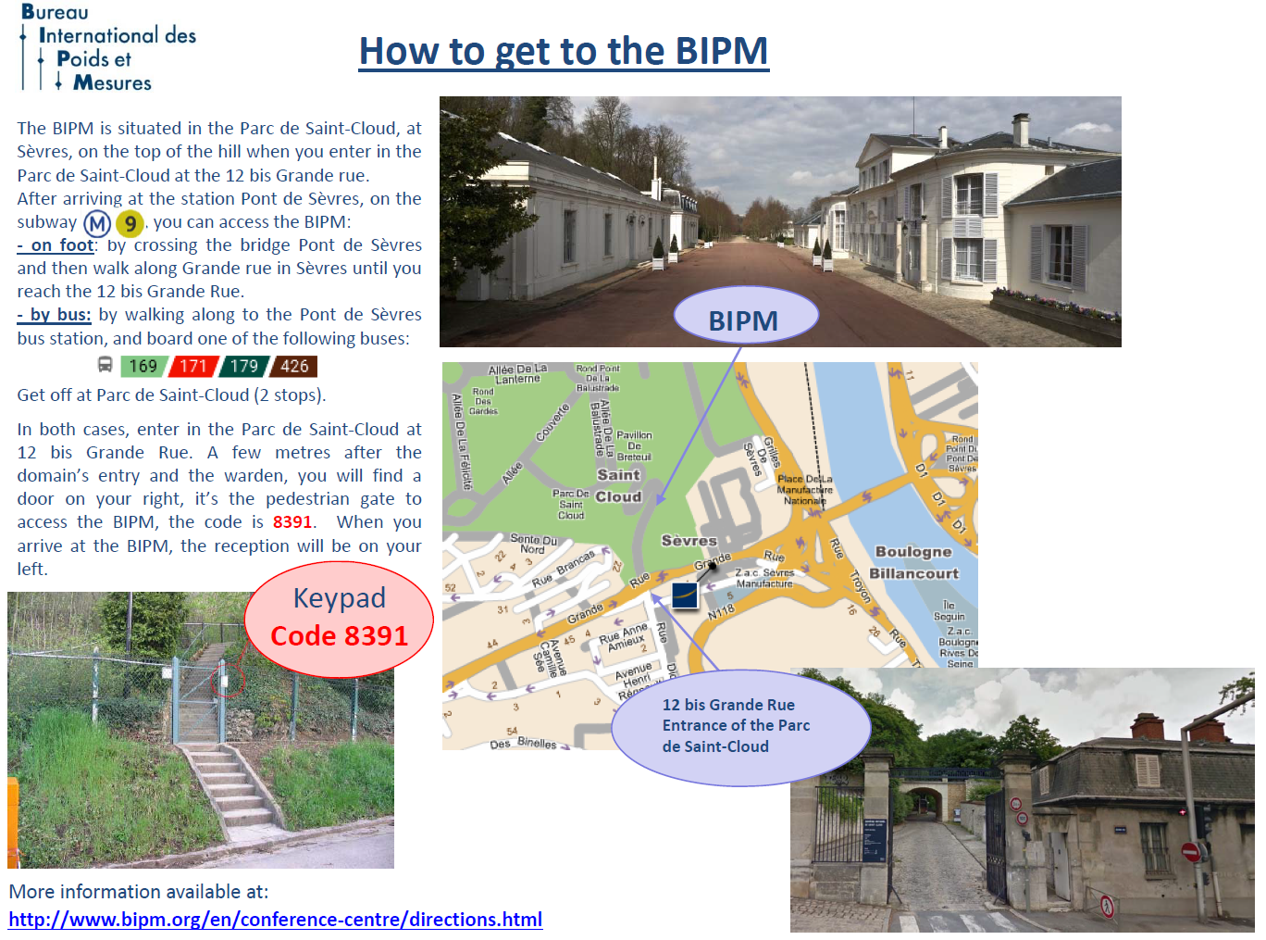
4.1 How to get to the BIPM
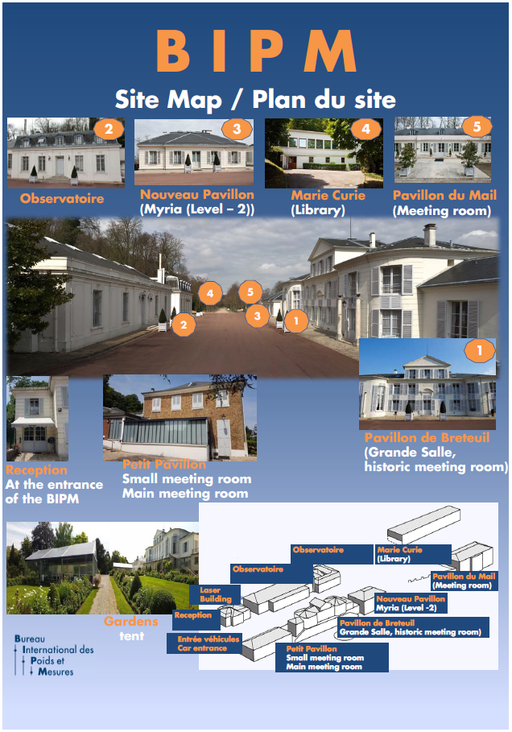
4.2 BIPM Site map
5 Accommodation
Hotels in the vicinity
Hotel Novotel****
11-13, Grande rue
92310 Sèvres
Tel: + 33 1 46 23 20 00
Fax: + 33 1 46 23 02 32
email: H1979@accor.com
Website: http://www.novotel.com/gb/hotel-1979-novotel-paris-pont-de-sevres/index.shtml
-15% of the daily price on room and breakfast if you indicate that you are a making a reservation to attend a meeting at the BIPM
Aprt’hotel Paris/Boulogne
Résidence Lagrange City Boulogne
16, Cours de l'Ile Seguin 92200 Boulogne-Billancourt
Tel: + 33 1 46 10 01 58
Fax: + 33 1 46 21 34 55
email: boulogne@groupe-lagrange.com
Website: http://www.lagrange-city-paris-boulogne.com/
Hôtel Radisson Blu****
33, avenue Edouard Vaillant
92660 Boulogne Billancourt Cedex
Tel: + 33 1 46 08 85 00
Fax: + 33 1 46 08 87 29
email: reservations.boulogne@radissonblu.com
Website: https://www.radissonblu.com/en/hotel-parisboulogne
Ibis Styles Paris Boulogne Marcel Sembat***
92, boulevard de la République
92100 Boulogne
Tel: + 33 1 46 08 08 02
Fax:+ 33 1 46 08 27 16
email: HA039@accor.com
Website: http://www.ibis.com/gb/hotel-A039-ibis-styles-paris-boulogne-marcel-sembat/index.shtml
Hotel Villa Sorel**
20, rue Georges Sorel 92100 Boulogne Billancourt
Tel: + 33 1 46 04 91 58
Fax:+ 33 1 46 04 08 37
email : info@villasorel.com
Website: http://www.villasorel.com/en/index.php
Wifi unlimited internet: free of charge
Hotel de France**
112, av. du Général Leclerc 92100 Boulogne Billancourt
Tel: + 33 1 46 04 65 65
Fax:+ 33 1 46 04 03 16
email : resa.hoteldefrance@gmail.com
Website: https://www.hoteldefranceboulogne.fr/
Wifi unlimited internet: free of charge
Best Western Select Hotel***
66, avenue du Général-Leclerc
92100 Boulogne Billancourt
Tel: + 33 1 46 04 70 47
Fax: + 33 1 46 04 07 77
email: reception@select-hotel.fr
website: http://www.bestwestern.fr/en/hotel-Boulogne-billancourt,Best-Western-Select-Hotel,93602

Hôtel Alpha***
26, rue Emile Landrin
92100 Boulogne Billancourt
Tel: + 33 1 46 05 80 51
Fax: + 33 1 46 05 17 33
email: hotel@alpha-paris-hotel.com
Website: http://www.alpha-paris-hotel.com/English.phtml
Wifi unlimited internet: free of charge
Hôtel Ibis**
12, rue de la Ferme
92100 Boulogne Billancourt
email: h6245@accor.com
Website: http://www.ibis.com/gb/hotel-6245-ibis-paris-boulogne-billancourt/index.shtml
Hôtel Campanile
885, avenue Roger Salengro
92370 Chaville
Tel: +33 1 47 50 63 00
Fax: +33 1 47 50 69 42
email: chaville@campanile.fr
Website: http://www.campanile.com/en/hotels/campanile-paris-ouest-chaville
Please note that the BIPM is in no case liable for hotel reservation.
The BIPM cannot offer discounted rates, except for the few hotels for which special rates are mentioned above.
In case of “no show” the visitor will be charged for it.
For visitors who would like to stay in Paris, please note that the BIPM is 15 minute walk from the line 9 of the metro (Pont de Sèvres) and 10 minute walk from the tram line T2 (Musée de Sèvres). More information is available at: http://www.bipm.org/en/conference-centre/directions/
6 VISA and immigration information
A visa may be necessary for participants from some countries to enter France. To check the visa requirements please contact the French Embassy in your country. Please see the link for more information regarding visas for France https://france-visas.gouv.fr/en_US/web/france-visas.
Participants who should require a personal Letter of Invitation for obtaining a visa are requested to contact BIPM via e-mail at meetings@bipm.org as soon as possible after registration with ITU.
7 Network
7.1 Internet Access
Local Secretariat will give you the Access SSID information on site.
8 Practical Information

8.1 Sévres, Paris, France
Paris, France's capital, is a major European city and a global center for art, fashion, gastronomy and culture. Its 19th-century cityscape is crisscrossed by wide boulevards and the River Seine. Beyond such landmarks as the Eiffel Tower and the 12th-century, Gothic Notre-Dame cathedral, the city is known for its cafe culture and designer boutiques along the Rue du Faubourg Saint-Honoré.

8.2 Climate
Paris in France has a temperate, oceanic climate with warm summers and cold winters. There is a marked difference between the seasons but extreme hot or cold temperatures are rare.
Rainfall is moderate and steady year-round. The city is known for its sudden showers, although its annual average rainfall is low compared with other regions in France.
Monthly average values of the temperature and precipitation in Paris are given in the table below:
 | June
Average Max Temperature | 23C / 73F
Average Minimum Temperature | 14C / 57F
Sunshine hours | 6 hours
Average Precipitation | 24 mm
https://www.holiday-weather.com/paris

8.3 Electricity and Voltage
France uses power outlets and plugs of types C & E. All power sockets in France provide a standard voltage of 230V with a standard frequency of 50Hz.
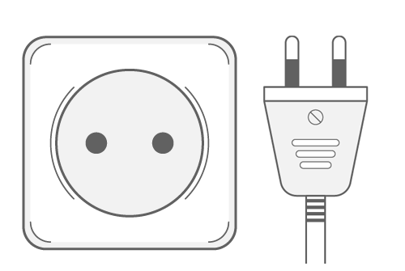
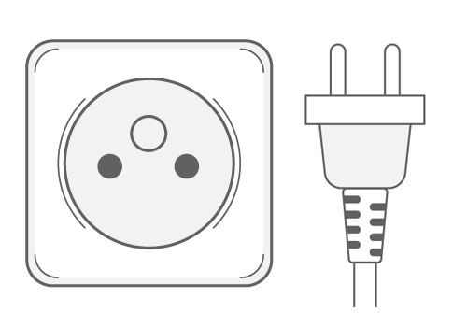

8.4 Language
French

8.5 Time Zone
UTC/GMT +1 hour.

9 Local Contact
If you have any questions about the meeting arrangements, please contact Ms Céline Fellag Ariouet cfellag@bipm.org.

Annex 3
Information on registration for participants in ITU-R events
Please ensure that the box “Remote” is ticked during the registration process, if attending remotely. If the box is not ticked, physical participation will be assumed.
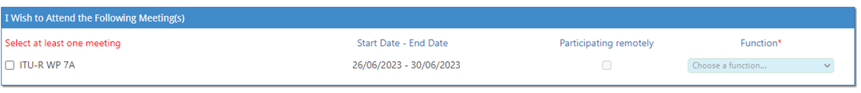
______________

* Where translation is required, contributions should be received at least three months prior to the meeting.

