INTERNATIONAL TELECOMMUNICATION UNION
Radiocommunication Bureau
(Direct Fax N°. +41 22 730 57 85)

Circular Letter  7/LCCE/41 | 6 December 2004
To Administrations of Member States of the ITU, Radiocommunication Sector Members
and ITU-R Associates participating in the work of Working Parties 7B, 7C and 7D
of Radiocommunication Study Group 7
Subject: Meetings of Working Parties 7B, 7C and 7D
Working Party 7B: Space radio systems
Working Party 7C: Earth-exploration satellite systems and meteorological elements
Working Party 7D: Radio astronomy
Introduction
By means of this Circular Letter, we wish to announce that meetings of ITU-R Working Parties 7B, 7C and 7D will take place in San Diego, California at the kind invitation of the United States of America, from 7 to 11 March 2005.

Place of the meetings
The meetings will take place at the:

Doubletree Hotel Mission Valley
7450 Hazard Center Drive
San Diego, California, CA 92108

For further information see Annex 1.

Programme of the meetings

Group | Date | Opening
Working Party 7B | 7-11 March 2005 | 7 March 14:00 hours
Working Party 7C | 7-11 March 2005 | 7 March 09:30 hours
Working Party 7D | 7-11 March 2005 | 7 March 11:00 hours
Joint Meeting of Working Parties | 11 March 2005 | 11 March 15:00 hours
Services directly connected with meeting activities, such as delegate registration, document distribution, etc. will be located in the vicinity of the meeting room. Registration of delegates will start at 08:30 hours on the opening day.
A draft agenda for the meetings is contained in Annex 2. The Questions assigned may be found on: http://www.itu.int/ITU-R/pulications/que/rsg7/index.asp. The Working Parties will conduct their work in English.

Contributions
Contributions in response to the work of Working Parties 7B, 7C and 7D are invited. These will be processed according to the provisions laid down in Resolution ITU-R 1-4, posted on http://www.itu.int/ITU-R/study-groups/rsg7/index.asp and distributed to participants on CD-ROM at the opening of the meeting.
One copy of each contribution should be sent to the Director, Radiocommunication Bureau for processing. A copy should also be sent to the Chairmen of the relevant Working Party and to the Chairman and Vice-Chairmen of Study Group 7. The pertinent addresses can be found on
http://www.itu.int/ITU-R/study-groups/index.asp (see Chairmen and Vice-Chairmen)
Participants are encouraged to submit contributions by electronic mail to:
rsg7@itu.int
As decided at the last meeting of the SG 7 Steering Group, the deadline for submitting contributions is Monday, 28 February 2005 at 12:00 hours Geneva time. Documents received after the deadline will be forwarded to the next meeting of the concerned Working Party.

Documentation
All contributions will be made available to the delegates on CD-ROM as well as on the ITU-R Study Group 7 Web page at: http://www.itu.int/ITU-R/study-groups/rsg3/index.asp (go to Web page of the related Working Party) .Participants are expected to bring with them to the meeting paper copies of all of the input documents of interest to them (if necessary). Delegates also should indicate in the registration form whether they wish receive paper copies of temporary, administrative and information documents during the meeting

Hotel accommodation and arrival information
Annex 1 contains details on hotel accommodation; delegates are advised to make reservations at the earliest opportunity. Also included in Annex 1 is information concerning arrival in San Diego, together with a map indicating the conference hotel.

Participation
The intended participation of your representative(s) should be advised not later than one month before the opening of the meeting, by means of the annexed form (Annex 4) (to be photocopied as required).

Valery Timofeev
Director, Radiocommunication Bureau
Annexes: 4
Distribution:

– Administrations of Members of the ITU and other members of the Radiocommunication Sector participating in the work of Working Parties 7B, 7C and 7D of Radiocommunication Study Group 7
– Chairman and Vice-Chairmen of Radiocommunication Study Group 7
– ITU-R Associates participating in the work of Radiocommunication Study Group 7
– Secretary General of the ITU, Director of the Telecommunication Standardization Bureau, Director of the Telecommunication Development Bureau
Annex 1
Information for participants

1 Meeting venue and hotel accommodation
The venue of the meeting is:
Doubletree Hotel Mission Valley
7450 Hazard Center Drive
San Diego, California, CA 92108
Home page: http://www.doubletree.com/en/dt/hotels/index.jhtml?ctyhocn=SDGO-DT
Tel: +1-619-207-5466
Fax: +1-619-297-5499

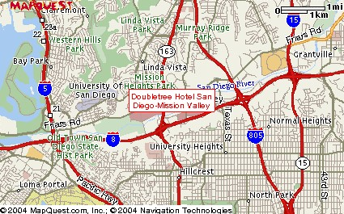

The hotel rooms are reserved for your disposal from 6 March to 11 March 2005, plus 3 days before and 3 days after the meeting on a space available basis at the conference rate.
Room reservation (Special hotel rates)
The conference rate for the Study Group 7 Working Parties meeting is the US per diem rate (currently US $129), single or double. Reservations must be made on or before 6 February to take advantage of the conference rate.

Delegates should indicate the following when requesting a room:

"ITU-R Working Parties 7B, 7C, 7D".
The hotel code is "IPR" to obtain the conference rate of $129.

2 Transportation
Transport connections between San Diego International Airport (SAN) and the Doubletree Hotel Mission Valley is complimentary; for the return trip to the airport, there is a US $5 fee. Arrangements may be made by using the hotel courtesy telephone in the lobby of the airport.
Rental cars are available from a variety of car rental companies in the immediate vicinity of the airport. It is best to make reservations for car rentals in advance. A map and driving directions are included below.
Direction by car:
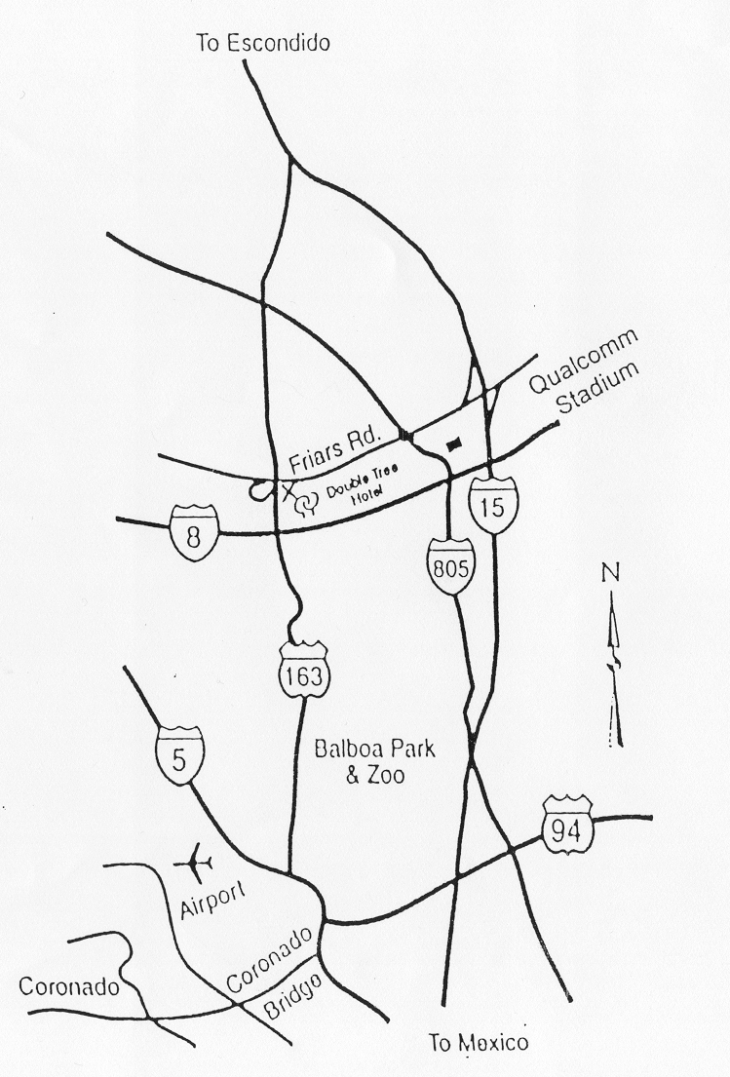
From San Diego International Airport:
Harborn Boulevard South to Grape Street, turn left to go to Interstate 5 South on ramp to 163 North. Go to Friars Road East, turn right on Frazee Road (1st light), turn right on Hazard Center Drive.

From Los Angeles via Interstate 5:
Take Interstate 5 to 805 South to 163 South, take Friars Road exit, turn right on Frazee Road (1st light), then turn right on Hazard Center Drive.

From Los Angeles via Interstate 15:
Take Interstate 15 to 163 South, take Friars Road East exit, turn right on Frazee Road (1st light), turn right on Hazard Center Drive.

From Interstate 8 (Arizona):
Take Interstate 8 West to 163 North, take Friars Road East, turn right on Frazee Road (1st light), turn right on Hazard Center Drive.

Should directions be necessary from a specific area to the Doubletree Hotel San Diego-Mission Valley, please call our guest services desk for assistance at
(619) 297-5466 extension 4175.

3 Contact point
For any further information you may require or if you need a personal invitation letter or official document from the US Administration for your visa application, please contact:
Mr. Wayne A. Whyte, Jr.
National Aeronautics and Space Administration
Glenn Research Center
NASA Glenn Research Center,
21000 Brookpark Road
Mail Stop 501-1
Tel: +1 216 433-3482
Fax: +1 216 977 7444
Email: Wayne.A.Whyte@nasa.gov

4 Invitation
A copy of the invitation letter from the United States of America is reproduced in Annex 3.

5 Visas
Delegates are urged to apply, as soon as possible, for U.S. visas, if needed, to facilitate entrance to the United States. If a special invitation is required, please contact the meeting coordinator, Mr. Wayne Whyte (see Section 3 above).

Annex 2
Draft agenda for the meetings of
Working Parties 7B, 7C and 7D
(San Diego, 7-11 March 2005)

1 Introduction by the Chairman
2 Approval of the agenda
3 Status of Questions assigned to the Working Party and related work
4 Chairman’s progress Report
5 Work programme for the meeting
6 Introduction of input documents
7 Establishment of drafting groups and attribution of documents
8 Preparation of output documents
9 Discussion of the future work plan
10 Venue of the next meetings
11 Any other business

S. TAYLOR
Chairman, WP 7B

E. MARELLI M. OHISHI
Chairman, WP 7C Chairman, WP 7D

Annex 3
Copy of the invitation letter
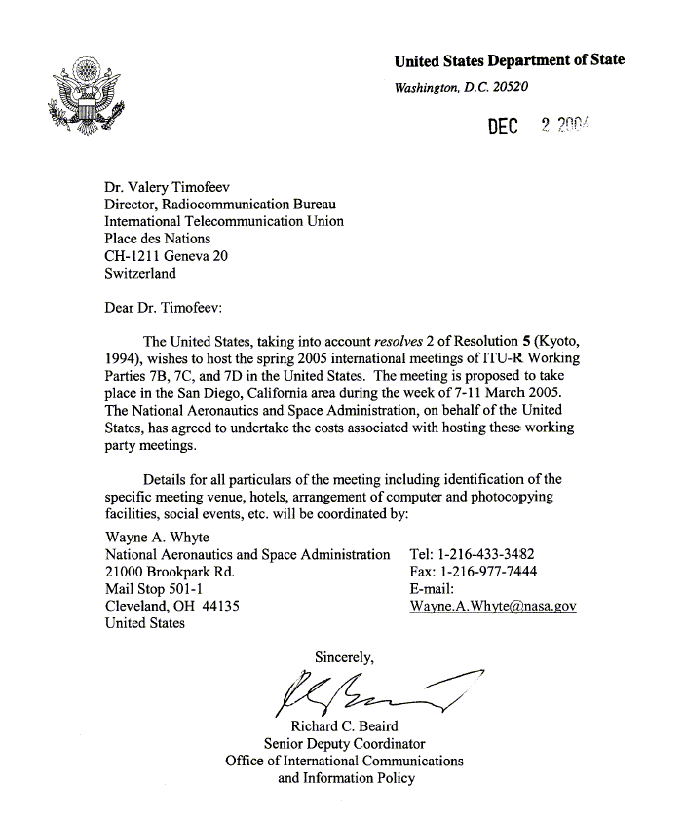

Annex 4
Registration Form
ITU-R Meetings
San Diego, United States, 7 - 11 March 2005
Radiocommunication Bureau |  |  |  |  |  |  |  |  |  |  |  |  | I wish to participate in
 | WP 7B  07-11/03 |  |  |  |  | WP 7C  07-11/03 |  |  |  |  | WP 7D  07-11/03
 | Mr. Mrs. Ms. Miss: |  |  |  |  |  | …………………………………………………………. |  |  |  |  |  |  |  |  |  |  |  |  |  | …………………………………………………………………...
 |  |  |  |  |  |  |  |  |  | (family name) |  |  |  |  |  |  |  |  |  |  | (first name)
 | Accompanied by family member(s): |  |  |  |  |  |  |  |  | …………………………………………… |  |  |  |  |  |  |  |  |  |  | …………………………………………………………………...
 |  |  |  |  |  |  |  |  |  | (family name) |  |  |  |  |  |  |  |  |  |  | (first name)
 | 1. REPRESENTATION
 | Name of Member State: |  |  |  |  |  |  |  |  | …………………………………………………………………………………………………………………….
 | ❒ Head of Delegation |  |  |  |  |  |  |  |  |  |  | ❒ Deputy |  |  |  |  |  |  |  |  |  |  |  |  |  | ❒ Delegate
 | (to be completed by representatives of Member States only)
 | Name of Sector Member: |  |  |  |  |  |  |  |  | …………………………………………………………………………………………………………………….
 | r |  |  | Recognized Operating Agencies |  |  |  |  |  |  |  |  |  |  |  |  |  | r |  |  |  | Regional Telecommunication Organizations
 | r |  |  | Scientific or Industrial Organizations |  |  |  |  |  |  |  |  |  |  |  |  |  | r |  |  |  | Intergovernmental Organizations operating Satellite Systems
 | r |  |  | UN, Specialized Agencies and the IAEA |  |  |  |  |  |  |  |  |  |  |  |  |  | r |  |  |  | Other Entities dealing with Telecommunication matters
 | r |  |  | Regional and other International Organizations |  |  |  |  |  |  |  |  |  |  |  |  |  | r |  |  |  | Associates
 | 2. OFFICIAL ADDRESS
 | Name of the Company: |  |  |  |  |  |  | …………………………………………………………………………………………………………………………
 | Street Address: |  |  |  |  |  |  | …………………………………………………………………………………………………………………………
 | City/State/Code/Country: |  |  |  |  |  |  | …………………………………………………………………………………………………………………………
 | Business tel.: |  |  |  |  |  |  | …………………………………………… |  |  |  |  |  |  |  |  |  |  |  | Fax: |  |  |  |  | ……………………………………………
 | E-mail: |  |  |  |  |  |  | …………………………………………… |  |  |  |  |  |  |  |  |  |  |  | In case of emergency: |  |  |  |  | ……………………………………………
 | 3. DOCUMENTS
 | I wish to receive paper copies during the meeting: |  |  |  |  |  |  |  |  |  |  |  |  | r |  | Yes |  |  |  |  |  |  |  |  |  | r | No
 | Date : |  | ……………………………………………………………………… |  |  |  |  |  |  |  |  |  |  |  |  |  |  |  | Signature: |  |  |  | …………………………………………………………...
 |  | For BR Secretariat use only
 |  | Approved (if applicable) |  |  |  |  |  |  | Personal Section |  |  |  |  |  | Meeting Section |  |  |  |  |  |  |  |  | Pigeonhole
 |  | To be returned duly completed to the Radiocommunication Bureau |  |  |  |  |  |  |  |  |  |  |  | Place des Nations  CH-1211 Geneva 20  Switzerland |  |  |  |  |  |  |  |  |  |  |  | Telephone: +41 22 730 5802  Telefax: +41 22 730 6600  Email: linda.kocher@itu.int

