|  |  |  |
| --- | --- | --- |
| **Radiocommunication Bureau (BR)** | | |
| Circular Letter  **5/LCCE/118** | | 17 March 2025 |
|  | | |
|  | | |
| **To Administrations of Member States of the ITU, Radiocommunication Sector Members, ITU-R Associates and ITU Academia participating in the work of Radiocommunication Study Group 5D** | | |
|  | | |
|  | | |
| Subject: | **Meeting of Working Party 5D (Kobe, Japan, 24 June – 3 July 2025)**  **– Working Party 5D: IMT Systems** | |
|  |
|  |

# 1 Introduction

By means of this Circular Letter, I wish to announce that the 49th meeting of ITU-R Working Party 5D kindly hosted by the Administration of Japan, will take place in Kobe, Japan, on the dates indicated in the table below:

|  |  |  |  |
| --- | --- | --- | --- |
| Groups | Meeting dates | Deadline for contributions 1600 hours UTC | Opening session (Japan time, GMT + 8 hours) |
| Working Party 5D | 24 June – 3 July 2025 | Thursday, 12 June 2025 | Tuesday, 24 June 2025 at 0900 hours |

2 Programme of the meetings

The draft agenda for the meeting is contained in Annex 1.

The status of texts assigned to Working Party 5D can be found on:

[www.itu.int/md/R23-SG05-C-0001/en](http://www.itu.int/md/R23-SG05-C-0001/en)

The Working Party will conduct its work in English only.

The working hours of the meeting are planned from 0900 to 1700 hours (Kobe time), a more precise time schedule will be included in the ADM documents of the meetings.

3 Contributions

Contributions will be processed according to the provisions laid down in Resolution [ITU-R 1-9](https://www.itu.int/pub/R-RES-R.1).

The deadline for reception of contributions not requiring translation[1]* (including Revisions, Addenda and Corrigenda to contributions) is **twelve calendar days** (1600 hours UTC) prior to the start of the meeting (see table above). Submissions received later than these deadlines cannot be accepted. Resolution ITU-R 1-9 provides that contributions which are not available to participants at the opening of the meeting cannot be considered.

Members are encouraged to submit their contributions as early as possible and to include a contact name and email address to facilitate the discussion (cf. § A2.2.4.4 of Resolution ITU-R 1-9).

Participants are requested to submit contributions by electronic mail to:

[rsg5@itu.int](mailto:rsg5@itu.int)

A copy of each contribution should also be sent to the Chair of Study Group 5 and the Chair of Working Party 5D. Their addresses can be found on:

[www.itu.int/go/ITU-R/wp5d/cvc](http://www.itu.int/go/ITU-R/wp5d/cvc)

<http://itu.int/go/ITU-R/SG5/Chair>

# 4 Documents

Contributions will be posted “as received” within one working day on the Working Party 5D webpage established for this purpose. The official versions will be posted on <http://www.itu.int/ITU-R/go/rsg5/en> (see “contributions” of the relevant Working Party) within 3 working days.

Wireless LAN facilities will be available in all the meeting rooms. All participants are kindly requested to download the documents from the above website before the meeting starts to avoid congestion of the wireless LAN network.

Participants will need to bring their WLAN-capable notebook computers to the paperless meeting.

# 5 Registration

Registration to this event is mandatory and will be carried out exclusively on-line via Designated Focal Points (DFPs) for ITU-R event registration. **Participants must first complete an online registration form and submit their registration request for approval by the corresponding focal point.** Participants require an ITU account for this purpose and are strongly encouraged to **register early** and to indicate **if they intend to attend the meeting in person or remotely.**

The list of ITU-R DFPs (TIES protected) as well as detailed information on this event registration system can be found at:

[www.itu.int/en/ITU-R/information/events](http://www.itu.int/en/ITU-R/information/events)

*Note: For ITU-R events held abroad, visas cannot be obtained through the ITU Secretariat.*

**6 Practical information/Visa requirements/Accommodation**

All practical information for participants, including travel, visa requirements, accommodation, is presented in Annex 2.

**7 Remote participation and webcast**

Access to meeting sessions is restricted to event registered participants only and can be accessed from the webpage for remote participation:

[www.itu.int/en/events/Pages/Virtual-Sessions.aspx](http://www.itu.int/en/events/Pages/Virtual-Sessions.aspx)

These virtual meeting session connections will become available 30 minutes before the starting time of each session.

Some of the meeting rooms at the venue do not allow for the audio integration of the remote participation platform with the room audio system. Therefore, in-person participants are required to connect to the remote participation platform to hear interventions of remote participants. Consequently, in-person participants need to bring a good quality wired headset with integrated microphone for use during all meetings. The use of wireless headsets is strongly discouraged.

For those interested in following the proceedings of ITU-R meetings remotely, an audio webcast of Working Party 5D plenary sessions will be provided. Participants do not need to register for the meeting to use the webcast facility, however TIES access is required.

For further questions relating to this Circular Letter, please contact Mr Uwe Löwenstein, Study Group 5 Counsellor, at uwe.loewenstein@itu.int.

Mario Maniewicz  
Director

**Annexes:** 2

Annex 1  
  
Draft agenda for the 49th meeting of Working Party 5D

(Kobe, 24 June – 3 July 2025)

**1** Opening remarks

**2** Approval of the agenda

**3** Report of the 48th meeting of Working Party 5D (Document [5D/563](https://www.itu.int/md/R23-WP5D-C-0563/en))

**4** Reports from Rapporteurs and Correspondence Groups

**5** Working structure and document assignment

**6** Any other business

H. ATARASHI  
 Chair, Working Party 5D

Annex 2  
  
Practical information for participants

# Practical information for the participants

This Annex provides information on the meeting and guidance to the delegates for their travel and stay in Kobe, Japan.

# 1 Meeting venue

The meeting will be held at:

**Place:** Kobe Fashion Mart, 9F Event Floor

**Address:** 6-9 Koyocho-naka, Higashinada-ku, Kobe-City, Hyogo-ken 658-0032, Japan

**Phone:** +81-78-857-8020

**URL:** <https://www.kfm.or.jp/en/>

# 2 Transportation and access

From Kansai International Airport (KIX)

• By airport bus

There are two to three airport buses per hour between the airport and Kobe Sannomiya. You can buy a bus ticket at the airport or pay with electronic money such as ICOCA or Suica. The fare is 2,200 yen. There are only three buses per day that stop at the Bay Sheraton Hotel (near the venue). For more information, please refer to the following websites:

<https://www.kate.co.jp/en/>

<https://www.kate.co.jp/en/timetable/detail/KB>

From Sannomiya, take the JR Kobe Line heading towards Osaka (the up direction) and get off at Sumiyoshi Station. At Sumiyoshi Station, transfer to the Rokko Liner and get off at Island Center Station. Kobe Fashion Mart is a one-minute walk from the station. The journey takes about 25 minutes and costs 440 yen.

If you take a taxi from Sannomiya to the venue, the journey takes about 20 to 30 minutes and costs about 4,000 yen.

• By train

Take the JR Kansai Airport Line rapid train from Kansai International Airport Station and get off at Osaka Station.

At JR Osaka Station, transfer to the JR Kobe Line and get off at Sumiyoshi Station. Transfer to the Rokko Liner at Sumiyoshi Station and get off at Island Center Station. Kobe Fashion Mart is a one‑minute walk from the station.

The journey takes about two hours and costs 1,990 yen.

For more information, please see the following website:

<https://www.kansai-airport.or.jp/en/>

**From Kobe Airport**

This information is for flights arriving at Kobe Airport, which is mainly served by **domestic** flights. However, there is some early information that some international flights are planned to be operated to/from Kobe Airport from April 2025 onwards.

• By airport bus

You can take a bus to Universal Studios via Bay Sheraton. It takes about 30 minutes and costs 500 yen. Get off at Bay Sheraton and it's a 2-3 minutes’ walk to the venue. However, the frequency of buses is low, about once every 2 hours.

• By train

From Kobe Airport, take the Port Liner and get off at Sannomiya Station.

At Sannomiya, take the JR Kobe Line heading towards Osaka (the up direction) and get off at Sumiyoshi Station. At Sumiyoshi Station, transfer to the Rokko Liner and get off at Island Center Station. Kobe Fashion Mart is a 1-minute walk from the station. The journey takes about 45 minutes and costs 780 yen.

• By taxi

If you take a taxi from Kobe Airport, the journey takes about 30 minutes and costs about 7,000 yen.

For more information, please see the following website:

<https://www.kairport.co.jp/eng/index.html>

From Shinkansen Shin-Kobe Station

Get off at Shin-Kobe and take the subway to Sannomiya (1 stop).

Take the JR Kobe Line heading towards Osaka (the up direction) from Sannomiya and get off at Sumiyoshi Station.

Transfer to the Rokko Liner at Sumiyoshi Station and get off at Island Center Station.

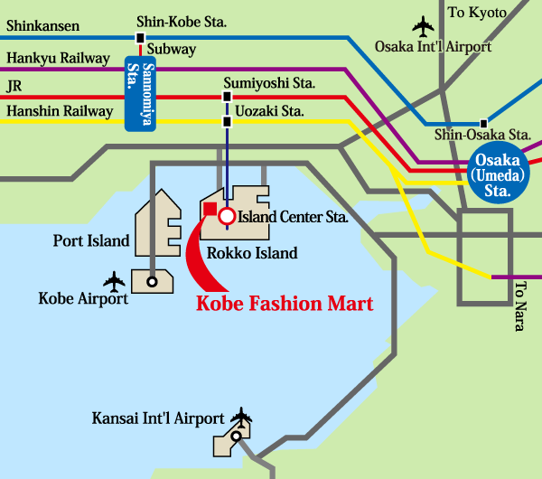

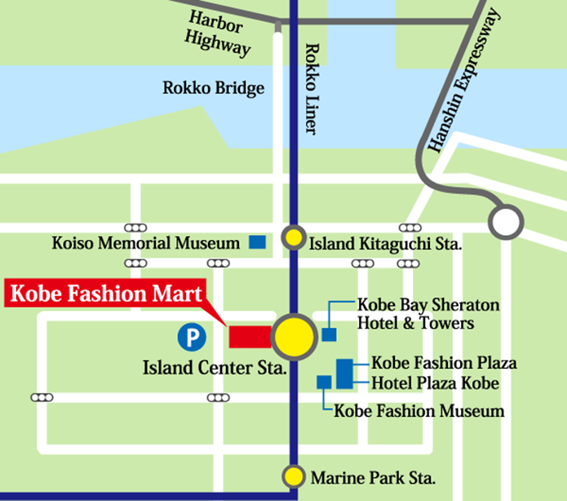

# 3 Visa

All foreign visitors entering Japan must have a valid passport. Visitors from countries **whose citizens are required to obtain a visa should, as soon as possible and** at least **one month** before the start date of the meeting, **apply for a visa** from the office (embassy or consulate) representing Japan in your country or, if there is no such office in your country, from the one that is closest to the country of departure.

You may need a **letter of invitation from the Japanese host**, which you will need to present to the Japanese embassy/consulate in your area in order to obtain your visa. To obtain an invitation letter, please complete the form at the following URL:

<https://www.ituaj.jp/?page_id=33749>

This visa support website is in preparation and will be available from 1 April 2025. After 1 April, please complete the form at the above URL as early as possible.

***In order to receive an invitation letter, your information should be provided to the host before 16 May 2025.***

1. *NOTE 1: A proof of registration to the Working Party 5D meeting #49 will be requested by the host so, make sure you have registered for the Working Party 5D meeting #49 and your focal point has approved your registration before requesting the visa invitation letter. Invitation letters will not be delivered to non-registered delegates. Proof of registration will need to be uploaded to the above-mentioned website (e.g. confirming email from ITU, in “PDF” or “JPG” formats).*

*NOTE 2: The host will do the utmost to provide invitation letters that are requested late; however, it cannot guarantee that a visa will be received in time for* *the Working Party 5D meeting #49.*

The focal point for visa support in Japan is:

*Mr Junichi KISHIMOTO and Ms Mariko SHIMIZU*

*The ITU Association of Japan*

*E-mail:* [*wp5d-visa@ituaj.jp*](mailto:wp5d-visa@ituaj.jp)

For more information, please visit the website of the Ministry of Foreign Affairs of Japan at:

<http://www.mofa.go.jp/j_info/visit/visa/>

# 4 Hotel accommodation

A room block has been set aside for ITU delegates in the hotels listed below (but there are no discounts). In order to facilitate the meeting, the hosts have guaranteed a certain number of room nights at these hotels. If you would like to book a room out of these hotels, please apply from the following URL:

<https://amarys-jtb.jp/wp5d2025/>

This hotel reservation website is in preparation and will be available from 1 April 2025. After 1 April, please make every effort to book your rooms as early as possible. Reservations must be made by 16 May 2025. The room block may sell out prior to the cutoff date. Because there are other major conferences and conventions occurring during the time of the meeting, delegates are encouraged to respect this deadline.

Should you experience any difficulties when making your reservations, please contact the assistants shown in section 11.

Hotel List

|  |  |
| --- | --- |
| **Hotel name** | **① Kobe Bay Sheraton Hotel & Towers ★★★★** |
| **Address** | 2-13 Koyocho-naka, Higashinada-ku, Kobe, Hyogo 658-0032, Japan |
| **Phone No** | +81-78-857-7000 |
| **URL** | <https://www.marriott.com/en-us/hotels/osakb-kobe-bay-sheraton-hotel-and-towers/overview/> |
| **Transfer time** | 4-minutes’ walk from meeting venue |
| **Hotel name** | **② Hotel Plaza Kobe ★★★★** |
| **Address** | 2-9-1 Koyocho-naka, Higashinada-ku, Kobe, Hyogo 658-0032, Japan |
| **Phone No** | +81-78-846-5400 |
| **URL** | <https://global.hotelplazakobe.co.jp/> |
| **Transfer time** | 6-minutes’ walk from meeting venue |
| **Hotel name** | **③ Green Rich Hotel Kobe Sannomiya ★★★** |
| **Address** | 4-1-22 Gokodori, Chuo-ku, Kobe, Hyogo 651-0087, Japan |
| **Phone No** | +81-78-241-0022 |
| **URL** | <https://greenrichhotels.jp/kobe-sannomiya/> |
| **Transfer time** | About 33 minutes by public transportation from meeting venue |
| **Hotel name** | **④ Daiwa Roynet Hotel KOBE-SANNOMIYA ★★★** |
| **Address** | 5-1-6 Gokodori, Chuo-ku, Kobe, Hyogo 651-0087, Japan |
| **Phone No** | +81-78-291-4055 |
| **URL** | <https://www.daiwaroynet.jp/en/kobesannomiya/> |
| **Transfer time** | About 33 minutes by public transportation from meeting venue |
| **Hotel name** | **⑤ KOBE MOTOMACHI TOKYU REI HOTEL ★★★** |
| **Address** | 1-2-35 Sakaemachi-dori, Chuo-ku, Kobe, Hyogo 650-0023, Japan |
| **Phone No** | +81-78-327-0109 |
| **URL** | <https://www.tokyuhotels.co.jp/en/kobemotomachi-r/index.html> |
| **Transfer time** | About 30 minutes by public transportation from meeting venue |

Hotel Location

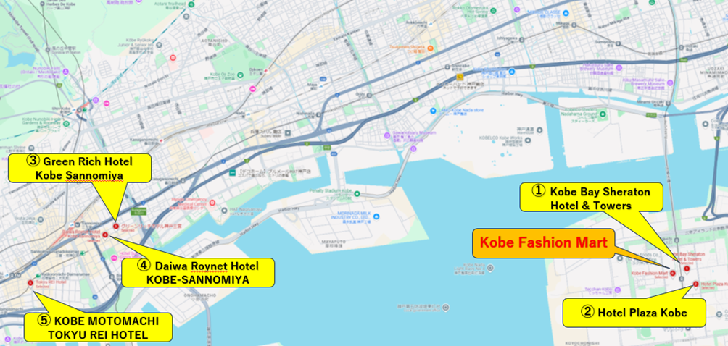

# 5 Currency and banking

The Japanese currency unit is Japanese Yen (JPY). There are four kinds of bills (10,000 yen, 5,000 yen, 2,000 yen and 1,000 yen) and six kinds of coins (500 yen, 100 yen, 50 yen, 10 yen, 5 yen and 1 yen) used. Only Japanese Yen (JPY) is accepted at stores and restaurants. Major foreign currencies may be exchanged to JPY at foreign exchange banks at International Airports on presentation of your passport.

Major credit cards are accepted by most hotels, restaurants, department stores, but not local small shops. Visa, MasterCard, and Amex are commonly used.

# 6 Local time

UTC+9 hours. (There is NO daylight-saving time in Japan.)

# 7 Electricity

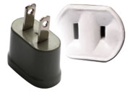The standard power supply in Japan is 100 volts. The frequency is 60 Hz in western Japan including Kobe. The type of power outlet/connector used in Japan is “A type” which is a two-parallel-pronged type. For your convenience, please bring a multi-voltage travel adapter.

**Type A plug**

**8 Climate**

June in Kobe is the beginning of summer. Low temperature of the day is about 20 degrees Celsius and high is about 30 degrees Celsius.

In Japan, the rainy season begins in late June, and the chances of rain increase. A folding umbrella is very convenient for rainy weather.

# 9 Language

Japanese is the official language and generally used. English is rarely used in civilian life, however, occasionally used in tourism and commerce in major cities including Kobe.

# 10 Emergency phone

Emergency call for Police: 110

Emergency call for Fire Department and Ambulance: 119

# 11 Meeting contact

Mr Junichi KISHIMOTO and Ms Mariko SHIMIZU

The ITU Association of Japan

E-mail: [wp5d-local@ituaj.jp](mailto:wp5d-local@ituaj.jp)

Mobile (in case of an emergency): +81 3 5357 7619 / +81 3 5357 7614

______________

1. * Where translation is required, contributions should be received at least three months prior to the meeting.