Radiocommunication Bureau (BR)

Addendum 1 to  Circular Letter  5/LCCE/105 |  | 24 February 2023
To Administrations of Member States of the ITU, Radiocommunication Sector Members,
ITU-R Associates participating in the work of Radiocommunication Study Group 5 and ITU Academia
Subject: | Meetings of Working Parties 5A and 5C (Merida, Mexico, 9 – 18 May 2023)  – Working Party 5A: Land mobile service above 30 MHz (excluding IMT); wireless access in the fixed service; amateur and amateur-satellite services  – Working Party 5C: Fixed wireless systems; HF and other systems below 30 MHz in the fixed and land mobile services
Further to the invitation letter dated 17 February 2023, please find attached additional information provided by the host country.
Mario Maniewicz
Director

Additional information for the meetings of Working Parties 5A and 5C (May 2023)

1 Introduction
This Annex provides both information on the meetings and guidance to the delegates for their stay in Mérida, Mexico.

2 Meeting Venue
The meeting will be held at:
Hotel: Holiday Inn Mérida
Address: Av. Colon: 498, Mérida, YUC 97000, Mexico
Phone: +52 (999) 942 88 00
E-mail: remanager@hinnmerida.com
URL: https://www.ihg.com/holidayinn/hotels/fr/fr/merida/midmx/hoteldetail

3 Floor Plan
Please find attached the next documents:
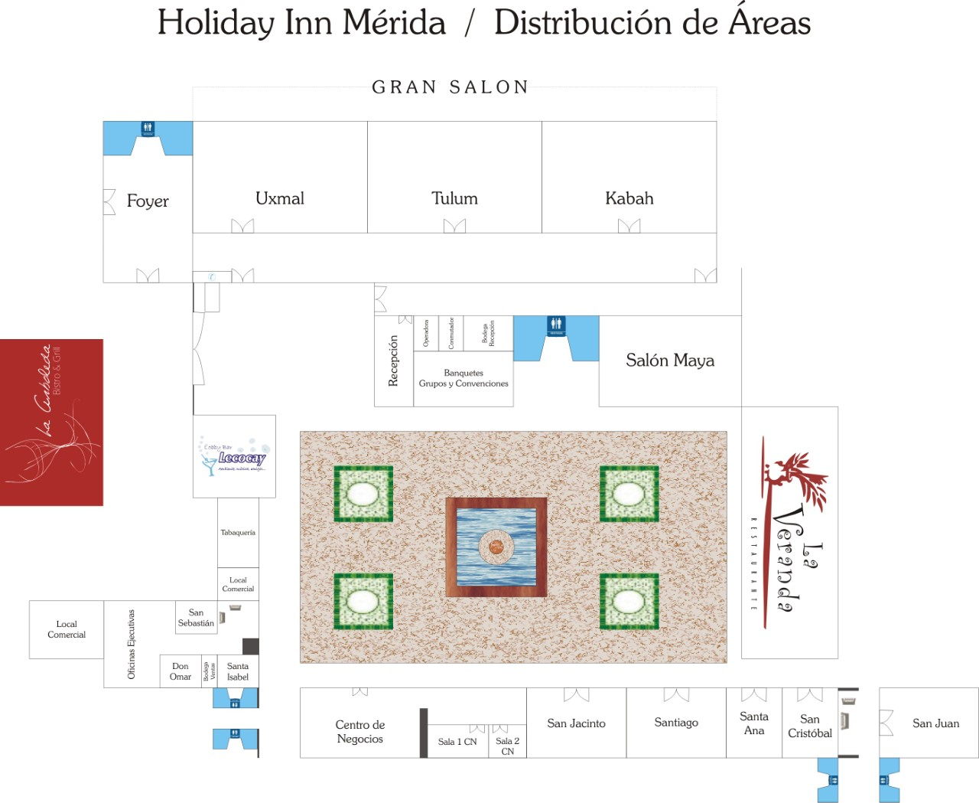
• General Layout of Holiday Inn Mérida

4 Registration
Badges will be issued only to individuals who have successfully undergone the ITU-R registration procedure (see section 6 of Circular Letter 5/LCCE/105 and here) and have been accredited. Participants will not be admitted to the venue without the badge.
Pre-Registration (badges): Monday, 8 May 2023, 1500-1800 hours
Registration (badges): Tuesday, 9 May 2023, 0800-1800 hours
Registration service will resume at the ITU Secretariat from 10 May.

5 Access to the meeting venue

5.1 Flights to Mérida International Airport (MID)
Mérida International Airport is located approximately 7 kilometers (4.3 miles) from the city center.
Telephone: +52 99-9940-6090
For more information, please see the following website: https://www.asur.com.mx
How to get to Mérida International Airport
• By car
Accessible via motorway 261, about 20 minutes to and from the city center. There are several parking lots opposite the terminals: about $3 USD for 1 hour; less than $15 USD for 24 hours.
Several car rental companies have counters on the first floor of the airport terminal.
• By bus
ADO bus company operates airport buses to the city center every hour, and tickets can be purchased at the first-floor counter of the airport terminal. Taxis can also get you to your final destination (Hotels Zone) from the bus terminal.
• Taxi
– The stops are located in front of the main gate of the airport terminal and cars can be reserved at the counter located on the ground floor. The ride to the center of Mérida takes about 30 minutes. More information: Tel +52 999 946 1529. Important: there may be long waiting lines.
– All taxi fares are based on travel, not per person; most taxis have a capacity of 4 people and in some cases, vehicles with 3 passengers.
– Fares to hotel zone and downtown start at $15 USD.
– By taxi, it takes around 20-30 minutes from the airport to the Mérida Holiday Inn Hotel.

6 Accommodation
Holiday Inn Mérida
Address: Av. Colon: 498, Mérida, YUC 97000, Mexico
Phone: +52 (999) 942 88 06
E-mail: remanager@hinnmerida.com or reservaciones2@hinnmerida.com
URL: https://www.ihg.com/holidayinn/hotels/fr/fr/merida/midmx/hoteldetail
Holiday Inn Mérida is recommended for all participants to stay during the meeting.

Booking at:
- By e-mail: reservaciones2@hinnmerida.com or remanager@hinnmerida.com
- By phone: +52 (999) 942 88 06 with Ms Vanessa Chi or Mr Oscar Tzun.
Holiday Inn Mérida fares below already included taxes, tips and breakfast buffet.
Room Type | MX Pesos | USD
Single | $ 2,832.20 | $154.58
Double | $ 3,211.50 | $175.28
Promotion Code: Evento "UIT - IFT"
This fare applies from 7 to 19 May 2023. If the participants would like to extend the stay, the price would vary.
Please note that the local secretariat is NOT responsible for the hotel reservation and participants are encouraged to make the reservation as early as possible.

6.1 Nearest Hotels
Hotel Name | Contact (52) | Room Type | Room Rates (breakfast included)  USD | MX Pesos | Distance to  Holiday Inn Merida
Fiesta Americana Mérida | Tel.: 999 942 1111 | Single | $125.41 | $ 2,300.00 | 4 min. walking  300 m
 |  | Double | $125.41 | $ 2,300.00
 |  | Master Suite | $298.06 | $ 5,480.13
Hotel NH Collection Mérida Paseo Montejo | Tel.: 999 964 0400 | Single | $161.64 | $ 2,972.00 | 9 min walking  900 m
 |  | Double | $164.02 | $ 3,016.00
 |  | Junior Suite | $171.14 | $ 3,147.00
Hotel Victoria | Tel.: 999 927 7777 | Single | $65.27 | $1,200.00 | 6 min walking  450
 |  | Double | $65.27 | $ 1,200.00
 |  | Superior (single) | $92.46 | $ 1,700.00
Hyatt Merida | Tel.: 999 942 1234 | Single | $128.90 | $2,364.00 | 2 min walking  160 m.
 |  | Double | $128.90 | $ 2,364.00
 |  | Suite Executive | $357.00 | $ 6,547.33
Delfina Boutique Hotel | Tel.: 999 688 9538 | Single | $250.08 | $ 4,598.00 | 15 min walking  1.1 km
 |  | Double | $250.08 | $ 4,598.00
 |  | Master Suite | $478.19 | $ 8,792.00
Hotel Ibis Mérida Paseo de Montejo | Tel.: 999 254 3800 | Single | $73.50 | $ 1,348.00 | 7 min walking  550 m
 |  | Double | $82.33 | $ 1,510.00
 |  | Superior (single) | $84.30 | $ 1,550.00

7 VISA and immigration information
A visa may be necessary for participants from some countries to enter Mexico. To check the visa requirements please contact the Mexican Embassy in your country. Kindly visit: http://www.inm.gob.mx/gobmx/word/index.php/paises-requieren-visa-para-mexico/ for more details.
Participants who should require a personal Letter of Invitation for obtaining a visa are requested to contact Ms Mariana Alday Álvarez via e-mail at mariana.alday@ift.org.mx as soon as possible after registration with ITU. Your e-mail must include the following information in order to be processed:
• Complete name
• Passport Number
• Nationality.
Foreigners travelling to Mexico must have a valid Passport, issued by the competent authority. In order to meet the requirements, procedures and criteria for the attention to and resolution of visa application procedure, is recommended that participants consult the web site of the National Institute of Migration, www.gob.mx/inm.
The countries and regions that do not require a visa to travel to Mexico can be found at the following link: www.inm.gob.mx/gobmx/word/index.php/paises-no-requieren-visa-para-mexico/.
In addition, information from countries and regions that require a visa to ravel to Mexico can be found at: www.inm.gob.mx/gobmx/word/index.php/paises-requieren-visa-para-mexico/.
People are encouraged to contacting the Embassy or Consulate of Mexico in their countries, https://www.gob.mx/gobierno/mexico-en-el-mundo if they require detailed information. Participants requiring visa must obtain it before travelling to Mexico.
IMPORTANT: As of 1 April 2022, all Colombian nationals must complete a mandatory pre-registration of their trip at the following link: https://www.inm.gob.mx/spublic/portal/inmex.html

8 Network

8.1 Internet Access
Participants staying at the venue will have an internet access code upon arrival at the hotel, which will serve inside the room and throughout the hotel. In the Convention Center, another code will be provided to access a high-speed wireless network.
Attendees who are not staying in the venue will be provided with a code that can be used only in the Convention Center.

8.2 Internet Lounge
The hotel has a Cybercafé area where guests and attendees can be assisted with internet access and printing documents.

9 Practical Information
Holiday Inn Mérida
There are 2 restaurants, "La Veranda" and "La Arboleda", the bar "Lecocay", an outdoor swimming pool, gym, laundry and dry-cleaning services as well as free parking.
Merida
Mérida is the economic and cultural capital of southeastern Mexico. It is a cosmopolitan destination that in 2019, was designated a Creative Gastronomic City by UNESCO. It is located less than 50 km from the Gulf of Mexico in the northeastern part of the state of Yucatán. It is bordered to the east by Quintana Roo, to the west by Campeche and to the north by the Gulf of Mexico.
It is characterized by its colonial architecture, of sober style, where there are buildings with high ceilings and large windows; but above all it is recognized by the color of the quarry, a material typical of the region with which many of its buildings were erected, an aspect that has earned it the nickname of Ciudad Blanca (White City).
Its main attractions include the Catedral de San Ildefonso, Casa de Montejo, Teatro José Peón Contreras, Arco de San Juan, Paseo de Montejo, among others.
Upon your arrival in Merida, you can get in touch with local tourism professionals for further information and to help organize your stay.
Offers practical information and useful recommendations (accommodation, restaurants, public transport, festivals, cultural events, etc.).
Phones: +52 999 920 4044
+52 999 942 00 00 Ext. 80119
E-mail: turismo@merida.gob.mx
URL: https://visitmerida.mx/
Medical information
Mexico has no entry restrictions in the context of the current pandemic situation. Nevertheless, entry depends on approval by health and immigration authorities upon arrival, and they may at any time verify if requirements as set forth in applicable legal provisions for immigration have been fulfilled. It´s recommended to check the requirements with the airline and airport connections flights.
Note: Given that the pandemic has not yet reached its end, it is important to consider the unpredictability of its development; therefore, any of the requirements established in this document may be modified to adjust to the different situations that may arise to comply with national and international regulations.

Useful addresses
Consulates
Country | Address | Telephone | Mail
Germany | Instituto Kresse, C 51 No 329 x 52×54, Fracc.  Francisco de Montejo, CP 97203, Mérida, Yucatán | +52 999 944 32 52 | merida@hk-diplo.de
Belize | “Dutton Hermanos” Calle 53, Nº498 (por 56 y 58)  Col. Centro, C. P.97000, Apartado postal 89,  Mérida, Yucatán | +52 999 928 6152 / 999 928 3962 | consbelice@dutton.com
Cyprus | Av. Balché Tablaje 19430, Temozón Norte,  Mérida, Yucatán, C.P. 97740 | +52 999 924 1887 / 999 947 3605 | tonyabxa@hotmail.com
Korea | Calle 12 #354 (Por 47 Y 51), Col. Melchor Ocampo,  C.P. 97165 Mérida, Yucatán | 52 999 166 6464 | jaristi@casadaristi.com
Cuba | Calle 1 D, No. 320 por 42 y 44, Col. Campestre,  C. P. 97120, Mérida, Yucatán | +52 999 944 4215  +52 999 944 4216  +52 999 944 3283 | consulcubamer1@prodigy.net.mx
Spain | Calle 50 #402, D x 33 Edificio "Vector 50" Colonia Jesús Carranza, 97109 Mérida, Yucatán | +52 999 948 3489 | consulado.es.mid@gmail.com
United States of America | Calle 60 No. 338-K x 29 y 31 Col. Alcala Martin, Mérida, Yucatán, Mexico 97050 | +52 999 942 5700 / 202 250 3711  Emergency:  +52 999 942 5700 | AskMeridaACS@state.gov meridacons@state.gov merida.usconsulate.gov
Finland | Calle 86-B No. 595-B  Apartado Postal 1121  C.P. 97000, Mérida, Yucatán, México | +52 999 984-0201/ 0273/ 0399 | fponce@mda.com.mx
France | Calle 60 No. 385 (Entre 41 Y 43) (Al Interior De Grupo Siptse) Col. Centro,  C. P. 97000, Mérida, Yucatán | +52 999 925 2886 /  999 930 1500 /  999 930 1542 /  999 930 1516 | manconat@siptse.com.mx  consuladofrancia@siptse.com.mx
Greece | Torre Vértice, piso 9, suite 905, Calle 4 x 15 No. 170 A, Fraccionamiento Montecristo, C.P. 97133, Mérida, Yucatán | +52 999 931107 /  +52 999 823271 | sperez@procon.com.mx sponce@procon.com.mx
Luxemburg | Calle 25 A, #500 B (Por 58 A) Col. Itziná,  C.P. 97100, Mérida, Yucatán | +52 999 9261 725 | chluxpyuc@yahoo.com.mx
Lebanon | Calle 11 No. 200, (Por 18) Fracc. Montecristo, C. P. 97127, Mérida, Yucatán | +52 999 926 4111 | robertoabraham@gmail.com

9.1 Climate
The climate is hot and humid with an average temperature of 26.61° C. Meteorologists classify it as "Awo" type (warm sub-humid with rain during the summer). The hottest season is from April to August with temperatures up to 40°. The rainy season runs from May through to January.

9.2 Electricity and Voltage
In Mexico the electric current is 110 -120 volts (identical to U.S.A. and Canada). Please bear in mind the following recommendations:
- Multi-voltage devices (laptops, etc.): plug adapter.
- Household appliances 220—240V: plug adapter + step-up transformer.
- Japanese household appliances of 100V: step-down transformer from Japan to the United States.
For your convenience, please bring a multi-voltage travel adapter.

9.3 Language
Official Language is Spanish, but in rural communities the Mayan language is still spoken.

9.4 Time Zone
Central Standard Time UTC/GMT-6 hours

9.5 Banks and Currency
The Mexican peso is the official currency of Mexico. To see the updated Exchange rate, you can enter the Bank of Mexico site: www.banxico.org.mx. Exchange rate (20 February 2023):
$18.40 = 1 USD.
Banks are open from 0900 to 1600 hours from Monday to Friday.

9.6 Mobile Phone Rental Service
Participants can buy a cheap phone for around $30 in any convenient stores such as “OXXO” or “7Eleven” and they are used on a pay as you go plan. Mobile operators countrywide are AT&T, Movistar and Telcel.

9.7 Helpful Numbers
Area Code: 999
Police Department: +52 999 942 0060
Fire Department: +52 (999) 924 92 42 or +52 (999) 923 29 71
Red Cross: 911 / +52 (999) 983 02 27 or +52 (999) 983 03 06
Ambulance: 911/ +52 (999) 983 02 43
Emergency: 911

9.8 Tipping
Like in the United States, leaving a tip, called “propina”, is expected in Mexico. In bars and restaurants, it is customary to tip between 10 and 15 percent. However, before leaving a tip, check the bill to make sure that a gratuity or service charge is not already included.

________________

