Radiocommunication Bureau (BR)

Circular Letter  5/LCCE/72 |  | 3 November 2017
To Administrations of Member States of the ITU, Radiocommunication Sector Members,
ITU-R Associates participating in the work of Radiocommunication Study Group 5
and ITU Academia
Subject: | Twenty-ninth meeting of Working Party 5D on IMT systems

1 Introduction
By means of this Circular Letter, I wish to announce that, at the kind invitation of the Administration of Republic of Korea, the 29th meeting of ITU-R Working Party 5D will take place in Seoul, Republic of Korea, from 31 January to 7 February 2018. The opening session will commence on 31 January 2018 at 0930 hours (see table below).
Group | Meeting date | Deadline for contributions  1600 hours UTC | Opening session
Working Party 5D | 31 January - 7 February 2018 | Wednesday  24 January 2018 | Wednesday, 31 January 2018  at 0930 hours

2 Programme of the meeting
A draft agenda for the meeting is contained in Annex 1. The status of texts assigned to the Working Party can be found on: https://www.itu.int/md/R15-SG05-C-0001/en.
The Working Party will conduct its work in English.

3 Venue
The meeting will take place at:
Hotel: Millennium Seoul Hilton HOTEL
Address: 50, Sowol-Ro, Jung-Gu, Seoul, 100-802, South Korea
Phone: +82 2 753 7788
Fax: +82 2 754 2510
URL: http://www3.hilton.com/en/hotels/south-korea/millennium-seoul-hilton-SELHITW/index.html
For further information see Annex 2.

4 Contributions
Contributions in response to the work of Working Party 5D are invited. These will be processed according to the provisions laid down in Resolution ITU-R 1-7.
The deadline for reception of contributions not requiring translation* (including Revisions, Addenda and Corrigenda to contributions) is seven calendar days (1600 hours UTC) prior to the start of the meeting. The deadline for reception of contributions for this meeting is specified in the table above. Submissions received later than this deadline cannot be accepted. Resolution ITU-R 1-7 provides that contributions which are not available to participants at the opening of the meeting cannot be considered.
Participants are requested to submit contributions by electronic mail to: rsg5@itu.int. A copy of each contribution should also be sent to the Chairman of Working Party 5D and to the Chairman and Vice-Chairmen of Study Group 5. The pertinent addresses can be found on:
http://www.itu.int/go/rsg5/ch
http://www.itu.int/go/rwp5d/ch

5 Documents
Contributions will be posted “as received” within one working day on the Working Party 5D webpage established for this purpose. The official versions will be posted on http://www.itu.int/md/R15-WP5D-C/en within 3 working days.
All participants are kindly requested to download the documents from the above website before the meeting starts to avoid congestion of Internet network.
Wireless LAN facilities will be available in all the meeting rooms and an Internet cafe facility will also be provided.
Participants will need to bring their laptops (equipped with a WLAN-card) with them to the meeting because this will be a completely paperless meeting.

6 Remote participation
Audio webcast of Plenary sessions of Working Party 5D and remote participation will not be available for this meeting.

7 Participation/Visa requirement
Advance registration for ITU-R events is mandatory and carried out exclusively online through Designated Focal Points (DFPs). Each ITU-R Member has been requested to designate a DFP responsible for the handling of all registration formalities, including visa support requests that should also be submitted by the DFP during the on-line registration process. Individuals wishing to be registered for an ITU-R event should directly contact the DFP for their entity. The list of ITU-R DFPs (TIES protected) as well as detailed information on event registration, visa support requirements, etc. can be found at:
www.itu.int/en/ITU-R/information/events
Specific information on deadlines to obtain visa and immigration documents are indicated in Annex 2. In particular, your attention is drawn to the need to apply for the visa well in advance.
François Rancy
Director
Annexes: 2
Distribution:
– Administrations of Member States of the ITU and Radiocommunication Sector Members participating in the work of Radiocommunication Study Group 5
– ITU-R Associates participating in the work of Radiocommunication Group 5
– ITU Academia
– Chairman and Vice-Chairmen of Radiocommunication Group 5
– Secretary General of the ITU, Director of the Telecommunication Standardization Bureau, Director of the Telecommunication Development Bureau

Annex 1
Draft agenda for the 29th meeting of Working Party 5D
(Seoul, Republic of Korea, 31 January - 7 February 2018)
1 Opening remarks
2 Adoption of the draft agenda
3 Report of the 28th meeting of Working Party 5D (Doc. 5D/758)
4 Reports from Rapporteurs and Correspondence Groups
5 Working structure and document assignment
6 Any other business
S. BLUST
Chairman, Working Party 5D

ANNEX 2
Additional information for the 29th meeting of Working Party 5D
1 Introduction
This Annex provides both information on the meeting and guidance to the delegates for their stay in Seoul, Republic of Korea.
2 Meeting Venue
The meeting will be held at:
Hotel: Millennium Seoul Hilton HOTEL
Address: 50, Sowol-Ro, Jung-Gu, Seoul, 100-802, South Korea
Phone: +82 2 753 7788
Fax: +82 2 754 2510
URL: http://www3.hilton.com/en/hotels/south-korea/millennium-seoul-hilton-SELHITW/index.html
3 Floor Plan

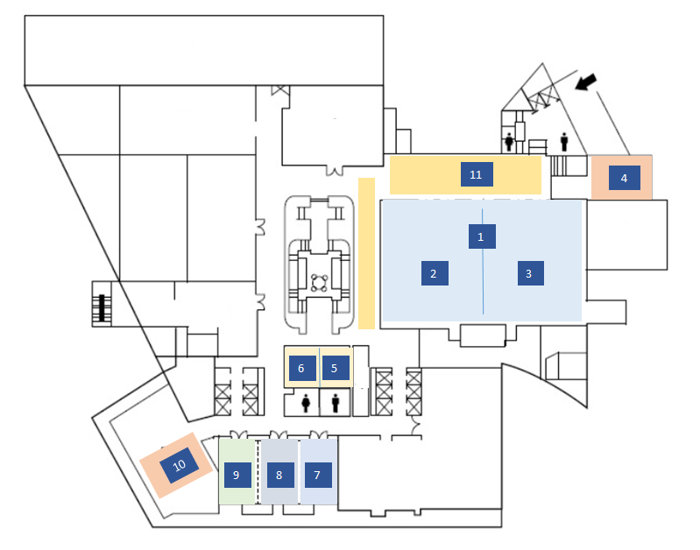
<Lower Level>
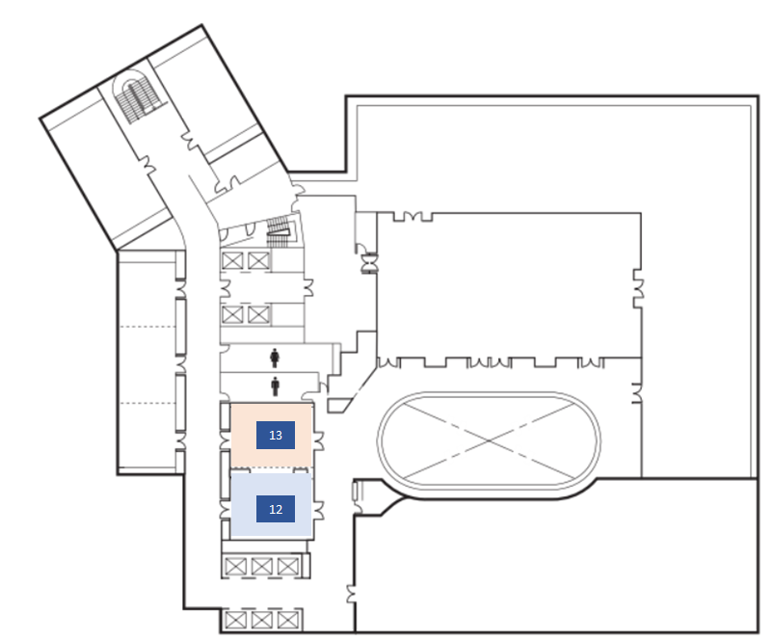
<3rd Floor>
 | Meeting | Venue
1 | Opening Ceremony & Plenary Session | Grand Ballroom A,B,C (Lower Level)
2 | Sub-Group 1 of WP 5D | Grand Ballroom A,B (Lower Level)
3 | Sub-Group 2 of WP 5D | Grand Ballroom C (Lower Level)
4 | Internet Lounger | Bride Room (Lower Level)
5 | Chairman Room | Rialto A (Lower Level)
6 | ITU Secretariat | Rialto B (Lower Level)
7 | Meeting 1 | Junior Ballroom A (Lower Level)
8 | Meeting 2 | Junior Ballroom B (Lower Level)
9 | Local Secretariat | Junior Ballroom C (Lower Level)
10 | Internet Lounger | Bride Room (Lower Level)
11 | Registration | Lobby (Lower Level)
12 | Meeting 3 | Jade A (3rd Floor)
13 | Meeting 4 | Jade B (3rd Floor) *Additional Meeting Room
* Meeting rooms might be changed based on program.

4 On-site Registration / Badges
Badges will be issued only to individuals who have successfully undergone the ITU-R registration procedure and have been accredited. Participants will not be admitted to the venue without the badge.
Pre-Registration (badges): Tuesday, 30 January 2018, Lower Lobby / 1500-1800 hours
Registration (badges): Wednesday, 31 January 2018, Lower Lobby / 0830-1800 hours
Registration service will resume at the Secretariat from 1 February, 0800 hours onward.
5 Access to the meeting venue

5.1 Flights to Incheon International Airport (airport code: ICN)
For more information, please see the following website: http://www.airport.kr/pa/en/a/index.jsp
From ICN airport to the hotel
- KAL Limousine Bus
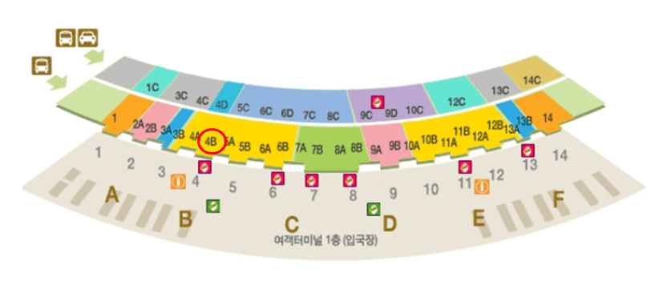Take bus No.6702 (Namsan Area), from either exit (bus stop) 4B, 1st floor of the airport.
Get off at Millennium Seoul Hilton bus will leave from the airport at the following times in the table below.
A ticket costs KRW 16,000 (About US$15).
- AREX Express train
Take AREX Express or Commuter train to Seoul station.
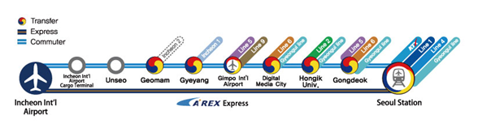

For more details, please visit Gimpo International Airport Official website at https://www.airport.co.kr/mbs/gimpoeng/jsp/bus/busList.jsp?id=gimpoeng_030101010000&busType=D
* Free Shuttle Bus from Seoul Station to Hotel
There is a free shuttle bus operating between Seoul station and the hotel.
When guests get off the AREX train and exit, they will be able to find the shuttle bus information desk on the 1st floor near exit No.15.
The shuttle bus runs at intervals of 1 hour from 8:30 onwards until 19:30.
It takes about 10 to 20 minutes to get to the hotel depending on the traffic.
Please see below time table for more details.

Departure from  Millennium Seoul Hilton* | Departure From  Seoul Station*
08:00 | 08:30
09:00 | 09:30
10:00 | 10:30
11:00 | 11:30
12:00 | 12:30
13:00 | 13:30
14:00 | 14:30
15:00 | 15:30
16:00 | 16:30
17:00 | 17:30
18:00 | 18:30
19:00 | 19:30

5.2 Flights to Gimpo International Airport (airport code: GMP)
From GMP airport to the hotel
There are subway, bus and AREX express train from Gimpo airport to Seoul station which is the nearest station from the hotel.
Please see attached route map below for your reference.
- Subway
Please exit arrival gate and proceed to Gimpo International airport subway station and take line number 5.
Get off at Singil station to transfer to line number 1, and get off at Seoul station.

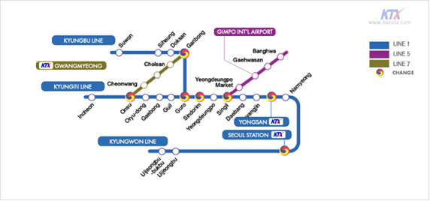

- Bus
Please proceed to Bus stop at arrival gate and take number 605 or 601 bus to Seoul station.

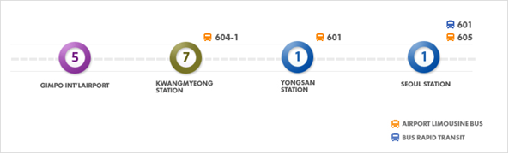

- Taxi
You are able to grab a public taxi at the right front of the Gimpo airport.
The fare will be approximately KRW 50,000~70,000 depending on traffic jam on the date of arrival.
6 Accommodation
Guest rooms have been blocked at a discounted rate at the meeting venue, Millennium Seoul Hilton hotel as well as hotel Manu Seoul. Delegates are encouraged to make their reservations at the designated hotels. Further information on the rates can be found below. The negotiated group rates are based on availability.
You are reminded that it is favourable to make your reservation as early as possible, in order to ensure availability in the recommended hotels, and preferably no later than 15 January 2018.
* Please note that the local secretariat is NOT responsible for the hotel reservation and participants are encouraged to make the reservation as early as possible

6.1 Millennium Seoul Hilton Hotel
Address: 50, Sowol-Ro, Jung-Gu, Seoul, 100-802, South Korea
Phone: +82 2 753 7788
URL: http://www3.hilton.com/en/hotels/south-korea/millennium-seoul-hilton-SELHITW/index.html

Hotel | Millennium Seoul Hilton
Room Type | Deluxe King
Room Rate | KRW 170,000  (Exclusive of 10% VAT & 10% Service Charge)
* Check in: 16:00 / Check out: 12:00
**Inclusive of breakfast for 1 person at our all day dining restaurant “Café 395” for guests staying in Deluxe category rooms and all Suites only.
* Inclusive of complimentary use of Internet in the guest room, Main Lobby and all restaurants.

Millennium Seoul Hilton Hotel is recommended for all participants to stay during the meeting. Please make your hotel booking in order to be eligible for the special rates given below at the earliest possible date or no later than 15 of January 2018.
Please use the following link to make your reservation. Select the dates of your stay, the number of rooms and guest. In Special Accounts and Rates, GN RRA is selected, so you do not need put information for Group Code and Corporate Account. You will see a green button for continuing. You select room type and payment information.
BookingLink: https://secure3.hilton.com/en_US/hi/reservation/book.htm?inputModule=HOTEL&ctyhocn=SELHITW&spec_plan=GNRRA&arrival=20180128&departure=20180209&cid=OM,WW,HILTONLINK,EN,DirectLink&fromId=HILTONLINKDIRECT
If you cannot access to the reservation link, please send the Hotel Reservation form (Attachment 1) directly to the hotel; e-mail address: reservations.seoulmillennium@hilton.com or
Tel.: +82-2-317-3000 (Mr. Kate Choi)

6.2 Hotel Manu Seoul
Address: 19 Toegye-ro, Namdaemunno 5(o)-ga, Jung-gu, Seoul
Phone: +82 777-0100
URL: http://www.hotelmanu.com/eng/main/
Hotel Manu Seoul is the nearest hotel from the meeting venue, Millennium Seoul Hotel, only 10 minutes walking distance. Please make your hotel booking through various hotel reservation website that offer great rate than book hotel directly.

Hotel | Hotel Manu Seoul
Room Type | Standard Double Room
Room Rate | KRW 100,000 *Depends on reservation date  (Exclusive of 10% VAT & 10% Service Charge
* Check in: 14:00 / Check out: 12:00
**Inclusive of breakfast for 1 person at our all day dining restaurant for guests staying.

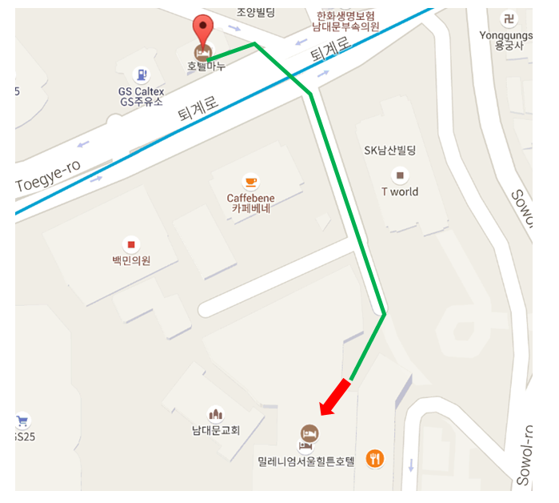
7 VISA and immigration information
A visa may be necessary for participants from some countries to enter Korea. To check the visa requirements please contact the Korean Embassy in your country. Kindly visit the Ministry of Foreign Affairs at http://www.mofa.go.kr/ENG/visa/application/index.jsp for more details.
Participants who should require a personal Letter of Invitation for obtaining a visa are requested to contact Ms. SUNG Joo-Young (National Radio Research Agency) via e-Mail at mimisicu90@Korea.kr as soon as possible after registration with ITU. Your e-mail must include the following information in order to be processed:
· First name
· Last name
· Company Postal address
· Date and place of birth
· Passport number
· Passport issuance and expiry dates
· Passport country of issuance
· Hotel for stay during the meeting
8 Network

8.1 Internet Access
Available area: All meeting rooms and Lobbies.
Access SSID: ITUwifi
– Local Secretariat will give you the Access SSID information on site.

8.2 Internet Lounge
Location: Bride Room (Lower Level)
Operating Hours: 30 January − 7 February 2018, 08:30-22:00
Wireless Network Printer Available
For the convenience of participants that you can use internet access at the local secretariat during the weekend. Internet access in your own laptop is available in the lower level. Also you may use printer in the local secretariat. (Junior Ballroom C).
9 Practical Information

9.1 Seoul
Seoul, the capital of South Korea, is a huge metropolis where modern skyscrapers, high-tech subways and pop culture meet Buddhist temples, palaces and street markets. Seoul is considered a leading and rising global city, resulting from an economic boom called the Miracle on the Han River, which transformed it to the world's 4th largest metropolitan economy. Further information at Seoul Tourist Information: http://english.visitkorea.or.kr/enu/index.kto.

9.2 Climate
Korea has four seasons, with a wet monsoon/summer season in the middle of the year, and a cold winter from November to March. The ideal time to visit Korea is during the autumn months (September-November) to witness spectacular foliage that is perhaps the biggest draw.
The average temperature of February is around -6~3°C. It will be quite cold, so please bring clothing with you.

9.3 Electricity and Voltage
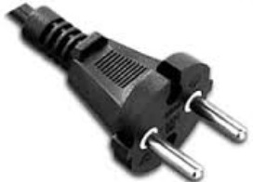
The standard voltage in Korea is 220 volts. The outlet has two round holes and is the same type used in France, Germany, Austria, Greece, Turkey, and many other countries.
For your convenience, please bring a multi-voltage travel adapter.
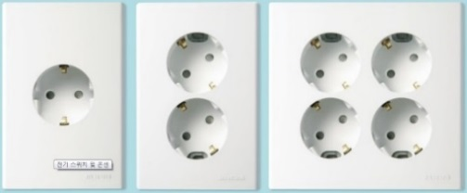

9.4 Language
Korean.

9.5 Time Zone
UTC+9 hours.

9.6 Banks & Currency
The unit of Korean currency is Korean Won (KRW). The exchange rate as of November 2017 is KRW 1,134 to 1 USD. Automated teller machines (ATM) are widely accessible throughout Seoul.

9.7 Mobile Phone Rental Service
Mobile rental services are available at the Incheon International Airport. Online reservations are accepted through each service provider's website. Additional discounts may be offered by making reservations online. However, reservations are not required in order to use cell phone rental services.
– You can find the below link for Cell-phone Rental Services
http://english.visitkorea.or.kr/enu/RE/RE_EN_1_2_4_1.jsp
* This page includes information on cell-phone fees, rental locations, and online reservations.

9.8 Sim Card Purchase (Korean Roaming SIM Card)
You can purchase a prepaid SIM Card that can be used in Korea and most foreign countries in convenient stores in Incheon International Airport and Gimpo International Airport.

9.9 Helpful Numbers
* Emergency Call 112 & 119
Dial 112 for the police, 119 for the fire department and medical emergencies (though most operators speak only Korean). A hotel staff or hotel manager can arrange for a doctor or an ambulance.
* Lost Property
In the event of misplaced or lost property, contact the Lost and Found Center of the Seoul Metropolitan Police Bureau:
102, Hongik-dong, Seongdong-gu
Tel: +82-2-2299-1282(Korean speakers only), Fax: +82-2-2298-1282
* Information Service – International Call 00794
International service “00794” is a telephone operator service that provides any information related to making international calls including foreign subscription number, national codes, area codes, and so on.
* International Call Service 00799
International call service “00799” is a telephone operator service used to make international calls from Korea. The Service features station-to-station calls (forwarding the receiver’s number to the operator for direct connection), collect or reverse charge calls (charging the receiver for the international call) and interpretation calls (having interpretation during the international call).
* Tourist Complaint Center 02-735-0101
The Tourist Complaint Center strives to resolve complaints from tourists in Korea as well as to improve tourism services by informing and providing consultation to relevant agencies. Complaints and inquiries can be filed via email or fax.

9.10 Tipping
No Tipping.

9.11 Local Contact
If you have any questions about the meeting arrangements, please contact Ms. SUNG Joo Young, National Radio Research Agency (RRA).
Phone: +82-61-338-4652 | Email: mimisicu90@Korea.kr

ATTACHMENT 1

ROOM RESERVATION FORM
ITU WP 5D (5G) International Conference

In order to secure a room at Millennium Seoul Hilton, please detach this page and e-mail or fax to reservation department with the appropriate information.

TEL : +82 2 317 3000 FAX : +82 2 317 3848
E-MAIL : Reservations.SeoulMillennium@hilton.com
CC e-mail : hansung.kim@hilton.com
ROOM TYPE | RATE | BENEFIT
DELUXE ROOM (Single ) | KRW170,000 | Inclusive of Breakfast for 1 person & Internet  Exclusive of 21% Tax & Service charge

GUEST INFORMATION
Last Name |  | First Name
Nationality |  | Hilton HHonors
Telephone |  | Fax
E-mail
Address
ROOM REQUIREMENT
Arrival Date |  | Departure Date
Room Type |  | Single / Double
Preferences
CREDIT CARD GUARANTEE
Credit Type | American Express □ Diners Club □ MASTER □ VISA □
Credit Number |  |  | Expiry Date | /

RESERVATION CUT OFF
Reservations received after the cut-off date of Jan 15th 2018 will be honored at the above rate based on hotel availability.

CANCELLATION POLICY
In case of a cancellation 48 hours prior to arrival, one night room rate will be charged to the above credit card.

SIGNED FOR AND ON BEHALF OF:

SIGNATURE DATE

______________

* Where translation is required, contributions should be received at least three months prior to the meeting.

