|  |  |  |
| --- | --- | --- |
| **Radiocommunication Bureau (BR)** | | |
| Circular Letter  **5/LCCE/56** | | 21 October 2015 |
|  | | |
|  | | |
| **To Administrations of Member States of the ITU, Radiocommunication Sector Members, ITU‑R Associates participating in the work of Radiocommunication Study Group 5 and ITU-R Academia** | | |
|  | | |
|  | | |
| Subject: | **Twenty-third meeting of Working Party 5D on IMT systems** | |
|  |
|  | | |

# 1 Introduction

By means of this Circular Letter, we wish to announce that, at the kind invitation of the Administration of China in cooperation with private sector companies, the 23rd meeting of ITU-R Working Party 5D will take place in Beijing, China, from 23 February to 2 March 2016. The opening session will commence on 23 February 2016 at 0930 hours (see table below).

|  |  |  |  |
| --- | --- | --- | --- |
| Group | Meeting date | Deadline for contributions 1600 hours UTC | Opening session |
| Working Party 5D | 23 February - 2 March 2016 | 16 February 2016 | Tuesday, 23 February 2016 at 0930 hours |

2 Programme of the meeting

A draft agenda for the meeting is contained in Annex 1. The Questions assigned may be found at: <http://www.itu.int/pub/R-QUE-SG05/en>. The Working Party will conduct its work in English.

3 Venue

The meeting will take place at:

**Xiyuan Hotel**  
 1 Sanlihe Street  
 Haidian District  
 Beijing  
 China

For further information see Annex 2.

4 Contributions

Contributions in response to the work of Working Party 5D are invited. These will be processed according to the provisions laid down in Resolution ITU-R 1-6.

The membership is encouraged to submit contributions (including revisions, addenda and corrigenda to contributions) in order for them to be received 12 calendar days prior to the start of the meeting. **The deadline for submission of contributions is Tuesday, 16 February 2016, 1600 hours UTC.** Submissions received later than this deadline cannot be accepted. Resolution ITU‑R 1-6 provides that contributions which are not available to participants at the opening of the meeting shall not be considered.

Participants are requested to submit contributions by electronic mail to: [rsg5@itu.int](mailto:rsg5@itu.int). A copy should also be sent to the Chairman of Working Party 5D and to the Chairman and Vice-Chairmen of Study Group 5. The pertinent addresses can be found on:

<http://itu.int/go/rsg5/ch>

<http://itu.int/go/rwp5d/ch>

# 5 Documents

Contributions will be posted “as received” within one working day on the Working Party 5D webpage established for this purpose: <http://www.itu.int/md/R15-WP5D.AR-C/en>.

The official versions will be posted on <http://www.itu.int/md/R15-WP5D-C/en> within 3 working days. All participants are kindly requested to download the documents from the above website **before the meeting starts** to avoid congestion of Internet network.

Wireless LAN facilities will be available in all the meeting rooms and an Internet access facility will also be provided.

Participants will need to bring their laptops (equipped with a WLAN-card) with them to the meeting because **this will be a completely paperless meeting**.

# 6 Remote participation

Audio webcast of plenary sessions of Working Party 5D and remote participation will not be available for this meeting.

**7 Participation/Visa requirement**

Advance registration to ITU-R events is mandatory and carried out exclusively online through Designated Focal Points (DFPs). Each ITU-R Member has been requested to designate a DFP responsible for the handling of all registration formalities, including visa support requests that should also be submitted by the DFP during the on-line registration process. Individuals wishing to be registered to an ITU-R event should directly contact the DFP for their entity. The list of ITU-R DFPs (TIES protected) as well as detailed information on event registration, visa support requirements, etc. can be found at:

[www.itu.int/en/ITU-R/information/events](http://www.itu.int/en/ITU-R/information/events)

Specific information on deadlines to obtain visa and immigration documents are indicated in Annex 2. In particular, your attention is drawn to the need to apply for the visa well in advance.

François Rancy

Director

**Annexes**: 3

**Distribution:**

– Administrations of Member States of the ITU and Radiocommunication Sector Members participating in the work of Radiocommunication Study Group 5

– ITU-R Associates participating in the work of Radiocommunication Group 5

– ITU-R Academia

– Chairman and Vice-Chairmen of Radiocommunication Group 5

– Secretary General of the ITU, Director of the Telecommunication Standardization Bureau, Director of the Telecommunication Development Bureau

Annex 1

Draft agenda for the 23rd meeting of Working Party 5D

(Beijing, China, 23 February - 2 March 2016)

**1** Opening remarks

**2** Adoption of the draft agenda

**3** Report of the 22ndmeeting of Working Party 5D (Doc. [5D/1042](http://www.itu.int/md/R12-WP5D-C-1042/en))

**4** Reports from Rapporteurs and Correspondence Groups

**5** Working structure and document assignment

**6** Any other business

S. BLUST

Chairman, Working Party 5D

ANNEX 2

Additional information for the 23rd meeting of Working Party 5D

# Introduction

The Administration of China and private sector companies are pleased to welcome the participants to the twenty-third meeting of ITU-R Working Party 5D on IMT Systems (23 February – 2 March, 2016). This Annex provides both information on the meeting and guidance to the delegates for their stay in Beijing, China.

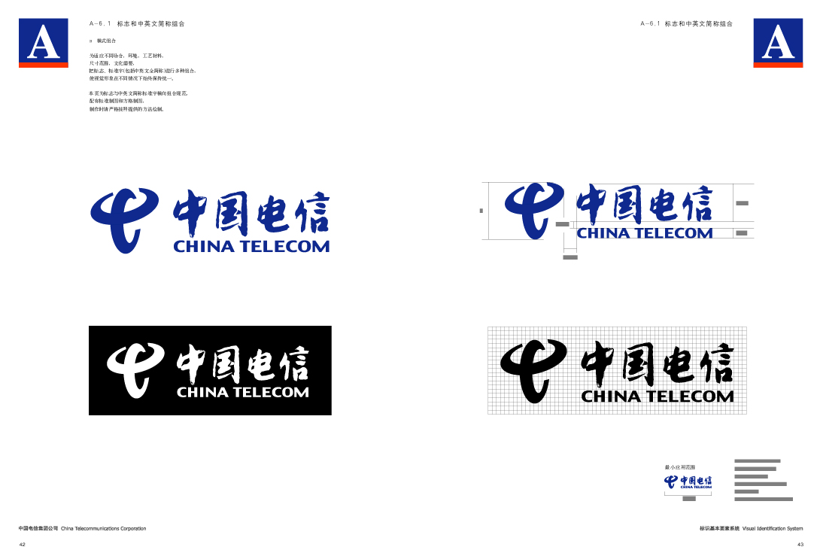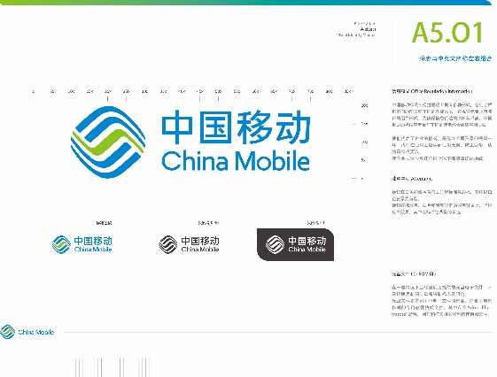

***With additional assistance from:***



# Meeting venue

The meeting will be held at:

**Xiyuan Hotel**

1 Sanlihe Street

Haidian District, Beijing, China

Tel.: +86 10 59692159

Fax: +86 10 59692199

The location map of the Xiyuan Hotel is referred to Figure 1.

Figure 1

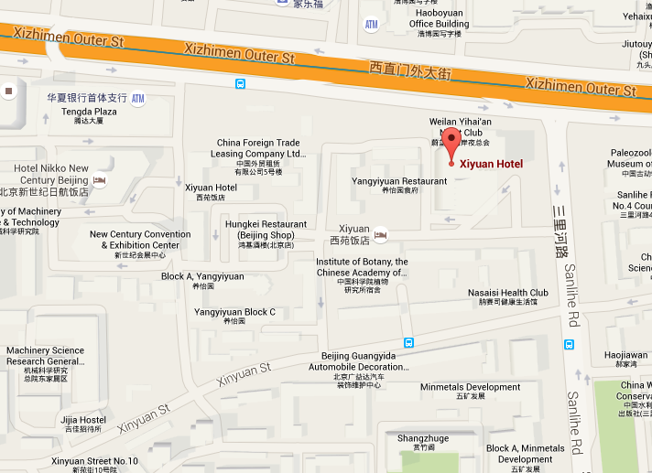

**SkyCity Convention Centre**

**3 Hotel accommodation**

In order to facilitate the meeting, a room block has been set aside for ITU delegates with the discounted rate at the meeting hotel. For convenience, delegates are encouraged to choose this meeting hotel (Xiyuan Hotel). Another option is Xindadu Hotel, which is 1.1 km away from the meeting venue.

**The reservation of accommodation will all be handled by the meeting organizer, while the expense will be paid by delegates when arriving at the hotel. Reservation can only be done by completing the Hotel Accommodation Reservation Form in Annex 3 and send to** [***ITU@uniplan.cn***](mailto:ITU@uniplan.cn) **before 30th December 2015** with the subject heading “*Hotel name - Delegate Full Name - Country*”.

The detail information of two hotels are as follows:

|  |  |  |  |  |  |  |
| --- | --- | --- | --- | --- | --- | --- |
| **Name of Hotel** | **ROOM RATE/ROOM TYPE** | | | | | **Facilities information** |
| **Twin** | **Single** | **Deluxe** | **Business** | **Suite** |
| **Xiyuan Hotel (5 Stars)**  1 Sanlihe Street, Haidian District, Beijing, China  *Tel.: +861059692159*  *Fax: +861059692199* | **500 CNY (79 USD)** Inclusive of all taxes   * 30 sqm * 11-18 floor * Twin beds * Standard decoration | **550 CNY  (87 USD)** Inclusive of all taxes   * 30 sqm * 11-18 floor * 1 queen size bed * Standard decoration | **580 CNY  (91 USD)** Inclusive of all taxes   * 30 sqm * 5-7 floor * 1 king size bed or twin beds * Deluxe decoration | **620 CNY  (98 USD)** Inclusive of all taxes   * 30 sqm * 8-10 floor /  19-20 floor * 1 king size bed or twin beds * Deluxe decoration with business facilities | **800 CNY  (126 USD**) Inclusive of all taxes   * 70 sqm * 5-7 floor * 1 king size bed * Deluxe decoration with business facilities * More functional with parlor | * No complimentary breakfast for all types of room * Daily breakfast   (Reserve rate:  Chinese style - 40 CNY  Western style - 70 CNY)   * Wireless Internet in room * Internet TV * 2 bottles of water daily |
| **Xindadu Hotel  (4 Stars)**21 Chegongzhuang Street, Xicheng District, Beijing, China  *Tel.: +861051668255*  *Fax: +861051668255* | **348 CNY (55 USD)** Inclusive of all taxes   * 18 sqm * 1-6 Floor * Twin beds * Standard decoration | **366 CNY (58 USD)** Inclusive of all taxes   * 14 sqm * 4-15 floor * 1 Queen size bed * Standard decoration | **466 CNY (73 USD)** Inclusive of all taxes   * 32 sqm * 4-15 floor * 2 king size beds * Deluxe decoration |  |  | * No complimentary breakfast for all type of rooms * Daily breakfast   (Reserve rate: 45 CNY)   * Wireless Internet in room * Internet TV * 2 bottles of water daily |

***Hotel reservation cancellation policy:***

* No charge for cancellation/amendment made **before 16 February 2016 (1 week before meeting).**
* Cancellation/Amendment **after 16 February 2016** will be charged for one night’s room and tax.
* Cancellation **on arrival date or no-show** will be charged for all reserved nights and tax.

# 4 Transportation from airport to the meeting venue

4.1 Taxi

It takes about 50 minutes by taxi from Beijing Capital International Airport to Xiyuan Hotel.   
Taxi fares range from approximately ¥98 to ¥112 CNY.

4.2 Subway

The subway is available from inside the Terminal 3. It takes about 110 minutes by subway and needs 690 m walk after twice transfer to Xiyuan Hotel. One way fare is ¥29 CNY. The route is as below:

Airport express (to Dongzhimen Station) - Line 2 (to Xizhimen Station) - Line 4 (to Dongwuyuan Station) - Exit D.

Please see the following website for further information:

<http://www.bjsubway.com/subwaymap/station_map.html>

# 5 Wireless Network

WLAN service will be provided in the meeting room for the duration of the meeting. Network ID and password will be made available on the first morning of the meeting. The venue has Wi-Fi access in most public areas as well.

# 6 Practical information

## 6.1 Banks & currency

The China currency unit is the Chinese Yuan (CNY). There are 8 kinds of notes (¥0.1, ¥0.5, ¥1, ¥5, ¥10, ¥20, ¥50 and ¥100) and 3 types of coins (¥0.1, ¥0.5 and ¥1). Major foreign currencies may be exchanged to Chinese Yuan at the airport and banks. Banks are usually open Monday to Friday from 0900 to 1700. Major credit cards are accepted in most hotels, restaurants and department stores.

For current exchange rates please consult the following website: <http://www.xe.com/>

## 6.2 Language

Mandarin is the official language of China. English is spoken in most hotels, banks and tourist locations.

## 6.3 Climate

In February and March, little to no rain is expected but snow is sometimes occurring.   
The temperature range is usually from -6°C to 10°C.

## 6.4 Local time

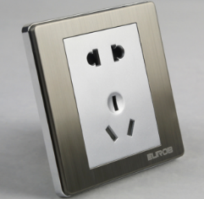GMT + 8 hours.

## 6.5 Electricity

Outlets in China work on 220 Volts, 50 Hz, with two or three prong flat plugs.

# 6.6 Emergency phones

The nationwide emergency phone numbers are: Police: 110 / Ambulance: 120 / Fire: 119.

## 7 Visa supporting document

Should you require a personal letter of invitation for a visa application, please send your request by email to [summer.li@uniplan.cn](mailto:summer.li@uniplan.cn) **before 15th December 2015** with a subject heading “*Request for Visa Supporting Document for WP 5D*”.

Your email must include the following information in order for it to be processed. Please allow up to 15 working days for your letter to be processed:

a) Copy of the passport,in particular,the page with personal information.

b) Personal Information as follows:

|  |  |
| --- | --- |
| Family name (last name) |  |
| middle name |  |
| Forename (first name) |  |
| Gender |  |
| Birth date (dd/mm/yyyy) |  |
| Birth place |  |
| Passport number |  |
| Passport issuing |  |
| Issuing date |  |
| Expiry date |  |
| Occupation |  |
| Company name |  |
| Company/Mailing |  |
| Postal |  |
| Telephone number |  |
| Fax number |  |
| Date of arriving |  |
| Days of stay |  |
| Reason |  |
| Where apply visa (country) |  |

**NOTE – Please verify that all information is accurate and will be valid at the time of the meeting.**

In addition, you may be asked for specific documentation showing strong social, economic, and other ties to your home country. Documents in a foreign language should have a notarized translation attached.

It may take up to 4-6 weeks for visa approval so please make your request for the invitation letter as soon as possible.

# 8 Local contact point

If you have any enquiries about the meeting arrangements, please contact:

**Summer Li**

**Uniplan**

**No. 39 DongSanHuan ZhongLu, Beijing, China**

**Telephone: +86 (10) 5969 2159**

[**summer.li@uniplan.cn**](mailto:ITU@uniplan.cn)

ANNEX 3

Hotel accommodation reservation form to be used.

|  |  |  |
| --- | --- | --- |
|  | **HOTEL ACCOMODATION RESERVATION FORM** | 中国信息通信研究院标志(矢量文件) |
| **PERSONAL INFORMATION:** | | |
| Reservation name:_____________________________________________________________________  Administration/Organization:____________________________________________________________  Business address:______________________________________________________________________  ____________________________________________________________________________________  Phone No.:_________________________________ Fax No.:__________________________________  E-mail address:________________________________________________________________________  Passport No.:_________________________________________________________________________  **Are you representing your Country’s Administration?** 🖵 Yes 🖵 No  **If “Yes” what’s your position in delegation:**  🖵 Head of Delegation (HoD) 🖵 Alternate HoD 🖵 Delegate | | |
| **HOTEL AND ROOM TYPE SELECTION:**  Please select your desire hotel and room type. For detail about hotel rates and facilities please check Annex 2 | | |
| 🖵 Xiyuan Hotel (5*): 🖵 Twin (500 CNY) 🖵 Single (550 CNY) 🖵 Deluxe (580 CNY)  🖵 Business (620 CNY) 🖵 Suite (800 CNY)  🖵 Xindadu Hotel (4*): 🖵 Twin (348 CNY) 🖵 Single (366 CNY) 🖵 Deluxe (466 CNY)  ***Note:*** *Payment for hotel room should be directly made to the hotel,* ***either by cash or credit card.*** | | |
| **RESERVATION DETAIL:** | | |
| Check In date and time:________________________________________________________________  Check out date and time:_______________________________________________________________  For twin booking, I will share with:________________________________________________________ | | |
| **PAYMENT INFORMATION:** | | |
| Payment method: 🖵 Cash 🖵 Credit Card  Credit card brand (Visa/Master/JCB...):___________________________________________________________________  Credit card number:___________________________________________________________________  Expiry date:__________________________________________________________________________  Name on the card:_____________________________________________________________________  Please check “Hotel Reservation Cancellation Policy” in Annex 3. | | |
| **OTHERS:** | | |
| * Accompanied by spouse: 🖵 Yes 🖵 No * Vegetarian diet: 🖵 Yes 🖵 No * Halal diet: 🖵 Yes 🖵 No * Chinese style breakfast: 🖵 Yes 🖵 No * Western style breakfast: 🖵 Yes 🖵 No | | |
| Date and signature: ___________________________________________________________________ | | |
| **PLEASE RETURN THIS FORM TO** [**ITU@uniplan.cn**](mailto:ITU@uniplan.cn) **BEFORE 30 DECEMBER 2015.**  With e-mail subject: Hotel - Delegate Full name - Country (*Example*: *Xiyuan Hotel - Summer Li - China*) | | |

______________