Radiocommunication Bureau (BR)

Circular Letter  5/LCCE/44 |  | 6 November 2013
To Administrations of Member States of the ITU, Radiocommunication Sector Members,
ITU-R Associates participating in the work of Radiocommunication Study Group 5
and ITU-R Academia

Subject: | Eighteenth meeting of Working Party 5D on IMT systems

1 Introduction
By means of this Circular Letter, we wish to announce that, at the kind invitation of the Administration of Viet Nam, the 18th meeting of ITU-R Working Party 5D will take place in
Ho Chi Minh City, Viet Nam (Socialist Republic of), from 12 to 19 February 2014. The opening session will commence on 12 February 2014 at 0930 hours (see table below).

Group | Meeting date | Deadline for contributions  1600 hours UTC | Opening session
Working Party 5D | 12-19 February 2014 | Wednesday, 5 February 2014 | Wednesday, 12 February 2014  at 0930 hours

2 Programme of the meeting
2.1 A draft agenda for the meeting is contained in Annex 1. The Questions assigned may be found at: http://www.itu.int/pub/R-QUE-SG05/en. The Working Party will conduct its work in English.
2.2 Working Party 5D Workshop
In conjunction with the work of Working Party 5D and, as planned at its previous meetings,
a Working Party 5D Workshop “Research views on IMT beyond 2020” will be held on
Wednesday, February 12th at 1400 hours (see Annex 2). The Workshop will be open to all
Working Party 5D participants.
2.3 Venue
The meeting will take place at:
New World Saigon Hotel
76 Le Lai Street, District 1, Ho Chi Minh City, Viet Nam
Tel: +84 8 3822 8888
Fax: +84 8 3823 0710
Email: saigon@newworldhotels.com
For further information, see Annex 3.
3 Contributions
Contributions in response to the work of Working Party 5D are invited. These will be processed according to the provisions laid down in Resolution ITU-R 1-6.
The membership is encouraged to submit contributions (including revisions, addenda and corrigenda to contributions) in order for them to be received 12 calendar days prior to the start of the meeting. The deadline for reception of contributions is seven calendar days (1600 hours UTC) prior to the start of the meeting. The deadline for reception of contributions for this meeting is specified in the table above. Submissions received later than this deadline cannot be accepted. Resolution ITU-R 1-6 provides that contributions which are not available to participants at the opening of the meeting shall not be considered.
Participants are requested to submit contributions by electronic mail to: rsg5@itu.int. A copy should also be sent to the Chairman of Working Party 5D and to the Chairman and Vice-Chairmen of Study Group 5. The pertinent addresses can be found on:
http://itu.int/go/rsg5/ch
http://itu.int/go/rwp5d/ch

4 Documents
Contributions will be posted “as received” within one working day on the Working Party 5D webpage established for this purpose: http://www.itu.int/md/R12-WP5D.AR-C/en. The official versions will be posted on http://www.itu.int/md/R12-WP5D-C/en within 3 working days.
All participants are kindly requested to download the documents from the above website before the meeting starts to avoid congestion of Internet network.
Wireless LAN facilities will be available in all the meeting rooms and an Internet cafe facility will also be provided.
Participants will need to bring their laptops (equipped with a WLAN-card) with them to the meeting because this will be a completely paperless meeting.

5 Remote participation
Audio webcast of plenary sessions of Working Party 5D and remote participation will not be available for this meeting.

6 Participation/Visa requirements/Accommodation
Advance registration to ITU-R events is mandatory and carried out exclusively online through Designated Focal Points (DFPs). Each ITU-R Member has been requested to designate a DFP responsible for the handling of all registration formalities, including visa support requests that should also be submitted by the DFP during the on-line registration process. Individuals wishing to be registered to an ITU-R event should directly contact the DFP for their entity. The list of ITU-R DFPs (TIES protected) as well as detailed information on event registration, visa support requirements, hotel accommodation, etc. can be found at:
www.itu.int/en/ITU-R/information/events
Specific information on deadlines to obtain visa and immigration documents are indicated in Annex 3. In particular, your attention is drawn to the need to apply for the visa well in advance considering the requirement of three-weeks to process each request and the closure of Government offices during the Tet Holiday (29 January – 8 February 2014).
7 Related event
The Administration of Viet Nam and Sponsoring Industry Companies will host a “Seminar on IMT towards 2020 and beyond” to be held on Tuesday, February 11th at 0900 hours, immediately prior to the Working Party 5D meeting and in the same venue. Other information is available on the event website:
http://www.cuctanso.vn/Page_content/Quick+links/SEMINAR_ON_IMT_TOWARDS_2020_AND_BEYOND/.
François Rancy
Director

Annexes: 3
Distribution:
– Administrations of Member States of the ITU and Radiocommunication Sector Members participating in the work of
Radiocommunication Study Group 5
– ITU-R Associates participating in the work of Radiocommunication Group 5
– ITU-R Academia
– Chairman and Vice-Chairmen of Radiocommunication Group 5
– Secretary General of the ITU, Director of the Telecommunication Standardization Bureau, Director of the Telecommunication Development Bureau
ANNEX 1
Draft agenda for the 18th meeting of Working Party 5D
(Ho Chi Minh City, Viet Nam, 12-19 February 2014)

1 Opening remarks
2 Adoption of the draft agenda
3 Report of the 17th meeting of Working Party 5D
4 Reports from Rapporteurs and Correspondence Groups
5 Working structure and document assignment
6 Meeting sessions for the final two days of the meeting

18th meeting of WP 5D | Tuesday, 18 February 2014 | Wednesday, 19 February 2014
Period 1 | Working sessions | General Aspects Plenary
Period 2 | Spectrum Aspects Plenary | WP 5D Closing Plenary
Period 3 | Working sessions | WP 5D Closing Plenary
Period 4 | Technology Aspects Plenary | –

7 Any other business

S. BLUST
Chairman, Working Party 5D

ANNEX 2
Working Party 5D Workshop
“Research views on IMT beyond 2020”

Objective of the Workshop
The objective of the Workshop is to provide Working Party 5D delegates with an overview and understanding of ongoing worldwide research activities and initiatives on future mobile communications reaching beyond 2020. This Workshop will assist Working Party 5D in the development of the new Recommendation ITU-R M.[IMT.VISION].
Terms of Reference for Workshop
Representatives from national/regional/global research groups/projects or programs and other interested parties are invited to present their work on future looking scenarios and visions of mobile communication systems beyond 2020, which could include:
– user demands trends;
– views on the future role of IMT in serving users and the society;
– the timeline/workplan to implement the visions;
– traffic, technology and spectrum aspects.
The Working Party 5D internal Workshop is intended to be held in a half-day. However, depending on the submitted presentations, the duration may be extended.
The Working Party 5D Chairman’s Report of the 17th meeting solicits proposals on presentations for the Workshop to be submitted to the contact person (Dr Håkan Ohlsén – hakan.ohlsen@ericsson.com) with the deadline being 15 January 2014, which is four weeks prior to the start of WP 5D #18.
The Workshop convener will be Mr Hu Wang of China (wanghu.wanghu@huawei.com).
ANNEX 3
Additional information for the 18th meeting of Working Party 5D

Introduction
The Vietnamese Administration is pleased to welcome the participants to the 18th meeting of ITU-R Working Party 5D on IMT systems (12-19 February 2014) in Ho Chi Minh City. This Annex provides both information on the meeting and guidance to the delegates for their stay while in Ho Chi Minh city, Viet Nam.
Meeting venue
The meeting will be held at
New World Saigon Hotel
76 Le Lai Street, District 1, Ho Chi Minh City, Viet Nam
Tel: +84 8 3822 8888
Fax: +84 8 3823 0710
Email: saigon@newworldhotels.com
Hotel accomodation
The following hotels near the meeting venue are recommended for participants to stay during the meeting. Reservation of the accommodation can only be done by completing the Hotel Accommodation Reservation Form and sending to local secretariat (see contact information below).

Name of Hotel | Room Rate/  Room Type |  | Star Rating / Distance | Facilities Information (Complementary) | Address
 | Single | Double / Twin
New World Saigon Hotel | 2,756,000 VND  (130 USD)  (Room RoH)  Inclusive of all taxes | 2,968,000  VND  (140 USD)  (Room RoH)  Inclusive of all taxes | 5-star  Meeting Venue Hotel  20 minutes from Tan Son Nhat Airport | - Daily buffet breakfast  - Wireless Internet in room  - Internet TV  - Daily seasonal fruit plate  - 2 bottles of water daily | See Meeting Venue information above.
Golden Central Hotel Saigon | 1,653,000 VND  (78 USD)  (Signature Deluxe)  Inclusive of all taxes | 1,653,000 VND  (78 USD)  (Signature Deluxe)  Inclusive of all taxes | 4-star  10 min walk from Venue  20 minutes from Tan Son Nhat Airport | - Daily buffet breakfast  - 2 bottles of water daily  - Wireless Internet in room | 140 Ly Tu Trong Str, Dist. 1,  Ho Chi Minh City, Viet Nam  Tel: +84 8 38270666  Fax: +84 8 38270566  Website: http://goldenhotelsaigon.vn/en/

Map of Hotels
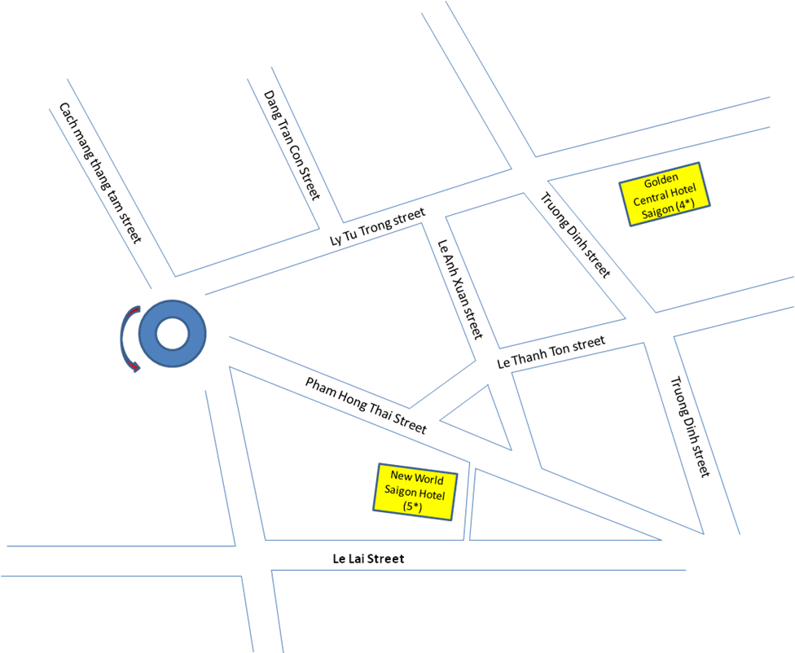

- Due to peak season of Ho Chi Minh City during the meeting period, you are kindly requested to send your Registration Form for finalizing the hotel reservation and other necessary arrangements to the contact persons indicated below by 8 January 2014 at the latest.
- Local Secretariat may not be able to guarantee hotel reservation and prices after the due date.
- Confirmation notices will be sent to participants for the Hotel booking reservation.
- Hotel Reservation Cancellation policy:
- No charge for Cancellation/Amendment made before 2 February 2014
- Cancellation/Amendment after 2 February 2014 will be charged at one night’s room and Tax
- Cancellation on Arrival date or No-show will be charged at all reserved nights and Tax.
Transportation and access
Tan Son Nhat International Airport (SGN), is the largest airport in Viet Nam. It is located 6 km north of the center (District 1) of Ho Chi Minh City. For further information, you can check at: http://www.vietnamairlines.com.vn/wps/portal/en/site/flight_info/time_table.
Airport taxis are available from Tan Son Nhat International Airport to the New World Saigon Hotel and the other Hotels with a fare of around VND 120,000 (about US$6). Delegates need to arrange their own transportation from airport to their respective hotels.
Visa and immigration information
Visas are exempted for the citizens of the countries which have signed a bilateral visa exemption agreement with Viet Nam. For information on entry visas to Viet Nam, participants are kindly requested to check the following web page of the Ministry of Foreign Affairs:
http://lanhsuvietnam.gov.vn/Lists/BaiViet/B%C3%A0i%20vi%E1%BA%BFt/DispForm.aspx?List=dc7c7d75%2D6a32%2D4215%2Dafeb%2D47d4bee70eee&ID=306
Tourist visas may be valid for 15 to 30 days. Tourist visa can only be obtained in Vietnamese Embassies and Consulates abroad.
A business visa will usually require a Visa Approval Letter (Visa Reference Number) which will be sent directly from Vietnamese Immigration Department to the relevant Vietnamese consulate or embassy. It takes at least 3 weeks to process the internal Visa Approval Letter (Visa Reference Number).
Please kindly be informed that during the major Vietnamese Tet Holiday which runs
from 29 January to 8 February, 2014 all Government offices will be closed (including the Immigration Department and Vietnamese Embassies in other countries). Therefore, delegates are urged to process their visa requests at their earliest convenience. During the Tet Holiday period we will not be able to attend to any enquiries or any requests for assistance relating to visa support.
Other information
Climate
The average temperature in Ho Chi Minh City during February varies from 26⁰C to 30⁰C degrees Celsius.
Currency
The legal tender of Viet Nam is Dong (VND). For money changing, banks and money changes are conveniently located over the city and at the airport, as well as at the hotels.
Exchange rate (as of 30th October 2013):
1 US Dollar (USD) 21,200 VND
1 € (EUR) 29,200 VND
Major Banks are open from 08.00 a.m. to 04.00 p.m., Monday to Friday. All main credit cards are welcome.
Food
A wide range of choices in the food/diet from Asian style to Western style is available in hotel restaurant and food-courts nearby the meeting venue. The local cuisine is excellent for different tastes.

Electricity
The mains voltage in Viet Nam is 220 Volts, 50 Hz. The power plugs used are of the 2-pin flat or circular.
Time Zone
GMT + 7 hours
Contact information
Local Secretariat:

To:  Ms Nguyen Thu Huyen  Authority of Radio Frequency Management  Ministry of Information and Communications  Socialist Republic of Viet Nam  Tel: +84 4 35564919 ext 502  Fax: +84 4 35564916  E-mail: huyennt@rfd.gov.vn | Copy to:  Ms Doan Thanh Huong  Mobile: +84 916 060708  Email: wp5dmeeting@gmail.com

HOTEL ACCOMODATION RESERVATION FORM
&
VISA SUPPORT REQUEST

Please indicate the meeting(s) you will be attending

( ) Seminar on IMT towards 2020 and beyond (11 February 2014)

( ) The 18th meeting of Working Party 5D (12-19 February 2014)
PERSONAL INFORMATION:
Reservation Name:__________________________
Administration/Organization:
Business Address:
__________________________________________________________________________________________
Phone No._____________________________ Fax No:____________________________
E-mail address:________________________________________________
Are you representing your Country’s Administration? : Yes No
If “Yes” what’s your position in delegation: Head of Delegation (HoD) Alternate HoD Delegate
PASSPORT INFORMATION FOR VISA: (Please provide only if you need support visa)
Please attach a scan copy of your passport. It is must be needed for the Visa Approval Letter.
Passport No.______________________ Date of Issue_________________ Expiry Date
Place of Issue _____________________ Date of Birth_________________ Place of Birth______________________
Passport Type: Ordinary/Official/ Diplomatic ______________________
Place of Getting Visa (Address of Vietnamese Embassy or Consulate in your country): __________________
Note: Please kindly be informed that during the major Vietnamese Tet Holiday which runs from 29 January to 8 February 2014 all Vietnamese Government offices will be closed. During the Tet Holiday period we will not be able to attend to any enquiries or any requests for assistance relating to support visa.
HOTEL AND ROOM TYPE SELECTION:
Please select your desire hotel and room type. For detail about hotel rates and facilities please check Annex 3.
New World Saigon Hotel (5*) (Room RoH): Single (130 USD) Double/Twin (140 USD)
Golden Central Hotel Saigon (4*): Signature Deluxe Queen Size (78 USD)
Signature Deluxe Twin (78 USD)
Note: Payment for hotel room should be directly made to an Event Agent who would be authorized by the Ministry of Information and Communications of Viet Nam. Payment could be made either by cash or credit card. 3% of total charge will be applied for payment using credit card according to the banking regulation and rate policy.
RESERVATION DETAIL:
Check In Date and Time:__________________________________________
Check Out Date and Time:_________________________________________
For twin booking, I will share with:__________________________________
PAYMENT INFORMATION:
Payment Method: Cash Credit Card
Credit Card Brand (Visa/Master/JCB...):____________________________
Credit Card number:___________________________________________
Expiry Date:__________________________________________________
Name on the Card:____________________________________________
Please check “Hotel Reservation Cancellation Policy” in Annex 3.
OTHERS:
- Accompanied by spouse: Yes No
- Vegetarian Diet: Yes No
- Halal Diet: Yes No
Date and Signature: _______________________________________________________________________
PLEASE RETURNED THIS FORM TO THE LOCAL SECRETARIAT ON OR BEFORE 8 JANUARY 2014.
To Ms Nguyen Thu Huyen Email: huyennt@rfd.gov.vn
& Ms Doan Thanh Huong Email: wp5dmeeting@gmail.com
with e-mail subject: FULL NAME – NAME OF COUNTRY (Example: Roberto Carlos – Portugal)
or via telefax to: +84 4 35564916

_________________

