INTERNATIONAL TELECOMMUNICATION UNION
Radiocommunication Bureau
(Direct Fax N°. +41 22 730 57 85)

Circular letter  5/LCCE/20 | 20 July 2010
To Administrations of Member States of the ITU,
Radiocommunication Sector Members and ITU-R Associates participating
in the work of Radiocommunication Study Group 5
Subject: Ninth meeting of Working Party 5D on IMT systems
Introduction
At the kind invitation of the Chinese Administration, this letter is to announce that the ninth meeting of ITU-R Working Party 5D will take place in Chongqing, China, from 13 to 20 October 2010. The meeting will be hosted and organized by China Communications Standards Association (CCSA).
The meeting will take place at:
Sofitel Forebase Chongqing
Address: 137 Second Ke Yuan Street, Jiulongpo District, 400039 Chongqing, P.R. China.
Tel: +86 23 6863 9999
Fax: +86 23 6863 7555
E-mail: sofitel@sofitel-forebase-chongqing.com
http://www.sofitel.com/gb/hotel-6415-sofitel-forebase-chongqing/index.shtml
For further information see Annex 1.

Programme of the meetings
A draft agenda for the meeting is contained in Annex 2. The Questions assigned may be found at:
http://www.itu.int/publ/R-QUE-SG05/en
Working Party 5D will conduct its work in English.

Contributions
Contributions in response to the work of Working Party 5D are invited. Contributions will be processed according to the provisions laid down in Resolution ITU-R 1-5 and posted on the web.
The deadline for submission of contributions is Wednesday, 6 October 2010, 16:00 hours UTC.
According to the ITU-R patent policy (Annex 1 to Resolution ITU-R 1-5), contributions containing a proposal for a Recommendation should draw the attention to any known patent or to any known pending patent application relating to systems or technologies considered in the proposal.
Copies of each contribution should be sent to the Study Group Department, Radiocommunication Bureau, for processing, to the Chairman of the Working Party and to the Chairman and Vice-Chairmen of Radiocommunication Study Group 5. The pertinent addresses can be found on:
http://www.itu.int/cgi-bin/htsh/compass/cvc.param.sh?acvty_code=wp5D
http://www.itu.int/cgi-bin/htsh/compass/cvc.param.sh?acvty_code=sg5
Participants are requested to submit contributions by electronic mail to:
rsg5@itu.int

Documentation
Contributions to this meeting are stored on the ITU web site at:
http://www.itu.int/md/R07-WP5D-C/en
Wireless LAN facilities will be provided in all meeting rooms and an Internet cafe facility will also be provided.
Participants will need to bring their laptops (equipped with a WLAN-card) with them to the meeting because this will be a completely paperless meeting (no paper copies of documents will be distributed).

Participation
Delegate/participant registration for the meeting will be carried out online via the ITU-R website. Each Member State/Sector Member/Associate was requested to designate a focal point to be responsible for the handling of all registration requests for his/her administration/organization. Individuals wishing to attend should contact directly the focal point designated for all Study Group activities for his/her entity. The list of designated focal points (DFPs) is available on the ITU-R Delegate Registration and Information webpage at:
http://www.itu.int/ITU-R/go/delegate-reg-info/en
Valery Timofeev
Director, Radiocommunication Bureau
Annexes: 2

Distribution:
– Administrations of Member States of the ITU Radiocommunication Sector Members participating in the work
of Radiocommunication Study Group 5
– ITU-R Associates participating in the work of Radiocommunication Study Group 5
– Chairman and Vice-Chairmen of Radiocommunication Study Group 5
– Secretary General of the ITU, Director of the Telecommunication Standardization Bureau, Director of the Telecommunication Development Bureau
Annex 1
Additional information for the ninth meeting of Working Party 5D

1 Introduction
The Chinese Administration is pleased to welcome the participants to the 9th meeting of ITU-R Working Party 5D on IMT Systems (13-20 October, 2010). This Annex provides both information on the meeting and guidance to the delegates for their stay in Chongqing.

2 Meeting venue
The meeting will be held at:
Sofitel Forebase Chongqing (5 star)
Address: 137 Second Ke Yuan Street, Jiulongpo District, 400039 Chongqing, P.R. China.
Tel: +86 23 6863 9999
Fax: +86 23 6863 7555
E-mail: sofitel@sofitel-forebase-chongqing.com
http://www.sofitel.com/gb/hotel-6415-sofitel-forebase-chongqing/index.shtml

3 Hotel accommodation
Pre-bookings have been made in the following two hotels. Bookings should be made directly to the hotels using the forms available in Appendices A & B, where further information such as cancellation policies, additional services, and booking deadlines can be found.
Participants wishing to make reservations should fill out the reservation form and send it to the hotel, with a copy to qixu@ccsa.org.cn & guohuijuan@ccsa.org.cn, to make sure that we can make reservation beforehand.
Please Note:
– Please contact the Hotel directly to make any reservation changes.
– Delegates who want to stay in the other hotel around the meeting venue can refer to item 3.2 below.
– Different hotels may have different cancellation policies, deadlines for booking, etc. Please pay attention to that.

3.1 Hotel – Meeting venue
Sofitel Forebase Chongqing
Address: 137 Second Ke Yuan Street, Jiulongpo District, 400039 Chongqing, P.R. China.
Tel: +86 23 6863 9999
Fax: +86 23 6863 7555
E-mail: sofitel@sofitel-forebase-chongqing.com
http://www.sofitel.com/gb/hotel-6415-sofitel-forebase-chongqing/index.shtml
Located in Chongqing Economic and Technological Development Zone, the Sofitel Forebase Chongqing is one of the premier hotels in China, offering luxury accommodation. It is perfect for business or leisure trips with easy access to the airport and Chengjiaping Exhibition Centre. Nearby attractions include Chaotianmen dock of Three Gorges, Chiqikou Ancient Town and Tianchi Hot Spring.
The rate for ITU-R WP 5D participants is from 750 RMB to 1300 RMB/night (including buffet breakfast and free internet access).
The Hotel reservation form for Sofitel Forebase Chongqing can be found in Appendix A.
– We would be grateful if you would send your reservation as soon as possible, but not later than 13 September, 2010 (deadline for pre-booking).

3.2 Hotel nearby the venue
Chongqing Carlton Hotel (5 star)
Address: No.259, Keyuan 4th Road, Hi-tech Industrial Development Zone,
Chongqing, China.
Tel: +86 23 6806 6806
Fax: +86 23 6806 6666
http://www.cqcarltonhotel.com/index.php
Chongqing Carlton Hotel has been considered one of the best choices for business travel, leisure and recreation in the city. It is 40-50 minutes-drive to Chongqing Jiangbei International Airport. It is very close to the meeting venue, about 5 minutes on foot.
The rate for ITU-R WP 5D participants is from 488 RMB to 868 RMB/night (including buffet breakfast and free internet access).
The Hotel reservation form for Chongqing Carlton Hotel can be found in Appendix B.
– We would be grateful if you would send your reservation as soon as possible, but not later than 20 August, 2010 (deadline for pre-booking).

4 Transportation & access

4.1 How to reach Chongqing
Chongqing Jiangbei International Airport (airport code: CKG) is a national level airport. It accommodates over 50 domestic and international airlines, including regular lines to Hong Kong, Dusseldorf in Germany, Tokyo, Nagoya in Japan and Seoul in South Korea and charter flights to Bangkok and Kuala Lumpur.
For more information, please visit: http://www.cqa.cn/u/jichang/#

How to reach Sofitel Forebase Chongqing
From airport:
– By taxi
It takes about 90 RMB from the Jiang Bei International Airport to the hotel by taxi and about 40-50 minutes.
If you take a taxi, please show the following note to the taxi driver:
请把我送到重庆申基索菲特大酒店
Please take me to Sofitel Forebase Chongqing
地址： 重庆市九龙坡区科园二路137号
Address: 137 Second Ke Yuan Street, Jiulongpo District, 400039 Chongqing, P.R. China.

– Airport transfer
If you need airport transfer please contact the hotel in advance. The pickup service is charged differently according to the type of car chosen. For detailed information see Appendix A.
– Map direction
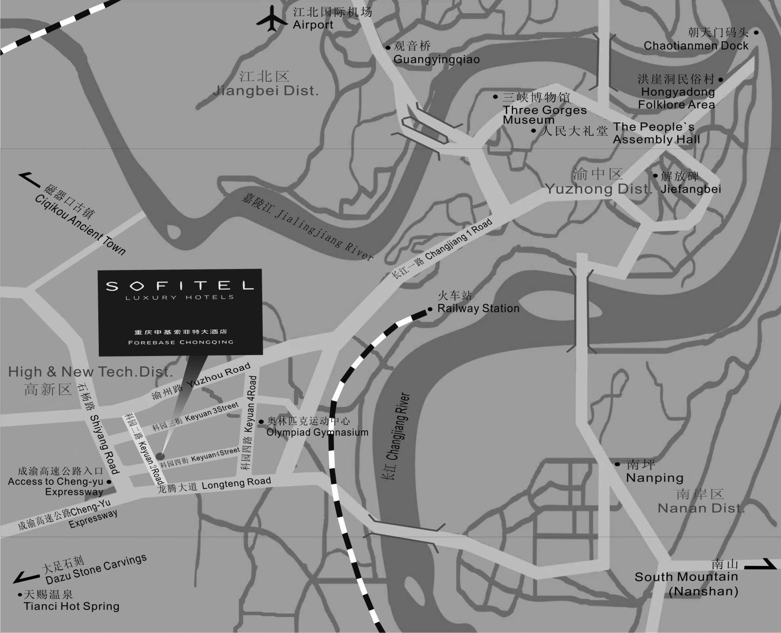

Public transport in Chongqing
- Taxis
In Chongqing, almost all taxis are yellow Suzuki cars, which are very eye-catching. And the high-quality service of the clean taxis is one of the characteristics of Chongqing. The flag-fall price is RMB 5, and the price per km is RMB 1.6. Three RMB fuel oil tax will be added into the total cost.
- Bus
The city bus system is developed. Three types of bus are available, including public trolleybus, new type bus and mini bus. At present, there are 27 lines of the mini bus, more than 90 lines of bus, and 5 lines of public trolleybus. The bus ticket is cheap, and the flag-fall price is RMB 1 or RMB 1.5.
- City Cable Car, Elevator and River Cableway
The city cable car and the elevator are the features of Chongqing due to the geography and the special roads and streets of this mountain city. The city cable car and the elevator are very convenient and time-efficient. Near the railway station, there is an elevator on the Kaixuan Road, combining with the upper and lower of the street. In addition, the river cableway has become the important transportation because the Yangtze River and the Jialing River run through the city. The flag-fall price is RMB 1.5.

5 Passports & visas
We would remind you that citizens of some countries are required to obtain a visa in order to enter and spend time in P.R. China. The visa must be requested and obtained from the office (embassy or consulate) representing China in your country or, if there is no such office in your country, from the one that is closest to the country of departure. Please be aware that visa approval might take time so kindly make your request for the invitation letter as soon as possible.
Participants who need an invitation letter and/or a visa supporting letter for entering China are advised to fill-in the INVITATION LETTER REQUEST FORM in Appendix C and email it to qixu@ccsa.org.cn & guohuijuan@ccsa.org.cn by September 24th, 2010 if you require an invitation letter for obtaining your Chinese visa.

6 Currency & banking
Local currency unit is RMB Yuan (￥).
Online exchange rates: http://finance.yahoo.com/currency
Banking
The nearest banks are Industrial Bank, China Construction Bank and China Merchants Bank. You can walk to these banks for financial affairs.
Banks in China are open Monday through Sunday. The opening time changes slightly depending on the bank, but typically from 9 AM to 5:30 PM.
Credit cards
Internationally-recognized credit cards such as VISA, MasterCard, American Express, JCB and Diners are typically accepted at most hotels and restaurants.

7 Network
WLAN service will be provided in the meeting room.
Broadband access (wired) to the Internet is available in guest rooms of both the Sofitel Forebase Chongqing and Chongqing Carlton Hotel, which is free.

8 Language
The official language in Chongqing is Chinese, while English is spoken in most restaurants, bars and hotels.

9 Local time
Central Time Zone (GMT +8 hours, Beijing, Hong Kong).

10 Tipping
Tipping is not usual in China since the restaurant prices already cover charge and service; therefore it remains at the customer’s discretion.

11 Climate
Chongqing has a subtropical climate with an annual average temperature of 18℃, an annual rainfall of 1,000 mm and an annual average humidity of 79%. The best weather is in April, May, September and October.
Further information:
http://www.weather.com.cn/english/

12 Electricity
The Standard electrical current/outlet in China is 50 Hz, 220V, AC. Please make sure that you have the correct adapter. Voltage converters will NOT be provided at the meeting. The type of electrical socket at the venue of the meeting is oblique flat blades (inverted V-shape) with ground.
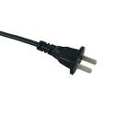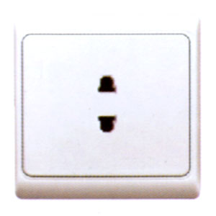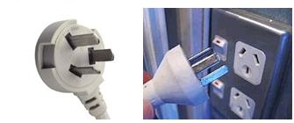
In the above picture the two kinds of sockets and plugs used in China are shown.

13 Emergency Phone

Traffic Accident | 122 | Fire Emergency | 119
Medical Emergency | 120 | Police Emergency | 110

14 Medical services around Sofitel Forebase Chongqing
– The First Affiliated Hospital, Chongqing Medical University
Add: No.1 Youyi Road, Yuan Jia Gang, Yu Zhong District, Chongqing, China.
Tel: +86 23 6565 9595
– Southwest Hospital
Add: 30, Gao Tan Yan Zheng Street, Sha Ping Ba District, Chongqing, China.
Tel: +86 23 6531 8301

15 Web link
More information about Chongqing is available from: http://english.cq.gov.cn/

16 Contact person
For any additional information, requests, etc., please contact:
Mr. QI Xu or Ms. GUO Huijuan
China Communications Standards Association (CCSA)
Fax: +86 10 8205 4513
E-mail: qixu@ccsa.org.cn; guohuijuan@ccsa.org.cn
At the same time, you can contact us to get any emergency help at our mobile phones:
Mr. QI Xu: +86 134 6672 4696
Ms. GUO Huijuan: +86 135 8161 4793

Appendix A
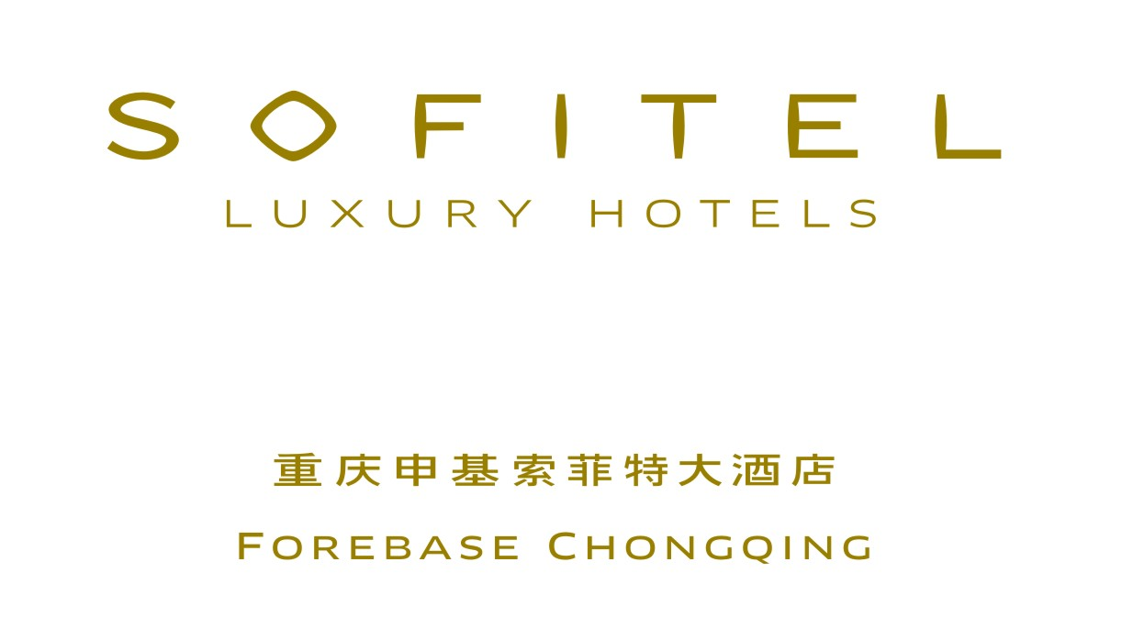
Room Reservation Form（ITU-R WP 5D）
预订单
New Booking 新预定 Amendment 更改 Cancellation 取消

Arriv Date抵店日期: Arriv Flight抵达航班: ETA抵店时间:____________
Dept Date离店日期: Dept Flight离开航班: ETD 离店时间:____________
Booked By订房人: Contact No/Email联系电话/邮箱:________________________________
Guaranteed Credit Card 担保的信用卡:
Last Name  姓 | First Name  名 | Country  国籍 | Room Type  房型 |  | Room Rate  房价 | Quantity  数量 | Confirmation No.  确认号
Mr.
Ms.
Mr.
Ms.
Remarks备注: Superior King / Twin Room高级大床／双床房:750 RMB Luxury King / Twin Room豪华大床／双床房:880RMB
Club Sofitel King /Twin Room 行政会所大床／双床房:1100 RMB Club Suite行政套房:1300 RMB
(including one/two Breakfast and Free Internet)
Payment Method付款方式:  Prepay预付 Cash现金 Credit Card信用卡  Cheque 支票 T/T电汇 City Ledger挂帐 |  |  |  | Payment Instruction付款说明:  O/A客人自付 P/B他人付费 All to Co.公司付全额费用  Rm Only to Co. OTHS PAX A/C 房费由公司支付，杂费客人自付
Visa Master Diners Amex JCB No & Validity 卡号及有效期:____________
Special Request特殊要求: High FL 高层楼 Same FL 同一楼层 Smoking RM Non-Smoking RM
Transportation Request租车服务: Airport Pick Up接机 Airport Drop Off 送机 Round Way 接机和送机
Type of Car车型: Others其他 Charge(Single Way) RMB Audi A6 4 seats RMB380
租车价格（单程）: Buick L8 6 seats RMB430
Coaster 23 seats RMB800
Confirmation Letter/Cancellation Letter Request要求回复确认信/取消信 Yes 是 No 否
Email Address邮件地址: Return Fax No. 回复传真号码:____________________________
Remarks备注: We should be grateful if you would send your reservation as soon as possible, but not later than 13 September, 2010(deadline for pre-booking).
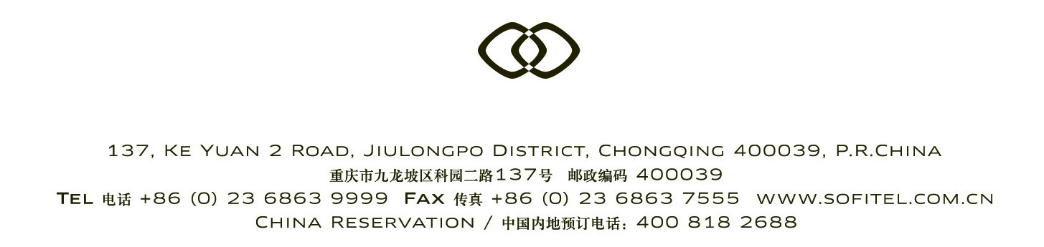
Please forward this form to reservation@sofitel-forebase-chongqing.com or +86 (23) 68692078.
TEL: +86 (23) 68639999 EXT: 6723 - 6725

Appendix B

Room Reservation Form（ITU-R WP 5D）
预订单
New Booking 新预定 Amendment 更改 Cancellation 取消
Arriv Date抵店日期: Arriv Flight抵达航班: ETA抵店时间:________________
Dept Date离店日期: Dept Flight离开航班: ETD 离店时间:________________
Booked By订房人: Contact No/Email联系电话/邮箱: ________________________________
Guaranteed Credit Card 担保的信用卡:
Last Name  姓 | First Name  名 | Country  国籍 | Room Type  房型 |  | Room Rate  房价 | Quantity  数量 | Confirmation No.  确认号
Mr.
Ms.
Mr.
Ms.
Remarks 备注: Deluxe Twin Room 豪华标间: 488 RMB Deluxe King Room 豪华单间: 488 RMB
Deluxe Suit(King) 豪华套房：868 RMB (including one/two Breakfast and Free Internet)
Payment Method付款方式:  Prepay预付 Cash现金 Credit Card信用卡  Cheque 支票 T/T电汇 City Ledger挂帐 |  |  |  | Payment Instruction付款说明:  O/A客人自付 P/B他人付费 All to Co.公司付全额费用  Rm Only to Co. OTHS PAX A/C 房费由公司支付，杂费客人自付
Visa Master Diners Amex JCB No & Validity 卡号及有效期:____________
Special Request特殊要求: High FL 高层楼 Same FL 同一楼层 Smoking RM Non-Smoking RM
Transportation Request租车服务: Airport Pick Up接机 Airport Drop Off 送机 Round Way 接机和送机
Type of Car车型: Others其他 Charge(Single Way) RMB Passat 4 seats RMB400
租车价格（单程）: Buick 5 seats RMB500
Coaster 26 seats RMB600
Confirmation Letter/Cancellation Letter Request要求回复确认信/取消信 Yes 是 No 否
Email Address邮件地址: Return Fax No. 回复传真号码: ____________________________
Remarks备注: We should be grateful if you would send your reservation as soon as possible, but not later than 20 August, 2010(deadline for pre-booking).
Please forward this form to reservation@cqcarltonhotel.com or +86 (23) 68066831
TEL: +86 (23)68066869

Appendix C
ITU-R WP5D Meetings (Oct.13 -20, 2010)
Chongqing, China
INVITATION LETTER REQUEST FORM
To enter China for the meetings indicated above, you may need a letter of invitation from the Chinese host, which you will need to present to the Chinese Embassy/Consulate in your area in order to obtain your visa. In order to obtain the invitation letter, please fill out the form below and send it to:

- Mr. QI Xu & Ms. GUO Huijuan
- E-mail: qixu@ccsa.org.cn & guohuijuan@ccsa.org.cn

With the email subject: 5D meetings – Invitation Letter Request
Company
Applicant  Information | [ Click and Type in your full name ] |  |  | rMr rMs rMrs
Applicant  Information | [ Nationality ] |  |  | [ Passport No.]
Applicant  Information | Date of birth : [ Year ] [ Month] [ Day ] |  |  | [ Job Title ]
Applicant  Information | If the country in which you'll obtain your visa is different from your nationality, please indicate it here:  [ Country to obtain your visa]
Address | [Click and Type in your address and ZIP code]  Telephone Number: [Click and Type in phone number]  Fax Number: [Click and Type in fax number]  E-mail: [Click and Type in email]
Places to visit after entry
Date of arrival at China |  |  | Date of departure from China
End of form
(Please do not forget to attach a copy of your passport photograph page before sending.)
Your information should be sent out before 24 September 2010.

After the end of 2008 Beijing Olympic Games, a scanned copy of the invitation letter is typically accepted by local Chinese Embassies / Consulates for processing visa requests. Therefore, without a special request for original invitation letter, CCSA will provide by default a scanned copy of the invitation letter. Please confirm whether your local Chinese Embassy / Consulate requires the original invitation letter for processing your visa request and let us know if it is needed.
Annex 2
Draft agenda for the 9th meeting of Working Party 5D
(Chongqing, 13 – 20 October 2010)

1 Opening of the meeting
2 Approval of the agenda
3 Report of the 8th meeting of Working Party 5D (Doc. 5D/790)
4 Reports from Rapporteurs and Correspondence Groups
5 Working structure and document assignment
6 Any other business

S. BLUST
Chairman, Working Party 5D

