|  |  |
| --- | --- |
| INTERNATIONAL TELECOMMUNICATION UNION | sigleITU |

|  |
| --- |
| *Radiocommunication Bureau*  *(Direct Fax N°. +41 22 730 57 85)* |

|  |  |
| --- | --- |
| **Circular Letter**  **3/LCCE/31** | 2 June 2010 |

**To Administrations of Member States of the ITU,   
Radiocommunication Sector Members and ITU-R Associates   
participating in the work of the Radiocommunication Study Group 3**

**Subject**: **Meetings of Working Parties 3J, 3K, 3L and 3M**

Working Party 3J: Propagation fundamentals

Working Party 3K: Point-to-area propagation

Working Party 3L: Ionosphericpropagation and radio noise

Working Party 3M: Point-to-point and Earth-space propagation

# Introduction

At the kind invitation of the Administration of Italy, this letter is to announce that meetings of ITU‑R Working Parties 3J, 3K, 3L and 3M will take place in Erice, Sicily, from 10 to 19 November 2010.

# Place of the meetings

The meetings will take place at the:

Foundation and International Centre for Scientific Culture "Ettore Majorana"  
Via Guarnotta, 26  
91016 ERICE (Sicily)  
Italy

Tel.: +39 0923 869133

Fax: +39 0923 869226

E-mail: [hq@emcsc.ccsem.infn.it](mailto:hq@emcsc.ccsem.infn.it)

Web: <http://www.ccsem.infn.it>

For further information see Annex 1.

# Programme of the meetings

|  |  |  |  |
| --- | --- | --- | --- |
| Group | Meeting date | Deadline for contributions at 16:00 hours UTC | Opening session |
| Joint Meeting of Working Parties | 10 November 2010 | - | Wednesday, 10 November 2010  at 13:00 hours (local time) |
| Working Party 3J | 10-19 November 2010 | Wednesday,  3 November 2010 | Wednesday, 10 November 2010 at 14:00 hours (local time) |
| Working Party 3M | 10-19 November 2010 | Wednesday,  3 November 2010 | Wednesday, 10 November 2010  at 15:30 hours (local time) |
| Working Party 3L | 12-19 November 2010 | Friday,  5 November 2010 | Friday, 12 November 2010 at 09:30 hours (local time) |
| Working Party 3K | 10-19 November 2010 | Wednesday,  3 November 2010 | Wednesday, 10 November 2010 at 17:00 hours (local time) |

Draft agendas for the meetings are contained in Annex 2. The Questions assigned may be found on:

<http://www.itu.int/publ/R-QUE-SG03/en>

Working Parties will conduct their work in English.

Services directly connected with meeting activities, such as delegate registration, document distribution, etc... will be located in the vicinity of the meeting room. Registration of delegates will start at 08:30 hours on the opening day.

Delegates may wish to note that these Working Parties meetings will be preceeded by the 1st International Workshop of the EU FP6/COST Project IC0802 “*Propagation tools and data for integrated Telecom, navigation and Earth observation systems*”, which is to be held at the same venue, from 8 to 9 November 2010. For more information, see <http://www.tesa.prd.fr/cost/> or contact the Workshop organisers, Dr. Antonio Martellucci, ESA/ESTEC ([Antonio.Martellucci@esa.int](mailto:Antonio.Martellucci@esa.int)) and Prof. Carlo Riva, Politecnico di Milano ([riva@elet.polimi.it](mailto:riva@elet.polimi.it)).

# Contributions

Contributions in response to the work of Working Parties 3J, 3K, 3L and 3M are invited. These will be processed according to the provisions laid down in Resolution ITU-R 1-5 and posted on the web.

According to the ITU-R patent policy (Annex 1 to Resolution ITU-R 1-5), contributions containing a proposal for a new Recommendation should draw the attention to any known patent or to any known pending patent application relating to systems or technologies considered in the proposal.

Copies of each contribution should be sent to the Study Group Department, Radiocommunication Bureau, for processing, to the Chairman of the Working Party and to the Chairman and Vice‑Chairmen of Radiocommunication Study Group 3.

The pertinent addresses can be found on:

<http://www.itu.int/cgi-bin/htsh/compass/cvc.param.sh?acvty_code=3>.

Participants are requested to submit contributions by electronic mail to:

[rsg3@itu.int](mailto:rsg3@itu.int)

**The deadline for submission of contributions is specified in the table above**. Submissions received later than the specified deadlines cannot be accepted.

# Documentation

Contributions to this meeting are stored on the ITU‑R Study Group 3 Web page at:

<http://www.itu.int/ITU-R/index.asp?category=study-groups&link=rsg3&lang=en>

(see the Contributions of each relevant Working Party under “Structure”).

Wireless LAN facilities will be provided in all meeting rooms. Participants will need to bring their laptops (equipped with a WLAN-card) with them to the meeting because **this will be a completely paperless meeting** (no paper copies of documents will be distributed).

# Hotel accommodation and arrival information

Annex 1 contains details on hotel accommodation; delegates are advised to make reservations at the earliest opportunity. Also included in Annex 1 is information concerning arrival in Erice, together with a map indicating the conference venue.

# Participation

Delegate/participant registration for the meeting will be carried out online via the ITU-R website.

Each Member State/Sector Member/Associate was requested to designate a focal point to be responsible for the handling of all registration requests for his/her administration/organization.

Individuals wishing to attend should contact directly the focal point designated for all Study Group activities for his/her entity. The list of designated focal points (DFPs) is available on the **ITU-R Delegate Registration and Information** webpage at:

<http://www.itu.int/ITU-R/go/delegate-reg-info/en>

# Passports & visas

At the following web page of the Italian Minister of Foreign Affairs: <http://www.esteri.it/visti/index_eng.asp> you can find out whether you need a visa to enter in Italy and in the Schengen States for up to 90 days. Contact person is provided in item 5 of Annex 1.

**Delegates are urged to process their visa requests at their earliest convenience.**

Valery Timofeev

Director, Radiocommunication Bureau

**Annexes:** 3

**Distribution:**

– Administrations of Member States of the ITU and Radiocommunication Sector Members participating in the work of Radiocommunication Study Group 3

– ITU-R Associates participating in the work of Radiocommunication Study Group 3

– Chairman and Vice-Chairmen of Radiocommunication Study Group 3

– Secretary General of the ITU, Director of the Telecommunication Standardization Bureau, Director of the Telecommunication Development Bureau

Annex 1

Information for participants

# 1 Meeting venue

The venue of the meeting is:

International Centre for Scientific Culture "Ettore Majorana"  
Via Guarnotta, 26  
91016 ERICE (Sicily)  
Italy

Tel.: +39 0923 869133  
Fax: +39 0923 869226  
Home page: <http://www.ccsem.infn.it>.

Figure 1

Location of Erice, Trapani and nearest International Airports

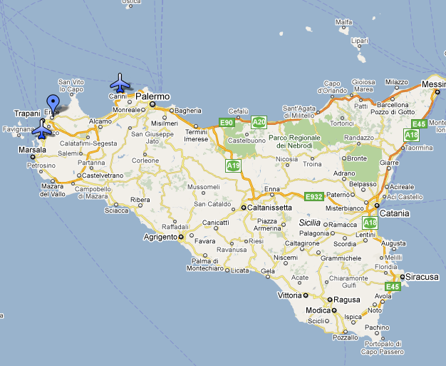

## 1.1 Description of the Maiorana Centre

The Centre is situated in the old pre‑medieval city of Erice where three restored monasteries (one of which was the residence of the Viceroy of Sicily during the XIV and XV Centuries) provide an appropriate setting for high intellectual endeavour. These ancient buildings are now named after great Scientists and strong supporters of the "Ettore Majorana" Centre.

The San Francesco Monastery (former Viceroys residence) is now the Eugene P. Wigner Institute with the "*Enrico Fermi*" Lecture Hall.

The San Domenico Monastery is now the Patrick M.S. Blackett Institute with the "*Paul A.M. Dirac*" Lecture Hall.

The San Rocco Monastery is now the Isidor I. Rabi Institute with the "*Richard P. Feynman*" Lecture Hall, the Directorate and the main Secretariat of the Centre.

There are living quarters in all three Institutes for people attending the Courses and meetings of the Centre. The Erice Station of the World Laboratory Seismological Network is located in the I.I. Rabi Institute. The "Daniel Chalonge" and the "Paul A.M. Dirac" Museums are situated at the Patrick M.S. Blackett Institute.

Figure 2

Map of Erice and location of “Patrick M.S. Blackett Institute”,   
San Domenico building

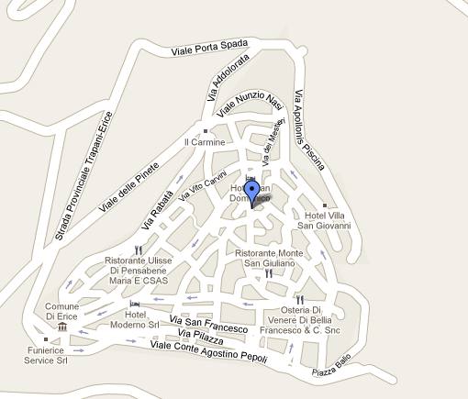

## 1.2 Erice historical and touristic information

According to legend, Erice, son of Venus and Neptune, founded a small town on top of a mountain (750 metres above sea level) more than three thousand years ago. The founder of modern history-i.e. the recording of events in a methodic and chronological sequence as they really happened without reference to mythical causes -the great Thucydides (‑500 B.C.), writing about events connected with the conquest of Troy (1183 B.C.) said: "After the fall of Troy some Trojans on their escape from the Achaei on the sea towards the West arrived in Sicily by boat and as they settled near the border with the Sicanians all together they were named Elymi: their towns were Segesta and Erice". This inspired Virgil to describe the arrival of the Troyan royal family in Erice and the burial of Anchise, by his son Enea, on the coast below Erice. Homer (~1000 B.C.), Theocritus (~300 B.C.), Polybius (~200 B.C.), Virgil (~50 B.C.), Horace (~20 B.C.), and others have celebrated this magnificent spot in Sicily in their poems.

Figure 3

Castle of Venus and the Cathedral, Erice, Sicily

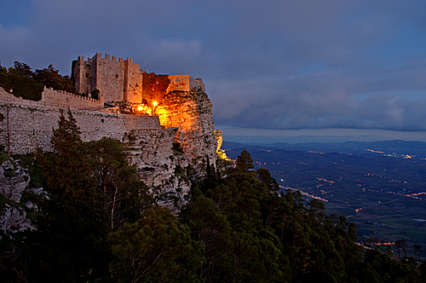 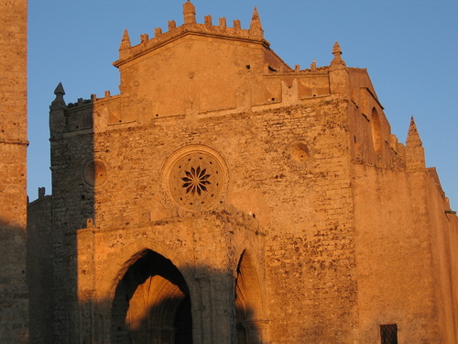

In Erice you can admire the Castle of Venus, the Cyclopean Walls (~800 B.C.) and the Gothic Cathedral (~1300 A.D.). Erice is at present a mixture of ancient and medieval architecture. Other masterpieces of ancient civilization are to be found in the neighbourhood: at Motya (Phoenician), Segesta (Elymian), and Selinunte (Greek). On the Aegadian Islands –theatre of the decisive naval battle of the first Punic War (264‑241 B.C.) – suggestive neolithic and paleolithic vestiges are still visible: the grottoes of Favignana, the carvings and murals of Levanzo. Splendid beaches are to be found at San Vito Lo Capo, Scopello, and Comino, and a wild and rocky coast around Monte Cofano: all at less than one hour's drive from Erice.

# 2 Accommodation, rates and registration

Accommodation, including full board (breakfast, lunch and dinner) and coffee breaks will be provided by the Ettore Maiorana Centre by hosting participants in its own living quarters and in local hotels at a special rate.

Participants shall register in advance for the accommodation in Erice using the personal data form for the Centre (see Annex 3).

The accommodation (including full board, lodging and local transportations) should be paid in advance by bank transfer into the following account:

**Bank address:** Banca Unicredit Private Banking,   
Filiale di Trapani, Via Garibaldi 9, 91100 Trapani (Italy)

**IBAN:** IT04 W03223 16400 000600 000655

**Account #:** 000600000655

**SWIFT:** UNCRIT2VTPW

**Bank account holder:** Ettore Majorana Centre and Foundation

**Transfer amount:** 1300 €/person for the period from 7 to 20 November 2010  
(arrival on 7/11/2010 and departure on 20/11/2010) or 110 €/person per day for a shorter stay

**Reason for payment:** *Name of the participant*, Radiowave propagation

Please be sure that your name appears on the receipt.

Participants are requested to send by 29 October 2010, copies of the receipt and of the accommodation personal data form to the local organizer, Prof. Carlo Riva, by fax (+39 02 2399 3413) and/or e‑mail ([riva@elet.polimi.it](mailto:riva@elet.polimi.it)) and to present them at the reception desk upon their arrival in Erice.

The fee can also be paid in Erice, upon registration:

1. In cash.
2. With travellers checks.
3. With Euro checks.

Credit cards are honoured by the local Bank and Post Office.

## 2.1 Other practical information on the accommodation

* Breakfast

Residents in the I.I. Rabi, Eugene P. Wigner and Patrick M.S. Blackett Institutes will have breakfast on a self‑service basis in the "coffee room" in the I.I. Rabi Institute (in the back of the courtyard on the right‑hand side under the staircase). Participants housed in the hotels will have breakfast at their hotels.

* Snacks

Coffee, tea, milk, mineral water, fruit and sandwiches are available (free of charge) in the "coffee room" at the I.I. Rabi Institute at any time.

* Lunch and dinner

A selected list of recommended restaurants is displayed in the entrance hall of the I.I. Rabi Institute. The closing day of each restaurant is given in the list.

The restaurant owner will ask the participants to sign a form where the appropriate activity is indicated (*Radiowave propagation*) in order to keep a record.

Please sign legibly; accompanying members must sign too.

At lunch and dinner, it is advisable for participants to distribute themselves in small groups in order to avoid too many people crowding into the same restaurant, and in order to have faster service. Please wear your badge.

* Mineral water

The local tap water is drinkable, however, you will find bottles of mineral water in your room (unless you are staying in one of the hotels). Empty bottles will be replaced by the room maid, free of charge. More bottles are available for all participants in the storage room at the I.I. Rabi Institute.

* Incoming mail

Pigeon holes for incoming mail are located in the entrance hall of the I.I. Rabi Institute.

* Laundry

Self‑service washing machines (and dryers) are available in the storage room at the back of the courtyard in the I.I. Rabi Institute.

* Telephone and mobile networks

The public telephone (and an automatic magnetic telephone‑card dispenser) in the I.I. Rabi Institute is located on the 1st floor at the back of the courtyard. There is also a public telephone in the Eugene P. Wigner Institute (ground floor). Public telephones are also available at the "Tabacchi" shops in Piazza Umberto I and in Via Generale G. Salerno not far from the Elimo Hotel. Magnetic telephone cards can also be purchased at the "Tabacchi" shops.

Information on mobile networks in Italy and coverage maps are available on: <http://www.gsmworld.com/roaming/gsminfo/cou_it.shtml>

* Computer room

The computer room is located off the left‑hand side of the I.I. Rabi courtyard.

* Shops

The shops in Erice are open from 09:00 am (or 10:00 am) to 01:00 pm and from 04:00 pm to 07:30 pm. We recommend those which allow a discount to the participants: please ask before paying. The Pharmacy is in Via Cordici off the main square (Piazza Umberto 1). There are no foreign language newspaper shops.

* Accompanying persons

It is necessary for those participants who would like to be accompanied by members of their families to contact the Course Secretariat well in advance of their arrival. Accommodation is limited and priority will be given to the first comers. The names of the accompanying persons must be communicated to the Course Secretariat well in advance of the beginning of the activity which the participant is interested to.

* Excursions and social events

There is no charge for the social events or any excursion programmed by the Centre.

The final schedule and programme will be communicated by the Centre at the start of the meeting. For the excursion, the bus pick‑up/drop‑off point will be the large parking area at Viale Pepoli (Porta Trapani).

On the arrival day there will be an informal welcome party in the "piano room" after dinner.

# 3 Travel guidelines

The centre will provide shuttle bus service (cost included in the accommodation fee) from the Airports of Palermo and Trapani. Participants should look for the Ettore Majorana meeting point inside the terminal at the arrival gate where the driver of the Ettore Majorana Centre will be waiting.

Participants shall communicate to the local organiser, Prof. Carlo Riva, by fax (+39 02 2399 3413) and/or e-mail ([riva@elet.polimi.it](mailto:riva@elet.polimi.it)) their **arrival and departure times and the flight numbers** no latest than **29 October 2010**.

On the official day of departure, transport to Palermo and Trapani airports will be provided by the Centre.

How to reach Erice

i) By air:

There are many national and international flights arriving to the airports in Palermo (see <http://www.gesap.it/index2.php3?lang=en>) and in Trapani (see <http://www.aeroportotrapani.com/eng/>). The shuttle of the Maiorana Centre (cost included in the lodging fee) will be available at Palermo and Trapani airports on the afternoon of the arrival day until 05:00 p.m. (and later upon request).

ii) By train:

Via Milan-Rome, you can reach Palermo central station with a direct connection (see <http://www.ferroviedellostato.com/homepage_en.html> for schedule and tickets). The shuttle bus of the centre at the Arrivals of the Palermo Airport can be reached from the Palermo Central station by means of the "Trinacria Express" train (for train schedule see <http://www.gesap.it/cartella_immagini/cartella_211/TIMETABLE%20PALERMO-PUNTA%20RAISI%20-%20PALERMO.pdf>). Should you decided to reach Erice by taxi from Palermo Central station, ask for confirmation of the price to the driver before taking the taxi. Taxi cost will NOT be reimbursed by the Maiorana centre.

iii) By car. There are two possibilities:

a) Drive along the Autostrada del Sole A1/E45 (up to Naples) and A3/E45 from Naples to Villa san Giovanni then take a ferry boat from Villa San Giovanni to Messina and drive to Erice (A20, about 350 km from Messina).

b) Take the ferry boat either from Genoa, Livorno, Civitavecchia or Naples (from 20 to 10 hrs trip duration) to Palermo, and then drive on to Erice (100 km from Palermo). The places on the ferry boat must be booked in advance. Schedule, cost and availability can be checked on: <http://www.ferriesonline.com/EN/index.taf>.

# 4 Tax & tipping

A value-added tax (VAT) is usually included in the retail price on most goods and services at a standard rate of 20%. The VAT is automatically added to the bill.

Tipping remains at the customer’s discretion.

# 5 Currency & banking

The official currency in Italy is the Euro (EUR). Exchange rate (as of 19 April 2010):

1 US Dollar (USD) 0.745 € (EUR)

1 € (EUR) 1.343 US Dollar (USD)

Further and updated information: <http://www.xe.com>

* Banking

Banks in Italy are open Monday through Friday and closed all day on Saturday and Sunday and on national holidays. The Bank is in the main square (Piazza Umberto 1) facing the “*Nuovo Edelweiss”* restaurant. Bank opening hours are from 08:30 am to 01:00 pm.

* Credit cards

Internationally-recognized credit cards such as VISA, MasterCard, American Express are typically accepted at most hotels and restaurants.

The Post Office is in Via Guarnotta, 100 metres away from the I.I. Rabi Institute's entrance (on the way to the Eugene P. Wigner Institute). It is open until 01:00 pm and it can change foreign currency.

# 6 Passports & visas

At the following web page of the Italian Minister of Foreign Affairs: <http://www.esteri.it/visti/index_eng.asp> you can find out whether you need a visa to enter in Italy and in the Schengen States for up to 90 days.

**If you need an individual invitation letter please contact:**

Mauro Fazio  
Ministero dello Sviluppo Economico  
Dipartimento per le Comunicazioni  
Viale America, 201  
00144 Roma

Fax: +39 06 5422 1004  
E-mail: [mauro.fazio@sviluppoeconomico.gov.it](mailto:mauro.fazio@sviluppoeconomico.gov.it)

**Delegates are urged to process their visa requests at their earliest convenience.**

# 7 Computer facilities

A wireless network, using IEEE802.11a/b/g/n, will be available.

# 8 Language in Erice

The official language is Italian, but English is spoken in most hotels and restaurants.

# 9 Local time

Italy utilizes the CET (Central European Time), that during Winter, is GMT+1 h.

# 10 Climate

As Erice is situated on top of a mountain at an altitude of 750 metres and it is much cooler than at sea level. Therefore, we would advise you to bring some warm clothing, and a windbreaker or anorak, (even in the Summer). The weather is rather unpredictable in Erice and the temperature in November can suddenly change within a range from 6 to 20 C° with a monthly average of about 16 C°. Further information: <http://www.eurometeo.com>.

Persons interested in visiting the nearby beaches are advised to bring some suntan lotion in case of sunny days.

# 11 Electricity

The common electrical current in Italy is AC (220 Volt/50 Hz cycle). In the above picture the two kinds of socket and plug used in Italy are shown. An adapter plug may be needed. Always check the power supply before using equipment.





# 12 Local contact persons

For any additional information, requests, etc., please contact:

Prof. Carlo Riva   
Politecnico di Milano  
Dipartimento di Ing. Elettronica  
Piazza Leonardo da Vinci 32  
20133 Milan, Italy

Tel.: +39 02 2399 3659  
Fax: +39 02 2399 3413  
E-mail: [riva@elet.polimi.it](mailto:riva@elet.polimi.it)

and/or:

Dr. Antonio Martellucci  
Chairman EU COST actionIC0802  
ESA/ESTEC - TEC-EEP  
Keplerlaan 1  
PO Box 299  
Noordwijk ZH 2200 AG  
The Netherlands

Tel.: +31 71 565 5603  
Fax: +31 71 565 4999  
E-mail: [Antonio.Martellucci@esa.int](mailto:Antonio.Martellucci@esa.int)

Annex 2

Draft agenda for the meeting of Working Party 3J

(Erice, 10-19 November 2010)

(Opening at 14:00 hours on 10 November 2010)

**1** Opening remarks

**2** Approval of the agenda

**3** Questions assigned to the Working Party:   
<http://www.itu.int/publications/publications.aspx?lang=en&parent=R-QUE-SG03&r_que_group=WP3J>

**4** Working Party 3J Chairman’s Report (Document 3J/104 at:  
<http://www.itu.int/md/R07-WP3J-C-0104/en>)

**5** Issues concerning Radiocommunication Assembly 2010 (RA-12) and World Radiocommunication Conference 2012 (WRC-12)

**6** Organization of the work during the meeting

**6.1** Allocation of texts and documents

**6.2** Liaison statements

**7** Reports by Working Group Chairmen and discussion of documents

**7.1** 3J-1: Effects of the clear atmosphere

**7.2** 3J-2: Effects of clouds and precipitation

**7.3** 3J-3: Global mapping and statistical aspects

**7.4** 3J-4: Vegetation and obstacle diffraction

**8** Handbooks

**9** Approval of output documents

**10** Any other business

M. PONTES  
 Chairman, Working Party 3J

Draft agenda for the meeting of Working Party 3K

(Erice, 10-19 November 2010)  
(Opening at 15:30 hours on 10 November 2010)

**1** Opening remarks

**2** Approval of the agenda

**3** Questions assigned to the Working Party:   
<http://www.itu.int/publications/publications.aspx?lang=en&parent=R-QUE-SG03&r_que_group=WP3K>

**4** Examination of WP 3K Chairman's Report (Document 3K/89 at:  
<http://www.itu.int/md/R07-WP3K-C-0089/en>)

**5** Issues concerning Radiocommunication Assembly 2010 (RA-12) and World Radiocommunication Conference 2012 (WRC-12)

**6** Organization of the work during the meeting

**6.1** Allocation of texts and documents

**6.2** Liaison statements

**7** Work programme

**7.1** Propagation aspects concerning terrestrial path specific prediction methods in the frequency range 30 MHz - 3 GHz (3K-1)

**7.2** Propagation aspects concerning terrestrial path general prediction methods in the frequency range 30 MHz - 3 GHz (3K-2)

**7.3** Propagation aspects concerning short-path personal communications and wireless LANS in the frequency range 300 MHz - 100 GHz (3K-3)

**7.4**  Propagation aspects concerning terrestrial wireless access systems (3K-4)

**7.5** Propagation aspects concerning ultra-wideband (UWB) devices from about 1 GHz to about 10 GHz (3K-5)

**7.6** Handbooks

**8** Approval of output documents

**9** Future work programme

**10** Any other business

R. GROSSKOPF  
Chairman, Working Party 3K

Draft agenda for the meeting of Working Party 3L

(Erice, 12-19 November 2010)  
(Opening at 09:30 hours on 12 November 2010)

**1** Opening remarks

**2** Approval of the agenda

**3** Questions assigned to the Working Party:   
http://www.itu.int/publications/publications.aspx?lang=en&parent=R-QUE-SG03&r_que_group=WP3KL

**4** Examination of WP 3K Chairman's Report (Document 3L/54 at:  
<http://www.itu.int/md/R07-WP3L-C-0054/en>)

**5** Issues concerning Radiocommunication Assembly 2010 (RA-12) and World Radiocommunication Conference 2012 (WRC-12)

**6** Organization of the work during the meeting

**6.1** Allocation of texts and documents

**6.2** Liaison statements

**7** Handbooks

**8** Approval of output documents

**9** Any other business

J. WANG  
 Chairman, Working Party 3L

Draft agenda for the meeting of Working Party 3M

(Erice, 10-19 November 2010)  
(Opening at 17:00 hours on 10 November 2010)

**1** Opening remarks

**2** Approval of the agenda

**3** Questions assigned to the Working Party:   
http://www.itu.int/publications/publications.aspx?lang=en&parent=R-QUE-SG03&r_que_group=WP3KM

**4** Examination of WP 3K Chairman's Report (Document 3M/104 at:  
<http://www.itu.int/md/R07-WP3M-C-0104/en>)

**5** Issues concerning Radiocommunication Assembly 2010 (RA-12) and World Radiocommunication Conference 2012 (WRC-12)

**6** Organization of the work during the meeting

**6.1** Establishment of drafting groups

**6.2** Allocation of texts and documents

**6.3** Liaison statements

**7** Approval of output documents

**8** Future work programme

**9** Any other business

C. WILSON  
Chairman, Working Party 3M

Annex 3

Accommodation and airport bus shuttle registration form  
Radiowave Propagation, ITU-R SG 3 & IC0802

(Erice, Sicily, 8-19 November 2010)

FULL NAME AND SURNAME: ________________________________________________

INSTITUTION: ______________________________________________________________

DEPARTMENT: _____________________________________________________________

STREET: ___________________________________________________________________

CITY: _________________________________ POSTAL CODE: ___________________

COUNTRY: ____________________________ TEL.: ____________________________

TELEFAX: _____________________________ TELEX: __________________________

ELECTRONIC MAIL: ________________________________________________________

JOB POSITION: _____________________________________________________________

PASSPORT No.: _____________________________________________________________

NATIONALITY: _____________________ SEX: M ( ) F ( )

BIRTH PLACE AND DATE: ___________________________________________________

DATE OF ARRIVAL IN ITALY: ________________________________________________

DATE OF ARRIVAL IN ERICE: ________________________________________________

FLIGHT NUMBER AND ARRIVAL TIME: _______________________________________

DATE OF DEPARTURE FROM ERICE: __________________________________________

FLIGHT NUMBER AND DEPARTURE TIME: ____________________________________

DATE OF DEPARTURE FROM ITALY: __________________________________________

SIGNATURE: ________________________________________________________________

NOTE - Please fill it up this form with your personal data (and of your accompanying person, if any) and send it to Prof. Carlo Riva, by fax (+39 02 2399 3413) and/or by e-mail ([riva@elet.polimi.it](mailto:riva@elet.polimi.it)). Bring with you the signed printed forms and present upon your arrival in Erice when registering at the Erice Secretariat.

__________________