INTERNATIONAL TELECOMMUNICATION UNION
Radiocommunication Bureau
(Direct Fax N°. +41 22 730 57 85)

Circular Letter  3/LCCE/22 | 15 August 2003
To Administrations of Members of the ITU and other members of the
Radiocommunication Sector participating in the work of Working Parties 3J, 3K, 3L and 3M of Radiocommunication Study Group 3
Subject: Meetings of Working Parties 3J, 3K, 3L and 3M
Working Party 3J: Propagation fundamentals
Working Party 3K: Point-to-area propagation
Working Party 3L: Ionospheric propagation
Working Party 3M: Point-to-point and Earth-space propagation
Introduction
By means of this Circular Letter, we wish to announce that meetings of ITU-R Working Parties 3J, 3K, 3L and 3M will take place in Fortaleza, Brazil at the kind invitation of ANATEL, the Brazilian Regulation Agency, from 20 to 28 November 2003.

Place of the meetings
The meetings will take place at the:
Caesar Park Hotel
Av. Beira Mar, 3980 – Praia do Mucuripe
Fortaleza – Ceará – Brazil
Home page: www.caesarpark-for.com.br
Tel: +55 85 466-5000
Fax: +55 85 466-5111
For further information see Annex 1.

Programme of the meetings

Group | Date | Opening
Joint Meeting of Working Parties | 20 November 2003 | 9:30 hours
Working Party 3J | 20-28 November 2003 | 15:45–17:00 hours
Working Party 3K | 20-28 November 2003 | 14:00-15:15 hours
Working Party 3L | 26-28 November 2003 | 09:30 hours
Working Party 3M | 20-28 November 2003 | 10:45-12:00 hours
Services directly connected with meeting activities, such as delegate registration, document distribution, etc. will be located in the vicinity of the meeting room. Registration of delegates will start at 08:30 hours on the opening days.
Delegates may wish to note that these Working Party meetings immediately follow the conference “ClimDiff 2003”, (sponsored by URSI Commission F), which is to be held at the same venue, from 17-19 November 2003. For more information, see http://www.climdiff.com.
Draft agendas for the meetings is contained in Annex 2. The Questions assigned may be found on: http://www.itu.int/ITU-R/pulications/que/rsg3/index.asp. The Working Parties will conduct their work in English.
Contributions
Contributions in response to the work of Working Parties 3J, 3K, 3L and 3M are invited. These will be processed according to the provisions laid down in Resolution ITU-R 1-4, posted on http://www.itu.int/ITU-R/study-groups/rsg3/index.asp and distributed to participants at the opening of the meeting.
One copy of each contribution should be sent to the Director, Radiocommunication Bureau for processing. A copy should also be sent to the Chairmen of the relevant Working Party and to the Chairman and Vice-Chairmen of Study Group 3. The pertinent addresses can be found in Annex 3 to this Circular. Participants are encouraged to submit contributions by electronic mail to:
rsg3@itu.int
The deadline for submitting contributions is Thursday, 13 November 2003 at 17:00 hours Geneva time. Resolution ITU R 1-4 provides that contributions which are not available to participants at the opening of the meeting shall not be considered.

Hotel accommodation and arrival information
Annex 1 contains details on hotel accommodation; delegates are advised to make reservations at the earliest opportunity. Also included in Annex 1, is information concerning arrival in Fortaleza, together with a map indicating the conference hotel.
Participation
The intended participation of your representative(s) should be advised not later than one month before the opening of the meeting, by means of the annexed form (Annex 4) (to be photocopied as required).

Valery Timofeev
Director, Radiocommunication Bureau
Annexes: 4
Distribution:

– Administrations of Members of the ITU and other members of the Radiocommunication Sector participating in the work of Working Parties 3J, 3K, 3L and 3M of Radiocommunication Study Group 3
– Chairman and Vice-Chairmen of Radiocommunication Study Group 3
– Secretary General of the ITU, Director of the Telecommunication Standardization Bureau, Director of the Telecommunication Development Bureau
Annex 1
(English only)
Information for participants

Meeting venue and hotel accommodation
The venue of the meeting is:
Caesar Park Hotel
Av. Beira Mar, 3980 – Praia do Mucuripe
Fortaleza – Ceará – Brazil
Home page: www.caesarpark-for.com.br
Tel: +55 85 466-5000
Fax: +55 85 466-5111
(See map below)
The hotel rooms are reserved for your disposal from 17 to 28 November 2003 so as also to cover the preceding “ClimDiff 2003” Conference (17-19 November 2003).
Room reservation (Special hotel rates)

Rooms | Single | Double
Superior Lateral Ocean View | R$ 216,60 | R$ 271,50
Luxe Front Ocean View | R$ 288,20 | R$ 354,60
Studio Front Ocean View | R$ 323,00 | R$ 389,30
Suite Junior Front Ocean View | R$ 392,20 | R$ 458,60
Suite Executive Front Ocean View | R$ 621,00 | R$ 687,30
- All taxes are included
- Breakfast and lunch are included
- Currency
USD 1,00 = R$ 3,03 (3 August 2003)

The special rates are valid only for reservations made through A&A Promoções e Eventos
Please send your requirements for reservations, by e-mail (or fax), to the following address before 20 October 2003:
A&A – Promoções e Eventos
Rua Dias Ferreira, 417 sala 405 - Leblon
22431-050 Rio de Janeiro – RJ - Brazil
Tel: + 55 21 2512-5308
Fax: + 55 21 2512-2495
E-mail: climdiff@aaeventos.com.br
Transport connections between Fortaleza Airport and the Caesar Park Hotel
We recommend a taxi from Airport to Caesar Park Hotel (about R$ 20,00)
For general information on Fortaleza, see http://www.turismo.setur.ce.gov.br
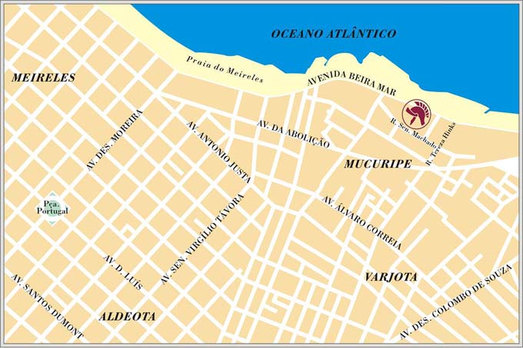
Caesar Park Hotel
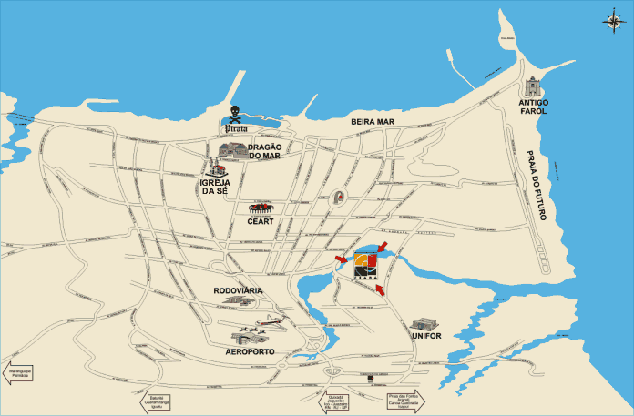

Caesar Park Hotel
Annex 2
Draft agenda for the meeting- of Working Party 3J
(Fortaleza, 20-28 November 2003)
(opening at 15:45 hours on 20 November 2003)

1 Opening remarks
2 Approval of the agenda
3 Questions assigned to the Working Party (Doc. 3/1 available on: http://www.itu.int/md/meetingdoc.asp?type=sitems&lang=e&parent=R03-SG03-C-0001)
4 Issues concerning future WRCs
5 Organization of the work during the meeting
5.1 Allocation of texts and documents
5.2 Liaison statements
6 Reports by subgroup Chairmen and discussion of documents
6.1 3J-A Effects of the clear atmosphere (C. Gibbins)
6.2 3J-B Effects of cloud and precipitation (M. Pontes)
6.3 3J-C Noise and radiometry
6.4 3J-D Global mapping (J.P.V. Poiares Baptista)
6.5 3J-E Statistical aspects (G. Brussaard)
6.6 3J-F Vegetation and obstacle diffraction (A. Nyuli)
6.7 3J-G Ground-wave propagation
7 Handbook on Radiometeorology
8 Approval of output documents
9 Any other business

G. Brussaard
Chairman, Working Party 3J

Documentation relevant to the meeting of Working Party 3J

Question ITU-R 201-2/3 | Question ITU-R 209/3
Question ITU-R 202-1/3 | Question ITU-R 214-1/3
Chairman's Report, Chairman, WP 3J, Doc. 3J/56 (17 July 2002)
Contributions to agenda items, received in accordance with Resolution ITU-R 1-4
Draft agenda for the meeting- of Working Party 3K
(Fortaleza, 20-28 November 2003)
(opening at 14:00 hours on 20 November 2003)

1 Opening remarks
2 Approval of the agenda
3 Questions assigned to the Working Party
4 Examination of WP 3K Chairman's Report (Doc. 3K/60)
5 Issues concerning future RRC and WRCs
6 Organization of the work during the meeting
  - Allocation of texts and documents
  - Liaison statements
7 Work programme
7.1 Propagation aspects concerning terrestrial path specific prediction methods in the frequency range 30 MHz - 3 GHz (3K-1)
7.2 Propagation aspects concerning terrestrial path general prediction methods in the frequency range 30 MHz - 3 GHz (3K-2)
7.3 Propagation aspects concerning short-path personal communications and wireless LANS in the frequency range 300 MHz - 100 GHz (3K-3)
7.4 Propagation aspects concerning terrestrial wireless access systems (3K-4)
7.5 Handbooks
8 Approval of output documents
9 Future work programme
10 Any other business

R. GROSSKOPF
Chairman, Working Party 3K

Documentation relevant to the meeting of Working Party 3K
Question ITU-R 203-3/3
Question ITU-R 211-2/3
Chairman's Report, Chairman, WP 3K, Doc. 3K/60 (7 June 2002)
Contributions to agenda items, received in accordance with Resolution ITU-R 1-4
Draft agenda for the meeting- of Working Party 3L
(Fortaleza, 26-28 November 2003)
(opening at 09:30 hours on 26 November 2003)
1 Opening remarks
2 Approval of the agenda
3 Questions assigned to Working Party
4 Issues concerning future WRCs
5 Work Programme of the meeting
5.1 Reports by the Chairmen of Rapporteur Groups
5.1.1 Correspondence group on HF digital communications (Cole)
5.1.2 Propagation above about 2 MHz (3L-RG1, Hortenbach)
5.1.3 Propagation below about 2 MHz (3L-RG2, Wang)
5.1.4 Trans-ionospheric propagation (3L-RG3, Leitinger)
5.1.5 Measurements and data banks (3L-RG4, Wakai)
5.2 Presentation and discussion of documents
5.3 Organization of drafting groups and allocation of documents
5.4 Liaison with other groups (including response to liaison statements)
6 Approval of output documents
7 Future work
8 Any other business

J. WANG
Chairman, Working Party 3L

Documentation relevant to the meeting of Working Party 3L

Question ITU-R 212-1/3 | Question ITU-R 222-1/3
Question ITU-R 213-1/3 | Question ITU-R 225-3/3
Question ITU-R 218-2/3 | Question ITU-R 226-2/3
Question ITU-R 221/3 | Question ITU-R 227-1/3
 | Question ITU-R 229/3

Chairman's Report, Chairman, WP 3L, Doc. 3L/24 (1 July 2002)
Contributions to agenda items, received in accordance with Resolution ITU-R 1-4

Draft agenda for the meeting- of Working Party 3M
(Fortaleza, 20-28 November 2003)
(opening at 10:45 hours on 20 November 2003)

1 Opening remarks
2 Approval of the agenda
3 Questions assigned to the Working Party (Doc. 3/1)
4 Working Party Chairman’s Report (Doc. 3M/82)
5 Requirements for WRC-07
6 Organization of the work during the meeting
7 Work programme of the meeting
7.1 Propagation aspects of terrestrial point-to-point communication (3M1 – T. Tjelta)
7.2 Propagation aspects of Earth-space communication (3M2 – G. Feldhake)
7.3 Propagation aspects of interference and coordination (3M3 – D.F. Bacon)
7.4 Specific aspects (3M4 – C.D. Wilson)
7.4.1 Climatic parameters (3M4A – T. Tjelta)
7.4.2 Precipitation effects (3M4B – M.S. Pontes)
7.4.3 Effects specific to mobile-satellite and broadcasting-satellite
communication (3M4C – D.V. Rogers)
7.4.4 Data banks (3M4D – B. Arbesser-Rastburg)
8 Liaison with other groups (including response to liaison statements)
9 Handbooks
10 Future work programme
11 Any other business
C.D. WILSON
Chairman, Working Party 3M

Documentation relevant to the meeting of Working Party 3M

Question ITU-R 204-3/3 | Question ITU-R 208-2/3
Question ITU-R 205-1/3 | Question ITU-R 226-2/3
Question ITU-R 206-3/3 | Question ITU-R 228/3
Question ITU-R 207-3/3
Chairman's Report, Chairman, WP 3M, Doc. 3M/82 (13 June 2002)
Contributions to agenda items, received in accordance with Resolution ITU-R 1-4
Annex 3
List of Chairmen and Vice-Chairmen

Chairman, SG 3

Dr. D.G. COLE
IPS Radio & Space Services
PO Box 1386
HAYMARKET NSW 1240
Australia
Tel: +61 2 92138000
Fax: +61 2 92138060
Internet: david@ips.gov.au

Vice-Chairmen, SG 3

Mr. B. ARBESSER-RASTBURG
European Space Agency (ESA)
ESTEC, TOS-EEP
Keplerlaan 1
2200 AG NOORDWIJK
Netherlands (Kingdom of the)
Tel: +31 71 5654541
Fax: +31 71 5654999
Internet: bertram@xe.estec.esa.nl / B.Arbesser-Rastburg@ties.itu.int

Mr. D.V. ROGERS
Communications Research Centre
3701 Carling Avenue
OTTAWA, Ontario K2H 8S2
Canada
Tel: +1 613 9985174
Fax: +1 613 9906339
Internet: dave.rogers@crc.ca

Mr. John WANG
Chairman, Working Party 3L
Federal Communications Commission - FCC
445 12th Street S.W.
WASHINGTON, D.C. 20554
United States of America
Tel: +1 202 4182435
Fax: +1 202 4181918
Internet: john.wang@fcc.gov

Chairman, WP 3J

Mr. G. BRUSSAARD
RADICOM
Hendrik van Herenthalslaan 11
5737 ED LIESHOUT
Netherlands (Kingdom of the)
Tel: +31 499 425430
Fax: +31 499 425470
Internet: gert.brussaard@radicom.nl

Chairman, WP 3K

Mr. R. GROSSKOPF
Institut für Rundfunktechnik GmbH
Florianmühlstrasse 60
80939 MÜNCHEN
Germany (Federal Republic of)
Tel: +49 89 32399409
Fax: +49 89 32399354
Internet: grosskopf@irt.de

Chairman, WP 3L

Mr. John WANG
(See Vice-Chairmen, SG 3)

Chairman, WP 3M

Mrs. C. WILSON
Commonwealth Scientific and Industrial
Research Organization (CSIRO)
Telecommunications & Industrial Physics
P.O. Box 76
EPPINGS, NSW 1710
Australia
Tel: +61 2 93724264
Fax: +61 2 93724490
Internet: Carol.Wilson@csiro.au

Annex 4
Registration Form
ITU-R Meetings
Fortaleza, Brazil, 20–28 November 2003
Radiocommunication Bureau I wish to participate in

WP 3J  20-28/11 | WP 3K  20-28/11 | WP 3M  20-28/11 | WP 3L  26-28/11

Mr. Mrs. Ms. Miss:
(family name) (first name)
Accompanied by:
(family name) (first name)

1. REPRESENTATION
Name of Member State:
❒ Head of Delegation  Deputy  Delegate
(to be completed by representatives of Member States only)
Name of Sector Member:
❒ Recognized Operating Agencies  Intergovernmental Organizations Operating Satellite Systems
❒ Scientific or Industrial Organizations  Other Entities Dealing with Telecommunication Matters
❒ Regional and other International Organizations  United Nations and its Specialized Agencies
❒ Regional Telecommunication Organizations  Associate Members

2. OFFICIAL ADDRESS
Name of the Company:
Street address:
City/State/Code/Country:
Business tel.: Fax:
E-mail: In case of emergency:

3. DOCUMENTS  English only

Date: Signature:
For BR Secretariat use only
Approved (if applicable) | Personal Section |  | Meeting Section |  | Pigeonhole
To be returned duly completed to the Radiocommunication Bureau |  | Place des Nations  CH-1211 Geneva 20  Switzerland |  | Telephone: +41 22 7305802  Telefax: +41 22 7306600  Email: linda.kocher@itu.int

