|  |  |
| --- | --- |
| INTERNATIONAL TELECOMMUNICATION UNION | sigleITU |

|  |
| --- |
| *Radiocommunication Bureau*  *(Direct Fax N°. +41 22 730 57 85)* |

|  |  |
| --- | --- |
| **Circular Letter**  **1/LCCE/89** | 7 May 2010 |

**To Administrations of Member States of the ITU,   
Radiocommunication Sector Members and ITU-R Associates   
participating in the work of Radiocommunication Study Group 1**

**Subject**: Meeting of Working Party 1C – Spectrum monitoring

# Introduction

At the kind invitation of the Administration of the Kingdom of the Netherlands, this Circular Letter is to announce that the next meeting of ITU‑R Working Party 1C (WP 1C) will take place in Amsterdam, Kingdom of the Netherlands, from 20 to 24 September 2010 (see the table below).

|  |  |  |  |
| --- | --- | --- | --- |
| Groups | Meeting dates | Deadline for contributions | Opening session |
| Working Party 1C | 20-24  September 2010 | Monday,  13 September 2010 16:00 hours UTC | 20 September 2010 at 11:00 hours (local time) |

# Place of the meeting

The meeting will take place at the:

Naval Barracks (Marine Etablissement) Amsterdam

Kattenburgerstraat 7

1018JA Amsterdam

Kingdom of the Netherlands

For further information see Annex 1.

# Programme of the meeting

A draft agenda for the meeting is contained in Annex 2. The Questions assigned may be found on: <http://www.itu.int/pub/R-QUE-SG01/en>.

Working Party 1C will conduct its work in English.

# Contributions

Contributions in response to the work of Working Party 1C are invited[1]*. These will be processed according to the provisions laid down in Resolution ITU-R 1-5 and posted on the Web, see “contributions” on the Working Party 1C web page at:

<http://www.itu.int/ITU-R/go/rwp1c>

**The deadline for reception of contributions by the Bureau is specified in the table above.** Contributions received later than the deadline cannot be accepted. Resolution ITU‑R 1‑5 provides that contributions which are not available to participants at the opening of the meeting shall not be considered.

According to the ITU-R patent policy (Annex 1 to Resolution ITU-R 1-5), contributions containing a proposal for a Recommendation should draw attention to any known patent or to any known pending patent application relating to systems or technologies considered in the proposal.

Participants are encouraged to submit contributions by electronic mail to:

[rsg1@itu.int](mailto:rsg1@itu.int)

A copy should be sent to the Chairman and Vice-Chairman of the Working Party 1C as well as to the Chairman and Vice-Chairmen of Study Group 1. The pertinent addresses can be found on:

<http://www.itu.int/cgi-bin/htsh/compass/cvc.param.sh?acvty_code=wp1C>  
<http://www.itu.int/cgi-bin/htsh/compass/cvc.param.sh?acvty_code=sg1>

Documentation

Contributions to this meeting are stored on the ITU web site at:

<http://www.itu.int/md/R07-WP1C-C/en>

Wireless LAN facilities will be provided in all meeting rooms and a cyber cafe facility will also be provided.

Participants are encouraged to use electronic working methods and will need to bring their laptops (equipped with a WLAN-card) with them to the meeting because **this will be a paperless meeting** (paper copies of documents will only be distributed on specific request).

# Participation

Delegate/participant registration for the meeting will be carried out online via the ITU-R website. Each Member State/Sector Member/Associate was requested to designate a focal point to be responsible for the handling of all registration requests for his/her administration/organization. Individuals wishing to attend should contact directly the focal point designated for all Study Group activities for his/her entity. The list of designated focal points (DFPs) is available on the **ITU‑R** **Delegate Registration and Information** webpage at:

<http://www.itu.int/ITU-R/go/delegate-reg-info/en>

**The on-site Delegate Registration desk will open at 10:00 hours on the first day of the meeting**. Please note that the confirmation of registration sent to each delegate/participant by e-mail must be presented, together with photo identification, in order to receive a badge.

Due to the nature of the venue, which is a military establishment, it is very important to register in advance for the meeting in order to make the necessary preparations for entering the building. Unannounced participation may cause unnecessary delays. On the first day of the meeting, participants will be requested to show an identification document with a photo. On subsequent days the badge is sufficient.

**Visas**

Participants requiring an **entry visa** for the Netherlands should submit their applications at the earliest possible opportunity. (See also § 5 of Annex 1.)

Valery Timofeev

Director, Radiocommunication Bureau

**Annexes:** 2

**Distribution:**

– Administrations of Member States of the ITU and Radiocommunication Sector Members participating in the work of Radiocommunication Study Group 1

– ITU-R Associates participating in the work of Radiocommunication Study Group 1

– Chairman and Vice-Chairmen of Radiocommunication Study Group 1

– Secretary-General of the ITU, Director of the Telecommunication Standardization Bureau, Director of the Telecommunication Development Bureau

Annex 1  
  
Additional information for the meeting of Working Party 1C

# 1 Introduction

The Radio Communications Agency Netherlands is pleased to welcome the participants to ITU‑R Working Party 1C to the city of Amsterdam. This Annex provides both information on the meeting and guidance to the delegates for their stay while in Amsterdam.

# 2 Meeting venue

The meeting will be held at:

Naval Barracks (Marine Etablissement) Amsterdam  
Kattenburgerstraat 7  
1018JA Amsterdam

See **No. 1** on the map in Attachment 1.

Due to the nature of the venue, which is a military establishment, it is very important to register in advance for the meeting in order to make the necessary preparations for entering the building. Unannounced participation may cause unnecessary delays. On the first day of the meeting, participants will be requested to show an identification document with a photo. On subsequent days the badge is sufficient.

# 3 Hotel accommodation

See **Nos. 2**, **3** and **4** on the map in Attachment 1.

Pre-bookings have been made in a number of hotels. Bookings should be made directly to the hotels using the information indicated below.

| **Mövenpick Hotel Amsterdam  City Centre (No. 2 map)** | **NH Grand Hotel Krasnapolsky (No. 3 map)** | **Bilderberg Hotel Jan Luyken (No. 4 map)** |
| --- | --- | --- |
| Piet Heinkade 11 NL-1019 BR Amsterdam  Tel.: +31 20 519 1200 Fax: +31 20 519 1239  E-mail: [hotel.amsterdam@moevenpick.com](mailto:hotel.amsterdam@moevenpick.com) | Dam 9 NL-1012 JS Amsterdam  Tel.: +31 20 554 9111 Fax: +31 20 622 8607  E-mail: [nhkrasnapolsky@nh-hotels.com](mailto:nhkrasnapolsky@nh-hotels.com) | Jan Luykenstraat 58 NL-1071 CS Amsterdam  Tel.: +31 50 573 0730 Fax: +31 20 676 3841  E-mail: [jan-luyken@bilderberg.nl](mailto:jan-luyken@bilderberg.nl) |
| Website: [Mövenpick Hotels & Resorts - Amsterdam - Overview](http://www.moevenpick-hotels.com/en/pub/your_hotels/worldmap/amsterdam/overview.cfm) | Website: [NH Grand Hotel Krasnapolsky Hotel in Amsterdam](http://www.nh-hotels.com/nh/en/hotels/the-netherlands/amsterdam/nh-grand-hotel-krasnapolsky.html?action=search&stype=default&fini=&fout=&nadults1=2&nchilds1=0&services=&maxPrice=&searchLauncher=home&stext=) | Website: <http://www.bilderberg.nl/hotels/hotel-jan-luyken/> |
| **Booking link**:  [Mövenpick Hotels & Resorts - Amsterdam - Your Reservation](https://gc.synxis.com/rez.aspx?Hotel=15718&Chain=7714)  Fill in your date of arrival and departure Fill in by Group code:  **Telecom** and push button ‘continue’ | **Booking link**:  <http://www.nh-hotels.com/events/en/event-detail/5415/ministerie_van_economische_zaken.html> | **Booking link**: Not available  Send a fax or email mentioning  **ITU-R WP 1C** |
| Rate per room per night for Standard single room  €159.00 | Rate per room per night for single room  €187.00 | Rate per room per night for Standard single room  €154.00 |
| Breakfast is included | Breakfast and citytax are included | Breakfast is included |
| Citytax 5% is not included |  | Citytax 5% is not included |

Additional hotels can be found here:<http://www.iamsterdam.com/en/visiting> or  
[Booking.com: 305 hotels in Amsterdam, Netherlands. Book your hotel now!](http://www.booking.com/city/nl/amsterdam.en.html?aid=303947;label=Boekings-nl-KljplCyUW7QlhTrlkADGHQS5220220489;sid=0ce33af00b9d01e48fb0a7cec88e15c4;city=-2140479)

# 4 Transportation & access

## 4.1 How to reach Amsterdam

The airport of Amsterdam is Schiphol Airport. There is a good train connection between Schiphol and Amsterdam Central Station (CS) (No. 5 map). Trains depart 5 times per hour during daytime and one time per hour during the night (01.00-06.00). Travel time is approximately 20 minutes and the price of a ticket is € 3.80. For further information see: <http://www.ns.nl/cs/Satellite/travellers>.

It is also possible to take a taxi from the taxi stand or order a Schiphol taxi beforehand. The fare of a taxi from the taxi stand is approximately € 50. For prices of pre-ordered Schiphol taxis see the following website: [Taxi Schiphol - Schiphol Taxi Amsterdam Airport - Schipholtaxi - Netherlands](http://www.schipholservice.biz/indexeng.html).

## 4.2 Transport Hotels – Meeting venue

There is a bus connection between the Central station and the meeting venue. Bus number 42. It departs from bus stop CS Bus Oost in the direction of KNSM eiland and get off at Kadijksplein. The journey takes a few minutes, so going by foot is an option. Some of the hotels are also on a walking distance from the meeting venue.

For door-to-door travel information see: <http://journeyplanner.9292.nl/>.

From June 2010 it will only be possible to use an OV chipcard in the metro, trams and busses in Amsterdam. These can be bought in advance or in the bus or tram.

For further information see: <http://www.gvb.nl/english/travellers/tickets-and-fares/ov-chipkaart-travel-products/Pages/ov-chipkaart-travel-products.aspx>.

# 5 Passports & visas

Delegates are advised to check with the embassy of the Netherlands in their country whether a visa is required for their visit to the Netherlands. If an invitation letter in addition to the ITU Circular Letter is needed for your visa application, please contact **Mrs. Christa Innemee**,   
**Tel.: +31 505877 160**, **E-mail:** [**christa.innemee@at-ez.nl**](mailto:christa.innemee@at-ez.nl) with all necessary information: your name, nationality, organization / company, gender, date of birth, address, passport number, date and place of issue and expiry date of the passport, telephone, fax and e-mail address.

# 6 Currency & banking

The currency in the Netherlands is the Euro. Foreign bank notes and traveller’s cheques can be exchanged into Euros at banks, exchange offices and major hotels.

All major credit cards are accepted.

# 7 Local time

GMT + 2 hour.

# 8 Climate

The average temperature in the Netherlands during September is 14 degrees Celsius. But as you know the weather in northern Europe is not very predictable, so in practice the temperature can vary between 10 and 20 degrees. For more information, please refer to:

[http:///](NULL)<http://www.weeronline.nl/Europa/Nederland/Amsterdam/4058223>

# 9 Electricity

The common electrical current in the Netherlands is AC (230 Volt/50 Hz cycle).

Wall Plug

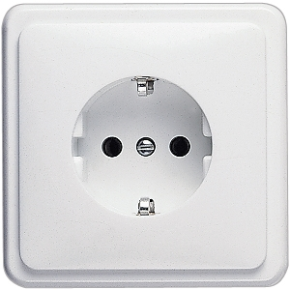

# 10 Web links

More information about Amsterdam is available from:

<http://www.iamsterdam.com/en/visiting>

# 11 Contact person

For any additional information, requests, etc., please contact:

Mrs. Christa Innemee  
Radio Communications Agency Netherlands

P.O. Box 450

9700 AL Groningen

The Netherlands

Tel.: +31 50 5877 160

Fax: +31 50 5877 400

E-mail: [christa.innemee@at-ez.nl](mailto:christa.innemee@at-ez.nl)

Attachment 1 to Annex 1

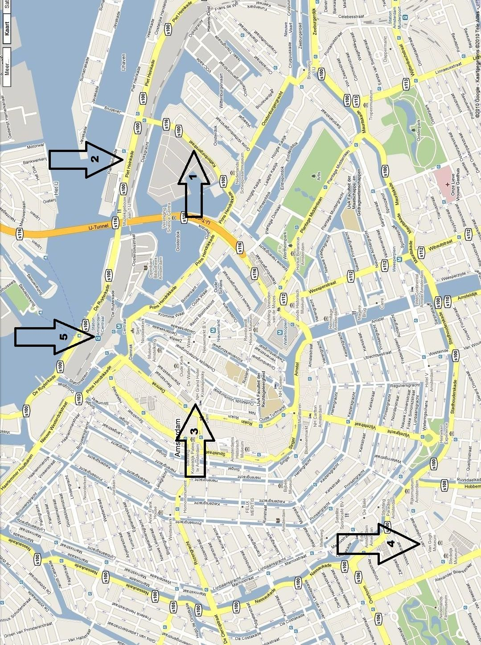

Annex 2  
  
Draft agenda for the meeting of Working Party 1C

(Amsterdam, 20-24 September 2010)

**1** Opening of the meeting

**2** Adoption of the draft agenda

**3** Report of the previous meeting of Working Party 1C (Document [1C/81(Rev.1)](http://www.itu.int/md/R07-WP1C-C-0081/en))

**4** Report from the 2009 meeting of Study Group 1 (Document [1/85](http://www.itu.int/md/R07-SG01-C-0085/en) and its Annexes)

**5** Report on the meeting of the RAG-10 ([CA/189](http://www.itu.int/md/R00-CA-CIR-0189))

**6** Reports on the correspondence activities since the September 2009 WP 1C meeting

**– Rapporteur Group on Spectrum Monitoring Handbook issues**

**– Correspondence Group on international monitoring information on emissions from terrestrial stations**

**– Correspondence Group on revision of ITU-R List VIII**

**– Correspondence Group on radar measurements (Question ITU-R 230/1)**

**– Correspondence Group on spectrum occupancy measurements**

**– Correspondence Group on SRD measurements**

**– Correspondence Group on ITU-R Recommendations and Reports developed by WP 1C**

**7** Introduction and attribution of the documents

**8** Establishment of Working Group(s) and/or Drafting Group(s) and   
 appointment of Chairmen

**9** Drafting of output documents

**10** Preparation of draft Recommendations and other texts for the Study Group 1 meeting   
 starting on 27 September 2010

**11** Consideration of the draft new edition of the Handbook on Spectrum Monitoring,  
 which should be proposed for approval

**12** Liaison with other Groups

**13** Discussion of the future work plan

**14** Date and location of next meeting

**15** Any other business

**16** Closing remarks

J. VERDUIJN  
 Chairman, Working Party 1C

1. * Contributors are urged to reduce the length of their contributions as much as possible. The recommended maximum length of an input document is 10 pages. Long documents should be structured as a small number of cover pages (preferably one) summarizing the document and an attachment containing the detailed information. The attachments of such long documents, when submitted as delayed contributions, would only be distributed on paper to the participants at the meeting, on request.