INTERNATIONAL TELECOMMUNICATION UNION
Radiocommunication Bureau
(Direct Fax N°. +41 22 730 57 85)

Circular Letter  1/LCCE/83 | 15 September 2008
To Administrations of Member States of the ITU and Radiocommunication Sector Members participating in the work of Working Parties 1A
and 1B of Radiocommunication Study Group 1
Subject: Meetings of Working Parties 1A and 1B and
associated meetings of WP 1B and WP 1C Rapporteur Groups
WP 1A: Spectrum engineering techniques
WP 1B: Spectrum management methodologies and economic strategies

Introduction
At the kind invitation of the Administration of the Republic of Korea, this Circular Letter is to announce that the 2nd meetings of ITU-R Working Parties 1A and 1B will take place in Seoul, Republic of Korea, from 25 February to 4 March 2009 (see the table below). These WP 1A and WP 1B meetings will be held in conjunction with meetings of the WP 1B Rapporteur Group on WRC-11 Agenda item 1.2 (on 24 February 2009) and of the WP 1C Rapporteur Group on Spectrum Monitoring Handbook issues (from 25 February to 4 March 2009).

Groups | Meeting dates | Deadline for contributions | Opening session
Joint meeting of Working Parties 1A and 1B | 25 February 2009 | Wednesday, 18 February 2009  16:00 hours UTC | 25 February at 09:30 hours  (local time)
Working Party 1A | 25 February to 4 March 2009 | Wednesday, 18 February 2009  16:00 hours UTC | 25 February at 10:45 hours  (local time) *
Working Party 1B | 25 February to 4 March 2009 | Wednesday, 18 February 2009  16:00 hours UTC | 25 February at 14:00 hours  (local time)
* Or earlier, immediately following the Joint meeting of Working Parties 1A and 1B.
Further information regarding the meetings of the WP 1B and WP 1C Rapporteur Groups will be communicated by Email to the respective Email Reflector of these groups:
– WP 1B Rapporteur Group on WRC-11 Agenda item 1.2: rwp1b-rg-wrc11ai1-2@itu.int
– WP 1C Rapporteur Group on Spectrum Monitoring Handbook issues: rrg1c-sm@itu.int

Programme of the meetings
A draft agenda for the subject meetings is contained in Annex 1. The Questions assigned may be found on: http://www.itu.int/pub/R-QUE-SG01/en. The Working Parties will conduct their work in English.

Contributions
Contributions in response to the work of Working Parties 1A and 1B are invited*. These will be processed according to the provisions laid down in Resolution ITU-R 1-5 and posted on the Web, see relevant Working Party web pages at:
http://www.itu.int/ITU-R/go/rsg1/en
(and see “contributions” of each relevant Working Party). A limited number of paper copies will be available at the meetings. The deadline for submission of contributions is shown in the table above. Submissions received later than the deadline cannot be accepted. Resolution ITU-R 1-5 provides that contributions which are not available to participants at the opening of the meeting shall not be considered.
Participants are encouraged to submit contributions by electronic mail to:
rsg1@itu.int
A copy should be sent to the Chairmen of the relevant Working Parties and to the Chairman and Vice-Chairmen of Study Group 1. The pertinent addresses can be found on:
http://www.itu.int/cgi-bin/htsh/compass/cvc.param.sh?acvty_code=1
Documentation
In addition to their availability on the above-mentioned web pages, a number of CD-ROMs containing all of the contributions will be available for participants at the start of the meeting. A CD-ROM containing all of the contributions and temporary documents will also be provided to each participant before the final plenary session.
Wireless LAN facilities will be provided in all meeting rooms and a cyber cafe facility will also be provided.
Participants are encouraged to use electronic working methods and to bring their laptops
(equipped with a CD-ROM drive and a WLAN-card) with them to the meeting. Please note that only a limited number of paper copies of the documents will be available at the meeting.

Place of the meeting
The meeting will take place at the:
Lotte Hotel
1. Sogong-dong, Jung-gu,
Seoul
Republic of Korea
E-mail: cth87@hotellotte.co.kr
Web: http://www.lottehotel.com
For further information see Annex 2.

Participation
In order to make the necessary arrangements, it is requested that the intended participation of your representative(s) be advised no later than one month before the opening of the meeting by means of the annexed form (Annex 3). It is very important that participants requiring entry visas for the Republic of Korea submit their applications at the earliest possible opportunity (see also § 5 of Annex 2).
Valery Timofeev
Director, Radiocommunication Bureau

Annexes: 3

Distribution:
– Administrations of Member States and Radiocommunication Sector Members participating in the work of Working Parties 1A and 1B of Radiocommunication Study Group 1
– ITU-R Associates participating in the work of Radiocommunication Study Group 1
– Chairman and Vice-Chairmen of Radiocommunication Study Group 1
– Secretary-General of the ITU, Director of the Telecommunication Standardization Bureau, Director of the Telecommunication Development Bureau

Annex 1
Draft agenda for the meetings of Working Parties 1A and 1B
(Seoul, 25 February – 4 March 2009)

1 Introduction by the Chairman
2 Approval of the draft agenda
3 Chairman’s Report to the Working Party
4 Report from the 2008 meeting of Study Group 1
5 Report on the meeting of RAG-09
6 Report from the various Rapporteurs, Chairmen of Correspondence Groups and Contact Persons
7 Introduction and attribution of the documents
8 Appointment of Chairmen/Coordinators for Working and Drafting Groups
9 Drafting of output documents
10 Preparation of draft Recommendations and other texts for the Study Group 1 meeting
(24-25 September 2009)
10.1 Review of the ITU-R Questions attributed to WPs
10.2 Review of the relevant ITU-R Recommendations
10.3 Review of the relevant ITU-R Reports
10.4 Review of the relevant ITU-R Resolutions
11 Liaison with other Groups
12 Discussion of the future work plan
13 Any other business
14 Date and location of next meeting
15 Closing remarks

X. ZHOU  Chairman, WP 1A |  | S. PASTUKH  Chairman, WP 1B

Annex 2
Additional information for the meetings of Working Parties 1A and 1B
and the associated meetings of the WP 1B
and WP 1C Rapporteur Groups

1 Introduction
Radio Research Laboratory, Korea Communications Commission is pleased to welcome participants of the ITU-R Working Parties 1A and 1B which will take place in Seoul, the capital of the Republic of Korea, from 25th February to 4th March 2009 and the associated meetings of WP 1B and WP 1C Rapporteur Groups which will start from 24th February 2009. This Annex provides both information on the meeting and guidance to the delegates for their stay while in Seoul.

2 Meeting venue
Lotte Hotel, Seoul
1, Sogong-dong, Jung-gu, Seoul, 100-070
Republic of Korea
Tel.: +82 2 759 7534
Fax: +82 2 752 8602
Web: http://www.lottehotel.com
The Lotte Hotel represents the very history of the Korean Hospitality Industry. Representing the Republic of Korea to the world, it has introduced the spirit of Korea world-round through a variety of important international events. Lotte Hotel Seoul is strategically located in the business centre of the Republic of Korea, so as to offer easy access to major business offices, shopping districts, cultural landmarks and entertainment facilities.

3 Hotel accommodation
The information about the main and an alternative hotel is available in Attachment 1. Bookings should be made directly to the hotel.

4 Transportation & access
Incheon International Airport is situated about 50 km (30 miles) west of Seoul. Limousine Buses are recommended to travel to your hotels. They run every 15 minutes and take around 50 minutes from the airport to the hotel. The tickets for the Limousine Bus are available at the Ticket office around the gate or bus stop on the arrival floor. The fare is KRW 8,000 ~ 14,000 as of September 2008.

Limousine buse – Timetable at the Inchon Airport and the Lotte Hotel Seoul

 | Bus Stop | First Bus | Last Bus | Interval | Travelling  Time | Fare | Contact
KAL Limousine Line No. 1 | Gate 4B and 11A | At Hotel  05:40 | At Hotel  19:00 | 15~20 mins. | 50 mins. | KRW 14,000 | KAL Limousine  +82 2 2667-0386~9
KAL Limousine Line No. 1 | Gate 4B and 11A | At Airport  05:50 | At Airport  22:33
Airport LimousineLine No. 601 | Gate 5B and 12A | At Hotel  05:00 | At Hotel  21:00 | 15~20 mins. | 50 mins. | KRW 8,000 | Airport Limousine +82 2 2664 9898
Airport LimousineLine No. 601 | Gate 5B and 12A | At Airport  05:13 | At Airport  22:30

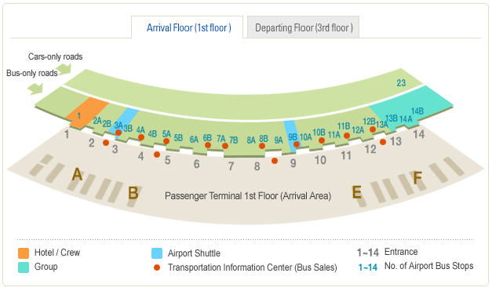

The expected taxi fare from Incheon Airport to JW Marriott Seoul is about KRW 65,000 (USD 64), but the time taken may increasing depending on traffic conditions. From midnight to 4 a.m., a 20% extra charge will be added to the fare. Translation service is available and a receipt will be issued upon your request. Deluxe taxi costs more expensive than that of regular taxi.

5 Passports & visas
Delegates are advised to check with the Korean Embassy in their own country to ascertain whether a visa is required for their visit to the Republic of Korea. If an invitation letter in addition to the ITU Circular Letter is needed for your visa application, please contact Mr. Yong-Ki KWON with all necessary information: your name, nationality, organization / company, sex, date of birth, address (home and office), passport number, date and place of issue and expiry date of the passport, telephone, fax and e-mail address.
For an invitation letter or any further information you may require, please contact:
Mr. Yong-Ki KWON
Radio Research Laboratory
Korea Communications Commission
1, Wonhyoro-3ga, Yongsan-gu, Seoul, 140-848, Republic of Korea
Tel.: +82 2 710 6461
Fax: +82 2 710 6467
Email: ygkwon@kcc.go.kr
Delegates are urged to process their visa requests at their earliest convenience.
For more information, please visit the Ministry of Foreign Affairs and Trade at http://www.mofat.go.kr/english/main/index.jsp?lang=eng.

6 Currency & banking
Currency
The unit of Korean currency is the Won (KRW). One US dollar is approximately 1015 Korean won, as of September, 2008. Foreign bank notes and travellers’ checks can be exchanged into Korean won at banks, currency exchanges and major hotels.
Banks
Many international banks are represented by branches in Seoul. Banks are open from 09:30 to 16:30 on weekdays and are closed on Saturdays and Sundays.
Credit cards
Internationally-recognized credit cards such as VISA, MasterCard, American Express, Diner’s Club and JCB card are acceptable at most hotels, department stores and restaurants.

7 Computer facilities
A wireless network, using IEEE802.11a/b/g, will be available.

8 Language
The official language is Korean but English is also spoken in most hotels, big restaurants and department stores.

9 Local time
Korea is +9 hours UTC.

10 Tax & tipping
A value-added tax (VAT) is usually included in the retail price on most goods and services at a standard rate of 10%. For meals and other services, VAT is automatically added to the bill. Major hotels and restaurants include service charge automatically to the bill at a typical rate of 10%. Additional tipping is neither a traditional custom nor expected so it remains at the customer’s discretion.

11 Climate
While in Seoul participants will experience late winter – a starting point of vigorous spring. During the meeting period, the country experiences still cold but sunny weather. The temperature is dynamic from -5°C to 15°C (Average of 10°C i.e. 50°F).

12 Electricity
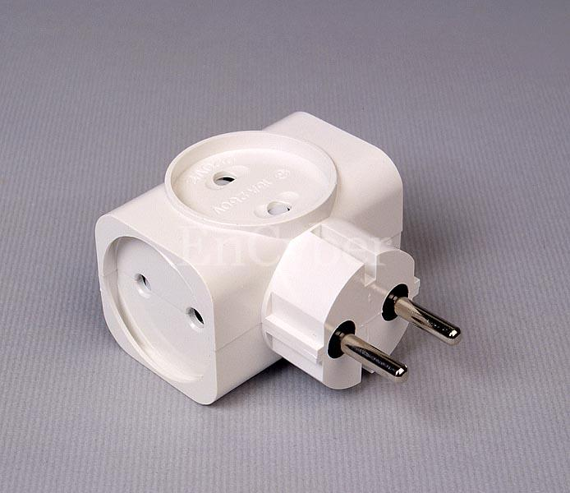
Outlets for 220 volts AC/60 Hz are available in major hotels.
Always check the power supply before using equipment.

13 Tourist information
For any further information about tourism in Seoul, please visit the website: http://www.visitseoul.net.

ATTACHMENT 1
Accommodation

Meeting Hotel
Lotte Hotel Seoul
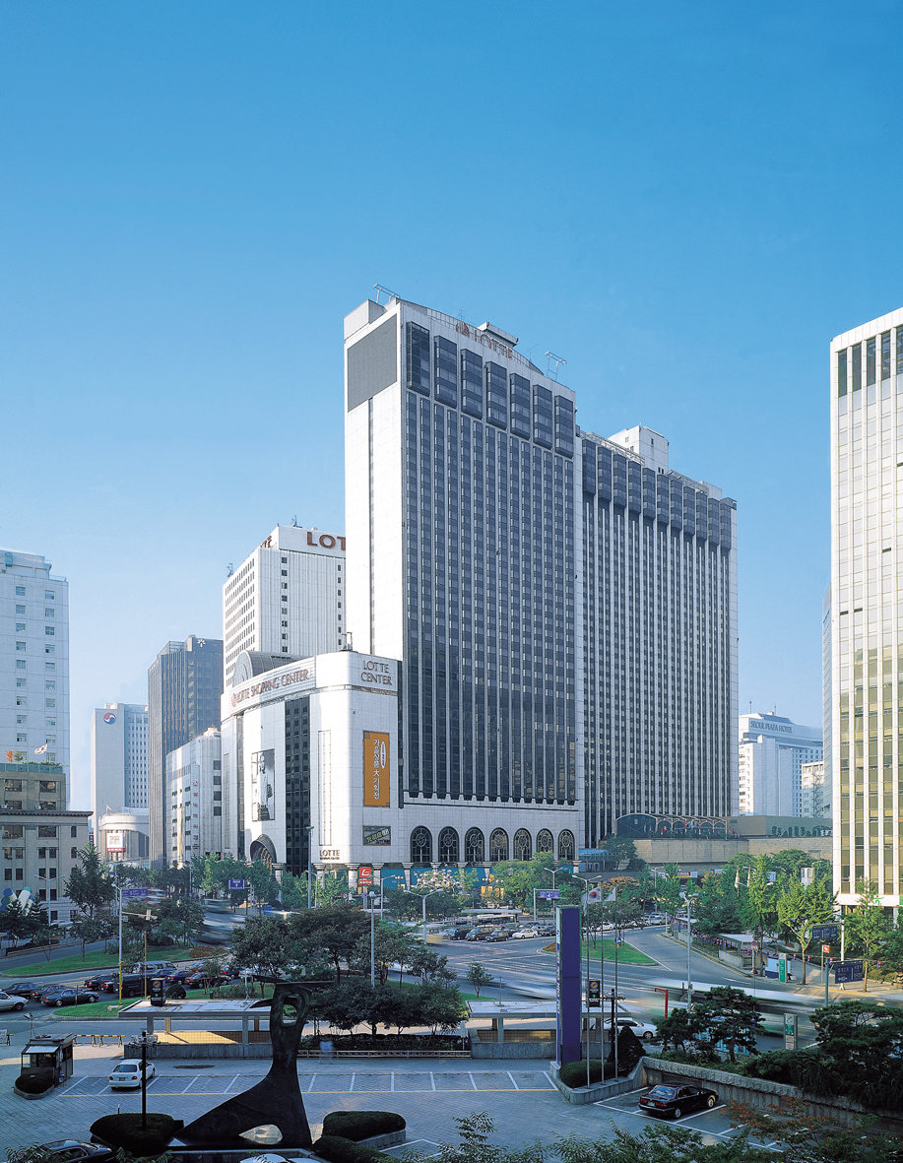
Lotte hotel Seoul will offer special rates and services to the participants at the meeting of ITU-R Working Parties 1A and 1B and the associated meetings of WP 1B and WP 1C Rapporteur Groups. An exclusive manager will handle all hotel accommodation for participants on a first-come, first-served basis.

Manager: Mr. Albert CHANG
Tel.: +82 2 759 7534
Fax: +82 2 752 8602
Email: cth87@hotellotte.co.kr

Room Type | Room rate (per night) |  | Breakfast
Room Type | Single | Double/Twin | Breakfast
Superior Room | KRW 145,000  (1-breakfast) | KRW 163,000  (2-breakfasts) | Included
Deluxe | KRW 195,000  (1-breakfast) | KRW 213,000  (2-breakfasts) | Included
Club Deluxe | KRW 230,000  (1-breakfast) | KRW 260,000  (2-breakfasts) | Included
Junior Suite | KRW 295,000  (1-breakfast) | KRW 313,000  (2-breakfasts) | Included
The special rates are subject to availability. A 10% service charge plus a 10% VAT will be added to the above rates, however, the 10% VAT will be exempted for non-resident, foreign travellers.
Hotel reservation
Room reservations can be made with the Lotte Hotel Seoul Reservations Department on:
Tel.: +82 2 759 7311
Fax: +82 2 773 4910
Email: reservation@hotellotte.co.kr.
Check-in: 14:00, Check-out: 12:00 noon.
Participants wishing to reserve hotel accommodation should complete the reservation form in the Attachment 2 and return it by email or fax to Lotte Hotel Seoul no later than 25th January 2009. Credit card information should be included on the form to guarantee the hotel reservation and to pay cancellation charges. All internationally-recognized credit cards are acceptable.
Cancellation policy
In the event of cancellation, written notification should be sent to Lotte Hotel Seoul. The following cancellation fees will be charged to your credit card automatically - cancellation within 15~8 days prior to the arrival date: 50% of one night room charge and tax; cancellation within 7~4 days prior to the arrival date: 80% of one night room charge and tax; cancellation within 3 days prior to the arrival date or no-show: 100% of one night room charge and tax. Once the no-show occurs, the whole room reservation will be automatically cancelled. If the individual shows up next day, the room will be offered based on availability at the best available rate.
Alternative accommodation
Best Western New Seoul Hotel
“Best western” New Seoul Hotel (4-star) is located within a 10-minutes walking distance from Lotte Hotel Seoul. Participants wishing to reserve a room at the Best Western New Seoul Hotel should complete the reservation form of Attachment 2 and return it by email or fax to the hotel directly no later than 25th January 2009.
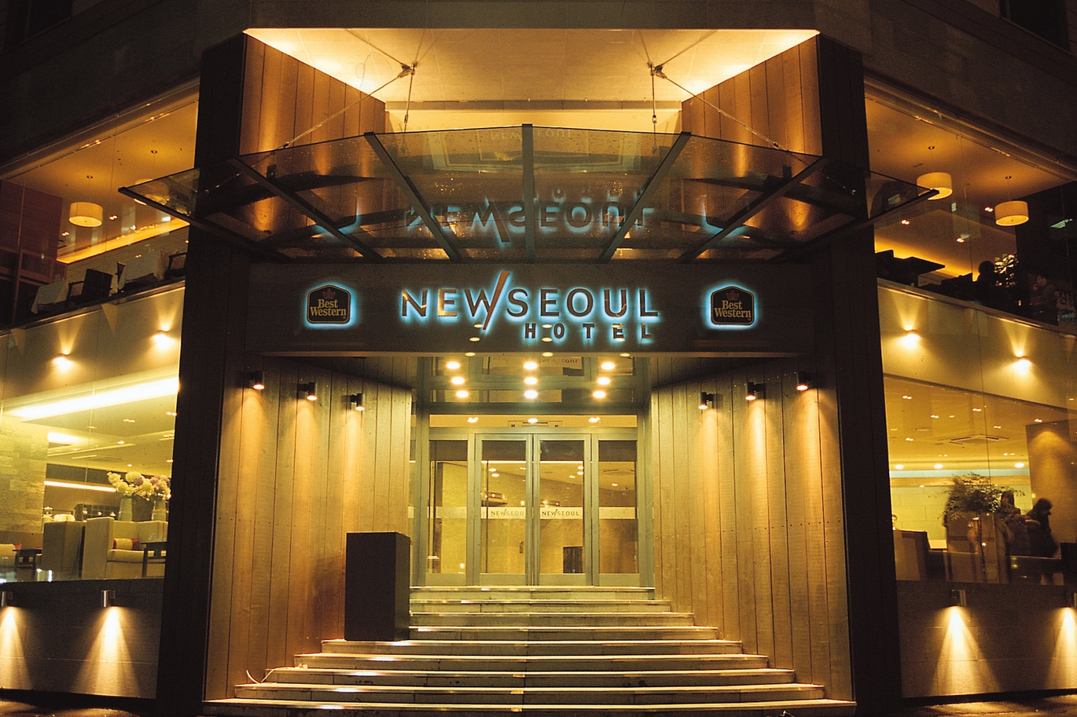
Manager: Ms. Oh Hee KWON
Tel.: +82 2 735 6211
Fax.: +82 2 735 0006
Email: bwhotel@naver.com
Homepage: www.bestwesternnewseoul.com
Add.: 29-1, Teapyoungro-1ga, Jung-gu, Seoul
700-111, Republic of Korea

Room Type | Room rate (per night) |  | Breakfast
Room Type | Single | Double/Twin | Breakfast
Standard Room | KRW 112,800  (1-breakfast) | KRW 124,800  (2-breakfasts) | Included
Standard Room | Total 30 rooms/day are available
A 10% service charge plus a 10% VAT will be added to the above rates, however, the 10% VAT will be exempted for non-resident, foreign travellers.
Cancellation policy
In the event of cancellation, written notification should be sent to Best Western New Seoul Hotel. The following cancellation fees will be charged to your credit card automatically - cancellation within 7~4 days prior to the arrival date: 50% of one night room charge and tax; cancellation within 3~1 day prior to the arrival date: 80% of one night room charge and tax; and cancellation on arrival date or no-show: 100% of one night room charge and tax. Once the no-show occurs without any notification, the whole room reservation will be automatically cancelled. If the individual shows up next day, the room will be offered based on availability at the best available rate.
ATTACHMENT 2
Hotel accommodation reservation form
The meetings of Working Parties 1A and 1B and the associated meetings
of the WP 1B and WP 1C Rapporteur Groups
24th February – 4th March, 2009, SEOUL
Contact to : | Lotte Hotel Seoul  Tel: +82-2-759-7311  Fax: +82-2-773-4910  Email:reservation@hotellotte.co.kr | Best Western New Seoul Hotel  Tel: +82-2-735-6211  Fax:+82-2-735-0006  Email: bwhotel@naver.com
Please confirm the following room reservation:
Ms. | Mr. | Last name: |  | First Name:
Ms. | Mr. | Last name: |  | First Name:
Title/Company
Address
TEL |  |  | Country
FAX |  |  | e-mail
Passport No. |  |  | Date and Place of issue |  |  | dd / mm /yy
Arrival Date |  | dd / mm /yy | Departure Date |  |  | dd / mm /yy
Flight Number |  |  | Flight Number
Room Type & Rate |  | □ Lotte Hotel  □ Superior Single: KRW 145,000  □ Superior Twin : KRW 163,000  □ Deluxe Single: KRW 195,000  □ Deluxe Twin: KRW 213,0000  □ Club Deluxe Single: KRW 230,000  □ Club Deluxe Twin: KRW 260,000  □ Junior Suite : KRW 295,000/313,000 |  |  | □ Best Western New Seoul  □ Standard Single: KRW 112,800  □ Standard Twin: KRW 124,800
* A 10% service charge plus a 10% VAT will be added to the above rates, however, the VAT will be exempted for non-resident, foreign travellers.
Booking Guaranteed:
Name of Card : | □ VISA □ MasterCard □ Other ( )
Card No. : | - - - |  | Exp. Date (Month/Year): |  | ( / )
Name of Card Holder : |  | Authorized Signature

ITU-R Block Meetings  Seoul, Republic of Korea, 25 February – 4 March 2009 | 
REGISTRATION FORM
WP 1A  25/2-4/3 | WP 1B  25/2-4/3
Mr. Mrs. Ms. Miss:
 |  |  |  |  |  | (family name) |  |  |  |  |  |  |  | (first name)
Accompanied by family member(s):
 |  |  |  |  |  | (family name) |  |  |  |  |  |  |  | (first name)
1. REPRESENTATION
Name of Member State:
❒ Head of Delegation |  |  |  |  |  |  | ❒ Deputy |  |  |  |  |  |  |  |  | ❒ Delegate
(to be completed by representatives of Member States only)
Name of Sector Member:
r |  | Recognized Operating Agencies |  |  |  |  |  |  | r |  |  | Regional Telecommunication Organizations
r |  | Scientific or Industrial Organizations |  |  |  |  |  |  | r |  |  | Intergovernmental Organizactions operating Satellite Systems
r |  | UN, Specialized Agencies and the IAEA |  |  |  |  |  |  | r |  |  | Other Entities dealing with Telecommunication matters
r |  | Regional and other International Organizations |  |  |  |  |  |  | r |  |  | Associates
2. OFFICIAL ADDRESS
Name of the Company:
Street Address:
City/State/Code/Country:
Business tel.: |  |  |  |  |  |  |  |  |  |  |  |  | Fax:
E-mail: |  |  |  |  |  |  |  |  |  |  |  |  | In case of emergency:
3. DOCUMENTS
I wish to receive paper copies during the meeting: |  |  |  |  |  |  |  |  |  |  |  |  | r |  | Yes |  |  |  | r | No
Date: |  |  |  |  |  |  |  |  |  |  | Signature:
 | For BR Secretariat use only
 | Approved (if applicable) |  |  | Personal Section |  |  |  |  |  | Meeting Section |  |  |  |  |  |  |  | Pigeonhole
 | To be returned duly completed to the Radiocommunication Bureau |  |  |  |  |  |  | Place des Nations  CH-1211 Geneva 20  Switzerland |  |  |  |  |  |  |  |  | Telephone: +41 22 730 5802  Telefax: +41 22 730 6600  Email: linda.kocher@itu.int

* Contributors are urged to reduce the length of their contributions as much as possible. The recommended maximum length of an input document is 10 pages. Long documents should be structured as a small number of cover pages (preferably one) summarizing the document and an attachment containing the detailed information. The attachments of such long documents, when submitted as delayed contributions, would only be distributed on paper to the participants at the meeting, on request.

