INTERNATIONAL TELECOMMUNICATION UNION
Radiocommunication Bureau
(Direct Fax N°. +41 22 730 57 85)

Circular Letter  1/LCCE/60* | 2 December 2003
To Administrations of Members of the ITU and other members
of the Radiocommunication Sector participating in the work of
Radiocommunication Study Group 1

Subject: First meeting of SG 1 Rapporteur Group to revise the Handbook on Computer-aided techniques for Spectrum Management

The Study Group 1, at its last meeting in November 6-7, 2003 decided to create a Rapporteur Group to revise the Handbook on Computer–Aided techniques for Spectrum Management, edition 1999. The Group will work according to the Terms of reference as contained in the SG 1 Decision [Doc. 1/17].
Date and place
The first meeting of Rapporteur Group will be held from 26 to 28 January 2004, following the kind invitation of the French administration. The meeting will take place at the premises of THALES, 146, Boulevard de Valmy, Bâtiment CARTIER (CIII)- sale K065, 92704 COLOMBES (France).
A copy of the invitation letter together with all practical information concerning the venue of this meeting, including hotel accommodation may be found in Annex 1.
Reservation for accommodation have to be made via the reservation form (Annex 2), which should be sent, whenever possible, before 22 December 2003 directly to the Hotel and the meeting co-ordinator for information.
Delegates may wish to note that THALES cannot be held responsible for bookings for accommodation.
The meeting will commence at 9:30 hours on 26 January 2004. The registration of delegates will start at 08.30 hours.
For more information, please contact meeting co-ordinator:
Mr. Philippe Mège, THALES Communications
Tel.: + 33.1.46.13.21.45
Fax: + 33.1.46.13.21.33
E-mail: philippe.mege@fr.thalesgroup.com
Work programme and submission of contributions
The programme of the meeting is contained in the invitation letter (Annex 1).
Contributions are invited in accordance with the Terms of Reference as indicated in the Decision [1/17]. These will be processed according to the provisions laid down in Resolution ITU-R 1. One copy of each contribution should be sent to the Director, Radiocommunication Bureau for processing. Contributions with indication of the contact person should also be sent to the Chairman of SG 1 and to the Chairman of the Rapporteur Group. It is recommended to widely use the email reflector that was established for the purpose of the Group in view to assist all potential participants and contributors to communicate.
http://www.itu.int/ITU-R/study-groups/reflectors-ftp/mail-ftp.asp?link=rsg1&lang=e&couns=rsg1
Participants are encouraged to submit contributions by electronic mail to:
dusan.schuster@itu.int
Documents may be found in the ITU Website:
http://www.itu.int/ITU-R/study-groups/rsg1/index.asp
Working language
The meeting will be conducted in English.
Participation
The intended participation of your representative(s) should be advised not later than one month before the opening of the meeting, by means of the annexed form (Annex 3).

Valery Timofeev
Director, Radiocommunication Bureau
Annexes: 3

Distribution:
– Administrations of Members of the ITU and other members of the Radiocommunication Sector participating in the work of Study Group 1
– Secretary General of the ITU, Director of the Telecommunication Standardization Bureau, Director of the Telecommunication Development Bureau
ANNEX 1
A copy of the letter from THALES (French only)
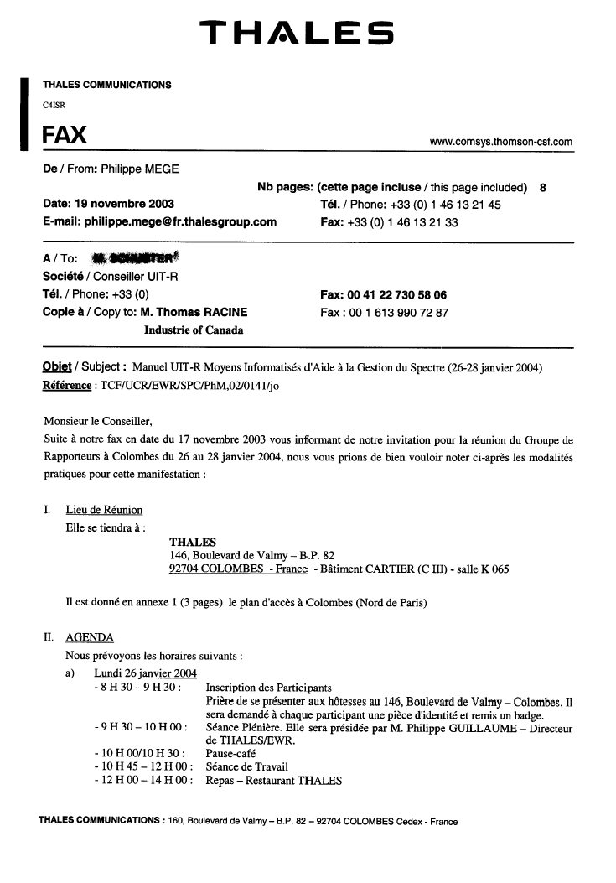

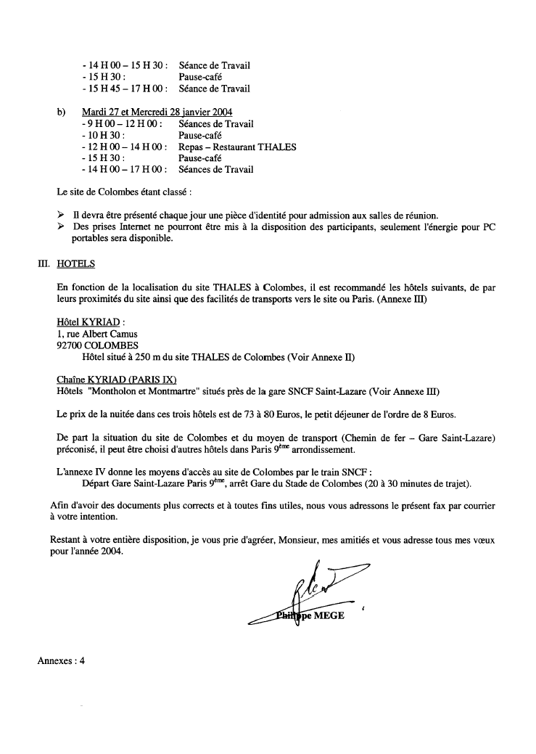
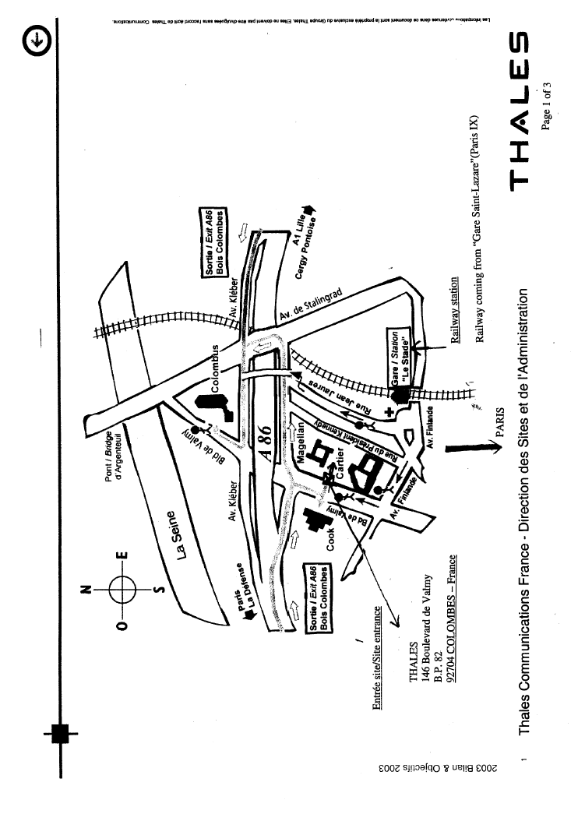
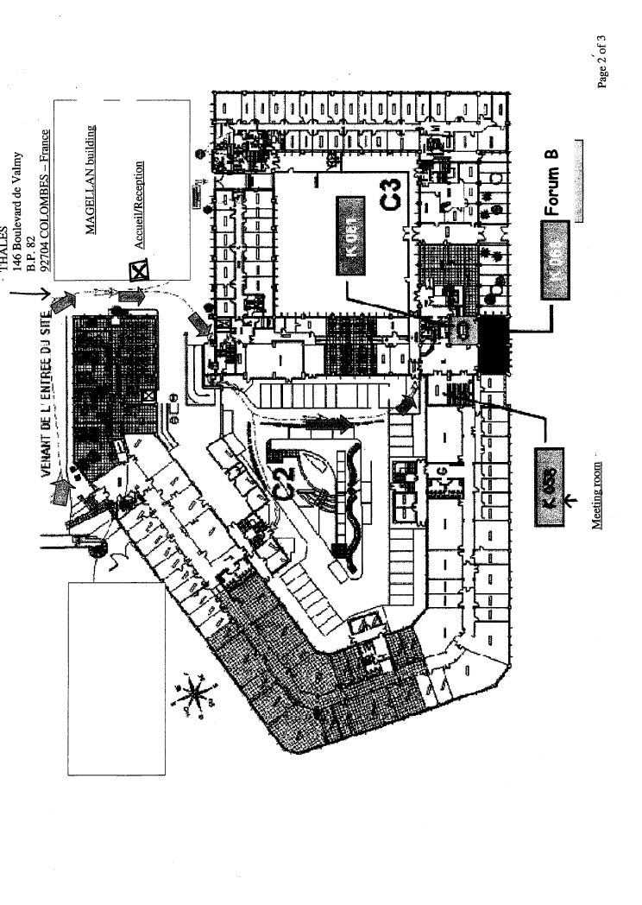

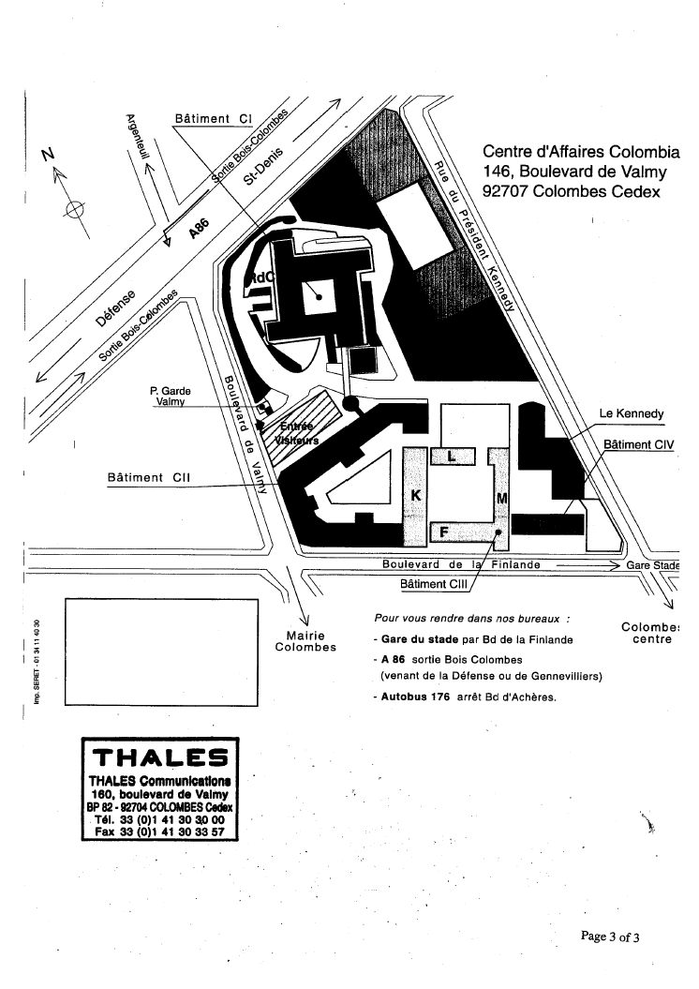
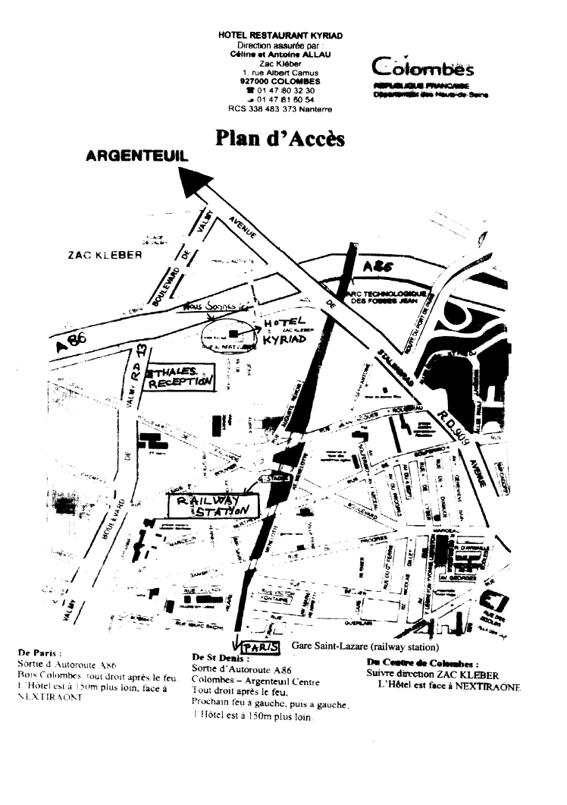
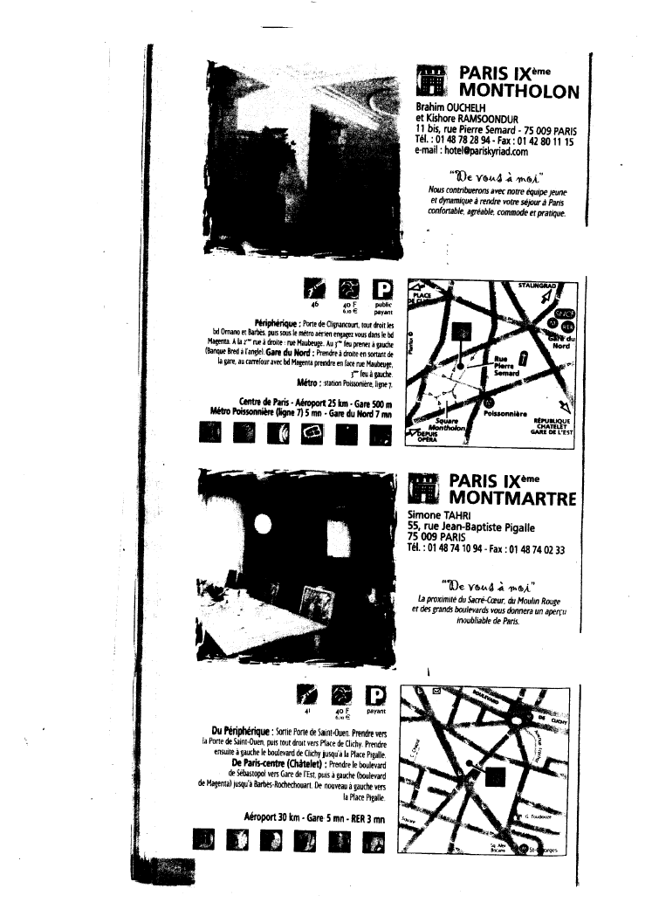
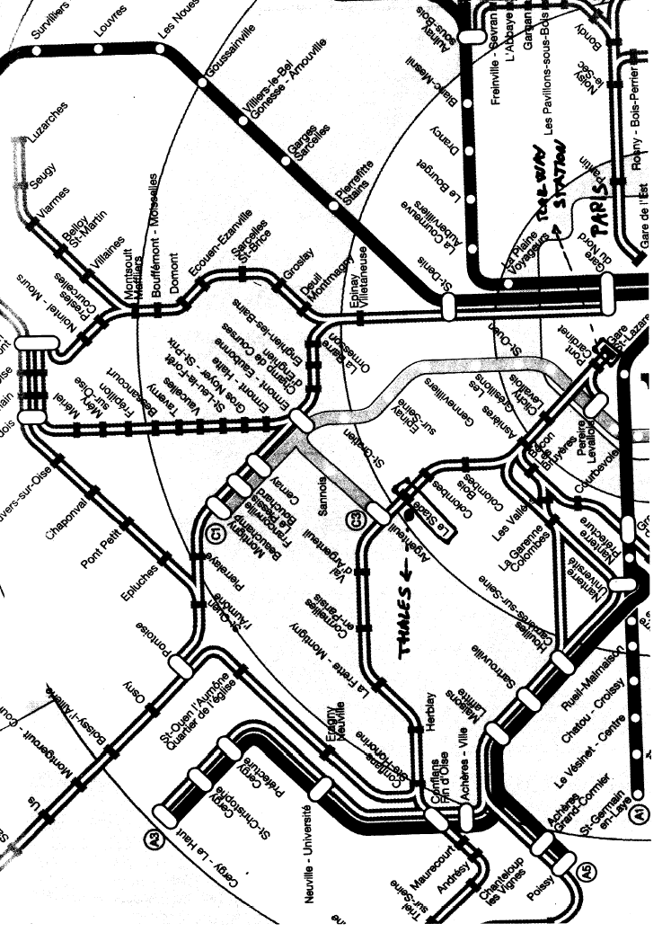
ANNEX 2
Hotel reservation form

ITU-R Rapporteur Group on Computer- aided techniques for Spectrum Management
26-28 January, COLOMBES, France

Kyriad
1, rue Albert Camus
92700 COLOMBES
Tél : +33 1 47 80 32 30
Fax : +33 1 47 81 60 54

Name  ........................................ | Initials  ........................................

Company/Organisation
........................................

Business address
........................................

Postcode and City
........................................

Country
........................................

Credit card number  ........................................ | Exp. date  ........................................

Telefax  ........................................ | Telephone  ........................................
E-mail

Date of arrival  ........................................ | Approximate time of arrival at hotel  ........................................................

Date of departure
........................................

Signature

Hotel reservation form must be returned before 22 December 2003 directly to the hotel
ANNEX 3
Registration Form
ITU-R Study Group 1 HNB
Paris, France, 26-28 January 2004
Radiocommunication Bureau
 | I wish to participate in |  | Study Group 1 HNB
 |  |  | ✓

Mr. Mrs. Ms. Miss:
(family name) (first name)

Accompanied by family member:
(family name) (first name)

1. REPRESENTATION
Name of Member State:
❒ Head of Delegation  Deputy  Delegate
(to be completed by representatives of Member States only)
Name of Sector Member: ..
❒ Recognized Operating Agencies  Regional Telecommunication Organizations
❒ Scientific or Industrial Organizations  Intergovernmental Organizations operating Satellite Systems
❒ UN, Specialized Agencies and the IAEA  Other Entities dealing with Telecommunication matters
❒ Regional and other International Organizations  Associates

2. OFFICIAL ADDRESS
Name of the Company: ..……..
Street address: ……………….
City/State/Code/Country: ……..
Business tel.:…………………. Fax:
E-mail: ……………………….. In case of emergency:
3. DOCUMENTS  English only
Date: …………………………. Signature:

For BR Secretariat use only
Approved (if applicable) | Personal Section |  | Meeting Section |  | Pigeonhole
To be returned duly completed to the Radiocommunication Bureau |  | Place des Nations  CH-1211 Geneva 20  Switzerland |  | Telephone: +41 22 730 5802  Telefax: +41 22 730 6600  Email: linda.kocher@itu.int

* English only.

