INTERNATIONAL TELECOMMUNICATION UNION

Radiocommunication Bureau
(Direct Fax N°. +41 22 730 57 85)

Circular Letter  CR/337 | 10 September 2012

To Administrations of Member States of ITU
Subject: Submission of graphical diagrams of satellite network filings
Reference: BR Circular Letter CR/284 dated 16 May 2008

To the Director-General
Dear Sir/Madam,
1. The Radiocommunication Bureau is pleased to inform your Administration that the validation tool for space notices, SpaceVal, is now extended to include the validation of graphical diagrams submitted in GIMS mdb format against the information captured in SpaceCap related to diagrams.
2. The purpose of this Circular Letter is to provide users with information and guidance on how the graphical information can be submitted to the Bureau using the improved software tools.
3. In addition to paper format, still permitted in accordance with Resolution 55 (Rev.WRC-12), the Bureau accepts graphical information for space networks in the following electronic format: GIMS GXT or GIMS mdb. Regarding diagrams submitted in GIMS GXT format, the Bureau often found diagrams to be missing, especially for satellite networks with numerous beams, or the header elements to be incorrect, or contours to be erroneously captured. Utilization of the GIMS mdb format would alleviate the common discrepancies described above. Indeed, the GIMS mdb format requires all diagrams for one notice to be grouped in a single file, thereby eliminating the possibility of incorrect information in the header; it also prevents contours with errors from being imported by removing possible diagram capture errors.

4. In addition, the new version (6.2 or later) of SpaceVal will allow users to cross-check the existence of diagrams captured using SpaceCap against the diagrams captured using GIMS for graphical data stored in GIMS mdb format. Administrations will then be able to verify that both the graphical part and the non-graphical part of the submission are consistent The software will also check that all diagrams (B.3.b. antenna gain contour diagrams, C.11.a service area diagrams, and B.3.e antenna gain towards geostationary satellite orbit diagrams) for all beams of a geostationary satellite network captured using SpaceCap have been provided in the graphical part in GIMS mdb format.
5. In view of the above, the Bureau would be grateful to administrations for using the GIMS mdb format for the submission of graphical information for space networks instead of the GIMS GXT format. Administrations are also kindly invited to advise the Bureau of any difficulty they may encounter in using the GIMS mdb format. The Bureau will continue to accept the submission of graphical data in GIMS GXT files up to 31 December 2012. After that date only GIMS mdb format diagrams shall be receivable.
6. In accordance with paragraph 3.3 of the Rules of Procedure concerning the receivability of forms of notices relating to space services, where a notice received by the Bureau does not contain all of the mandatory information as defined in Annex 2 of Appendix 4 or an appropriate reason for any omissions, the notice is regarded as incomplete. If, for example, a gain contour diagram is found to be missing in a notice, the notice is regarded as incomplete. The above errors, which will be flagged as Warnings in version 6.2 of SpaceVal until 31 December 2012, will be changed to Fatal Errors after that date.
7. Although it will still be possible to submit diagrams in paper format, as provided for under resolves 6 of Resolution 55 (WRC-12), administrations are urged and encouraged to make use of the electronic GIMS mdb format whenever possible so that they can benefit from the improved version of the software tools before submitting their satellite network filings to the Bureau.
8. The feature for cross-validation of diagrams is available for the submission of electronic notices under Articles 9 and 11 of the Radio Regulations, as well as submissions under Appendices 30, 30A and 30B. The steps involved in the validation are shown in Annex 1. Instructions for creating a GIMS mdb file can be found in Annex 2.
9. For diagrams captured in GIMS GXT format, users are invited to use the import facility (see detailed instructions in Annex 3) provided in the GIMS software to import them into a GIMS mdb format.
10. All the above-mentioned software tools are distributed with each copy of the BR IFIC DVD-ROM and are also available for download from the ITU website (http://www.itu.int/ITU-R/go/space-software/en). The Bureau seeks to update its software tools on a regular basis to improve usability and provide bug fixes. Therefore, users are requested to keep their versions of the software tools up to date. Also, the steps shown in the Annexes are provided here as a reference for the current release of the software tools; for any future changes, kindly consult the user manuals which can be found on the same website.

11. The Bureau remains at the disposal of your Administration if any further clarification is desired (contact: Mr Attila Matas by telephone +41 22 730 61 05, fax +41 22 730 57 85 or e-mail: matas@itu.int).
Yours faithfully,
François Rancy
Director, Radiocommunication Bureau
Annexes: 3
Distribution:
– Administrations of Member States of ITU

Annex 1
Steps for cross-validation of SNS and GIMS data
for a geostationary-satellite network

Using SpaceVal software
Select the SNS Microsoft Access database which contains the non-graphical data for the submission to be validated, by clicking the “Open” button:
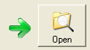

Then select the Notice Id from the combobox:
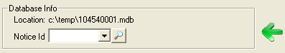

Indicate the corresponding GIMS Microsoft Access database by checking the box “Cross validation with Gims mdb file”:
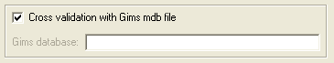

Then select the database from the Open dialogue box.

Finally, start the validation: 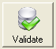

Starting SpaceVal from SpaceCap software
This option is also available through the SpaceCap software by selecting the Notice Id in the notice explorer and clicking the “SpaceVal” button:
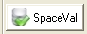

You will find a new frame “GIMS Cross Validation”. If you check the “Cross Validation with Gims” box and select a GIMS database, SpaceCap will initiate SpaceVal with the required parameters for cross-validation with GIMS:
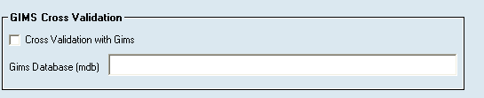

Steps of the validation process:

GIMS Cross Validation first checks that the GIMS Diagram headers match the corresponding SNS values for the following items: ntc_id, sat_name, long_nom, adm, ntf_rsn.
If GIMS and SNS headers are different, the GIMS Cross Validation will issue a warning/error*.

GIMS Cross Validation will issue a warning/error* if it finds either extra or missing diagrams in GIMS, for the network being validated.

In the validation report, the Validation item no. corresponding to a GIMS Cross Validation warning/error* will be 9000:
The following are examples of warnings found concerning GIMS Cross Validation:

*warning/error: Errors in headers as well as missing or extra diagrams will be flagged as warnings in GIMS Cross Validation up till 31 December 2012. After that date, they will be flagged as fatal errors.

Annex 2
Steps for creating an mdb file using GIMS
In the Database menu select New.
A dialogue box is shown in which you can specify the new database’s name and location:
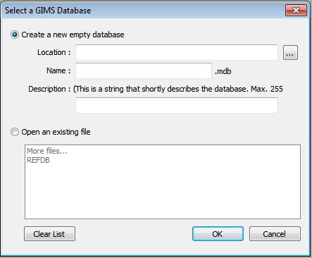

In the Location field, type in the path of the folder in which to create the new database.
In the Name field, give the name of the new database.

Annex 3
Steps for importing multiple GXT files into MDB file using GIMS
In the Database menu click on Tools and then on Import multiple GXT files.
In the GIMS Database Tools application that has been started:
1. Select the GXT files you want to import:
a) By clicking on to select all GXT files in a folder, or
b) By clicking on 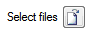to select individual GXT files.
2. Select the GIMS database in which to save the GXT files:
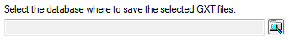
3. Click on the Start button to initiate the import process.
4. Review the files import status shown at the left of each file path:
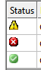
Files containing errors are not saved into the target database.
You can double-click each file path to view its content and correct errors. Alternatively you can open the report file, created by checking the Create report (RTF file) option, where all GXT validation messages have been saved.

______________

