Radiocommunication Bureau (BR)

Administrative Circular  CA/278 |  | 2 September 2025
To Administrations of Member States of the ITU and Radiocommunication Sector Members

Subject: | 1st ITU Inter-regional Information Session on WRC-27 Preparation,  Geneva, 3-5 December 2025
By means of this Administrative Circular (CA), I wish to announce that the first ITU Inter-regional Information Session (IRIS) on WRC-27 Preparation will be held at the ITU Geneva headquarters from 3 to 5 December 2025 inclusive.
The 1st IRIS is organized in response to Resolution 72 (Rev.WRC-19) and takes into account the relevant conclusions from the 32nd meeting of the Radiocommunication Advisory Group (see CA/277). It will be chaired by Mr Alexander Kühn, Chair of the 2027 Conference Preparatory Meeting (CPM-27).
Using latest information from the ITU-R responsible groups on the ongoing preparatory studies for WRC-27, as well as up-to-date information regarding the Radiocommunication Bureau and regional preparations for CPM27-2, RA-27 and WRC-27, round tables will provide all the stakeholders with the opportunity to exchange views and gain a deeper insight on the most challenging WRC-27 agenda items and issues, as well as of the draft preliminary common views and/or positions of the entities concerned.
Input documents
To meet the objectives, input documents in English can be provided as information to the 1st IRIS, in particular from the regional groups. They may be submitted by electronic mail to the BR Secretariat (brmail@itu.int), not later than 26 November 2025. Please note that documents provided in other official languages of the Union will not be translated and will be uploaded on the website of the event for reference during the discussions.
Website
All the relevant event information, including the programme, documentation, registration and participation, will be available on the event website at:
www.itu.int/iris-wrc-27/2025
As this information may be updated or complemented without notice, it is recommended that you consult the website regularly.
Programme, format and working hours
An outline of the preliminary draft programme for the 1st IRIS is provided in the Annex to this letter. It will be available with more details on the event website and will be updated as new information becomes available.
Registration / Visa requirements / Accommodation
Registration to this event is mandatory and will be carried out exclusively online via Designated Focal Points (DFPs) for ITU-R event registration. Participants must first complete an online registration form and submit their registration request for approval by the corresponding focal point. Participants require an ITU account for this purpose and are strongly encouraged to register early and to indicate if they intend to attend the meeting in person or remotely.
The list of ITU-R DFPs (TIES protected) as well as detailed information on this event registration system, visa support requirements, hotel accommodation, etc. can be found at:
www.itu.int/en/ITU-R/information/events
Please note that for meetings in Geneva, visa support must be requested during the online registration process and may take up to 21 days. Please see https://www.itu.int/en/ITU-R/information/events/Pages/visa.aspx for further information.
Remote Participation, Interpretation and Webcast
Access to the sessions of the 1st IRIS is restricted to event registered participants only. Delegates wishing to connect remotely to the sessions can access the information on the webpage for remote participation:
www.itu.int/en/events/Pages/Virtual-Sessions.aspx
These virtual session connections will become available 30 minutes before the starting time of each session.
Simultaneous interpretation in the six official languages of the Union will also be available.
Sessions will also be webcasted and recorded in the six languages for viewing during and after the event. Participants do not need to register to use the webcast facility, however TIES access is required.
For further information regarding the 1st IRIS, please contact the Radiocommunication Bureau by email at: IRIS-WRC@itu.int.
Mario Maniewicz
Director
Annex: 1
ANNEX
Outline of the preliminary draft programme* of the
1st ITU Inter-regional Information Session on WRC-27 Preparation
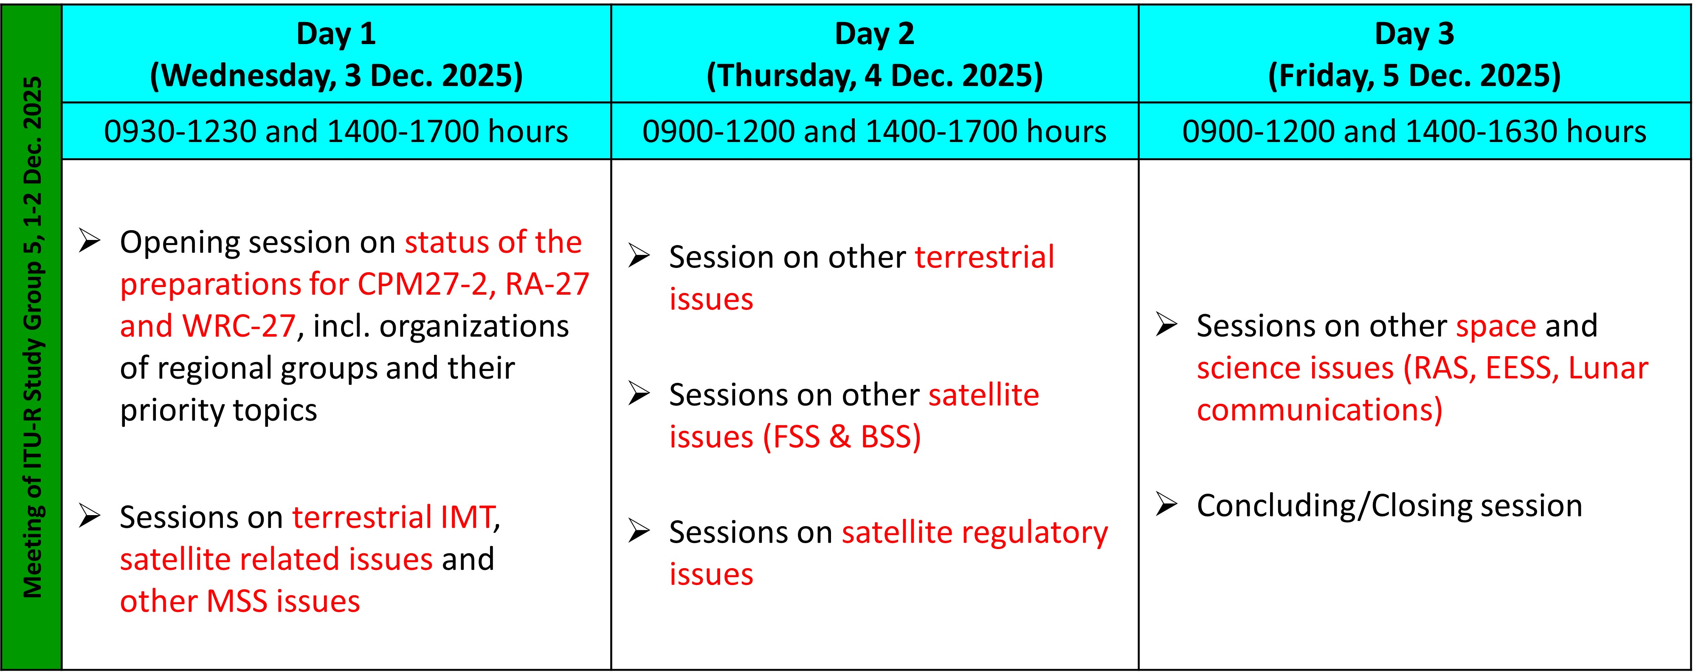
(Geneva, 3-5 December 2025)
* The timing of the sessions and the list of the WRC-27 agenda items/issues will be detailed in due course in the online programme on the event website.

______________

