INTERNATIONAL TELECOMMUNICATION UNION
Radiocommunication Bureau
(Direct Fax N°. +41 22 730 57 85)

Administrative Circular  CA/134 | 14 January 2004
To Administrations of Member States of the ITU and
Radiocommunication Sector Members
Subject: Admission of Sector Members as observers at meetings of Council - implementation of Resolution 109 (Marrakesh, 2002)
- The ITU Plenipotentiary Conference, Marrakesh, 2002, amended the provisions of the ITU Convention, to allow Sector Members to be represented as observers at meetings of ITU Council, subject to the conditions established by the Council, including conditions relating to the numbers of such observers and the procedure for appointing them (see CV 60B). In this connection, PP-02 also adopted Resolution 109 (Review and consolidation of provisions regarding observers), by which it decided to set up a group of Member States, open to all Member States, which would conduct its work by electronic means, with the following terms of reference (see also the web page created in this respect at http://www.itu.int/plenipotentiary/Observers/index.html) :
  - to review all the relevant provisions of the basic texts of the Union concerning observers, and
  - to prepare a report for consideration by the 2004 session of the Council, including recommendations regarding the status of Sector Member observers to the Council to be implemented by the Council on a provisional basis.
2. The Chairman of the Working Group on Observers addressed letters to the Directors of the three Bureaux by which she requested the Directors to seek advice from the concerned Sector Advisory Groups on the selection of Sector Member representatives, which may be admitted as observers to the ITU Council (see Annex to this Administrative Circular). In view of the reporting deadlines specified in Resolution 109 (Marrakesh, 2002) and those for the distribution of Council documents, the Chairman of the Working Group on Observers requested the relevant advice from the concerned Advisory Groups by 31 January 2004 at the latest.
3. Given the fact that the next meeting of the RAG is scheduled for November 2004, i.e., well after the deadline stipulated by the Chairman of the Working Group on Observers (and even after the 2004 session of the Council), the RAG advice cannot be formulated in a timely manner using standard procedures. On the other hand, it might be detrimental to the ITU-R membership, especially for the ITU-R Sector Members, to be left without an opportunity to express views on this issue. Therefore, the Chairman of the RAG suggested that attempts should be made to collect the views of the ITU-R membership using a consultation procedure.
4. In view of the above, I would very much appreciate if you could consider the issues dealt with in this Administrative Circular and communicate your views, especially on the "criteria" that could be established for the selection of representatives of ITU-R Sector Members as observers in the work of the Council, at your earliest convenience, but no later than 5 March 2004. The information collected in this respect will be forwarded to the Working Group on Observers for its use in fulfilment of its prescribed tasks.
5. As indicated in the letter of the Chairman of the Working Group on Observers, this consultation represents the only opportunity for ITU-R Sector Members to express their views. The Member States would still have the option of formulating their views directly to the Working Group on Observers.
Valery Timofeev
Director, Radiocommunication Bureau

Annex

Distribution:
− Administrations of Member States of the ITU
− Radiocommunication Sector Members
− Chairmen and Vice-Chairmen of Radiocommunication Study Groups and
Special Committee on Regulatory/Procedural Matters
− Chairman and Vice-Chairmen of the Radiocommunication Advisory Group
− Chairman and Vice-Chairmen of the Conference Preparatory Meeting
− Members of the Radio Regulations Board
− Secretary-General of the ITU, Director of the Telecommunication Standardization Bureau,
Director of the Telecommunication Development Bureau
Annex
INTERNATIONAL TELECOMMUNICATION UNION
General Secretariat

6 October 2003
Contact: | Legal Affairs Unit | Mr. Valery TIMOFEEV  Director  Radiocommunication Bureau
Tel: | +41 22 730 6125/5257
Fax: | +41 22 730 6503
E-Mail: | jur@itu.int
Subject: | Resolution 109 (Marrakesh, 2002) - Review and consolidation of provisions regarding observers (Working Group on Observers)

Dear Mr. Timofeev,
I am writing to you in my capacity as Chairman of the Working Group on Observers created to implement Plenipotentiary Conference Resolution 109 (Marrakesh, 2002) on the “Review and consolidation of provisions regarding observers” (hereinafter “Working Group on Observers”). Specifically, I am writing to request that you seek from your Sector Advisory Group advice concerning the selection of Sector Member representatives, which may be admitted as observers to the ITU Council and that such advice be in turn forwarded to the Working Group on Observers for its use in fulfillment of its prescribed tasks.
By way of background, in addition to Resolution 109 (Marrakesh, 2002), the 2002 Plenipotentiary Conference took several decisions concerning the roles of observers within ITU. Of note, the Plenipotentiaries amended the provisions of the ITU Convention to authorize Sector Members to be represented as observers at meetings of ITU’s Council. Specifically, CV ADD 60B, which will enter into force on 1 January 2004, states that:
“Sector Members may be represented as observers at meetings of the Council, its committees and its working groups, subject to the conditions established by the Council, including conditions relating to the number of such observers and the procedures for appointing them.”
The Working Group on Observers is tasked with developing recommendations, for Council’s consideration, regarding conditions to be established by Council for the admission of Sector Members as observers. Pursuant to the terms of Resolution 109 (Marrakesh, 2002) (see noting and taking into account sections), these recommendations will be informed by both Recommendation R29 of the Working Group on ITU Reform (WGR R29) and the comments concerning WGR R29 in the Report of the Council Group of Experts to Prepare for PP-02 on ITU Reform. Of particular note taking into account references a portion of WGR R29, specifically “that the advisory groups should develop criteria for the selection of Sector Member representatives”.
By way of background information for the Advisory Group, PP-02 also took decisions to expand the participation rights of Member State observers to Council and, pursuant to Resolution 109 (Marrakesh, 2002), the May 2003 session of ITU Council took a decision to enable, on a provisional basis, Member State observers to Council to address the meetings of Council.
In view of the reporting deadlines specified in Resolution 109 (Marrakesh, 2002) and those for the distribution of Council documents, the information concerning selection criteria of Sector Member representatives will be required by the Working Group on Observers by 31 January 2004 at latest. I fully recognize this deadline will pose challenges in light of the schedule of meetings for each Sector’s Advisory Group and that alternative means of consultation with the Advisory Groups may be required. However, it should be borne in mind that participation in the Working Group on Observers is limited to Member States. In view of this fact, this consultation represents the only opportunity for Sector Members to express their views.
Should you require additional information, please contact Mr. Arnaud Guillot, ITU Legal Adviser, who has been appointed to act as Secretary to the Working Group.

Yours sincerely,
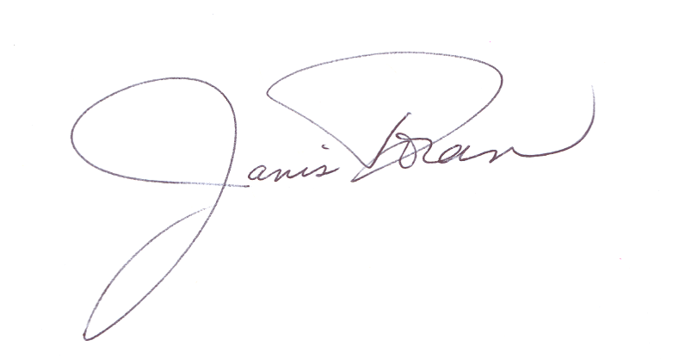
Janis DORAN
Chairman
Working Group on Observers
Resolution 109 (Marrakesh, 2002)

