Trends in Economics
and Finance:
The Use of Economic Modelling
in Telecommunications
Volume I I

Executive Summary

Market, Economics and Finance Unit
Telecommunication Development
Bureau and
SPC Network Strategy
and Policy Consultants Network Ltd

March 2006

For further information, please address your enquiries to:

Market, Economics & Finance Unit (MEF)
International Telecommunication Union (ITU)
Telecommunication Development Bureau (BDT)
Place des Nations
CH-1211 Geneva 20
Switzerland

Tel: +41 22 730 5791
Fax: +41 22 730 5484
E-mail: carmen.prado@itu.int
Website: www.itu.int/ITU-D/finance/

© ITU, 2006
International Telecommunication Union
Place des Nations
CH-1211 Geneva, Switzerland

First printing 2006

All rights reserved. No part of this publication may be reproduced, stored in a retrieval system, or transmitted in any form or by any means, electronic, mechanical, photocopying, recording or otherwise, without prior permission from the International Telecommunication Union.
The views expressed in this paper are those of the author and do not necessarily
represent the opinions of ITU or its membership. The terms and definitions used are the author’s own and can on no account be regarded as replacing the official ITU definitions.
Denominations and classifications employed in this publication do not imply any opinion on the part of the International Telecommunication Union concerning the legal or other status of any territory or any endorsement or acceptance of any boundary.

Contents

Page
1 Introduction 1
2 Economic Modelling: an Introduction 2
3 Economic Theory and Modelling 3
4 The application of modeling in Telecommunications 6
5 The Benefits and Challenges of Modelling 8

1 Introduction
Changing technologies to deliver electronic communications services are having a profound effect on the structure of telecommunication markets. An industry which was once characterised by monopoly supply is now competitive in many parts of the value chain. This new market structure still requires regulation to ensure that markets continue to open up to competition and that dominant operators function efficiently. At the same time, operators need more knowledge of their markets and their costs to be able to compete effectively with new competitors.
Economic and financial modelling therefore has an important role to play in supporting the development of competitive markets whilst still monitoring non-competitive elements of the value chain. It is also a vital tool for telecommunications providers which gives insights into market opportunities and behaviour.
This report was divided into three sections. The first section provides an introduction to economic modelling techniques and is aimed primarily at decision makers who need to know:
• What is economic modelling?
• What types of models are there?
• What are its uses in the telecommunication sector?
• What are the advantages of modelling and what are the challenges of creating an economic model?
• Where can economic modelling software be obtained?
• Where can further information on economic modelling be obtained?
Section 2 is an introduction to the basics of economic modelling and to modelling techniques. It also introduces the main modelling methods and how they can be used in the telecommunication sector. Section 3 reports on a survey of the uses of economic and financial modelling techniques used by regulators and operators around the world.

2 Economic Modelling: an Introduction
The economy is a complex entity involving thousands of individuals, households, businesses and governments making thousands of simultaneous decisions as they go about their economic affairs. The role of the economist is to sort out and understand at least some of the complex relationships within this system. In this task, the construction of economic models provides an important framework to explore, explain, predict, and communicate insights on various economic phenomena.

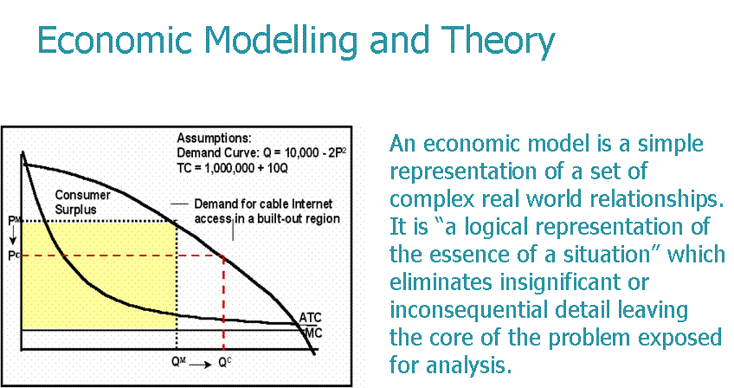

In the telecommunications industry, economic modelling techniques, such as regression analysis, simulations and linear programming are powerful tools that can aid decision making for governments, regulatory authorities and telecommunication operators. Nevertheless, in many countries such techniques are poorly understood and often underemployed. The aim of this section is to provide a simple introduction to economic modelling, with an emphasis on its potential applications to telecommunication issues. This introduction shall address a number of issues including:
• Explaining what an economic model is;
• Listing reasons why they are useful;
• Outlining the steps required to create an economic model;
• Classifying the different types of economic models;
• Presenting examples of economic modelling techniques used in the telecommunication industry.

3 Economic Theory and Modelling
Economic theories provide logical and coherent explanations of economic issues. Typically, an economic theory consists of a set of conceptual definitions about the economic variables under consideration and a set of assumptions about the relationship between these variables. Economists then follow a process of logical deduction deriving the implications of these assumptions. These are usually presented as conditional statements in the form of testable hypotheses concerning the issues.
The implications of economic theory when configured as economic hypothesis constitute an economic model. An economic model, therefore, derived from theoretical arguments, is effectively a simple representation of a set of complex real world economic relationships. In this manner, Wikipedia (2005) defines an economic model as a “logical representation of the essence of the situation.” What a model does is eliminate insignificant or inconsequential detail, leaving the core of the problem exposed for analysis.

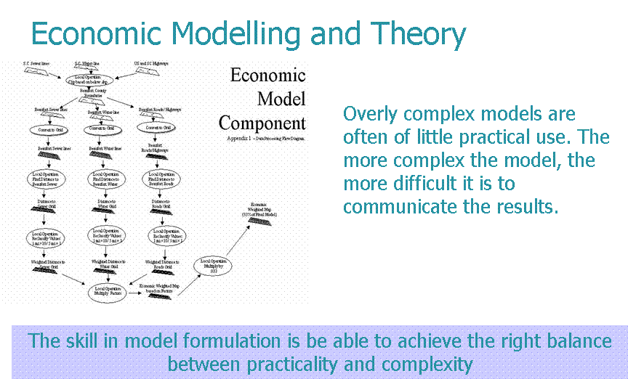

Simplification is particularly important for economics given the enormous complexity of economic processes. Economists therefore must make a reasoned choice of which variables and which relationships between these variables are relevant and which ways of analysing and presenting this information are useful. It is important that the model represents the economic
issue accurately. If, for example, a model uses a linear function for the costs of a mobile network expansion when the real cost function is highly non-linear, the recommendations of the model could be very misleading.
Nevertheless, to repeat, the model should be as simple as possible. Good models – where ‘good’ really means useful – capture the essence of the economic issue without getting bogged down in minor details. They should approximate the real world; not try to be a mirror image of it in every detail. Overly complex models are also often of little practical use. Firstly, overly complex models are sometimes too difficult to solve with the solution algorithms and computers available. Secondly, the more complex a model, the more difficult it is to communicate its results. If other users of the model cannot understand it, the chances are not too good that the model’s recommendation will ever be implemented.
On the other hand, overly simple models will lack representation of critical aspects of a situation or market and thus be of little value. As Einstein said, “Everything should be made as simple as possible – but no simpler”. Therefore, the key to formulating a good model lies in being able to achieve the right balance between being too simplistic and too complex.

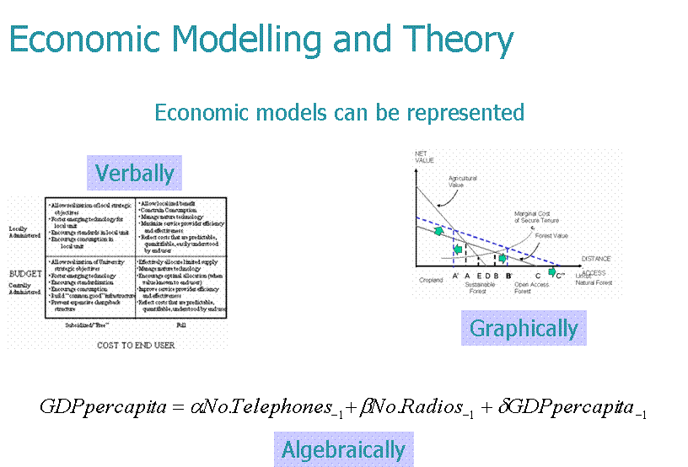

Economic models can be represented in a number of ways including:
• Verbally;
• Geometrically/graphically; and
• Algebraically.
In this later form, the relationships among economic variables implied by theoretical arguments are expressed by mathematical symbols and equations. It is this form of representation that is employed in most of the modelling techniques in industry and business. This is due to at least two reasons.

First, a mathematical model describes a problem concisely. This tends to make the overall structure of the issue or problem more comprehensible by dealing with a problem in its entirety and considering all its relationships simultaneously.
Second, a mathematical model forms a bridge to the use of high powered mathematical techniques and computers to analyse a problem. Modern desktop computer software is available for solving many types of mathematical models discussed below, including regressions and linear programming. A listing of some commercially available economic modelling software used in the telecommunication sector is available in this publication. Verbal and graphical representations are very useful for communicating results, however, and all three forms of representation of economic models may be combined to explain an economic phenomenon.

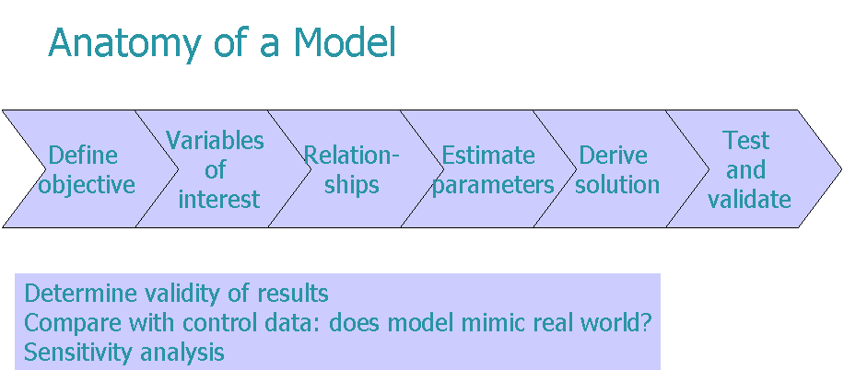

4 The application of modeling in Telecommunications
The applications of cost modelling have been chosen from a survey of telecommunication operators and regulators worldwide undertaken for this report. The applied models are ranked in order of popularity.

Table 1: Applications and Forms of Economic Modelling

Application | Applicable modelling techniques | Most appropriate for
Application | Applicable modelling techniques | Regulators | Operators
Costing | Accountancy Models (Long Run Incremental Cost, Fully Allocated Cost) | ✓ | ✓
Pricing |  | ✓ | ✓
Business risk analysis | Monte Carlo Simulation, System Dynamics |  | ✓
Competition and Market analysis | Structural equation modelling, Agent based modelling | ✓ | ✓
Revenue simulation | Accounting (regression, conjoint analysis as inputs) |  | ✓
Elasticity of demand | Regression (conjoint, multi-discriminant analysis as inputs) | ✓ | ✓
Business planning | System dynamics, Structural equation modelling, Monte Carlo simulation |  | ✓
Macro-economic conditions | Regression, structural equation modelling | ✓ | ✓
Consumer behaviour | Conjoint, multi-discriminant analysis, factor analysis, cluster analysis |  | ✓
Efficiency benchmarking | Data envelopment analysis, linear models, stochastic frontier analysis | ✓ | ✓
Forecasting | Structural equation modelling, regression, time series analysis | ✓ | ✓

This publication tries to briefly and easily describe the types of models which are applicable to solving certain problems faced by regulators and operators, for example:
• A regulator needs to calculate the cost of services to set regulated retail and interconnection charges
• A dominant operator needs to know the cost based price at which it should be able to provide services
• An operator needs to understand the business risks of the market environment
• A regulator or competition authority needs to understand the impact of dominance on market outcomes
• An operator needs to understand how a change in the market will affect its revenues
• An operator needs to be able to estimate how a change in price will affect demand for a service
• An operator needs to plan its business development in a market characterised by uncertainty
• A regulator needs to know how the macro-economic environment will affect the industry or how a telecommunication development will affect the wider economy
• An operator needs to understand how consumers choose between substitute products
• A regulator needs to know if the regulated firm can become more efficient
• A company needs to forecast future demand

5 The Benefits and Challenges of Modelling
Respondents reported many different benefits and challenges. Not surprisingly though, given that the majority of users use FAC and LRIC models, the most frequently reported benefit was that the model allowed the user (regulator or company) to calculate a cost based tariff for retail or interconnection services. The benefits listed below, as described by an Asian operator, are typical of the benefits of cost modelling described by operators:
• “To know method of cost allocation and cost of each service
• To be useful for commercial pricing
• To provide information for management
• To use information for determining regulatory framework with the regulator”
Looking to the benefits of other forms of modelling, the comment below is typical of the benefits companies receive from price elasticity models:
“In order not to lose market share, competition analysis and price and demand elasticity have proven to be good indicators of consumer behaviour.”
A European operator which uses modelling extensively summed up the benefits as:

“Great support tool for
decision making and planning”

Article number: 28379 No. 383-06
Trends in Economics and Finance: The Use of Economic Modelling in Telecommunications – Volume II

Price in Swiss francs:Catalogue Price: CHF 45.–
Member States and Sector Members: –15%
Administrations of Least Developed Countries: – 80%
Electronic Bookshop: CHF 45.– (No discount)
Please sign and return the completed Order Form to:
ITU  Sales and Marketing Division  Place des Nations  CH-1211 Geneva 20 – Switzerland | Telefax: +41 22 730 51 94  E-mail: sales@itu.int

For more information on this report, and other activities of the Market, Economics and Finance Unit of the Telecommunication Development Bureau of the ITU,
visit: www.itu.int/ITU-D/finance/

