Telecommunication Development  Advisory Group (TDAG)  33rd Meeting, Geneva, Switzerland, 7-10 April 2026 | 
 | Document TDAG-26/INF/7-E
 | 7 April 2026
 | English only
Director, Telecommunication Development Bureau
BDT's digital transformation acceleration approach
Summary:
This document contains an overview of the BDT approach to support countries in accelerating digital transformation, through a strategic engagement process towards defining, implementation and monitoring a Digital Transformation Strategy, leveraging from ITU-D priorities, BDT areas of work, and our modalities to support membership on digital transformation, ensuring no one is left behind.
Action required:
TDAG is invited to note this document.
References:
N/A

- Background
Despite global advancements, many countries face persistent gaps in digital infrastructure, affordability, and skills, hindering progress toward inclusive growth and digital transformation for sustainable development.
Digital impacts on all sectors and aspects of our lives. Think of e-health, e-agriculture, e-education and e-government services, innovation opportunities for value creation, the skills needed for adoption and the infrastructure for access. The Digital Transformation Ecosystem requires a holistic approach touching upon different catalysts to enable its evolution and development.
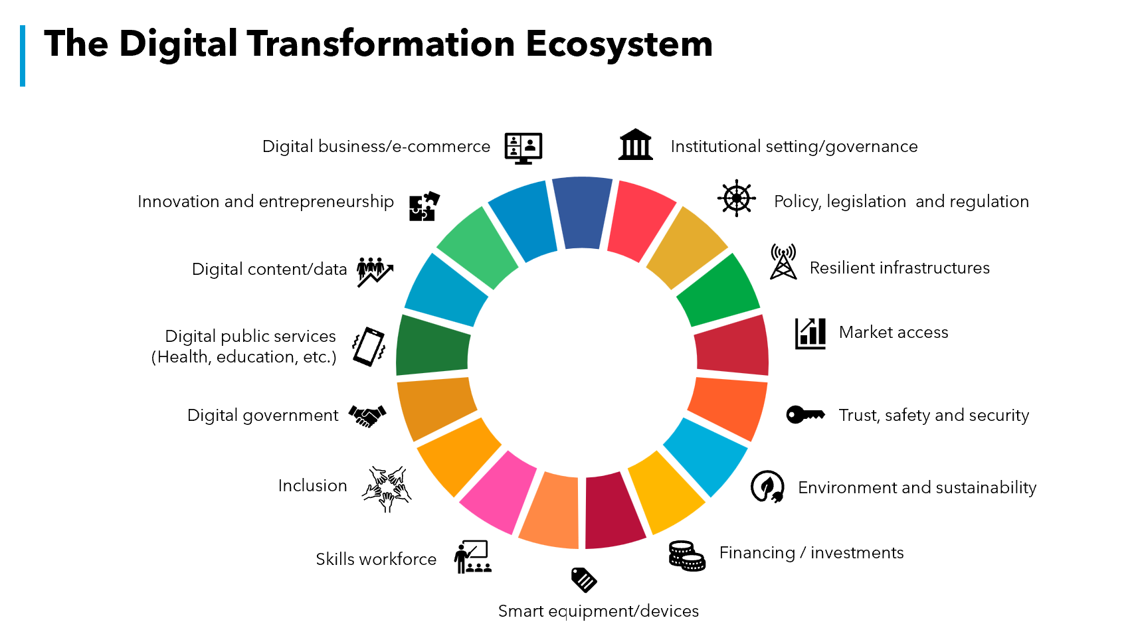
- BDT Role and Mandate
Recognizing that an estimated 2.2 billion people remain offline, the WTDC-25 theme challenged the global community to secure "Universal, meaningful, and affordable connectivity for an inclusive and sustainable digital future."
Against this background, Resolution 89 - Digital transformation for sustainable development, adopted in Kigali in 2022 and revised in Baku in 2025, instructs the Director of the Telecommunication Development Bureau :
- to facilitate efforts within the Telecommunication Development Bureau, with the assistance of the ITU regional offices, to promote digital transformation in line with ITU-D priorities, regional initiatives, WSIS action lines, SDGs, study Questions and ITU-D projects;
- to increase attention on projects related to new and emerging telecommunication/ICT services and technologies related to digital transformation through ITU-D priorities and regional initiatives, linking with the associated SDGs and WSIS action lines;
- to continue to address matters related to key telecommunication/ICT enablers of digital transformation for a variety of services and local content, taking into consideration the related financing mechanisms for affordable and cost-effective solutions and the associated policies and strategies, including for a variety of services and local content;
to undertake studies and projects related to digital transformation policies, methods and strategies, enabling developing countries to reap the full benefits of the digital economy;
- to continue, and further develop, ITU-D activities on digital transformation, including training programmes and awareness campaigns, and to support global capacity-building efforts for digital transformation;
- to promote and support national initiatives dedicated to the telecommunication/ICT dimensions of the digital economy;
- to assist Member States, upon request, and within available resources, to develop national digital transformation strategies using relevant ITU-D tools and resources on digital transformation;
- to assist Member States, upon request and within available resources, to develop strategies to leverage the diversity of telecommunication/ICT networks for the implementation of specific use cases related to digital transformation.
In addition, membership at WTDC clearly identified Digital Transformation as a key priority in several Regional Initiatives across the globe, as shown in the figure below.
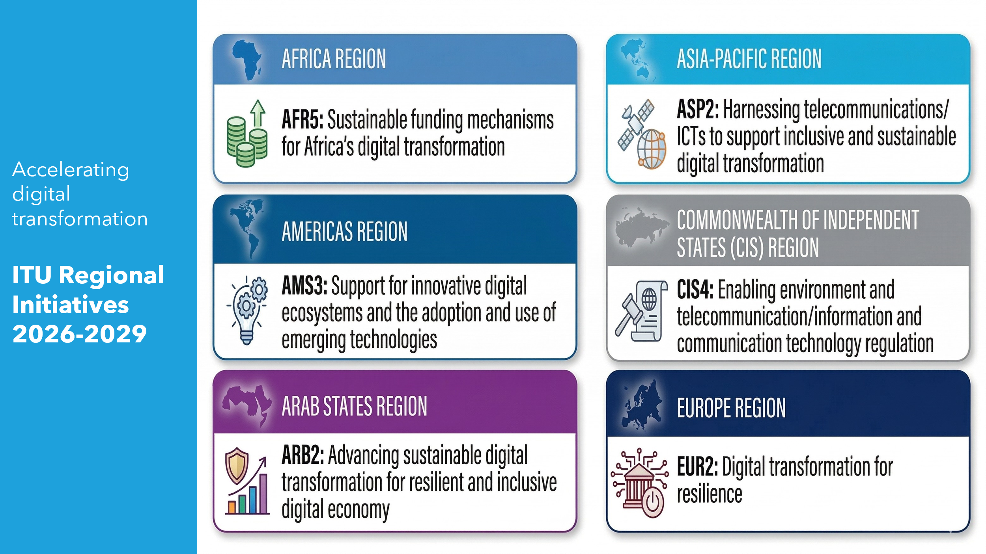
- BDT Engagement Process
Against this background, BDT has developed a strategic approach to support countries on digital transformation, through a two step process on digital transformation, leveraging from ITU-D priorities, BDT areas of work and our modalities to support membership on digital transformation.
Together, our team in headquarters and in regional and area offices work with members to bridge the digital and skills divide and drive digital transformation to leverage the power of ICTs.
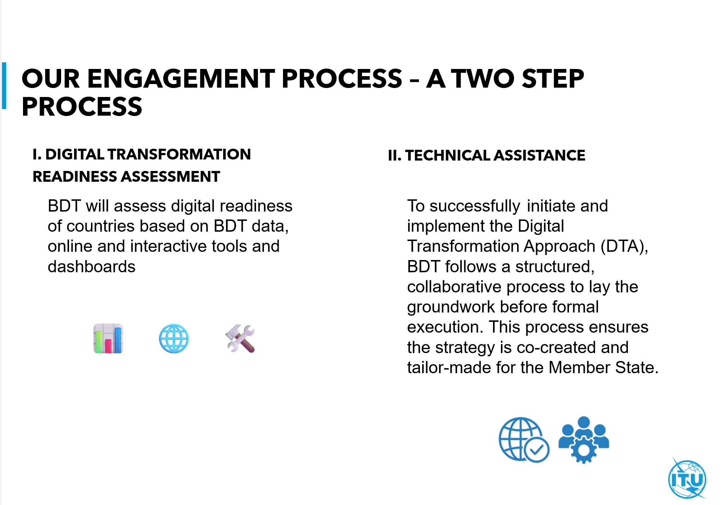
  - Digital Transformation Readiness Assessment
BDT conducts a comprehensive readiness assessment using ITU data and analysis tools to evaluate countries’ digital readiness.
The Digital Readiness Assessment is a key foundation to tailored technical assistance to countries to support digital transformation for sustainable development.
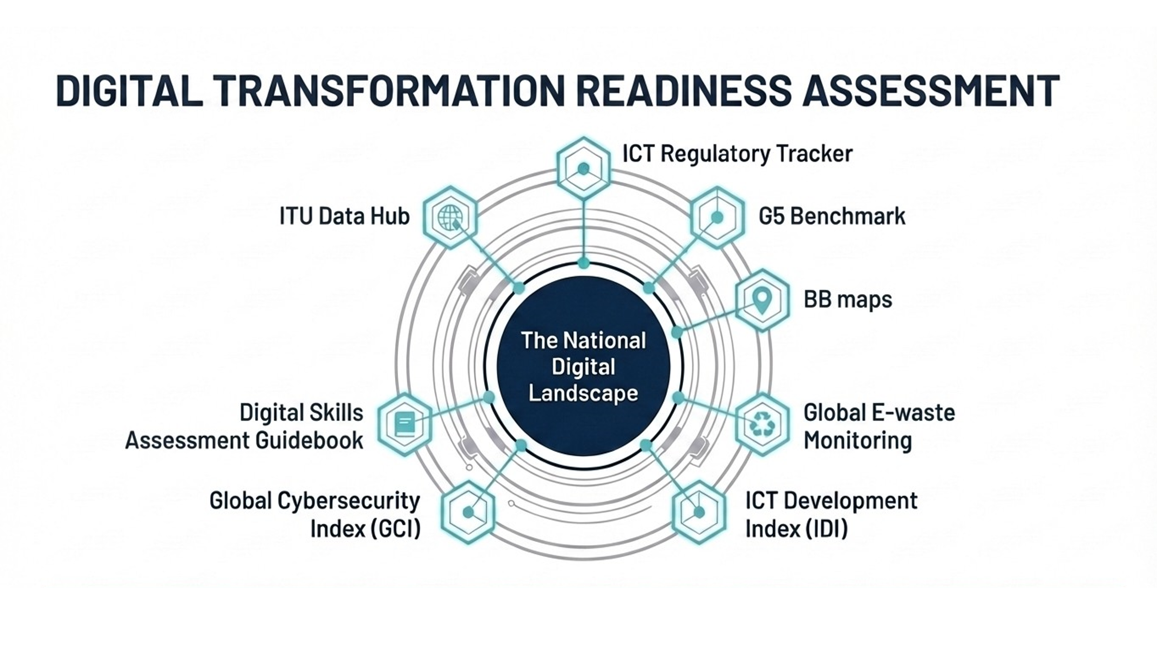
Examples of BDT Tools used to assess digital readiness include:
- Digital regulation platform resources such as ICT regulatory tracker, G5 benchmark, unified framework and country briefs on mapping the digital transformation journey
- ICT Price trends
- ICT Development Index (IDI)
- ITU Data Hub and dashboards
- CIRT Readiness Assessment
- NCS Assessment Tools – Checklist and Benchmarking Toolkit
- ICT accessibility self-assessment toolkit
- Digital Skills Assessment Guidebook
- A toolkit for strengthening ICT - centric ecosystems
- GovStack Country – Readiness Assessment
- Global E-waste Monitoring
- BB maps.
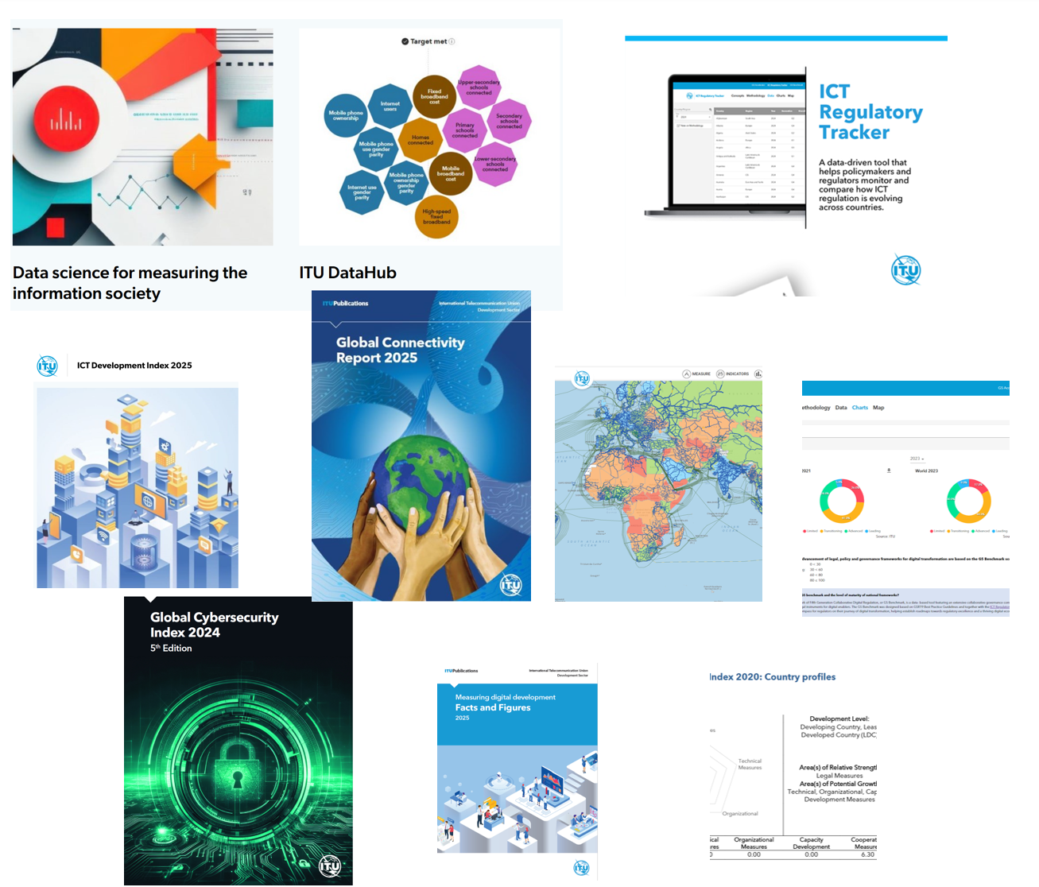
  - BDT Techical Assistance on Digital Transformation
BDT has structured its digital transformation technical assistance into a rigorous, cyclical four-phase approach:
- Phase 1: Country Engagement : Partnering directly with national policymakers to plan and identify lead authorities and stakeholders, and establish collaborative governance structures.
- Phase 2: Strategy Design: Creating a tailored National Digital Transformation Strategy equipped with actionable Key Performance Indicators (KPIs).
- Phase 3: Strategy Implementation: Bridging strategy to action through "Needs-Based Mapping." BDT deploys targeted products and tools to address specific ecosystem gaps, agreeing on concrete, short and medium term action plans backed by defined human and financial resources.
- Phase 4: Monitoring and Evaluation: Establishing formal monitoring processes to create a dynamic feedback loop. This phase utilizes BDT's interactive dashboards to evaluate outcomes and continuously adjust the strategy as the digital landscape evolves.
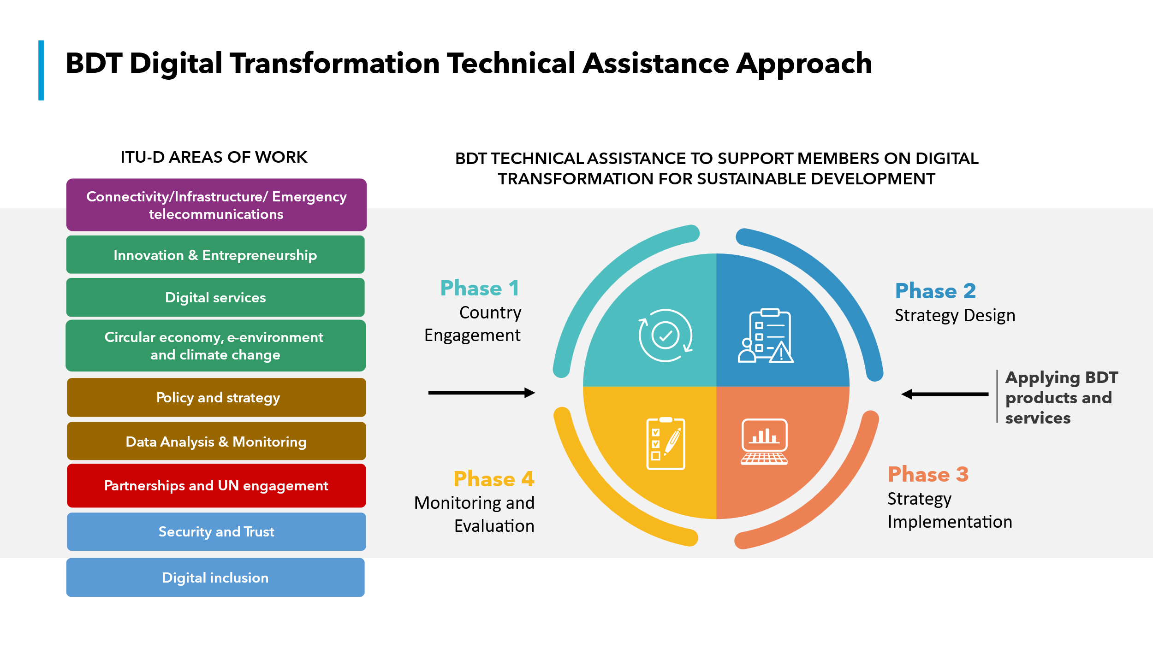
- Phase 1: Country Engagement : Partnering directly with national policymakers to plan and identify lead authorities and stakeholders, and establish collaborative governance structures.
Upon receipt of a request from a country, BDT engages with the country to explain its approach on digital transformation, and co-design the strategy.
In parallel, BDT supports countries in identifying the local authority, identifying stakeholders to be involved and establishing a governance structure, and in planning the development of the strategy.
This phase includes stakeholder mapping workshops to identify key ministries, regulators, private sector actors, and civil society organizations. BDT facilitates high-level dialogues to ensure alignment with national priorities such as broadband rollout or digital inclusion agendas.
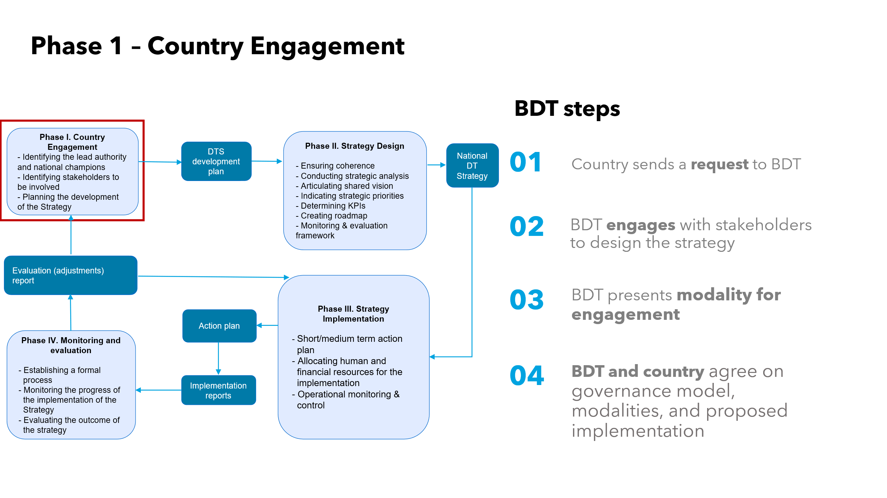
- Phase 2: Strategy Design: Creating a tailored National Digital Transformation Strategy equipped with actionable Key Performance Indicators (KPIs).
BDT tailors the proposed assistance to the country needs, leveraging BDT products and tools, working with the country to ensure coherence, conduct a strategic analysis, indicate strategic priorities, articulate a shared vision, determine KPIs and expected outcomes, create a roadmap and workplan, define the monitoring and evaluation framework, and implement a governance framework.
Based on the initial analysis and dialogue, BDT presents a tailored modality for assistance, levreaging the specific BDT products, tools, and expertise required for the country.
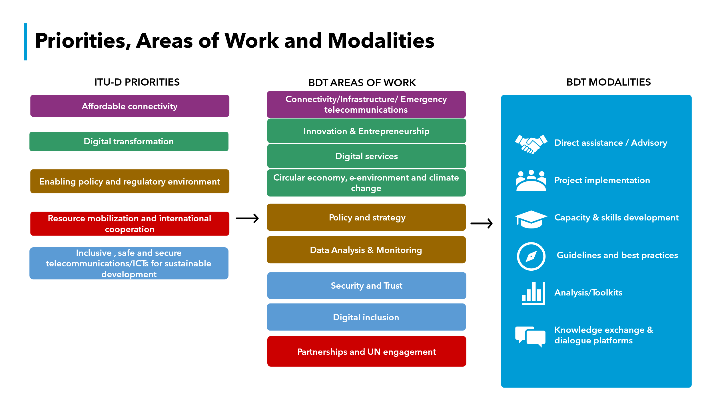
Examples of BDT Products and services to be leveraged include:
- ITU Academy Training Courses
- Digital regulation platform resources
- A toolkit for developing sustainable ICT- centric ecosystem projects
- E-Agriculture Strategy Guide - strategy and readiness assessment
- Building Smart Villages: A Blueprint
- Be Healthy Be Mobile handbooks and toolkits –mobile health interventions assessment
- Digital Health Platform Handbook: Building a Digital Information Infrastructure (Infostructure) for Health - national digital health infrastructure assessment
- Digital Innovation Alliance toolkits and trainings
The strategy is co-designed through multi-stakeholder consultations, aligning with frameworks like the UN SDGs or regional initiatives (e.g., EU Digital Decade).
Example KPIs include “80% broadband coverage by 2030” or “50% SME digital adoption by 2025.” The roadmap prioritizes quick wins (e.g., launching a national digital ID system) and long-term enablers (e.g., cybersecurity legislation).
A funding strategy is integrated, highlighting public-private partnerships and ITU-D grant opportunities. A joint roadmap and workplan is co-developed with the country, outlining timelines, deliverables, and governance structures (e.g., steering committees).
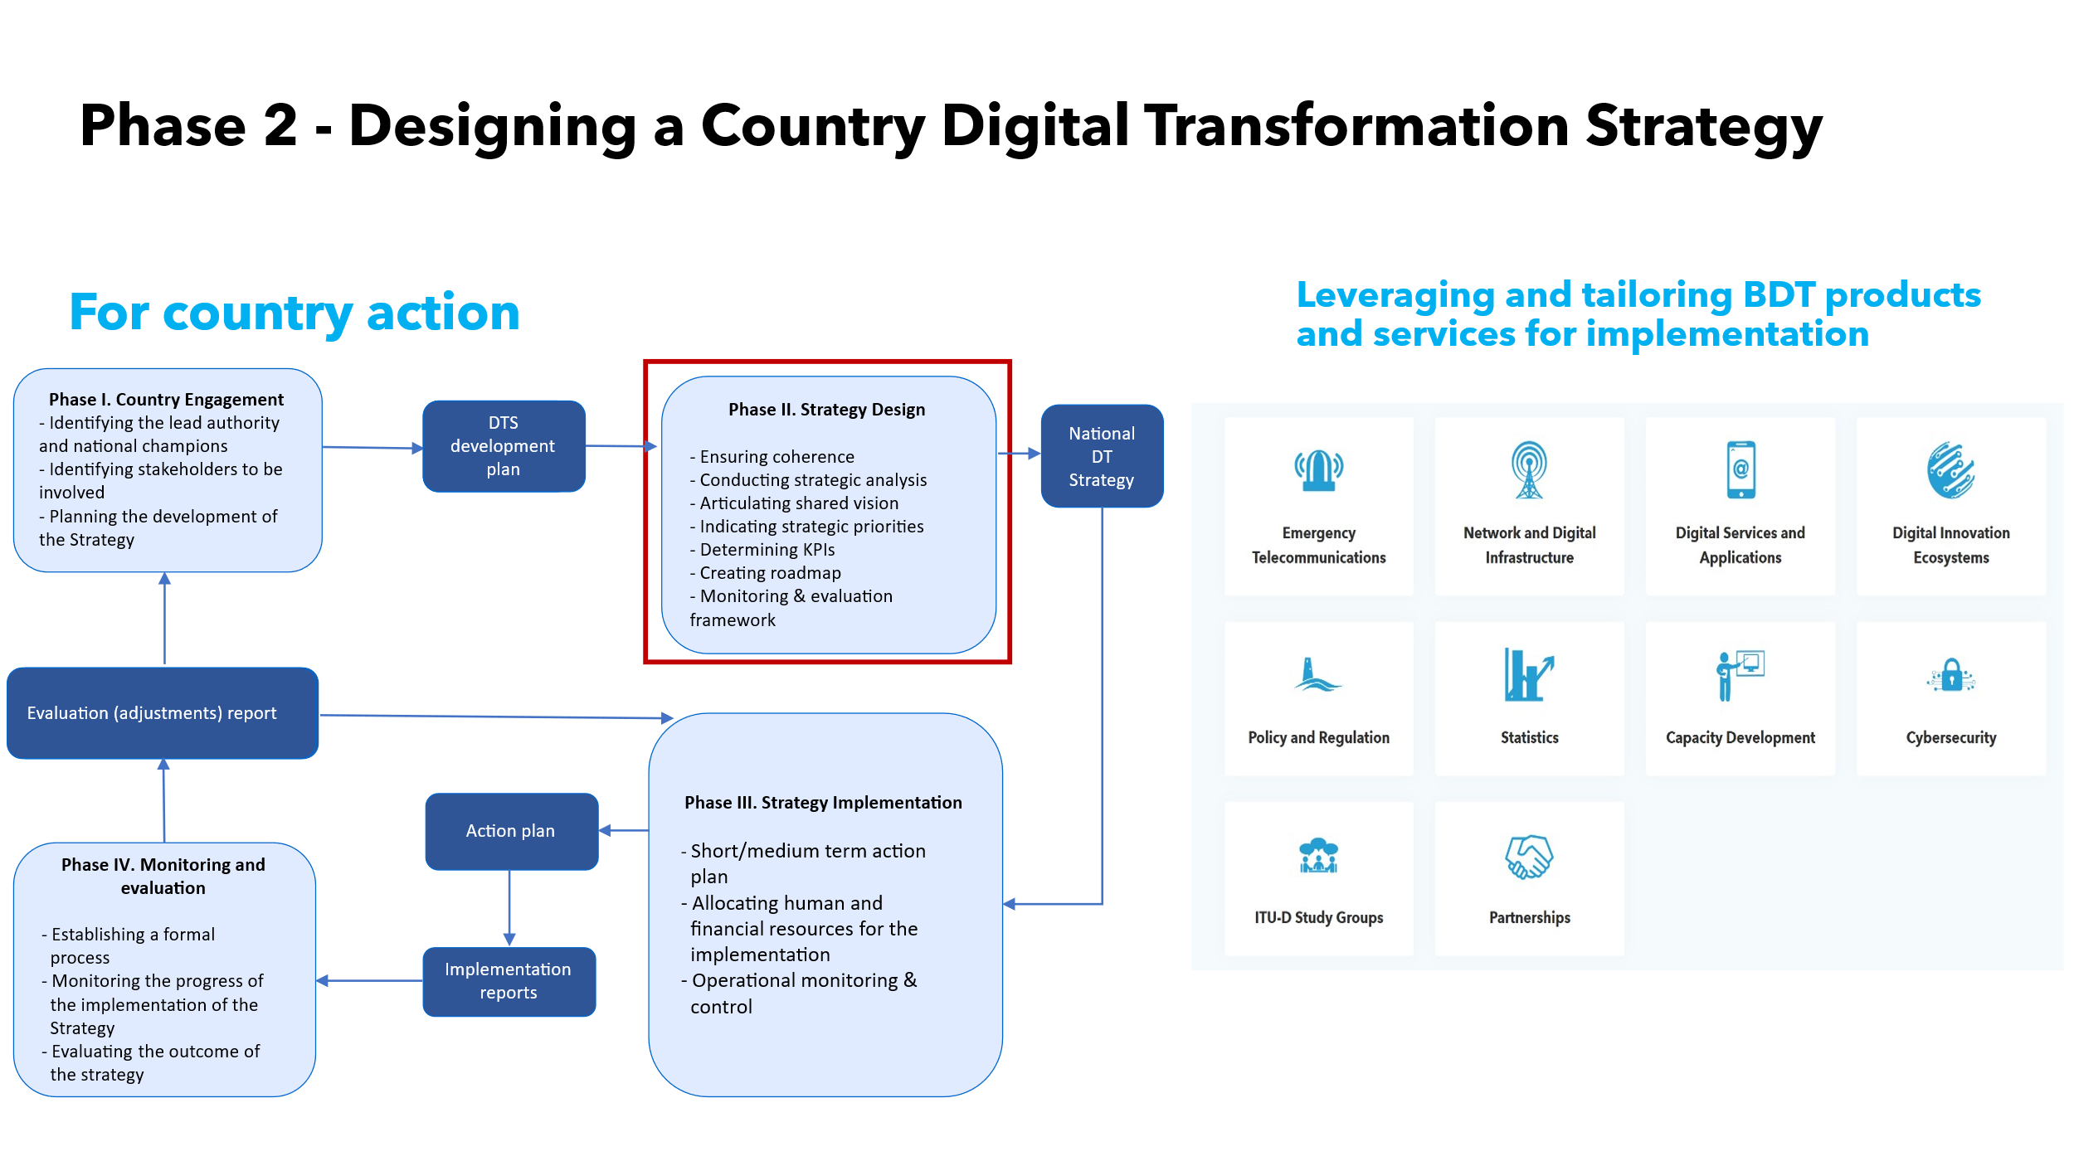
- Phase 3: Strategy Implementation: Bridging strategy to action through "Needs-Based Mapping." BDT deploys targeted products and tools to address specific ecosystem gaps, agreeing on concrete, short and medium term action plans backed by defined human and financial resources.
BDT and the country formally agree on the proposed implementation roadmap and short and medium term action plans. This agreement seamlessly transitions the partnership into the detailed strategy development and execution phases.
BDT works closely with the country to develop and implement a short and medium term action plan, carefully planning the allocation of human and financial resources for implementation, and identifying operational monitoring and evaluation.
BDT assists in drafting annual implementation plans with sector-specific targets (e.g., health, education). This includes assistance and guidance in mobilizing resources. BDT facilitates capacity-building workshops for policymakers and establishes real-time dashboards to track progress. Risk mitigation strategies, such as contingency funding for cybersecurity threats, are incorporated.
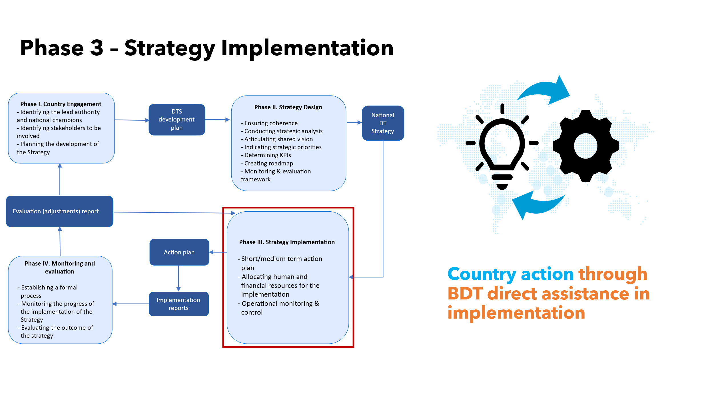
- Phase 4: Monitoring and Evaluation: Establishing formal monitoring processes to create a dynamic feedback loop. This phase utilizes BDT's interactive dashboards to evaluate outcomes and continuously adjust the strategy as the digital landscape evolves.
This is an iterative impact analysis, during and after the assistance, in line with the modality used,to gather lessons learned and practices to be re-used for future endeavors. This includes capturing the outcomes and providing updated status at the country level.
BDT conducts regular reviews using predefined metrics to measure socio-economic impact, such as GDP growth linked to digital adoption. Lessons learned are documented in case studies (e.g., collaborative regulation country reviews) and shared via ITU’s Digital Regulation Platform and Impact Stories. A feedback loop ensures strategy adjustments based on emerging trends. Final evaluations inform the next cycle of the national strategy, ensuring continuous improvement.
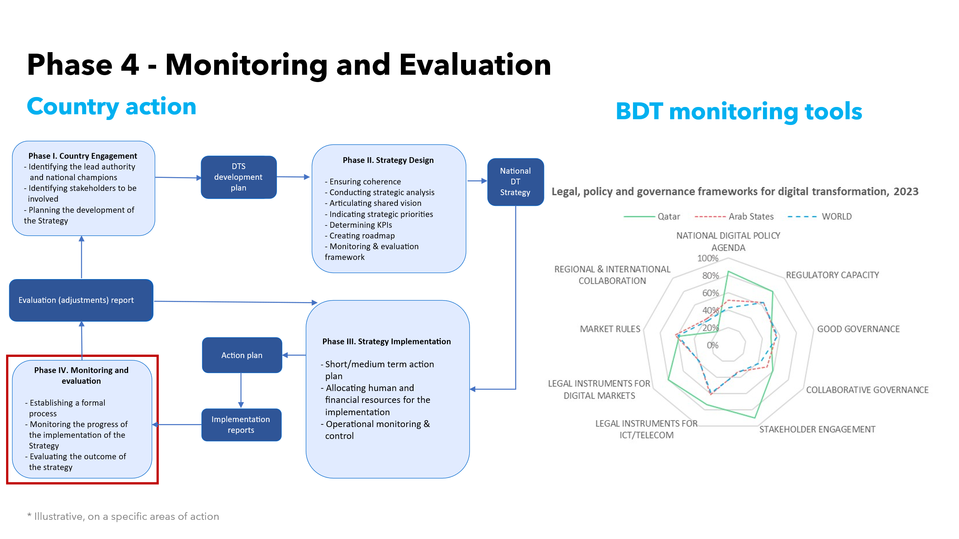
- Examples of BDT Activities on Digital Transformation
BDT, through its Secretariat, is currently executing a series of initiatives, programmes and activities aimed at achieving digital transformation in a holistic and systematic manner.
- BDT work on Digital Transformation is implemented through the BDT Operational Plan (see TDAG-26/2).
- BDT-wide efforts support individual countries plans and efforts towards digital transformation:
Digital government transformation
Increasing access for Member States to ITU tools and knowledge products to accelerate digital transformation through the GovStack project, under which a set of 15 specifications for digital government building blocks (e.g., Id, payments, exchange, consent, registries, e-Signature, GIS, eMarketplace, etc.) were published.
Capacity and Skills Development Programmes, Tools, and Platforms
- The ITU Academy and the ITU Academy Training Centres (ATCs).
- Capacity Development for Digital Transformation funded by the European Commission to provide ITU Academy training to policymakers and government officials within the ICT sector.
- The Digital Transformation Centres (DTC) Initiative.
- The Innovation and Entrepreneurship Alliance, supporting strategic foresight and SME resilience.
Policy and Regulation Tools
- The Digital Regulation Platform and Training.
- The G5 Benchmark and tools employed to assess of the state of readiness of national policy, legal and governance frameworks for digital transformation.
- The visualization tools on the G5 Benchmark platform that allow for a deep and customized analysis of data based on 54 indicators by region and country, vital for Phase 4 Monitoring and Evaluation.
Data Analysis, and Emerging Priorities
- ITU Statistics that collect and disseminate vital information and research to support evidence-based decision-making for universal and meaningful connectivity and sustained digital transformation.
- ITU products and services on the circular economy, e-environment and climate change, including data and analysis, for a green digital transformation and the advancement of the circular economy (e-waste management).
Digital infrastructure planning, development, and deployment, including the promotion of Smart Villages and emergency telecommunications.
Initiatives on gender, youth, accessibility, and cybersecurity (including Child Online Protection) to support inclusive digital transformation, and safe use of digital technologies and services
- Coordination with other sectors
Given the importance of this topic for the work of ITU-D, BDT ensures cohesion and coordination of efforts with other sectors, avoid duplication of mandates and scope of work, and to foster cross-sector coordination.
________________

