Telecommunication Development  Advisory Group (TDAG)  33rd Meeting, Geneva, Switzerland, 7-10 April 2026 | 
 | Document TDAG-26/INF/6-E
 | 6 April 2026
 | English only
Director, Telecommunication Development Bureau
Report on activities related to Climate Change Monitoring & Adaptation and Early Warning Systems (including Artificial Intelligence)
Summary:
This document provides an overview of the work undertaken by the Telecommunication Development Bureau (BDT) since TDAG-25 on early warning systems (EWS), emergency telecommunications, and climate change monitoring. The document highlights ITU’s leadership role in the Early Warnings for All (EW4All) initiative, including its work on artificial intelligence (AI) through the AI for EW4All Group. It also outlines ITU’s work on monitoring the environmental impact of the ICT sector, including greenhouse gas (GHG) emissions and energy use, through global and national data frameworks.
Action required:
TDAG is invited to note this document and provide guidance as deemed appropriate.
References:
WTDC Resolutions 34, 66 (Rev. Baku, 2025)
PP Resolution 136, 182 (Rev. Bucharest, 2022)

- Introduction
This document provides an overview of the work undertaken by the Telecommunication Development Bureau (BDT) since TDAG-25 related to early warning systems and climate change adaptation, with a focus on the use of artificial intelligence (AI) for early warning systems (EWS) and on monitoring the environmental impact of the digital sector. It highlights BDT’s leadership in the Early Warnings for All (EW4All) initiative and the central role of the BDT in developing harmonized definitions, methodologies and statistical indicators for ICT sector climate monitoring. The work has been carried out in close collaboration with partners from a range of different stakeholder groups.
- Early Warning Systems
The Early Warnings for All (EW4All) initiative was launched by the United Nations Secretary-General in 2022 with the objective of ensuring that every person on Earth is protected by a multi-hazard early warning system. EW4All promotes an end-to-end and people-centred approach to early warning systems, bringing together governments, United Nations entities, development partners, the private sector and civil society to strengthen national early warning capacities.
EW4All is structured around four mutually reinforcing pillars: disaster risk knowledge, led by the United Nations Office for Disaster Risk Reduction (UNDRR); detection, observation, monitoring and forecasting, led by the World Meteorological Organization (WMO); warning dissemination and communication, led by the International Telecommunication Union (ITU); and preparedness and response, led by the International Federation of Red Cross and Red Crescent Societies (IFRC).
Figure 1: Four pillars of the EW4All initiative
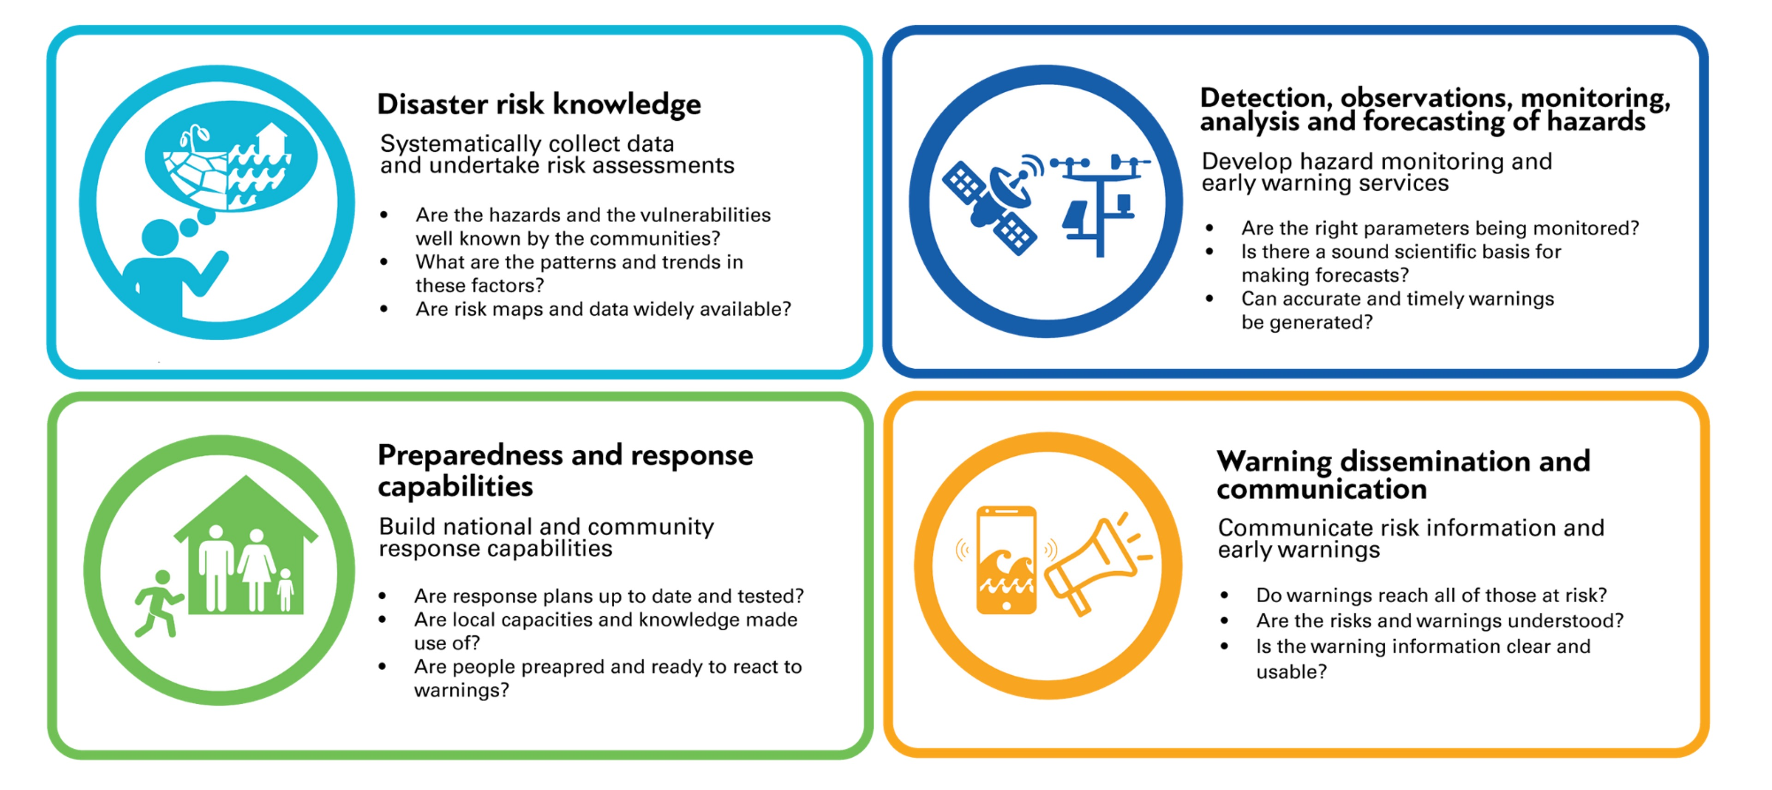
ITU's Telecommunication Development Bureau leads Pillar 3 on Warning Dissemination and Communication, which focuses on ensuring that early warnings reach all people at risk in a timely, reliable, understandable and actionable manner, including those in remote areas and vulnerable situations. The pillar addresses the critical “last-mile” dimension of early warning systems and supports the enabling technical, regulatory and institutional frameworks required for effective alert dissemination.
ITU's mandate in this area is grounded in WTDC Resolution 34 (Rev. Baku, 2025), which calls for the use of telecommunications and information and communication technologies for disaster risk reduction, the implementation of early warning systems, including to ensure that at-risk populations receive alerts.
In implementing Pillar 3, ITU works with the national authorities, telecommunication regulators, mobile network operators, meteorological and hydrological services, disaster management agencies, broadcasters, humanitarian actors and development partners. It also engages private-sector and technical partners, including GSMA, Microsoft and Google, to strengthen innovation, tools and implementation support.
A central feature of ITU’s approach is the promotion of multi-channel warning dissemination, combining mobile alerts, media broadcasting, satellite communications, digital tools and community-based mechanisms to expand reach and strengthen resilience. Within this, ITU places particular emphasis on mobile-enabled alerting, in particular Cell Broadcast, and supports countries through technical guidance, regulatory engagement and implementation planning. ITU also promotes Common Alerting Protocol (CAP, ITU-T Recommendation X.1303.) to improve interoperability across channels.
ITU’s support to countries includes capacity and gap assessments, national roadmaps, feasibility studies and technical specifications for mobile-based alerting systems (cell broadcast), support to legal and regulatory frameworks, capacity-building on CAP and warning dissemination, connectivity and coverage analysis and implementation support. ITU also advances work on artificial intelligence for early warning systems and on warning dissemination in fragile, conflict-affected and post-conflict settings.
Since the launch of EW4All, ITU has significantly expanded support to countries under Pillar 3. To date, ITU has conducted over 125 activities across 33 countries globally to strengthen warning dissemination and communication systems. This support has included 33 Pillar 3 capacity gap assessments, 27 national early warning roadmaps, 20 subnational connectivity assessments, 9 national ICT resilience and affordability assessments, 15 feasibility studies for mobile-enabled early warning systems, 6 functional requirements or technical specification documents, and 11 trainings on CAP and warning dissemination.
These activities have supported countries across Africa, Asia and the Pacific, Latin America and the Caribbean, multiple Small Island Developing States and fragile and conflict-affected countries. Additional requests for ITU support continue to grow, reflecting increasing demand from countries to strengthen warning dissemination capacities as part of EW4All implementation.
Figure 2: Countries with mobile EWS (using Cell Broadcast only)
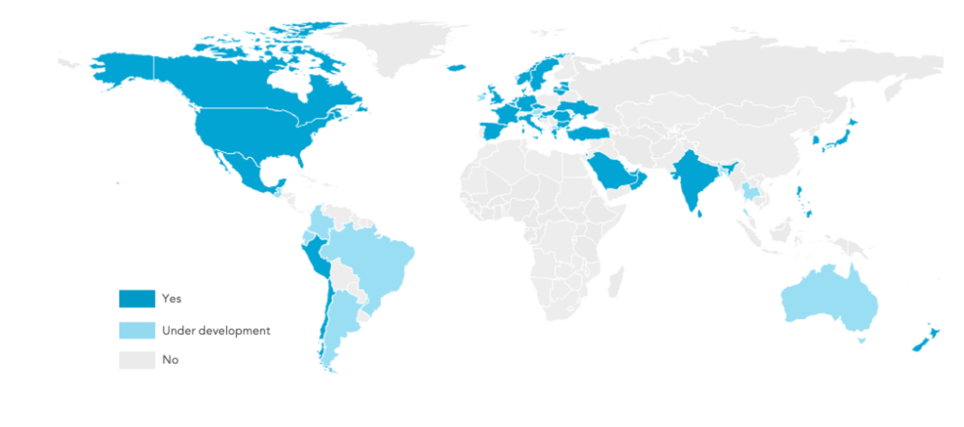
Although mobile connectivity has expanded rapidly worldwide, the deployment of mobile public warning systems remains limited, with only 37 countries currently using cell broadcast. In response, ITU supports countries to establish and implement cell broadcast systems through technical assistance, regulatory and institutional guidance and country-level implementation support. In addition, ITU has established the Technical Expert Group on Mobile Early Warning Systems (EW4All-TEG mobile) as a dedicated platform for experts and practitioners to exchange experience, review technical approaches and promote good practices on public warning system design, regulation, standards and implementation.
  - AI for Early Warnings
Rapid advances in AI create important opportunities to strengthen the effectiveness, reach and timeliness of early warning systems. To realize this potential, coordinated action is needed to identify gaps, match needs with solutions, and ensure that AI tools are relevant, accessible and aligned with multi-hazard early warning systems. In this context, ITU has established the AI for EW4All Group as the central platform for coordinating AI-related work on early warning systems, bringing together expertise in AI, data science and disaster risk management to support coherent and effective action under Early Warnings for All.
  - The AI for EW4All Group: Mandate and Structure
The AI for EW4All Group was established by the Early Warnings for All Inter-Agency Expert Group (IAEG), to advance the application of AI, data science and disaster risk management for early warning systems. The Group, which is led by ITU, comprises over 140 members representing governments, international organizations, research institutions, private sector companies, civil society organizations and technical experts from all regions of the world.
The Group identifies key gaps in the application of AI for early warning systems and helps connect country and community needs with relevant technical expertise through a structured matchmaking approach. It also supports country pilot working groups that co-design and implement AI solutions for specific early warning challenges, generating practical lessons while strengthening national capacity and ownership. As an ITU-led initiative under EW4All, the Group also serves as a global coordination platform on AI work on EWS globally. This includes promoting exchange through the Solutions Spotlight, documenting relevant tools in the AI Solutions Catalogue, connecting needs with expertise through a structured matchmaking process, and supporting country pilot working groups. Through these mechanisms, the Group is helping to build a global community of practice and to accelerate the use of AI in support of Early Warnings for All.
  - AI Tools, Technical Solutions and Country Pilots
The AI for EW4All Group is advancing a portfolio of technical solutions, tools and country pilots that demonstrate the practical application of AI for early warning systems, from global analytical tools to locally tailored innovations for specific hazards and vulnerable groups.
A major output is the AI for EWS Report, being developed jointly by ITU, UNDRR, WMO and IFRC, with contributions from the AI for EW4All Group and broader stakeholder consultations. The report positions AI as a strategic enabler of multi-hazard early warning systems, examining its relevance across the four pillars of early warning systems, highlighting practical case studies, identifying key barriers, and offering recommendations for policy-makers, practitioners and the technical community. It will be launched at the AI for Good Global Summit on 7 July 2026, alongside a dedicated workshop to discuss findings and priorities for action.
Another important product is the Early Warning Connectivity Map (EWCM), developed through collaboration between ITU, Microsoft AI for Good Lab, Planet Labs and the Institute for Health Metrics and Evaluation (IHME). The tool helps countries identify not only where populations are located, but also whether they are covered by mobile networks. It combines three data layers: connectivity data based on mobile coverage and crowdsourced data; AI-generated population density maps derived from satellite imagery; and hazard data covering 11 types of natural hazards. By integrating these layers, the EWCM helps identify populations exposed to hazard risks but beyond the reach of mobile alerts, providing an evidence base for targeted investments in telecommunications infrastructure and complementary warning dissemination channels. The tool has been completed for 33 pilot countries and is currently being piloted in Ethiopia, Liberia and others to support national early warning planning.
Country implementation of AI solutions is also being supported through the Republic of Korea-funded project “Advancing Early Warnings through AI Matchmaking and Pilot Accelerator 2026–2028”. The project supports multi-stakeholder country working groups bringing together government agencies, telecommunication operators, meteorological services, disaster management authorities, civil society and technical experts to identify priority needs, assess risks and co-design context-specific AI solutions. It also provides technical assistance and capacity development to support implementation and sustainability.
In parallel, innovation challenges have helped surface new ideas and engage the wider technical community. The AI for EW4All Innovation Challenge 2025, organized as a global hackathon, attracted more than 50 solutions from around the world, with four finalists selected based on innovation, relevance, feasibility and potential impact.
As the ITU lead of EW4All, BDT coordinates all EW4All related activities within ITU, in close cooperation with the other Sectors, and the General Secretariat. All activities across ITU on AI for EW4All and across the early warning value chain of the 4 Pillars are coordinated with the AI for EW4All Group.
- Climate Change Monitoring
  - Monitoring the Climate Impact of the ICT Sector
The ICT sector is a critical enabler of sustainable development, yet it also contributes to global greenhouse gas emissions (GHG) and environmental impacts. Current estimates suggest that the ICT sector accounts for between 1.5 and 4 percent of global emissions, a range comparable to the aviation industry. However, the lack of harmonized methodologies, consistent definitions and regulated GHG tracking has hindered the development of evidence-based policies and the ability of governments, regulators and companies to set and monitor meaningful ICT sector decarbonization targets.
Recognizing this challenge, ITU Member States have assigned ITU a clear mandate to lead the development of harmonized approaches to measuring and monitoring the environmental impact of the digital sector. This mandate is articulated in WTDC Resolution 66 (Rev. Baku, 2025), where the resolution underscores the importance of ICTs in monitoring and reporting GHG emissions from the ICT sector and at national level, and supporting harmonized environmental and emissions data collection. It calls for capacity building, training and technical assistance to help countries integrate ICTs into national climate strategies, resilience planning and emissions monitoring frameworks. The mandate is further reflected in Target 2.5 of the ITU Strategic Plan 2024-2027, which acknowledges the contribution of greening ICTs and telecommunications to mitigate and address the adverse effects of climate change in relation to global greenhouse gas emissions.
BDT Statistics team holds the mandate, expertise, and institutional networks to lead work related to indicator development, data methodologies, and international statistics standards in this domain. This recognizes the team's expertise in developing international statistical indicators, its established networks of national statistical offices and regulatory authorities, and its track record of producing high-quality, internationally comparable data through processes such as the Expert Group on Telecommunication/ICT Indicators (EGTI) and the Expert Group on Household Indicators (EGH).
As such, work relating to environmental indicators, data collection methodologies, and statistics for the ICT sector should be coordinated and led by the ITU-D Statistics team, working through the Expert Group on Telecommunication/ICT Indicators (EGTI) and the Expert Group on Household Use of ICT (EGH). Given the cross-cutting nature of environmental data, this work will require close collaboration with subject matter experts across ITU, in particular the BDT's Climate Change and Emergency Telecommunications (CET) Division and ITU-T's Standardisation Bureau (TSB). The Statistics team provides the methodological foundation and data collection frameworks, while CET contributes expertise on climate policy and environmental statistics and TSB on environmental standards. This collaborative approach ensures that ITU's work is comprehensive, coherent and aligned with the needs of Member States and the broader international community.
The environmental impact of the digital sector encompasses multiple dimensions, including direct emissions from telecommunications networks, data centres and manufacturing facilities (Scope 1), indirect emissions from purchased electricity (Scope 2), and value chain emissions from raw material extraction, component manufacturing, product use and end-of-life disposal (Scope 3). Energy consumption is a key driver of emissions, particularly as the sector expands to meet growing demand for data, cloud services and emerging technologies such as AI. Understanding these impacts requires granular data disaggregated by subsector, technology type and geographic region, as well as information on corporate climate commitments, renewable energy procurement and energy efficiency measures. ITU's work addresses all of these dimensions through a combination of company-level data collection, national-level frameworks and international indicator development.
  - Monitoring ICT Industry Climate Impact
At the global level, ITU monitors the climate impact of the world's largest digital companies through the Greening Digital Companies (GDC) Report and Dashboard, developed in partnership with the World Benchmarking Alliance. The GDC Report is an annual publication that tracks GHG emissions, energy use and climate commitments of 200 digital companies spanning telecommunications operators, data center providers, cloud service providers, device manufacturers and internet platforms. The report, now in its 5th year, provides a comprehensive picture of industry trends, and identifies areas where collective action is needed to accelerate decarbonization. The media impact of the 2025 GDC Report was substantial, with over 350 written mentions in 11 languages and an estimated 383,000 views in the first week following launch. The report was picked up by major international news agencies including Reuters, Keystone and DPA, as well as national news agencies such as the UAE News Agency and Moroccan News Agency. This widespread coverage reflects growing public and policy interest in the environmental impact of the digital sector and the need for credible data.
Complementing the annual report, the Greening Digital Dashboard provides open access to data on emissions, energy consumption and climate targets for the 200 companies. By making this data openly available, ITU is enabling evidence-based target setting and paving the way for the development of a global ICT GHG emissions database that can inform international climate policy and track progress toward net-zero goals. Together, the report and dashboard strengthen transparency, drive corporate accountability, and generate evidence to support science-based target setting.
  - National ICT Sector Climate Monitoring
A critical gap exists at the national level: most countries lack the harmonised frameworks, institutional capacity, and data infrastructure needed to measure and report ICT sector emissions consistently. To address this, the Expert Group on Telecommunication/ICT Indicators (EGTI) established the Subgroup on National Greenhouse Gas Emission Monitoring Indicators at its 15th meeting in September 2024.
The Subgroup, chaired by Arcep - the French telecommunications regulatory authority - brings together members from all ITU regions and has developed a structured framework of environmental indicators designed to measure the climate and energy footprint of the ICT sector at the national level. The framework covers Scope 1, 2, and 3 emissions, energy use, and climate targets, disaggregated across key ICT sub-sectors: telecom networks, data centres, and end-user device manufacturers. Recognizing that not all indicators can be collected immediately in all countries, the Subgroup developed a dual-priority system that classifies indicators based on environmental relevance and feasibility of data collection. High-priority indicators are those that are both environmentally significant and feasible to collect with existing data sources and regulatory frameworks, while medium and lower-priority indicators may require additional capacity building, legal frameworks or methodological development. Country-level implementation is being advanced through several pilots to test the feasibility of data collection, identify practical challenges, and generate lessons that can inform refinement of the framework and guidance for other countries. For example, under the ITU-FCDO Digital Access Programme partnership, pilot implementations of the EGTI Subgroup indicator framework are underway in Brazil and South Africa. ITU Members are invited to join and support the piloting.
In March 2025, ITU published a case study "Measuring National ICT Sector Climate Impact: Arcep Case Study" in collaboration with the World Bank and Arcep, the French telecommunications regulatory authority. The case study was launched in March 2025 through a webinar that attracted over 150 attendees. It provides a detailed blueprint for ICT regulators worldwide on how to establish data collection systems, develop legal frameworks for mandatory reporting, and determine which sectors and technologies to include in the scope of measurement. The Arcep approach covers not only telecommunications networks but also data centers, end-user devices and digital services, providing a comprehensive view of the national digital ecosystem's environmental footprint. The case study has been widely recognized as a model for scaling from traditional telecommunications regulation to full digital ecosystem coverage, and it is informing the development of similar frameworks in other countries.
Under the project 'Advancing Green Digital Action Towards a Net-Zero Digital Sector in the Philippines and Tanzania', funded by the Government of the Republic of Korea (MSIT), ITU is supporting both countries through capacity-building, data gap assessments, and the development of national decarbonisation strategies. Activities include the development of a global data collection survey aligned with EGTI indicators and an ITU Academy e-learning course on national ICT sector environmental impact.
Recognising that ICT regulators are uniquely positioned to drive sector-wide climate monitoring, BDT has developed a range of tools and guidance to support national policy development: The article 'Monitoring Sustainability: Incorporating ESG into ICT Policy Making and Regulation', published at the Global Symposium for Regulators 2025 (GSR-25), offers practical guidance for regulators to develop and integrate ESG frameworks into policy. An interactive 'Green Data Centres for Policy-Makers' e-learning course was launched in August 2025 on the ITU Academy with GIZ.
These activities reinforce ITU’s role as a leading organization for ICT environmental statistics and highlight the importance of evidence-based monitoring for the green digital transformation. The work of BDT ensures that methodologies are robust, practical, and aligned with real-world data collection. As this climate monitoring work continues to expand, the Statistics team will continue to lead statistics methodological and indicator development, working closely with CET and partners to provide coherent guidance to Member States.
- Conclusions
Both above workstreams (Early Warning Systems and Climate Change Monitoring) reflect a common operational approach: convening multi-stakeholder expert communities, fostering public–private partnerships, developing shared methodologies and knowledge products, piloting solutions in real country contexts, and building the capacity of national authorities to take ownership of tools and data. In both areas, ITU-D and its secretariat BDT play a central role as coordinator and convener, in line with its mandate.
To sustain and scale this work, strong cross-team collaboration within ITU is essential. The leadership of the Statistics team on indicators and methodologies must be complemented by the subject matter expertise of CET, TSB, and other relevant divisions.
To ensure coherence and avoid duplication across the ITU system it is important to ensure that:
- All work on AI for EW4All, should be coordinated by the ITU-led AI for EW4All Group.
- All work on definitions, methodologies, and standards for ICT data and statistics should be led by the BDT Statistics team, especially through the EGTI and EGH expert groups, in close coordination with subject matter experts from across ITU.
_____________

ITU and World Bank. 2024. Measuring the Emissions and Energy Footprint of the ICT Sector: Implications for Climate Action. https://www.itu.int/en/ITU-D/Environment/Pages/Publications/Measuring-Emissions-and-Energy-Footprint-ICT-Sector.aspx

