Telecommunication Development  Advisory Group (TDAG)  33rd Meeting, Geneva, Switzerland, 7-10 April 2026 | 
 | Document TDAG-26/INF/4-E
 | 24 March 2026
 | English only
Director, Telecommunication Development Bureau
Report on Digital Skills
Summary:
This document provides an overview of the work undertaken by the Telecommunication Development Bureau (BDT) since TDAG-25 related to digital skills and capacity development. It includes training activities carried out through the ITU Academy and its ITU Academy training centres (ATC) programme, the digital transformation centre initiative, as well as research and policy work related to digital skills.
Action required:
TDAG is invited to note this document and provide guidance as deemed appropriate.
References:
WTDC Resolutions 37, 40, 73 (Rev. Baku, 2025) and Resolution 87 (Rev. Kigali, 2022)

- Introduction
This document provides an overview of the work undertaken by BDT since TDAG-25 related to digital skills and capacity development. It includes training activities carried out through the ITU Academy and the ITU Academy training centres (ATC) programme, the digital transformation centre initiative, as well as research and policy work related to digital skills. It highlights the impact these activities have achieved in terms of strengthening digital capacities across the ITU membership and contributing to closing the digital divide through digital literacy training in remote and underserved communities. The work has been carried out in close collaboration with partners from a range of different stakeholder groups.
- ITU Academy platform
The ITU Academy portal is the main gateway to ITU capacity development and training activities. It offers ICT professionals and policy makers access to capacity development opportunities using various methodologies and tailored to different learning styles, such as online instructor-led, self-paced or face-to-face courses. Its extensive training catalogue offers a broad array of topics that are relevant to ITU membership. The ITU Academy catalogue continues to evolve in step with the fast-changing technology landscape, with new courses regularly added on artificial intelligence, quantum technologies, data governance, satellite communication and other emerging areas. ITU Academy courses offer practical, applicable knowledge that participants can use directly within their institutions, complemented by essential non-technical skills such as teamwork and cross-sector collaboration.
In recent years, the ITU Academy experienced significant growth (see Figure 1). From May 2025 to April 2026, the ITU Academy registered 24 300 additional users, bringing the total number of learners to over 87 000, from all Member States, with more than 88 per cent coming from developing countries. During this period, over 220 courses were delivered via the platform to over 30 000 registered course participants, of which 4 900 had completed their courses by March 2026. Over 3 800 participants also completed course evaluation surveys and 95 per cent rated the quality of the training as good or excellent.
Figure 1: ITU Academy registrations
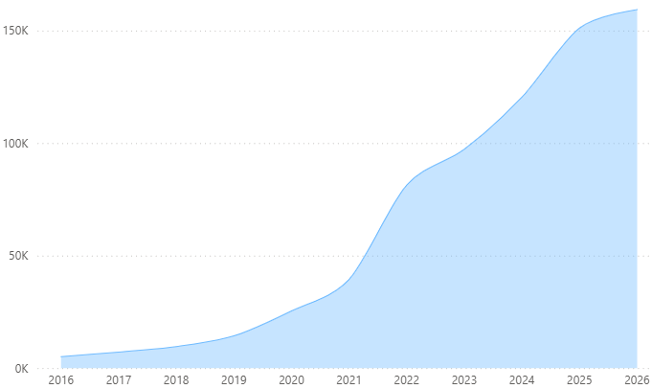
While the majority of courses are delivered through online learning, the number of face-to-face courses has recently, supported by project funds (see below). The following provides selected examples of face-to-face courses delivered through the ITU Academy over the past year:
- AI governance in practice: developing secure and innovative frameworks (Geneva, Switzerland)
- AI governance in practice: developing secure and innovative frameworks (Bangkok, Thailand)
- Excellence in digital government (Johannesburg, South Africa)
- GovStack essentials: transforming public services with modern digital infrastructure (Talinn, Estonia)
- Summer school on evidence-based digital policies for universal and meaningful connectivity (Maastricht, Netherlands)
- ITU Academy Training Centres programme
In line with WTDC Resolution 73 (Rev. Baku 2025), the ITU Academy Training Centres (ATC) programme started its first year of implementation in 2023, with 14 ATCs selected as core capacity development partners of ITU delivering high-quality courses addressing the most important training topics identified by the ITU membership, including policy and regulation, network infrastructure, spectrum management, cybersecurity, digital inclusion and digital services.
Three years on from the start of the ATC programme, 169 courses were implemented by the ATCs, with nearly 20 000 registrations and 4 000 participants receiving course certificates. From May 2025 to April 2026, 71 courses were conducted under the ATC programme, with 614 participants certified. The majority of course participants are from public sector entities (Ministries, Regulatory Authorities) and telecommunication entities, followed by academic institutions, the private sector and other organizations. Participants come from all Member States, with 92 per cent from developing countries and the majority from Africa (see Figure 2). The course satisfaction rate for ATC courses stands at a very high rate of 95 per cent.
Figure 2: ITU Academy Training Centres course participants, by region
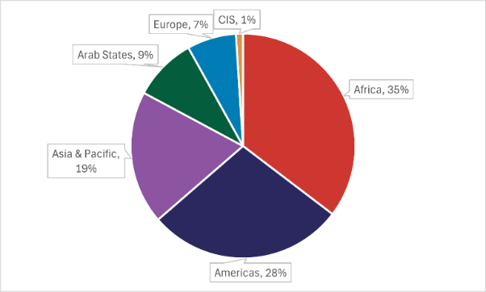
All ATC courses are delivered through the ITU Academy platform. Information about these courses, including the full 2026 catalogue, as well as on the ITU ATC programme itself, is available on the ITU Academy website. Eighty-five per cent of ATC courses are delivered online through instructor-led formats, enabling broad global reach of the programme.
BDT has organized several training sessions aimed at the instructors of the ATCs. These focused on how to conduct engaging instructor-led training (both in online and face-to-face environments), how to increase the range of tools used in order to deliver more interactive training, as well as how to optimize session design. The goal of the initiative was to impact the quality of the training courses by improving facilitation, delivery skills and by allowing for exchanges of best practices among the participating institutions.
As part of the programme cycle, annual meetings have been organized with the participating institutions on a yearly basis, both online and face-to-face. In 2023, the first annual ATC meeting took place in Geneva, Switzerland in October, followed one year later by the 2024 meeting in Manama, the Kingdom of Bahrain. The most recent annual ATC meeting took place in June 2025 in Santo Domingo, Dominican Republic. It brought together 17 delegates from the 14 ATCs representing partner institutions from the Arab Republic of Egypt, Jamaica/Barbados, Federative Republic of Brazil, Federative Republic of Nigeria, Kingdom of the Netherlands, People's Republic of China, Peru, Republic of Estonia, Republic of India, Republic of Kenya, Republic of Lithuania, Republic of Mauritius, Republic of Poland, and Republic of South Africa. During the meeting, participants focused on analysing the ATC programme implementation to date, and on how to build on lessons learned regarding training course organization and management. The meeting also provided updates on the ITU Academy revised guidelines and upcoming features, and discussed the training evaluation framework and learner feedback, as well as consolidating links between participating institutions to encourage networking and collaboration projects. The annual meeting was held in conjunction with the Global Digital Transformation Centres (DTC) Workshop and was hosted by the Centros Tecnológicos Comunitarios (CTC), in collaboration with the Instituto Dominicano de las Telecomunicaciones (INDOTEL). The 2026 annual meeting will take place in Geneva, from 21-25 April.
- ITU-EU project on capacity development for digital transformation
Funded by the Global Gateway initiative of the European Union over a period of four years, ITU, in collaboration with UNDP, started the implementation of the project “Capacity Development for Digital Transformation” in 2024. The project supports the delivery of training to policy makers and government officials through the ITU Academy platform and aims to train at least 5 000 participants on 18 foundational topics related to digital transformation. Training delivery takes place in partnership with the ATCs, as well as other UN partners.
Since the beginning of the project, a total of 64 training courses were delivered in both face-to-face and online formats, with an additional 22 courses planned by the end of 2026. To date, over 3 600 participants, from 120 countries, mostly developing countries, have been trained, achieving a participant satisfaction rate of 96 per cent. All courses fall under the 18 topics specified in the project document, with the total number of applicants exceeding 8 800. Between May 2025 and April 2026, 1 684 policymakers and government officials were trained. In addition, the newly developed ITU training course on “AI governance in practice: developing secure and innovative frameworks” under the project is currently being delivered across various regions.
- School connectivity project
Through the project “Capacity development to accelerate school connectivity in collaboration with the Giga Initiative”, which was launched in 2024, BDT supports Member States’ school connectivity efforts by providing tailored training courses for the Giga Learning Hub through the ITU Academy. Giga is the ITU-UNICEF initiative to connect every school in the world to the Internet by 2030. The training courses cover the entire school connectivity journey from early inception and planning to infrastructure mapping and modelling, financing and procurement, technical implementation and connectivity monitoring, and more, drawing upon ITU’s expertise in ICT connectivity and enabling environments. The first training course was launched in February 2025, and in 2025 a total of 128 delegates from 52 countries were trained through 5 tailored training courses (3 in person and 2 online). Since May 2025, 8 courses will have been developed and delivered.
- Digital Transformation Centres Initiative
The Digital Transformation Centres (DTC) Initiative (DTCI) was launched in September 2019 by ITU in partnership with Cisco with the objective of supporting countries to strengthen digital capacities of citizens at basic and intermediate levels. The Initiative delivers training through a network of institutions operating nationally, and with the infrastructure, expertise, and experience to run digital skills training. The Initiative targets beneficiaries predominantly from rural and underserved communities with low or no digital skills.
The number of DTCs has grown to 16 in total, covering Africa, the Americas, the Arab States and the Asia-Pacific regions (see Figure 3). Since October 2025, three DTCs joined the Initiative: the Ministry of Public Administration and Artificial Intelligence (MPAAI) – Trinidad and Tobago; the Digital Bridge Institute (DBI) – Nigeria; and the Malaysian Communications and Multimedia Commission (MCMC).
Figure 3: Digital Transformation Centres (DTC) countries
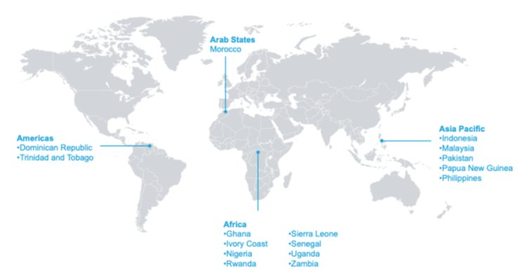
Since the launch of the Initiative (until December 2025), over 714 000 course participants from rural and underserved communities, of which 52 per cent are women, have been trained on basic and intermediate digital skills. During the reporting period (May 2025 until December 2025), over 184 000 course participants (47 per cent female) were reached. In 2025, the five-year review of the DTC Initiative "Empowering communities through digital skills: Looking back, moving forward" (2020–2025)” was released. The report reflects on the Initiative’s success, the power of multi-stakeholder partnerships and cross-sectoral collaboration, as well as the lasting impact of investing in people’s digital capacities.
Through the project “Boosting digital skills through Digital Transformation Centres”, ITU and the Government of Norway support the activities implemented under the DTC Initiative, particularly those aimed at scaling the delivery of digital skills training in local communities and among underserved groups. Whereas the first phase of the project commenced in January 2021 and closed in September 2024, a second phase started in 2024 and will be implemented until June 2026. These projects demonstrate the significant transformative impact that can be made in the lives of those who have been reached through the Initiative. As the Initiative continues to evolve, there is scope for additional collaboration to help extend these efforts further.
Recent highlights from the project include the following (as of April 2026):
- Support was provided to the DTCs in Rwanda, Senegal and Sierra Leone, to train underserved communities on basic and intermediate digital skills, the DTC in Ghana to provide 120 female SME-owners and the DTC in Côte d’Ivoire to train 100 trainers.
- The DTCs in Ghana, Pakistan, Uganda and Zambia conducted community outreach activities.
- Through the partnership with ST Foundation, the ‘Introduction to Computer Basics for Visually Impaired Persons (ICBVI)’ course is available to DTCs. Following the April 2025 training of trainers, the DTC in Uganda reached 120 learners (48% women), and five DTCs now have the capacity to train persons with visual impairments.
- In collaboration with Cisco, global campaigns are organized to promote key International Days (Girls in ICT Day, World Telecommunication and Information Society Day, Youth Skills Day, etc). These efforts have raised awareness of digital skills and helped more learners engage successfully with the Cisco platform and courses.
Under the initiative, ITU and Cisco, together with other partners, facilitate networking opportunities for DTCs by organizing face-to-face workshops and virtual meetings every year. These meetings contribute to strengthening the global DTC network and provide a platform to discuss implementation, review progress and achievements made, and explore new ideas to support the work of the DTCs. In 2023 and 2024, Global DTC Workshops were respectively hosted by the Department of Information and Communication Technology (the DTC in the Republic of the Philippines) and the ICT Training and Development Center under the Ministry of Communications and Informatics (the DTC in Indonesia) in collaboration with Indosat Ooredoo Hutchison. In 2025, the DTC workshop was hosted by the Centros Tecnológicos Comunitarios (CTC) the DTC in the Dominican Republic, in collaboration with the Instituto Dominicano de las Telecomunicaciones (INDOTEL). It was held in conjunction with the annual meeting of the ITU Academy training centres (ATCs) with the objective of encouraging collaborations within the DTC-ATC network, share best practices to ensure a continued quality of training offer, and support the work of these capacity development programmes. The 2026 DTC Global Workshop will take place in Geneva, from 21-25 April.
- Digital Skills Toolkit and training course
The ITU Digital Skills Toolkit 2024 was launched on 17 September, at the Digital Skills Forum 2024. The toolkit offers a comprehensive, step-by-step guide to support the ITU membership to create effective national digital skills strategies and policies. This practical resource offers actionable insights and examples, making it a valuable tool for countries at all stages of digital development. An eLearning course, based on the Toolkit, was launched in March 2026 and is available on the ITU Academy. The course targets policy makers, government officials and other stakeholders involved in developing national policies and programmes for digital skills development. Upon completation of the course, participants will be able to examine the important role of digital skills in national digital transformation strategies and develops a detailed national roadmap for designing and monitoring such strategies, based on the steps included in the Toolkit.
_____________

See the impact story and project documentary
Updates on the latest activities conducted by the DTCs are available on the DTC news webpage.

