Telecommunication Development  Advisory Group (TDAG)  33rd Meeting, Geneva, Switzerland, 7-10 April 2026 | 
 | Document TDAG-26/17-E
 | 3 March 2026
 | Original: English
Director, Telecommunication Development Bureau
ITU-D Operational Plan 2026
Summary:
This document presents an overview of the actions being undertaken under the 2026 ITU-D Operational Plan, both at regional and global levels, in accordance with the Baku Action Plan (BAP). It outlines the allocation of funds for the delivery of outputs across each ITU region and and through multi-regional activities, as well as for each ITU-D Priority and Enabler.
Action required:
TDAG is invited to note this document.
References:
WTDC-25 Baku Action Plan

Introduction
The ITU-D Operational Plan (OP) for 2026 is aligned with the structure of the Union’s Strategic Plan for 2024-2027. It follows the framework of the Baku Action Plan (BAP), setting out the ITU-D Priorities and supporting Enabler, together with the corresponding outcomes, products and services as well as the indicators used to measure the level of achievement level resulting from the activities of the Sector.
The planning process for OP-26 focused on defining a coherent framework for planning actions, ensuring full alignmentwith the BAP and overall strategic consistency. The actions proposed under OP-26 were developed through thorough consultations with Member States and are aligned with the priorities of each region.

Allocation of funds by beneficiary region
Currently, a total of 130 actions are being implemented globally and across regions. Slightly more than half of the OP-26 budget (57 percent) is allocated to outputs with a global focus and multi-region actions, reflecting potential to generate broad impact and operational efficiencies. Approximately 7 percent of the budget is allocated equally to each region to support the delivery of outputs benefiting all six regions of ITU.
To strengthen implementation, synergies will be pursued among regional outputs and between regional and global initiatives, in collaboration with the Radiocommunication and the Standardization Bureaux and the General Secretariat. In addition, partnerships with national, regional, and global entities, as well as with projects implemented by BDT, will continue to be prioritized with a view to amplifying the impact of BAP implementation at both regional and global levels.
Figure 1: Overview of OP-26 fund allocation by beneficiary region
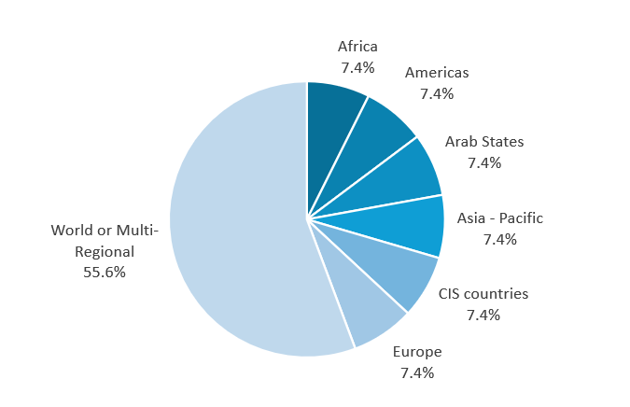
Figure 2: Overview of OP-26 funds allocated by ITU-D Priorities and Enabler (in CHF)
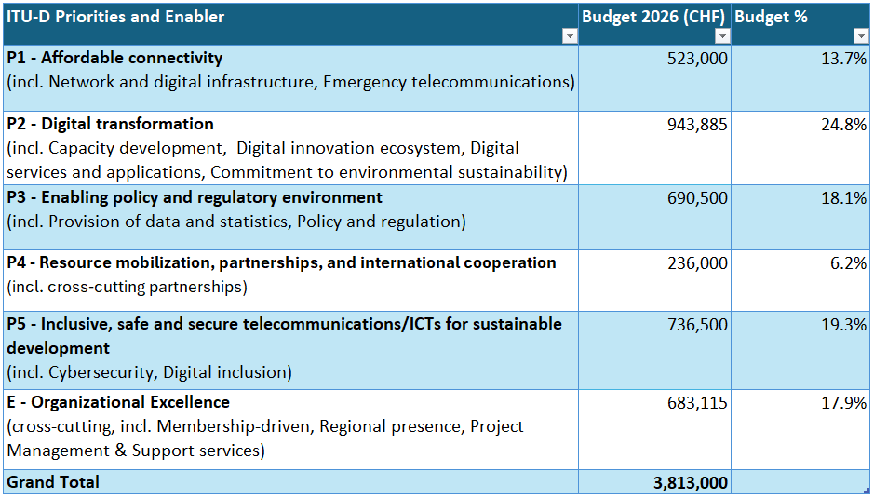

Conclusion
TDAG is invited to take note of this document and provide advice on ways to continue delivering impact at global and regional levels, while ensuring alignment with the outcomes established under the Baku Action Plan.
_____________

