Telecommunication Development  Advisory Group (TDAG)  33rd Meeting, Geneva, Switzerland, 7-10 April 2026 | 
 | Document TDAG-26/6-E
 | 3 March 2026
 | Original: English
Chair, ITU-D Study Group 2
Scope of work of ITU-D Study Group 2 for the 2026-2029 study period
Summary:
This report provides the scope of work of ITU-D Study Group 2 (SG2) for the 2026-2029 study period as agreed by the 2025 World Telecommunication Development Conference (WTDC-25). It also contains information on WTDC-25 decisions impacting ITU-D study groups and the work plan for Study Group 2 to implement the mandate.
The first meeting of ITU-D Study Group 2 for the new study period will take place from 20 to 24 April 2026.
Action required:
TDAG is invited to take note of this document and provide any guidance as deemed appropriate.
References:
WTDC Resolution 2 (Rev. Baku, 2025), WTDC Resolution 1 (Rev. Baku, 2025)

WTDC-25 decisions with impact on ITU-D Study Group 2
The ITU-D study groups follow the processes and working methods set out in Resolution 1 (Rev. Baku, 2025) “Rules of procedure of the ITU Telecommunication Development Sector” and work in accordance with the work plans adopted by WTDC-25. WTDC-25 reinforced the role of the ITU-D study groups in providing a platform for members to share experiences, present ideas, exchange views, and achieve consensus on strategies to address telecommunication/ICT priorities. In doing so, the role of the ITU-D study groups in assisting Member States in achieving their development goals was strengthened.
Regarding the scope, ITU-D Study Group 2 (SG2) will continue to focus on “Digital transformation”. The new management team appointed by WTDC-25 to lead the work of the study group consists of a chair and 13 Vice-Chairs. New coordination roles on specific topics have been assigned to the Vice-Chairs. A call for SG2 rapporteurs and Vice-Rapporteurs has been sent out to the membership and appointments will be made at the first SG2 meeting, which will take place from 20 to 24 April 2026.
SG2 has five Questions compared to the previous seven. While the number of Questions has been reduced, all main topics from the previous study Questions were maintained with some of them merged into the new Questions. New topics were also approved, such as those on the availability and affordability of user devices, and the adoption and utilization of new and emerging telecommunication/ICT services and technologies. The delivery of interim deliverables is to be incorporated into the Question-specific work plans, where feasible. The capacity building of the ITU-D study groups will continue to be prominent in the Study Questions, realized through the exchange of case studies and the organization of workshops and webinars.
There are several changes to the rules of procedure and working methods as reflected in the revised Resolution 1 (Rev. Baku, 2025) compared to the previous study period. The changes to the working methods include new or modified provisions related to office bearers (e.g. nominating member contacted if absent for two consecutive meetings), output reports (e.g. maximum 70 pages for all new output reports of a Question), interim deliverables (e.g. a compilation of published interim deliverables may constitute an output report), collaboration with other ITU Sectors (e.g. additional/revised procedures for intersectoral correspondence groups and intersectoral rapporteur groups), supporting activities for study groups (e.g. events related to the priorities and objectives of the Baku Action Plan and WTDC resolutions, held during or around study group meetings), and other topics.

Introduction to the work of ITU-D Study Group 2

Scope of work
Study Group 2 (SG2) was established in accordance with Resolution 2 (Rev. Baku, 2025) to examine, through Questions adopted by the ITU membership at WTDC-25, issues relating to digital transformation.
In this context, SG2 is responsible for several substantive topics, which are the following:
- Telecommunications/ICTs for digital transformation, including e-health and e-education
- Building confidence and security in the use of ICTs
- Using telecommunications/ICTs for monitoring and mitigating the impact of climate change, and consideration of circular economy and safe disposal of electronic waste
- Combating counterfeit telecommunication/ICT devices and theft of mobile telecommunication devices
- Implementation of conformance and interoperability testing for telecommunication/ICT devices and equipment
- Human exposure to electromagnetic fields
- Challenges and prospects for developing countries in access to emerging telecommunication/ICT technologies, platforms, applications and use cases
- Using telecommunications/ICTs to create smart cities and the information society
- Adoption of telecommunications/ICTs and improving digital skills
- Availability and affordability of user devices
- Utilization of new and emerging telecommunication/ICT technologies

Study Group 2 management
WTDC-25 designated the SG2 leadership for the ninth cycle (2026-2029): Mr Fadel Digham (Egypt) was appointed as Chair; and thirteen Vice-Chairs were appointed:
- Ms Imelda Salum Banali (Tanzania, AFR)
- Mr Mohamed Lamine Minthe (Guinea, AFR)
- Ms Fifatin Carrelle Lucrece Toho (Benin, AFR)
- Mr Víctor Antonio Martínez Sánchez (Paraguay, AMS)
- Ms Aisha Al Marzooqi (United Arab Emirates, ARB)
- Ms Maha Ziad Yousef Mouasher (Jordan, ARB)
- Mr Hideo Imanaka (Japan, ASP)
- Mr Sandeep Kumar Gupta (India, ASP)
- Mr Tongning Wu (China, ASP)
- Mr Javokhir Aripov (Uzbekistan, CIS)
- Ms Uliana Stoliarova (Russian Federation, CIS)
- Ms Lidia Stepinska-Ustasiak (Poland, EUR)
- Ms Carmen-Madalina Clapon (Romania, EUR)

Study Group 2 Questions
WTDC-25 entrusted Study Group 2 with the following Questions:
- Question 1/2: Enabling telecommunications/ICTs for digital transformation and smart sustainable cities and communities
- Question 2/2: ICTs for the environment, and assessment of human exposure to electromagnetic fields
- Question 3/2: Securing information and communication networks: Best practices for developing a culture of cybersecurity
- Question 4/2: Availability and affordability of user devices, and telecommunication/ICT equipment issues, including conformance and interoperability
- Question 5/2: Adoption and utilization of new and emerging telecommunication/ICT services and technologies, and development of digital skills

Appointment of Study Group 2 rapporteurs and vice-rapporteurs
A call for Rapporteurs and Vice-Rapporteurs has been sent out to the membership and subsequent appointments will be made for the five study Questions at the first ITU-D SG2 meeting, which will take place from 20 to 24 April 2026. The nomination and appointment process is following the TDAG-approved guidelines for composing rapporteur teams, presented during the TDAG-25 meeting.
The list of all candidatures received can be found online at this link.

Strategy and work plan for Study Group 2
The structure of the Baku Action Plan and its contribution to the ITU strategic plan (see Annex 1) provide clear linkages to the ITU-D study groups. The activities of the ITU-D study groups, along with regional initiatives and resolutions agreed upon at WTDC-25, feed into the five ITU-D priorities, which facilitate the delivery of the ITU-D mandate and guide the BDT for the next planning cycle on what ITU-D aims to achieve, in line with the overall RBM approach and the strategic goals and thematic priorities of the Union.
In order for Study Group 2 to reach its expected results for the 2026-2029 study period, in accordance with the scope of work as defined in Resolution 2 (Rev. Baku, 2025) “Establishment of study groups”, certain key elements are to be considered and put in place from the outset.
Four annual study group meetings are planned as well as three sets of rapporteur group meetings. In addition, workshops and webinars on topics related to the Questions under study are foreseen to be held throughout the study period to the extent possible. Proposals for workshops and webinars are encouraged from the membership for consideration at the annual study group meetings.
The reduction in study Questions highlights certain practical elements. The time management plan for SG2 meetings has been reviewed so that SG2 management team meetings and joint SG1-SG2 management team meetings can be held on Mondays instead of Sundays. Furthermore, the duration of SG2 rapporteur group meetings (including workshops and webinars) will span 7.5 instead of 10 working days. It is also expected that the shortened duration will improve options for hosting the meetings outside ITU HQ premises when required by the ITU HQ building construction project.
Good planning at the beginning of the study period will also allow for strategic synergies to be sought between the work of the SG2 study Questions, with Questions in SG1, as well as with study groups in the other Sectors. Furthermore, as in the previous study period, synergies will continue to be sought between study Question activities and other workstreams such as programmes, regional initiatives and projects. Contributions on the activities undertaken at related national, regional and global meetings and events are encouraged to enrich the work of the study Questions.
To ensure such synergies, and in preparation for the first SG2 meeting, a call between the SG2 Chair and the SG2 Vice-Chairs was held on 4 February 2026, and which focused in the responsibilities of the Vice-Chairs and their expected roles as coordinators on specific topics, in accordance with provision 3.2.3 of WTDC Resolution 1. Following this call, coordinator assignments were made based on expressions of interest received from the SG2 Vice-Chairs. When a role could not be filled by any SG2 Vice-Chair, additional members, such as Rapporteurs and Vice-Rapporteurs, were invited to fill the role. The topics assigned include encouragement of joint activities (e.g. joint interim deliverables, joint workshops), engagement of women and youth, increased participation from ITU-D Sector Members and Academia members, strengthening of synergies/collaboration with BDT activities, other groups and ITU Sectors. A Vice-Chair was also assigned to ensure a good implementation of the TDAG-approved guidelines on composing rapporteur teams and on better use of ITU-D study group products.
Furthermore, as in the previous study periods, BDT focal points (from headquarters and the regions) have been nominated as part of the management team for study Questions. They play a crucial role in serving as a bridge between the ITU-D study groups and BDT activities, as well as identifying and facilitating contributions from the regions and beneficiaries of ITU projects and initiatives.
Other changes are applicable in accordance with the new changes in WTDC Resolution 1 (Rev. Baku, 2025), including:
- notification on the work plan, in particular the table of contents of the study Questions, to other ITU Sectors in order to request their opinions;
- reinforcement of engagement of role bearers to ensure their active and meaningful participation.
The preliminary work plan for Study Group 2 can be found in Annex 2. The work plan will be revised each year as appropriate to guide the work of the study group.

Collaborative tools
Collaborative tools to facilitate electronic participation in the work of the ITU-D study groups will continue to be provided. In addition to remote participation services and webcast, mailing lists have been made available to participants and management team members.
Microsoft Team channels will be created for use by each Question management team at their convenience. Machined-based captioning and translation will also be available during management team meetings to facilitate communication with members who are less fluent in English.
A contributions repository and dashboard, which facilitates the search of previous contributions and their abstracts, will be provided and updated on a regular basis. Automatic document (machine) translation named “ITUTranslate” is available on the TIES protected document management repository whereby contributions, reports and other meeting documents can be translated from one UN official language into another UN official language. ITU-D study group web pages can also be translated into all UN official languages with the ITUTranslate widget.
The first meeting of ITU-D Study Group 2 will include induction and training sessions on the working methods and the collaborative tools that are available to those participating in the work of the ITU-D study groups. The briefing for delegates document has been updated and is available to the public in all UN official languages. This document is proposed for reading prior to attending the onboarding sessions.
Study group participants are encouraged to explore the tools and to provide any feedback to the secretariat to assist in their improvement.

Conclusion
With its new agreed scope of work and assigned study Questions, Study Group 2 will meet from 20 to 24 April 2026. The first meetings will closely look at the expected results agreed on by the membership at WTDC-25, identify methods for conducting its work and agree on detailed work plans for each study Question. These meetings will also appoint rapporteurs and Vice-Rapporteurs for each of the study Questions.
The 2026 block of Study Group 2 Rapporteur Group meetings are planned to take place from 7 to 16 October 2026.

Annex 1: Structure of Baku Action Plan and its contribution to the ITU strategic plan

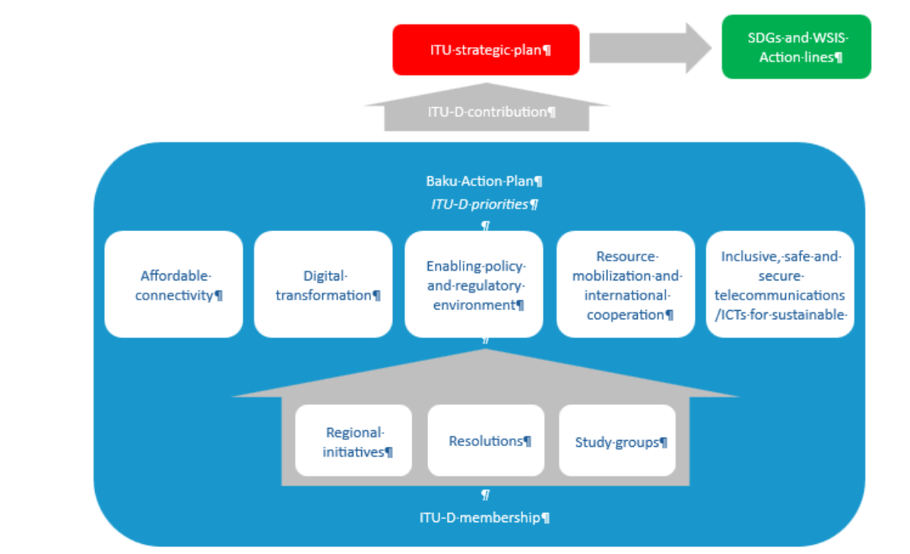

Annex 2: Work plan of ITU-D Study Group 2
_______________

Source: Annex 1 to WTDC Resolution 2 (Rev. Baku, 2025).
See circular letter BDT/PPS/CSTG-1.
The web page for this meeting is available here.
Available at this link.
Available at this link.
Available at this link.
The contributions repository & dashboard from the 2022-2025 study period can be found here.
https://translate.itu.int/documents.

