Telecommunication Development  Advisory Group (TDAG)  33rd Meeting, Geneva, Switzerland, 7-10 April 2026 | 
 | Document TDAG-26/5-E
 | 3 March2026
 | Original: English
Chair, ITU-D Study Group 1
Scope of work of ITU-D Study Group 1 for the 2026-2029 study period
Summary:
This report provides the scope of work of ITU-D Study Group 1 for the 2026-2029 study period as agreed by the 2025 World Telecommunication Development Conference (WTDC-25). It also contains information on WTDC-25 decisions with impact on ITU-D study groups and the work plan for Study Group 1 to implement the mandate.
The first meeting of ITU-D Study Group 1 for the new study period will take place from 13 to 17 April 2026.
Action required:
TDAG is invited to take note of this document and provide any guidance as deemed appropriate.
References:
WTDC Resolution 2 (Rev. Baku, 2025), WTDC Resolution 1 (Rev. Baku, 2025)

WTDC-25 decisions with impact on ITU-D Study Group 1
The ITU-D study groups follow the process and working methods set out in Resolution 1 (Rev. Baku, 2025) “Rules of procedure of the ITU Telecommunication Development Sector adopted by WTDC-25. WTDC-25 reaffirmed the role of the ITU-D study groups to provide membership with a platform to share experiences, present ideas, exchange views, and achieve consensus on strategies to address current and future telecommunication/ICT priorities. In so doing, the role of the ITU-D study groups to assist Member States in achieving their SDG targets and specific development goals was strengthened.
The changes to the working methods Resolution 1 (Rev. Baku, 2025) include new or modified provisions related to office bearers (e.g. nominating member is informed if the office bearer is absent for two consecutive meetings), output reports (e.g. a maximum 70 pages instead of 50 pages for new output reports of a Question), interim deliverables (e.g. a compilation of published interim deliverables may constitute an output report), collaboration with other ITU Sectors (e.g. additional/revised procedures for intersector correspondence groups and intersector rapporteur groups), supporting activities to study groups (e.g. events related to the priorities and objectives of the Baku Action Plan and WTDC resolutions, held during or around study group meetings), and other topics.
As detailed in Resolution 2 (Rev. Baku, 2025), ITU-D Study Group 1 (SG1) has a renewed focus on “Universal meaningful connectivity for bridging the digital divide”. The new management team appointed by WTDC-25 to lead the work of SG1 is made up of 1 Chair and 16 Vice-Chairs for SG1. Coordination roles on specific topics will be assigned to the vice-chairs.
SG1 comprises 5 Questions compared to the previous 7, which reduces topic/contribution overlaps and enhances efficient use of resources. While the number of Questions has been reduced, main topics from the previous study Question were maintained with some of them merged into the new Questions. The 5 Questions will also study new topics. The 5 study Questions are to research, in line with their respective terms of references, on new and emerging telecommunications/ICTs, including applications of artificial intelligence (AI), in delivering universal meaningful connectivity.
Specific study Questions will study new topics including: the complementarity of terrestrial and non-terrestrial networks; data-driven policy design; institutionalised cross sectoral collaboration (e.g., ICT, finance, energy, education, transport) to align telecommunication/ICT infrastructure goals with national development priorities; the use of AI in the technical delivery on the broadcasting chain; the use of AI, digital twins, and other relevant tools in new and emerging telecommunication/ICT services and technologies for disaster risk prediction, reduction, and management; economic impact of new and emerging telecommunication/ICT services and technologies, including applications of AI and metaverse; national spectrum valuation; mobile money; contribution of telecommunication/ICT services to social return on investment; how accessible telecommunication/ICT solutions can improve work environment and access to employment opportunities, especially for persons with disabilities and persons with specific needs; innovative consumer awareness and empowerment strategies.
The delivery of interim deliverables is to be built into the Question-specific work plans, to the extent feasible. The capacity building of the ITU-D study groups will continue to be prominent in the study Questions, which will be realized through the exchange of case studies and organization of workshops and webinars.

Introduction to the work of ITU-D Study Group 1

Scope of work
Study Group 1 (SG1) was established in accordance with Resolution 2 (Rev. Baku, 2025) to examine, through Questions adopted by the ITU membership at WTDC-25, issues relating to universal meaningful connectivity for bridging the digital divide.
Topics to be studied by SG1 are:
- National policy and regulatory aspects of broadband telecommunication/ICT development
- Economic aspects in the field of national telecommunications/ICTs, including facilitating the implementation of the digital economy and the provision of telecommunication/ICT services, including for rural and remote areas
- National approaches for providing access to telecommunications/ICTs in rural and remote areas, with special focus on developing countries, including least developed countries, small island developing states, landlocked developing countries and countries with economies in transition
- Access to telecommunication/ICT services to enable inclusive communications, especially for persons with disabilities and persons with specific needs
- Migration and adoption of digital technologies for broadcasting for different environments
- Use of telecommunications/ICTs for disaster risk reduction and management, particularly in developing countries
- Consumer information, empowerment, protection and rights for telecommunication/ICT services, especially for vulnerable groups
- New and emerging telecommunications/ICTs, including applications of artificial intelligence (AI), in delivering universal meaningful connectivity

Study Group 1 management
WTDC-25 designated the SG1 leadership for the ninth cycle (2026-2029): Mr Roberto Mitsuake Hirayama (Brazil) was appointed as Chair; and sixteen Vice-Chairs were appointed:
- Ms Hadiza Kachallah (Nigeria (Federal Republic of), AFR)
- Mr Malick Ndiaye (Senegal (Republic of), AFR)
- Mr Francisco Antonio Casaccia Torres (Paraguay (Republic of), AMS)
- Mr Ali Rasheed Hamad Al-Hamad (Kuwait (State of), ARB)
- Mr Abdelwaheb Galizra (Algeria (People's Democratic Republic of), ARB)
- Mr Wesam M. Sedik (Egypt (Arab Republic of), ARB)
- Ms Memiko Otsuki (Japan, ASP)
- Mr Sunil Singhal (India (Republic of), ASP)
- Ms Sha Wei (China (People's Republic of), ASP)
- Mr Dao Ngoc Tuyen (Viet Nam (Socialist Republic of), ASP)
- Mr Ilgar Abdullayev (Azerbaijan (Republic of), CIS)
- Ms Anastasia Konukhova (Russian Federation, CIS)
- Ms Umida Musayeva (Uzbekistan (Republic of), CIS)
- Ms Cristina Aguiar (Portugal, EUR)
- Mr Mehmet Alper Tekin (Republic of Türkiye, EUR)
- Mr Teddy Woodhouse (United Kingdom of Great Britain and Northern Ireland, EUR)

Study Group 1 Questions
WTDC-25 entrusted Study Group 1 with the following Questions:
- Question 1/1: Enabling policies and strategies for universal connectivity with a focus on underserved, remote and rural areas
- Question 2/1: Enabling policies and regulations for adopting digital telecommunication/ICT services and technologies for distribution and broadcasting
- Question 3/1: The use of telecommunications/ICTs for disaster risk reduction and management
- Question 4/1: Economic aspects of national telecommunications/ICTs
- Question 5/1: Consumer protection and empowerment, and meaningful accessibility for all, especially for persons with disabilities and persons with specific needs

Appointment of Study Group 1 Rapporteurs and Vice-Rapporteurs
A call for Rapporteurs and Vice-Rapporteurs has been sent out to the membership on 16 December 2025 and subsequent appointments will be made for the five study Questions at the opening plenary of the first ITU-D SG1 meeting on 13 April 2026. The appointment of Rapporteurs will be based both on expertise in the subject to be studied and on the ability to coordinate the work. The appointment of Vice-Rapporteurs will also seek regional balance. The practical guidelines agreed at TDAG 2025 are to be considered in this context.
The list of all candidatures received can be found online at the following link: https://www.itu.int/en/ITU-D/Study-Groups/2026-2029/Pages/candidates.aspx

Strategy and work plan for Study Group 1
The structure of the Baku Action Plan and its contribution ITU-D to the ITU strategic plan (see Annex 1) provides clear linkages to the ITU-D study Groups. ITU Study Groups together with regional initiatives and resolutions agreed at WTDC-25, feed into the 5 ITU-D priorities which facilitate delivery of the ITU-D mandate and guides BDT for the next planning cycle on what ITU-D aims to achieve, in line with the overall RBM approach and the strategic goals and thematic priorities of the Union.
For Study Group 1 to reach its expected results for the 2026-2029 study period, in accordance with the scope of work as defined in Resolution 2 (Rev. Baku, 2025) “Establishment of study groups”, certain key elements are to be considered and put in place from the outset:
- Four annual study group meetings are planned as well as three sets of rapporteur group meetings. In addition, workshops and webinars, with the participation of experts beyond the realm of ITU-D members, on topics related to the Questions under study are foreseen to be held in Geneva and in the regions, in line with proposals from the membership, and are to be held throughout the study period to the extent possible. Proposals for workshops and webinars are encouraged from the membership for consideration at the annual study group meetings.
- The reduction in study Questions brings to light certain practical elements. The time management plan of SG1 meetings have been reviewed such that SG1 management team meetings and joint SG management team meetings can be held on weekdays (Mondays and Fridays) instead of Sundays. Furthermore, the time management plan of SG1 Rapporteur Group meetings (including workshops) would span 7.5 days instead of 14 days. It is also expected that the shortened duration will improve options for hosting the meetings outside ITU HQ premises when the ITU HQ building construction project requires so.
- Good planning at the beginning of the study period will also allow for strategic synergies to be sought between the work of the SG1 study Questions, with Questions in SG2, as well as with groups in the other Sectors. As requested by the membership, a need to report on the synergies achieved through the work of the related study Questions, programmes, regional initiatives and projects will be considered in all activities that are undertaken by the ITU-D study groups (3.8.1 Resolution 1(Rev. Baku, 2025)).
- At the beginning of the study period, specific functions are assigned to SG1 Vice-Chairs through coordinator roles (3.2.3 Resolution 1(Rev. Baku, 2025)) to assist the SG1 Chair and the SG1 in delivering expected outputs. One of the coordinator roles will include following up on guidelines from TDAG including the “practical guidelines for promoting Study Group products” (see section 6.4 of document TDAG-25/62). When a role could not be filled by any SG1 Vice-Chair, additional members, such as rapporteurs and Vice-Rapporteurs, are invited to fill the role.
- At the beginning of the study period, the SG1 Chair may inform other sectors on the SG1 and study Questions workplans on the table of content of final output reports and request their inputs (3.8.2 Resolution 1(Rev. Baku, 2025)).
- For a sustainable work with quality outputs, the SG1 Chair, Vice-Chairs, Rapporteurs and Vice-Rapporteurs are required to be physically present at meetings and fully engaged in discharging their duties. This is achieved with commitment and support of their nominating entities. Nonattendance to meetings will be raised to the nominating entities, reminding them of their commitment (3.2.8 and 3.3.1 Resolution 1(Rev. Baku, 2025)).
- Contributions on the activities (projects, workshops, meetings) undertaken at related national, regional and global level by ITU-D members are encouraged to enrich the work of the Study Questions.
- At the beginning of the study period, BDT focal points for SG1 (from regional offices and from HQ) are nominated as part of the management team of study Question. They play a crucial role in identifying and facilitating contributions from the region and from beneficiaries of ITU projects and initiatives.
The preliminary work plan for Study Group 1 can be found in Annex 2. The work plan will be revised every year to guide the work of the study group.

Collaborative tools
SG1 secretariat, in collaboration with BDT IT support, puts in place collaborative tools that allows active collaborators, management team members and meeting participants to work together efficiently. These tools are evolving. In addition to remote participation services and the webcast in the languages of the respective meeting, mailing lists are mae available to participants and management team members. MS teams are created for use by each Question management team as per their convenience. The automatic captioning in various languages is highly appreciated by the Question management team members as it improves accessibility and exchanges during the e-Meetings. Captioning in all SG1 meetings and Sign language interpretation in Question 5/1 meetings is offered and appreciated. At the last SG1 management team meeting and joint SG1-SG2 management team meeting in 2025 (usually have no interpretation facility), AI-interpretation was trialled and further trials of additional tools may be conducted.
The contributions repository & dashboard, which facilitates the search of previous contributions, and their abstracts is updated. Automatic document (machine) translation names “ITUTranslate” is available on the ties protected document management repository whereby contributions, reports and other meeting documents can be translated from one UN official language into another UN official language by the reader. The ITU-D Study Group website for 2026-2029 has been developed and is online. All ITU-D study Group website pages, as is the case for all BDT webpages, are available in all UN official languages with the ITUTranslate widget.
To access collaborative tools as well as all SG1 documents, an active TIES account is required.
Study group participants are encouraged to explore the tools and to provide any feedback to the secretariat (devsg@itu.int) to assist in their improvement.

Conclusion
With its new agreed scope of work and assigned study Questions, Study Group 1 will meet from 13 to 17 April 2026. The first meetings will closely look at the expected results agreed on by the membership at WTDC-25, identify methods for conducting its work and agree on detailed work plans for each study Question. These meetings will also appoint Rapporteurs and Vice-Rapporteurs for each of the study Questions.
Onboarding sessions on the work of the ITU-D study groups, with details on the working methods and tools available to study group participants, will be provided on the first day of the meeting. The briefing for delegates document has been updated and is available to the public in all UN official languages. This document is proposed for reading prior to attending the onboarding sessions.
The 2026 block of Study Group 1 Rapporteur Group meetings are planned to take place from 28 September to 7 October 2026.

Annex 1: Structure of Baku Action Plan and its contribution to the ITU strategic plan

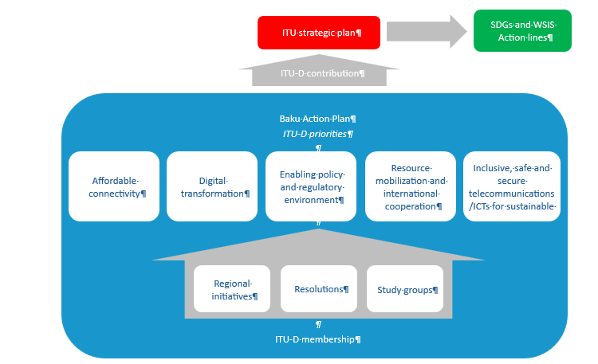

Annex 2: ITU-D Study Group 1 work plan
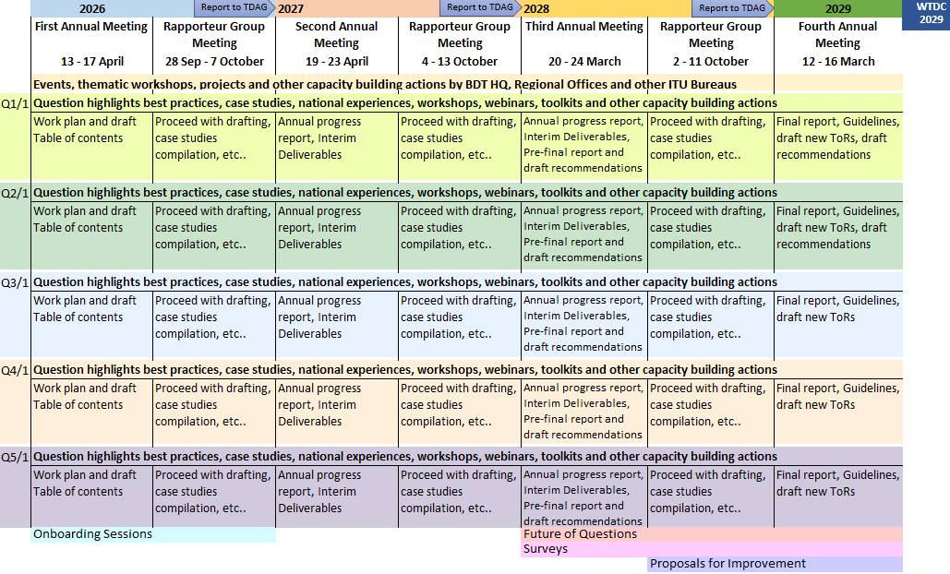
________

The contributions repository & dashboard for the previous study period (2018-2022) can be found here.
https://translate.itu.int/documents

