Telecommunication Development  Advisory Group (TDAG)  33rd Meeting, Geneva, Switzerland, 7-10 April 2026 | 
 | Document TDAG-26/2(Add.2)-E
 | 3 March 2026
 | Original: English
Director, Telecommunication Development Bureau
Impact framework for the implementation of the Baku Action Plan (BAP)
Summary:
The document puts forward an impact framework for the implementation of the Baku Action Plan (BAP), it includes the ITU-D Priorities and their expected outcomes, the Enabler, the products and services to be delivered and a set of outcomes and output indicators. It also presents the ITU-D Operational Plan for 2026 (OP-26) and the allocation of funds under each ITU-D Priority and Enabler.
Action required:
TDAG is invited to examine this document and provide guidance as deemed appropriate.
References:
TDAG-26, Document 2
WTDC-25 Baku Action Plan

New approach to developing the ITU-D Operational Plan and BAP implementation

1.1 BAP implementation vision and strategy 2026-2029
The World Telecommunication Development Conference held in Baku, Azerbaijan in 2025 (WTDC-25) adopted the Baku Action Plan (BAP) defining the direction of the work of the ITU's Development Sector (ITU-D) until the next WTDC and charting a pathway for digital development that aligns closely with the World Summit on the Information Society (WSIS) Plan of Action as well as the Sustainable Development Goals (SDGs) set out by the United Nations for 2030.
The overall strategy for BAP implementation is built around:
- the coherence and integration of Operational Plan actions and outputs, the outcomes of ITU-D Priorities, projects and regional initiatives, ITU-D Resolutions as well as to the ITU Strategic Goals;
- enhanced cross-functional and outcome-based collaboration across teams, including regional and area offices, with a view to increasing the efficiency of ITU-D products and services and their impact on beneficiary countries, government agencies, national stakeholders and communities;
- strong implementation synergies with the ITU Radiocommunication Bureau (BR), the ITU Standardization Bureau (TSB) and the General Secretariat;
- greater integration between project implementation, OP actions, Regional Initiatives, and partner efforts will be pursued during the current implementation cycle to ensure the timely and effective delivery of quality outputs.

1.2 Crafting the framework for the ITU-D Operational Plan 2026 (OP-26)
The ITU-D Operational Plan for 2026 is aligned with the structure of the BAP as well as the Strategic Plan for the Union for 2024-2027. The structure of BAP outlines the ITU-D Priorities and Enablers, and their corresponding outcomes, ITU-D products and services as well as indicators to measure progress. The impact framework for BAP implementation for OP-26 will serve as a basis for the ITU-D Operational Plan 2026-2029 once the 2027-2030 ITU budget has been approved by Council.
The planning process of OP-26 consisted of defining the framing principles for initiating actions, ensuring alignment with BAP and overall coherence (Figure 1). The actions proposed underwent thorough consultation with Member States and align with the priorities of each region.
Figure 1: 2026 Operational Planning: outcomes, outputs and actions
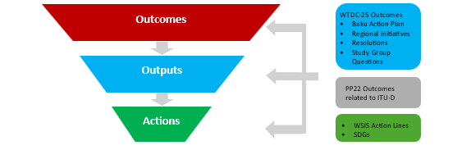
In accordance with the BAP, OP-26 elaborates actions to deliver outputs, and their corresponding measurable indicators in alignment with the outcomes of ITU-D Priorities, taking into account the experience from implementing the Kigali Action Plan (KAP), and ensuring the continuity of the delivery of services to ITU membership. The new implementation framework, anchored in Result Based Management (RBM) principles, will enable proper monitoring and evaluation of the implementation of the outcomes of ITU-D Priorities and the Enabler.

Implementation cycle 2026-2029: OP-26 allocation of resources

2.1 General allocation of funds for the implementation of OP-26
Taking into account the new BAP structure and lessons learned from the implementation of the KAP the allocation of funds under OP-26 (Table 1) was defined through internal consultations between headquarters and regional and area offices, as well as consultations with Member States, and align with the priorities of each region.
It is important to note that the figures below represent exclusively the funds available for OP-26 actions and external services. A number of ITU-D products and services are delivered by internal staff without incurring additional cost and thus not reflected in Table 1.
Table 1: Breakdown of funds allocated under OP-26, by ITU-D Priority
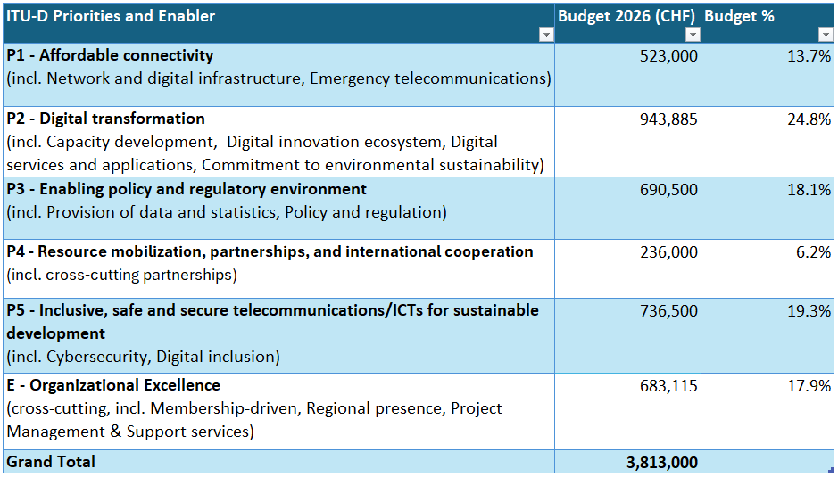
Notes: These are preliminary figures.
‘P’ stands for ITU-D Priority; E’ stands for Enabler

2.2 OP-26 allocation of funds by beneficiary region
Based on the experience from the implementation of the Kigali Action Plan and the needs identified through consultations with Member States, slightly more than half of the OP-26 budget (56 percent) has been allocated to outputs with global focus and multi-region actions, which are expected to generate broad impact and leverage operational efficiencies.
Approximately 7 percent of funding has been allocated to each region to support delivery of outputs in alignment with regional priorities, ensuring an equitable distribution of resources. Further implementation synergies will be sought among regional outputs, and between regional and global outputs as well as with the outputs of the other ITU Bureaus and the General Secretariat. Partnerships with national, regional and global entities and projects implemented by BDT will further amplify the impact of BAP implementation in the regions and at the global level.
Figure 2: Breakdown of OP-26 outputs by beneficiary region
(cumulative for all ITU-D Priorities and Enabler)
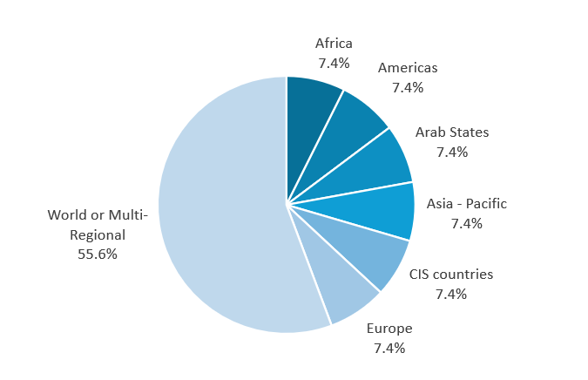
* as % of OP-26 budget

2.3 Linkages between ITU-D Priorities and the ITU Thematic Priorities
The BAP forms the basis for the development of the ITU-D operational plan to monitor and achieve the priorities identified by the Member States at WTDC-25 throughout the 2026-2029 implementation cycle. It is results-based and steers the implementation of these priorities in alignment of the thematic priorities, product and service offerings and enablers defined in the ITU strategic plan for 2024-2027 within the limits set in the financial plans for the concerned timeframes.
There are strong linkages between the ITU-D Priorities as defined in BAP and the Thematic Priorities set out in the ITU Strategic Plan 2024-2027, as mapped in the table below.
Figure 4: Linkages between ITU-D Priorities & Enabler, and ITU Thematic Priorities
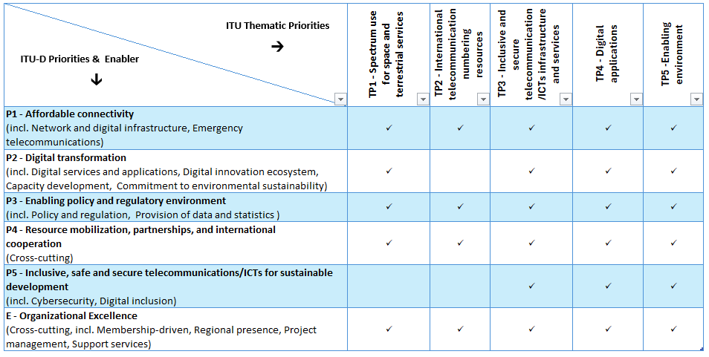
Note: in brackets next to each ITU-D Priority/Enabler are listed the respective topics / programmes through which the actions are undertaken and outputs delivered.

2.4 Implementation of OP-26: division of responsibilities and reporting
The outputs defined in the 2026 Operational Plan will be delivered by the responsible Departments of the Telecommunication Development Bureau (BDT) and Regional Offices. The Support Services are delivered by BDT and the General Secretariat, subject to agreed annual Service Level Agreements (for the provision of internal services). The Support Services delivered by the General Secretariat are described in the General Secretariat Operational Plan.
The delivery of outputs (ITU-D Products and Services) and the related support services is planned, monitored and evaluated by ITU management based on the outcomes of the ITU-D Priorities and Enabler as defined in BAP and aligned to the objectives of the ITU Strategic Plan. In addition:
- The annual report to TDAG on the implementation of BAP will report on the products and services delivered by BDT as well as the progress made towards achieving the outcomes set in BAP by Member States.
- The annual report to Council on the implementation of the ITU Strategic Plan will report on the progress made in Thematic Priority areas and towards achieving the ITU Strategic goals.
- The implementation of BAP began in January 2026 and will continue until the end of 2029. The implementation of the ongoing work will be reported to TDAG-27.

2.5 Risk analysis
With regard to risk management, apart from the operational risks included in the 2026 Operational Plan, which will be reviewed periodically by senior management, each Department and Regional Office will identify, assess and manage risks associated with the delivery of the respective outputs and support services, following a multi-level risk management approach.
The table below identifies the major operational risks for the 2026-2029 timeframe. These risks will be reassessed on a regular basis to account for changes in the internal and external environment likely to have impact on the implementation of ITU-D Operational Plans.
Perspective | Description of risk | Probability | Impact level | Mitigation
Finance | Lack of resources/  Insufficient funding | Medium | High | - Appropriate budget forecast to be prepared  - Adequate implementation strategies developed to reduce costs and improve efficiency  - Mobilization of additional/extra-budgetary resources as required  - Development of new partnerships
Human resources | Lack of qualified experts in the field of activity | High | High | - Anticipate resources requirements and timely initiate recruitment and procurement  - Create, keep up-to-date and further develop a roster of experts  - Strengthen internal expertise in key areas
Stakeholders/ partners | Lack of support/  commitment from partners and countries | Medium | Medium | - Ensure and enhance cooperation with Member States so as to guarantee appropriate level of involvement by countries  - Coordinate with UNRCOs and UNDSS to assess and evaluate country specific risks  - Develop new implementation and capacity development mechanisms to strengthen country ownership and the sustainability of interventions
Environment | Delays in country activities due to unforeseen local events | Medium | High | - Communicate effectively with partners and donors  - Develop adaptive and responsive implementation mechanisms  - Integrate risk management in project and activity planning

Impact framework for BAP implementation 2026-2029
The impact framework for the implementation of BAP follows a results chain, as outlined in the tables that follow, linking ITU-D Priorities to outcomes and related indicators and outputs. The actions under OP-26 were planned on the basis of the refined outcomes and indicators adopted at WTDC-25, ensuring alignment between operational planning, monitoring and reporting.
Progress on the outcome indicators, which monitor the changes and impact at the country level to which BDT contributes, will be reported at the end of the BAP cycle in 2029. Progress on output indicators which measure achievements related to the development of products or services elaborated by BDT, will be reported annually to TDAG. Baselines and targets for the outcome indicators will be made available through the associated dashboards.

3.1 ITU-D Priority 1: Affordable connectivity
Priority/ Topic | Outcomes | Outcome indicators | Outputs  (ITU-D Products and services) | Budget 2026 (in CHF) | % of Priority/ Enabler Total | % of Total Budget
All Affordable connectivity |  |  |  | 523,000 |  | 13.25%
Emergency telecommunications | • Strengthened capacity of Member States to use telecommunications/ICTs for disaster risk reduction and management, to ensure availability of emergency telecommunications | • Number of Member States with a national emergency telecommunications plan as part of their national disaster risk reduction strategies | • Model policies and strategies, toolkits  • Technical interventions  • Convening platforms  • Learning frameworks | 205,000 | 39.2% | 5.2%
Network and digital infrastructure | • Improved broadband connectivity in developing countries, least developed countries (LDCs), small island developing states (SIDS) and landlocked developing countries (LLDCs), countries with specific needs  • Improved telecommunication/ICT infrastructure and service, in particular broadband coverage, quality of service and affordability of services and devices and with regard to rural and underserved areas | • Number of Member States with broadband plans  • Percentage of individuals using the Internet  • Percentage change in (fixed and mobile) broadband costs relative to household income  • Percentage of individuals who own a mobile phone  • Percentage of rural population in LDCs, LLDCs, and SIDS covered by IMT-2000 (‘3G’) networks or higher  • Percentage of Member States with available data where at least 90 per cent of the population in rural areas is covered by IMT-Advanced (‘4G’) networks or higher  • Percentage of Member States with entry-level mobile broadband data basket available at no more than 2% GNI per capita  • Percentage of Member States with entry-level fixed broadband data basket available at no more than 2% GNI per capita | • Technical interventions  • Convening platforms  • Learning frameworks  • Convening platforms  • Model policies and strategies, toolkits | 318,000 | 60.8% | 8.1%

3.2 ITU-D Priority 2: Digital transformation
Priority/ Topic | Outcomes | Outcome indicators | Outputs  (ITU-D Products and services) | Budget 2026 (in CHF) | % of Priority/ Enabler Total | % of Total budget
All Digital transformation |  |  |  | 943,885 |  | 24.75%
Digital innovation ecosystem | • Enhanced national capacity to develop and adopt local telecommunications/ICTs.  • Strengthened capacity to develop and integrate telecommunication/ICT innovation and digitalization in national development agendas | • Number of Member States having adopted innovation strategies and initiatives related to telecommunications/ICTs  • Number of Member States having adopted multi-sector policies at the national level on digital transformation / development | • Learning frameworks  • Model policies and strategies, toolkits  • Technical interventions | 269,500 | 28.6% | 7.1%
Digital services and applications | • Enhanced capacity to accelerate digital transformation and sustainable development through the use of new and emerging telecommunications/ICTs and services | • Number of Member States having adopted a digital sectoral strategy at the national level | • Learning frameworks  • Convening platforms  • Model policies and strategies, toolkits  • Technical interventions | 163,385 | 17.3% | 4.3%
Capacity Development | • Enhanced human and institutional capacity of the ITU membership in telecommunications/ICTs to foster digital transformation  • Improved digital skills and capabilities for digital transformation | • Number of Member States with digital skills strategies at national level  • Percentage of individuals with basic digital skills | • Model policies and strategies, toolkits  • Technical interventions  • Learning frameworks | 357,000 | 37.8% | 9.4%
Commitment to environmental sustainability | • Enhanced capacity to develop telecommunication/ICT strategies and solutions on environmental sustainability | • Number of Member States having adopted an e-waste policy, legislation, or regulation at national level  • Number of Member States that collect data on e-waste monitoring and generation  • Number of Member States having adopted a telecommunication/ ICT strategies and solutions on environmental sustainability | • Learning frameworks  •Convening platforms  • Model policies and strategies, toolkits  • Statistics | 154,000 | 16.3% | 4.0%

3.3 ITU-D Priority 3: Enabling policy and regulatory environment
Priority/ Topic | Outcome | Outcome indicators | Outputs  (ITU-D Products and services) | Budget 2026 (in CHF) | % of Priority/ Enabler Total | % of Total budget
All Enabling policy and regulatory environment |  |  |  | 690,500 |  | 18.11%
Policy and regulation | • Strengthened capacity of Member States to enhance their telecommunication/ICT policy, legal and regulatory frameworks conducive to sustainable development and digital transformation  • Strengthened capacity of Member States to update regulatory frameworks on space-based telecommunications/ ICT | • Number of countries advancing to the next generation of regulation (G1-G4) and/or to a higher level of preparedness for the digital transformation (G5).  • Number of Member States that have established space-based telecommunications/ ICT regulatory frameworks | • Learning frameworks  • Convening platforms  • Model policies and strategies, toolkits  • Technical interventions | 384,000 | 55.6% | 10.1%
Provision of data and statistics | • Strengthened capacity of Member States to produce and collect high quality, internationally comparable statistics which reflect developments and trends in telecommunications/ICT, empowered by new and emerging technologies and services, based on agreed standards and methodologies | • Percentage of Member States that submitted valid data no older than two years for at least 80 per cent of the indicators of the ITU World Telecommunication Indicators short questionnaire  • Percentage of Member States submitting valid data no older than three years for at least 80 per cent of the indicators for the ITU’s household questionnaire  • Percentage of Member States that submitted valid sex disaggregated data no older than three years for the indicator ‘Share of individuals using the Internet’  • Percentage of Member States that submitted valid location disaggregated data (rural/urban) no older than three years for the indicator ‘share of individuals using the Internet’  • Percentage of Member States that submitted valid data no older than three years for at least five of the information and communication technologies (ICTs) skills listed in the questionnaire | • Learning frameworks  • Convening platforms  • Statistics | 306,500 | 44.4% | 8.0%

3.4 ITU-D Priority 4: Resource mobilization, partnerships and international cooperation
Priority/ Topic | Outcome | Output indicators | Outputs  (ITU-D Products and services) | Budget 2026 (in CHF) | % of Priority/ Enabler Total | % of Total budget
All Resource mobilization, partnerships, and international cooperation |  |  |  | 236,000 |  | 6.19%
Cross-cutting | • Strengthened resource-mobilization strategy through cooperation including with international and regional financial and development institutions  • Strengthened United Nations-wide joint planning, collaboration and cooperation and with financial and development institutions at the international and regional levels  • Increased support for LDCs, LLDCs and SIDS | • Total project funds raised by BDT  • Ratio of internal/external sources for project funds  • Total number of contributing partners to ITU-D projects  • Number of ICT development agreements signed between ITU and partners to support implementation of the ITU-D Action Plan  • Number of impact evaluation reports produced by BDT  • Number of financially supported ITU-D projects in LDCs, LLDCs and SIDS  • Amount of project funding for LDCs, LLDCs and SIDS | • Convening platforms | 236,000 | 100% | 6.2%

3.5 ITU-D Priority 5: Inclusive, safe and secure telecommunications/ICTs for sustainable development
Priority/ Topic | Outcome | Outcome indicators | Outputs  (ITU-D Products and services) | Budget 2026 (in CHF) | % of Priority/ Enabler Total | % of Total budget
All Inclusive, safe and secure telecommunications/ICTs for sustainable development |  |  |  | 736,500 |  | 19.32%
Cybersecurity | • Increased literacy and awareness of cybersecurity issues  • Strengthened capacity to respond to cyber incidents and cyberattacks  • Increased child online protection | • Number of Member States having adopted cybersecurity strategies in their national development agenda  • Number of Member States with established computer incident response teams (CIRTs)  • Percentage of Members States whose National CIRTS (or equivalent) is a member or participant in relevant regional or global cooperation initiatives  • Number of Member States with a child online protection policy/strategy  • Number of Member States with online child support systems identified (e.g., helplines, referral systems) | • Convening platforms  • Learning frameworks  • Model policies and strategies, toolkits  • Technical interventions  • Statistics | 465,000 | 63.1% | 12.2%
Digital inclusion | • Strengthened capacity of the ITU membership to develop strategies, policies and practices for digital inclusion and equity, in particular for the empowerment of women and girls, persons with disability | • Number of Member States having developed a digital inclusion policy and strategy at national level  • Number of Member States that have implemented digital inclusion initiatives within the past two years. | • Learning frameworks  • Convening platforms  • Model policies and strategies, toolkits  • Technical interventions | 271,500 | 36.9% | 7.1%

Outputs
To achieve the outcomes established by WTDC-25 for each ITU-D Priority area, BDT will continue to develop products and services to support implementation at the national, regional, and international levels. These products and services (outputs) are cross-cutting, contributing collectively to the achievement of all priorities.
Key categories of ITU-D outputs include:
- Model policies and strategies
BDT develops guidance and policy frameworks to support Member States in designing tailored national telecommunications/ICT frameworks and strategic plans. Examples include, but not limited to, the National Emergency Telecommunication Plans (NETPs), innovation playbooks, broadcasting guidelines and strategies, national cybersecurity strategies, digital inclusion policy guidelines and national strategies, regulatory policy guidance, and policy recommendations that support digital transformation and investment, etc.
- Toolkits and analytical tools
BDT provides practical tools and digital platforms to support planning, infrastructure deployment, policy assessment, and decision-making. Examples include the Connectivity Planning Platform (CPP) and broadband maps, which provide geospatial, innovation toolkits, infrastructure visualisation, connectivity modelling, and statistical insights for infrastructure planning and investment decisions, digital accessibility toolkits to advance digital inclusion for all people as well as other digital ecosystem planning and regulatory toolkits.
- Convening platforms
BDT organizes global and regional, forums, including multi-stakeholder and dialogues that facilitate knowledge exchange, partnership development, and coordination among governments, industry, and development partners. Examples include the Global Symposium for Regulators (GSR), Global Innovation Forum (GIF), Digital Skills Forum (DSF), Regional Development Forums (RDF), World Telecommunication/ICT Indicators Symposium (WTIS), Accessible Regional – ICT for ALL events, etc.
- Learning frameworks and capacity-development resources
BDT provides in-person training activities, on-line self-paced, or tutor led structured training programmes and courses through its capacity building initiatives and develops knowledge resources including thematic reports and toolkits helping policymakers, regulators, and practitioners to strengthen both individual and institutional skills. These include the learning frameworks developed by the Digital Transformation Lab, ITU Academy courses and other learning mechanisms, workshops, executive training sessions etc.
- Statistics, research, and knowledge products
BDT produces data, indicators, and analytical publications that support evidence-based decision-making. Examples include ICT indicators, Digital Innovation Profiles, strategic foresight reports, Collaborative Regulation Country Reviews, the Digital Regulation Platform, the Global E-waste Monitor, and other various thematic studies that assess national digital ecosystems and innovation capacity.
- Technical interventions and implementation support
BDT provides direct technical assistance, advisory services and pilot initiatives to support countries in implementing national ICT policies and strategies. These interventions help Member States to deploy infrastructure, advance digital inclusion, nurture digital innovation environments, strengthen cybersecurity and digital services delivery to advance an inclusive digital transformation.
BDT will monitor the delivery of outputs and their contribution to the achievement of ITU-D priority outcomes through cross-cutting output indicators, including:
ITU-D Product /Services | Indicators
Technical interventions | Number of ITU-D projects signed
 | Number of Member States having received technical assistance
 | Number of resolutions/ recommendations/ decisions implemented
 | Number of software tools implemented
Statistics | Number of data points available in published dataset
 | Number of digital companies tracked to monitor emissions, energy use and climate commitments
 | Number of individuals participating in capacity development activities led by BDT
 | Number of Member States engaged
Number of participants in BDT led events
(incl. RDFs, GSR, GIF, DSF, WTIS, EGTI, GIICT, GYF, etc.)
 | Number of weekly users on ITU Datahub
Model policies, strategies, toolkits | Number of Member States assisted
Number of tools /frameworks / resources developed
(Incl. policies, strategies, country profiles, maps, guidelines, toolkits, publications, etc.)
Learning frameworks | Number of individuals participating in capacity development activities led by BDT
 | Number of individuals trained in basic and intermediate digital skills
 | Number of ITU Academy users
 | Number of professionals trained and certified in telecommunications/ (ICTs) topics
Convening platforms | Amount of project funding for LDCs, LLDCs and SIDS
 | Number of best practices /guidelines elaborated
 | Number of financially supported ITU-D projects in LDCs, LLDCs and SIDS
 | Number of ICT development agreements signed between ITU and partners to support implementation of the ITU-D Action Plan
 | Number of impact evaluation reports produced by BDT
 | Number of Member States engaged
 | Number of new ITU-D members
Number of participants in BDT led events
(incl. RDFs, GSR, GIF, DSF, WTIS, EGTI, GIICT, GYF, etc.)
 | Number of partnerships signed
 | Ratio of internal/external sources for project funds
 | Total number of contributing partners to ITU-D projects
 | Total project funds raised by BDT

Enabler: Organizational excellence
WTDC-25 defined “Organizational excellence” as the enabling mechanism to facilitate implementation and support the achievement of the outcomes of the ITU-D Priorities. It focuses on optimizing and improving operational efficiency and effectiveness so BDT can rapidly respond to changes in the telecommunication/ICT landscape and better meet countries and members’ needs. This involves strengthening internal processes, accelerating decision-making, fostering cross-functional collaboration, encouraging innovation, and enhancing performance and talent management through a culture and skills transformation plan. Key areas include:
- Membership-driven approach: prioritizing the needs of all members, particularly developing countries, and strengthening engagement with industry and new members.
- Regional presence: empowering Regional and Area Offices to enhance local responsiveness, programme implementation, partnerships, and reporting on progress, resource use and impact.
- Project management: enhancing capacity, tools, and practices to ensure efficient, accountable planning, execution, monitoring, and timely completion of development projects.
- Support services: strengthening administrative and operational functions such as communications, fellowships, events, documentation, performance monitoring, human resources, budget support, and coordination across ITU sectors.
A dedicated budget has been allocated to these areas to ensure effective delivery of ITU-D programmes and strategic outcomes.
Enabler | Budget 2026 (in CHF) | % of Enabler Total | % of Total budget
Organizational excellence | 683,115 |  | 17.92%
Membership-driven | 15,000 | 2.2% | 0.4%
Regional presence | 82,500 | 12.1% | 2.2%
Support services | 535,615 | 78.4% | 14.0%
Project Management | 50,000 | 7.3% | 1.3%
As part of BDT’s ongoing efforts to enhance operational efficiency, transparency and accountability, a structured internal process mapping initiative is being undertaken across key functions in the bureau. Delivered through a phased and evidence-based approach, the initiative ensures that proposed improvements are informed by a thorough understanding of current practices. Complementing the 2024 realignment, the work is expected to enhance quality, strengthen coordination and better align operations with BDT’s strategic objectives.
_____________

See output indicators on page 17 of this document.
The outcome indicators are currently being refined, in alignment with the ITU strategic plan, to better reflect the results to be achieved
This priority is achieved through BDT’s efforts to mobilize resources, attract new partners and maintain existing ones. Progress is thus measured through ‘outputs’ indicators.
Indicator baselines and targets will be made available in the ITU-D Operational Plan (OP) interactive dashboards.

