 | World Telecommunication Development Conference 2025 (WTDC-25)  Baku, Republic of Azerbaijan, 17–28 November 2025 |  |  | 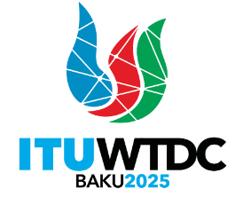
MEETING OF HEADS OF DELEGATION |  |  | Document WTDC-25/DT/5-E
 |  |  | 30 October 2025
 |  |  | English only
Director, Telecommunication Development Bureau
Secretariat of the Conference
Secretary of the Conference |  | Ms Doreen Bogdan-Martin
Executive Secretary |  | Mr Cosmas Luckyson Zavazava
Secretary of the Plenary |  | Ms Archana Gulati
Committee 1 (Steering) |  | Ms Archana Gulati
Committee 2 (Budget Control) |  | Mr Alassane Ba
Committee 3 (Objectives) |  | Ms Sofie Maddens
Committee 4 (ITU-D Working Methods) |  | Mr Marco Obiso
Committee 5 (Editorial) |  | Ms Negar Takesh
Working Group of the Plenary  (ITU-D Strategic Plan and Declaration) |  | Mr Jaroslaw Ponder
Legal Adviser |  | Mr Antoine Dore

________________

